Enhancement of reconstructed image quality and calculation speed for multiple wavefont recording method
Md Sifatul Islam¹, Yu Zhao¹, Yan-Ling Piao¹, Seok-Hee Jeon², Nam Kim^{1*}
¹School of Information and Commu. Eng., Chungbuk Univ., Cheongju, Chungbuk 361-763, Korea
Tel.:82-43-276-9957, E-mail: namkim@chungbuk.ac.kr
² Department of Electronics Engineering, Incheon National University.12-1 Songdo-dong,Incheon,Korea

For faster generation of the computer generated hologram (CGH) a virtual plane called wavefront recording plane (WRP) was introduced between the hologram plane and the object. The complex amplitude from the object is first recorded on the WRP, is expressed by equation (1) where A_{j} is the intensity of the jth point, k is the wave number, r_{j} is the distance between the jth point to the pixel (x, y) in the WRP. Secondly wavefront from the WRP is propagated to the CGH plane by a Fast Fourier transform (FFT). Compared with single WRP method, computation is further reduced by using multiple WRP (MWRP) is used [1] but using too many WRPs might take more time than the minimum computational time [2].
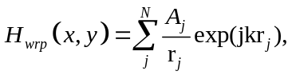 (1)
In this paper, we focus on reconstructed image quality enhancement for complex objects, long objects which have lots of curves and edges. We visualize the object in layers with respect to object point’s depth. In our proposed method a new WRP is set only when the number of object point in current layer is not equal to the number of points in the previous layer, demonstrated in figure 1(d). Since our method does not require to calculate WRP position at every depth it reduces memory usage and also creating new WRP for new curves or edges cause lesser super imposition of inferences - causing clearer reconstructed image showing finer edges or curves.
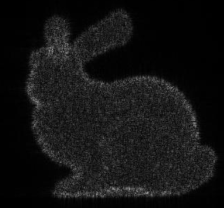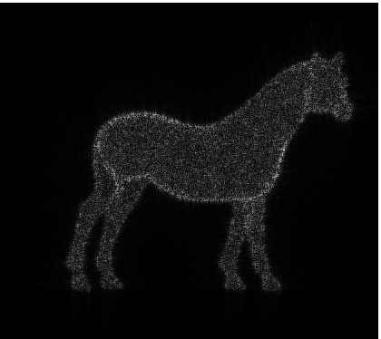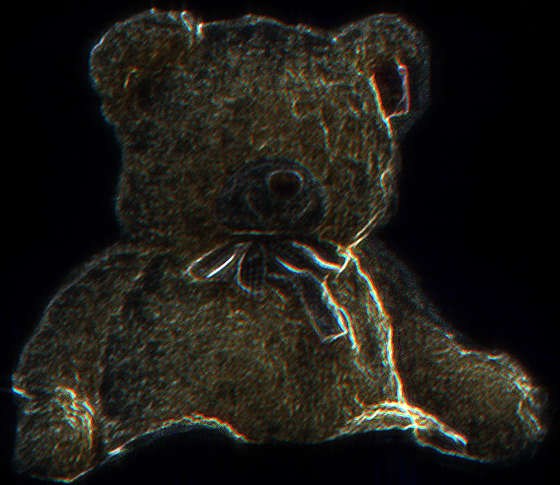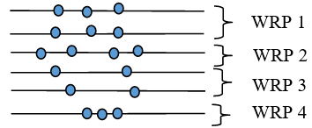
(a) (b) (c) (d)
Fig. 1. Reconstructed images of grey objects (a) horse (b) rabbit, (c) full color bear, (d) outline of the position of WRPS

The horse, bunny, full color bear with 48.5k, 36k, 669k object points respectably are chosen to verify the idea and their reconstructed images of proposed method are shown in Fig. 1(a), (b), (c). Peak signal-to-noise ratio (PSNR) of the reconstructed images with the proposed method is 24, 16, and 15 whereas with MWRP PSNR is 23, 15, 14. Moreover the computational cost of proposed method is 433, 318 and 25152 seconds while for MWRP cost is 436, 323, and 23504 seconds. Due to huge uniformity of points between layers computational cost for bear in MRWP is lower than proposed method. The experimented results clearly shows that higher PSNR can be achieved for complex objects, long objects which have lots of curves and edges, and also lower calculation time is also possible.
Acknowledgment
This work was supported by ITRC (Information Technology Research Center) support program and Openholo
References
1. A.-H. Phan, M.-L. Piao, S.-K. Gil, and N. Kim, “Generation speed and reconstructed image quality enhancement of a long-depth object using double wavefront recording planes and a GPU,” Appl. Opt. 53, 4817–4824 (2014).
2. A. Symeonidou, D. Blinder, A. Munteanu, and P. Schelkens, “Computer-generated holograms by multiple wavefront recording plane method with occlusion culling,” Opt. Express 23, 22149–22161 (2015).

