Enhancement of reconstructed image quality and calculation speed for multiple wavefront recording method
Md Sifatul Islam¹, Yu Zhao¹, Erkhembaatar Dashdavaa¹, Yan-Ling Piao¹, Seok-Hee Jeon², Nam Kim^{1*}
¹School of Information and Commu. Eng., Chungbuk Univ., Cheongju, Chungbuk 361-763, Korea
Tel.:82-43-276-9957, E-mail: namkim@chungbuk.ac.kr
² Department of Electronics Engineering, Incheon National University.12-1 Songdo-dong,Incheon,Korea

For faster generation of the computer generated hologram (CGH) a virtual plane called wavefront recording plane (WRP) was introduced between the hologram plane and the object. Firstly, the complex amplitude from each object point is recorded on the WRP. Secondly wavefront from the WRP is propagated to the CGH plane by a Fast Fourier transform (FFT). FFT of each object point to the WRP is still computationally costly. Thus multiple WRP (MWRP) was introduced which reduced the computational time farther [1] but using too many WRPs in conventional MWRP method might take more time than the minimum computational time [2].
In this paper, we focus on reconstructed image quality enhancement for non-uniform, complex objects, long objects which have lots of curves and edges with non-uniform distribution of points. We visualize the object in layers with respect to object point’s depth. In our proposed method first WRP is created for the farthest depth layer, d₁ and number of points in this layer, N (z₁) is remembered. If number of points in the current layer is greater than the previous layer a new WRP is created, N (z_{i}) > N (z_{i+1}), as shown in figure 1(a). Since our method does not require to calculate WRP position at every depth it reduces memory usage and also creating new WRP for new curves or edges cause lesser super imposition of inferences - causing clearer reconstructed image.
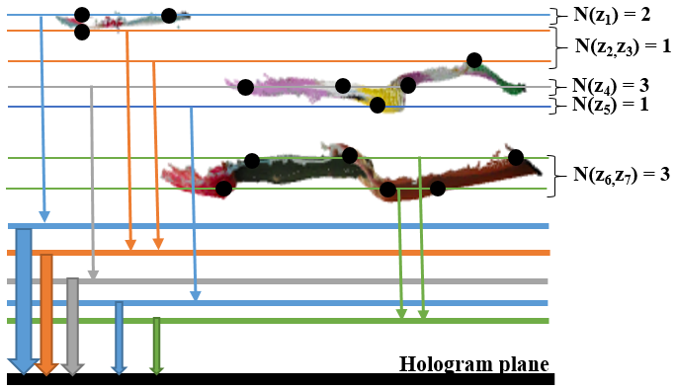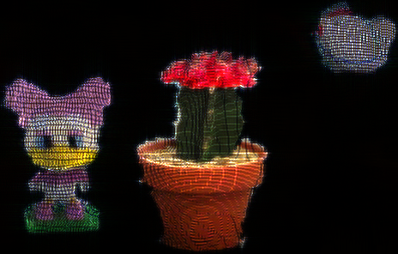
(a) (b) (c) (d)
Fig. 1. (a) Schematic diagram of proposed method, (b) original image of three objects, reconstruction image of three objects using (c) conventional multiple WRP method, (d) proposed method

The proposed method is compared with conventional MWRP, using three objects of 35,263 points. In conventional MWRP method the computation time, PSNR, and number of WRP created is 287 sec., 18.33 dB, 8 respectively; whereas in proposed method calculation time, PSNR and number of WRP created is 249 sec., 18.45 dB, and 122 respectively. Schematic diagram of the proposed method, original image, the reconstructed images using conventional MWRP and proposed method are shown in Fig. 1(a), (b), (c), (d) respectively. This clearly verifies that higher PSNR and also lower calculation time can be achieved for complex, long depth objects which have non-uniform object point distribution.
Acknowledgment
This research was supported by the Korea government, under the ITRC (Information Technology Research Center) support program (IITP-2017-2015-0-00448) supervised by the IITP (Institute for Information & communications Technology Promotion). This work was also supported by Institute for Information & communications Technology Promotion (IITP) grant funded by the Korea government (No.2017-0-00417, Openholo library technology development for digital holographic contents and simulation).
References
1. A.-H. Phan, M.-L. Piao, S.-K. Gil, and N. Kim, “Generation speed and reconstructed image quality enhancement of a long-depth object using double wavefront recording planes and a GPU,” Appl. Opt. 53, 4817–4824 (2014).
2. A. Symeonidou, D. Blinder, A. Munteanu, and P. Schelkens, “Computer-generated holograms by multiple wavefront recording plane method with occlusion culling,” Opt. Express 23, 22149–22161 (2015).

