Enhancement of Reconstructed Image Quality Using Limited Multiple Wavefont Recording Plane Method
Md Sifatul Islam¹, Yu Zhao¹, Yan-Ling Piao¹, Erkhembaatar Dashdavaa¹, Seok-Hee Jeon², Nam Kim^{1*}
¹School of Information and Commu. Eng., Chungbuk National Univ., Cheongju, Chungbuk 361-763, Korea
Tel.:82-43-276-9957, E-mail: namkim@chungbuk.ac.kr
² Department of Electronics Eng., Incheon National Univ., 119 Academy-ro, Incheon 22012, Korea

For faster generation of the computer generated hologram (CGH) a virtual plane called wavefront recording plane (WRP) was introduced between the hologram plane and the object. Firstly, the complex amplitude from each object point is recorded on the WRP. Secondly wavefront from the WRP is propagated to the CGH plane by a Fast Fourier transform (FFT). FFT of each object point to the WRP is computationally costly. Thus multiple WRP (MWRP) was introduced which reduced the computational time farther [1-2] but using too many WRPs might take more time than the minimum computational time [2].
In this paper, we focus on reconstructed image quality enhancement for complex objects, long objects which have lots of curves and edges, using limited number of MWRPs (LMWRP). We visualize the object in layers with respect to object point’s depth. In LMWRP method first WRP is created for the farthest depth layer, z₁ and number of points in this layer, N (z₁) is remembered. Onwards from the second depth layer, if number of points in the current layer is greater than the previous layer a new WRP is created, N (z_{i}) > N (z_{i+1}), as shown in figure 1(a). Since our method does not require to calculate WRP position at every depth it reduces memory usage and also creating new WRP for new curves or edges cause lesser super imposition of inferences - creating clearer reconstructed image showing finer edges or curves.
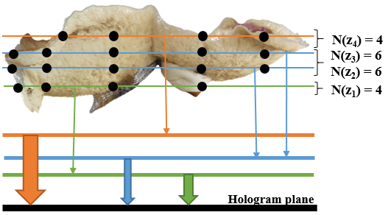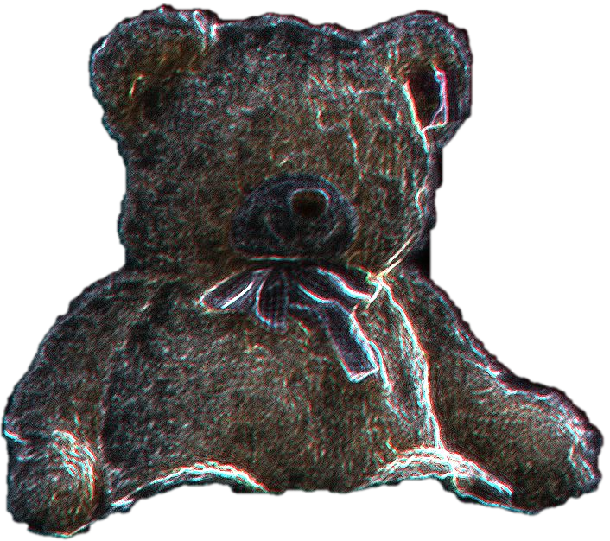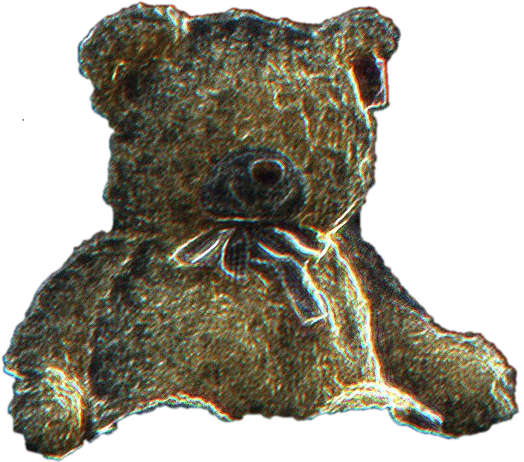
(a) (b) (c) (d)
Fig. 1. Reconstructed images of bear with (a) proposed method (b) MWRP method, (c) full color Bear object, (d) outline of the position of WRPS
A horse, a bunny, a full color bear with 48.5k, 36k, 669k object points respectably are chosen to verify the idea. Peak signal-to-noise ratio (PSNR) of the reconstructed images with LMWRP method is 24.2, 15.8, and 14.85 whereas with MWRP PSNR is 23.3, 14.9, 13.78. The reconstructed images of proposed method, MWRP method and the original image are shown in Fig. 1(b), (c), (d) respectively. Though this proposed method is only restricted to non-uniform objects these results clearly verify that higher PSNR can be achieved with LMWRP method.
Acknowledgment
This research was supported by the Korea government, under the ITRC (Information Technology Research Center) support program (IITP-2017-2015-0-00448) supervised by the IITP (Institute for Information & communications Technology Promotion). This work was also supported by Institute for Information & communications Technology Promotion (IITP) grant funded by the Korea government (No.2017-0-00417, Openholo library technology development for digital holographic contents and simulation).
References
1. A.-H. Phan, M.-L. Piao, S.-K. Gil, and N. Kim, “Generation speed and reconstructed image quality enhancement of a long-depth object using double wavefront recording planes and a GPU,” Appl. Opt. 53, 4817–4824 (2014).
2. A. Symeonidou, D. Blinder, A. Munteanu, and P. Schelkens, “Computer-generated holograms by multiple wavefront recording plane method with occlusion culling,” Opt. Express 23, 22149–22161 (2015).

