

Formal Modeling of a Vending Machine in VDM++

Mestrado Integrado em Engenharia Informática e Computação

Métodos Formais em Engenharia de Software

*Pascoal Faria*

Contents

1. Informal system description and list of requirements 3

1.1 Informal system description 3

1.2 List of requirements 3

2. Visual UML model 4

2.1 Use case model 4

2.2 Class model 6

3. Formal VDM++ model 7

3.1 Class MoneyUtils 7

3.2 Class Product 8

3.3 Class VendingMachine 9

4. Model validation 12

4.1 Class MyTestCase 12

4.2 Class TestVendingMachine 12

5. Model verification 16

5.1 Example of domain verification 16

5.2 Example of invariant verification 16

6. Conclusions 17

7. References 17

# 1. Informal system description and list of requirements

## 1.1 Informal system description

Slot for inserting coins

Slot to pick change

Credit: 1.20

Displays status and amount inserted

Buttons to select products (showing price and name)

Slot to pick product

Vending Machine

Cancel button

Keypad to enter key to open machine (not visible on the front)

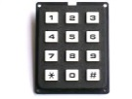

## 1.2 List of requirements

|  |  |  |
| --- | --- | --- |
| **Id** | **Priority** | **Description** |
| R1 | Mandatory | The factory operator can configure the products at sale (with names and prices) and the maintenance code. |
| R2 | Mandatory | The maintenance operator can load/extract products and coins to/from the machine, using the maintenance code to unlock the door. |
| R3 | Mandatory | The end user (buyer) can buy products, by entering coins and selecting the desired product. |
| R4 | Mandatory | The machine should be able to give change, in case the user inserts coins in excess. |
| R5 | Mandatory | The end user (buyer) should be able to cancel a purchase operation and receive back the amount inserted. |

These requirements are directly translated onto use cases as shown next.

# 2. Visual UML model [1]

## 2.1 Use case model [2]

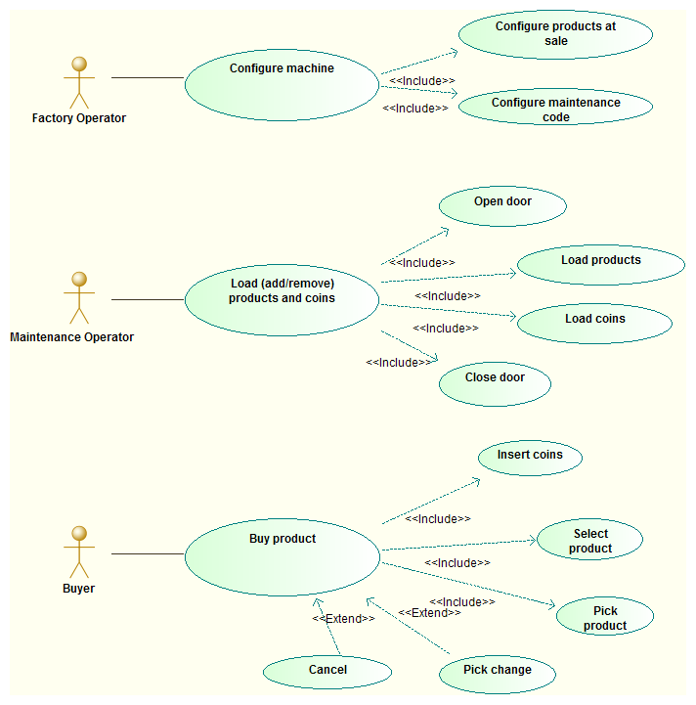

The major use case scenarios (to be used later as test scenarios) are described next.

|  |  |
| --- | --- |
| **Scenario** | **Configure machine** |
| **Description** | Normal scenario for configuring (at the factory) the products at sale (with name and price) and the maintenance code. |
| **Pre-conditions** | 1. The product names are unique. *(input)* |
| **Post-conditions** | 1. The products names and prices are configured as intended. *(final system state)*  2. The maintenance code is configured as intended. *(final system state)*  3. The stock of coins is empty. *(final system state)*  4. The stock of products is empty. *(final system state)*  5. The machine is in the idle state. *(final system state)* |
| **Steps** | (unspecified) |
| **Exceptions** | (unspecified) |
| **Scenario** | **Load stock** |
| **Description** | Normal scenario for loading (adding) products and setting (adding/removing) the stock of coins in a vending machine. |
| **Pre-conditions** | 1. The machine is initially idle. *(initial system state)*  2. The operator knows the code for unlocking the door. *(input)*  3. The products to load are among the ones configured in the machine. *(input)* |
| **Post-conditions** | 1. The items were added to the stock of products. *(final system state)*  2. The stock of coins was set to the intended one. *(final system state)*  3. The machine is idle again. *(final system state)* |
| **Steps** | 1. Unlock and open the machine door.  2. Set the stock of coins and add the products, by any order.  3. Close the machine door. |
| **Exceptions** | (none) |

|  |  |
| --- | --- |
| **Scenario** | **Buy product** |
| **Description** | Normal purchase scenario in a vending machine. |
| **Pre-conditions** | 1. The machine is initially idle (ready). *(initial system state)*  2. The machine has the product in stock. *(initial system state)*  3. The buyer has enough coins. *(input)*  4. If needed, the machine has coins in stock to give change. *(initial system state)* |
| **Post-conditions** | 1. The buyer received the product. *(output)*  2. The buyer received the change, if needed. *(output)*  3. The stock of the product is updated in the machine. *(final system state)*  4. The stock of coins is updated in the machine. *(final system state)*  5. The machine is idle (ready) again. *(final system state)* |
| **Steps** | 1. The buyer inserts the coins.  2. The machine displays the money inserted (credit).  3. The buyer selects the product.  4. The machine delivers the product and the change, if needed.  5. The buyer picks the product and the change, if existent |
| **Exceptions** | 1. The buyer cancels the purchase (alternative to step 3) - see scenario description next.  1. The product is out of stock (step 4).  2. The machine cannot make change (step 4).  3. The buyer forgets to pick the product (step 5).  4. The buyer forgets to pick the change (step 5). |

|  |  |
| --- | --- |
| **Scenario** | **Cancel purchase** |
| **Description** | Alternative purchase scenario in a vending machine, in which the user cancels. |
| **Pre-conditions** | 1. The machine is initially idle (ready). *(initial system state)*  2. The buyer has coins to insert. *(input)* |
| **Post-conditions** | 1. The buyer received back the amount inserted (same or equivalent coins). *(output)*  2. The amount of money is unchanged in the machine. *(final system state)*  3. The machine is idle again. *(final system state)* |
| **Steps** | 1. The buyer inserts the coins.  2. The machine displays the money inserted (credit).  3. The buyer cancels the operation.  4. The machine returns back the coins inserted.  5. The buyer picks the coins. |
| **Exceptions** | 1. The buyer forgets to pick the coins (step 5). |

## 2.2 Class model [3] [4]

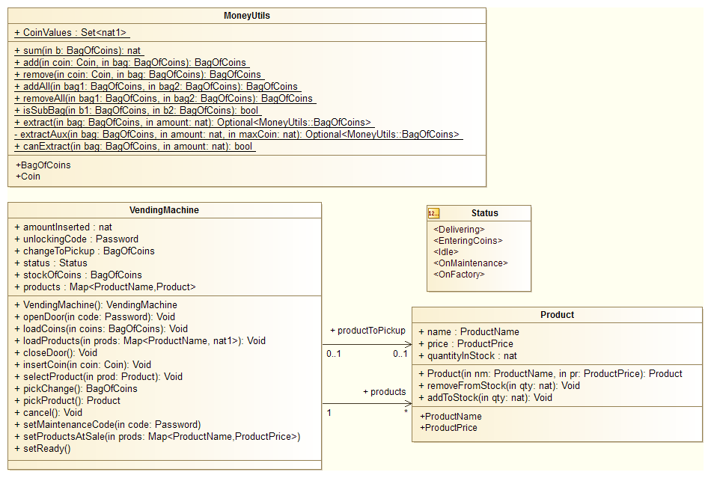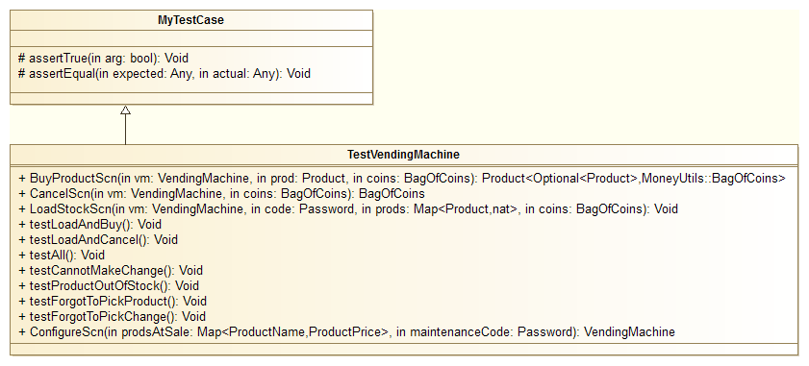

|  |  |
| --- | --- |
| **Class** | **Description** |
| MoneyUtils | Defines utility types and functions to work with bags (multisets) of coins. |
| Product | Defines a product at sale in a vending machine. |
| VendingMachine | Core model; defines the state variables and operations available to the users. |
| MyTestCase | Superclass for test classes; defines assertEquals and assertTrue. |
| TestVendingMachine | Defines the test/usage scenarios and test cases for the vending machine. |

# 3. Formal VDM++ model

## 3.1 Class MoneyUtils [5]

**class** MoneyUtils

/*

Contains utility types and functions to work with bags (multisets) of coins.

Illustrates the definition of auxiliary data types, as well as the definition

of a functionality (extract/makeChange) at different levels of abstraction.

JPF, FEUP, MFES, 2014/15.

*/

**values**

-- possible coin values, in cents of euros

**public** CoinValues : **set** **of** **nat1** = {1, 2, 5, 10, 20, 50, 100, 200};

**types**

**public** Coin = **nat1**

**inv** c == c in **set** CoinValues;

**public** BagOfCoins = **map** Coin **to** **nat1**; -- maps coin values to quantities

**functions**

-- Computes the total amount in a bag of coins

**public** sum: BagOfCoins -> **nat**

sum(b) ==

if b = {|->} **then** 0

**else** let c **in set** dom b **in** b(c) * c + sum({c} <-: b);

-- Adds a coin to a bag of coins and returns the new bag

**public** add: Coin * BagOfCoins -> BagOfCoins

add(coin, bag) ==

if coin in **set** dom bag **then** bag ++ { coin |-> bag(coin) + 1}

**else** bag munion {coin |-> 1};

-- Removes a coin from a bag of coins and returns the new bag

**public** remove: Coin * BagOfCoins -> BagOfCoins

remove(coin, bag) ==

if bag(coin) = 1 **then** {coin} <-: bag **else** bag ++ {coin |-> bag(coin) - 1}

**pre** coin in **set** dom bag;

-- Adds two bags of coins and returns the new bag

**public** addAll: BagOfCoins * BagOfCoins -> BagOfCoins

addAll(bag1, bag2) ==

{ c |-> (if c in **set** dom bag1 **then** bag1(c) **else** 0)

+ (if c in **set** dom bag2 **then** bag2(c) **else** 0) |

c **in set** dom bag1 union dom bag2};

-- Subtracts the first bag of coins from the second one, and returns the result

**public** removeAll: BagOfCoins * BagOfCoins -> BagOfCoins

removeAll(bag1, bag2) ==

{c |-> bag2(c) - (if c in **set** dom bag1 **then** bag1(c) **else** 0) |

c **in set** dom bag2 & not (c in **set** dom bag1 and bag1(c) = bag2(c))}

**pre** isSubBag(bag1, bag2);

-- Checks if the first bag of coins is a subbag of the second one

**public** isSubBag: BagOfCoins * BagOfCoins -> **bool**

isSubBag(b1, b2) ==

dom b1 subset dom b2

and forall c **in set** dom b1 & b1(c) <= b2(c);

/*

-- Extracts (computes) a subbag that makes up a given amount.

-- Version 1, highest possible level of abstraction, following definition (not used).

public extract1: BagOfCoins * nat -> BagOfCoins

extract1(bag, amount) ==

let e in set allSubBags(bag) be st sum(e) = amount in e

pre canExtract1(bag, amount);

-- Checks if is is possible to make a given amount from a bag.

-- Version 1, highest possible level of abstraction, following definition (not used).

public canExtract1: BagOfCoins * nat -> bool

canExtract1(bag, amount) ==

exists e in set allSubBags(bag) & sum(e) = amount;

-- Auxiliary function for version 1, that generates a set with all possible subbags

-- of a a bag of coins (not used).

private allSubBags: BagOfCoins -> set of BagOfCoins

allSubBags(bag) ==

if bag = {|->} then {{|->}}

else let c in set dom bag in

dunion {{s, add(c, s)} | s in set allSubBags(remove(c, bag))};

*/

-- Extracts (computes) a subbag that makes up a given amount.

-- Version 2, less abstract, following a greedy algorithm with backtracing.

-- Returns nil if there is no solution.

**public** extract: BagOfCoins * **nat** -> [BagOfCoins]

extract(bag, amount) ==

extractAux(bag, amount, amount);

-- Auxiliary function that does the work of 'extract'.

-- The third argument is the maximum value of coins to use.

**private** extractAux: BagOfCoins * **nat** * **nat** -> [BagOfCoins]

extractAux(bag, amount, maxCoin) ==

if amount = 0 **then** {|->}

**else** let coins = reverse [c | c **in set** dom bag & c <= maxCoin and c <= amount] **in**

if coins = [] **then** nil

**else** let c = hd coins,

remaining = extractAux(remove(c, bag), amount - c, c)

**in** if remaining <> nil **then** add(c, remaining)

**else** extractAux(bag, amount, c - 1);

-- Checks if is is possible to make a given amount from a bag.

-- Version 2, less abstract.

**public** canExtract: BagOfCoins * **nat** -> **bool**

canExtract(bag, amount) ==

extract(bag, amount) <> nil;

**end** MoneyUtils

## 3.2 Class Product

**class** Product

/*

Defines a product at sale in a vending machine.

JPF, FEUP, MFES, 2014/15.

*/

**types**

**public** ProductName = **seq1** **of** **char**;

**public** ProductPrice = **nat1**; -- in cents

**instance variables**

/* **Tip**: variables are declared public to facilitate queries */

**public** name: ProductName;

**public** price: ProductPrice;

**public** quantityInStock : **nat** := 0;

**operations**

**public** Product : ProductName * ProductPrice ==> Product

Product(nm, pr) == (

name := nm;

price := pr;

return self

);

**public** removeFromStock: **nat** ==> ()

removeFromStock(qty) ==

quantityInStock := quantityInStock - qty

**pre** qty <= quantityInStock;

**public** addToStock: **nat** ==> ()

addToStock(qty) ==

quantityInStock := quantityInStock + qty;

**end** Product

## 3.3 Class VendingMachine

**class** VendingMachine

/*

Contains the core model of the vending machine.

Defines the state variables and operations available to the users.

Among other features, illustrates the usage of 'atomic'.

JPF, FEUP, MFES, 2014/15.

*/

**types**

**public** BagOfCoins = MoneyUtils`BagOfCoins;

**public** ProductName = Product`ProductName;

**public** ProductPrice = Product`ProductPrice;

**public** Status=**<OnFactory>** | **<OnMaintenance>** | **<Idle>** | **<EnteringCoins>** | **<Delivering>**;

**public** Password = **seq** **of** **char**;

**instance variables**

/* Tip: variables declared public to facilitate queries */

-- Items observable by buyer (in display, selection buttons, and pickup slots):

**public** products: **map** ProductName **to** Product := { |-> };

**public** status : Status := <OnFactory>;

**public** amountInserted: **nat** := 0;

**public** changeToPickup : BagOfCoins := {|->};

**public** productToPickup : [Product] := nil;

-- Items observable by maintenance operator:

**public** stockOfCoins: BagOfCoins := {|->};

-- Items observable by factory operator:

**public** maintenanceCode : Password := [];

**inv** amountInserted <> 0 <=> status = <EnteringCoins>;

**inv** changeToPickup <> {|->} or productToPickup <> nil <=> status = <Delivering>;

**inv** productToPickup <> nil => productToPickup in **set** rng products;

**operations**

/** FACTORY OPERATIONS **/

**public** VendingMachine: () ==> VendingMachine

VendingMachine() ==

return self;

**public** setMaintenanceCode: Password ==> ()

setMaintenanceCode(code) ==

maintenanceCode := code

**pre** status = <OnFactory>;

**public** setProductsAtSale: **map** ProductName **to** ProductPrice ==> ()

setProductsAtSale(prods) ==

products := {name |-> new Product(name, prods(name)) | name **in set** dom prods}

**pre** status = <OnFactory>;

**public** setReady: () ==> ()

setReady() ==

status := <Idle>

**pre** status = <OnFactory>;

/** MAINTENANCE OPERATIONS **/

**public** openDoor: Password ==> ()

openDoor(code) ==

if code = maintenanceCode **then**

status := <OnMaintenance>

**pre** status = <Idle>;

**public** loadCoins: BagOfCoins ==> ()

loadCoins(coins) ==

stockOfCoins := coins

**pre** status = <OnMaintenance>;

-- 'prods' is a mapping from product name to number of items

**public** loadProducts: **map** ProductName **to** **nat1** ==> ()

loadProducts(prods) ==

for **all** nm **in set** dom prods **do**

products(nm).addToStock(prods(nm))

**pre** status = <OnMaintenance>

and dom prods subset dom products;

**public** closeDoor: () ==> ()

closeDoor() ==

status := <Idle>

**pre** status = <OnMaintenance>;

/** BUYER OPERATIONS **/

**public** insertCoin: MoneyUtils`Coin ==> ()

insertCoin(coin) ==

atomic (

stockOfCoins := MoneyUtils`add(coin, stockOfCoins);

amountInserted := amountInserted + coin;

status := <EnteringCoins>

)

**pre** status in **set** {<Idle>, <EnteringCoins>};

**public** selectProduct: ProductName ==> ()

selectProduct(prodName) ==

let p = products(prodName),

chg = MoneyUtils`extract(stockOfCoins, amountInserted - p.price) **in** (

p.removeFromStock(1);

atomic (

stockOfCoins := MoneyUtils`removeAll(chg, stockOfCoins);

amountInserted := 0;

changeToPickup := chg;

productToPickup := p;

status := <Delivering>

)

)

**pre** status = <EnteringCoins>

and prodName in **set** dom products

and products(prodName).quantityInStock > 0

and amountInserted >= products(prodName).price

and MoneyUtils`canExtract(stockOfCoins,

amountInserted - products(prodName).price);

**public** pickChange: () ==> BagOfCoins

pickChange() ==

let r = changeToPickup **in** (

atomic(

changeToPickup := {|->};

status := if productToPickup = nil **then** <Idle> **else** <Delivering>

);

return r

)

**pre** changeToPickup <> {|->};

**public** pickProduct: () ==> ProductName

pickProduct() == (

let r = productToPickup.name **in** (

atomic (

productToPickup := nil;

status := if changeToPickup = {|->} **then** <Idle> **else** <Delivering>

);

return r

)

)

**pre** productToPickup <> nil;

**public** cancel: () ==> ()

cancel() ==

let chg = MoneyUtils`extract(stockOfCoins, amountInserted) **in**

atomic (

stockOfCoins := MoneyUtils`removeAll(chg, stockOfCoins);

amountInserted := 0;

changeToPickup := chg;

status := <Delivering>

)

**pre** status = <EnteringCoins>;

**end** VendingMachine

# 4. Model validation

## 4.1 Class MyTestCase

**class** MyTestCase

/*

Superclass for test classes, simpler but more practical than VDMUnit`TestCase.

For proper use, you have to do: New -> Add VDM Library -> IO.

JPF, FEUP, MFES, 2014/15.

*/

**operations**

-- Simulates assertion checking by reducing it to pre-condition checking.

-- If 'arg' does not hold, a pre-condition violation will be signaled.

**protected** assertTrue: **bool** ==> ()

assertTrue(arg) ==

return

**pre** arg;

-- Simulates assertion checking by reducing it to post-condition checking.

-- If values are not equal, prints a message in the console and generates

-- a post-conditions violation.

**protected** assertEqual: ? * ? ==> ()

assertEqual(expected, actual) ==

if expected <> actual **then** (

IO`print("Actual value (");

IO`print(actual);

IO`print(") different from expected (");

IO`print(expected);

IO`println(")\n")

)

**post** expected = actual

**end** MyTestCase

## 4.2 Class TestVendingMachine

**class** TestVendingMachine **is subclass of** MyTestCase

/*

Contains the test cases for the vending machine.

Illustrates a scenario-based testing approach.

The test cases cover all usage scenarios as well as all states and transitions.

Also illustrates the usage of assertions and '||'.

JPF, FEUP, MFES, 2014/15.

*/

**operations**

/***** USE CASE SCENARIOS ******/

-- Normal scenario for configuring the vending machine in the factory,

-- as described in section 2.1 of the report, covering requirement R1.

-- 'prodsAtSale' is a map from names to prices.

**public** ConfigureScn: **map** Product`ProductName **to** Product`ProductPrice * VendingMachine`Password ==> VendingMachine

ConfigureScn(prodsAtSale, maintenanceCode) == (

**dcl** vm : VendingMachine := new VendingMachine();

|| ( vm.setProductsAtSale(prodsAtSale),

vm.setMaintenanceCode(maintenanceCode));

vm.setReady();

return vm;

)

**post** {p.name |-> p.price | p **in set** rng RESULT.products} = prodsAtSale /*1*/

and RESULT.maintenanceCode = maintenanceCode /*2*/

and RESULT.stockOfCoins = {|->} /*3*/

and forall p **in set** rng RESULT.products & p.quantityInStock = 0 /*4*/

and RESULT.status = <Idle> /*5*/;

-- Normal scenario for loading (adding) products and

-- setting (adding/removing) the stock of coins in a vending machine,

-- as described in section 2.1 of the report, covering requirement R2.

**public** LoadStockScn: VendingMachine * VendingMachine`Password *

**map** Product`ProductName **to** Product`ProductPrice * MoneyUtils`BagOfCoins ==> ()

LoadStockScn(vm, code, prods, coins) ==

(

-- manual old values

**dcl** oldQuantityInStock : **map** Product **to** **nat** :=

{p |-> p.quantityInStock | p **in set** rng vm.products};

-- steps

vm.openDoor(code);

|| (vm.loadProducts(prods), vm.loadCoins(coins));

vm.closeDoor();

-- manual post-condition checking (not supported otherwise)

assertTrue(forall prodName **in set** dom prods &

let p = vm.products(prodName) **in**

p.quantityInStock = oldQuantityInStock(p) + prods(prodName)) /*1*/

)

**pre** vm.status = <Idle> /*1*/

and code = vm.maintenanceCode /*2*/

and dom prods subset dom vm.products /*3*/

**post** vm.stockOfCoins = coins /*2*/

and vm.status = <Idle>; /*3*/

-- Normal purchase scenario in a vending machine,

-- as described in section 2.1 of the report, covering requirements R3 and R4.

**public** BuyProductScn: VendingMachine * Product`ProductName * MoneyUtils`BagOfCoins

==> [Product`ProductName] * MoneyUtils`BagOfCoins

BuyProductScn(vm, prod, coins) == (

-- manual old values

**dcl** oldQuantityInStock : **nat** := vm.products(prod).quantityInStock;

**dcl** oldStockOfCoins : MoneyUtils`BagOfCoins := vm.stockOfCoins;

-- steps

**dcl** inserted : **nat** := 0;

**dcl** deliveredProd : [**seq** **of** **char**] := nil;

**dcl** change : MoneyUtils`BagOfCoins := {|->};

**dcl** result : [Product`ProductName] * MoneyUtils`BagOfCoins;

for **all** c **in set** dom coins **do**

for **all** - **in set** {1 , ..., coins(c)} **do** (

vm.insertCoin(c);

inserted := inserted + c;

assertEqual(inserted, vm.amountInserted)

);

vm.selectProduct(prod);

|| (deliveredProd := vm.pickProduct(),

if MoneyUtils`sum(coins) > vm.products(prod).price **then**

change := vm.pickChange());

result := mk_(deliveredProd, change);

-- manual post-condition checking (not supported otherwise)

assertTrue(vm.products(prod).quantityInStock = oldQuantityInStock - 1); /*3*/

assertTrue(MoneyUtils`addAll(vm.stockOfCoins, change) =

MoneyUtils`addAll(oldStockOfCoins, coins)); /* 4*/

return result;

)

**pre** vm.status = <Idle> /*1*/

and (prod in **set** dom vm.products and vm.products(prod).quantityInStock > 0) /*2*/

and MoneyUtils`sum(coins) >= vm.products(prod).price /*3*/

and MoneyUtils`canExtract(MoneyUtils`addAll(vm.stockOfCoins, coins),

MoneyUtils`sum(coins) - vm.products(prod).price) /*4*/

**post** let **mk_**(deliveredProd, change) = RESULT **in** (

deliveredProd = prod /*1*/

and MoneyUtils`sum(change)=MoneyUtils`sum(coins)-vm.products(prod).price/*2*/

and vm.status = <Idle> /*5*/

);

-- Exceptional buying scenario in which the user cancels the purchase.

-- as described in section 2.1 of the report, covering requirement R5.

**public** CancelScn: VendingMachine * MoneyUtils`BagOfCoins ==> MoneyUtils`BagOfCoins

CancelScn(vm, coins) == (

-- 'manual' old value

**dcl** oldStockOfCoins : MoneyUtils`BagOfCoins := vm.stockOfCoins;

-- steps

**dcl** inserted : **nat** := 0;

**dcl** result : MoneyUtils`BagOfCoins;

for **all** c **in set** dom coins **do**

for **all** - **in set** {1 , ..., coins(c)} **do** (

vm.insertCoin(c);

inserted := inserted + c;

assertEqual(inserted, vm.amountInserted)

);

vm.cancel();

result := vm.pickChange();

-- 'manual' post-condition checking (not supported otherwise)

assertTrue(MoneyUtils`addAll(oldStockOfCoins, coins) =

MoneyUtils`addAll(vm.stockOfCoins, result)); /*2*/

return result

)

**pre** vm.status = <Idle> /*1*/

and MoneyUtils`sum(coins) > 0 /*2*/

**post** MoneyUtils`sum(RESULT) = MoneyUtils`sum(coins) /*1*/

and vm.status = <Idle>; /*3*/

/***** TEST CASES WITH VALID INPUTS ******/

-- Test case in which we initialize a vending machine and

-- then buy two products, the first one with exact money and

-- the second one with change.

**public** testLoadAndBuy: () ==> ()

testLoadAndBuy() == (

**dcl** vm: VendingMachine := ConfigureScn({"Bolicao" |-> 50, "Bongo" |-> 70}, "xa1!");

LoadStockScn(vm, "xa1!", {"Bolicao" |-> 1, "Bongo" |-> 1}, { |-> });

let **mk_**(-, change) = BuyProductScn(vm, "Bolicao", {20 |-> 1, 10 |-> 3}) **in**

assertEqual({ |-> }, change);

let **mk_**(-, change) = BuyProductScn(vm, "Bongo", {20 |-> 4}) **in**

assertEqual({10 |-> 1}, change)

);

-- Test case in which we initialize a vending machine an then enter coins and cancel.

-- Also forces backtracking in the greedy algorithm for making change.

**public** testLoadAndCancel: () ==> ()

testLoadAndCancel() == (

let vm = ConfigureScn({"Bolicao" |-> 50}, "xa1!"),

coins = {20 |-> 3}

**in** (

LoadStockScn(vm, "xa1!", {"Bolicao" |-> 1}, { 50 |-> 1});

assertEqual(coins, CancelScn(vm, coins))

)

);

-- Entry point that runs all tests with valid inputs

**public** testAll: () ==> ()

testAll() == (

testLoadAndBuy();

testLoadAndCancel();

);

/***** TEST CASES WITH INVALID INPUTS (EXECUTE ONE AT A TIME) ******/

**public** testCannotMakeChange: () ==> ()

testCannotMakeChange() == (

let vm = ConfigureScn({"Bolicao" |-> 50}, "xa1!") **in** (

LoadStockScn(vm, "xa1!", {"Bolicao" |-> 1}, { |-> });

vm.insertCoin(100);

vm.selectProduct("Bolicao"); -- breaks pre-condition

)

);

**public** testProductOutOfStock: () ==> ()

testProductOutOfStock() == (

let vm = ConfigureScn({"Bolicao" |-> 50}, "xa1!") **in** (

vm.insertCoin(50);

vm.selectProduct("Bolicao"); -- breaks pre-condition

)

);

**public** testForgotToPickProduct: () ==> ()

testForgotToPickProduct() == (

let vm = ConfigureScn({"Bolicao" |-> 50}, "xa1!") **in** (

LoadStockScn(vm, "xa1!", {"Bolicao" |-> 1}, { |-> });

vm.insertCoin(50);

vm.selectProduct("Bolicao");

-- forgot: vm.pickProduct();

vm.insertCoin(50); -- breaks pre-condition

)

);

**public** testForgotToPickChange: () ==> ()

testForgotToPickChange() == (

let vm = ConfigureScn({"Bolicao" |-> 50}, "xa1!") **in** (

LoadStockScn(vm, "xa1!", {"Bolicao" |-> 1}, { |-> });

vm.insertCoin(50);

vm.cancel();

-- forgot: vm.pickChange();

vm.insertCoin(50); -- breaks pre-condition

)

);

**end** TestVendingMachine

# 5. Model verification

## 5.1 Example of domain verification

One of the proof obligations generated by Overture is:

|  |  |  |
| --- | --- | --- |
| No. | PO Name | Type |
| 61 | VendingMachine`setProductsAtSale | legal map application |

The code under analysis (with the relevant map application underlined) is:

**public** setProductsAtSale: **map** ProductName **to** ProductPrice ==> ()

setProductsAtSale(prods) ==

products := { name |-> **new** Product(name, prods(name)) | **name in set dom prods**};

In this case the proof is trivial because the quantification '**name in set dom prods'** assures that the map is accesses only inside its domain.

## 5.2 Example of invariant verification

Another proof obligation generated by Overture is:

|  |  |  |
| --- | --- | --- |
| No. | PO Name | Type |
| 73 | VendingMachine`pickChange | state invariant holds |

The code under analysis (with the relevant state changes underlined) is:

**public** pickChange: () ==> BagOfCoins

pickChange() ==

**let** r = changeToPickup **in** (

**atomic**(

changeToPickup := {|->};

status := **if** productToPickup = **nil** **then** **<Idle>** **else** **<Delivering>**

);

**return** r

)

**pre** changeToPickup **<>** {|->};

The relevant invariant under analysis is:

**inv** changeToPickup **<>** {|->} **or** productToPickup **<>** **nil** <=> status = **<Delivering>**;

After the execution of the '**atomic**' block we have (technically, this is the post-condition of the block):

changeToPickup = {|->} **and** (status = **if** productToPickup = **nil** **then** **<Idle>** **else** **<Delivering>)**

We have to prove that this implies that the invariant holds, i.e., that the following condition holds:

(changeToPickup = {|->} **and** (status = **if** productToPickup = **nil** **then** **<Idle>** **else** **<Delivering>)) =>**

**(**changeToPickup **<>** {|->} **or** productToPickup **<>** **nil** <=> status = **<Delivering>)**

This formally implies that:

(status = **if** productToPickup = **nil** **then** **<Idle>** **else** **<Delivering>)**

**=> (**productToPickup **<>** **nil** <=> status = **<Delivering>)**

which can be rewritten as:

(**if** productToPickup = **nil** **then** status = **<Idle>** **else** status = **<Delivering>)**

**=> (if** productToPickup **=** **nil** **then** status <> **<Delivering>) else** status = **<Delivering>)**

which is obviously true.

# 6. Conclusions

The model that was developed covers all the requirements.

If space permitted, as future work, it would be useful to also specify and test the behavior in exceptional conditions.

This project took approximately 16 hours to develop.

# 7. References

1. Validated Designs for Object-oriented Systems, J. Fitzgerald, P.G. Larsen, P. Mukherjee, N. Plat, M. Verhoef, Springer, 2005
2. VDM-10 Language Manual, Peter Gorm Larsen et al, Overture Technical Report Series No. TR-001, March 2014
3. Overture tool web site, http://overturetool.org

1. **Tip**: Diagrams can be modeled with Modelio 3.2 to take advantage of the integration with Overture.
2. **Tip**: Coarse grained use cases, representing user goals, were decomposed into fine grained use cases, corresponding to simpler user interactions (to be modeled as operations).
3. **Tip**: Typically, you may have three kinds of classes, for modeling (i) data types , (i) the system itself and (iii) test cases.
4. **Tip:** It is more practical to create the class diagrams in the end of the project, using the export/import features of Overture and Modelio. In the begin of the project, you can simply sketch the class structure on paper to organize ideas.
5. **Tip**: Copy/paste the source code from the files generated by Overture with coverage information.