**Hacked Hogwarts Student list**

**11c.04.04 Hacked Hogwarts Student List // Siff Leva Jensen**

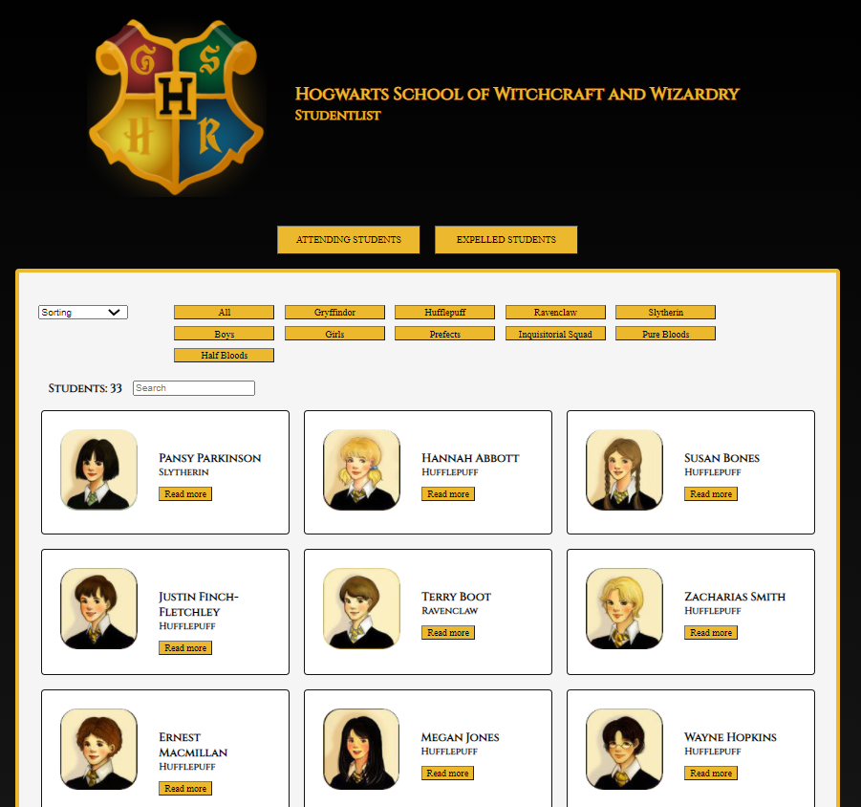

Final solution:

GitHub repository:

Table of content

Wireframes 1

Components 1

Features 1

User stories 2

Can-/Can’t-list 2

Pseudocode / Activity Diagrams for algorithms 3

Expelling 3

Prefects 3

Blood-status 3

HackTheSystem 3

Complete Activity Diagram 3

List of Student-object properties 3

# Wireframes

## Ideas

## Final

# Components

* Fetch data
* Clean data
* Display list-view
* Filter list
* Sort list
* Search list
* Expel students
* Make a student member of the Inquisitorial Squad
* Make a student prefect
* Display pop-up/modal of each student
* “hackTheSystem”-function (insert myself as a student, mess with blood status and students will only be able to be members of the Inquisitorial Squad temporarily).

# Features

* Fetch JSON-data
* Fetch JSON-data for blood status
* Split and capitalize information from JSON-data
* Get photos from the image-folder
* Filter by…
  + All
  + House
  + Gender
* Sort by…
  + House A-Z
  + House Z-A
  + First name A-Z
  + First name Z-A
  + Last name A-Z
  + Last name Z-A
* Filter by… (separate lists)
  + Attending students
  + Expelled students
* Search the student list
* Display list-view (student list)
* Remove expelled students to the expelled-student list
* Expel a student
* Make a student (if from Slytherin and pureblooded) a member of the Inquisitorial Squad
* Make a student a prefect (only two from each house – of each gender)
* Display pop-up/modal of each student with house-theme
* “hackTheSystem”-function
  + Insert myself as a student, who can’t be expelled
  + Mess with the blood status (Muggleborn/halfbloods become purebloods – Purebloods become muggleborn/halfbloods)
  + Adding a student to the Inquisitorial Squad is only temporary (user will be notified)

# User stories

* As a user…
  + I want to be able to filter the list of students to find a specific student(s) quickly (ex. expelled student, boys, girls or by house).
  + I want to be able to ad and remove people from The Inquisitorial Squad.
  + I want to be able to sort the list of students to get a better overview.
  + I want to be able to search in the student list to quickly find a specific student(s).
  + I want to be able to make a student prefect.
  + I want to be able to expel a student.
  + I want to be able to “hackTheSystem” to mess with everything

# Can-/Can’t-list

“can” 🡪 green  
“can’t” 🡪 red

|  |
| --- |
| Fetch JSON-data |
| Split into first-, middle- and last name |
| Capitalize names |
| Get photos from file |
| Display students (list-view) |
| Sort list of students |
| Filter list of students (ex. gender, house, etc.) |
| Search in list of students |
| Interface must show number of students (attending, expelled, displayed and of each house) |
| Pop-up theme according to house |
| Pop-up contains student details (full name and photo) |
| Fetch blood status |
| Display blood status on student pop-up |
| Expel a student, and move this student to “expel-list” |
| Display expel-list |
| Make two students from each house of each gender prefects |
| Make/remove student a member of the Inquisitorial Squad (if he/she is from Slytherin and pureblooded) |
| hackTheSystem called from console (or with a secret button) 🡪 |
| * I will be displayed in the student list and can’t be expelled |
| * Purebloods become muggleborns or halfblood, while muggleborns and halfbloods becomes pure |
| * Adding students to the Inquisitorial Squad is only temporary, the students is removed and notifies the user about this |

# Pseudocode / Activity Diagrams for algorithms

## Expelling

## Prefects

## Blood-status

## HackTheSystem

# Complete Activity Diagram

# List of Student-object properties

* 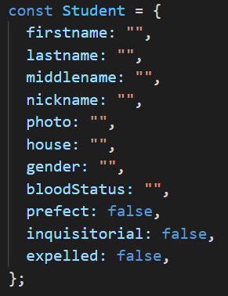firstname
* lastname
* middlename
* nickname
* photo
* house
* gender
* bloodStatus
* prefect
* inquisitorial
* expelled

# Additional comments

“hackTheSystem” can be called by clicking on the two o’s in school in the headline

