Task 1 – Activity B: Design Documents
Local Produce Hub — Greenfield Local Hub (GLH)

1. Visual and Interface Designs
When I started planning how the Local Produce Hub should look and feel, my main priority was making sure it was something both customers and producers would actually want to use. From my research into the food retail sector, I found that customer facing software such as online storefronts and mobile apps are the main way users browse and purchase products. I took a mobile first approach because a lot of GLH's customers will be browsing on their phones, and the research showed that home cooking customers specifically need simple, mobile friendly interfaces that clearly display products, filters and stock status. I chose an earthy green and cream colour palette to reflect GLH's identity as a local, natural food cooperative. I wanted someone landing on the homepage for the first time to immediately understand what GLH is about.
1.1 Customer Storefront – Low Fidelity
Before adding any colour or detail, I sketched out a black and white layout to get the structure right. At this stage I wasn't thinking about how it looked I just needed to visualise where everything should be. I decided that the product grid should be the dominant element on the page, with a search bar and filter options directly above it so the customers can immediately narrow down by category or dietary needs, both of which came up in my research as key requirements for home cooking customers. At this stage I confirmed that the basket icon and the customer's loyalty points balance should sit in the top navigation bar so they're always visible. Getting this structure agreed before moving on meant I could build the high fidelity version with confidence.
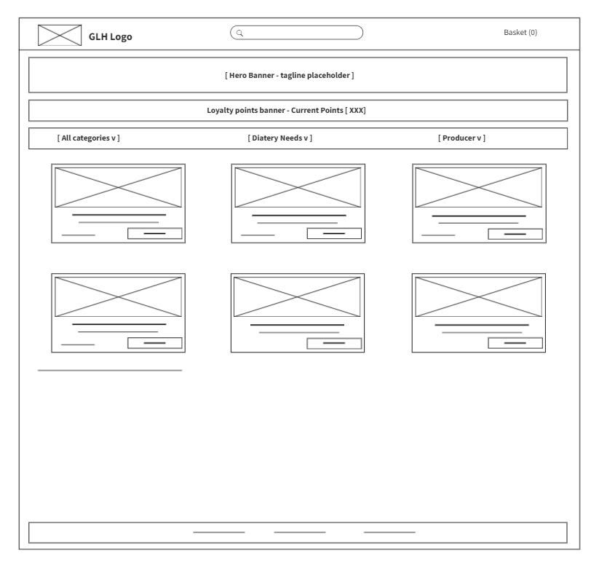

1.2 Customer Storefront – High Fidelity
Once I confirmed the layout, I built the full visual design. I applied the green (#4CAF50) and cream palette throughout, with a bold hero banner reading "Shop Fresh, Shop Local" the first thing a new customer sees should immediately communicate GLH's purpose. Each product card shows the product image, the producer's name, the live price and a colour coded stock badge, green for in stock, amber for low stock and red for out of stock. I chose those colours deliberately because they're universally understood without needing labels, and they meet WCAG accessibility contrast standards. I added a loyalty strip just below the navigation bar showing the customer's current points total, which directly supports the loyalty and notifications functional.
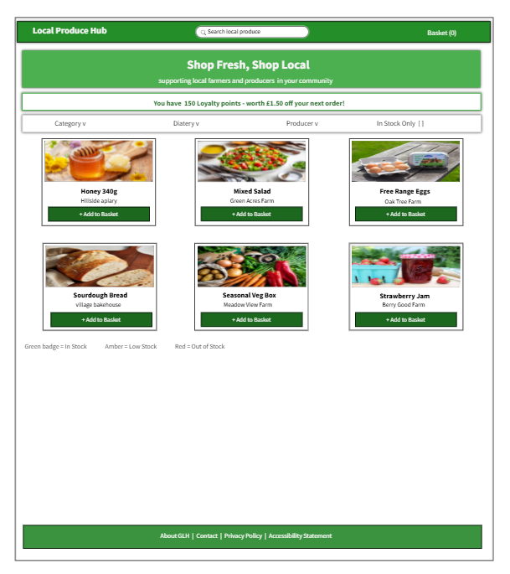

requirement from the proposal and should help drive repeat purchases one of GLH's key KPIs.
1.3 Producer Dashboard – Low Fidelity
The producer dashboard needed a completely different feel from the customer storefront. Based on my research, local producers and small farms need dashboards that let them add, edit or delete product details and stock, view customer orders to help plan production and deliveries. So when I sketched this low fidelity version, I kept it very clean and straight to the point. I placed a sidebar on the left with an estimate placement for the selections of, My Products, My Orders and Sales Summary so the producers always know where to go. The main area is a straightforward table where I’m going to put the current stock, price and an Edit button. The goal was that a farmer who isn't particularly confident with technology could sit down and figure it out in under a minute.
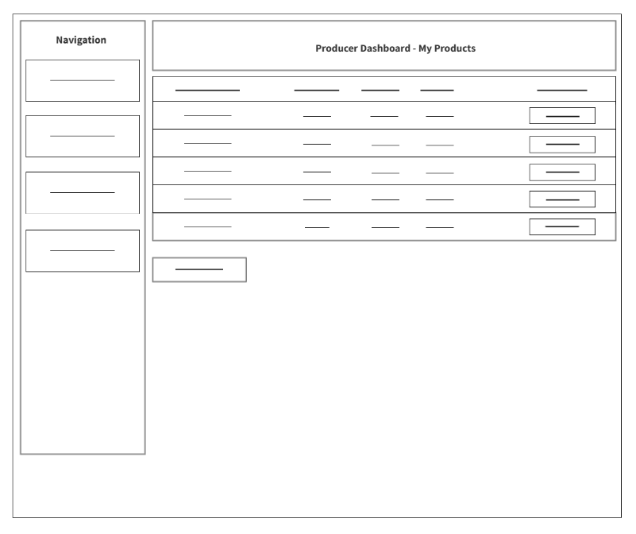

1.4 Producer Dashboard – High Fidelity
In the high fidelity version I added the green branding and introduced colour coding that makes a practical difference. If stock is running low, the box turns amber, if it hits zero, it turns red. A producer can quickly scan the table in a few seconds and immediately know what needs attention. I also added a weekly sales bar chart in the Sales Summary panel. It's simple but it gives the producers a rapid visual sense of which products are selling well. This supports the proposal's requirement for an optional sales summaries that can help plan the production more efficiently. This directly responds to the research finding that producers need tools to efficiently manage stock and understand their orders without spending time on emails and spreadsheets.
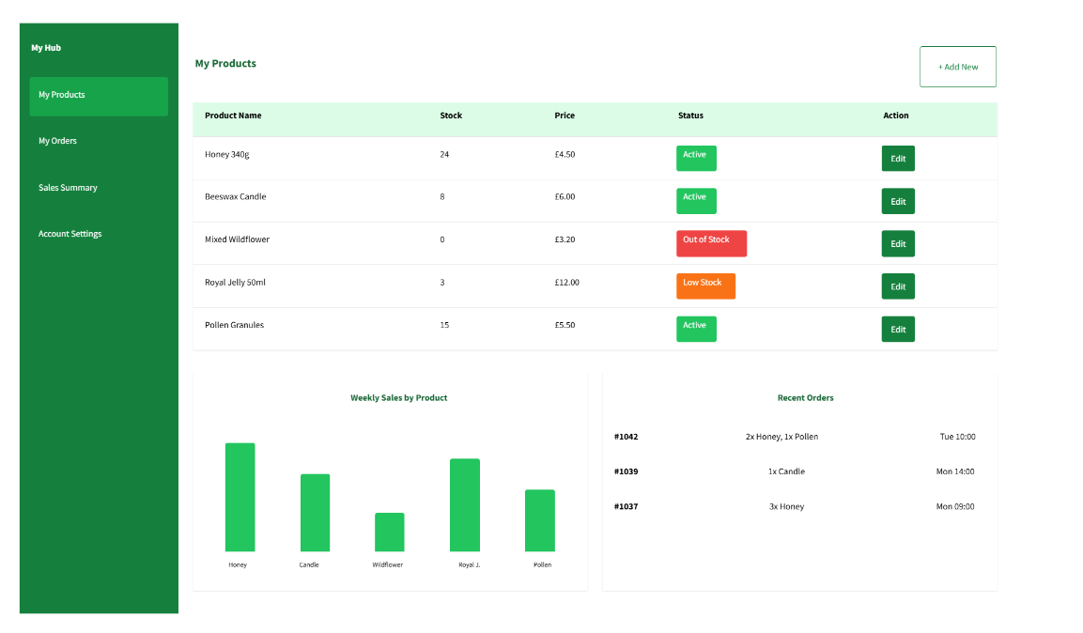

1.5 Checkout and Slot Booking – Low Fidelity
For the checkout I knew from the research that keeping things clear and simple is essential because if the process is confusing, customers abandon their basket.Hence why I split the checkout into three steps: Basket, Slot, Payment. A progress bar at the top shows exactly which step you're on, which makes the whole process feel much less overwhelming than putting everything on one long page. I confirmed the positions of the order summary, the slot selector and the payment fields at this stage, along with Back and Continue buttons at every step so customers never feels stuck or confused.
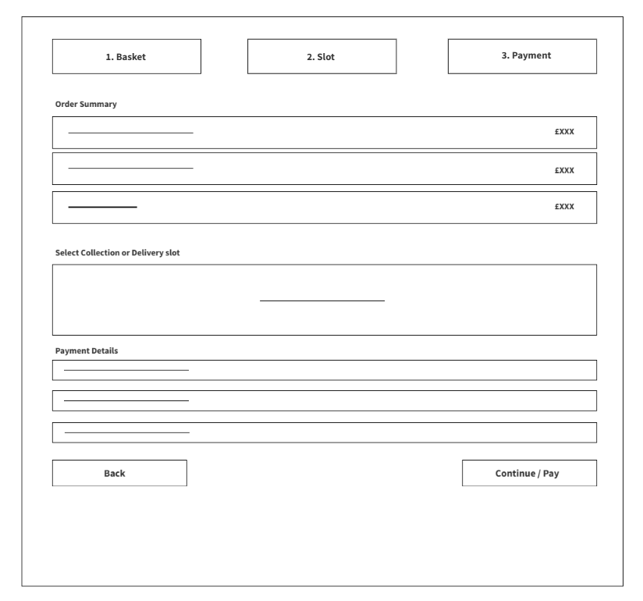
1.6 Checkout and Slot Booking – High Fidelity
In the final design I added the details that make the experience trustworthy. I highlighted the active step in the progress bar in dark green. I made the slot grid is colour coded showing that available slots are green, nearly full slots are amber and fully booked slots are red with a "Full" label which means that the delivery and collection scheduling problem identified in the proposal and stops it from overbooking. The loyalty discount appears as a clear line item in the order summary before payment so customers can see exactly how much they're saving, which supports both the Consumer Rights Act 2015 requirement for transparent pricing before checkout and GLH's goal of encouraging repetitive purchases. The payment step uses a Stripe hosted integration so GLH never directly handles card details, keeping transactions secure in line with the security non functional requirements.
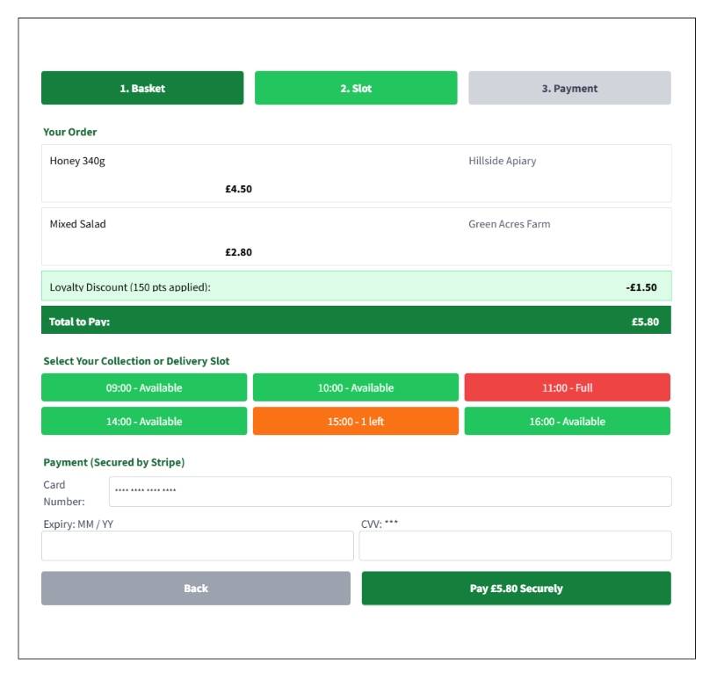

2. Data Requirements
To make the Local Produce Hub work properly I needed to carefully plan how data will be stored and how everything connects together. I settled on five main database tables: producers, products, customers, orders and order items. The main thing about this structure is that it creates a complete chain where you can take any order item and trace it back through the product to the producer and the specific batch it came from. You can go the other way to find which customers received items from a particular batch. This meets the Food Safety Act 1990 and Food Standards Act 1999 requirement to support traceability one step back and one step forward in the supply chain. All personal data, passwords, emails and payment references are handled in line with the UK GDPR: minimised, encrypted where appropriate and only accessible to authorised users with the correct role.

2.1 Producer Table
The Producer table is the agenda of all GLH cooperative members. It stores everything that needs to display a producer's profile and for them to link their products and orders back to them for traceability.
Variable Name | Purpose | Data Type | Reason
producer_id | A unique name for each producer, used as the primary key | String | Without a unique ID it would be impossible to reliably link products and orders back to the right producer for traceability needs
name | The producer's trading name | String | Displayed on the product pages which directly supports GLH's goal of communicating the story of local food to customers
bio | A description of the farm, its methods and values | Text | Supports the Producer Information Hub functional requirement to display the producer profiles
location | The producer's town or region | String | Allows customers see where their food actually comes from, supporting transparency
certifications | Accreditations such as organic or free range | JSON Array | Stored as an array as different producers hold different numbers of certifications
contact_email | The producer's login email and contact address | String | Must be unique so the system can identify and locate the producers securely at login
password_hash | The producer's password in encrypted format | String | We never store the real password, only an unreadable hash which protects the producers accounts meeting GDPR security requirements

2.2 Product Table
Every item GLH sells lives in the Product table. This is where the platform gets the information it needs for product pages, live stock checks and the food labelling compliance required by the Food Safety Act 1990.
Variable Name | Purpose | Data Type | Reason
product_id | A unique refference for each product | String | Main point: needed to link products to order items and stock records consistently
producer_id | Links this product back to its producer | String (FK) | This foreign key is what makes food traceability possible as every product can be traced to its source
name | The product's display name | String | Shown on product cards and in the customer's basket
price | The current selling price | Decimal | Stored as a decimal to handle pence (currency) accurately, supporting the Consumer Rights Act 2015 requirement for clear pricing
stock | The current available quantity | Integer | Checked every time something is added to a basket to prevent overselling, this directly supports the out of stock handling part
allergens | A list of allergen information | Array | Required by Food Safety Act compliance. product pages must display allergen information clearly
batch_ref | A reference to the specific batch or harvest | String | The key field for food traceabilityand this enables the one step back chain to the producer as required by the Food Safety Act 1990 and Food Standards Act 1999
2.3 Customer Table
The Customer table stores account and loyalty information for every registered user. Security is the most important consideration here given the UK GDPR requirements around personally identifiable information.
Variable Name | Purpose | Data Type | Reason
customer_id | A unique reference for each customer account | String | Primary key: brings together all the orders, loyalty points and preferences for that customer
email | The customer's login identifier | String | Must be unique. The main part of a secure authentication and an all order notifications
password_hash | The customer's password in encrypted form | String | Storing a hash means, even if the database was ever compromised, passwords could not be read meeting GDPR security requirements
first_name | The customer's given name | String | Storing a hash means, even if the database was ever compromised, passwords could not be read meeting GDPR security requirements
loyalty_points | The customer's running loyalty points total | Integer | Updated automatically after every eligible purchase and applied as a discount at checkout, supporting the Loyalty and Notifications functional requirement
data_consent | Records whether the customer has agreed to data storage | Boolean | A legal requirement under UK GDPR. The system must be able to prove consent was given and recorded
2.4 Order Table
Every transaction processed by the platform is recorded here. The Order table drives fulfilment, customer notifications and the traceability audit trail.
Variable Name | Purpose | Data Type | Reason
order_id | A unique reference for each order | String | Primary key: referenced in every email, notification and producer view
customer_id | Links the order back to the customer | String (FK) | Allow order history and the quick re order feature identified in the Account and Order History functional requirement
status | The current state of the order (Pending, Ready, Dispatched) | Enum | Drives the customer an automatic notification for an order status and changes
total | The final amount charged after any loyalty discount | Decimal | Stored for financial records and to generate accurate customer receipts, supporting Consumer Rights Act 2015 compliance
slot_time | The collection or delivery slot the customer selected | DateTime | Used by the scheduling part to track capacity and prevent overbooking
placed_at | The exact time the order was submitted | Timestamp | Required for measuring Order Fulfilment Time KPIs and for maintaining the traceability audit log
2.5 OrderItem Table
This table links orders to products and is what makes multi-producer order splitting possible. It also completes the food traceability chain.
Variable Name | Purpose | Data Type | Reason
item_id | A unique reference for each line in an order | String | Allows each product line to be tracked and done independently
order_id | Links this line back to its parent order | String (FK) | Without this, you couldn't assemble a full order or split it by producer
product_id | Links this line to the specific product purchased | String (FK) | Completes the traceability chain: OrderItem → Product → batch_ref → Producer
quantity | How many units the customer ordered | Integer | Used to reduce stock levels and generate picking lists for producers
ERD Summary: One Customer places many Orders (1:M). One Order contains many OrderItems (1:M). Each OrderItem links to one Product (M:1). Each Product belongs to one Producer (M:1). This chain means that for any item in any order, the system can trace it back to the producer and batch it came from, and forward to the customer who received it — satisfying the one step back and one step forward traceability requirement of the Food Safety Act 1990 and Food Standards Act 1999.

3. Algorithm Designs
This section explains the logic behind five of the most complex problems in the Local Produce Hub. I've written each one in pseudocode, a style that looks like plain English rather than actual code so that the GLH's managers can follow what the system is doing without needing a technical background. For three of the algorithms I've also created a flowchart that maps the logic visually, using diamonds for decisions, rectangles for processes and ovals for start and end points, which I think makes it really clear for non technical stakeholders like GLH's cooperative members.
3.1 Algorithm 1 – Stock Update with Low-Stock Alert
This algorithm sits in the middle of the producer dashboard. The research showed that producers need to be able to update stock easily, also that GLH staff need to manage stock capacity. So I designed this algorithm to handle them both at once. The tricky part is making sure a producer can only edit their own products. Also that the system automatically alerts GLH staff when a product drops to five units or fewer so they can follow up with the producer before customers start seeing out of stock messages everywhere.

FUNCTION UpdateStock(product_id, new_stock, requesting_producer_id)

1. Load the product record from the database using product_id

2. Check ownership:
IF product.producer_id DOES NOT MATCH requesting_producer_id THEN
Record the attempted breach in the security log
RETURN "You can only edit your own products."
END IF

3. Check the new stock value is valid:
IF new_stock IS LESS THAN 0 THEN
RETURN "Stock cannot be a negative number."
END IF

4. Save the updated stock:
SET product.stock = new_stock
SAVE the change to the database

5. Check whether a low-stock alert is needed:
IF new_stock IS 5 OR FEWER THEN
SEND an email to GLH staff:
"Low stock alert: " + product.name
+ " only has " + new_stock + " units remaining."
END IF

6. RETURN "Stock successfully updated to " + new_stock
END FUNCTION

Flowchart 1 – Stock Update & Low-Stock Alert: 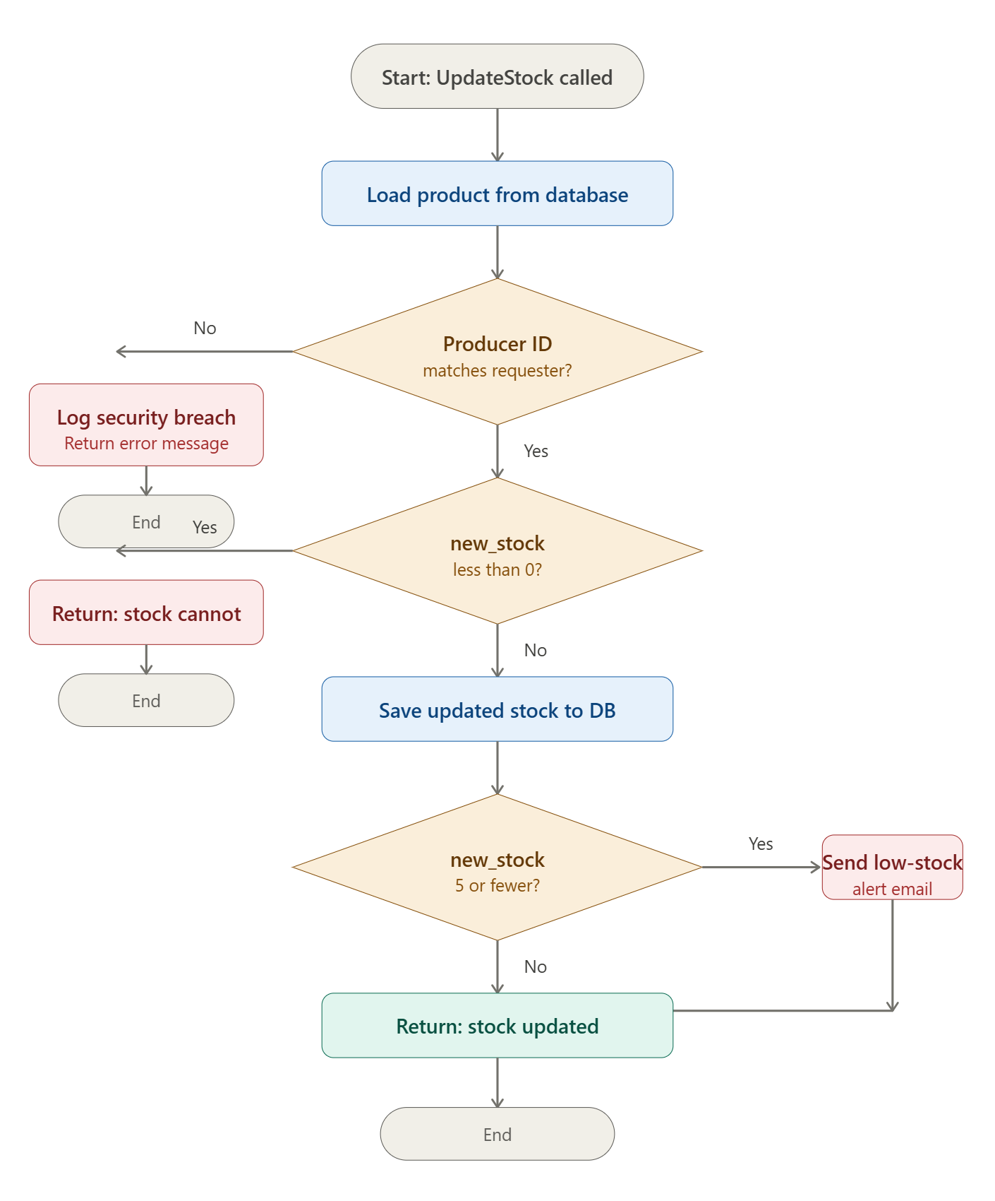

3.2 Algorithm 2 – Order Splitting and Producer Notification
This algorithm solves one of the most important problems identified in Section 4 of the proposal. The fact that a customer's order might contain items from several different producers. We can't send the whole order to every producer, Producer A should only see their own lines and not what Producer B is selling. This algorithm loops through every item in the order, groups them by producer and sends each producer a customised notification with only their relevant lines and the slot time.

text
FUNCTION SplitAndNotifyOrder(order_id)

1. Load all the items in this order from the database

2. Create an empty grouping: producer_groups = {}

3. Loop through each item one by one:
Find out which producer this item belongs to
If that producer doesn't have a group yet, create one
Add this item to that producer's group
End of loop

4. Notify each producer:
For each producer in producer_groups:
Send a message listing only their items
Include the customer's chosen collection or delivery slot
End of loop

5. Return the full producer_groups map
(GLH staff see everything; each producer only sees their own lines)
END FUNCTION

Flowchart 2 – Order Splitting Across Producers:
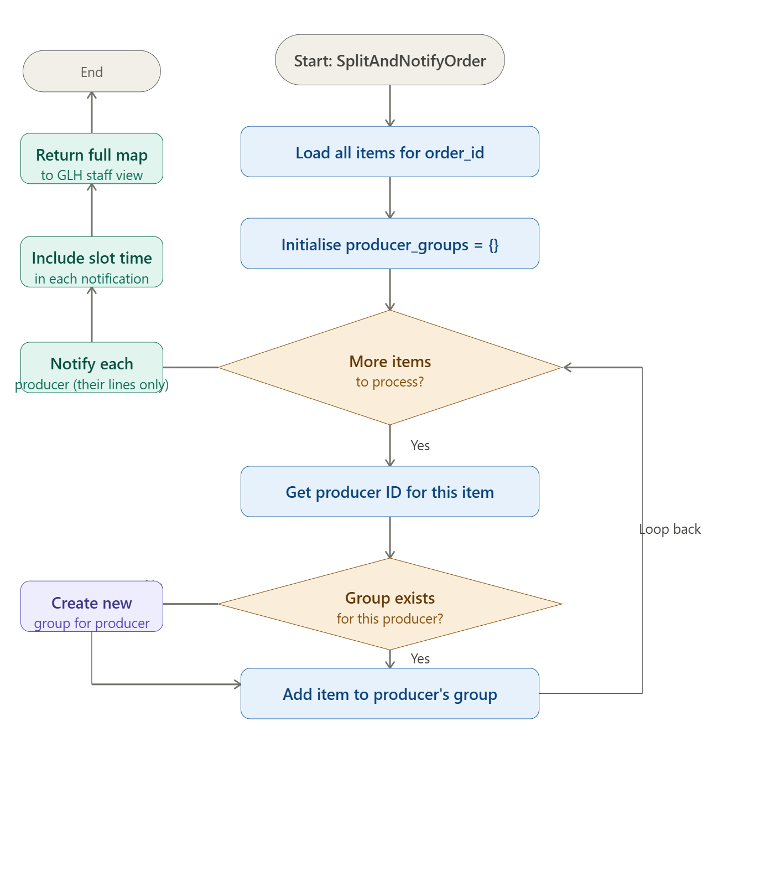

3.3 Algorithm 3 – Loyalty Points and Discount Calculation
Getting the loyalty calculation right was extremely important because if the customers feel like their points are being miscalculated, it quickly damages trust and repeat purchase rate is one of GLH's core KPIs. The logic is that customers earn five points per pound spent and every hundred points is worth one pound off a future order. I also created an audit log so there's a permanent record of every time points are awarded or redeemed. This means GLH staff can investigate any dispute and the system remains accurate and accountable.
text
FUNCTION ApplyLoyalty(customer_id, order_subtotal)

1. Load the customer's account from the database

2. Calculate the discount the customer is entitled to:
SET discount = customer.loyalty_points divided by 100
// 200 points = £2.00 discount
IF the discount is more than the order total THEN
Cap the discount at the order total
// You cannot discount more than the order is worth
END IF

3. Calculate the new points being earned on this order:
SET points_earned = order_subtotal multiplied by 5, rounded down
// A £12.00 order earns 60 points

4. Update the customer's points balance:
Subtract the redeemed points, add the newly earned points
Save the updated balance to the database

5. Create an audit log entry recording:
Customer ID, order ID, points redeemed, points earned and timestamp

6. Calculate the final order total:
SET new_total = order_subtotal minus discount

7. RETURN the new total, the discount applied and the points earned

END FUNCTION

3.4 Algorithm 4 – Slot Booking with Capacity Control
This algorithm directly addresses the delivery and collection scheduling problem from Section 4 of the proposal. If two customers try to book the last slot at the same time and both succeed, it causes a real technical problem for GLH. By looking over at the booking count before confirming, the system can prevent it from taking place. If a slot is full, then the customer recieves a message which allows them to pick a different time.
text
FUNCTION BookSlot(customer_id, requested_slot_time, slot_capacity = 20)

1. Count how many confirmed bookings already exist for this slot:
SET current_bookings = number of orders with this slot_time
that are not cancelled

2. Is the slot already at capacity?
IF current_bookings IS 20 OR MORE THEN
RETURN "This slot is fully booked — please choose a different time."
END IF

3. Reserve the slot:
Set the order's slot_time to the requested time
Set the order status to "Pending"
Save the order to the database

4. Confirm the booking:
Send a confirmation email to the customer
including their chosen date and time

5. RETURN "Slot booked successfully for " + requested_slot_time

END FUNCTION

Flowchart 3 – Slot Booking wih Capacity Check: 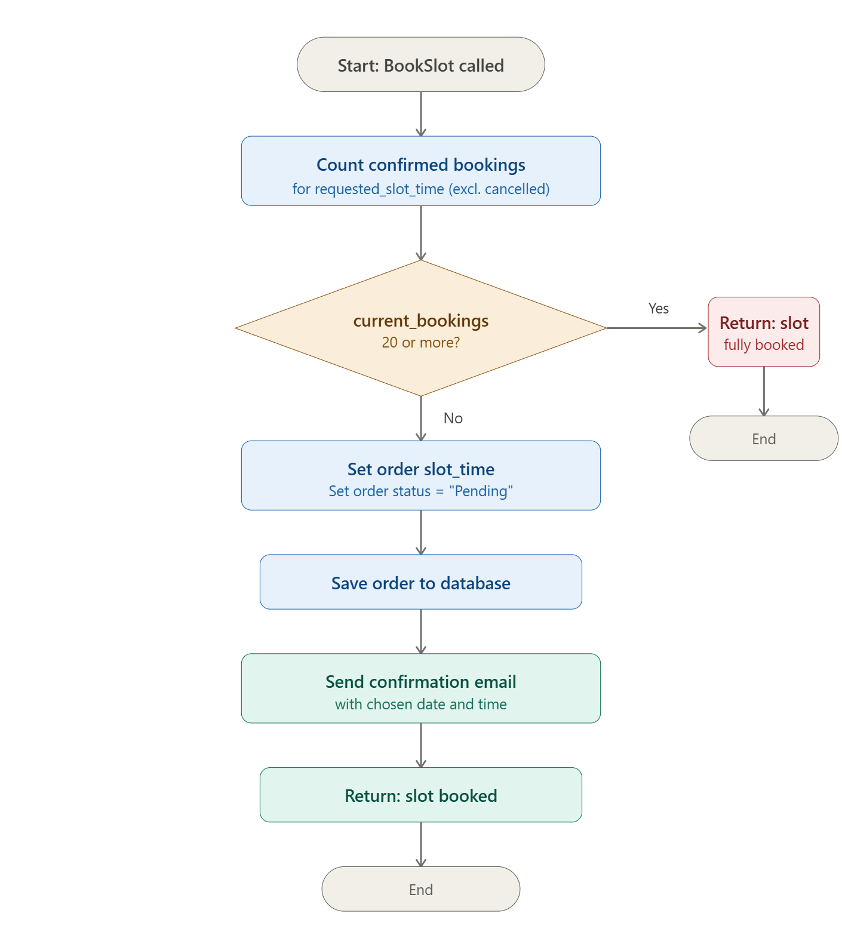

3.5 Algorithm 5 – Food Traceability Query
This algorithm exists completely for compliance reasons. The Food Safety Act 1990 and Food Standards Act 1999 ensure that the food items can be traced one step back and one step forward through the supply chain. If a food safety issue is found with a batch, then GLH needs to quickly find which customers received items from that batch. This joins all five tables to build that complete chain back to the producer and forward to the customers.
text
FUNCTION TraceByBatch(batch_ref)

1. Search across all relevant tables:
Find all Orders containing an OrderItem
where that OrderItem's Product matches the given batch_ref
Also retrieve the Producer, Product and Customer details for each result

2. If no results are found:
RETURN "No orders found containing batch: " + batch_ref

3. Return the full traceability chain:
- One step BACK: Producer name, contact details, batch reference
(where the food came from)
- One step FORWARD: Order IDs, customer details, order dates
(who received the food and when)

END FUNCTION

