# Installation iCommands on Ubuntu20

Please copy each bullets below carefully and paste on your ubuntu terminal running in your virtual-box.

Prepare IROS APT repository

* LSB_RELEASE="bionic"
* wget -qO - https://packages.irods.org/irods-signing-key.asc | sudo apt-key add –
* echo "deb [arch=amd64] https://packages.irods.org/apt/ ${LSB_RELEASE} main" | sudo tee /etc/apt/sources.list.d/renci-irods.list
* sudo apt-get update

Install python-urlib3, python-requests and libssl1.0.0

* wget -c \

http://security.ubuntu.com/ubuntu/pool/main/p/python-urllib3/python-urllib3_1.22-1ubuntu0.18.04.2_all.deb \

http://security.ubuntu.com/ubuntu/pool/main/r/requests/python-requests_2.18.4-2ubuntu0.1_all.deb \

http://security.ubuntu.com/ubuntu/pool/main/o/openssl1.0/libssl1.0.0_1.0.2n-1ubuntu5.7_amd64.deb

sudo apt install \

./python-urllib3_1.22-1ubuntu0.18.04.2_all.deb \

./python-requests_2.18.4-2ubuntu0.1_all.deb \

./libssl1.0.0_1.0.2n-1ubuntu5.7_amd64.deb

rm -rf \

./python-urllib3_1.22-1ubuntu0.18.04.2_all.deb \

./python-requests_2.18.4-2ubuntu0.1_all.deb \

./libssl1.0.0_1.0.2n-1ubuntu5.7_amd64.deb

Install irods-icommands

* sudo apt install -y irods-icommands

Your iCommands installation has been completed. You can see the iCommands by executing ‘ls /usr/bin’

# Configure the iRODS environment

This step only need to be executed the first time. To configure your iRODS environment you need to go to the [iRODS-Go-Frontend (kuleuven.be)](https://tier1-pilot.irods-q.hpc.kuleuven.be/#/) (the zone that you are a user of). After you pass the authentication layer you will find the required information under the ‘IRODS LINUX CLIENT’ title on the coming page.

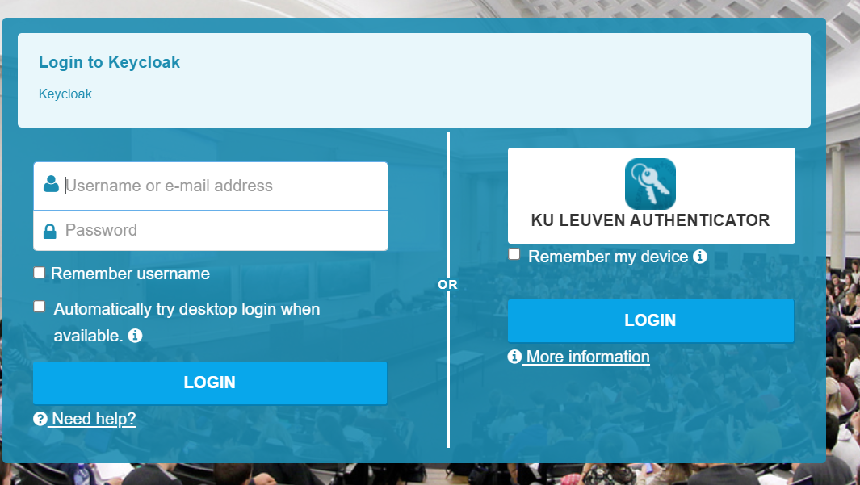

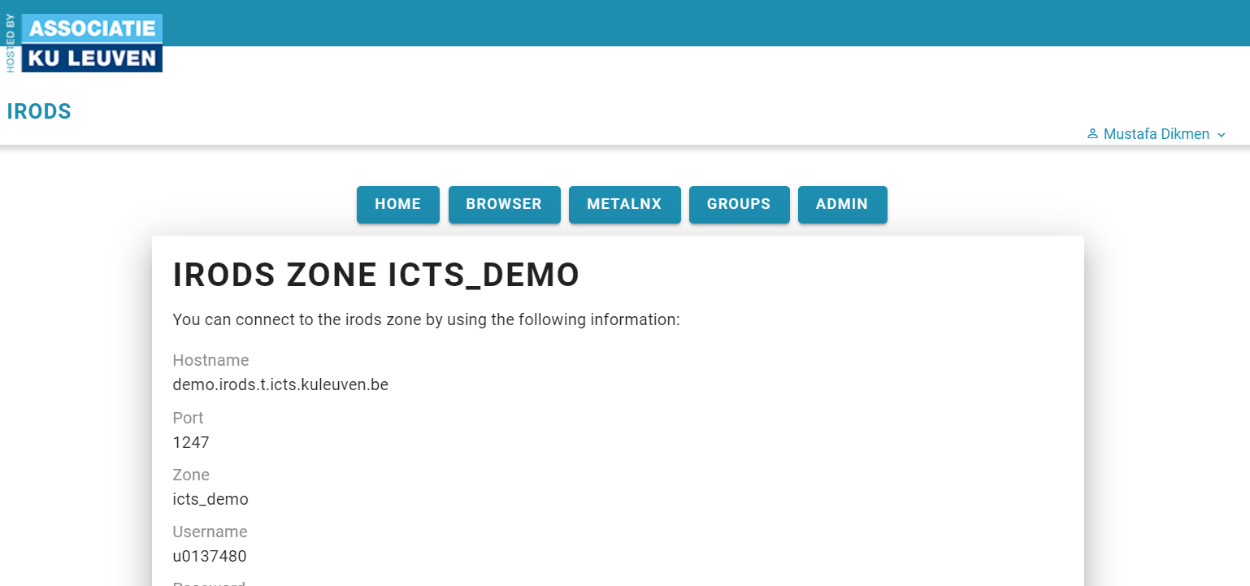

Once you copy the code snippet section (given an example below) from the portal mentioned above and paste on your iCommand installed Linux terminal, you will create your irods_enviroment.json file and you will have an active iRODS session after executing the ‘iinit’ command. To test it you can execute ‘ils’ to be able to list your iRODS home directory.

mkdir -p ~/.irods

cat > ~/.irods/irods_environment.json <<'EOF'

{

"irods_host": "irods.hpc.kuleuven.be",

"irods_port": 1247,

"irods_zone_name": "kuleuven_tier1_pilot",

"irods_authentication_scheme": "PAM",

"irods_encryption_algorithm": "AES-256-CBC",

"irods_encryption_salt_size": 8,

"irods_encryption_key_size": 32,

"irods_encryption_num_hash_rounds": 16,

"irods_user_name": "vsc33586",

"irods_ssl_ca_certificate_file": "",

"irods_ssl_verify_server": "cert",

"irods_client_server_negotiation": "request_server_negotiation",

"irods_client_server_policy": "CS_NEG_REQUIRE",

"irods_default_resource": "default"

}

EOF

iinit --ttl 168 **'your password'** && echo You are now authenticated to irods. Your session is valid for 168 hours.

# Install the Python iRODS Client (PRC)

First check your Linux machine whether it has python package management system by executing ‘pip --version’ or ‘pip3 --version’. If you don’t see any result, then you need to install the python package management system like below:

sudo apt update

sudo apt install python3-pip

After that, you will need to install the Python iRODS client:

pip install python-irodsclient

## Testing PRC installation

Create a python file by using a text editor, i.e. ‘vim’ can be an option. So, type the following to create a test file:

‘vi test_irods.py’

And paste code snippet below to interact with iRODS through the PRC:

import os

import ssl

from irods.session import iRODSSession

try:

env_file = os.environ['IRODS_ENVIRONMENT_FILE']

except KeyError:

env_file = os.path.expanduser('~/.irods/irods_environment.json')

ssl_context = ssl.create_default_context(purpose=ssl.Purpose.SERVER_AUTH, cafile=None, capath=None, cadata=None)

ssl_settings = {'ssl_context': ssl_context}

with iRODSSession(irods_env_file=env_file, **ssl_settings) as session:

coll = session.collections.get("/kuleuven_tier1_pilot/home/vsc33586")

print(coll.path)

## How to Use Miniconda on Your Linux OS with PRC

Here you will learn how to install Miniconda from command line on Ubuntu 18.04. The whole Miniconda installation procedure needs only 3 steps, except creating and activating a conda environment that is explained later.

* To download the latest shell script to Ubuntu 18.04, execute the following command.

wget https://repo.anaconda.com/miniconda/Miniconda3-latest-Linux-x86_64.sh

* To make the Miniconda installation script executable, do the following.

chmod +x Miniconda3-latest-Linux-x86_64.sh

* Run the installation script on Ubuntu 18.04 to install Miniconda.

./Miniconda3-latest-Linux-x86_64.sh

* During the installation follow the instructions and give answers to questions.
* Be sure that if you choose ‘yes’ to ‘conda init’ question at the end it will add the base environment to your.bashrc file on your Ubuntu system. But it will not hurt anything.

To manage dependencies and isolate the PRC usage from others, creating a separate environment is recommended. To do this:

* Create a virtual environment by using the relevant conda command.

conda create --name prc-irods python=3.9.5

* Activate your environment.

conda activate prc-irods

* Install the Python iRODS client.

pip install python-irodsclient

* You can use the previous snippet to connect to iRODS via PRC using python interpreter.

