Exercise 3

1. Least Square Approximation

2. Figure dispalying the yearly average temperatures
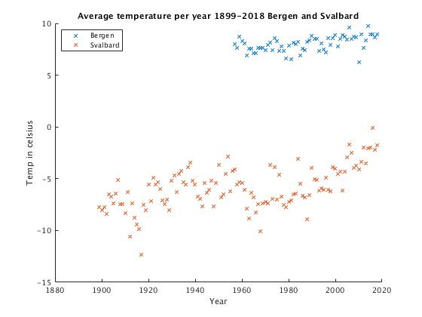

3. When considering the linear fit of the enitre dataset of the temperatures, it will reach 2 degrees celsius at around 2204-2205

4. Below is a figure with plots of the data from 1960-2018 and 2008-2018 (with padded length)
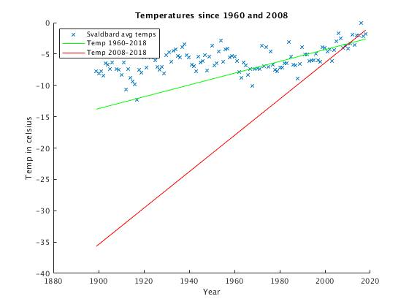

From it we can see that the rate of increase is considerably higher when considering only the last 10 years

5. Figure with 1960-data and 2008-data with labeled intersection of 2 degrees celsius
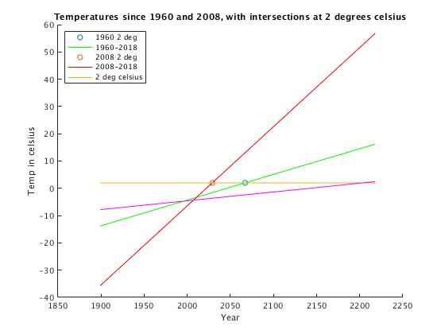

6. 1-5th polynomial fits of the Bergen data
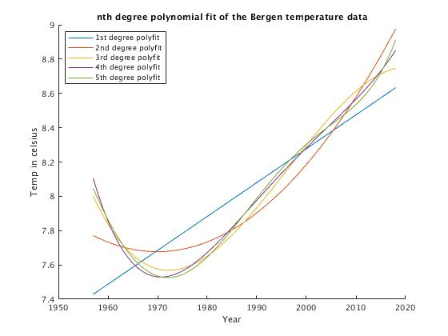

7. Figure displaying the temperature of both data sets with extrapolation up until 2040

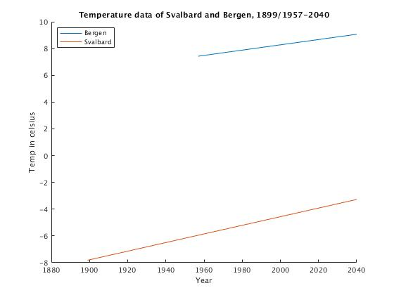

The figure indicates that that the average temperature will contiune to rise with no indication of lowering, also at seemingly equal rates as seen by the relativly similar angles of the plots.

2. Splines

1. Implicit spline interpolation is dependent on the axis of the plot wheras explicit is inpendent. In other words, the function assosiacted with a curve (spline) between two points will be altered along in accordance with changing the axis under implicit interpolation while explicit interpolation is unaffected by such changes.

3. Spline Theory

nr 2 and 4 do not describe a Hermite spline interpolation curve p(t)

4. Itertative Methods
A common problem with the Newton-Raphson method is that it requires a good initial guess to actually converge on a value: Bad initial guesses can result in divergence. In addition, when we are interested in very large amount of decimals there is the matter of storing the number as a data type that can in fact hold all the decimals without overflowing.

