Labprotokoll for Lab 5, Parkeringshus

|  |  |
| --- | --- |
| **Innleveringsfrist:** | Se Canvas |
| **Innlevering** | **Lab 5: Parkeringsanlegg** |
| **Navn på studenter :** | **Simen Fuglestad Endre Røberg Løseth** |
| **Innlevert zip-fil** | **NN_NN_lab5.zip**  **Dette dokumentet (labprotokollen) leveres som pdf.** |

|  |
| --- |
| **Oppgave 1: Reset synchronizer** |
|  |

***Sett inn vhdl-kode***

***Sett inn bilde av simulering her. Ta med kode***

***constant periode : time := 10 us;***

***p_clk : process***

***begin***

***clock_50 <= '0';***

***loop***

***wait for periode/2;***

***clock_50 <= not clock_50;***

***end loop;***

***wait;***

***end process p_clk;***

***init : PROCESS***

***-- variable declarations***

***BEGIN***

***-- code that executes only once***

***rst_n <= '0', '1' after 50 us, '0' after 70 us, '1' after 102 us;***

***WAIT;***

***Sett inn bilde av RTL skjema her***

**Oppgave 2: Lag en puls ved negativ flanke på innsignal.**

***Sett inn vhdl-kode***

***Sett inn bilde av simulering her. Ta med kode***

***Samme klokkeprocess som før***

***init : PROCESS***

***-- variable declarations***

***BEGIN***

***-- code that executes only once***

***sig_inn <= '0', '1' after 37 us, '0' after 53 us, '1' after 83 us;***

***WAIT;***

***Sett inn bilde av RTL skjema her***

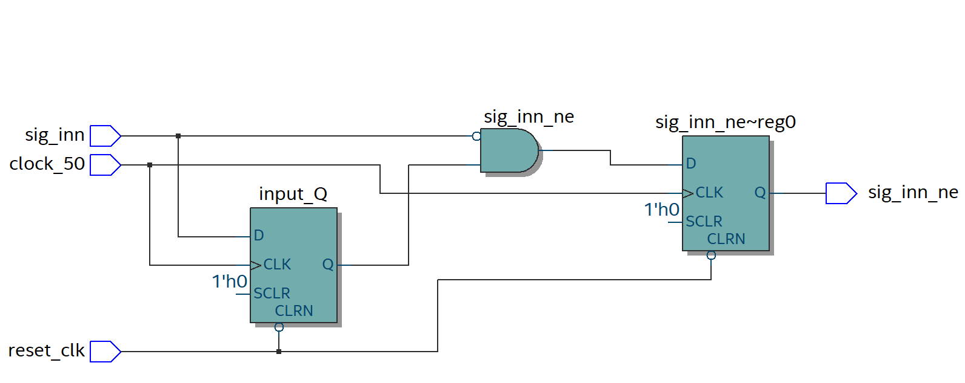

|  |
| --- |
| **Oppgave 3: Antiprell** |

***Sett inn vhdl-kode***

***Sett inn bilde av simulering her. Ta med kode***

***Samme klokkeprocess som før***

***init : PROCESS***

***-- variable declarations***

***BEGIN***

***-- code that executes only once***

***input <= '0', '1' after 100 us, '0' after 10111 us;***

***WAIT;***

***Sett inn bilde av RTL skjema her***

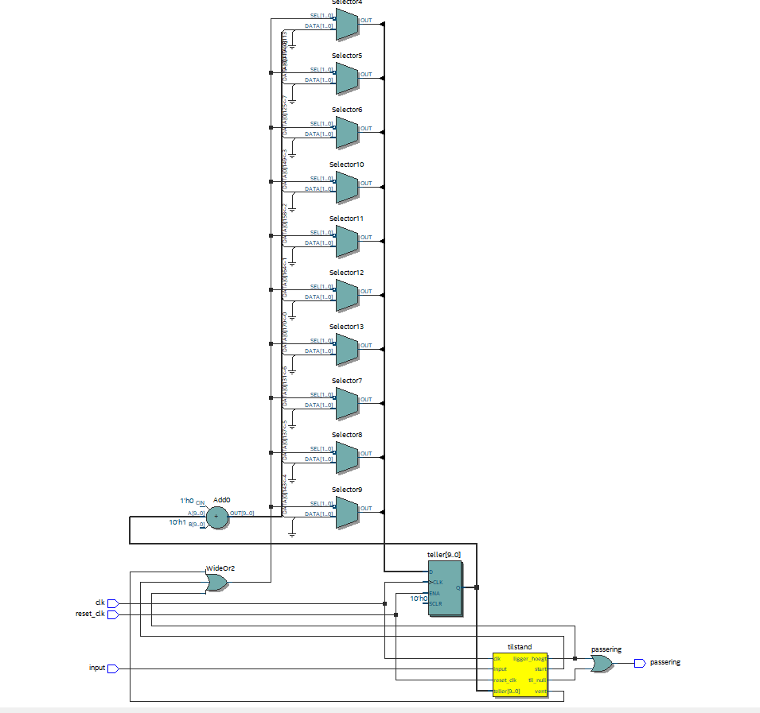

|  |
| --- |
| **Oppgave 4: Tell antall biler (opp-ned-teller)** |

***Sett inn vhdl-kode***

***Sett inn bilde av simulering her. Ta med kode***

***Samme klokkeprocess som før***

***init : PROCESS***

***BEGIN***

***bil_inn <= '0', '1' after 40 us, '0' after 78 us, '1' after 150 us, '0' after 250 us;***

***bil_ut <= '0', '1' after 270 us, '0' after 300 us, '1' after 320 us, '0' after 360 us;***

***WAIT;***

***Sett inn bilde av RTL skjema her***

**Oppgave 5: Tell antall biler som passerer en sensor.**

|  |
| --- |
| Lever zipfil av prosjektet |