In this project, I attempted to find the counts where hitters were most successful during the 2019 season, then find the hitters that were ending their at-bats in these counts the most in an effort to identify which players could potentially be under/over performing.

The data for this project was gathered by scraping Baseball Savant, which I used to create a dashboard to assist me in my analysis. I could not analyze every individual outlier performance from 2019 in this post, but the visualization I created could be accessed [here](https://datastudio.google.com/open/1I11Ub3NmUHq_9Tr8fcmAtNlFbk56uL1q), and the Github Repository for my project could be found [here](https://github.com/sig98/CountPerformance2019) so you can take a look for yourself!

As the chart above shows, MLB hitters performed their best in counts with one, or no strikes, and their worst in two strike counts. Using this data, I then explored individual performances in each count on the dashboard I had built to attempt and find outliers, and discover was ending at-bats in each count the most. Once players were identified, I would investigate why their performances were outliers and if their performances were sustainable. This post will highlight two of the more interesting unsustainable cases in hitters I found: Paul DeJong and Javier Baez.

**Paul DeJong - .250/.280/.417, 23 at-bats** **in 2-0 counts**

League-wide data shows that in 2-0 counts hitters have a slugging percentage of .700. These are significant numbers because, ideally, hitters would be finishing plate appearances in hitter-friendly counts that lead to improved results. For Paul DeJong, 2-0 counts did exactly the opposite of league-wide trends. DeJong finished 23 at-bats in 2-0 counts in 2019, recording only 6 hits with 4 of those being singles. His swinging-strike rate in 2-0 counts was over 6% lower than his overall swinging strike rate in 2019, which should have led to results that were at least in-line with league trends. Despite all of this, DeJong only managed to bat .250 in 2-0 counts, with an underwhelming .417 Slugging percentage.

DeJong is putting himself in more counts where hitters thrive, which, for a hitter with a wRC+ of 100, should lead to similar results to the league-average. However, Dejong's 2-0 stats show that his underperformance is driven by a .217 BABIP in 2-0 counts, well below the .310 league BABIP in 2-0 counts, as well as his personal BABIP’s of .259 in 2019 and .292 for his career. Why might this be happening? The first place to look would be the shift: In 2019 DeJong was shifted in 24.5% of his at-bats when compared to 8.3% in 2018, but actually performed better in these at-bats than when he was not being shifted at all, with a .326 wOBA against shifts, compared to a .323 wOBA when not being shifted.

Another possible explanation would be the actual types of pitches he faced in 2-0 counts, as DeJong performs significantly worse against off-speed pitches than fastballs. However, in 2-0 counts, DeJong saw similar to league-average amounts of fastballs:

**DeJong**

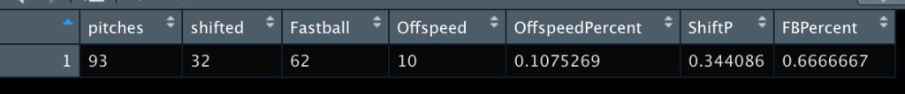

2019 2-0 pitch mix against Paul DeJong

**League**



MLB 2-0 pitch-mix, NOTE: stats like shift percentage might be inflated a bit due to no IBB data being included

Pitch data shows that pitchers are not using a different pitch-mix against DeJong when compared to the average major league hitter. What it does show, however, is that DeJong is shifted more in 2-0 counts than the average major leaguer. Nonetheless, the 5% difference is insignificant given DeJong's performance against the shift. Therefore, if DeJong continues to reach 2-0 counts at the rate he is, his results should improve in 2020 and beyond.

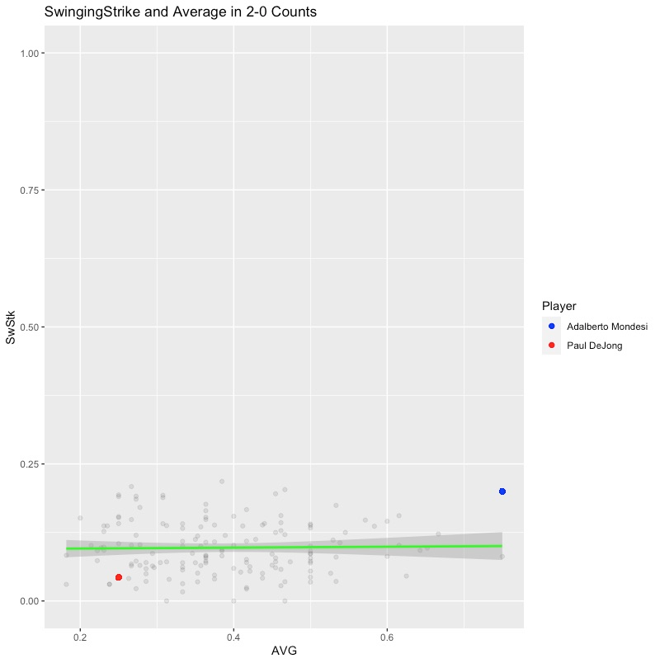

Swinging-Strike Rate and Average, 2019 MLB 2-0 Counts (Baseball Savant)

**Javier Baez - .258/.258/.500 in 62 ABs** **in 0-2 counts**

Javier Baez carried an impressive .758 OPS in 0-2 counts in 2019, a mark that is nearly double the league-wide average. Given that Baez has an 86th percentile sprint speed and barrels the ball extremely well, a higher-than-normal BABIP should be expected. This is shown to be true through his .339 BABIP in 2019. However, in 0-2 counts Baez’s BABIP inflated to .500, and his swinging-strike rate increased to 21.6% from his season-long mark of 18.4%.

Hitters should be aiming to finish their at-bats in as many favourable counts as possible and limit the amount ending in unfavourable counts. 2019 saw 0-2 counts bring the worst results of any count in terms of average, slugging percentage, BABIP, and OPS while being 5th in count of at-bats finished. In 2019 Baez saw 62 at-bats finish in 0-2 counts, his 4th highest total; Baez is not only over-performing in 0-2 counts, he is not avoiding them either. In a count which should be providing his worst results, Baez’s slugging % is in line with his 2019 season mark in a sizeable sample. 0-2 counts also produce the lowest BABIP of any count, signifying a decrease in quality of contact.

Baez's results are in no way sustainable given the fact that 0-2 counts are pitcher-friendly, he swings and misses more, and his underlying metrics such as his BABIP point to luck more than skill in this count. In 2020 and beyond, I would be expecting considerably worse results in 0-2 counts for Javier Baez.

Swinging-Strike Rate and Average, MLB 2019 0-2 Counts (Baseball Savant)

There are, of course, countless examples of hitters having outlier performances in specific counts in any season but trying to make sense of them can help to paint a clearer picture of breakouts and slumps. This 'unsustainability' of performances will only be increased in 2020 as the MLB plays through a 60-game schedule and should lead to incredibly interesting stat lines and perceived performances in hitters.