Solid perirenal dedifferentiated liposarcoma mimicking a cystic mass adjacent to an enhancing renal nodule: a case report
Yujie Shu¹˒²†, Jinxin Qu¹˒²†, Jiaqing Gao¹˒², Qiang Wang¹*
¹ Department of Urology, The Affiliated Hospital of Guizhou Medical University, Guiyang, Guizhou, China
² Clinical Medical School, Guizhou Medical University, Guiyang, Guizhou, China
Corresponding author: Qiang Wang; Email: gymnwq@163.com
† Yujie Shu and Jinxin Qu contributed equally to this work and share first authorship.

Abstract
Background: Perirenal dedifferentiated liposarcoma can resemble a cystic lesion on imaging. An adjacent enhancing renal nodule may further complicate interpretation. We describe a solid tumor with near-water attenuation that was initially considered cystic, leading to a change in the planned operation after intraoperative reassessment.
Case presentation: A 43-year-old man underwent evaluation for abdominal pain at an outside hospital. Imaging identified a left ureteral stone and incidental right renal and retroperitoneal masses. Contrast-enhanced computed tomography at our hospital showed a 34 × 28 mm enhancing renal lower-pole nodule and a 153 × 102 × 139 mm low-attenuation perirenal mass with internal septa. The renal nodule was suspected to be malignant, whereas the larger mass was considered predominantly cystic. The patient declined preoperative needle biopsy after discussion with him and his family, and partial nephrectomy was planned. During surgery, the large mass was densely adherent to the kidney and adjacent structures. Attempted aspiration yielded no fluid, prompting reassessment of its nature. Laparoscopic right radical nephrectomy and retroperitoneal tumor resection were performed. The resected mass was solid, soft, and gelatinous. Histology, immunohistochemistry, and MDM2 fluorescence in situ hybridization established high-grade dedifferentiated liposarcoma with focal cartilaginous differentiation and superficial renal involvement. Pathology consultation supported a common origin for the renal and perirenal lesions. The patient received adjuvant chemotherapy. Abdominal computed tomography at the last follow-up, 3 months after surgery, showed no recurrence.
Conclusions: Near-water attenuation does not exclude a solid perirenal neoplasm. In this case, a small enhancing renal nodule and a much larger cystic-appearing mass represented abnormalities of a common tumor origin. Discordant imaging and operative findings required reassessment, while the diagnosis depended on pathological and molecular evaluation.
Keywords: dedifferentiated liposarcoma; perirenal tumor; renal mass; MDM2; case report

Background
Retroperitoneal sarcomas are uncommon mesenchymal malignancies, with liposarcoma among the principal histological subtypes. These tumors may grow substantially before causing specific symptoms and can displace or involve neighboring organs. Consensus guidance recommends assessment by a specialist multidisciplinary team and complete macroscopic resection when feasible [1, 2].
Liposarcoma near the kidney may be mistaken for a primary renal tumor, particularly when its imaging appearance is predominantly cystic. A study of 30 renal or perirenal mass biopsies identified this diagnostic difficulty and the value of MDM2 testing [3]. Cystic-appearing perirenal dedifferentiated liposarcomas have been described in individual reports and a two-case series [4, 5]. A recent report also documented a retroperitoneal dedifferentiated liposarcoma interpreted as a Bosniak IV renal cyst [6].
Here, an enhancing renal nodule and a much larger low-attenuation perirenal mass were initially assessed as separate lesions. The patient declined preoperative biopsy. Intraoperative findings led to a change from planned partial nephrectomy to radical nephrectomy with tumor resection, and subsequent pathology supported a common tumor origin. We describe the imaging–pathology discrepancy and its effect on diagnostic assessment and surgical planning. This report follows the CARE framework [7].

Case presentation

Patient information and diagnostic assessment
A 43-year-old man presented with a 2-day history of left flank and abdominal pain with hematuria. He reported no fever, chills, nausea, vomiting, or recent weight loss. His medical history included hyperthyroidism treated with methimazole. There was no history of surgery or relevant family history. His temperature was 36.1 °C, pulse 105 beats/min, and respiratory rate 20 breaths/min. There was no costovertebral angle tenderness or palpable renal mass. Noncontrast computed tomography (CT) at an outside hospital showed a left ureteral stone with mild upstream dilatation and incidental right renal and perirenal masses. Contrast-enhanced abdominal CT was performed at our hospital on June 26, 2026; the report was reviewed the following day.
The right perirenal mass measured 153 × 102 × 139 mm and had an irregular, lobulated contour. Attenuation was approximately 11, 14, and 16 Hounsfield units (HU) across the three reported phases, with little overall enhancement. Thin internal septa showed mild enhancement, and several small hyperdense nodular foci and mild surrounding stranding were present. The mass displaced the right kidney and adjacent bowel. Its boundary with the smaller renal lesion appeared relatively well defined. Representative axial and coronal CT sections are shown in Fig. 1.
A 34 × 28 mm nodule at the right renal lower pole projected beyond the renal contour. It enhanced heterogeneously, with reported attenuation values of 80, 97, and 69 HU, lower than those of the surrounding renal parenchyma. The nodule was considered suspicious for malignancy. The larger retroperitoneal mass was described as cystic or cystic-solid. On clinical review, its low attenuation and internal septa favored a predominantly cystic lesion. Magnetic resonance imaging was recommended in the radiology report, but no completed examination was documented. Preoperative needle biopsy was discussed with the patient and his family. He declined biopsy, and partial nephrectomy was planned for the smaller renal lesion; the nature of the larger mass remained uncertain.
No significant abdominal, retroperitoneal, pelvic, or inguinal lymphadenopathy was identified. Several tiny low-density hepatic nodules with little or no enhancement were present, the largest measuring approximately 4 mm; their nature was indeterminate on the available examination. The left kidney showed no obvious abnormality. A left ureteral calculus measuring approximately 5 × 3 mm was identified without hydronephrosis.

Therapeutic intervention and operative findings
On July 1, 2026, laparoscopic exploration was undertaken with an initial plan for right partial nephrectomy. The definitive procedure comprised right radical nephrectomy, retroperitoneal tumor resection, and adhesiolysis. Left ureteroscopic holmium laser lithotripsy and double-J stent placement were performed during the same operation.
A lobulated retroperitoneal mass, approximately 14 cm in diameter, was densely adherent to the right renal lower pole, duodenum, and inferior vena cava. The treating team reported that fine-needle puncture with attempted aspiration yielded no fluid. Together with the operative appearance and attachments of the mass, this raised concern for a solid tumor. The plan was changed to right radical nephrectomy with retroperitoneal tumor resection. The mass was dissected from the neighboring structures, and the renal vessels and ureter were divided. The kidney and retroperitoneal tumor were macroscopically removed. Operative time was 5 h 5 min, and estimated blood loss was 500 mL. The patient was hemodynamically stable at completion and returned to the ward.
Ureteroscopy showed an approximately 0.5-cm yellow-brown stone impacted in the left mid-ureter, with local narrowing, tortuosity, and a small amount of polypoid tissue. The stone was fragmented with a holmium laser, and a double-J stent was placed.

Histopathological, immunohistochemical, and molecular findings
The kidney measured 11 × 5 × 5 cm and contained a soft, gray-white nodule measuring 3 × 3 × 2.5 cm. An adherent, partly encapsulated extrarenal mass measured 15.3 × 11 × 5.5 cm. Its cut surface was gray-yellow, solid, soft, and gelatinous. The initial assessment identified a renal spindle-cell tumor and a retroperitoneal lesion suspicious for liposarcoma, pending ancillary studies. Hematoxylin and eosin (H&E) images showed a cellular spindle-cell field and an adipocytic field (Fig. 2A, B). Subsequent assessment established dedifferentiated liposarcoma with focal cartilaginous differentiation and superficial renal parenchymal involvement. A supplementary report assigned histological grade III (high grade), without specifying the grading system. No perineural or vascular invasion was reported. The ureteral and vascular margins were negative; the remaining soft-tissue margins were not fully characterized. After consultation, the pathology department considered the renal nodule and larger perirenal mass to be of a common tumor origin. The available reports did not map each radiological lesion to a specific histological component.
Immunohistochemistry showed positivity for vimentin, p16, CDK4, and MDM2. S-100 was positive in the well-differentiated liposarcoma component and negative in the dedifferentiated component. CD34 highlighted blood vessels, and STAT6 was weakly positive. Cytokeratin, smooth muscle actin, desmin, HMB45, Melan-A, and caldesmon were negative. The Ki-67 labeling index was approximately 10% in the well-differentiated component and 70% in the dedifferentiated component. Color reproductions of the p16 and CDK4 images included in the supplementary pathology report are shown in Fig. 2C and D.
MDM2 fluorescence in situ hybridization (FISH) was performed on formalin-fixed, paraffin-embedded tumor tissue using an MDM2 (12q15) probe. Analysis of 100 tumor cells yielded an MDM2/CSP12 signal ratio of 11.77, above the laboratory amplification threshold of 2.0, with clustered amplification. These findings supported the histological diagnosis. MDM2 amplification is useful in diagnosing well-differentiated and dedifferentiated liposarcoma but should be interpreted alongside morphology [8, 9]. Two FISH fields are shown in Fig. 2E, F.

Follow-up and outcomes
The patient received adjuvant chemotherapy after surgery; the regimen and number of cycles were not available for this report. At the last follow-up, 3 months after surgery, abdominal CT showed no evidence of recurrence. The clinical course is summarized in Table 1.

Timeline
Table 1. Timeline of clinical events.
Date/period | Clinical event
June 25–27, 2026 | Outside evaluation for abdominal pain showed left ureteral stone and incidental right renal/retroperitoneal masses. Hospital contrast CT identified an enhancing renal nodule and a large low-attenuation septated mass, provisionally interpreted as cystic. Further preoperative biopsy was declined after discussion; partial nephrectomy was planned.
July 1, 2026 | Laparoscopic exploration revealed a large densely adherent mass. Attempted fine-needle aspiration yielded no fluid; concern for a solid lesion prompted revision to radical nephrectomy and retroperitoneal tumor resection. Left ureteroscopic lithotripsy and stenting were performed concurrently.
July–September 2026 | Supplementary reports diagnosed DDLPS with focal cartilaginous differentiation and superficial renal involvement; MDM2 FISH ratio 11.77. Later report assigned histological grade III; grading system unspecified.
3 months after surgery | Adjuvant chemotherapy was administered. Abdominal CT showed no evidence of recurrence. Long-term outcome remains undetermined.

Discussion and conclusions
This case illustrates a discrepancy between the radiological appearance and gross consistency of a perirenal tumor. The large mass had near-water attenuation and internal septa, whereas the smaller renal nodule enhanced and appeared anatomically distinct. These findings initially suggested a renal malignancy accompanied by a separate cystic lesion. During surgery, the appearance and attachments of the larger mass, together with the failure to obtain fluid, led to reassessment. The solid, gelatinous cut surface and subsequent pathological findings confirmed that its low attenuation had not represented a simple fluid-filled cyst.
Similar diagnostic difficulties have been reported, although the underlying pathological findings vary. Zhao et al. described a perirenal dedifferentiated liposarcoma interpreted as a multiloculated renal mass, with extensive hemorrhage and necrosis on gross examination [4]. Vetter et al. reported two tumors with extensive cystic change [5], and Uchihashi et al. described a lesion containing a large volume of bloody fluid [10]. Niakani et al. recently reported a tumor mimicking a Bosniak IV cyst [6]. In contrast, the gross report in our case described a solid, soft, gelatinous mass. We therefore regard it as a cystic imaging mimic; the available histology does not establish whether myxoid stroma, necrosis, or another process accounted for the low attenuation. Enhancing septa and internal nodular foci warrant attention even when most of a mass has attenuation close to water.
The apparent separation of the two lesions was another source of uncertainty. Renal involvement by perirenal liposarcoma can complicate radiological classification, and a recent imaging study examined renal parenchymal defects and deformation across perirenal liposarcoma subtypes [11]. Nie et al. reported concurrent renal dedifferentiated and retroperitoneal well-differentiated liposarcomas [12]. In our patient, pathology consultation supported a common origin, with superficial renal involvement. Nevertheless, the available specimen mapping was insufficient to identify the precise site of origin or assign the smaller renal nodule to the dedifferentiated component. The spindle-cell and adipocytic findings, immunophenotype, and MDM2 amplification supported the diagnosis in combination [8, 9]. Focal cartilaginous differentiation was an additional feature of the liposarcoma.
Preoperative diagnostic uncertainty persisted because the patient declined needle biopsy. For a suspected retroperitoneal sarcoma, specialist review and image-guided core-needle biopsy are recommended to establish the histological diagnosis and guide planning [1]. An aspiration attempt serves a different purpose and cannot replace tissue sampling. Failure to obtain fluid may reflect solid tissue, viscous contents, or sampling position; it does not by itself establish malignancy. Here, aspiration contributed to reconsideration of the lesion, but the operative assessment and postoperative pathology were also necessary to explain the change in management.
Dense adhesion to the kidney and concern for a solid tumor led to combined renal and retroperitoneal resection. Superficial renal involvement on pathology helps explain this anatomical relationship, although it does not establish that nephrectomy was the only feasible option. Macroscopic removal cannot be equated with negative microscopic margins, because the full soft-tissue margin status was unavailable. Prognosis in retroperitoneal liposarcoma depends on several clinical and pathological factors [13], and extended surveillance is required [1, 2]. The absence of recurrence on abdominal CT at 3 months is reassuring as a short-term observation, but does not demonstrate durable control or a benefit from chemotherapy.
This report is limited by the short follow-up, unavailable chemotherapy details, incomplete soft-tissue margin assessment, and unspecified grading system. Specimen mapping and dedicated images of cartilage differentiation and renal invasion were also unavailable. The initial surgical plan, biopsy refusal, and aspiration attempt were reconstructed from the treating team’s retrospective account, whereas the definitive procedure was documented in the operative record. These gaps limit conclusions about anatomical origin, resection status, and long-term outcome.
A solid perirenal dedifferentiated liposarcoma may have near-water attenuation and resemble a cystic lesion beside an enhancing renal nodule. The diagnostic difficulty in this case arose from assessing the two abnormalities separately. Reassessment of the operative findings and subsequent pathological and molecular evaluation established the diagnosis. Abdominal CT showed no recurrence at 3 months; longer follow-up is needed.

Abbreviations
CT, computed tomography; DDLPS, dedifferentiated liposarcoma; FISH, fluorescence in situ hybridization; H&E, hematoxylin and eosin; HU, Hounsfield units.

Declarations

Ethics approval and consent to participate
The requirement for ethics approval was waived by the Institutional Review Board of the Affiliated Hospital of Guizhou Medical University because this was a retrospective single-patient case report involving no additional research intervention. The study was conducted in accordance with the Declaration of Helsinki and applicable institutional requirements.

Consent for publication
Written informed consent was obtained from the patient for publication of this case report and the accompanying clinical and pathological images. A copy of the written consent is available for review by the Editor-in-Chief on request.

Availability of data and materials
All data generated or analyzed during this case report are included in this published article. Additional de-identified information may be available from the corresponding author on reasonable request, subject to patient privacy and institutional requirements.

Competing interests
The authors declare that they have no competing interests.

Funding
The authors received no specific funding for this work.

Authors’ contributions
YS drafted the manuscript. JQ collected and organized the clinical, imaging, and pathological data. JG collected the postoperative follow-up data. QW critically revised and supervised the manuscript. All authors read and approved the final manuscript.

Acknowledgements
Not applicable.

References
1. Swallow CJ, Strauss DC, Bonvalot S, Rutkowski P, Desai A, Gladdy RA, et al. Management of primary retroperitoneal sarcoma (RPS) in the adult: an updated consensus approach from the Transatlantic Australasian RPS Working Group. Ann Surg Oncol. 2021;28:7873-7888. https://doi.org/10.1245/s10434-021-09654-z.
2. Gronchi A, Miah AB, Dei Tos AP, Abecassis N, Bajpai J, Bauer S, et al. Soft tissue and visceral sarcomas: ESMO-EURACAN-GENTURIS Clinical Practice Guidelines for diagnosis, treatment and follow-up. Ann Oncol. 2021;32:1348-1365. https://doi.org/10.1016/j.annonc.2021.07.006.
3. Potterveld SK, Mubeen A, Anderson WJ, Clay MR, Bourgeau M, Charville GW, et al. Diagnosing liposarcoma on (peri)-renal mass biopsy: a clinicopathological study of 30 cases. Histopathology. 2024;85:254-262. https://doi.org/10.1111/his.15197.
4. Zhao T, Bradley WR, Sadow PM. Perirenal dedifferentiated liposarcoma excised as a multiloculated kidney mass by imaging. Int J Surg Pathol. 2025;33:1649-1657. https://doi.org/10.1177/10668969251331174.
5. Vetter VK, Limani P, Ensle F, Brown ML, Bankel L, Bühler MM, et al. Dedifferentiated liposarcoma with extensive cystic change causing significant diagnostic challenges: report of two cases and review of the literature. Diagn Pathol. 2025;20:23. https://doi.org/10.1186/s13000-025-01619-0.
6. Niakani S, Alshamsi H, Roldan-Testillano R, Gauvin S, Toupin JF, Rompré-Brodeur A. Dedifferentiated liposarcoma mimicking a Bosniak IV cyst: a rare case of radiographic mimicry. Soc Int Urol J. 2026;7:21. https://doi.org/10.3390/siuj7020021.
7. Gagnier JJ, Kienle G, Altman DG, Moher D, Sox H, Riley D; CARE Group. The CARE guidelines: consensus-based clinical case report guideline development. J Clin Epidemiol. 2014;67:46-51. https://doi.org/10.1016/j.jclinepi.2013.08.003.
8. Weaver J, Downs-Kelly E, Goldblum JR, Turner S, Kulkarni S, Tubbs RR, et al. Fluorescence in situ hybridization for MDM2 gene amplification as a diagnostic tool in lipomatous neoplasms. Mod Pathol. 2008;21:943-949. https://doi.org/10.1038/modpathol.2008.84.
9. Kimura H, Dobashi Y, Nojima T, Nakamura H, Yamamoto N, Tsuchiya H, et al. Utility of fluorescence in situ hybridization to detect MDM2 amplification in liposarcomas and their morphological mimics. Int J Clin Exp Pathol. 2013;6:1306-1316.
10. Uchihashi K, Matsuyama A, Shiba E, Kimura Y, Ogata T, Yabuki K, et al. Retroperitoneal dedifferentiated liposarcoma with huge cystic degeneration: a case report. Pathol Int. 2017;67:264-268. https://doi.org/10.1111/pin.12525.
11. Nishina Y, Morita S, Ogawa Y, Inoue A, Kunihiro Y, Yoshida K, et al. Renal parenchymal defects occasionally observed in non-well-differentiated perirenal liposarcomas unlike in well-differentiated types. J Comput Assist Tomogr. 2025;49:905-910. https://doi.org/10.1097/RCT.0000000000001767.
12. Nie L, Chen X, Gong J, Zhang M, Xu M, Chen N, et al. Synchronous renal dedifferentiated liposarcoma and retroperitoneal well-differentiated liposarcoma: a case report with literature review. Int J Surg Pathol. 2021;29:667-671. https://doi.org/10.1177/1066896920981682.
13. Sun P, Ma R, Liu G, Wang L, Chang H, Li Y. Pathological prognostic factors of retroperitoneal liposarcoma: comprehensive clinicopathological analysis of 124 cases. Ann Transl Med. 2021;9:574. https://doi.org/10.21037/atm-21-972.

Figures
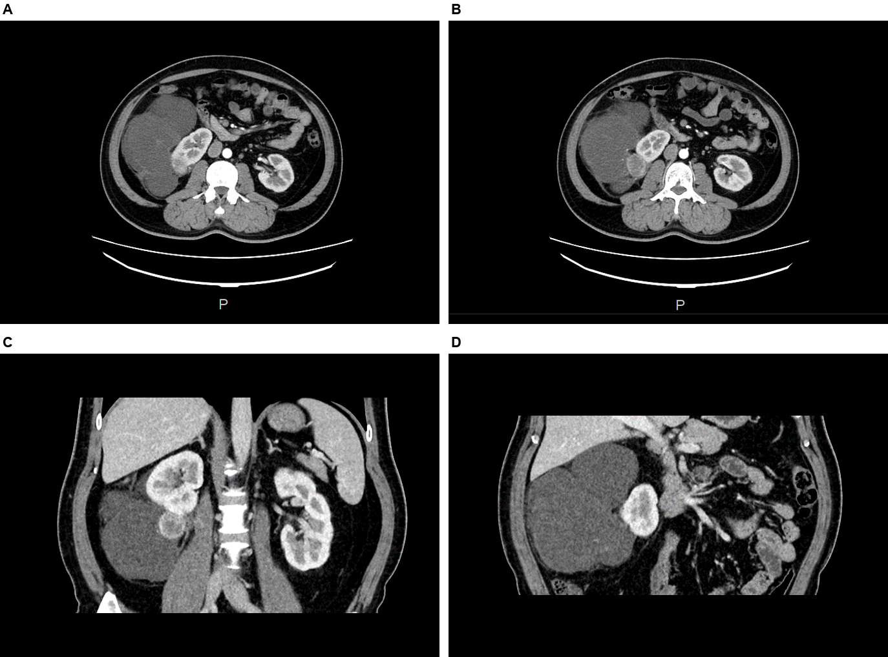
Figure 1. Preoperative contrast-enhanced CT. (A) Axial section showing the large lobulated, low-attenuation right perirenal mass and medial displacement of the kidney. (B) Adjacent axial section showing an enhancing nodule projecting beyond the renal contour beside the larger mass. (C) Coronal section showing the renal lower-pole nodule and its relationship to the perirenal mass. (D) Coronal section showing the extent and lobulated contour of the larger mass. Measurements and localization are based on the radiology report.
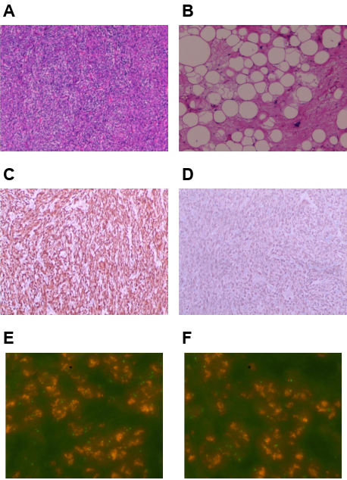
Figure 2. Histological and ancillary findings. (A, B) H&E images showing a cellular spindle-cell field and an adipocytic field, respectively. (C, D) p16 and CDK4 immunohistochemical images; positivity was documented in the pathology report. (E, F) MDM2 FISH fields accompanying the report of clustered amplification. The MDM2/CSP12 signal ratio was 11.77 in 100 analyzed tumor cells (laboratory threshold ≥2.0).

