APPEARED IN PROCEEDINGS OF ECAL91 - EUROPEAN CONFERENCE ON ARTIFICIAL LIFE, PARIS, FRANCE, ELSEVIER PUBLISHING, 134–142.

**Distributed Optimization by Ant Colonies**

Alberto Colorni, Marco Dorigo, Vittorio Maniezzo

Dipartimento di Elettronica, Politecnico di Milano

Piazza Leonardo da Vinci 32, 20133 Milano, Italy

e-mail: dorigo@ipmel1.elet.polimi.it maniezzo@ipmel1.elet.polimi.it

# Abstract

Ants colonies exhibit very interesting behaviours: even if a single ant only has simple capabilities, the behaviour of a whole ant colony is highly structured. This is the result of coordinated interactions. But, as communication possibilities among ants are very limited, interactions must be based on very simple flows of information. In this paper we explore the implications that the study of ants behaviour can have on problem solving and optimization. We introduce a distributed problem solving environment and propose its use to search for a solution to the travelling salesman problem.

# Introduction

In this paper we propose a novel approach to distributed problem solving and optimization based on the result of low-level interactions among many cooperating simple agents that are not aware of their cooperative behaviour. Our work has been inspired by the study of ant colonies: in these systems each ant performs very simple actions and does not explicitly know what other ants are doing. Nevertheless everybody can observe the resulting highly structured behaviour.

In section 2 we explain the background on which our speculations have been built. We decided to develop a software environment to test our ideas on a very difficult and well known problem: the travelling salesman problem - TSP. We call our system, described in section 3, the ***ant system*** and we propose in this paper three possible instantiations to the TSP problem: the **ANT-quantity** and the **ANT-density** systems, described in section 4, and the **ANTcycle** system, introduced in section 5. Section 6 presents some experiments, together with simulation results and discussion. In section 7 we sketch some conclusions and prefigure the directions along which our research work will proceed in the near future.

# Motivations

The animal realm exhibits several cases of social systems having poor individual capabilities when compared to their complex collective behaviours. This is observed at different evolutionary stages, from bacteria [11], to ants [8], caterpillars [5] molluscs and larvae. Moreover, the same causal processes that originate these behaviours are largely conserved in higher level species, like fishes, birds and mammals. These species make use of different communication media, adopted in less ubiquitous situation but essentially leading to the same patterns of behaviours (see for example the circular mills [3]).

This suggests that the underlying mechanisms have proven evolutionarely extremely effective and are therefore worth of being analyzed when trying to achieve the similar goal of performing complex tasks by distributing activities over massively parallel systems composed of computationally simple elements.

One of the better studied natural cases of distributed activities regards ant colonies [2]: we outline here the main features of the models so far proposed to explain ant colonies behaviour. These features have been the basis for the definition of a distributed algorithm, that we have applied to the solution of "difficult" (NP-hard) computational problems.

The problem of interest is how almost blind animals manage to establish shortest route paths from their colony to feeding sources and back.

In the case of ants, the media used to communicate among individuals information regarding paths and used to decide where to go consists of *pheromone trails*. A moving ant lays some pheromone (in varying quantities) on the ground, thus marking the path it followed by a trail of this substance. While an isolated ant moves essentially at random, an ant encountering a previously laid trail can detect it and decide with high probability to follow it, thus reinforcing the trail with its own pheromone. The collective behaviour that emerges is a form of *autocatalytic* behaviour — or *allelomimesis* — where the more are the ants following a trail, the more that trail becomes attractive for being followed. The process is thus characterized by a positive feedback loop, where the probability with which an ant chooses a path increases with the number of ants that chose the same path in the preceding steps.

In Fig.1 we present an example of how allelomimesis can lead to the identification of the shortest path around an obstacle.

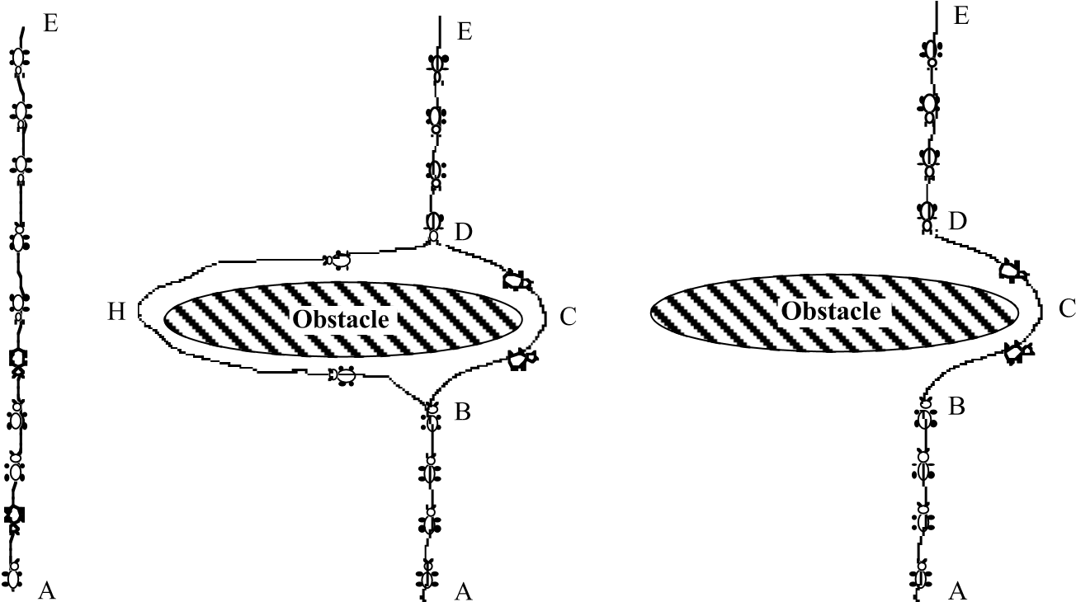

1. b) c)

Fig.1 - a) Some ants are walking on a path between points A and E

1. An obstacle suddenly appears and the ants must get around it
2. At steady-state the ants choose the shorter path

The experimental setting is the following: there is a path along which ants are walking (for example it could be a path from a food source A to the nest E - Fig.1a). Suddenly an obstacle appears and the previous path is cut off. So at position B the ants walking from E to A (or at position D those walking in the opposite direction) have to decide whether to turn right or left (Fig.1b). The choice is influenced by the intensity of the pheromone trails left by preceding ants. A higher level of pheromone on the right path gives an ant a stronger stimulus and thus an higher probability to turn right. The first ant reaching point B (or D) has the same probability to turn right or left (as there was no previous pheromone on the two alternative paths). Being path BCD shorter than BGD, the first ant following it will reach D before the first ant following path BGD. The result is that new ants coming from ED will find a stronger trail on path DCB, caused by the half of all the ants that by chance decided to approach the obstacle via ABCD and by the already arrived ones coming via BCD: they will therefore prefer (in probability) path DCB to path DGB. As a consequence, the number of ants following path BCD will be higher, in the unit of time, than the number of ants following BGD. This causes the quantity of pheromone on the shorter path to grow faster than on the longer one, and therefore the probability with which any single ant chooses the path to follow is quickly biased towards the shorter one. The final result is that very quickly all ants will choose the shorter path (Fig.1c). However, the decision of whether to follow a path or not is never deterministic, thus allowing a continuos exploration of alternative routes.

Computational models have been developed, to simulate the food-searching process [3], [8]. The results are satisfactory, showing that a simple probabilistic model is enough to justify complex and differentiated collective patterns. This is an important result, where a minimal level of individual complexity can explain a complex collective behaviour.

An increase in the computational complexity of each individual, once established the lowest limit needed to account for the desired behaviours, can help in escaping from local optima and to face environmental changes. Trail laying regulated by feedback loop just eases ants to pursue the path followed by the first ant which reached its objective, but that path could easily be suboptimal. If we move from the goal of modeling natural reality to that of designing agents that perform food-seeking in the most efficient possible way, an increase in the individual agent's complexity could direct the search in front of an increment of computational cost. In this case we face the trade-off between individual performance and computational overhead caused by increasing population size: we are interested in the simplest models that take into account efficient shortest route identification and optimization.

译文

基于蚁群的分布式优化

摘要

蚁群展现出一种非常有趣的习性：尽管单独一只蚂蚁只具有简单的能力，但整个蚁群的行为却高度结构化。这是协同交互的结果。然而，由于蚂蚁之间通信的能力非常有限，交互作用必然基于一种非常简单的信息流。在本文中，我们通过研究蚂蚁的行为中蕴含的机理，将其应用于对问题的解决与优化。我们提出一种分布式问题解决环境，并且打算将其应用于寻找旅行商问题的解。

1.引言

在本文中，我们提出一种新的途径对分布式问题进行求解和优化，这种途径是基于在许多没意识到合作行为的单个媒介中底层交互的结果。通过学习蚁群，我们的工作受到启发：在这些系统中每一只蚂蚁执行非常简单的动作且并不清楚地知道其它蚂蚁在做什么。然而每个人都可以注意到这样一个高度结构化的行为结果。

在第二节中，我们说明了我们的构想建立的背景。我们决定开发一款软件环境来测试我们的想法，基于一个非常困难且著名的问题：旅行商——TSP问题。我们把在第三节中描述的系统称为蚂蚁系统并且在本文中我们针对TSP问题提出了三个可能的实例：在第四节中描述的ANT-quantity和ANT-density系统，以及在第五节中介绍的ANT-cycle系统。第六节中列举了一些实验以及模拟结果与讨论。在第七节中，我们简述了一些结论和预测了在不久将来沿着我们研究工作继续进行的方向。

2.动机

与它们复杂的集体行为相比，动物界显示了几例拥有贫乏个体发展潜力的社会系统。这是从细菌[11]到蚂蚁[8]、毛虫[5]、软体动物和幼虫的不同进化阶段观察得到的。此外，更高层次的物种已保存下来的这些行为也是由相同的因果过程产生的，如鱼类、鸟类和哺乳动物。这些物种使用不同的交流媒介，虽然是在极少普遍存在的情况下采用的但本质上导致了了相同的行为模式（参见circular mills例子[3]）。

这表明，潜在的机制已被证明进化地极具效果，因此值得被研究分析，尤其是当试图实现通过大规模并行系统由简单元素来分配活动去执行复杂任务的相似目标。

一个更好研究有关蚁群[2]自然情况下的分布式活动是：到目前为止，我们概述的模型的主要特征解释了蚁群行为。这些特征是分布式算法定义的基础，已经被我们应用到解决“困难”（NP难度）的计算问题上。

令人感兴趣的问题是这些相当于失明的动物如何设法建立了最短路径来回于它们的聚居地和料源。

对蚂蚁来说，媒介是用来传达有关路径的单个信息和用来组成决定去哪的信息素。一个移动的蚂蚁在地面上释放一些信息素（在不同数量），因此通过一系列这种物质标记它遵循的路径。本质上来说，一个单个蚂蚁移动是随机的，遇到以前铺置的道路，蚂蚁能够辨别出这条道路并且极大可能决定遵循它，从而通过自己的信息素加强这条道路的标记。形成这种集体行为是一种自动催化行为或者是allelomimesis行为——遵循一条道路的蚂蚁越多，这条道路就会吸引越多的蚂蚁去遵循。因此，这个过程的特征是一个正反馈循环，其概率相当于一个蚂蚁选择了一个路径导致在相同基础上选择相同路径的蚂蚁增加的数量。

图1中我们给出了一个例子关于allelomimesis如何绕过障碍识别最短路径。



图1

图1——（a）一些蚂蚁正在走点A和点E之间的一条路径

（b）一个障碍突然出现，蚂蚁必须绕过它

（c）在相同的基础上，蚂蚁选择最短路径

实验设置如下：蚂蚁沿着一个路径在走（假如从食物源A到蚂蚁窝E之间有一条路径——图1a）。突然出现一个障碍并且把之前的路径切断。所以从E到A上蚂蚁走到位置B（或者那些在相反位置上的蚂蚁走到位置D）必须决定是向右或向左走（图1b）。这个选择是深受先前蚂蚁留下的信息素的影响。在右侧路径上的更高等级的信息素给了一个蚂蚁较强的刺激，因此向右转的可能性更高。第一只蚂蚁到达点B（或D）选择向右或向左转是相同的概率（因为在两条可选择的路径上都没有以前的信息素）。路径BCD比BGD短，所以选择BCD的第一只蚂蚁比选择BGD的第一只蚂蚁要更早到达D。结果是，从ED过来的新蚂蚁将发现在路径DCB上有更强的踪迹，这是因为所有蚂蚁的一半随机决定通过ABCD越过障碍而且已经到达的那些蚂蚁选择BCD通过的：因此比起路径BGD，它们更喜欢（从概率上）路径DCB。因此，在单位时间内，遵循路径BCD的蚂蚁数量比遵循路径BGD的蚂蚁数量要更高。这导致信息素数量在较短路径上要比在较长路径上增长的快，因此任何一个蚂蚁选择要遵循的路径时极大可能偏向较短路径。最终结果是，所有蚂蚁很大可能选择较短的路径（图1c）。但是，是否遵循一个路径的决定是不确定的，因此，允许可选择路线的一个连续探索。

计算模型已被发展用来模拟寻找食物的过程。结果是令人满意，这表明一个简单的概率模型是足以解释复杂和辨别集体模式的。这是一个重要结果，一个最低等级的个体复杂性能够解释一个复杂的集体行为。

在每一个个体的计算复杂度的增加下，一旦为了预期的行为而建立的最低限度需求，就可以帮助摆脱局部最优和面对环境的变化。受反馈循环控制的路径铺设只是使蚂蚁轻松地去追求第一只蚂蚁主观遵循的路径，但这个路径很有可能不是最理想的。如果我们从建立自然现实模型的目的上转变成完成寻找食物的最有效途径的设计代理上，个体代理复杂度的增加能够指导在计算成本增量之前的搜索。在这种情况下，我们要面对在个体性能和因为增加种群数量而造成的计算开销之间进行权衡：我们感兴趣的是最简单模型能考虑到有效最短路径的识别和优化。