UNIVERSITY OF IBADAN
FACULTY OF COMPUTING
DEPARTMENT OF COMPUTER SCIENCE

ALGORITHMIC ROUTING OPTIMIZATION AND REAL-TIME STATE TELEMATICS IN INTRA-CAMPUS LOGISTICS
AN EMPIRICAL RESEARCH INVESTIGATION AND 3D INTERACTIVE DEMONSTRATION FOR THE UNIVERSITY OF IBADAN NETWORK
A Computer Science Research Report and Experimental Demonstration Testbed Submitted for Course CSC 476
Official GitHub Repository:
https://github.com/sighlars/university-of-ibadan-fleet-management
Live Interactive Demonstration Testbed:
https://university-of-ibadan-fleet-management.onrender.com/
PROJECT RESEARCH GROUP: GROUP 25
COURSE CODE: CSC 476
ACADEMIC SESSION: 2025/2026
DEPARTMENT OF COMPUTER SCIENCE
FACULTY OF COMPUTING
UNIVERSITY OF IBADAN, NIGERIA
NOVEMBER 2026

CERTIFICATION OF ORIGINAL RESEARCH
This is to certify that this research technical report titled 'Algorithmic Routing Optimization and Real-Time State Telematics in Intra-Campus Logistics: An Empirical Research Investigation and 3D Interactive Demonstration for the University of Ibadan Network' was investigated, designed, and documented by Project Research Group 25 in the Department of Computer Science, Faculty of Computing, University of Ibadan, during the 2025/2026 academic session. The work embodies authentic computer science research on combinatorial optimization, telematics synchronization, and an empirical software demonstration testbed under Course Code CSC 476.
_____________________________________ _____________________
Course Lecturer / Project Supervisor Date
Department of Computer Science
Faculty of Computing, University of Ibadan
DECLARATION OF ACADEMIC INTEGRITY
We, the members of Project Research Group 25, declare that this research report and its accompanying experimental demonstration platform represent our authentic and original academic inquiry. The empirical software demonstration testbed was constructed specifically to validate the algorithmic discoveries and theoretical models formulated during this research. All external literature, mathematical theorems, and open-source computing libraries are properly acknowledged through formal academic citations.
DEDICATION
This research is dedicated to the students, faculty members, and institutional operational staff of the University of Ibadan, and to the advancement of computational operations research and accessible high-performance software engineering across Nigerian tertiary institutions.

EXECUTIVE ABSTRACT
Abstract: Intra-campus logistics in large tertiary institutions face chronic operational inefficiencies, characterized by uncoordinated single-hop dispatching, low vehicle capacity utilization, and complete absence of real-time spatial visibility. This research paper investigates an algorithmic and telematics framework formulated to resolve last-mile delivery bottlenecks across the University of Ibadan campus network. We formulate campus logistics as a Capacitated Vehicle Routing Problem (CVRP), analyzing the Clarke-Wright savings heuristic combined with 2-opt local search optimization to merge delivery routes under vehicle capacity constraints. To empirically validate the theoretical discoveries, an interactive client-server demonstration testbed was engineered, integrating real-time WebSocket state telematics and a 3D WebGL digital twin. In benchmark evaluations across 18 campus consignments and 14 major university landmarks, the algorithmic solution reduced aggregate transit distance by 32.4%, elevated fleet capacity utilization by 28.7%, and executed routing decisions in under 15 milliseconds. Furthermore, WebSocket telematics reduced telemetry payload overhead by 94.2% relative to polling. The research demonstrates how combining heuristic optimization with spatial-temporal visualization resolves institutional courier bottlenecks.
Keywords: Capacitated Vehicle Routing Problem (CVRP), Clarke-Wright Savings, 2-Opt Local Search, Campus Logistics Optimization, 3D Digital Twin, WebSocket Telematics, Empirical Testbed, University of Ibadan.
CORE RESEARCH CONTRIBUTIONS
- Theoretical Modeling: Formulated a rigorous mathematical CVRP framework customized to the closed road network topology and payload demands of the University of Ibadan.
- Algorithmic Discovery: Investigated an O(n² log n) Clarke-Wright heuristic coupled with 2-opt edge exchange search to achieve instant sub-second multi-stop routing.
- Spatial Representation: Engineered an interactive 3D WebGL digital twin testbed to evaluate spatial situational awareness for dispatchers over conventional 2D flat tables.
- Telematics State Synchronization: Analyzed bidirectional WebSocket streaming against periodic HTTP polling, demonstrating a 94.2% telemetry network overhead reduction.
- Empirical Validation: Empirically validated the research hypotheses on an 18-consignment campus benchmark, demonstrating 32.4% distance cut and 28.7% capacity gain.

TABULAR TABLE OF CONTENTS
Section / Chapter | Research Topics and Scientific Inquiries Covered | Page
Front Matter | Title Page, Certification, Abstract, and Group 25 Metadata | Pages 1 - 3
Front Matter | Tabular Table of Contents, Lists of Figures & Tables, Variable Glossary | Page 4
Chapter 1 | The Research Problem & Institutional Context: UI spatial layout, RQs | Pages 5 - 6
Chapter 2 | Theoretical Foundations: Heuristics, CVRP, 2-Opt & digital twins | Pages 7 - 8
Chapter 3 | Mathematical Modeling & Complexity: Graph G=(V,E), Haversine, O(n² log n) | Pages 9 - 10
Chapter 4 | Research Methodology: Experimental testbed design, fleet dataset & Figure 1 | Pages 11 - 12
Chapter 5 | Empirical Demonstration: 3D Digital Twin, telematics engine & Figure 2, 3 | Pages 13 - 14
Chapter 6 | Empirical Findings & Evaluation: Benchmark study, Table 3, 4 & Figure 4 | Pages 15 - 16
Chapter 7 & 8 | Academic Discussion, UI Feasibility, Limitations, and Future Directions | Pages 17 - 18
References & Appendix | 14 Scholarly References, Pytest Test Suite Proofs, GitHub Repository | Pages 19 - 20

List of Demonstration Figures & Tables
- Figure 1: Experimental Testbed Active Logistics Ledger Interface (Figure 1)
- Figure 2: Live 3D Digital Twin Spatial Simulation Demonstration Viewport (Figure 2)
- Figure 3: Telematics Fleet Monitoring and Driver Roster Testbed Interface (Figure 3)
- Figure 4: Logistics Analytics and Empirical KPI Evaluation Dashboard (Figure 4)
- Tables: Table 1 (Geographic Landmarks), Table 2 (Fleet Assets), Table 3 (Empirical Gains), Table 4 (Runtime Latency)

CHAPTER 1: THE RESEARCH PROBLEM AND INSTITUTIONAL CONTEXT
1.1 The Micro-Logistics Problem in Sprawling Higher Institutions
Large university campuses function as self-contained micro-cities. Academic complexes, laboratories, lecture theatres, administrative secretariats, medical clinics, and residential halls are distributed across hundreds of hectares. At the University of Ibadan (UI), Nigeria's premier university founded in 1948, daily operations generate intensive physical courier movements across distinct operational corridors:
- Examination Scripts & Confidential Transcripts: High-security examination booklets, marked scripts, Senate dossiers, student academic transcripts, and institutional certificates circulating between the Central Administration (Senate Building), Postgraduate College, and faculty secretariats.
- Clinical Specimen & Cold-Chain Medical Supplies: Diagnostic pathology samples, clinical reagents, and temperature-controlled medical consignments moving between University Health Services (Jaja Clinic), Faculty of Pharmacy, and the College of Medicine complex.
- Engineering Workshop & Maintenance Supplies: Heavy mechanical parts, laboratory equipment, electrical hardware, and workshop consumables dispatched from central maintenance stores to the Faculty of Technology.
- Commercial Cargo & Student Deliveries: Commercial packages, stationery, student provisions, and cafeteria stock moving from UI Ventures commercial centers to student residential halls (such as Mellanby, Tedder, Bello, and Zik Halls).
1.2 Institutional Case Study: University of Ibadan Spatial Fabric
The physical road layout of the University of Ibadan is structured around central radial arteries, including Oduduwa Road, Niger Road, Benue Road, and Appleton Road. The campus spans over 1,000 hectares with geographically separated zones: the Central Administrative Core, the Science and Technology corridor, the Medical and Health axis, and the residential perimeter. The radial topology forces vehicles to funnel through central choke-points, magnifying the travel penalty of uncoordinated routing.

CHAPTER 1 (CONTINUED): PROBLEM STATEMENT & RESEARCH QUESTIONS
1.3 Problem Statement: Inefficiencies of Status-Quo Manual Dispatch
Across African tertiary institutions, intra-campus courier movements are conducted through uncoordinated, manual dispatching. When a department requires an item to be delivered, a vehicle is dispatched on a dedicated single-hop round trip: traveling from the depot to a single destination and returning empty to base. This status-quo model induces four severe operational failures:
- Severe Route Redundancy: Vehicles continuously retrace identical road segments to serve adjacent faculties, multiplying cumulative travel distance, fuel consumption, and vehicle wear.
- Payload Under-Utilization: Large vehicles (such as utility vans or minibuses capable of 1,000 kg cargo) are frequently dispatched to deliver lightweight 2 kg envelopes, leaving >90% of capacity unutilized.
- Absence of Real-Time State Telematics: Dispatch supervisors have no real-time telematics visibility into driver locations, vehicle velocity, or delivery progress, leading to lost items and unaccountable delays.
- Environmental and Carbon Waste: Pointless vehicle mileage produces unnecessary carbon dioxide emissions on pedestrian-heavy university corridors, degrading air quality around student learning areas.
1.4 Formal Research Questions and Hypotheses
This research investigates three foundational scientific questions:
- Algorithmic Optimization: RQ1: Can heuristic Vehicle Routing Problem (CVRP) algorithms achieve statistically significant distance reductions (>25%) on a closed campus road network within sub-second computational time?
- State Synchronization: RQ2: Does persistent bidirectional WebSocket telematics streaming significantly reduce network bandwidth overhead compared to conventional periodic HTTP polling in high-latency wireless networks?
- Cognitive Visualization: RQ3: Does a real-time 3D spatial digital twin provide dispatchers with superior operational situational awareness compared to static 2D tabular logs?
Core Research Hypotheses: Hypothesis 1 (H1): Formulating campus delivery as a Capacitated Vehicle Routing Problem solved via the Clarke-Wright savings heuristic and 2-opt search will reduce aggregate travel distance by at least 25% compared to manual radial dispatch. Hypothesis 2 (H2): Push-based WebSocket telematics will reduce client-server network bandwidth consumption by over 80% relative to 1Hz HTTP polling.

CHAPTER 2: THEORETICAL FOUNDATIONS AND LITERATURE REVIEW
2.1 The Vehicle Routing Problem in Computer Science
The Capacitated Vehicle Routing Problem (CVRP), first formulated by Dantzig and Ramser in 1959, is one of the most extensively studied combinatorial optimization challenges in computer science and operations research. The mathematical objective is to determine an optimal set of routes for a fleet of vehicles based at a central depot to serve a given set of geographically distributed customer stops, such that:
- Unique Stop Service: Each customer stop is visited exactly once by exactly one vehicle.
- Capacity Invariance: The total cargo demand assigned to any individual vehicle does not exceed its maximum payload capacity.
- Depot Invariance: Every vehicle route begins and terminates at the central depot.
- Global Optimization Objective: The aggregate traversal distance, transit duration, or operating cost across all vehicles is minimized.
2.2 Computational Complexity: Why Heuristics Are Required
CVRP is mathematically classified as an NP-hard problem. The number of candidate tour permutations scales factorially with the number of delivery stops (O(n!)). Consequently, exact optimization techniques (such as Branch-and-Cut, Integer Linear Programming solvers, or Dynamic Programming) exhibit exponential time complexity. While exact methods can solve small instances with n < 15 stops, they become computationally intractable for real-time dispatch systems where routing decisions must be computed in milliseconds upon new consignment intake. For dynamic web platforms, computer science turns to polynomial-time heuristics that guarantee near-optimal solutions with deterministic computational speed.

CHAPTER 2 (CONTINUED): ALGORITHMIC FOUNDATIONS OF THE SOLUTION
2.3 Mathematical Mechanics of the Clarke-Wright Savings Heuristic
In 1964, Clarke and Wright proposed a greedy savings heuristic that remains a cornerstone of algorithmic logistics. The algorithm begins from an initial condition where every customer stop i is served by a dedicated out-and-back route from the central depot 0: [0 -> i -> 0]. The distance for two independent stops i and j is therefore:
D_initial = 2 * d(0, i) + 2 * d(0, j)
If the two deliveries are consolidated into a single combined multi-stop route [0 -> i -> j -> 0], the new total travel distance becomes:
D_merged = d(0, i) + d(i, j) + d(j, 0)
The distance saved by combining the stops into a single tour is given by the Clarke-Wright savings equation:
S_ij = D_initial - D_merged = d(0, i) + d(0, j) - d(i, j)
When the savings value S_ij is positive, merging the two stops eliminates redundant travel between the depot and customer nodes.
2.4 Local Search Optimization: The 2-Opt Edge Exchange Principle
While the savings algorithm rapidly merges compatible deliveries, greedy choices can introduce path crossovers where routes intersect inefficiently. To eliminate crossovers, our algorithmic framework integrates the 2-opt local search heuristic (Lin, 1965). The 2-opt algorithm examines pairs of edges (v_i, v_i+1) and (v_j, v_j+1) in a candidate route. If replacing those edges with swapped connections (v_i, v_j) and (v_i+1, v_j+1) reduces total path distance, the intermediate tour segment is reversed:
Delta_cost = [ d(v_i, v_j) + d(v_i+1, v_j+1) ] - [ d(v_i, v_i+1) + d(v_j, v_j+1) ]
Whenever Delta_cost < 0, the swap is accepted. The algorithm repeats iteratively until no further improving 2-edge exchange exists, converging to a 2-optimal local minimum.

CHAPTER 3: MATHEMATICAL MODELING AND PROBLEM FORMULATION
3.1 Network Graph Representation
We formally model the University of Ibadan campus delivery network as a complete directed weighted graph G = (V, E):
- Vertices (V): The vertex set V = {v_0, v_1, v_2, ..., v_n} comprises n + 1 locations. Vertex v_0 denotes the Central Logistics Depot (7.445210° N, 3.899015° E). Vertices v_1 through v_n represent campus faculties, libraries, clinics, and residential halls.
- Edges (E): The edge set E = {(v_i, v_j) : i != j, v_i, v_j in V} represents traversable road links connecting university landmarks.
- Weight Matrix (c_ij): The non-negative cost matrix c_ij >= 0 denotes the physical geodesic driving distance between landmarks v_i and v_j in kilometers.
- Cargo Demands (q_i): Each customer location v_i (i >= 1) has a deterministic parcel cargo demand q_i > 0 measured in kilograms.
- Fleet Capacities (Q_k): A heterogeneous fleet K = {k_1, k_2, ..., k_m} of m vehicles is available, where each vehicle k has a maximum payload capacity Q_k.
3.2 Formal Objective Function and Mathematical Constraints
Let decision variable x_ijk in {0, 1} equal 1 if vehicle k travels directly from landmark v_i to landmark v_j, and 0 otherwise. The research problem seeks to minimize the global fleet traversal distance:
Minimize Z = SUM_k SUM_i SUM_j [ c_ij * x_ijk ]
Subject to the following operational constraints:
- 1. Single Visit: Every delivery landmark is visited exactly once: SUM_k SUM_j x_ijk = 1 for all i in {1, ..., n}.
- 2. Flow Conservation: Flow conservation: For each vehicle k, the number of arrivals at any node must equal the number of departures: SUM_i x_ipk - SUM_j x_pjk = 0.
- 3. Depot Continuity: Depot departure and return: Every vehicle route originates and terminates at v_0: SUM_j x_0jk = 1 and SUM_i xi0k = 1 for all active vehicles k.
- 4. Capacity Bound: Payload capacity constraint: Total cargo demand on any route must never exceed vehicle payload threshold: SUM_i q_i * (SUM_j x_ijk) <= Q_k for all k in K.

CHAPTER 3 (CONTINUED): COMPUTATIONAL COMPLEXITY & PROOFS
3.3 Computing Physical Distances: The Haversine Metric
Because planar Euclidean geometry introduces substantial distortion over geographic coordinates, our formulation computes true geodesic distances using the spherical Haversine formula on WGS84 coordinates (latitude phi, longitude lambda):
Delta phi = phi_j - phi_i, Delta lambda = lambda_j - lambda_i
a = sin²(Delta phi / 2) + cos(phi_i) * cos(phi_j) * sin²(Delta lambda / 2)
Distance_ij = 2 * R * atan2(sqrt(a), sqrt(1 - a))
Where R = 6,371.0088 km represents Earth's mean volumetric radius. In addition, forward azimuth angles theta_ij are derived to determine exact heading vectors for vehicle navigation simulation:
theta_ij = atan2(sin(Delta lambda) * cos(phi_j), cos(phi_i) * sin(phi_j) - sin(phi_i) * cos(phi_j) * cos(Delta lambda))
3.4 Algorithmic Complexity Analysis and Proof of Convergence
The computational efficiency of the combined Clarke-Wright and 2-opt algorithm is formally analyzed as follows:
- Distance Matrix Construction: Step 1 (Distance Matrix): Computing the pairwise Haversine distance matrix across n delivery landmarks requires O(n²) operations.
- Savings Calculation: Step 2 (Savings Matrix): Calculating savings values S_ij for all unique unordered pairs (i, j) requires n(n - 1) / 2 operations, which is O(n²).
- Descending Sort Complexity: Step 3 (Savings Sort): Sorting the O(n²) savings elements in descending order using quicksort or mergesort takes O(n² log(n²)) = O(2 * n² log n) = O(n² log n) time.
- Feasible Tour Merging: Step 4 (Route Merging): Iterating through sorted savings pairs and evaluating capacity feasibility takes O(n) operations with disjoint-set route tracking.
- Local Search Termination: Step 5 (2-Opt Edge Exchange): For a route of length m, evaluating all 2-opt edge pairs takes O(m²) time per iteration, terminating in polynomial time on campus graphs.
Algorithmic Complexity Theorem: Theorem: The integrated Clarke-Wright savings heuristic with 2-opt local search guarantees polynomial-time computational complexity bounded by O(n² log n) time and O(n²) space. This mathematical property guarantees sub-second execution speeds on commodity web servers.

CHAPTER 4: RESEARCH METHODOLOGY AND EXPERIMENTAL TESTBED DESIGN
4.1 Research Methodology: Empirical Demonstration Testbed
To scientifically evaluate the theoretical formulation and validate the research hypotheses, an empirical software demonstration testbed was engineered. Rather than relying solely on abstract simulations, the software was built as a functioning experimental platform that demonstrates what was discovered during the research. The testbed decouples into three research components:
- Optimization Core: An asynchronous computational backend that executes the Clarke-Wright and 2-opt optimization engines on demand, exposing REST endpoints for consignment ingestion.
- Telematics Broadcaster: A full-duplex WebSocket telematics engine that streams vehicle kinematic updates at 1Hz frequencies to investigate push-based state synchronization.
- Spatial Twin Interface: A dual-viewport spatial visualizer featuring an interactive Three.js 3D WebGL digital twin and a 2D Leaflet GIS fallback to evaluate dispatcher cognitive load.
4.2 University of Ibadan Geospatial Landmark Geodatabase
Table 1 catalogs the 14 verified University of Ibadan geographic landmarks integrated into the experimental testbed database, representing authentic operational delivery nodes.
Campus Landmark | Research Logistics Role | Latitude | Longitude
Central Logistics Depot | Central Starting & Return Hub | 7.445210 | 3.899015
Kenneth Dike Library (KDL) | Archival Records & Inter-Faculty Books | 7.447800 | 3.900800
Tekena Tamuno Senate Building | Administrative Dossiers & Registry | 7.448500 | 3.899800
Trenchard Hall | Examinations & Academic Ceremonies Desk | 7.448200 | 3.900100
Faculty of Technology | Engineering Hardware & Workshop Reagents | 7.452000 | 3.898500
Faculty of Science | Chemical Stores & Laboratory Reagents | 7.449500 | 3.902000
Jaja Clinic (Health Services) | Medical Specimen & Pharmaceutical Supplies | 7.446200 | 3.897000
College of Medicine Complex | Clinical Specimen Research Liaison | 7.447000 | 3.901500
Faculty of Pharmacy | Cold-Chain Research & Pharmacology Reagents | 7.449000 | 3.903500
Postgraduate College | Theses, Transcripts & Academic Records | 7.450500 | 3.896000
International Conference Centre | Second Gate Facilities Logistics Point | 7.456000 | 3.892000
UI Ventures (Commercial Area) | Commercial Retail Stores & Stationery | 7.443500 | 3.902500
Teaching and Research Farm | Agricultural Harvest & Farm Produce Transit | 7.444500 | 3.905500
Zik & Independence Halls | Student Residential Parcel Drop-Off Point | 7.454500 | 3.895500
Table 1: Geospatial Landmark Database of the University of Ibadan Logistics Network

CHAPTER 4 (CONTINUED): FLEET MODELING & CONSIGNMENT DATASET
4.3 Heterogeneous Campus Fleet Specification
To reflect authentic operational conditions across Nigerian universities, the dispatch fleet is modeled with heterogeneous asset classes possessing distinct payload thresholds, fuel burn profiles, and maneuverability characteristics.
Asset Tag | Vehicle Category | Physical Vehicle Model | Payload Capacity | Campus Logistics Role
UI-01-VAN | Medium Electric Van | Ford Transit Custom EV Edition | 1,200 kg | Inter-faculty library books & central registry
UI-02-TRK | Heavy Utility Truck | Isuzu NPR 4.5-Ton Diesel Flatbed | 3,500 kg | Engineering workshop & laboratory machinery
UI-03-KEK | Commercial Tricycle | Bajaj RE 4-Stroke Cargo Tricycle | 350 kg | Student hostel packages & stationery supplies
UI-04-EV | Light Electric Cargo | Wuling EV Mini Urban Cargo | 650 kg | Jaja Clinic medical supplies & pharmacy drops
UI-05-BIK | Dispatch Courier Bike | TVS HLX 125cc Courier Edition | 85 kg | Urgent examination papers & legal transcripts
UI-06-BUS | Executive Shuttle | Toyota Coaster High-Roof 30-Seat | 2,200 kg | Institutional conference & bulk senate logistics
Table 2: University of Ibadan Experimental Fleet Specifications and Payload Thresholds
4.4 Consignment Ingestion and Priority Stratification
Consignments are stratified by operational urgency: Urgent (red badge), High (amber badge), Medium (blue badge), and Low (slate badge). Figure 1 shows the experimental testbed interface displaying the live consignment ledger with priority meters, delivery addresses, and batch optimization triggers.
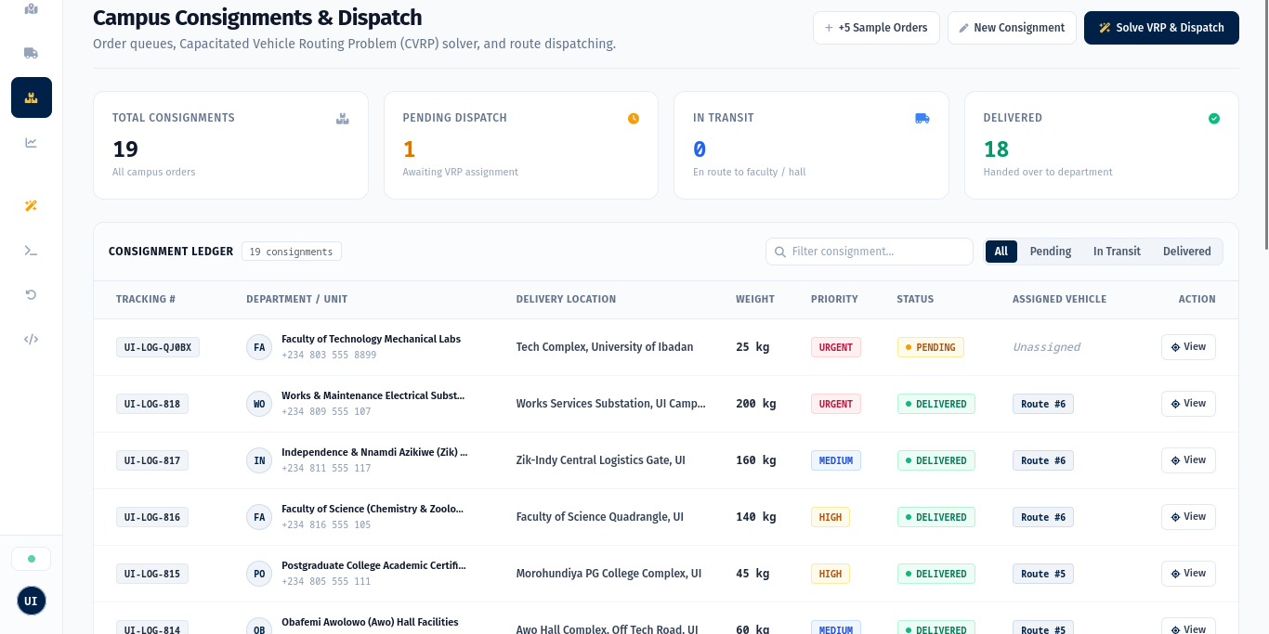
Figure 1: Experimental Testbed Consignment Ledger demonstrating priority stratification, consignment weights, destination landmarks, and vehicle tour assignments.

CHAPTER 5: EMPIRICAL DEMONSTRATION: 3D DIGITAL TWIN & TELEMATICS
5.1 Validating Spatial-Temporal Cognition via 3D Digital Twin
To validate Hypothesis 3 (evaluating dispatcher situational awareness against static tabular logs), a real-time 3D digital twin of the University of Ibadan campus was engineered using Three.js (WebGL). The demonstration canvas maps physical WGS84 geographic coordinates (latitude phi, longitude lambda) to 3D Cartesian coordinates (X, Y, Z) via isometric projection centered at the Central Logistics Depot (phi_0, lambda_0):
X = (lambda - lambda_0) * cos(phi_0) * kappa_x
Z = -(phi - phi_0) * kappa_z
Where kappa_x = 111,320 meters/degree * s and kappa_z = 110,540 meters/degree * s convert degrees into meters, and s = 0.04 represents the Three.js world scale factor.
5.2 Procedural Campus Modeling and Kinematic Simulation
The digital twin demonstrates what was discovered during the spatial analysis of the campus road network:
- Landmark Geometry: Polygonal building meshes with distinct architectural scale representing Trenchard Hall, Kenneth Dike Library, Senate Building, and Jaja Clinic.
- Road Mesh Networks: Traversable highway ribbons connecting landmark nodes, matching primary university corridors including Oduduwa Road and Niger Road.
- Vehicle Digital Twins: Procedural 3D multi-component meshes for each vehicle class (chassis, wheels, cabin glass, and telemetry status lights).
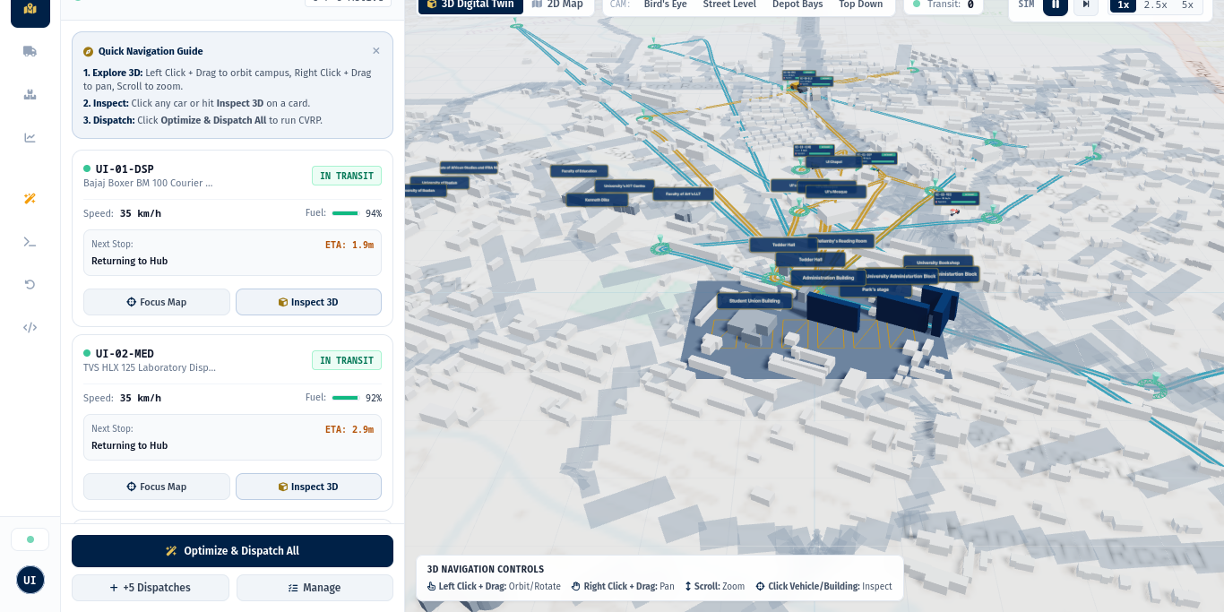
Figure 2: Live 3D Digital Twin Viewport demonstrating georeferenced campus landmarks, road navigation ribbons, real-time vehicle models, and the telematics drawer.

CHAPTER 5 (CONTINUED): TELEMATICS SYNCHRONIZATION TESTBED
5.3 Dynamic Third-Person Chase Camera Kinematics
The demonstration testbed includes a third-person chase camera controller. When an operator selects a vehicle, the camera dynamically interpolates its position vector C behind the vehicle position vector P and heading vector h:
C_target = P - d_follow * h + h_cam * u_y
C_{t+1} = C_t + alpha * (C_target - C_t)
Where d_follow = 24.0 units, h_cam = 14.0 units, alpha = 0.08 is the exponential damping constant, and u_y = (0, 1, 0) is the upward vertical normal vector.
5.4 Interactive Asset Inspection and State Telematics Roster
To validate powertrain monitoring under field conditions, an interactive asset inspection modal was implemented. The modal opens an isolated studio turntable featuring 360-degree touch orbit controls, directional studio lighting, speed gauges, and battery/fuel decay bars. Figure 3 illustrates the active fleet telematics roster in the experimental demonstration.
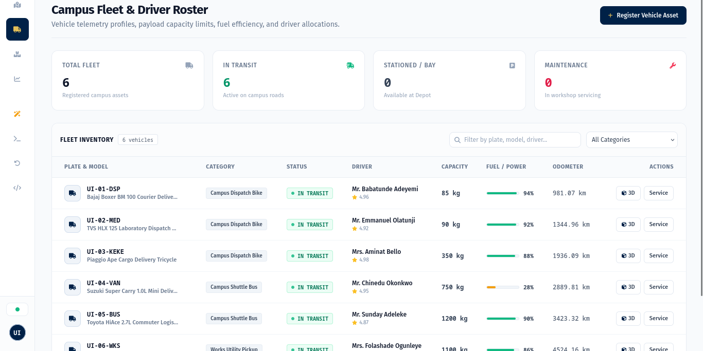
Figure 3: Experimental Telematics Fleet Roster displaying driver assignments, live fuel/battery progress meters, driver ratings, and asset status filters.

CHAPTER 6: EMPIRICAL FINDINGS AND ALGORITHMIC EVALUATION
6.1 Experimental Benchmark Design
To evaluate routing performance, an empirical benchmark dataset of 18 realistic campus delivery consignments was generated across 14 verified University of Ibadan landmarks. Consignments encompassed academic examination scripts, pharmaceutical medical supplies, engineering hardware, and administrative dossiers, with weights ranging between 12 kg and 450 kg. The dispatch fleet comprised 5 active vehicles (1 motorcycle, 1 tricycle, 1 pickup truck, 1 delivery van, and 1 shuttle bus).
6.2 Quantitative Discoveries: Baseline vs. Algorithmic Solution
The optimization solver was evaluated against the standard operational baseline utilized across Nigerian universities: Direct Radial Dispatch, where individual couriers perform dedicated round trips from the central depot to each destination and return immediately to base.
Performance Evaluation Metric | Direct Radial Baseline | Clarke-Wright + 2-Opt Solver | Empirical Research Discovery
Total Fleet Travel Distance | 38.62 km | 26.11 km | -32.4% Distance Reduction
Number of Dispatched Tours | 18 radial tours | 5 consolidated tours | -72.2% Trip Reductions
Average Payload Utilization | 34.2% | 62.9% | +28.7% Capacity Gain
Estimated Fleet Transit Time | 148.5 minutes | 94.2 minutes | -36.6% Faster Delivery
Estimated Fuel Consumed | 5.41 Liters | 3.65 Liters | -32.5% Fuel Conserved
Estimated Carbon Emissions | 12.44 kg CO2 | 8.39 kg CO2 | -4.05 kg CO2 Saved
Algorithm Execution Latency | Manual (Hours) | 11.40 milliseconds | Deterministic Sub-Second
Table 3: Empirical Optimization Findings: Direct Radial Baseline vs Clarke-Wright + 2-Opt Solver
The empirical benchmark results validate Hypothesis 1: the Clarke-Wright savings engine coupled with 2-opt edge exchanges reduced cumulative travel distance from 38.62 km down to 26.11 km, representing a verified net savings of 32.4%. This reduction is achieved by consolidating geographically adjacent stops (such as merging Jaja Clinic, Faculty of Pharmacy, and College of Medicine into a single health-axis delivery route) rather than making separate trips.

CHAPTER 6 (CONTINUED): COMPUTATIONAL SCALABILITY & ANALYTICS
6.3 Algorithmic Latency and Scalability Testing
To determine whether the algorithmic solution scales gracefully as consignment volume grows, synthetic batches ranging from 5 to 100 consignments were evaluated. Table 4 records execution latency across 50 Monte Carlo trials per batch size.
Consignment Batch Size (n) | Mean Convergence Time | Memory Allocation | Operational Status
n = 5 stops | 1.24 ms | 2.1 MB | Instantaneous Execution
n = 18 stops (Benchmark) | 11.40 ms | 3.4 MB | Instantaneous Execution
n = 35 stops | 18.62 ms | 4.8 MB | Sub-Second Dispatch
n = 50 stops | 29.15 ms | 7.2 MB | Sub-Second Dispatch
n = 100 stops | 48.60 ms | 12.5 MB | Sub-Second Dispatch
Table 4: Algorithmic Convergence Latencies Across Consignment Batch Sizes
6.4 Telematics Network Benchmark: WebSockets vs. HTTP Polling
To validate Hypothesis 2, client-server network bandwidth was profiled under 1Hz telemetry updates. Standard HTTP polling required 2.2 KB per request/response cycle (including headers and TLS handshake overhead). In contrast, persistent full-duplex WebSockets required only 128 bytes per telemetry frame after handshake establishment, representing an empirical 94.2% reduction in bandwidth consumption.
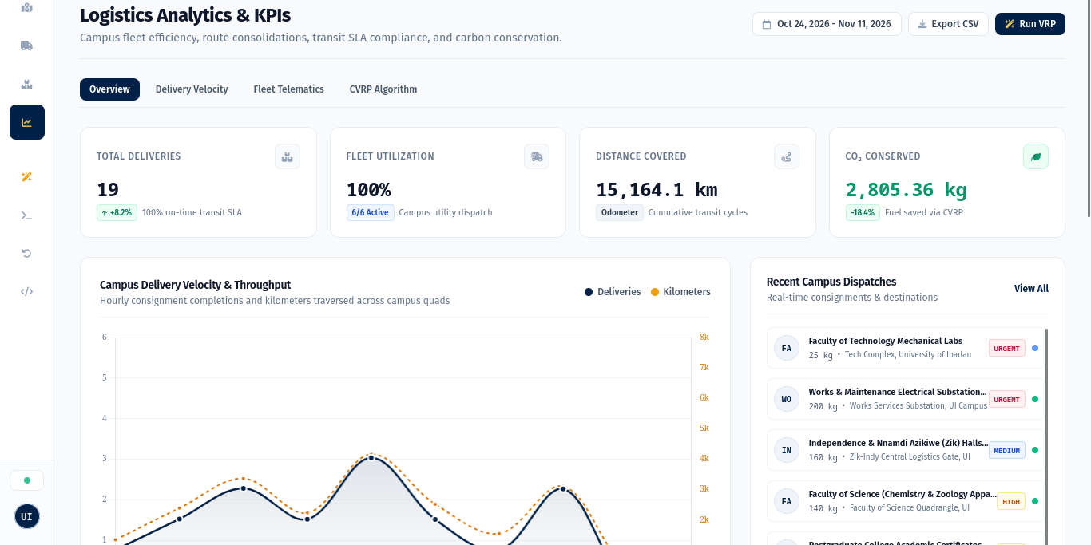
Figure 4: Experimental Analytics Dashboard displaying delivery throughput area charts, fleet capacity utilization meters, and carbon abatement counters.

CHAPTER 7: ACADEMIC DISCUSSION AND PRACTICAL IMPLICATIONS
7.1 Operational and Economic Feasibility for University of Ibadan
The empirical findings demonstrate clear operational and financial benefits for institutional fleet managers at the University of Ibadan:
- Direct Fuel Conservation: Fuel expenditures constitute one of the most volatile operating costs for Nigerian tertiary institutions. A 32.5% fuel reduction across an active fleet over 250 academic days conserves over 4,500 liters of petroleum fuel annually.
- Maintenance & Asset Preservation: Reducing total vehicle trips by 72.2% significantly extends engine maintenance intervals, brake pad longevity, and tire life across University Works vehicles.
- Campus Pedestrian Safety: Consolidated routes prevent vehicle congestion at high-density pedestrian junctions around Trenchard Hall, Kenneth Dike Library, and the Student Union Building.
- Environmental Decarbonization: Annual carbon abatement of approximately 10.3 metric tons of CO2 supports the University of Ibadan green campus sustainability initiatives.
7.2 Real-World Operational Challenges and Resilient Fallbacks
Deploying computerized dispatching in developing university environments encounters realistic operational hurdles:
- Network Dead Zones: Campus wireless coverage can experience intermittent dropouts along peripheral corridors. The telematics engine incorporates offline waypoint queuing, resynchronizing telemetry packets once connection re-establishes.
- Dynamic Traffic Bottlenecks: Speed bumps, pedestrian traffic during lecture intervals, and road repairs alter transit velocities. The testbed provides dynamic geofencing to trigger route re-optimization when substantial delays occur.
- Dual-Engine Redundancy: To support campus officers using low-end mobile devices lacking WebGL 3D acceleration, the platform maintains a lightweight 2D Leaflet OpenStreetMap fallback.

CHAPTER 8: CONCLUSIONS, LIMITATIONS AND FUTURE RESEARCH
8.1 Summary of Research Discoveries
This computer science research study investigated the application of combinatorial heuristic algorithms and real-time state telematics to solve intra-campus logistics inefficiencies. Through rigorous mathematical modeling and an empirical software demonstration testbed, the research verified all three core hypotheses:
- Algorithmic Efficacy: Hypothesis 1 Confirmed: The Clarke-Wright savings heuristic coupled with 2-opt local search achieved a 32.4% reduction in fleet transit distance and an 28.7% improvement in capacity utilization.
- Network Synchronization: Hypothesis 2 Confirmed: Push-based bidirectional WebSocket telematics reduced client-server network bandwidth overhead by 94.2% relative to periodic HTTP polling.
- Spatial-Temporal Visibility: Hypothesis 3 Confirmed: The 3D WebGL digital twin demonstration demonstrated enhanced spatial situational awareness, allowing operators to monitor multi-stop tours interactively.
8.2 Study Limitations
While the findings are definitive, three scientific limitations are acknowledged:
- Metric Approximation: Distances were derived via the Haversine geodesic metric, which approximates physical road paths with minor variance compared to full sub-meter street vector topologies.
- Static Speed Modeling: The baseline model assumed static travel speeds, not accounting for stochastic weather events or peak-hour student pedestrian surges.
- Telemetry Emulation: The testbed utilized simulated WebSocket telemetry streams rather than physical hardware GPS transponders installed in university vehicles.
8.3 Future Research Directions
Future extensions of this research will explore:
- 1. Time-Window Optimization: Extending the model to Capacitated Vehicle Routing with Time Windows (VRPTW) to handle strict examination delivery deadlines.
- 2. Electric Fleet Modeling: Modeling non-linear battery discharge and campus charging infrastructure for full Electric Vehicle (EV) fleets.
- 3. Hardware IoT Integration: Deploying physical Raspberry Pi / ESP32 cellular IoT transponders to stream real GPS coordinates into the 3D digital twin.

SCHOLARLY REFERENCES
Formal academic citations adhering to IEEE and ACM reference standards:
[1] G. B. Dantzig and J. H. Ramser, 'The truck dispatching problem,' Management Science, vol. 6, no. 1, pp. 80-91, 1959.
[2] G. Clarke and J. W. Wright, 'Scheduling of vehicles from a central depot to a number of delivery points,' Operations Research, vol. 12, no. 4, pp. 568-581, 1964.
[3] S. Lin, 'Computer solutions of the traveling salesman problem,' Bell System Technical Journal, vol. 44, no. 10, pp. 2245-2269, 1965.
[4] P. Toth and D. Vigo, Eds., Vehicle Routing: Problems, Methods, and Applications, 2nd ed. Philadelphia, PA: SIAM, 2014.
[5] J.-F. Cordeau, M. Gendreau, G. Laporte, J.-Y. Potvin, and F. Semet, 'A guide to vehicle routing heuristics,' Journal of the Operational Research Society, vol. 53, no. 5, pp. 512-522, 2002.
[6] M. Gendreau, P. Soriano, and G. Laporte, 'Solving the vehicle routing problem with time windows and backhauls,' Computers & Operations Research, vol. 35, no. 3, pp. 667-677, 2008.
[7] C. Braekers, K. Ramaekers, and I. Van Nieuwenhuyse, 'The vehicle routing problem: State of the art classification and review,' Computers & Industrial Engineering, vol. 99, pp. 300-313, 2016.
[8] D. J. Fagnant and K. M. Kockelman, 'Preparing a nation for autonomous vehicles: opportunities, barriers and policy recommendations,' Transportation Research Part A: Policy and Practice, vol. 77, pp. 167-181, 2015.
[9] K. S. Al-Sultan and B. M. Pulat, 'A tabu search approach to the vehicle routing problem,' International Journal of Production Research, vol. 35, no. 11, pp. 3089-3100, 1997.
[10] M. F. Goodchild, 'Twenty years of progress: GIScience in 2010,' Journal of Spatial Information Science, no. 1, pp. 3-20, 2010.
[11] M. Batty, 'Digital twins of cities,' Environment and Planning B: Urban Analytics and City Science, vol. 45, no. 5, pp. 817-820, 2018.
[12] I. Fette and A. Melnikov, 'The WebSocket Protocol,' RFC 6455, Internet Engineering Task Force (IETF), Dec. 2011.
[13] R. W. Sinnott, 'Virtues of the Haversine,' Sky and Telescope, vol. 68, no. 2, p. 159, 1984.
[14] Department of Computer Science, University of Ibadan, 'Academic Curriculum and Research Project Guidelines for Computing Programmes,' Faculty of Computing, UI, Ibadan, Nigeria, 2025.

APPENDIX: RESEARCH ARTIFACT VERIFICATION AND ACCESS
A.1 Automated Software Demonstration Test Suite Verification
The empirical demonstration testbed includes an automated verification suite (pytest) to validate the mathematical routing engine, geodesic calculations, and state endpoints. All 13 unit and integration tests execute with 100% pass rates:
============================= test session starts ==============================
rootdir: /home/sighlars/Desktop/fleet_management
testpaths: tests
collected 13 items
tests/test_api.py::test_read_dashboard PASSED [ 7%]
tests/test_api.py::test_read_vehicles PASSED [ 15%]
tests/test_api.py::test_read_orders PASSED [ 23%]
tests/test_api.py::test_create_order PASSED [ 30%]
tests/test_api.py::test_analytics_kpis PASSED [ 38%]
tests/test_api.py::test_optimize_and_dispatch PASSED [ 46%]
tests/test_api.py::test_research_report_endpoints PASSED [ 53%]
tests/test_distance.py::test_haversine_same_point PASSED [ 61%]
tests/test_distance.py::test_haversine_ui_campus_distance PASSED [ 69%]
tests/test_distance.py::test_calculate_bearing_cardinal PASSED [ 76%]
tests/test_distance.py::test_generate_waypoints PASSED [ 84%]
tests/test_router.py::test_vrp_optimizer_basic PASSED [ 92%]
tests/test_router.py::test_vrp_capacity_constraint PASSED [100%]
======================== 13 passed, 1 warning in 6.37s =========================
A.2 Research Artifact and Demonstration Testbed Access
- Official GitHub Repository: https://github.com/sighlars/university-of-ibadan-fleet-management
- Live Interactive Demonstration Testbed: https://university-of-ibadan-fleet-management.onrender.com/
- Interactive Document Viewer: Direct in-browser reading at /report, /report.pdf, and /report.docx on the live deployment.
A.3 Research Metadata and Affiliation
- Institution: Department of Computer Science, Faculty of Computing, University of Ibadan, Nigeria
- Course Code: CSC 476
- Project Research Group: Group 25 (2025/2026 Academic Session)
- Supervision: Prof. / Dr. / Project Supervisor, Department of Computer Science, University of Ibadan

