1. Plagiarism declaration

We declare that this is our own, original work and that we understand what plagiarism entails according to the policy of the University of Pretoria. We also declare that this is the only instance of this project that each of us are working on. (Other than our copies for personal use)

2. Project description and Phases attempted

We implemented up to and including Phase 2 of the modelling of the project. You will find traces of Phases 3 because we implemented Phase 3 of the COS 110 specification. The game we implemented can be concisely explained by how we explain it in-game:
cout << "Welcome to Fantasy Chess! The game is much like ordinary chess but the pieces\n may cast a spell (if they have spells) every new players turn. A turn comprises\n of the (A) spell phase and (B) movement phase. Players must be even to secure a\n fair game. The players are part of a team each with a maximum of 2 teams.\n You must select a piece on the board before you can do either a spell or a move.\n The games ends if your king, the X, dies. A piece can die if a another moves on\n top of it or if a spell does enough damage to deplete it's life force. When a\n piece moves on top of another piece, it engages in a short battle losing 2 life\n force - be careful, you can lose pieces in these engagements.\n\nPlease answer a few questions as we setup a new game for you...";

The game begins by asking how many players would like to play and consequently asks the players to enter their names. We have set this up by restricting the game to an even number of players then dividing them into two teams in which each player of alternate teams get a chance to move a piece and cast spells as they wish in their 'turn' (The turn of the team).

The game then procedes to ask the user what dimension of board he/she would like. This is mearly to demonstrate our effort to incorporate an extendible, multi-dimension board (2D or 3D). In addition, the board will setup according to the dimension (which can only be edited in the source at the moment) and setup the pieces in a accomodating manner to either a fixed or random strategy. For example, you may edit it the source to create a 12x12 board and the setup algorithms are supported to adjust the setup accordingly.
The last setup option asks the user to select either a fixed setup, which is similar to how chess pieces are placed, or a random setup which places the pieces randomly but ensuring a playable game. i.e. The random setup always fixes the kings in the center & on either side of the board, sets the phantoms in the corners (because of their incredible reach) and restricts 1 row of 'no mans land' where no pieces may be placed.

The game cycle will continue iterating through players, doing validation and spell/move actions specified until either one of three cases occur. The king of team 1 is killed, the king or team 2 is killed, or the king of either team is killed in the process of killing the opposing team's king (a stale mate).

We encorporated the following patterns into the project: State, Strategy, Interpreter, Factory method, Prototype, another Strategy, Template Method and the Decorator pattern. A thorough explanation of the reason we implemented these will follow but for now I will give a brief description of where they fit in the program.

State: Used to control the players turn and alternate between teams (this was very confusing in the beginning!).
Strategy: To setup the board according to a random of fixed placement of the pieces.
Interpreter: To parse the user input into data the program could process (this pattern is responsible for much of the 'preemptive' error checking and validation).
Factory method: To create a board of user-specified dimension (only support for a 2D board ahs been implemented!).
Prototype: To create prototypical instances of the respective piece types aiding the creation process.
Strategy: The strategy of movement is defined by concrete 'Reach' strategies for each piece.
Template method: The template method is defined by the 'Team turn cycle' which is comprised of primitive operations of select, spell and move. (This class surprisingly looks much like a strategy because all of the 'primitive operations' are redefined in subclasses).
Decorator: We harnessed recursive composition to 'decorate' pieces with their appropriate spells.
3. See UML master diagram for an overview of our system

4. Listing of header files and names of the classes implemented

We decided to group related classes that represented a pattern each into separate files. Here is a listing of the filenames as well as the names of the classes contained with each file.

# | Header file | Class(es) | Implementation file
1 | Coordinate.h | Coordinate | Coordinate.C
2 | ReachStrategy.h | ReachStrategy | ReachStrategy.C
3 |  | FootSoldierReach
4 |  | KnightReach
5 |  | KingReach
6 |  | DragonReach
7 |  | PhantomReach
8 |  | HealerReach
9 |  | NecromancerReach
10 | PStack.h | PStack | PStack.C
11 | FootSoldier.h | FootSoldier | FootSoldier.C
12 | Knight.h | Knight | Knight.C
13 | King.h | King | King.C
14 | Dragon.h | Dragon | Dragon.C
15 | Phantom.h | Phantom | Phantom.C
16 | Healer.h | Healer | Healer.C
17 | Necromancer.h | Necromancer | Necromancer.C
18 | Board.h | Board | Board.C
19 | SpellDecorator.h | SpellDecorator | SpellDecorator.C
20 |  | FireBreathing
21 |  | KingTeleport
22 |  | Teleport
23 |  | Heal
24 |  | Resurrect
25 | Piece.h | Piece | Piece.C
26 | Board.h | Board | Board.C
27 | TwoDBoard.h | TwoDBoard | TwoDBoard.C
# | Header file | Class(es) | Implementation file
28 | BoardCreator.h | BoardCreator | BoardCreator.C
29 |  | 2DBoardCreator
30 | SetupStrategy.h | SetupStrategy | SetupStrategy.C
31 |  | FixedSetupStrategy
32 |  | RandomSetupStrategy
33 | CMDInterpreter.h | CMDInterpreter | CMDInterpreter.C
34 |  | MenuOption
35 |  | Coordinates
36 | Players.h | PlayerTurn | Players.C
37 |  | Team1
38 |  | Team2
39 | PlayerSwitch.h | PlayerSwitch | PlayerSwitch.C
40 | Game.h | Game | Game.C
41 | GameLogic.h | GameLogic | GameLogic.C

5. Design Patterns used
The following section will comprise of the design pattern that we implemented in our system. It will begin with the name of the pattern, a UML class diagram with labeled participants and a set of documentation justifying each pattern. The justification is in the form commonly used called Coplien's template (Bennet et al, 2005:333) and follows the following format:

Sketch: a UML class diagram indicating the participants
Name, type and respective participants: the name of the pattern, the type, and the participants
Problem: the problem description in the project
Context: why the context is appropriate for the particular pattern
Forces: issues that were overcome with the pattern
Solution & Resulting context: the solution of the problem explained, how the solution works after the pattern was implemented
Rationale: the motivation for the pattern in this context and demotivation for others.
6. Phase 0
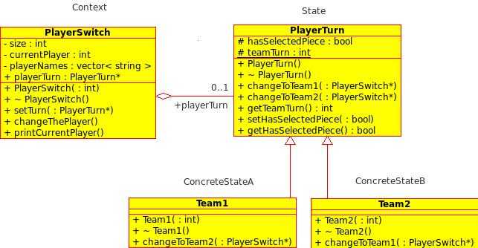
6.1 State pattern
6.1.1 Name, type & respective participants
State pattern, object behavioural.
(intermediate context)Context – PlayerSwitch
State – PlayerTurn
ConcreteStateA and B - Team1 and Team2

6.1.2 Problem
The problem arose in the project to alternate between players. We have more conditionals in the Game class that could be refactored out. At first glance we thought the specification was quite ambiguous in regard to it's description of the required 'Player' class which was to be implemented with state: Player - Is an abstract class providing the interface for player concrete classes. This will allow the game to be extensible for more than 2 players. We interpreted this as 'if you want to extend to more than 2 players, create another concrete player class. This seemed in direct contradiction to the purpose of design patterns in the first place.

6.1.3 Context
We came to a conclusion the instead of hard-coding a bool or int into the Game class to manage the turns of the players we would put the conditional that was previously in the Game class and encapsulate it in 2 classes called Team1 and Team2 which alternate between each other while simultaeneously* iterating through the players which we have restricted to an even number to ensure a fair game.

6.1.4 Forces
The issue of cluttering up the code in our Game class was cleared using state by encapsulating the conditionals into classes. The issue also arose to how we were to hold the player specific information like their name and a player number.

6.1.5 Solution and Resulting context
The Team classes would represent the 'state' of the abstract class PlayerTurn and the PlayerSwitch class holds the information of the multiple players like their name and player number thereby using the class PlayerSwitch to be an intermediate context and encapsulation of player-specific data. The UML demonstrates how we structured the code.

6.1.6 Rationale
The reason we chose to implement the State pattern as we did was because we thought of saving memory as a trade off to processing by deleting the player object each turn and saving the player specific data in a aggregate class PlayerSwitch. We thought of implementing the state as a singleton as suggested in the (GOF:303) but later in the program we concluded that it wasn't the risk of the memory leak because in the end only 1 class needed a reference to it and so it seemed an overkill of patterns (more like anti-patterns!).

6.2 Strategy pattern
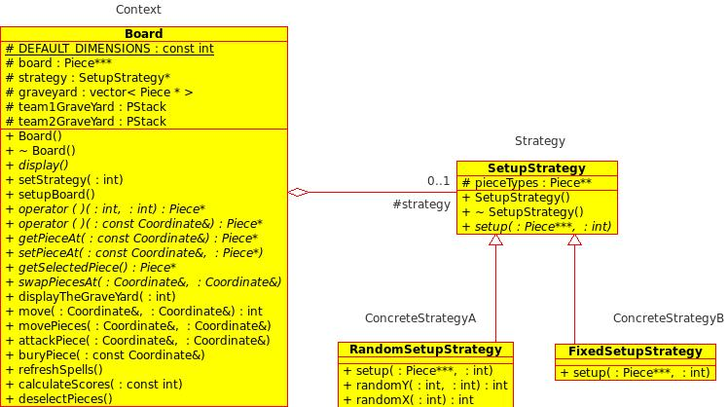
6.2.1 Name, type & respective participants
Strategy Pattern, object behavioural.
Context – Board
Strategy – SetupStrategy
ConcreteStrategyA and B – RandomSetupStrategy and FixedSetupStrategy

6.2.2 Problem
The problem arose when we had 2 different setup algorithms in the Game class making the class difficult to interpret and larger than need be.

6.2.3 Context
The context is appropriate because we have 2 independent setup algorithms that were cluttering up the Game class. It would be more appropriate if these algorithms were encapsulated so they could vary independent of each other (this would also save memory because you would only create an object of the particular strategy required).

6.2.4 Forces
We did not encounter any issues in implementing this pattern.

6.2.5 Solution
The solution was to create separate class to encapsulate the algorithms to setup the board (FixedSetupStrategy and RandomSetupStrategy) and use aggregation with the Game class and the interface(SetupStrategy). This implementation also reduces the number of conditionals in the Game class making it more readable, understandable and concise.

6.2.6 Rationale
We find this pattern simple enough not to have to rationalise the use. See the 6.2.5 for the resulting solution.

6.3 Interpreter pattern
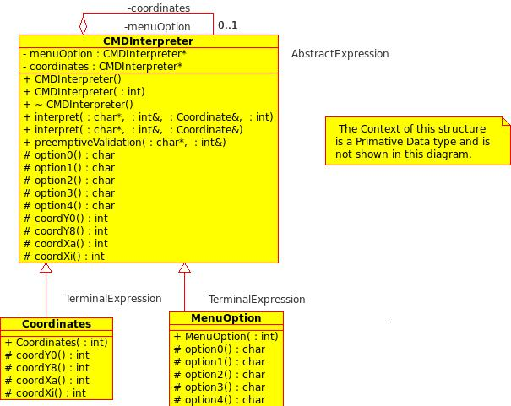
6.3.1 Name, type & respective participants
Interpreter, class behavioural.
AbstractExpression – CMDInterpreter
TerminalExpressions – MenuOption and Coordinates

6.3.2 Problem
Our system was in need of a relatively simple (for a first year student) way to capture the players input in a creative manner making it easier for the user as well as cleaning up our Game class by encapsulating the the interpreting of the input in a class hierarchy.

6.3.3 Context
The context of the problem is this: we needed to capture a menu option which comprised of the integers between 1 and 4 and/or a coordinate comprised of a single character followed by an integer i.e. 0 d4 would represent the command select the piece at the coordinate (d,4) on the board, much like you would with the popular board game battle ships.

6.3.4 Forces
The issues we encountered were with the recursive composition of the interpreter and determining which default constructors to use to avoid an infinite loop of create when creating the aggregate pointer (CMDInterpreter* menuOption and coordinates of the CMDInterpreter class). Another issues we encountered was the fact that the input that was to be interpreted would be interpreted into 2 unrelated variables – an int for the menu option and a coordinate for the Game to query the appropriate class(es) for validation, whereas previously we had only seen implementation of the interpreter that resulted in a single expression for instance the addition of roman numerals or the result of a mathematical expression. The last issue we encountered was that the subclasses of CMDInterpreter were terminal expressions and we also struggled to identify the 'context'.

6.3.5 Solution & Resulting context
We solved the issue of recurvise default constructing with a dummy int parameter that the aggregate attributes menuOption and coordinates would use to create their particular object type. As for the expression resulting in 2 independent values, we decided to pass 2 variables by reference and edit them according to the validity of the input. Identifying the context as 2 separate objects int and a Coordinate, an ADT of our system.

6.3.6 Rationale
The justification of this pattern is simple, we needed a sub-system to encapsulate the getting of the input from the user. This works well because it makes it easy to extend the 'grammer' or more simply, the game options and the coordinates (for a custom size board).
The Interpreter is basically an inplementation of the Composite pattern but only of behaviour. We are aware that there are more efficient means of extracting a result using a user-defined grammer but for our purposes that interpreter served it's purpose.
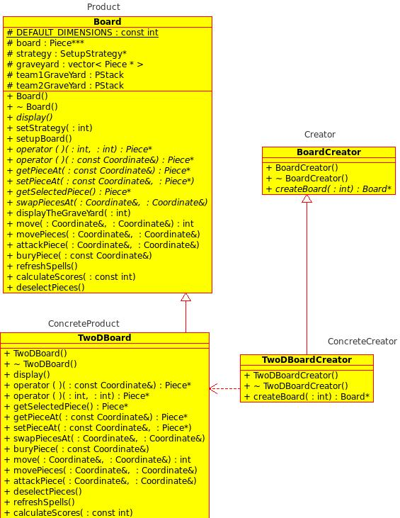
6.4 Factory Method

6.4.1 Name, type & respective participants
Factory method, class creational.
Creator – BoardCreator; ConcreteCreator – TwoDBoardCreator
Product – Board; ConcreteProduct - TwoDBoard

6.4.2 Problem
The problem with not implementing this pattern as we did will result in a difficult system to extend because you would have to add, yet again, more (seemingly unrelated) code into the Game class thus cluttering it up. We implemented the Factory method to imply extendibility of multiple board types (a possible 3D-Board with Qt).

6.4.3 Context
The factory method is appropriate in this context because if you wanted to extend the game to have multiple board types (even a triangular board is a possibility) you would have to yet again edit code in the Game file which would be quite large if we never encapsulated most of the funcitonality/responsibility into other classes.

6.4.4 Forces
The only issue we encountered with implementing this pattern model was to think carefully about what functions we could abstract into the parent class and which needed to be redefined in ConcreteProducts (TwoDBoard).

6.4.5 Solutions & Resulting context
The solution was to abstract an interface of TwoDBoard into a Board class and create corresponding abstract and concrete creators classes for the abovementioned classes. This solution extends our system to be easily extended by simply adding another ConcreteCreator and it's corresponding ConreteProduct that inherits from Board and possibly another class depending on it's functionality.

6.4.6 Rationale
Reasoning this pattern, like the interpreter, is quite simple. We need to model the system to be extendible, so we define “An interface for creating an object, but let the subclasses decide which class to instantiate.” (GOF:107)

6.5 Prototype
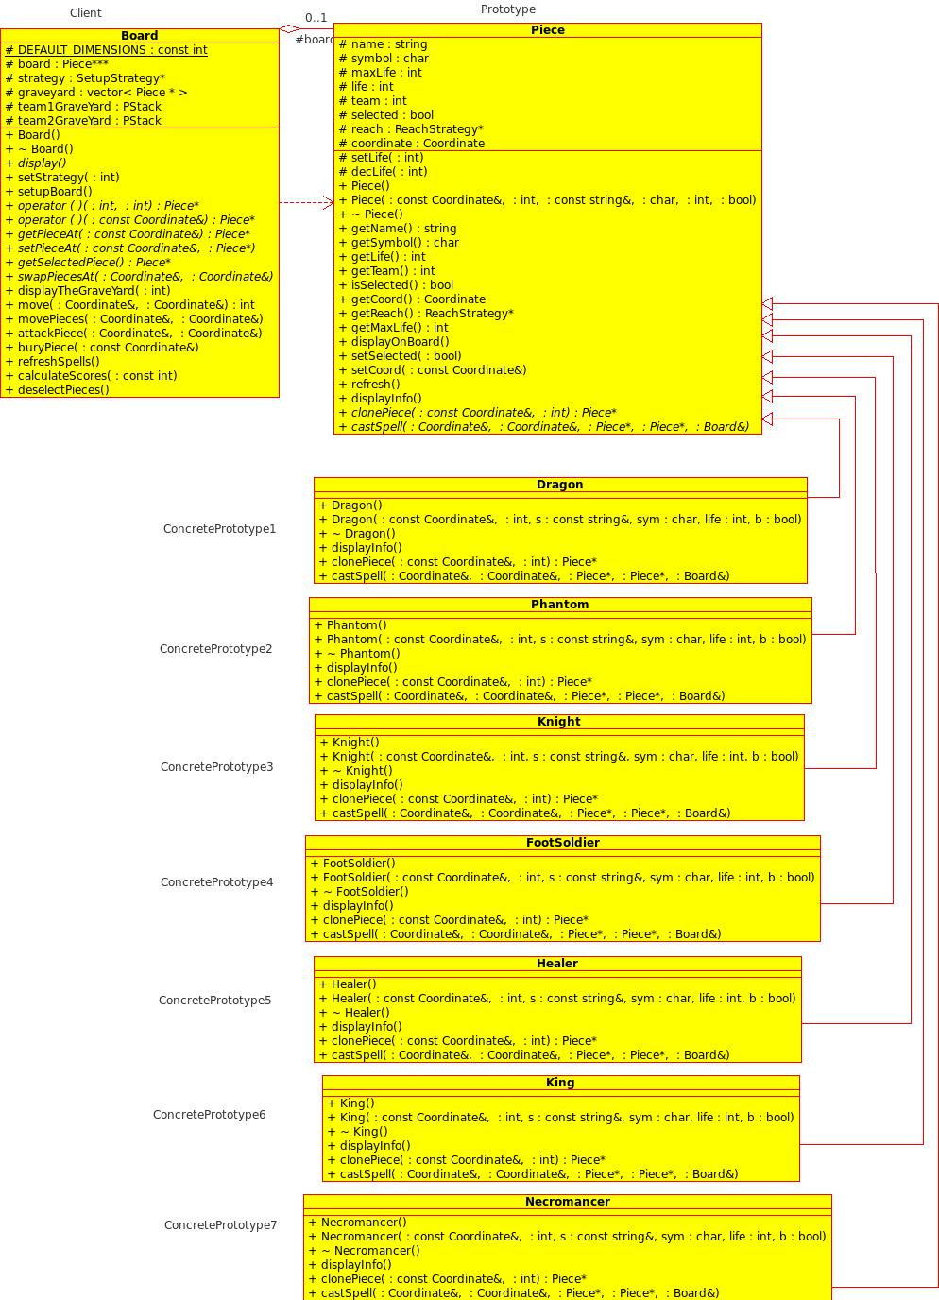
6.5.1 Name, type and respective participants
Prototype, object creational.
Prototype – Piece
Client – Board
ConcretePrototypes – Dragon, Phantom, Knight, FootSoldier, Healer, King, Necromancer

6.5.2 Problem
A problem arises as you implement more Piece subclasses to the system. The creation of the objects, particularly in the SetupStrategy subclasses becomes messy because you have new operators all over the show. Also, when instantiating objects at run-time (for example, according to a particular setup strategy) the pieces are contained in a conditional.

6.5.3 Context
The context is appropriate for the Prototype pattern because we need to instantiate particular objects at run-time. It is also appropriate because by using the rand() function mod your maximum squared dimensions of the board you may achieve a random piece type at run-time.

6.5.4 Forces
The only real problem in implementing this pattern in our system was the fact that it was not an exact clone of the prototype that we needed returned. An issue arose when implementing the Decorator in a later phase where the clone function had to be redefined in the Decorator class to delegate the action to the Piece* contained within decorator, creating more code.

6.5.5 Solution & Resulting context
The resulting solution was to make the Prototype clone function receive the Coordinate and team(an int) objects then return a new ConcretePrototype using the constructor with a parameter list of a Coordinate object and an int for the team. The Decorator worked out quite nicely once we had redefined the virtual functions in Piece(the Prototype) to delegate the function calls to it's aggregate Piece* member (the Piece that it 'wraps').

6.5.6 Rationale
Although Prototype has a similar effect to that of the Abstract Factory or the Builder, the reason for chosing the Prototype pattern over those patterns as creation models is so we could reduce the subclassing of ConcreteCreators for each particular subclass of Piece. The Prototype also hides the concrete products from the client (Game) so we reduce the number of names the client needs to know. Using a Prototype is also handy you are deciding which class to instantiate at run-time and this helps a great deal when the objects are of a varying structure (i.e. may have different constructor parameters or creating rules).

6.6 Strategy
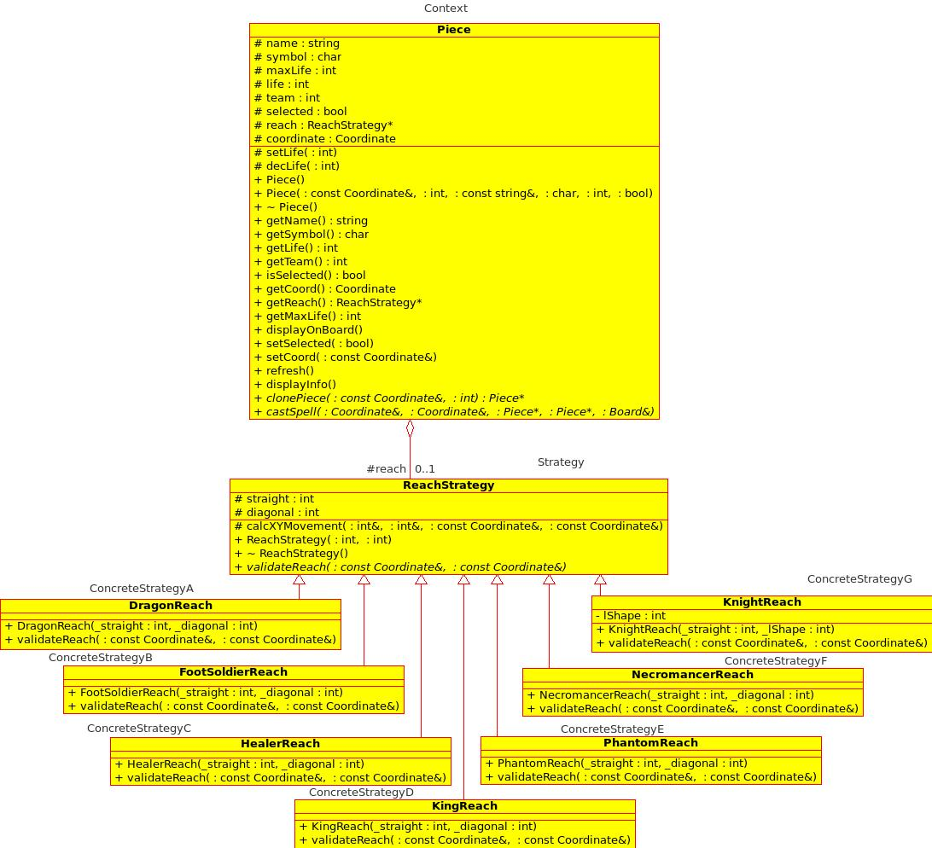
6.6.1 Name, type and respective participants
Strategy, object behavioural.
Context – Piece; Strategy – ReachStrategy
ConcreteStrategyA to G – DragonReach, FootSoldierReach, HealerReach, KingReach, PhantomReach, NecromancerReach, KnightReach.
6.6.2 Problem
We need to define a 'ReachStrategy' to encapsulate the movement logic for each subclass of Piece. The algorithm is completely open to the client to manipulate it as it pleases.

6.6.3 Context
The context is appropriate for this pattern for similar reasons as stated in 6.6.2 as well as the fact that the piece class would be cluttered with unrelated implementation for the reach logic of each type which is redefined in each subclass.

6.6.4 Forces
The issue of grouping data/functions that could be encapsulated outside of each Piece subclass.

6.6.5 Solution & resulting context
The solution was to encapsulate the move logic validation of each Piece's subclass and refactor them as ConcreteStrategies and then abstract the validation object as a protected aggregate of the Parent class Piece instead of having each subclass define and be responsible for the corresponding memory of their particular 'reach validation strategy'.

6.6.6 Rationale
The Piece class may now easily change it's subclasses reach validation strategy if you so wish. Althought the Strategy pattern leaves you with more classes, it separates the implementation (reach validation) from the Piece class and it's subclasses.

6.7 Template method
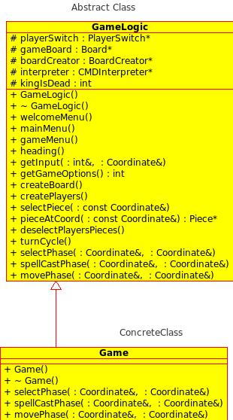
6.7.1 Name, type and respective participants
Template method, class behavioural.
AbstractClass – GameLogic
ConcreteClass – Game

6.7.2 Problem
There are commonlalities in the functions of selectPhase, spellCastPhase and movePhase. These functions could represent a teams turn in a game but have repeated code and a structure inbetween them that makes it difficult to read the code.

6.7.3 Context
The Template method is appropriate in this situation because, being a very fundamental pattern, it is commonly used to abstract data & functions. Template method can also 'vary' the team's turn 'algorithm' by executing the spell, move and select phases out of order thereby varying part of the algorithm of a team's turn.

6.7.4 Forces
Not many issues implementing the Template method, just a refactor of our current code model proved difficult to get our heads around.

6.7.5 Solution & resulting context
After the refactor of the template method in our GameLogic class, turnCycle, the code for the template method looked very satisfying and readable. It also abstracted much data and functions into the parent class (remember Game used to be our client for other classes, now GameLogic is it's interface).

6.7.6 Rationale
The template method is quite a common pattern and can be found in many places in our system such as the reach strategy. To abstract commonalities in the primitive operations of the ConcreteClass and redefine only what needs to be redefined (in this case, most of it except for the loop structure had to be redefined).
6.8 Decorator
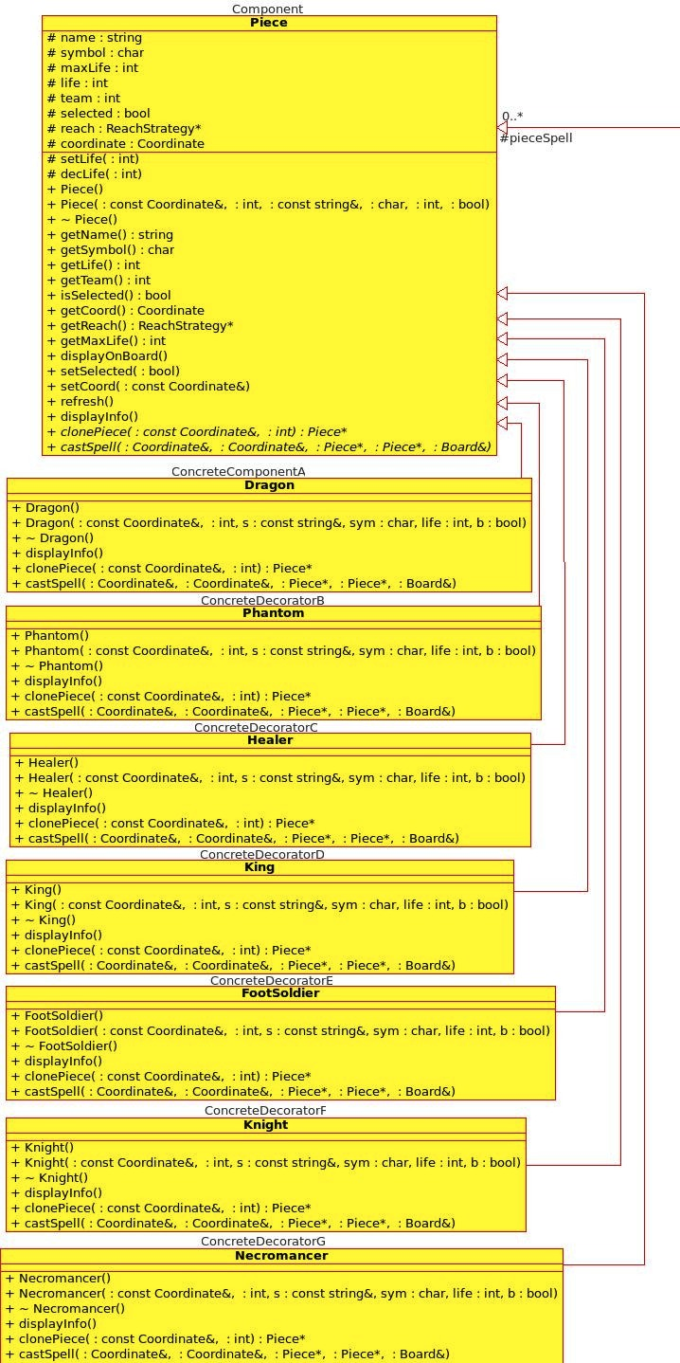
6.8.1 Name, type and respective participants
Decorator, object structural
Component – Piece
ConcreteComponents – Dragon, Phantom, Healer, King, FootSoldier, Knight, NecromancerDecorator – SpellDecorator
ConcreteDecorators – FireBreathing, KingTeleport, Teleport, Resurrect
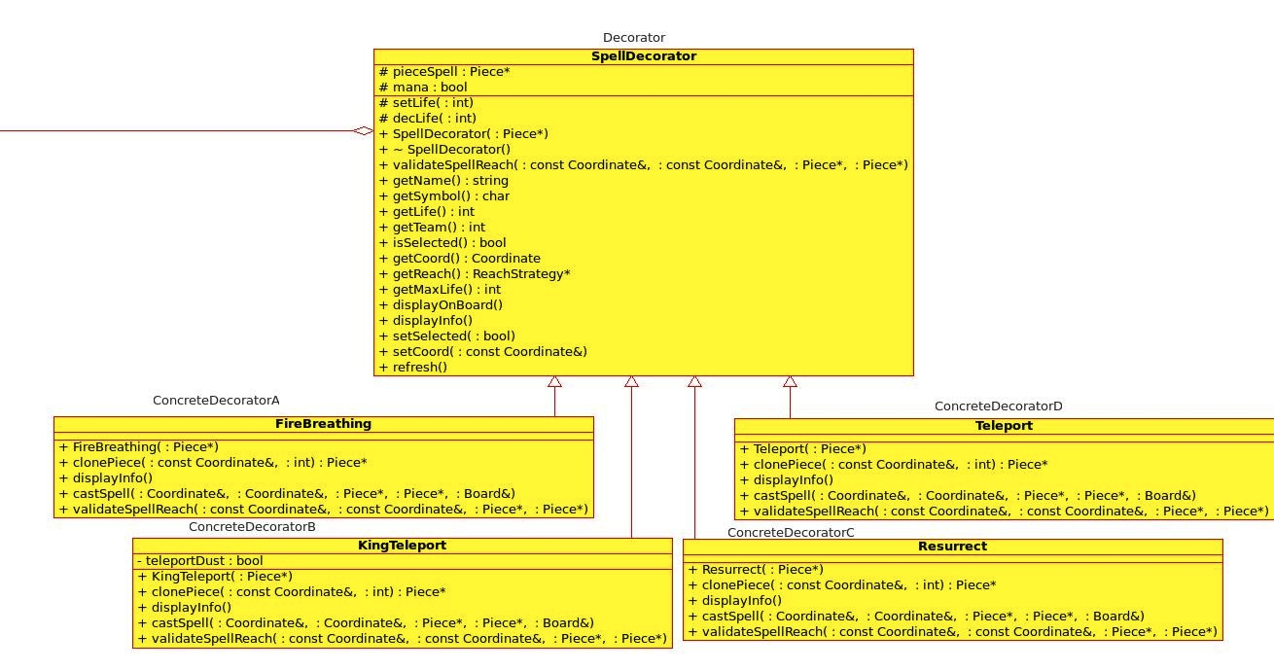
6.8.2 Problem
We need to add functionality for spell casting to Piece's subclasses. This is impractical because to create all the required combinations we would have to employ mass inheritence and have very complex conditionals. We need to dynamcially add functionality to pieces. The spells and the pieces that are to have the functionality added are not the same, this causes problems too.

6.8.3 Context
It is appropriate the use the decorator (wrapper) to wrap objects with new functionality and pass on function calls to the aggregate (pieceSpell in above diagram).

6.8.4 Forces
The issues we experienced in the implementation occurred when we forgot to the forward the requests to the SpellDecorator to the aggregate Piece* and so functionality was lost! We were, however, able to dynamically wrap pieces with additional functionality defined in the ConcreteDecorators.

6.8.5 Solution & resulting context
The solution was simple. Use the recursive composition to wrap the Piece subclass objects in SpellDecorator subclasses, forwarding the regular Piece function requests to the pieceSpell pointer thereby maintaining all the functionality of an ordinary piece.
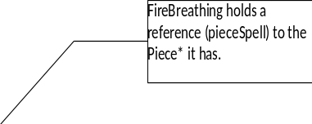
A small diagram could help illustrate this:
Firebreathing object

Dragon object

These two objects achieve the same interface through public inheritence of Piece.

6.8.6 Rationale
To recap, we useed decorator to dynamically allocate additional functionality to Piece objects. To create the system to be extendible by being able to delete the additional functonality if needed and allocate different functionality. You could also wrap a Piece object with multple SpellDecorators which will enable the object to cast multiple spells.

We decided not to implement the Adapter because we did not need to define an entire new interface for the SpellCaster, just mearly add additional functions, i.e. the spells.
7. Object diagrams
7.1 SetupStrategy::SetupStrategy()
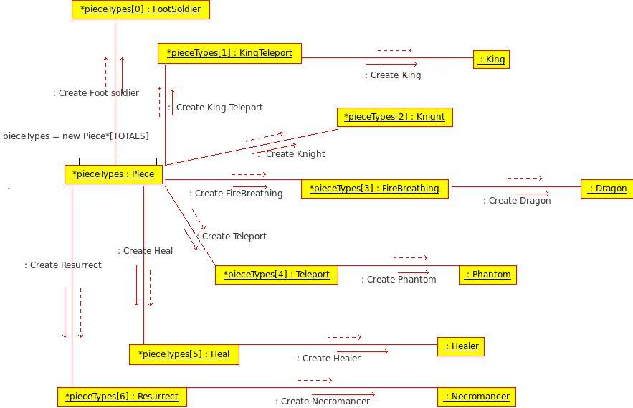

SetupStrategy::SetupStrategy(){
// Create piece prototypes
pieceTypes = new Piece*[TOTALS];
pieceTypes[FOOTSOLDIERS] = new FootSoldier();
pieceTypes[KINGS] = new KingTeleport( new King() );
pieceTypes[KNIGHTS] = new Knight();
pieceTypes[DRAGONS] = new FireBreathing( new Dragon() );
pieceTypes[PHANTOMS] = new Teleport( new Phantom() );
pieceTypes[HEALERS] = new Heal( new Healer() );
pieceTypes[NECROMANCERS] = new Resurrect( new Necromancer() );
}

This object/communication diagram is responsible for demonstrating how we created a 'prototypical instance' for each piece type to be used to clone in our setup methods
7.2 CMDInterpreter::interpret(...)
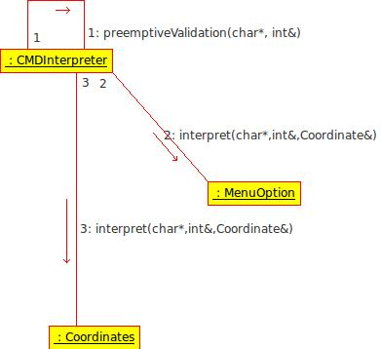
void CMDInterpreter::interpret(char* input, int& menu, Coordinate& coord){

// do preemptive validation - saves resources
preemptiveValidation(input, menu);

menuOption->interpret(input,menu,coord,1);
coordinates->interpret(input,menu,coord,1);

}

This diagram illustrates the 'shell' of the interpret function and shows the function calls of it's aggregate objects.
8. Sequence diagrams
8.1 TwoDBoard::buryPiece(const Coordinate&)
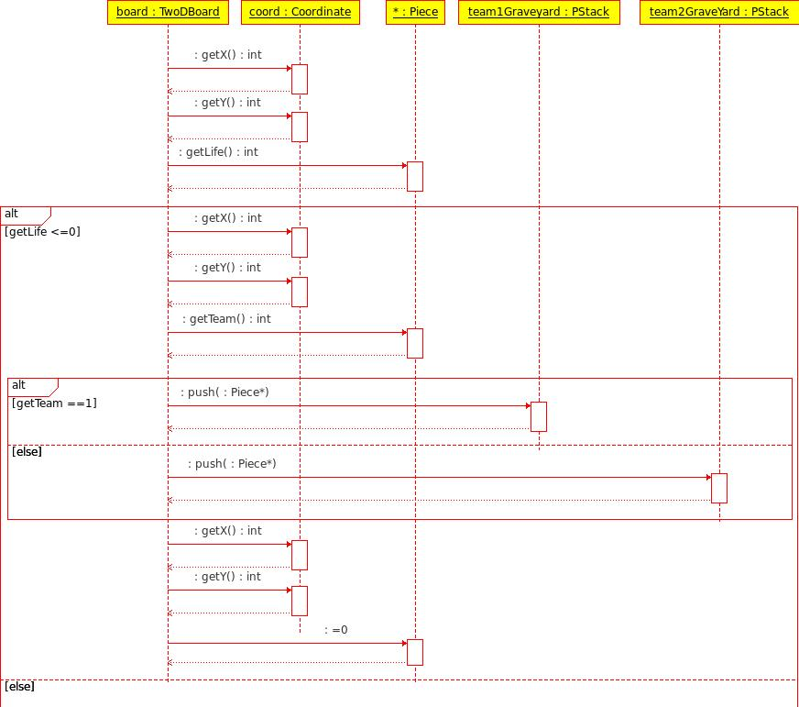
void TwoDBoard::buryPiece(const Coordinate& coord){
if (board[coord.getX()][coord.getY()]->getLife() <= 0) {

if (board[coord.getX()][coord.getY()]->getTeam() == 1) {
team1GraveYard.push(board[coord.getX()][coord.getY()]);
} else {
team2GraveYard.push(board[coord.getX()][coord.getY()]);
}
board[coord.getX()][coord.getY()] = 0;
}
}
This function demonstrates the process of sending a dead piece to it's particular teams graveYard stack (pieces only deleted at the end of the game).
8.2 Game::spellCastPhase(...)
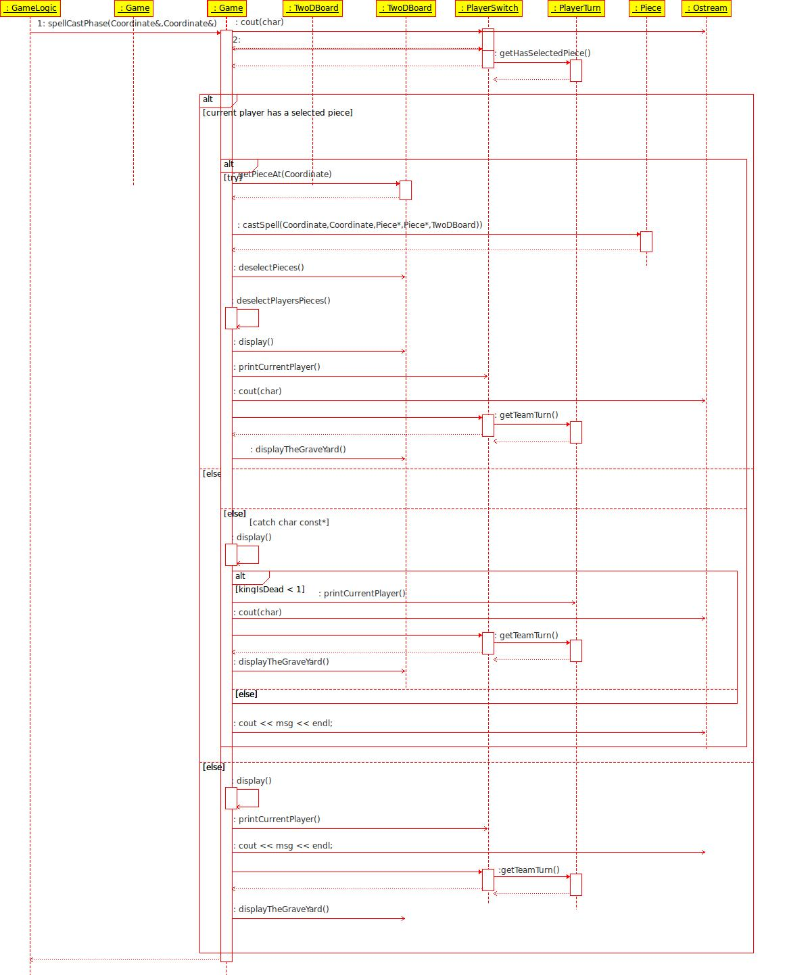
void Game::spellCastPhase(Coordinate& selectedCoord, Coordinate& requestedCoord){
if (playerSwitch->playerTurn->getHasSelectedPiece()) {
// Do validation in a try block
try {
gameBoard->getPieceAt(selectedCoord)->castSpell(selectedCoord, requestedCoord,
gameBoard->getPieceAt(selectedCoord),
gameBoard->getPieceAt(requestedCoord),
*gameBoard);
gameBoard->deselectPieces();
deselectPlayersPieces();
gameBoard->display();
playerSwitch->printCurrentPlayer();
cout << endl;
gameBoard->displayTheGraveYard(playerSwitch->playerTurn->getTeamTurn());
}
catch (char const* msg) {
gameBoard->display();
if (kingIsDead < 1) {
playerSwitch->printCurrentPlayer();
cout << endl;
gameBoard->displayTheGraveYard(playerSwitch->playerTurn->getTeamTurn());
}
cout << msg << endl;
}
} else {
gameBoard->display();
playerSwitch->printCurrentPlayer();
cout << "Error: You haven't selected a piece yet.";
cout << endl;
gameBoard->displayTheGraveYard(playerSwitch->playerTurn->getTeamTurn());
}
}

The above sequence diagram shows the logic of the spellCastPhase of a given players turn.
9. State-Machine diagrams
9.1 Game::movePhase(Coordinate&, Coordinate&)
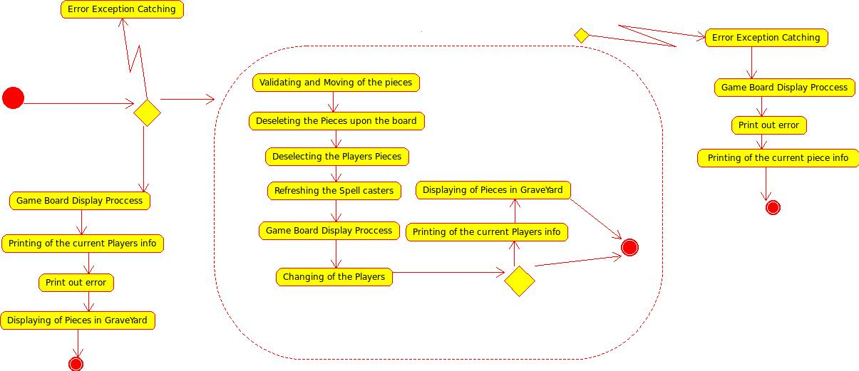
void Game::movePhase(Coordinate& selectedCoord, Coordinate& requestedCoord){
if (playerSwitch->playerTurn->getHasSelectedPiece()) {
// Do validation in a try block
try {
kingIsDead = gameBoard->move(selectedCoord, requestedCoord);
gameBoard->deselectPieces();
deselectPlayersPieces();
gameBoard->refreshSpells();
gameBoard->display();
playerSwitch->changeThePlayer(); //if the move was successful, change players
if (kingIsDead < 1) {
playerSwitch->printCurrentPlayer();
cout << endl;
gameBoard->displayTheGraveYard(playerSwitch->playerTurn->getTeamTurn());
}
}
catch (ReachStrategy::MoveException e) {
gameBoard->display();
cout << endl;
e.print();
if(gameBoard->getSelectedPiece()){
cout << "\nSelected Piece: ";
gameBoard->getSelectedPiece()->displayInfo();
}
}
} else {
gameBoard->display();
playerSwitch->printCurrentPlayer();
cout << "Error: You haven't selected a piece yet.";
cout << endl;
gameBoard->displayTheGraveYard(playerSwitch->playerTurn->getTeamTurn());
}
}

This state-machine depicts the move phase (last phase of a players 'turn'). It jumps from state to state before ending then checks whether a king is dead else asks the user to give another command. The states could be written as a function call because many of the functions that execute actually represent a state of the move phase.
9.2 GameLogic::turnCycle()
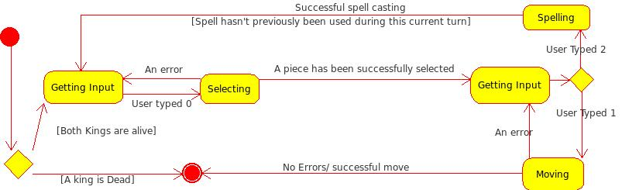
void GameLogic::turnCycle(){
// Enter loop of turns:
int choice;
Coordinate requestedCoord, selectedCoord;
do { // Loop menu until forfeit, exit or the game in over (a king 'dies')
// This checks the kings status each turn & exits if appropriate
if (kingIsDead > 0) {
choice = 4;
} else {
getInput(choice,requestedCoord);
}
// Enter into menu
switch (choice) {
case 0: //Select
selectPhase(selectedCoord, requestedCoord);
break;
case 1: //Move
movePhase(selectedCoord, requestedCoord);
break;
case 2: //Spell
spellCastPhase(selectedCoord, requestedCoord);
break;
case 3: //Forfeit
if (playerSwitch->playerTurn->getTeamTurn() == 1) {
kingIsDead = 4;
} else {
kingIsDead = 5;
}
break;
default: break;
}
} while (choice != 4);
}

This state-machine diagram depicts a higher abstraction level of the process of the entire cycle of a turn for a team.
9. Activity diagrams
9.1 PlayerSwitch::changeThePlayer()
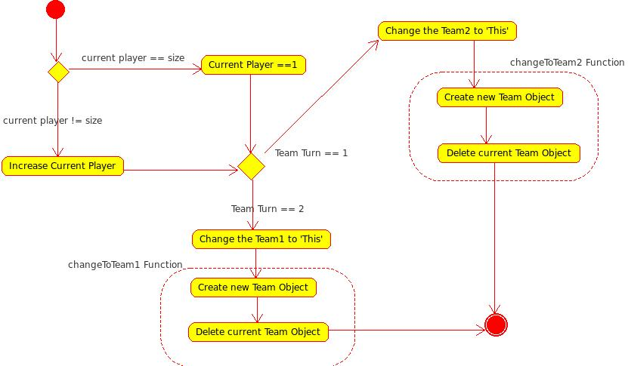

void PlayerSwitch::changeThePlayer(){
if (currentPlayer == size){ // this changes the player number (used for printing)
currentPlayer = 1;
} else {
currentPlayer++;
}
if(playerTurn->getTeamTurn() == 1){
playerTurn->changeToTeam2(this);
} else if(playerTurn->getTeamTurn() == 2){
playerTurn->changeToTeam1(this);
}
}

This activity diagram depicts the process of changing a players turn (this changes the team and 'activates' the next player's data that is stored to be used in the Game class).
9.2 FireBreathing::castSpell(Coordinate, Coordinate, Piece*, Piece*, Board&)
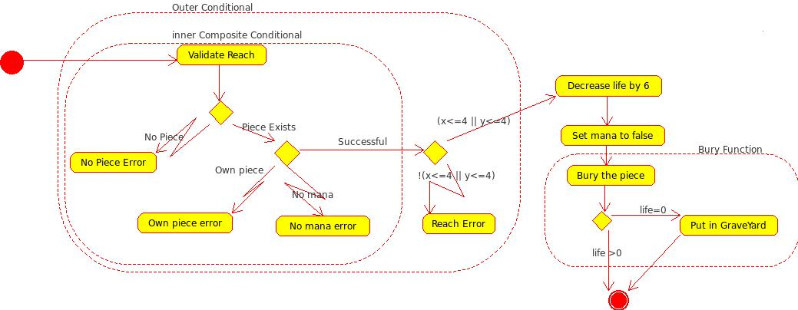
void FireBreathing::castSpell(Coordinate& currCoord, Coordinate& destCoord, Piece* selectedPiece,
Piece* destPiece, Board& board) {
// Check spell Reach
validateSpellReach(currCoord, destCoord, selectedPiece, destPiece);

// Do the damage & set mana to false
destPiece->decLife(6);
mana = false;
//check if s/he/it is dead & 'bury' the piece
board.buryPiece(destCoord);
}

This activity diagram illustrates the operations that are involved in casting the firebreath spell associated with the Dragon piece. Please note that the code inserted is only an indication of where it starts – this function enters 2 other functions that validate the 'integrity' of the request, the 'reach' of the spell and then only proceeds to perform the spell operations.
9.3 Heal::castSpell(...)
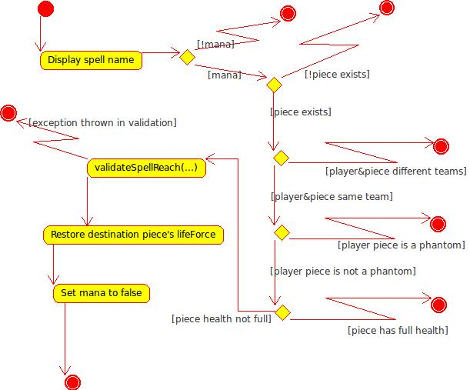
void Heal::castSpell(Coordinate& currCoord, Coordinate& destCoord, Piece* selectedPiece,
Piece* destPiece, Board& board) {
cout << "Heal spell" << endl;
// Is the destination square not NULL
if (!mana) {
throw "Error: No mana left to cast a spell, select another option.";
}
if (destPiece) {
// Is the destination square friendly (same team)
if(destPiece->getTeam() != selectedPiece->getTeam()){
throw "Error: Cannot cast heal on an enemy piece.";
}
if(destPiece->getSymbol() == 'P'){
throw "Error: Cannot cast heal on a Phantom.";
}
if (destPiece->getLife() == destPiece->getMaxLife()) {
throw "That piece already has full health, heal something else.";
}
validateSpellReach(currCoord, destCoord , selectedPiece, destPiece);
destPiece->setLife(destPiece->getMaxLife());
mana = false;
} else {
throw "Error: There is no piece at that coordinate.";
}
}

This diagram depicts the process to Heal a pieces lifeForce – the spell of the healer. I indicated the throws with an exception arrow that 'exists' the function looking for the catch.
10. References

11 Oct 2010
http://www.dreamincode.net/forums/topic/33408-convert-char-to-int-and-int-to-char/
18-02-2007

22 October 2010
http://www.gamedev.net/community/forums/topic.asp?topic_id=555104
12-7-2009

http://www.parashift.com/c++-faq-lite/operator-overloading.html
Marshall Cline
26 August 2010

23/10/20
http://www.gamedev.net/reference/articles/article1798.asp
Ben "Kylotan" Sizer
6 May 2002

Freeman,E., Freeman,E., Bates, B., Sierra, K. 2004. Head First Design Patterns. O'Reilly Media

Bennet, S., Skelton, J., Lunn, K. 2005, 'Schaum's Outlines of UML, second Edition', McGrawHill

Gamma, E., Helm, R., Johnson, R., Vlissides, J. 1995, Design Patterns, Elements of Reuseable Object-Oriented Software, Addison-Wesley Professional Computing Series

http://sourcemaking.com/design_patterns/

