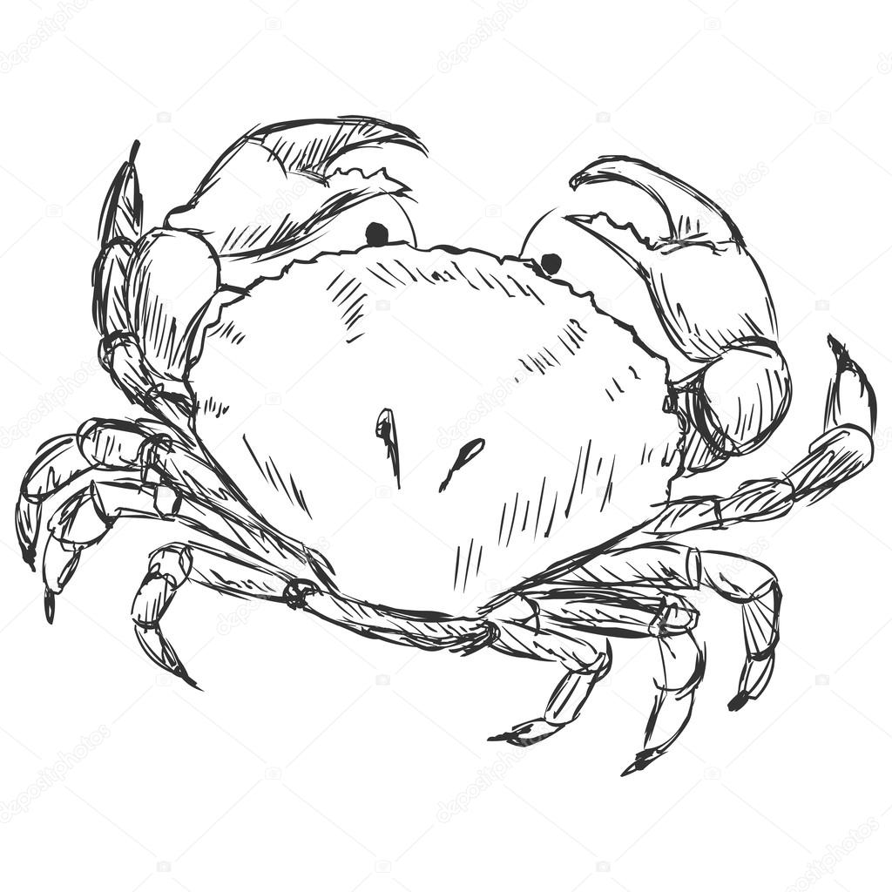
Sherbet
a virgin-controlled
current year computer
powered by graphicdesign

We have forked Urbit from the base distribution
as Sherbet. We are re-architecting Sherbet
on top of the coldest Nock kernel possible:
the ball of mud itself.

Legacy Web 2.0 services are mature, stable, and free-as-in-North-Korea. You know you can build for the ages on them because they haven't added relevant new features in those same ages.

Some of the exciting changes we've planned for Sherbet include:

- Offering actual stars with the purchase of any Azimuth star. Remember those sketchy mail services that offered to name a star for your ex and maybe she’d come back? NASA needs to discover more exoplanets before we can offer those, so just stars for now.
- Specifying Hoon on top of Excel. Excel offers a functional programming language that many developers already know, allowing a free mix of runes on top of Excel functions.
- Replacing Clay with GMail. Why tag, label, and obsess over data storage when you can just search for it? GMail can serve as a file system replacement for all time, and it avoids awkward questions about immutability, whatever that is. And it can store more than 2 GB at a time.
- Updating Jael with physical keys. No one can memorize all those syllables, so we're rolling out a hardware dongle (a padlock) that secures your Sherbet. Bonus: the key doubles as a weapon in case of a wrench attack!
- Supporting Ames-over-SMS. SMS can send up to 1,120 bits in a package.
- Resurrecting Ford as Ford Model T. We all miss that friendly %f vane. You can build any AST you want, as long as it's black.
- Turning Gall into an actual decapod. Surprise!

We’re selling galaxies now to secure the future of Sherbet. To take a seat in our Galactic Parliament, send all of your Bitcoin to 1CounterpartyXXXXXXXXXXXXXXXUWLpVr.

