Perbandingan Metode Spam Classifier Untuk SMS

Muhammad Insan Al-Amin (23517009), Sigit Kariagil Bimonugroho (23517032)

Institut Teknologi Bandung, Indonesia

These instructions give you guidelines for preparing papers for IEEE Transactions on Magnetics. Use this document as a template if you are using Microsoft *Word*. Otherwise, use this document just for helpful information, and prepare your paper using any word processor or LaTeX (the general IEEE LaTeX template is available at [www.ieee.org/publications_standards/ publications/authors/author_templates.html](http://www.ieee.org/publications_standards/publications/%20authors/author_templates.html)). This *Word* template is useful for estimating the length of an article but it is optional. The electronic file of your paper will be formatted further at IEEE. Paper titles should be written in uppercase and lowercase letters. Avoid writing long formulas with subscripts in the title; short formulas that identify the elements are fine (e.g., “Nd-Fe-B”). Do not begin a title with the word “On.” Avoid starting a title with articles like “The.” Full names of authors are much preferred but initials may be used instead. Chinese, Japanese, and Korean authors are encouraged to include their names in native characters in parentheses after their Romanized names. More information may be found at [www.ieee.org/publications_standards/publications/authors/auth_names_ native_lang.pdf](http://www.ieee.org/publications_standards/publications/authors/auth_names_native_lang.pdf). Department names are optional in the affiliations. Do not give street addresses in the affiliations (except for authors with no institutional affiliation). Define all symbols used in the abstract, and again in the text. Do not cite references in the abstract.

*Index Terms*—About four key words or phrases in alphabetical order, separated by commas.

# Analisis Dataset

T

his document is a Microsoft *Word* template for IEEE Transactions on Magnetics. Use of this document as a template is optional. If you are reading a paper version of this document, please download the electronic file, transmag2015.doc, from [www.ieee.org/publications_ standards/publications/authors/author_templates.html](http://www.ieee.org/publications_standards/publications/authors/author_templates.html) so you can use it to prepare your manuscript. If you would prefer to use LaTeX, download IEEE’s LaTeX style and sample files from the same Web page. Use those LaTeX files for formatting, but please follow the instructions in transmag2015.doc (or transmag2015.pdf).

Authors may prepare their papers for review using any word processor, one or two columns, single or double spaced. Please follow the writing style specified in this document.

When you open transmag2015.doc, select “Print Layout” from the “View” menu in the menu bar (View > Print Layout). Then type over sections of transmag2015.doc or cut and paste from another document and then use markup styles (Home > Styles). For example, the style at this point in the document is “Text”). Highlight a section that you want to designate with a certain style; then select the appropriate name on the style menu. The style will adjust your fonts and line spacing. Use italics for emphasis; do not underline.

To insert images in *Word*, position the cursor at the insertion point and either use Insert > Picture or copy the image to the Windows clipboard and then Home > Paste. IEEE will do the final formatting of your paper, so do not worry about precisely positioning figures and tables. In fact, they are best placed at the end of the paper, with the proper insertion points indicated in the text.

If you have a question about formatting your paper, or a suggestion on improving these instructions, please contact [r.goldfarb@ieee.org](mailto:r.goldfarb@ieee.org).

# Pemrosesan Dataset

## ScholarOne® Manuscripts

Authors of regular and conference-related papers should prepare their papers for review using Microsoft *Word* and this template or LaTeX and the files contained in IEEEtran.zip. If your paper is submitted in conjunction with a conference, please observe any page limits specified by the conference. **Do not change the font sizes or line spacing to squeeze more text into a limited number of pages. Leave some white space around your figures.** Conference-related papers follow the same review procedures as regular papers.

Regular and conference-related papers must be submitted electronically to IEEE’s on-line manuscript submission and peer-review system, *ScholarOne® Manuscripts.* Regular papers should be submitted at [mc.manuscriptcentral.com/ transmag-ieee](http://mc.manuscriptcentral.com/transmag-ieee); for conference-related papers, go to [mc.manuscriptcentral.com/magconf-ieee](http://mc.manuscriptcentral.com/magconf-ieee). You should first check if you have an existing account. If there is none, please create a new account. (Your log-in information is the same on both sites.) After logging in, go to your Author Center and click on the link, “Click here to submit a new manuscript.”

Along with other information, you will be asked to select the type of submission from a pull-down list. If you are submitting a conference-related paper, choose the type appropriate for your conference. You will also be asked to select the subject of your article. Additionally, conference authors are asked for the conference paper number. Using the format specific to your conference, enter this number in the text box and also in the header at the top of this document.

There are 7 stages (screens) to the submission process; you must complete all 7 for a complete submission. At the end of each stage you must click “Save and Continue”; simply uploading files is not sufficient. After step 7 you should see a confirmation that the submission is complete. You should also receive an e-mail confirmation. For inquiries regarding the submission of your paper on *ScholarOne® Manuscripts,* please contact [oprs-support@ieee.org](mailto:oprs-support@ieee.org) or call +1 732 465 5861.

*ScholarOne® Manuscripts* will accept files for review in the following formats: DOC, DOCX, RTF, PS, or PDF. PDF is preferred at the review stage. If you used LaTeX to prepare your document, you must generate a PDF or PS file to upload to *ScholarOne® Manuscripts*. Whatever format you upload, your figures should be embedded in the file, usually at the end.

You will be asked to file an electronic copyright form during the submission process. (Authors are responsible for obtaining any security clearances.) .

# Skenario Pengujian

Most authors will be able to prepare images in one of the allowed formats listed above. This section provides optional, additional information on preparing PS, EPS, and TIFF files. No matter how you convert your images, it is a good idea to print the files to make sure nothing was lost in the process.

For more information on graphics files, please go to [www.ieee.org/publications_standards/publications/authors/ authors_journals.html](http://www.ieee.org/publications_standards/publications/authors/authors_journals.html) and click on the link “Using Microsoft Products or PDFs to Submit Graphics.”

## IEEE Graphics Checker

*Graphics Checker* is part of the IEEE’s “Author Digital Toolbox,” a collection of tools for authors at [www.ieee.org/publications_standards/publications/authors/ authors_journals.html](http://www.ieee.org/publications_standards/publications/authors/authors_journals.html). The direct link for *Graphics Checker* is [graphicsqc.ieee.org](http://graphicsqc.ieee.org/). You can upload image files in batches of up to 10 to be analyzed and compared to IEEE’s requirements for metadata, file size, file type, file naming, resolution parameters, and color format. You will receive a detailed report on the usability of each image analyzed. The report will include an explanation of any error found, along with, when possible, application-specific tips on how to fix the image. (You may ignore warnings that the author’s name is not part of the file name.) For more Information, contact the IEEE Graphics Help Desk at [graphics@ieee.org](mailto:graphics@ieee.org). You will receive an e-mail response and sometimes a request for a sample graphic for IEEE to check.

## Scanning Images to PS and EPS

If you have a scanner, a quick way to prepare figure files is to print your figures on paper exactly as you want them to appear, scan them, and then save them to a file in PostScript (PS) or Encapsulated PostScript (EPS) formats. Use a separate file for each image. File names should be of the form FIG1.PS or FIG2.EPS.

## Scanning Images to TIFF

Using a scanner as above, you may save the images in TIFF format. The following specifications are the minimum requirements for TIFF images; you may use higher resolution. As a rule, if your image file size is below 500 kB, your TIFF image probably does not have enough resolution.

High-contrast line figures and tables should be prepared with at least 600 dpi resolution and saved with no compression, 1 bit per pixel (monochrome), with file names of the form FIG3.TIF. To obtain a 3.45 inch figure (one column width) at 600 dpi, the figure requires a horizontal size of 2070 pixels.

Photographs and grayscale figures should be prepared with at least 220 dpi resolution and saved with no compression, 8 bits per pixel (grayscale). To obtain a 3.45 inch figure (one column width) at 220 dpi, the figure should have a horizontal size of 759 pixels.

Color figures should be prepared with at least 400 dpi resolution and saved with no compression, 8 bits per pixel (palette or 256 color). To obtain a 3.45 inch figure (one column width) at 400 dpi, the figure should have a horizontal size of 1380 pixels.

## Printing images to PS Files

You may create PostScript figures by “printing” them to files. First, download a PostScript printer driver from [www.adobe.com/support/downloads/product.jsp?product= pdrv&platform=win](http://www.adobe.com/support/downloads/product.jsp?product=%20pdrv&platform=win) (Windows) or [www.adobe.com/support/ downloads/product.jsp?product=44&platform=Macintosh](http://www.adobe.com/support/%20downloads/product.jsp?product=44&platform=Macintosh) (Macintosh) and also install the “PPD Files: Adobe” printer definition. In *Word*, paste your figure into a new document. Print to a file using the PostScript printer driver. File names should be of the form FIG5.PS. Use “Open Type” fonts when creating your figures, if possible: Times Roman, Helvetica, Helvetica Narrow, Courier, Symbol, Palatino, Avant Garde, Bookman, Zapf Chancery, Zapf Dingbats, and New Century Schoolbook.

## Converting PDF to TIFF

Experienced computer users can convert figures and tables from their original format to TIFF. Some useful image converters are Adobe *Photoshop*, Corel *Draw*, Microsoft *Photo Editor* (part of Office 97 through Office XP), *Picture Manager* (Office 2003, 2007, 2010), and *Photo Gallery* (Office 2013). A free, versatile program for image manipulation and format conversion is GIMP, available from [www.gimp.org](http://www.gimp.org).

From Microsoft Office applications, such as *PowerPoint*, you may print or save as PDF. You may then convert a figure in the PDF file to TIFF with Adobe *Acrobat* or *Reader*: View > Zoom to a large magnification (e.g., 1600%). Use the Snapshot Tool to select the figure and copy it to the Windows clipboard. Open Microsoft *Photo Editor,* Edit > Paste as New Image, crop, and adjust resolution as above. (If using *Picture Manager,* use Picture > Crop, Picture > Resize, File > Export.)

Note that the obvious way to convert *PowerPoint* PPT to TIFF (File > Save As > Save as type TIFF) gives poor results.

Alternatively, you may open the PDF in *Photoshop* or GIMP. Set the resolution to open at 1200 dpi. In GIMP, use “Export As” and save in TIFF format with no compression.

## Saving Files in TIFF

Most graphing programs allow you to save graphs in TIFF; however, you often have no control over compression or number of bits per pixel. You should open these image files in a program such as Microsoft *Photo Editor* and re-save them using no compression, either 1 or 8 bits, and either 600 or 220 dpi resolution (File > Properties; Image > Resize). See Section III.C for an explanation of number of bits and resolution.

## Using Print Screen

If your graphing program cannot export to TIFF, you can use the Print Screen function. Set your monitor to its highest resolution. Adjust the magnification so that you can view the entire image on the screen. (In *PowerPoint,* you may use Slide Show to get a full-screen image.) Move the cursor so it is out of the way. Press “Print Screen” on your keyboard; this copies the screen image to the Windows clipboard. Open Microsoft *Photo Editor* and click Edit > Paste as New Image. Crop the image (click Select button; select the part you want, then Image > Crop). Adjust the properties of the image (File > Properties) to get a width of 3.45 inches. Save the file (File > Save As) in TIFF with no compression (click “More” button). Similar functionality is available in GIMP and *Photoshop*.

# Hasil Eksperimen dan Analisis

Submission of a manuscript is not required for participation in a conference. Do not submit a reworked version of a paper you have submitted or published elsewhere, including conference papers. Do not submit “preliminary” data or results. The submitting author is responsible for obtaining agreement of all coauthors and any consent required from sponsors before submitting a paper. IEEE Transactions on Magnetics strongly discourages courtesy authorship. It is the obligation of the authors to cite relevant prior work. If you copy sentences, paragraphs, figures, or tables from another paper, even if it is your own paper, you must cite that paper at the corresponding point in your manuscript. IEEE’s plagiarism (and excessive duplication) guidelines are described in detail at [www.ieee.org/publications_standards/publications/rights](http://www.ieee.org/publications_standards/publications/rights).

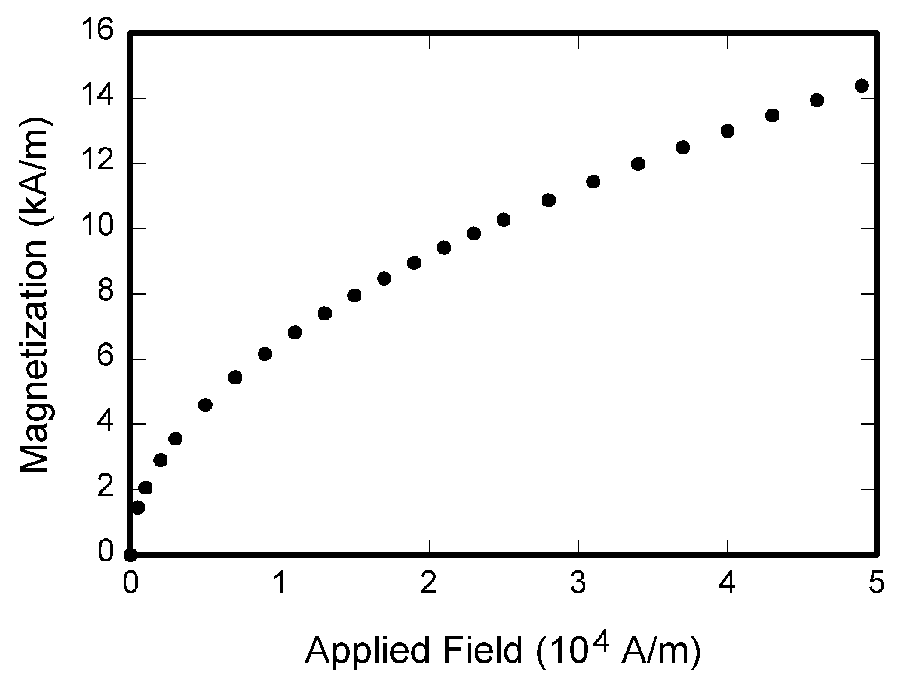

Fig. 1. Magnetization as a function of applied field. Note that “Fig.” is abbreviated. There is a period after the figure number, followed by two spaces. It is good practice to explain the significance of the figure in the caption.

TABLE I

Units for Magnetic Properties (Short Title Here)

|  |  |  |
| --- | --- | --- |
| Symbol | Quantity | Conversion from Gaussian and  CGS EMU to SI a |
| Φ | magnetic flux | 1 Mx → 10−8 Wb = 10−8 V·s |
| *B* | magnetic flux density,  magnetic induction | 1 G → 10−4 T = 10−4 Wb/m2 |
| *H* | magnetic field strength | 1 Oe → 103/(4π) A/m |
| *m* | magnetic moment | 1 erg/G = 1 emu  → 10−3 A·m2 = 10−3 J/T |
| *M* | magnetization | 1 erg/(G·cm3) = 1 emu/cm3  → 103 A/m |
| 4π*M* | magnetization | 1 G → 103/(4π) A/m |
| σ | specific magnetization | 1 erg/(G·g) = 1 emu/g → 1 A·m2/kg |
| *j* | magnetic dipole  moment | 1 erg/G = 1 emu  → 4π × 10−10 Wb·m |
| *J* | magnetic polarization | 1 erg/(G·cm3) = 1 emu/cm3  → 4π × 10−4 T |
| χ*,* κ | susceptibility | 1 → 4π |
| χρ | mass susceptibility | 1 cm3/g → 4π × 10−3 m3/kg |
| μ | permeability | 1 → 4π × 10−7 H/m  = 4π × 10−7 Wb/(A·m) |
| μr | relative permeability | μ → μr |
| *w, W* | energy density | 1 erg/cm3 → 10−1 J/m3 |
| *N, D* | demagnetizing factor | 1 → 1/(4π) |

No vertical lines in table. Statements that serve as captions for the entire table do not need footnote letters. A longer description of the table would go here.

aGaussian units are the same as cgs emu for magnetostatics; Mx = maxwell, G = gauss, Oe = oersted; Wb = weber, V = volt, s = second, T = tesla, m = meter, A = ampere, J = joule, kg = kilogram, H = henry.

The Transactions does not publish conference records or proceedings. The Transactions does publish papers related to conferences on basic and applied magnetics that have been recommended for publication on the basis of peer review. As a matter of convenience and service to the technical community, these topical papers are collected and published in one issue of the Transactions. Conference-related papers published in the Transactions have the same peer-review requirements and the same status as regular papers.

Occasionally authors wish to submit a regular manuscript based on a previously published paper that appeared in a conference proceedings. Such submissions must contain a significant amount of new content, must cite the prior conference-proceedings paper, and must state, in the text, what is new in the current manuscript.

At least two favorable reviews are required for a paper to be accepted for publication. In the event of an unfavorable review, it is at the discretion of the editor whether to seek additional reviews. The editors additionally make a determination of suitability, which is different from a judgment of whether a paper is sound or flawed. The editors consider whether a paper contributes significant new material, is within the scope of the journal, or is more suited to another journal.

For conference-related papers, the decision to accept or reject a paper is made by the conference editors and publications committee based on peer review and the scope of the conference. Undecipherable English is a valid reason for rejection. Authors of rejected papers may revise and resubmit them to the Transactions as regular papers, whereupon they will be reviewed by two new referees.

# Kesimpulan

A conclusion section is not required. Although a conclusion may review the main points of the paper, do not replicate the abstract in the conclusion. A conclusion might elaborate on the importance of the work or suggest applications and extensions.

Referensi

1. Shafi’i Muhammad Abdulhamid, “A Review on Mobile SMS Spam Filtering Techniques” Federal University of Technology, Minna PMB 65, Nigeria, IEEE, Agustus 2017.
2. J. Clerk Maxwell, *A Treatise on Electricity and Magnetism,* 3rd ed., vol. 2. Oxford: Clarendon, 1892, pp. 68-73.
3. I. S. Jacobs and C. P. Bean, “Fine particles, thin films and exchange anisotropy,” in *Magnetism,* vol. III, G. T. Rado and H. Suhl, Eds. New York: Academic, 1963, pp. 271-350.
4. T. L. Gilbert, *Formulation, Foundations and Applications of the Phenomenological Theory of Ferromagnetism,* Ph.D. dissertation, Illinois Inst. Tech., Chicago, IL, 1956, unpublished.
5. D. P. Arnold, “Review of microscale magnetic power generation,” submitted for publication.
6. S. O. Demokritov and V. E. Demidov, “Micro-Brillouin light scattering spectroscopy of magnetic nanostructures,” *IEEE Trans. Magn.,* to be published.
7. C. J. Kaufman, Rocky Mountain Research Laboratories, Boulder, CO, private communication, 2004.
8. Y. Yorozu, M. Hirano, K. Oka, and Y. Tagawa, “Electron spectroscopy studies on magneto-optical media and plastic substrate interface,” *IEEE Transl. J. Magn. Jpn.,* vol. 2, pp. 740-741, August 1987 [*Dig. 9th Annual Conf. Magn. Jpn.,* p. 301, 1982].
9. M. Young, *The Technical Writer’s Handbook.* Mill Valley, CA: University Science, 1989.