Graviton Rev. 2B change requests

1. Change connector J10 from right angle (P/N S8B-ZR) to thru-hole (P/N **B8B-ZR**). *This part needs to be ordered.*
2. C361 is too tall. Change C361 (P/N GRM32EC81C476KE15L) to P/N **EMK325BJ226MD-T**. *This part needs to be ordered.*
3. R195 was loaded with the wrong part. Should be P/N CSR1206-0R007F1. See Tina for more details.
4. Zener diode D18 is backwards. Please rotate.  
   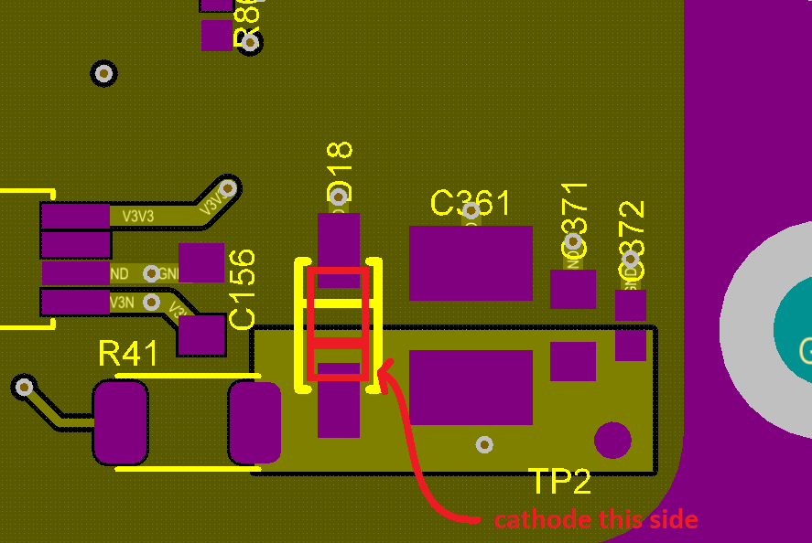
5. 5V trace too thin yielding incorrect current measurements. As a result, this is causing instability in the 5V supply. Please use a piece of wick (copper braided wire), copper film, wire, or other thick conductor to bridge L39 to R195. The connection needs to be less than 1mOhm. As a suggestion I recommend removing L39, adding the conductor, and then re-installing L39.  
   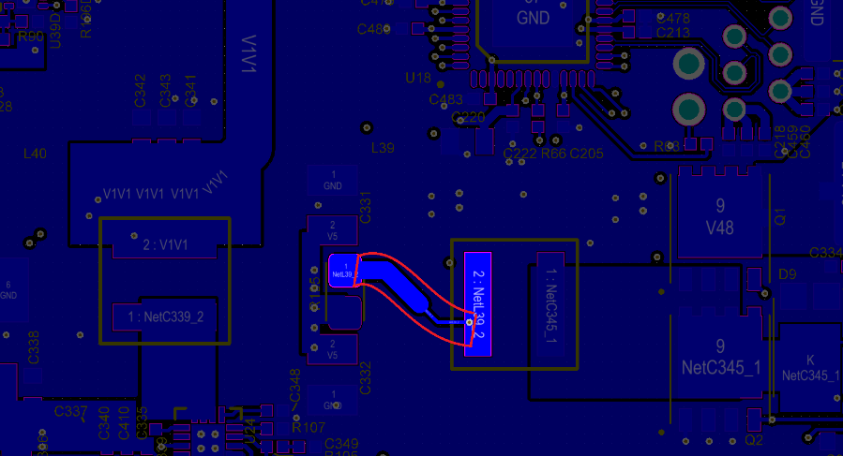
6. Add two thru-hole LEDs as shown below  
   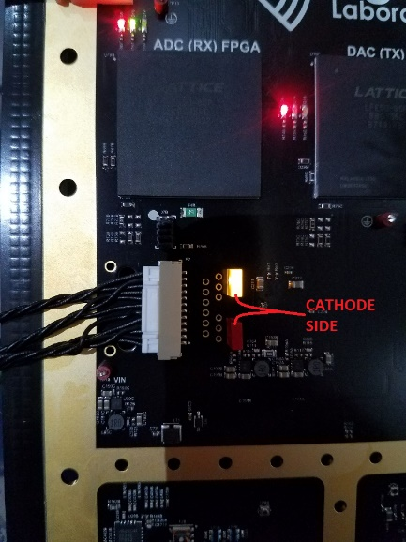  
   orange and red LEDs to be provide to SEM by Signal Laboratories.
7. Remove the tabs before delivery to Signal Laboratories.  
   