#1. “**DAC 1.2V regulators not regulating**”

Solution: Connect feedback pin.

Instructions: Jumper C412 and C416

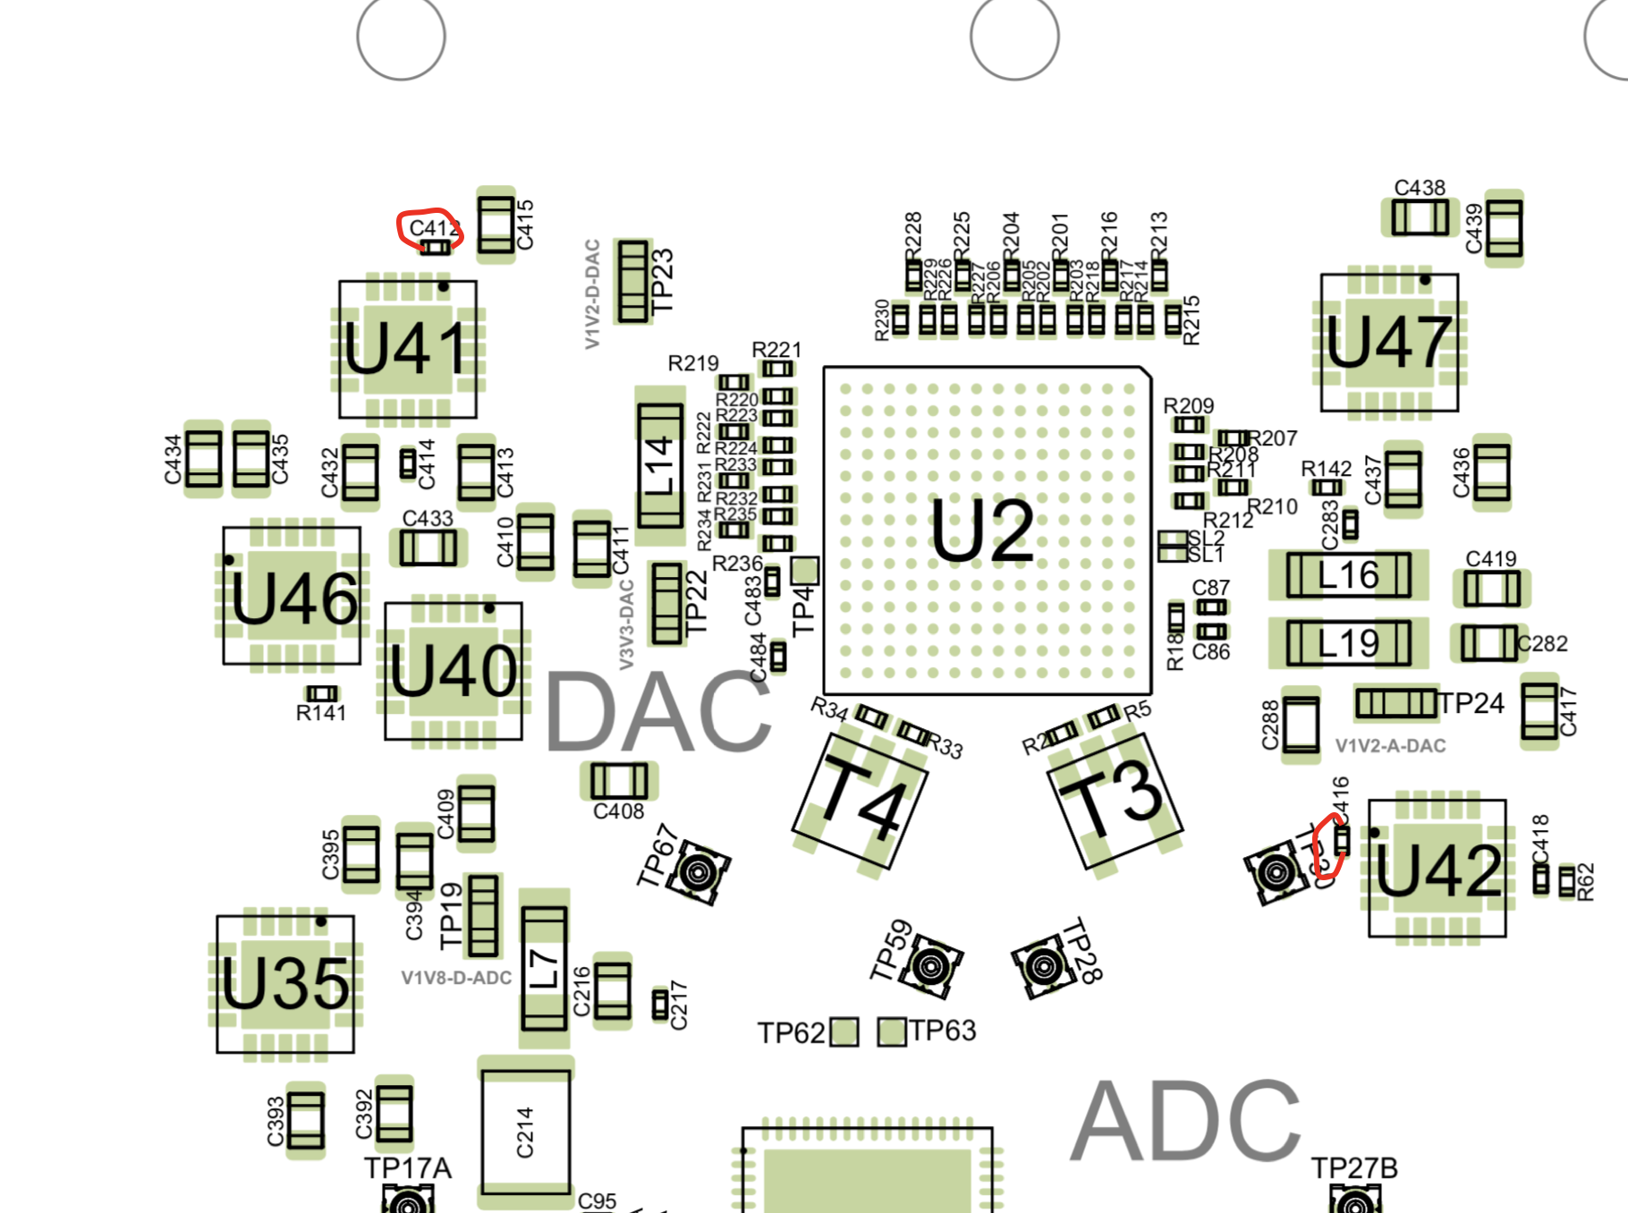

#2. “**SPI bus being held low**”

Solution: DAC, SYNTH, and CLOCK power supplies need to be jumpered ON (i.e. on by default).

Instructions: Jumper R62 to C417 (as shown below). Jumper R66 to C428 (as shown below). Jumper R60 to C404 (as shown below).

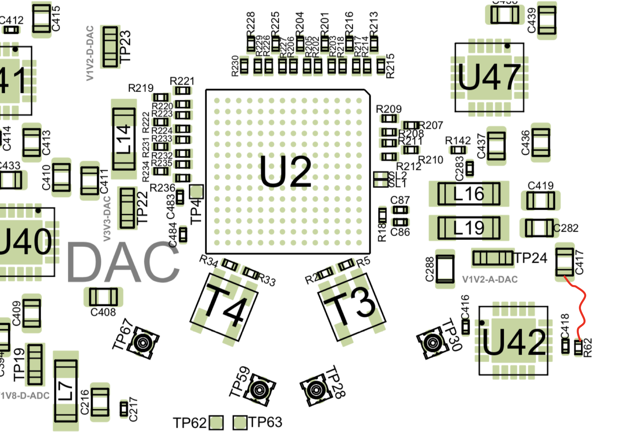

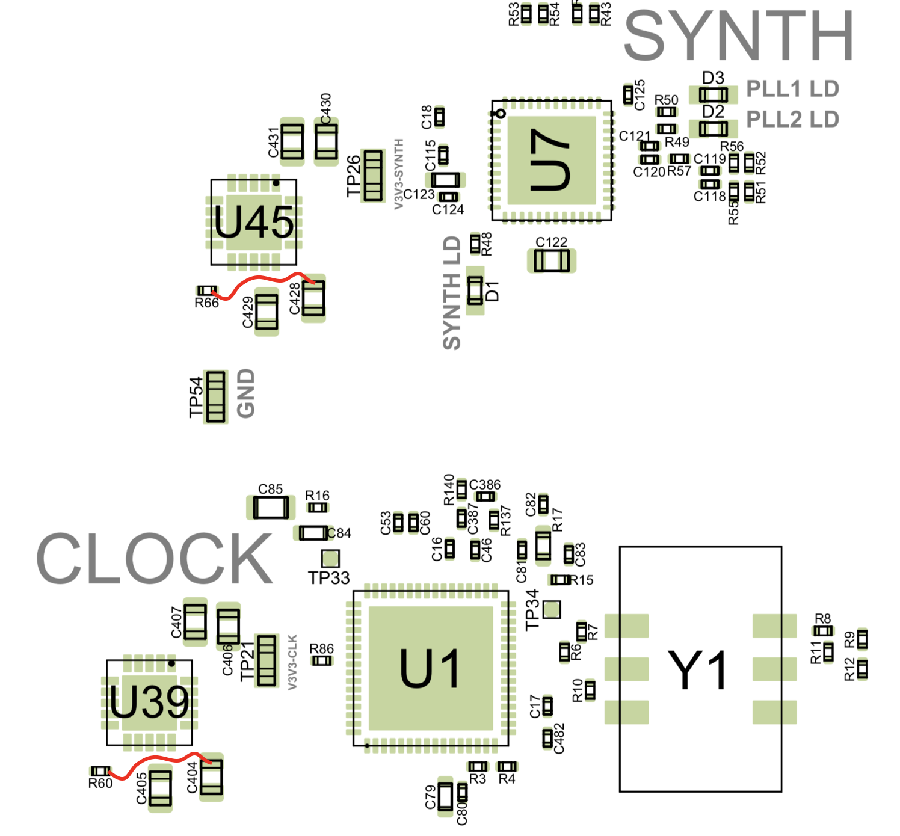

3. “**Not enough solder on Solder-Link pads**”

Solution: Verify all solder-links are bridged. If not, bridge them. All solder links are highlighted below.

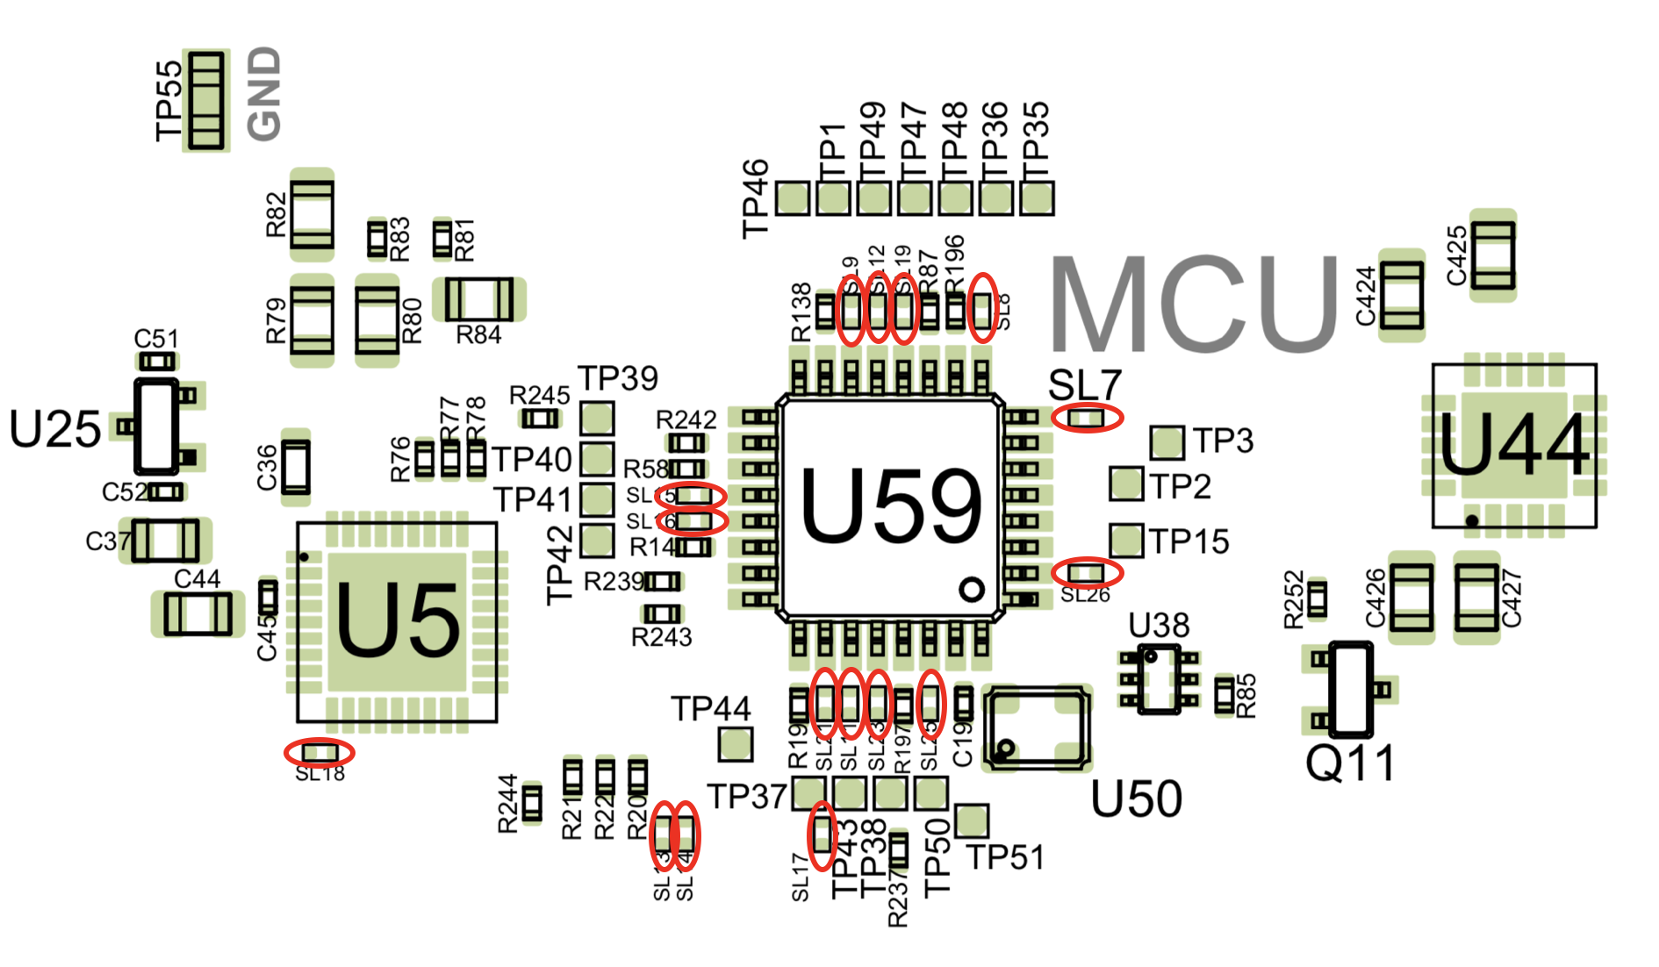

4. “**U25 is wrong**”

Solution: substitute P/N MCP1700T-5002E/TT and rotate 120 degrees (as shown below).

Note: MCP1700T-5002E/TT is already in BOM. It just needs rotating.

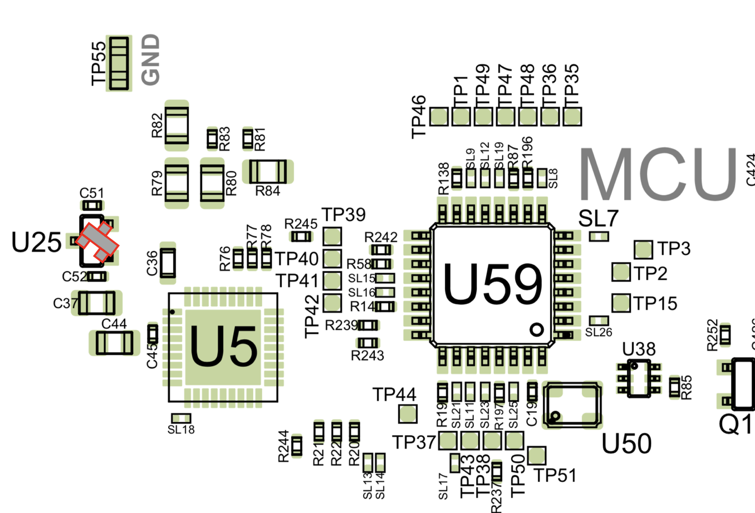

5. “**5MHZ Oscillator Quality Issue**”

Solution: terminate at drive side instead of receive side

Instructions: Short R137 (as shown below). Make R198 22-Ohms. Make C385 100nF.

