# Russia-Ukraine War and its Effect on the Indian Economy

**Introduction**

The Russia-Ukraine War is an ongoing conflict that began in 2014 when Russia annexed Crimea from Ukraine. Since then, fighting has continued in the Donbas region in eastern Ukraine, with Russian-backed separatists fighting Ukrainian government forces.

The conflict has resulted in thousands of deaths and displacement of people. Despite ceasefires and attempts at diplomatic solutions, the situation remains unresolved, and tensions between Russia and Ukraine continue to grow.

The ongoing conflict between Russia and Ukraine has had far-reaching consequences, not just politically and socially but also economically. With international sanctions impacting both countries, businesses and individuals are feeling the brunt of the economic fallout.

A country that benefits from a war between two other countries is sometimes referred to as a “war profiteer” or a “bystander profiteer”. This means that the country may benefit economically or politically from the conflict, without being directly involved in the fighting.

In this Case Study, we shall explore the economic and financial implications on Indian Economy, and let’s find out whether India is a war profiteer.

**Flow of Discussion**

We looked at the major industries of both Ukraine and Russia and we have decided to focus on 5 major areas:

* Metals and Minerals
* Oil & Gas
* Coal Sector
* Food and Agro
* Fertilizers and Chemicals

We selected these five industries based on their significant contributions to the economies of Russia and Ukraine, as well as their potential relevance to the Indian market.

**1.1 Metals and Minerals**

Metals and minerals play a crucial role in the global economy. They are used in a wide range of industries, including construction, manufacturing, transportation, and electronics.

The demand for metals and minerals is only expected to increase as the global population grows and urbanization continues, making them a valuable commodity in the global market. The availability and accessibility of these natural resources can have a significant impact on a country’s economic growth and development, making them a critical factor in international trade and investment.

The war has had a significant influence on metals, which are essential to our daily lives, and are seeing significant price increases worldwide because the majority of metals are produced or refined in Russia or Ukraine. For the auto industry, this has led to a sharp decline in operating profitability as well as anticipated price increases in the upcoming quarters. Several light metals and minerals, such as aluminum, copper, nickel, and zinc, are abundant in both Russia and Ukraine.

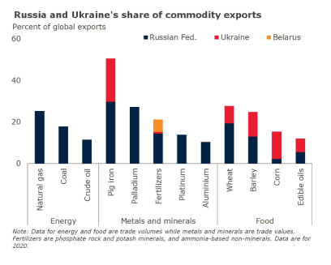

***Russia and Ukraine Commodity exports***

**Russia’s share of global metals and minerals export:**

* Russia is the fourth-largest exporter of tungsten in the world and exports **12.3%** of the world’s platinum supply.
* Russia is the second-largest supplier of cobalt, one of the essential components needed in the creation of rechargeable batteries, in terms of raw materials.
* It is also the second-largest producer of vanadium, which is used to make steel and for large-scale energy storage.
* The nation is the tenth-largest provider of lead and the sixth-largest exporter of gold, making about **4.4%** of global production.

**Ukraine’s share of global metals and minerals exports:**

* Ukraine is one of the world’s largest exporters of iron ore, with exports valued at over **$2 billion** in 2020.
* Ukraine is also a significant exporter of steel, with exports valued at over **$4 billion** in 2020.
* Ukraine is an important exporter of copper and aluminum, with exports valued at over **$400 million** and **$700 million** respectively, in 2020.

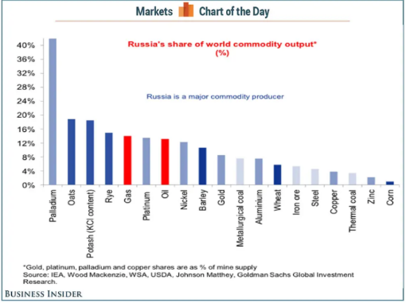

***Metals and Minerals Exported by Russia***

**Impact of the War on Russian Metal Producers:**

Russian metal producers like Nickel and Palladium giant **Nornickel** have said Western sanctions and self-sanctioning by some suppliers have made it difficult for industrial companies to obtain imported equipment, spare parts, materials, and technologies.

Due to the impact of sanctions on Russia’s crucial industries, Moscow has presented India with a catalog of over 500 goods that can be supplied, such as automobile, aircraft, and train components, as well as almost 200 metallurgical items.

**Can Indian exporters help fill the gap in the global commodities market?**

According to the Managing Director of **Jindal Steel**, India has the potential to help fill the global supply chain gap by increasing its steel exports to European Union (**EU**) and Middle Eastern and North African (**MENA**) countries.

As one of the top five iron ore producers in the world, India can expand its exports to markets where Russia was previously the primary supplier. There is already a growing demand for Indian steel among countries in West Asia and Europe (Like Italy and Belgium).

Based on an analysis of data from the **UN Comtrade**, around 2,700 Indian exporters are dealing in 11 major products previously exported by Russia and Ukraine. These products include crude petroleum oil, corn, wheat, sunflower oil, iron ore, iron and steel, platinum, gold, copper, turbo-jets and turbo-propellers, and insulated wire and electric conductors. The analysis shows that India has a Revealed Comparative Advantage (RCA) in the exports of iron ore, iron and steel, and turbo-jets.

Although India also has an RCA in copper, the closure of a major copper smelter in 2018 due to environmental concerns resulted in India becoming a net importer of metal. Therefore, it is unlikely that copper exports from India will see a significant increase.

Apart from gold, India is also a significant exporter of silver, with exports valued at over **$1.5 billion** in 2020. In addition, India exports platinum and palladium, with exports valued at over **$800 million** and **$1 billion** respectively in 2020. India also exports a variety of other products, including diamonds, gemstones, and jewelry.

**1.2 Oil and Gas**

Also referred to as liquid gold, Oil and gas are two of the most important natural resources in the global economy. They are used in a wide range of industries, including transportation, manufacturing, and energy production. Currently, Europe is facing an Oil crunch as Russia stopped its exports to most EU countries. This in turn has created an energy crisis in the European Union.

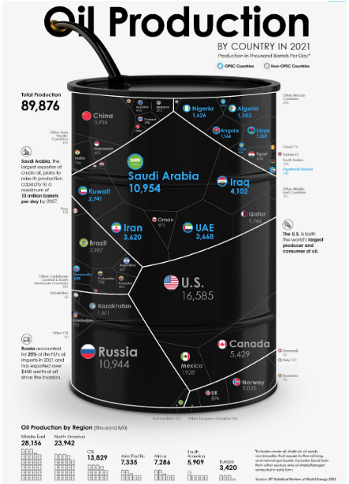

***Oil production by country***

**India’s current situation:**

India’s heavy reliance on crude oil as a commodity has traditionally harmed the average consumer due to the government’s lack of emphasis on renewable energy sources. Administrations have made limited efforts to shift towards a greener economy, resulting in a lack of incentives for consumers to purchase fuel-efficient electric cars despite existing tax waivers. With electric vehicles priced at over a million rupees in a country where a significant portion of the population earns just INR 10,000, consumers have resorted to purchasing fuel-inefficient automobiles, exacerbating their dependence on fossil fuels.

Furthermore, India, the world’s third-largest coal importer, is currently experiencing coal shortages, with coal accounting for around 70% of the country’s electricity generation. As a result, most of India’s coal-fired power plants have critically low inventory levels amid increasing electricity demand.

**Oil and Gas:**

The Russia-Ukraine conflict has had a significant impact on India’s energy security, highlighting the country’s vulnerability to external factors that can impact its energy supply. India is heavily dependent on oil and gas imports, and any disruptions in supply or price increases can have a significant impact on its economy and energy security.

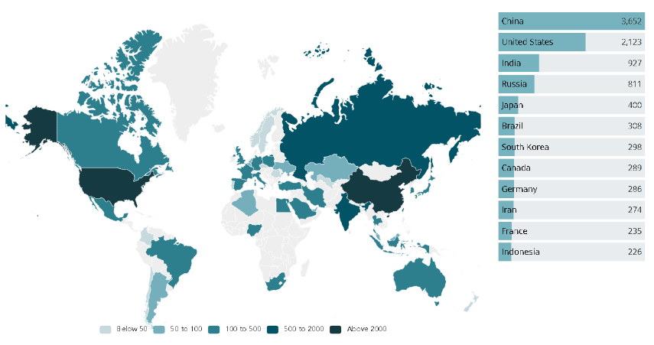

***Global energy consumption in 2021 by Country***

To understand, it is important to look at India’s energy mix and its reliance on imports. India is the world’s third-largest energy consumer, with its energy mix dominated by fossil fuels. The country’s primary energy consumption is dominated by oil, which accounts for approximately 37% of total consumption, followed by coal (29%), natural gas (6%), and renewable energy sources (28%).

India imports more than 80% of its crude oil requirements and about 45% of its natural gas requirements. As of 2021, Russia is the third-largest supplier of crude oil to India after Iraq and Saudi Arabia. According to data from India’s Ministry of Petroleum and Natural Gas, Russia accounted for about **9.2%** of India’s total crude oil imports in the financial year 2020–21. India’s crude oil imports from Russia amounted to around 22.6 million metric tonnes (MMT) during the year. India’s crude oil imports from Russia increased between January and July 2021 to about **56%** higher than in the same period in 2020. The increase in India’s crude oil imports from Russia in 2021 can be attributed to several factors, including the improvement in global oil demand and prices, as well as the easing of COVID-19 restrictions in India.

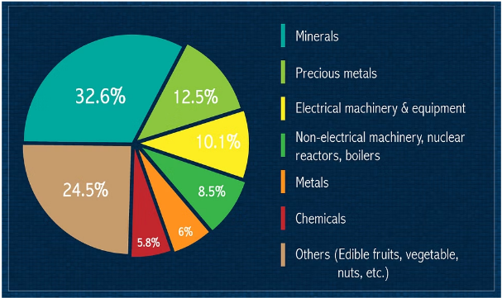

***India’s imports by industry in 2018–2019***

The conflict has led to a surge in global oil and gas prices, impacting India’s energy security. Any disruptions in Russia’s supply of oil and gas can have a significant impact on India’s energy security, leading to higher fuel and electricity prices and potential supply shortages.

It has also had a significant impact on liquefied natural gas (LNG) prices in India, as Russia is one of the country’s largest suppliers of LNG. The conflict has led to supply disruptions and increased demand for LNG from other countries, resulting in a surge in global LNG prices.

India is heavily dependent on LNG imports, with LNG accounting for approximately **50%** of the country’s total natural gas consumption. According to data from the Petroleum Planning and Analysis Cell (PPAC), India imported around **33.68 million metric tonnes** of LNG in the financial year **2020–21**, with Russia accounting for around **22%** of these imports.

The surge in LNG prices has had a significant impact on India’s economy and energy security. India’s power sector is heavily reliant on natural gas, with around 25% of the country’s total electricity generation capacity being fuelled by natural gas. Higher LNG prices have led to an increase in the cost of electricity generation, leading to higher electricity prices for consumers.

Higher LNG prices have also impacted India’s industrial sector, which is a major consumer of natural gas. Industries such as fertilizers, petrochemicals, and steel are heavily dependent on natural gas, and higher prices have led to an increase in input costs, reducing their competitiveness and profitability.

Russia started increasing natural gas prices for the European Union (EU) in the second half of 2021, and prices will continue to rise if the war continues. In July, the European Commission circulated a Safe Gas for a Safe Winter plan urging EU members to reduce their gas demand by 15% over eight months starting on August 1. The plan, which is not binding, triggered intra-EU debates on whether it would be enough for Europe to prepare for winter. Meanwhile, **Gazprom** has progressively cut natural gas deliveries to Europe via **Nord Stream 1** and in mid-August announced plans to stop deliveries for 3 days, ostensibly for maintenance. The impact of sanctions on Russia’s economy has been limited, mainly because the EU has not restricted imports of Russian natural gas.

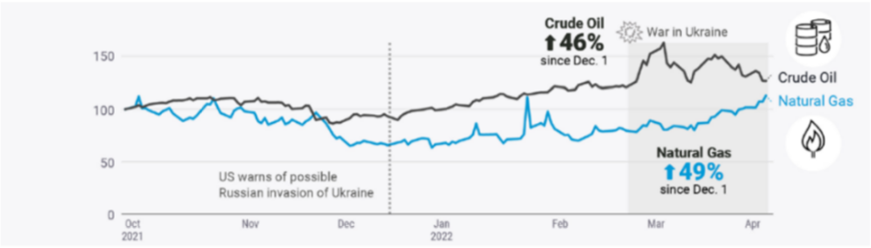

***Oil and gas usage in Ukraine***

Higher crude oil prices have led to an increase in the cost of transportation, which has impacted the prices of goods and services in the country. The transport sector in India is heavily reliant on crude oil, with the majority of the fuel used in the country’s transportation system being derived from crude oil. Higher crude oil prices have led to an increase in the cost of fuel, which has resulted in higher transportation costs for goods and passengers.

This has also impacted India’s industrial sector, which is a major consumer of crude oil. Industries such as petrochemicals, plastics, and fertilizers are heavily dependent on crude oil, and higher prices have led to an increase in input costs, reducing their competitiveness and profitability.

India has also purchased a lot of oil from Russia as there is a good discount on the oil just for a handful of countries. According to **Vortexa**, India imported just **68,600 bpd** of oil from Russia in March 2022 and this year the purchases have jumped to **1,646,311 bpd**.

To mitigate the impact of higher LNG prices, India has been taking steps to diversify its sources of LNG and reduce its dependence on imports from Russia. The country has been exploring alternative sources of LNG, such as the US and Australia, and has signed long-term supply contracts with these countries to ensure a stable supply of LNG.

India has also been investing in the development of its domestic natural gas resources to reduce its reliance on imports. The country has been promoting the exploration and production of natural gas through various policy measures, such as the New Exploration Licensing Policy (**NELP**) and the Open Acreage Licensing Policy (**OALP**). These policies have increased domestic production, which reached 32.87 billion cubic meters in 2020–21, up from 32.35 billion cubic meters in 2019–20.

India has been taking steps to diversify its energy mix and reduce its reliance on imports by exploring alternative sources of energy and increasing domestic production. The country has also been looking to strengthen its relationships with other oil and gas-producing countries to ensure a stable supply of energy. These measures will help India to reduce its vulnerability to external factors and ensure a secure and sustainable energy future.

**1.3 Coal Sector**

India is heavily dependent on coal imports, with coal accounting for approximately 70% of the country’s total electricity generation. According to data from the Ministry of Coal, India imported around **169 million** tonnes of coal in the financial year 2020–21, with Russia accounting for around **6%** of these imports.

The price of coal has increased from around **$60 per tonne in 2020** to over **$200 per tonne in 2021** owing to the conflict. This increase in coal prices has had a significant impact on India’s energy security and economy.

Higher coal prices have led to an increase in the cost of electricity generation, which has impacted the prices of goods and services in the country and has resulted in higher electricity tariffs for consumers. The power sector in India is heavily reliant on coal, with the majority of the country’s electricity being generated from coal-fired power plants.

This has also trickled down to impact India’s industrial sector, which is a major consumer of coal. Industries such as steel, cement, and aluminum are heavily dependent on coal, and higher prices have led to an increase in input costs, reducing their competitiveness and profitability.

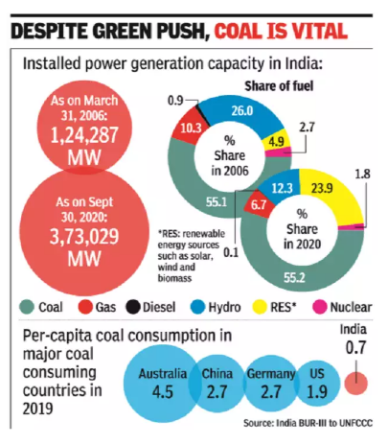

***Power Generation by Industry, 2019***

To mitigate the impact of higher coal prices, India has been taking steps to reduce its dependence on imports and diversify its sources of coal. The country has been promoting the exploration and production of domestic coal resources through various policy measures, such as the Coal Mines Special Provisions Act, of 2015, and the Mines and Minerals (Development and Regulation) Act, of 1957. These policies have increased domestic production, which reached 729.10 million tonnes in 2019–20, up from 729 million tonnes in 2018–19.

India has also been exploring alternative sources of coal, such as Australia and Indonesia. It has signed long-term supply contracts with these countries to ensure a stable coal supply. In addition, the country has been investing in the development of alternative energy sources, such as solar and wind power, to reduce its dependence on coal.

The government of India has also been promoting the use of cleaner coal technologies, such as supercritical and ultra-supercritical coal-fired power plants, which are more efficient and emit fewer greenhouse gases than traditional coal-fired power plants. The country has set a target of installing 65 GW of supercritical and ultra-supercritical power generation capacity by 2022.

**Analyzing the political situation:**

Russia is known to provide crude oil and coal at a lower cost compared to other suppliers, which makes it an attractive option. As India has a significant demand due to its heavy dependence on coal-fired power plants and crude oil-powered transportation systems, it makes economic sense for India to import from Russia.

Russia is the world’s second-largest coal exporter and has significant reserves, which ensures a stable supply of coal to India. India and Russia have also had a long-standing strategic partnership, and cooperation in the energy sector has been an essential part of it. The partnership has helped India to secure long-term crude oil supplies at stable prices.

Diversification of supply sources is essential for India’s energy security. By importing crude oil and coal from Russia, India can reduce its dependence on traditional crude suppliers like Saudi Arabia and Iraq and coal suppliers like Indonesia and Australia.

However, relying on Russia exposes India to geopolitical risks and any disruption in crude oil supplies from Russia could impact India’s energy security. Overdependence on any single supplier can be risky, and this applies to India’s reliance on Russia for coal, oil & gas. Any political or economic changes in Russia could harm India’s energy security.

Also, Coal is known to be a significant source of carbon emissions and air pollution, which is a significant environmental concern in India. Continual dependence on imports may not align with India’s efforts to shift towards cleaner sources of energy.

**1.4 Food and Agro**

Food and agro-produce are essential for sustaining human life and play a crucial role in the global economy. Agriculture is one of the oldest and most significant industries in the world, providing food and raw materials for a wide range of industries.

Countries with a strong agriculture sector can generate significant revenue from exports and can provide food security for their citizens. In addition, the agriculture industry is a major employer, providing jobs for millions of people worldwide. Indian economy is mainly dependent upon agriculture.

Food goods like vegetables, fruits, legumes, oil, etc. are likely to be expensive as a result of how the rise in oil prices has influenced freight movement. This benefits the entire cycle from farmer to merchant by generating revenues for nearby Indian traders. The agro-industry and Indian agriculture have hope as a result. A thriving agro-industry will drive up the need for chemicals and fertilizers, hence fostering the growth of these sectors.

**Case Study:**

The **World Food Programme**, a UN organization that offers food relief to nations in need, receives one of the greatest contributions from countries worldwide: **Ukraine**. According to David Beasley, the WFP’s director, it supplies **40%** of the organization’s wheat.

This flow has now been halted by the war, and the WFP is trying to give Ukrainians the food they require to survive this crisis.

The conflict in Ukraine could have a significant effect on the world’s food supply, which would have far-reaching effects on world hunger and food security. However, it doesn’t have to happen because there is still time to act and contain a more serious problem.

Both Ukraine and Russia are significant players in the world food markets. They are net exporters of wheat, maize (corn), and barley, three of the most important cereal crops. Sunflower oil, one of the most popular vegetable oils worldwide, is also a dominant export for both. For domestic food supplies, several nations, like India, primarily rely on sunflower oil imports.

According to the charts, Ukraine and Russia account for almost one-fourth of all wheat exports in 2019. **1/5th** of the world’s crop of both barley and maize. Over two-thirds of the sold sunflower oil come from them, with Ukraine alone contributing to over half of the global exports.

***Grain Exports by Ukraine during the Conflict***

The potential effects of decreased food production from Russia and Ukraine won’t be felt everywhere. The nations that import products directly from these nations are among the most susceptible.

It won’t, however, be limited to these direct importers. Given the rising cost of food, all nations that are net importers of these goods may have serious consequences.

Country-by-country import statistics for these important crops in order to pinpoint the nations that are most at risk and may require assistance in the months to come. You may view the global situation for a variety of commodities and measures in the data explorer below.

You can view which nations import the most sunflower oil, wheat, maize, or barley; which nations import from Ukraine; and/or Russia; and how dependent they were on imports for the domestic supply.

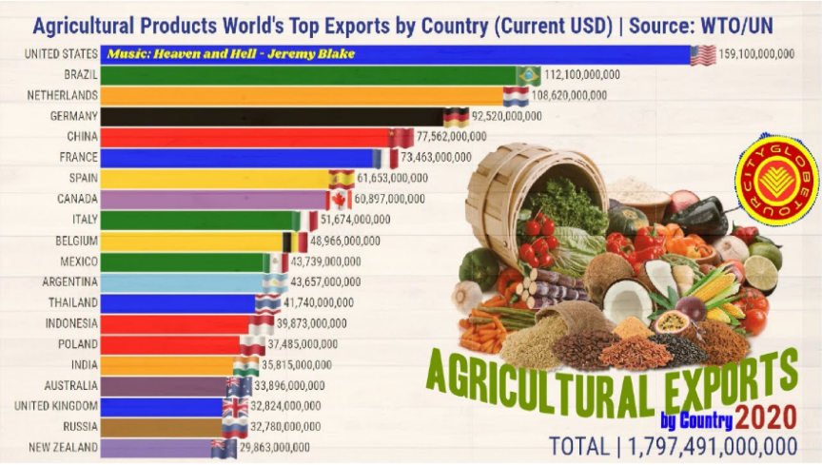

***Top Exports by Country***

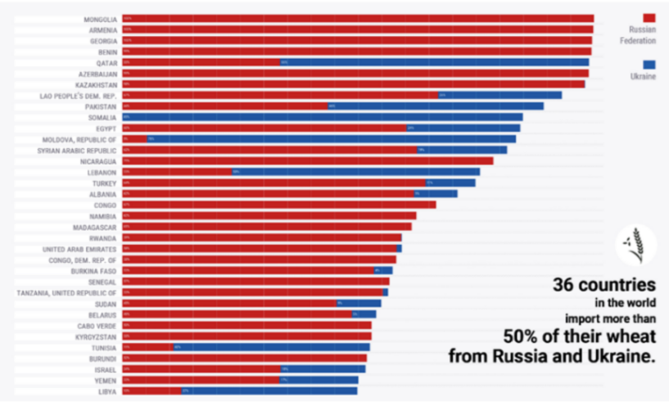

***UNGC Report on Global Impact of War in Ukraine on Food, energy, and finance systems***

**1.5 Fertilizers and Chemicals**

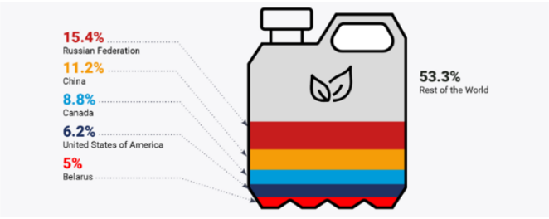

**World Fertilizers contribution**

Chemicals and fertilizers are essential to the world economy, especially the agricultural sector. Fertilizers are crucial for boosting agricultural yields and guaranteeing food security for a population that is expanding worldwide. In addition, a variety of businesses, including the pharmaceutical, textile, and plastics industries, use chemicals.

Dr. Mansukh Mandaviya, Union Minister of Chemicals and Fertilisers, Health, and Family Welfare, officially opened the Annagro-industry 022 (Fertiliser Sector by 2030 agro-industry) today. In his remarks, Dr. Mandviya listed fertilizers as one of the crucial elements for guaranteeing food security. He claimed that the cost of fertilizers and raw materials had significantly increased during the previous three years. “Our government has brought various reforms and ensured that fertilizers are made available to Indian farmers at reasonable prices,” the minister stated. This has been accomplished by boosting the fertilizer subsidy from US$10 billion for the pre-pandemic year 2019–20 to roughly US$27 billion in the present year.

The Minister said, “The availability and rising costs of fertilizers pose serious difficulties to the global economy today. For the greater good of global food security, our international partners must establish fair and open systems and adopt a long-term perspective when addressing fertilizer-related challenges.

Long-term Agreements and Memorandums of Understanding will be crucial in advancing this goal steadily, according to Dr. Mandaviya. To provide consistency in the fertilizer supplies to the farmers, the government has arranged a number of these agreements and memorandums of understanding between Indian fertilizer producers and international suppliers.

Even though it sells internationally, India’s domestic market and internal demand are what primarily fuel the country’s chemical industry. Due to its significant contribution to India’s export revenues, it has developed through time into a crucial gear in the economic machinery of the nation. To learn more about this varied industry in India, continue reading.

The chemical industry in India is very diversified, with more than 80,000 commercial products. Bulk, specialty, agrochemicals, petrochemicals, polymers, and fertilizers are a few examples of categories. Due to its proximity to the Middle East, which is the largest producer of petrochemical feedstock worldwide, India benefits from economies of scale. It is self-sufficient, and because competitors’ exports are declining, India’s exports are expected to rise.

***Chemicals Sales in 2020 by Country***

We can see that the EU, which includes both Russia and Ukraine, contributes significantly to the manufacture and export of chemicals, and that Russia is one of the EU’s main trading partners. Countries that follow them are gradually falling behind. India is adopting a neutral stance, which is good in this situation.

***Fertilizer Producers by Country***

More price hikes for fertilizer are on the horizon as the Russia-Ukraine crisis adds to fears of global shortages, stoking concerns about rising food costs.

Russia is the world’s second-largest producer of potash, a key nutrient used in important commodities crops and produces, behind Canada. It produces all significant fertilizers at low costs and in high volumes. Trade flows may suffer as a result of regional unrest and Russian sanctions. In a call with analysts on Wednesday, U.S.-based Mosaic Co., a significant fertilizer manufacturer, warned of potash shortages.

All of this indicates that farmers are cutting back on fertilizer use due to increased costs. This could result in poorer agricultural production and an increase in food costs globally. The cost of food is currently at its highest point in ten years, according to a United Nations indicator.

The force majeure declaration made last week by a Belarusian potash miner — which was primarily brought on by U.S. sanctions and being cut off from international markets — also adds to the unrest in the fertilizer markets. A percent of the world’s supply comes from Belarus. The price of potash in international contracts has already reached its highest level since 2008.

Other fertilizer costs have skyrocketed due to high natural gas prices, which has forced some European facilities to suspend or reduce production. Another important concern would be the migration of people from war-torn countries to safer countries with cultural riches that may benefit countries like India. The invasion acted as a catalyst for rising energy and fertilizer prices.

Russia restricted ammonium nitrate shipments beyond the Eurasian Economic Union bloc on the eve of its invasion of Ukraine. This measure echoed Russia’s prior response to the COVID-19 outbreak when it imposed export quotas on wheat and meslin, rye, barley, and maize despite the growing possibility of a worldwide food security disaster. Russia also refused to sign a joint statement published at the WTO by the major agricultural and agrifood exporters that promised to open and predictable commerce in the face of the pandemic in April 2020.

Fertilizer prices have more than doubled since the start of the Ukraine war, and energy prices are skyrocketing. According to the World Bank, the current energy crisis differs from the 1970s energy price shock in that the room for substitution between different types of major energy commodities is limited because their prices are all rising. COVID-19 drove up oil and coal prices, but the current energy crisis is the result of the conflict, as Russia is the world’s largest exporter of natural gas and a major source of crude oil and coal.

According to the World Bank, the war-induced spike in energy prices might cut global output by **0.8%** in two years, with food, construction, petrochemicals, and transportation likely to be among the most affected.

The question is whether, how quickly, and to what degree Russia will be able to reposition itself towards alternative markets like China and India. Experts at the Kyiv School of Economics estimated that shifting from advanced economies to alternative markets will cost Russia USD 80 billion in yearly exports due to greater logistics, infrastructure, and entrance costs, as well as lower skill and knowledge transfer.

According to data from the Centre for Monitoring Indian Economy’s (CMIE) database, Russia has been losing prominence in terms of trade with India. Prior to the fall of the Soviet Union, Russia was a major export destination for India, accounting for over 10% of total exports. By 2020–21, this figure will be less than 1%.

To be sure, India’s overall trade has grown throughout this time. In 2020–21, Russian imports accounted for 1.4% of total Indian imports. While the risk of present economic interruption is low, a conflict and subsequent sanctions might stymie India’s aspirations to expand commercial and investment relations with Russia.

“Improving trade and economic cooperation between India and Russia is a key priority for both countries’ political leadership, as evidenced by revised targets of increasing bilateral investment to $50 billion and bilateral trade to $30 billion by 2025,” according to an economic brief on India-Russia relations on the website of the Indian embassy in Russia. The brief adds that India’s total trade with Russia in 2020 was $9.31 billion.

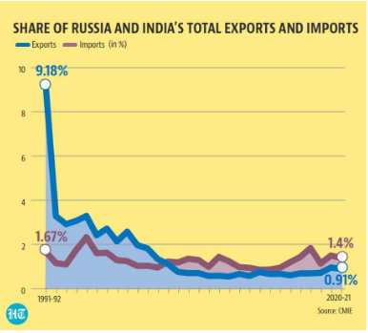

**A Comparison of Imports and Exports between Russia and India**

**Conclusion:**

The ongoing conflict between Russia and Ukraine has the potential to cause significant economic impacts on India. *The increase in oil prices and the disruption of global supply chains could lead to inflation and a slowdown in economic growth*. Additionally, the imposition of sanctions by the international community could affect trade relations between India and Russia, as well as other countries. It is important for India to closely monitor the situation and take appropriate measures to mitigate any negative impacts on its economy. This could include diversifying its oil and gas imports, seeking new trade partners, and investing in domestic industries to reduce reliance on imports. While the full extent of the economic impact remains uncertain, it is clear that the conflict in Ukraine has the potential to affect the global economy, *and India must be prepared to respond accordingly.*