DESIGN A PROTOTYPE FOR ONLINE MOBILE PAYMENT APPLICATION USING FIGMA

Aim:To design a prototype for online mobile payment application using figma.

Procedure: **Step 1: Understand the Requirements**

Before you start designing, make sure you have a clear understanding of the features and functionalities required for the mobile payment application. This may include user registration, linking bank accounts or cards, making payments, viewing transaction history, and more.

**Step 2: Create a New Figma Project**

1. Log in to Figma or create an account if you don't have one.
2. Start a new project and choose the appropriate device size (e.g., iPhone X).

**Step 3: Design the Main Screens**

Design the following key screens that cover the primary user flow of the mobile payment application:

1. **Welcome/Onboarding Screen**:
   * Introduce the app and its benefits.
   * Include a "Get Started" button.
2. **Registration/Login Screen**:
   * Provide fields for user registration (name, email, password).
   * Include social login options (e.g., Google, Facebook) if applicable.
   * Allow users to log in with existing credentials.
3. **Home/Account Overview Screen**:
   * Display user account balance.
   * Show quick links to popular actions (e.g., Send Money, Pay Bills).
   * Provide a transaction summary or recent activity.
4. **Send Money Screen**:
   * Allow users to select recipients (contacts or manually enter details).
   * Provide an amount field.
   * Include a "Send" button.
5. **Transaction History Screen**:
   * List past transactions with details (recipient, amount, date).
   * Include filters and sorting options.

**Step 4: Design Interaction and Flows**

1. Use Figma's prototyping tools to create interactions between screens.
2. Set up basic navigation, such as linking buttons to relevant screens.
3. Create transitions (slide, dissolve, etc.) to make the prototype more realistic.

**Step 5: Design User Interface Elements**

1. Use Figma's design tools to create buttons, input fields, icons, and other UI elements.
2. Maintain a consistent color scheme and typography.
3. Ensure the design is user-friendly and intuitive.

**Step 6: Add Interactive Elements**

1. Enhance the prototype with interactive elements like buttons, sliders, and toggles.
2. Show how user actions (e.g., tapping "Send") lead to changes on the screen.

**Step 7: Review and Iterate**

1. Review the prototype for usability and completeness.
2. Share the prototype with stakeholders or potential users to gather feedback.
3. Iterate on the design based on the feedback received.

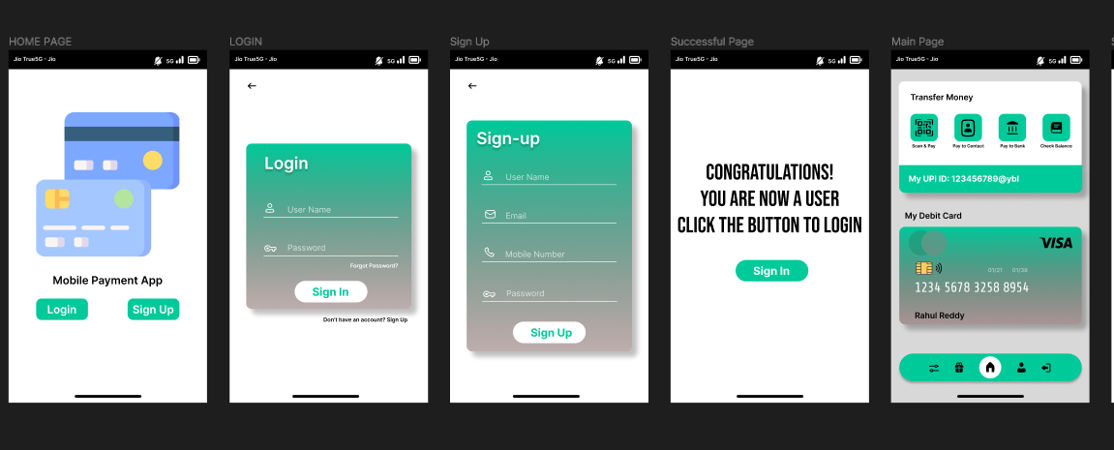

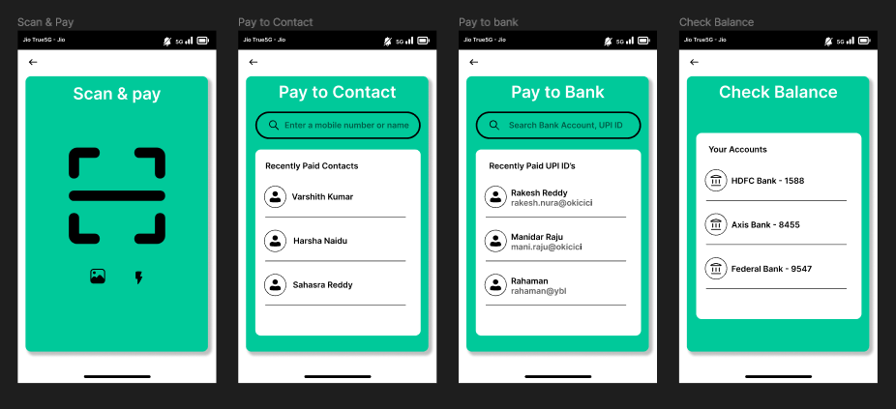

Thus an prototype for online mobile payment application using figma has been designed.