Algorithms in Bioinformatics

Stabilization matrix method – Mini project
Sigmar Stefansson and Francesco Favero
Denmarks Tekniske Universitet
22 October 2010

Supervisor: Morten Nielsen

ABSTRACT
We look at Stabilization matrix methods using two different kinds of minimizations procedures. These we use for predicting binding affinity of immunogenic peptides to major histocompatibility complex (MHC) molecules.
The testing data available was from 35 different MHC molecules from HLA-A and HLA-B, with number of peptides ranging from 59 to 3089.

Introduction
In simple mathematical terms the SMM algorithm tries to minimize the difference between the predicted values and the measured values according to a norm.

||H w - ymeas|| + twΛw (1)

In this case the L2 norm is used. The second term suppresses the effect of noise in the experimental data [1]. The regulation parameter lambda is used to deal with over-fitting in the SMM algorithms [6]. In terms of the smm algorithm, the H is a matrix encoding the peptides, w is the prediction (position specific scoring) matrix and ymeas is vector containing the measured binding affinity of the peptides.
Over-fitting occurs when a statistical model describes random error or noise instead of the underlying relationship [3]. A model having too many degrees of freedom, in relation to the amount of data available is susceptible to over-fitting. A model which has been overfit will generally have poor predictive performance. Among common methods of avoiding over-fitting are early stopping and cross-validation.
In other words, the training is stopped based on test set performance (when it starts decaying). Cross-validation is about combining models. In K-fold cross-validation, the original sample is randomly partitioned into K subsamples. Of the K subsamples, a single subsample is retained as the validation data for testing the model, and the remaining K − 1 subsamples are used as training data. The cross-validation process is then repeated K times (the folds), with each of the K subsamples used exactly once as the validation data [2].

Materials and methods
We were given semi-completed code for the implementation of the Stabilization matrix method. The minimization procedures were gradient descent in one case and monte carlo in the other. The testing data available was from 35 different MHC molecules from HLA-A and HLA-B, with number of peptides ranging from 59 to 3089. In addition to finishing the code we added some optimizations like skipping unnecessary memory allocations at performance critical locations. We ran the matrix creation on each 35 MHC molecules to get the broadest perspective.
The data for each MHC molecule was split into five parts, equally (or nearly equally) sized. Each part was then used for the validation of the model trained on the rest (4/5) of the data, resulting in 5 iterations to be used for (5-fold) cross-validation.
As noted in [1] the use of the lambda value suppresses the effect of noise in the measured data. In the case of zero value lambda, the optimal entries for the weight vector w minimize the difference between predicted and measured values. Minimizing with a non-zero value for lambda results in a shift of the optimal entries in w towards values closer to zero. It should be noted here that the lambda value used as a parameter in the code is the per target normalized lambda value, not the global one.

Results
Figure 1 shows the trend for Pearson's correlation coefficient (PCC, prediction accuracy) using different lambda values for various data sizes.
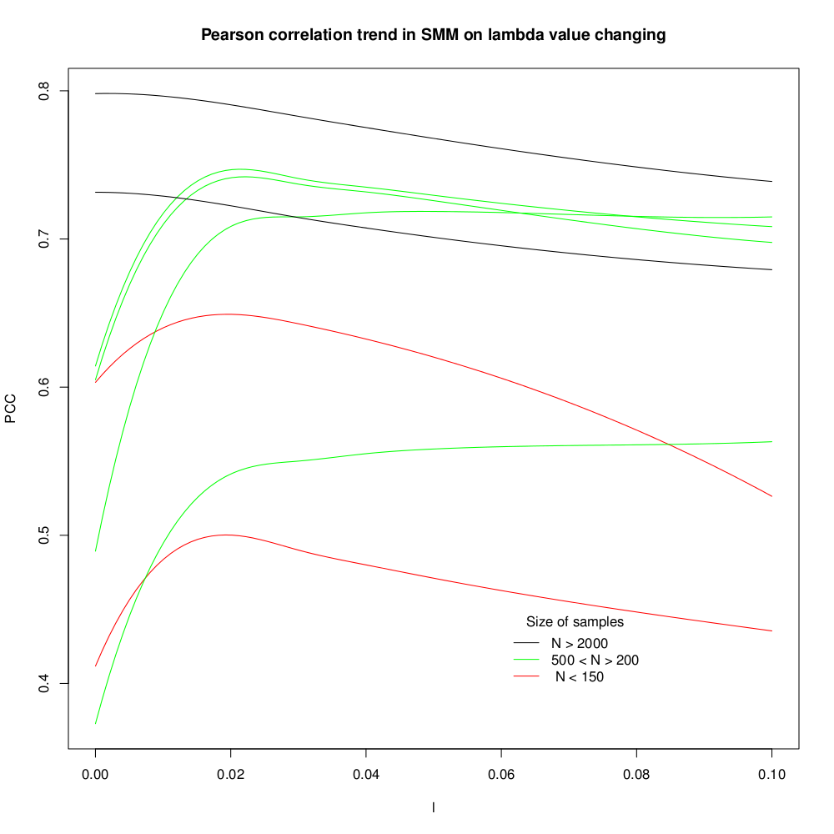
Figure 1

As a general rule, as the data size gets larger the less important the effect of a non-zero lambda becomes. For large data sets a lambda value of zero seems to give the best results. A large dataset should average out the noise. Similar graph showing results from the Monte Carlo version says the same story (Figure 2).

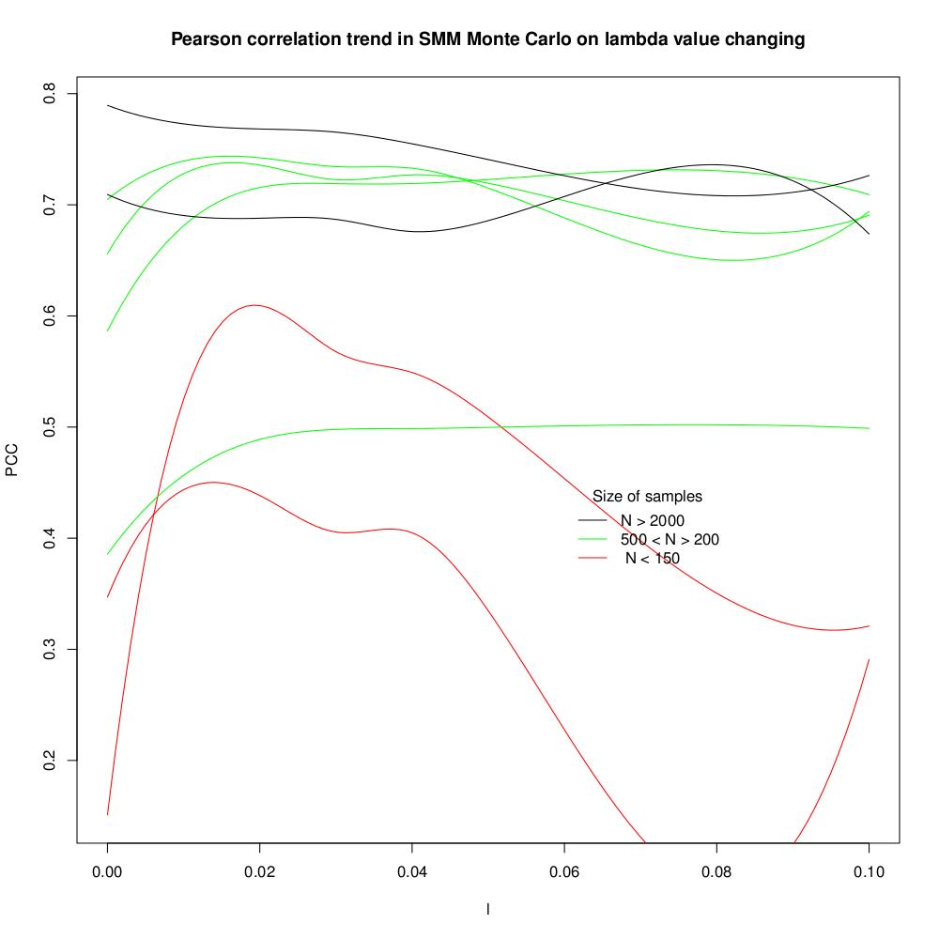
Figure 2

For the small datasets an optimal lambda value is less than 0.02.
Next we run the smm algorithms on a data from five different kinds of MHC molecules (with different data sizes) showing the error as a function of iterations. For the smm algorithm using gradient descent and 500 iterations, a default lambda value of 0.05 is used (Figure 3). Similar chart is shown for the monte carlo version of the algorithm in Figure 4 showing 12000 iterations. The reason for showing different different data sizes on the same chart is just for showing the trends in the two different algorithms. The gradient descent method converges much faster to an optimal value than the monte carlo method. The data sizes and percentage of number of binding peptides are shown in the parantheses right by the names of the lines representing each MHC molecule.

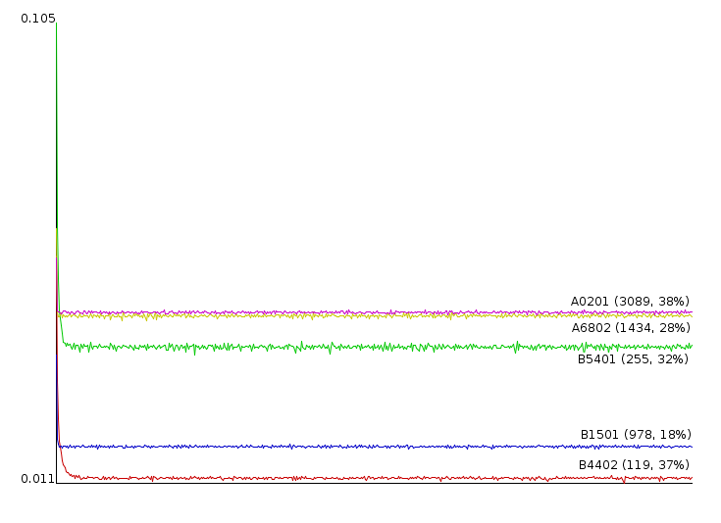
Figure 3
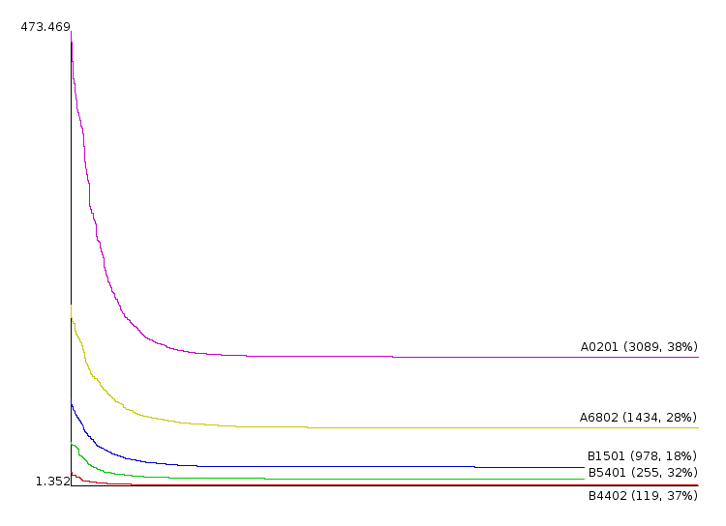
Figure 4

References
[1] http://www.biomedcentral.com/1471-2105/6/132
[2] http://en.wikipedia.org/wiki/Cross-validation_(statistics)
[3] http://en.wikipedia.org/wiki/Overfitting
[4] http://en.wikipedia.org/wiki/Major_histocompatibility_complex
[5] http://www.cbs.dtu.dk/services/NetMHC-3.2
[6] http://www.cbs.dtu.dk/courses/27623.algo/presentations/Hobohm/Hobohm.pdf

