**MIDS W205**

**Lab # 11 Lab Title Working with graphs**

**Alan Wang**

**W205-5**

1. **What is the shortest path between DR. STRANGE and DR. DOOM?**
2. First, I need to find DR. STRANGE

Neo4j command:

**MATCH (drstrange:Hero) WHERE drstrange.name STARTS WITH "DR. STRANGE" RETURN drstrange**

I got (via export):

**drstrange**

**{"degree":4,"name":"DR. STRANGER YET"}**

**{"degree":777,"name":"DR. STRANGE/STEPHEN"}**

**{"degree":18,"name":"DR. STRANGE | MUTANT"}**

**{"degree":9,"name":"DR. STRANGE DOPPELGA"}**

From which, I got Dr. STRANGE/STEPHEN

1. And DR. DOOM

Neo4j command:

**MATCH (drdoom:Hero) WHERE drdoom.name STARTS WITH "DR. DOOM" RETURN drdoom**

I got (via export):

**drdoom**

**{"degree":52,"name":"DR. DOOM | MUTANT X-"}**

**{"degree":13,"name":"DR. DOOM DOPPELGANGE"}**

**{"degree":10,"name":"DR. DOOM CLONE/VICTO"}**

**{"degree":441,"name":"DR. DOOM/VICTOR VON"}**

**{"degree":11,"name":"DR. DOOM | TIMESLIDE"}**

From which, I got Dr. DOOM/VICTOR VON

1. Then I need to find the shortest path between DR. STRANGE and DR. DOOM:

Neo4j command:

**MATCH p=(drstrange:Hero {name: 'DR. STRANGE/STEPHEN'})- [:APPEARED*0..2]-(drdoom:Hero {name: 'DR. DOOM/VICTOR VON'}) RETURN p, length(p) ORDER BY length(p) LIMIT 1**

I got (via export as png) from Neo4J as the shortest path between DR. STRANGE and DR. DOOM:

C:\Users\Alan\Downloads\graph.png

1. **List the 5 shortest paths between DR. STRANGE and DR. DOOM**

Neo4j command:

**MATCH p=(drstrange:Hero {name: 'DR. STRANGE/STEPHEN'})- [:APPEARED*0..2]-(drdoom:Hero {name: 'DR. DOOM/VICTOR VON'}) RETURN p, length(p) ORDER BY length(p) LIMIT 5**

I got via export as png for the shortest 5 paths between DR. STRANGE and DR. DOOM

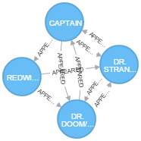

1. **List 5 Friends of Friends with the most connections and COLOSSUS II.**
2. First I need to locate COLOSSUS II:

Neo4j command:

**MATCH (colossusii:Hero) WHERE colossusii.name STARTS WITH "COLOSSUS II" RETURN colossusii**

I got (via export):

**colossusii**

**{"degree":118,"name":"COLOSSUS II DOPPELGA"}**

**{"degree":760,"name":"COLOSSUS II/PETER RA"}**

**{"degree":18,"name":"COLOSSUS II | MUTANT"}**

From which, I got COLOSSUS II/PETER RA

1. Then find 5 friends of friends with the most connections with COLOSSUS II.

Neo4j command:

**MATCH (colosusii:Hero { name: 'COLOSSUS II/PETER RA' })-**

**[:APPEARED*2..2]-(friend_of_friend)**

**WHERE NOT (colosusii)-[:APPEARED]-(friend_of_friend)**

**AND friend_of_friend.name <> 'COLOSSUS II/PETER RA'**

**RETURN friend_of_friend.name, COUNT(*)**

**ORDER BY COUNT(*) DESC , friend_of_friend.name LIMIT 5**

I got via export as csv:

**friend_of_friend.name COUNT(*)**

**WONG 453**

**MOONSTONE II/KARLA S 370**

**CARTER, PEGGY 367**

**POWER MAN/ERIK JOSTE 350**

**KINGPIN/WILSON FISK 342**

1. **Visualize 10 Friends of friends for IRON MAN**
2. First I need to locate IRON MAN:

Neo4j command:

**MATCH (ironman:Hero) WHERE ironman.name STARTS WITH "IRON MAN" RETURN ironman**

I got (via export):

**ironman**

**{"degree":1132,"name":"IRON MAN/TONY STARK"}**

**{"degree":338,"name":"IRON MAN IV/JAMES R."}**

**{"degree":82,"name":"IRON MAN V/TEEN TONY"}**

**{"degree":4,"name":"IRON MAN ARMOR"}**

**{"degree":112,"name":"IRON MAN DOPPELGANGE"}**

**{"degree":19,"name":"IRON MAN III/EDDIE M"}**

From which, I got IRON MAN/TONY STARK

1. Then visualize 10 friends of friends with IRON MAN:

Neo4j command:

**MATCH (ironman:Hero { name: 'IRON MAN/TONY STARK' })-**

**[:APPEARED*2..2]-(friend_of_friend)**

**WHERE NOT (ironman)-[:APPEARED]-(friend_of_friend)**

**AND friend_of_friend.name <> 'IRON MAN/TONY STARK'**

**RETURN friend_of_friend, friend_of_friend.name**

**LIMIT 10**

I got via export as png:

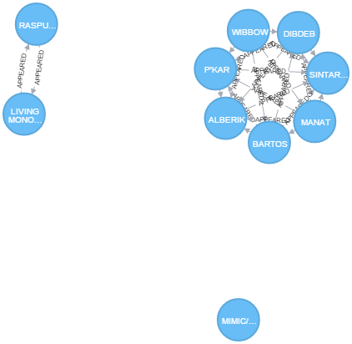

1. **Discover how the Avengers grew over time from 5 to 10. Find team members starting with 5 and incrementing to 10. Who was added to the team? Is the resulting graph ever not fully connected?**
2. First, I will start with the IRON MAN and THOR’s teammate relationship as depicted in the description as an example modified to get the whole team:

Neo4j command:

**MATCH p=(tony:Hero {name:'IRON MAN/TONY STARK'}) -[e:APPEARED]-> (other) <-[f:APPEARED]- (donald:Hero {name:'THOR/DR. DONALD BLAK'})**

**with p as team**

**ORDER BY e.w DESC, f.w DESC**

**unwind nodes(team) as members**

**with distinct members as members**

**return members limit 5**

I got via export png:

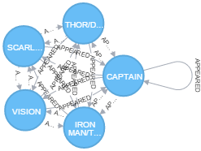

That is:

**IRON MAN,**

**CAPTAIN AMERICA,**

**SCARLET WITCH,**

**VISION, and**

**THOR**

1. Then, I will start to grow it from limit 3 to 4 and so on until I got a team of 10.

For the 6th:

Neo4j command:

**MATCH p=(tony:Hero {name:'IRON MAN/TONY STARK'}) -[e:APPEARED]-> (other) <-[f:APPEARED]- (donald:Hero {name:'THOR/DR. DONALD BLAK'})**

**with p as team**

**ORDER BY e.w DESC, f.w DESC**

**unwind nodes(team) as members**

**with distinct members as members**

**return members limit 6**

I got:

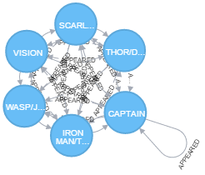

That is: new member: **WASP:**

**WASP**

**IRON MAN,**

**CAPTAIN AMERICA,**

**SCARLET WITCH,**

**VISION, and**

**THOR**

1. For the 7th:

Neo4j command:

**MATCH p=(tony:Hero {name:'IRON MAN/TONY STARK'}) -[e:APPEARED]-> (other) <-[f:APPEARED]- (donald:Hero {name:'THOR/DR. DONALD BLAK'})**

**with p as team**

**ORDER BY e.w DESC, f.w DESC**

**unwind nodes(team) as members**

**with distinct members as members**

**return members limit 7**

I got:

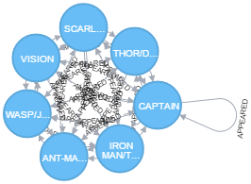

That is: new member: **ANT-MAN**

**ANT-MAN,**

**WASP**

**IRON MAN,**

**CAPTAIN AMERICA,**

**SCARLET WITCH,**

**VISION, and**

**THOR**

1. For the 8th:

Neo4j command:

**MATCH p=(tony:Hero {name:'IRON MAN/TONY STARK'}) -[e:APPEARED]-> (other) <-[f:APPEARED]- (donald:Hero {name:'THOR/DR. DONALD BLAK'})**

**with p as team**

**ORDER BY e.w DESC, f.w DESC**

**unwind nodes(team) as members**

**with distinct members as members**

**return members limit 8**

I got:

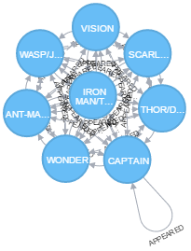

That is: new member: **WONDER MAN**

**WONDER MAN,**

**ANT-MAN,**

**WASP**

**IRON MAN,**

**CAPTAIN AMERICA,**

**SCARLET WITCH,**

**VISION, and**

**THOR**

1. For the 9th:

Neo4j command:

**MATCH p=(tony:Hero {name:'IRON MAN/TONY STARK'}) -[e:APPEARED]-> (other) <-[f:APPEARED]- (donald:Hero {name:'THOR/DR. DONALD BLAK'})**

**with p as team**

**ORDER BY e.w DESC, f.w DESC**

**unwind nodes(team) as members**

**with distinct members as members**

**return members limit 9**

I got:

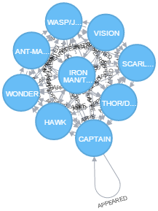

That is: new member: **HAWK**

**HAWK,**

**WONDER MAN,**

**ANT-MAN,**

**WASP**

**IRON MAN,**

**CAPTAIN AMERICA,**

**SCARLET WITCH,**

**VISION, and**

**THOR**

1. For the 10th:

Neo4j command:

**MATCH p=(tony:Hero {name:'IRON MAN/TONY STARK'}) -[e:APPEARED]-> (other) <-[f:APPEARED]- (donald:Hero {name:'THOR/DR. DONALD BLAK'})**

**with p as team**

**ORDER BY e.w DESC, f.w DESC**

**unwind nodes(team) as members**

**with distinct members as members**

**return members limit 10**

I got:

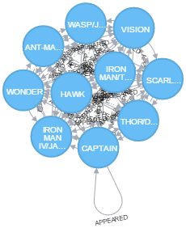

That is: new member: **IRON MAN IV**

**IRON MAN IV,**

**HAWK,**

**WONDER MAN,**

**ANT-MAN,**

**WASP**

**IRON MAN,**

**CAPTAIN AMERICA,**

**SCARLET WITCH,**

**VISION, and**

**THOR**

1. Yes, this graph has been and will be fully connected because the ‘definition’ (the query we applied) specifies that “Appear” defines a team and appears is symmetric, so, this graph will be fully connected (i.e you can go from any node to any other node.