Carrera Race Monitor
  - User Guide

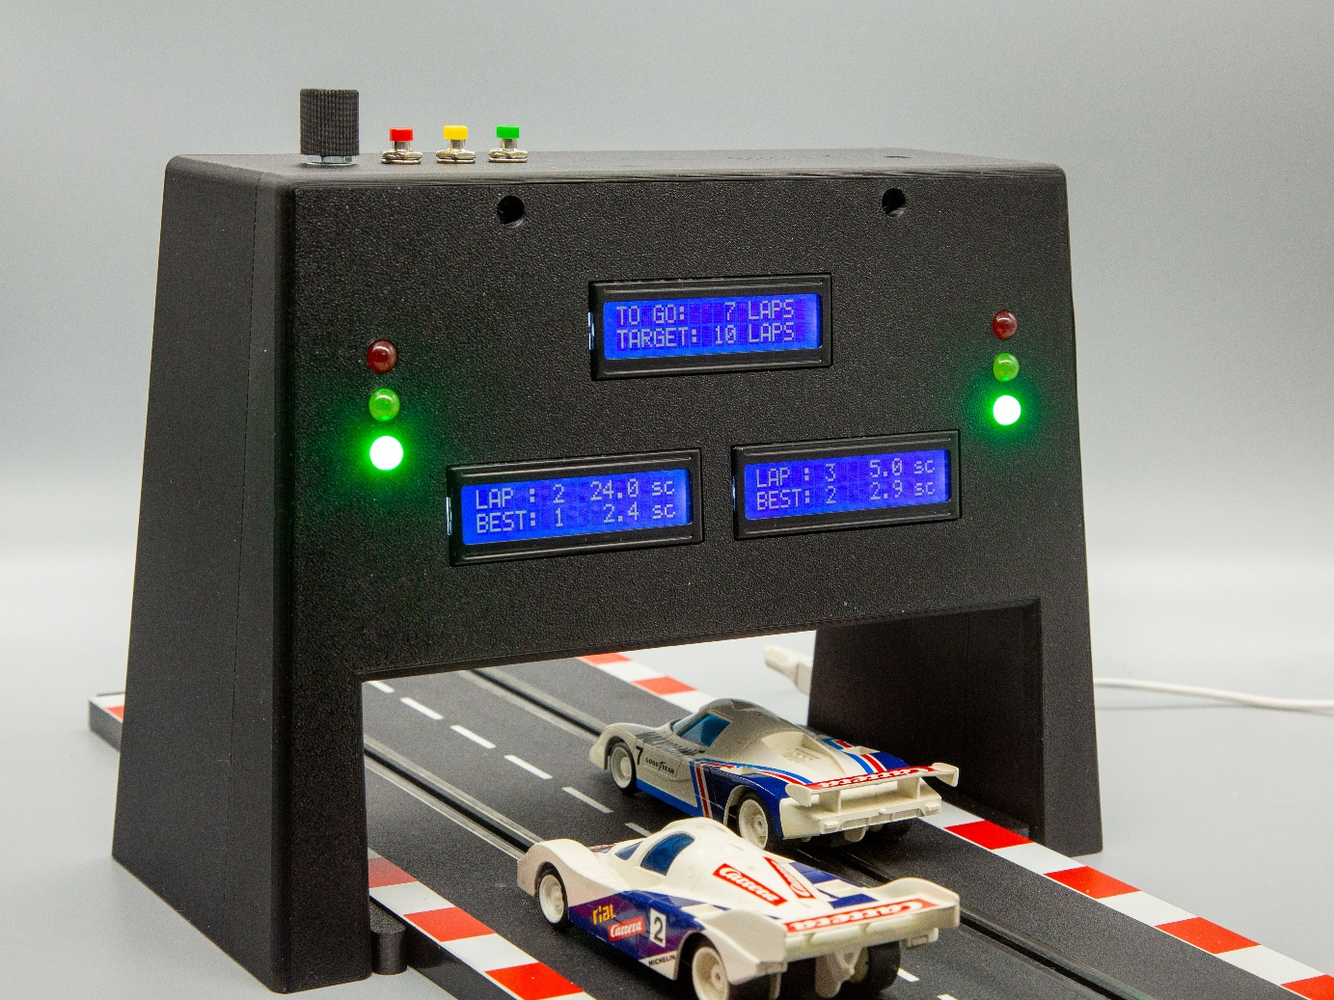

Carrera Race Monitor (CRM) is a device which allows monitoring slot car races.
You can use it to count laps with lap times and fastest laps for up to two tracks
CRM supports different race modes, such as open races, lap-limited or time-limited races.
Optionally, you can activate start-control with phases of car-lineup, traffic-light controlled start and false start control.
With start-control activated, you may also configure handicaps which delay the start on one track with respect to the other by a certain number of seconds.
Configured settings can be saved as default for future CRM starts.
CRM is multilingual and supports language switch during operation.
Currently supported languages are English and German, however the infrastructure for translation is part of the system and can be used by end users for adding new languages or modifying existing ones.
All functions and configurations are accessible through simple push buttons and a selector button.
CRM can be adjusted to different track widths. It supports most of the Carrera models but is not restricted to this brand.
While the current version is restricted to functions included in the CRM bridge itself, future software extensions may include web access through mobile devices such as a tablet as well as support of an integrated camera.

This document is the User Guide for Carrera Race Monitor.

Carrera Race Monitor is built from a 3D printed housing with off-the-shelf electronics components controlled by a Raspberry Pi Zero. The software is written in Python and Flask.
Required parts, print files and assembly instructions are described in a separate document (CRM_Assembly_Instructions.pdf).

  - Table of Contents
1 Device Description 4
2 Starting Carrera Race Monitor 6
2.1 Connecting with a Browser 6
3 Competition or Solo 6
4 Race Modes 7
4.1 Circuit Display 7
4.2 Race Start 7
4.3 Track Display 7
4.4 Race End 8
5 Start Control 9
5.1 Car Lineup 9
5.2 Ready to Start 9
5.3 Start 9
5.4 False Start 10
5.5 Start Control with Handicap 10
6 Configuration 11
7 Sensor Calibration 13
7.1 Access to Potentiometer 13
7.2 Preparation 13
7.3 Calibration Process 13
8 Internationalization 14
8.1 Convenience Scripts 14
8.2 Workflow 14
9 Service Installation and Software Updates 15
9.1 Service Installation 15
9.2 Upgrades 16
9.3 Uninstall 16

Device Description

Element | Description
Circuit Display | This display shows general instructions or race information
Track Display | The Track Display shows information specific for a track
Traffic Light | The Traffic Light signals a starting countdown for a track.  In case of a handicap, the start times can be different for the tracks
Adjustable Sensor Support | The supports for the obstacle sensors can be adjusted to the track width:  Outer position: 100 mm (Evolution, Digital 132, Digital 124)  Inner position: 60 mm (GO!!!, GO+, Digital 143)  Marked position: 71 mm (Carrera Profi)
Obstacle Sensors | These sensors are used to detect cars
Access to Potentiometer | The sensors need to be calibrated to track and car height. These holes allow inserting a screwdriver to adjust the sensor's poti.
USB-C Socket | For power supply
Reset Button | Pressing this button enters the configuration menu.  Pressing the button twice within a few seconds will switch off displays and traffic lights
Restart Button | Pressing this button will restart a race with the current race settings.  All counters will be reset.
Start Button | This button will only be activated during automatic start control if cars are aligned and detected by the sensor.  Pressing the button will initiate the start sequence with red, yellow and green phases.
Select Button | This button is only activated after the Reset Button has been pressed.  Turning the button allows changing the option for the current menu item.  Pressing the button confirms the selection and switches to the next menu item.  Pressing the Restart Button at any time will terminate the configuration modus, deactivate the Select Button and start a new race with the current settings.
Buzzer Opening | this is where the buzzer is located
Camera Mount | This can be used for attachment of a Raspberry Pi Camera with the cable guided through the camera cable outlet.

Starting Carrera Race Monitor
Connect a USB-C power supply to the USB-C socket.
While the system is starting up, the LCD displays will show
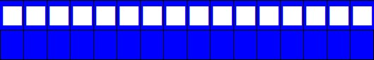
and some of the traffic lights may be light.
After about 40 sec, the services (see chapter 9) will start up and the displays will show their default setup as described below.

Connecting with a Browser
Carrera Race Monitor provides a Web UI through the crm_client service.
You can connect from a browser with
http://<host>:5100
NOTE: The web UI is currently not yet implemented and just shows dummy information.

Competition or Solo
While normally both tracks of a circuit are in use, you can also switch to single-track and choose the track to be used (see Configuration menu item 1):
If only a single track is activated, any handicap (see chapter 5.5) which might have been configured previously will be cleared and Configuration menu item 4 will be skipped.

Race Modes
CRM supports 3 different race modes (see Configuration menu item 2):
- OPEN
Races are open ended.
This is the default mode.
- LAPS
Races are limited by the configured number of laps.
When the first car has finished this number of laps, the race is finished
- TIME
Races are limited by the configured time in minutes.
When the time limit is reached, the race is finished

Circuit Display
The race mode is shown in the circuit display:
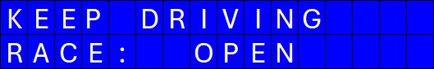
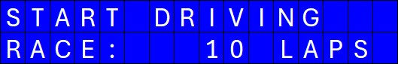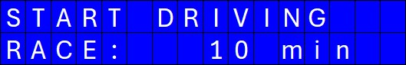

Race Start
For mode OPEN, there is no explicit race start.
For LAPS and TIME, the race starts when the first car passes the sensor for the first time.
The circuit display will then show the remaining laps:
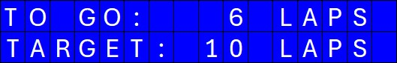
or the remaining time:
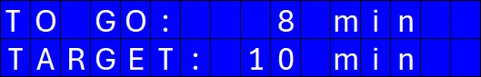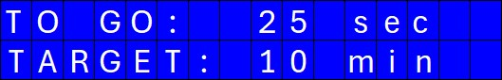
For times larger than 1 minute, the rounded number of minutes is shown.
If the remaining time is less than a minute the remaining seconds are shown.

Track Display
When Start-Control is disabled, and a new race is started by pushing the RESTART button, the track display will be empty:
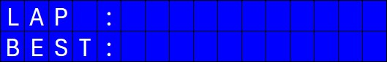
The race will start when the car has passed the CRM Sensor for the first time:
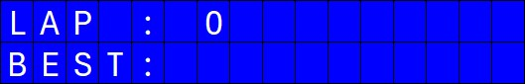
Afterwards, the CRM will count the number of laps and display the time used for the last lap.
It will also show the fastest lap together with its lap time:
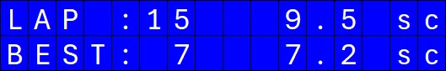

Race End
For mode OPEN, a race never ends.
For mode LAPS the race ends when the first car has finished the requested number of laps.
For mode TIME, the race ends when the specified time has passed by.
The circuit display shows
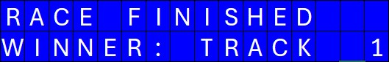
If sound is enabled (see Configuration menu item 5) a fanfare sound is played.
The winner is the track with the largest number of laps finished.

Start Control
For a controlled start, start-control can be enabled (see Configuration menu item 3).
If activated, a race start will go through the following phases:
- Care lineup
- Traffic-light phase
- Start on green with false-start check

Car Lineup
The circuit display will request lining up cars:
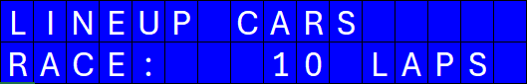
The track displays, when no car is detected, will show:
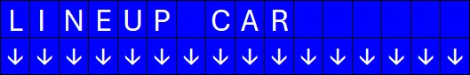
or, when a car is detected:
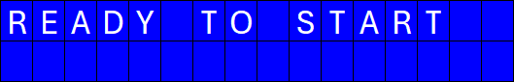

Ready to Start
If both track sensors detect a car, the circuit display will signal that the race can be started:
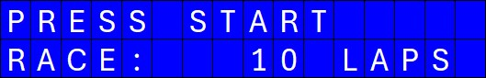

Start
To continue with the start procedure, the green START button must be pressed.
This will start the traffic light phase with
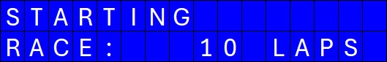
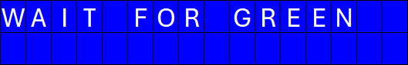
At the same time, the traffic lights will run through
- red
- red + yellow
- green
with a delay of 2 seconds between each step.
The race starts after green has been shown.
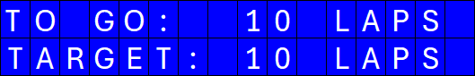
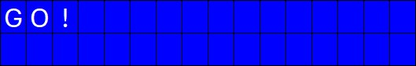

False Start
If a car leaves its position before green has been shown, the track is marked as false start:
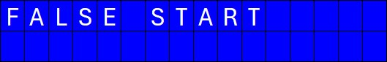
If sound is enabled (see Configuration menu item 5), an alarm sound is played.
After a few seconds CRM returns to car lineup (chapter 5.1)

Start Control with Handicap
CRM supports assigning a handicap of a few seconds to one of the tracks (see Configuration menu 4).
Turning SELECT to the left increases the handicap for Track 1, turning right increases the handicap for Track 2.
The handicap for a track has an effect during start (chapter 5.3):
While the red traffic light is turned on for both tracks at the same time, the yellow and subsequently the green phase will start later for the track with the handicap by the specified number of seconds.

Configuration
- Press the RESET Button to enter the configuration menu.
- At any menu item, use the SELECT button to choose an option.
- Then push the SELECT button to proceed to the next menu,
or push the RESTART button to start a race with the selected options.
1. | 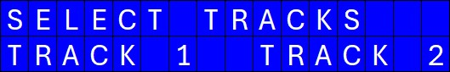
 |  | 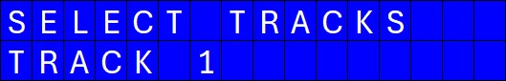
 |  | 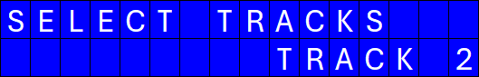
2. | 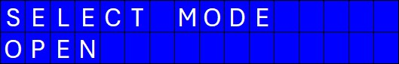
 |  | 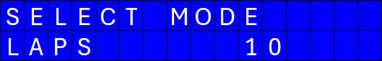
 |  |  | 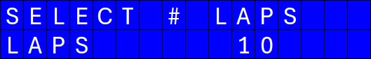
 |  | 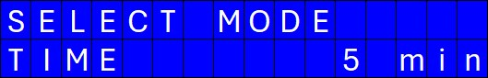
 |  |  | 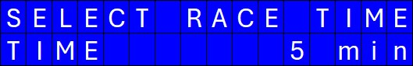
3. | 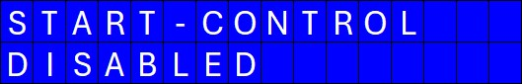
 |  | 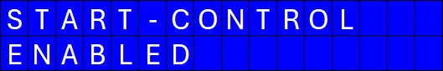
4. | 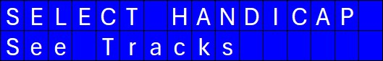
 |  | 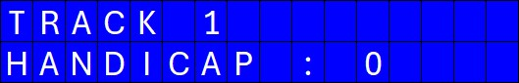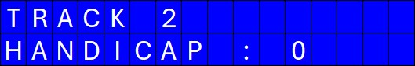
 |  | 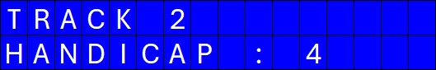
5. | 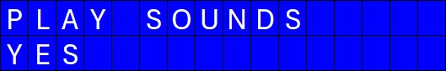
 |  | 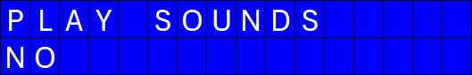
6. | 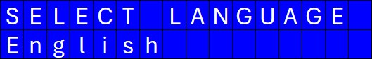
 |  | 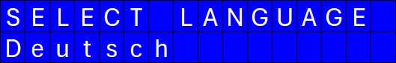
7. | 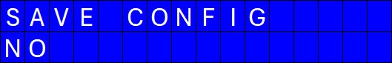
 |  | 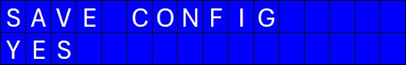 |  | Note that the configuration will only be saved after pushing SELECT button when YES is selected.

Sensor Calibration
The detection range of the obstacle sensor for car detection needs to be adjusted to your specific setup.

Access to Potentiometer
For each track, the potentiometer for adjustment of the detection range is accessible through a hole in the sensor support:
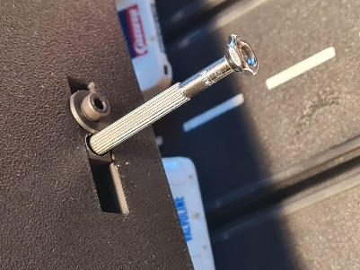

Preparation
Have 2 cars available for calibration.
Configure the following settings (see chapter 6):
No Handicap
Then, press the yellow RESTART button.

Calibration Process
If a track sensor does not recognize a car, the track display will show:
If a car is detected, it will show:
Turn the potentiometer until the display shows car detection when a car is placed underneath and no detection when there is no car.

Internationalization
The user interface of Carrera Race Monitor supports multilingual features through Python Babel. The required infrastructure has been installed together with Carrera Race Monitor.
This chapter describes how to set up new languages and how to adapt translations.

Convenience Scripts
Convenience scripts for UI translation are located at
$HOME/scripts
where
$HOME = ~/prg/Carrera_Race_Monitor
is the home directory for Carrera Race Monitor.
- init_language.sh
initializes a new language if it does not yet exist.
- extract_translations.sh
extracts multilingual strings for all currently installed languages.
If translations had already been extracted for a language they will be updated, if necessary.
- compile_translations.sh
is used to compile all translated files. This is necessary to apply translations.

Workflow
- Connect to the CRM using SSH:
ssh <user>@<host>
with <user> and <host> as specified during Raspberry Pi setup.
- Activate the project's virtual environment
cd prg/Carrera_Race_Monitor
source .venv/bin/activate
- Initialize a new language
This needs to be done only once for each language
scripts/init_language.sh <lang_code>
where <lang_code> is the 2-letter language code, such as "en", "de", "fr".
You can find resources for available languages under $HOME/code/locales.
- Extract translations
This will extract the text strings to be translated from source code and update language-specific translation files (messages.po)
scripts/extract_translations.sh
- Translate the messages in the language-specific messages.po
You need to translate all new entries as well as those with a "#, fuzzy" marker.
Remove the "#, fuzzy" marker after translation.
Note that texts to be displayed on the 16 character LCD displays are always given in the required length, filled up with spaces, if necessary.
Therefore, translations must not exceed the length of the msgid strings.
- Compile translated messages:
scripts/compile_translations.sh
- Restart the system

Service Installation and Software Updates
The Carrera Race Monitor software has already been installed during system assembly to execute device tests (See CRM_Assembly_Instructions).

Service Installation
To automatically start Carrera Race Monitor when the system is powered up, it is necessary to install and enable two services:
- crm_server.service
runs the server software
- crm_client.service
runs the client to which you can connect with a browser
Service installation is automatically done using the automated installer in a ssh session:
bash <(curl -fsSL https://raw.githubusercontent.com/signag/Carrera_Race_Monitor/main/scripts/install_Carrera_Race_Monitor.sh)
If the installer is run on a system where Carrera Race Monitor is already installed, the following option will be offered:

===================================================
=== Carrera_Race_Monitor Automated Installer ===
=== ===
=== Exit at any step with Ctrl+C ===
===================================================

RPI Model : Raspberry Pi Zero 2 W Rev 1.0
Detected OS codename: trixie full
Hostname : raspi12

Running as user : sn
Installing at : /home/sn/prg

=====================
Installation Mode
=====================
Installation Path : /home/sn/prg/Carrera_Race_Monitor (exists)
Service Status Server : crm_server.service (not configured)
Service Status Client : crm_client.service (not configured)

A Carrera_Race_Monitor installation exists already.

Do you want to skip update of Carrera_Race_Monitor and software stack and only reconfigure the services[Y/n]:

If you confirm with "y" or <Enter>, the software update will be skipped and only the services will be configured and enabled.

Upgrades
To upgrade to a new version of Carrera Race Monitor or to install bugfixes, just run the installer again:
bash <(curl -fsSL https://raw.githubusercontent.com/signag/Carrera_Race_Monitor/main/scripts/install_Carrera_Race_Monitor.sh)
The Installer will now show:
===================================================
=== Carrera_Race_Monitor Automated Installer ===
=== ===
=== Exit at any step with Ctrl+C ===
===================================================

RPI Model : Raspberry Pi Zero 2 W Rev 1.0
Detected OS codename: trixie full
Hostname : raspi12

Running as user : sn
Installing at : /home/sn/prg

=====================
Installation Mode
=====================
Installation Path : /home/sn/prg/Carrera_Race_Monitor (exists)
Service Status Server : crm_server.service (running, will be stopped)
Service Status Client : crm_client.service (running, will be stopped)

A Carrera_Race_Monitor installation exists already.

Do you want to skip update of Carrera_Race_Monitor and software stack and only reconfigure the services[Y/n]:

Replying with "n" will now
- Stop running services
- Run through the complete installation procedure, updating Carrera Race Monitor as well as required packages to the latest version
- Remove and reinstall the services.

Uninstall
For uninstalling Carrera Race Monitor, run
bash <(curl -fsSL https://raw.githubusercontent.com/signag/Carrera_Race_Monitor/main/scripts/uninstall_Carrera_Race_Monitor.sh)

Troubleshooting

Car passage not recognized
If Carrera Race Monitor does not recognize a car passing with high speed while it is recognized when passing with low speed, you can try reducing the bounce_time parameter for the track sensors:
In ~/prg/Carrera_Race_Monitor/config edit crm_config.json:
…
"devices": {
…
"SNS_Track_1": {
"type": "Obstacle_Sensor",
"params": {
"GPIO_pin": 14,
"bounce_time": 0.01
}
},
"SNS_Track_2": {
"type": "Obstacle_Sensor",
"params": {
"GPIO_pin": 18,
"bounce_time": 0.01
}
},
…

