Carrera Race Monitor
  - Assembly Instructions

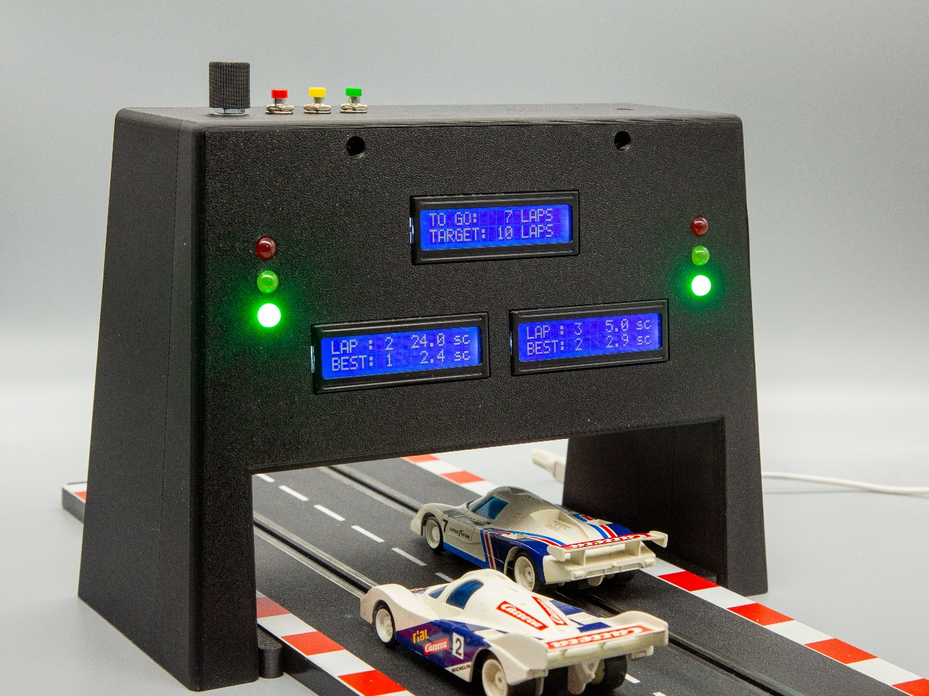

  - Table of Contents
1 Preparation 4
1.1 Parts 4
1.2 Stock Items 5
1.3 Tools 6
2 Prepare Raspberry Pi Zero 7
2.1 Automated Installer Steps 8
2.1.1 Preparation 8
2.1.2 Protocol 8
3 Print required Parts 10
4 Prepare Devices 11
4.1 LCD Displays 11
4.2 Prepare Board for Logic Level Shifter 12
4.2.1 Board Layout 12
4.3 Traffic Light Modules 14
4.4 Obstacle Sensor 14
4.5 Push Buttons 14
4.6 Rotary Encoder 15
4.7 Active Buzzer 15
5 Prepare Cabling 16
5.1 Electrical Layout 16
5.2 Device-GPIO Connections 17
5.3 GPIO Header Usage 18
5.4 Cable Connections 19
5.4.1 Prepare 40-Pin Rainbow Ribbon Cable 19
5.4.2 General 20
5.4.3 LCD to Level Shifter Board Connection 20
5.4.4 LCD to Raspberry Pi Connection 20
5.4.5 Traffic Light Connection 21
5.4.6 Obstacle Sensor Connection 21
5.4.7 Buzzer Connection 22
5.4.8 Push Button Connections 22
5.4.9 Rotary Encoder Connection 23
5.4.10 Final 40-Pin Rainbow Cable 23
6 Test Connections 24
7 Assemble the System 26
7.1 Press Threaded Inserts 26
7.1.1 Top Connectors 26
7.1.2 Bottom Connectors 26
7.1.3 Camera Adapter 27
7.2 Assemble Front Part 28
7.3 Assemble Back Part 29
7.3.1 USB Cable 29
7.3.2 Rotary Encoder 29
7.3.3 Push Buttons 30
7.3.4 Buzzer 31
7.3.5 Mount Raspberry Pi 32
7.3.6 Preparing the Obstacle Sensors 33
7.3.6.1 Press Threaded Inserts 33
7.3.6.2 Mount Obstacle Sensors 34
7.3.7 Mounting Obstacle Sensors 35
7.4 Connect and Test 36
7.5 Close Housing 36
7.6 Final Test 36
8 Adapting the Configuration 37

Preparation

Parts
Part # | Description | Model | Req. | Source | Sales Qnty | Price | Cost | Remark
#01 | Raspberry Pi | Zero WH | 1 | https://amzn.eu/d/0cRGxUfx | 1 | 39,99 | 39,99 € | §1, §2, §3, §4
#02 | Micro SD Card | 32 GB or larger | 1 | https://amzn.eu/d/0cVfw0CE | 2 | 30,99 | 15,50 €
#03 | Power Supply | 5V, 2.5 A | 1 | https://amzn.eu/d/03NTup31 | 1 | 9,49 | 9,49 € | §5
#04 | USB-C to Micro USB Adapter |  | 1 | https://amzn.eu/d/0hMWu9zx | 3 | 4,95 | 1,65 €
#05 | LCD Display | AZDelivery 3 x HD44780 16 x 2 LCD Module Display Bundle with I2C Interface | 3 | https://amzn.eu/d/07rp2ziM | 3 | 10,09 € | 10,09 €
#06 | Logic Level Converter 3.3V 5V | TXS0108E | 1 | https://amzn.eu/d/002lTpKL | 6 | 8,69 € | 1,45 €
#07 | Circuit Board | PCB 160 x 100 mm Strip Grid Board Copper | 0,33 | https://amzn.eu/d/06ZO410I | 1 | 5,49 € | 1,81 €
#08 | Traffic Light | AZDelivery Traffic Light Module | 2 | https://amzn.eu/d/0eYiQ6vp | 5 | 5,19 € | 2,08 €
#09 | Obstacle Sensor | Hailege LM393 3-Wire IR Reflective Photoelectric Sensor | 2 | https://amzn.eu/d/00Azx0tn | 10 | 9,59 € | 1,92 €
#10 | Push Button | 7 mm Pre-Wired Mini Momentary Push Button | 3 | https://amzn.eu/d/00PTFzne | 12 | 7,89 € | 1,97 €
#11 | Rotary Encoder | KY-040 Rotary Encoder Module 360° Rotary Encoder with Knob Pack of 5 | 1 | https://amzn.eu/d/02uSWvmZ | 5 | 6,99 € | 1,40 €
#12 | Active Buzzer | Active Buzzer Module DC 3.3V-5V Signal Sound Alarm Sensor Module Low Level Trigger Buzzer Control Board | 1 | https://amzn.eu/d/02J0ZU2s | 3 | 5,49 € | 1,83 €
#13 | 40-Pin GPIO Rainbow Ribbon Cable | ZDE 40-Pin GPIO Rainbow Ribbon Cable Computer Accessories 20 cm Compatible with Raspberry Pi 5 4B 3 2 Model B B+ (Male to Female) | 1 | https://amzn.eu/d/02IsTBP4 | 1 | 6,99 € | 6,99 €
#14 | USB C Cable | USB C 3.1 10Gbps Male to USB C Female Screw Cable for Panel Mounting | 1 | https://amzn.eu/d/0dHg8eoC | 1 | 11,19 € | 11,19 €
#15 | USB-C to Micro USB Adapter | USB-C to Micro USB Adapter [Pack of 3] USB Type C Female to Micro USB Male Quick Charge (Black) | 1 | https://amzn.eu/d/0dyDGZxG | 3 | 4,95 € | 1,65 €
Remarks:
§1 In the project, a Raspberry Pi Zero 2 WH has been used, but a Raspberry Pi Zero WH will do as well.
§2 Make sure to use a Raspberry Pi with on-board Wireless LAN (W)
§3 If available, use a variant with a 40-pin GPIO Header already pre-soldered (H). The pins must be on the front side of the device.
§4 The sales price for a Raspberry Pi Zero, at the time of writing, was unusually high, which is assumed to be due to a shortage of older cheap components due to currently limited production capacity. The usual price for a Zero W is about 17 €, with a little bit more for the Zero 2 W.
§5 The Raspberry Pi Zero has a Micro USB socket. In operation, a USB-C socket will be used for power supply, but during testing an adapter (#04) must be used.

Stock Items
The following list shows required items, which may be available in stock, such as various screws.
Item # | Description | Model | Required | Source | Sales Qnty | Price | Cost
#100 | JST 2.54 mm XH-5 male connector for circuit boards |  | 1 | https://amzn.eu/d/0bRL9IFD | 310 | 7,99 € | 0,03 €
#101 | JST 2.54 mm XH-4 male connector for circuit boards |  | 3 | See #100 | 310 | 7,99 € | 0,08 €
#102 | 24 AWG Solid-Core Wire Kit, PVC-Coated | Fermerry | 0,5 | https://amzn.eu/d/018R1h6N | 45 | 17,29 € | 0,19 €
#103 | JST XH2.54 Socket 2P male | XH 2.54mm Connector Pin Header & Ribbon Cable Kit Compatible JST XH Male 2/3/4/5/6/7/8 Male Housing | 3 | https://amzn.eu/d/0dberzft | 55 | 15,99 € | 0,87 €
#104 | JST XH2.54 Socket 3P male | Included in #103 | 3 | See #103 | 55 | 15,99 € | 0,87 €
#105 | JST XH2.54 Socket 4P male | Included in #103 | 2 | See #103 | 55 | 15,99 € | 0,58 €
#106 | JST XH2.54 Socket 5P male | Included in #103 | 2 | See #103 | 55 | 15,99 € | 0,58 €
#107 | JST XH2.54 Connector 2P female | GTIWUNG 480-Piece JST-XH 2.54 mm Connector Set 2.54 mm Pitch Female Pin Header, 2/3/4/5/6 Pin Housing JST Adapter Cable Male and Female | 3 | https://amzn.eu/d/0hjBtLqG | 480 | 7,99 € | 0,05 €
#108 | JST XH2.54 Connector 3P female | Included in #107 | 3 | See #107 | 480 | 7,99 € | 0,05 €
#109 | JST XH2.54 Connector 4P female | Included in #107 | 5 | See #107 | 480 | 7,99 € | 0,08 €
#110 | JST XH2.54 Connector 5P female | Included in #107 | 3 | See #107 | 480 | 7,99 € | 0,05 €
#111 | 24 AWG Stranded Wire, Silicone | Fermerry 24 AWG Stranded Wire, Silicone, Tinned Copper Wire Coil, 6 Colours/3 m Each, Flexible 24 Gauge Hook-up Electric Cable Kit, 0.2 mm² Cable, Wire, Connection Cable Set, 200 °C, Assortment | 4,2 | https://amzn.eu/d/0j31d7ef | 18 | 15,19 € | 3,54 €
#112 | Dupont connector 3P female | Treki 620pcs Dupont Connector Kit 2.54mm Pitch Dupont Connector Housing 1/2/3/4/5/6 Pin Dupont Male Female Pin Header Dupont Crimp Pins Repair Circuit Board | 3 | https://amzn.eu/d/0aPNh0uM | 620 | 8,99 € | 0,04 €
#113 | Dupont connector 4P female | Included in #113 | 5 | See #113 | 620 | 8,99 € | 0,07 €
#114 | Dupont connector 5P female | Included in #113 | 3 | See #113 | 620 | 8,99 € | 0,04 €
#115 | Cable labels | Caianwin Pack of 200 Cable Labels 10 Colours Waterproof Cable Marking | 20 | https://amzn.eu/d/0dijC8ml | 200 | 4,99 € | 0,50 €
#116 | Heat Shrink Tubing | Eventronic ET1001 Heat Shrink Tubing - Electrical Insulation - Heat Shrink Wrap Cable Sleeves - 5 Colours, 12 Sizes, 560 Pieces | 4 | https://amzn.eu/d/0auIVSY4 | 560 | 7,49 € | 0,05 €

Item # | Description | Model | Required | Source | Sales Quantity | Price | Cost
#150 | Threaded Insert M4x8x6 | 360 x Threaded Insert M2 M2.5 M3 M4 M5 M6 | 2 | https://amzn.eu/d/0fQnbrcJ | 360 | 11,89 € | 0,07 €
#151 | Cylinder Screw M4x16MM | 1230 Piece M2 M3 M4 M5 Screws Set, Cylinder Screws with Hexagon Socket | 2 | https://amzn.eu/d/02jguqhI | 1230 | 10,58 € | 0,02 €
#152 | Threaded Insert M4x4x6 | Included in #150 | 2 | See #150 | 360 | 11,89 € | 0,07 €
#153 | Cylinder Screw M4x8MM | Included in #151 | 4 | See #151 | 1230 | 10,58 € | 0,03 €
#154 | Cylinder Screw M3x6MM | Included in #151 | 19 | See #151 | 1230 | 10,58 € | 0,16 €
#155 | Threaded Insert 1/4"x6.4x8 | Short UNC Thread Insert 1/4 Inch Pack of 20 RX-1/4 Inch 20 x 6.4 | 1 | https://amzn.eu/d/050ffsfM | 20 | 9,99 € | 0,50 €
#156 | USB C Cable | USB C 3.1 10Gbps Male to USB C Female Screw Cable for Panel Mounting | 1 | https://amzn.eu/d/0dHg8eoC | 1 | 11,19 € | 11,19 €
#157 | Cylinder Screw M2.5x8 | 300pcs M2.5 x 3-20mm Hex Socket Cap Screw Set 12.9 Degree Black Alloy Steel Socket Head Cap Screw with Nut | 4 | https://amzn.eu/d/02TtpPMP | 300 | 9,03 € | 0,12 €
#158 | Threaded Insert M4x6x6 | Included in #150 | 2 | See #150 | 360 | 11,89 € | 0,07 €
#159 | M4 x 12 mm Washers | Pack of 60 M4 x 12 mm Plastic Washers Black | 2 | https://amzn.eu/d/05JZ5ayJ | 60 | 4,39 € | 0,15 €

Tools
The following list makes suggestions for tools to be used:
Tool # | Description |  | Model | Required | Source | Sales Quantity | Price | Cost | Remark
#200 | Soldering Equipment | Weller WE 1010 |  | 1 | https://amzn.eu/d/0f4Y4Rm0 | 1 | 163,99 € | 163,99 € | §1
#201 | PCB Clamp | Self-printed |  | 1 | Model from makerworld | 1 |  | 0,00 €
#202 | Fibreglass Eraser | Fibreglass Eraser |  | 1 | https://amzn.eu/d/0c6Nza4S | 1 | 10,70 € | 10,70 €
#203 | Multimeter
#204 | Crimping Tool | Preciva 2220pc DuPont Crimping Tool Crimping Tool Set Fits 0.08-1.5 (AWG28-16) mm Non-Insulated Cable Lugs and Sockets, Suitable for ATX, EPS, PCIE, SATA Power Pins |  |  | https://amzn.eu/d/0852hMcK |  | 36,99 €
#205 | Heat Insert Press | Self-printed |  |  | Model from makerworld
#206 | PH1 Screwdriver with long shaft
#207 | Hex Key Allen Wrench 3.5 mm
#208 | Socket Wrench 10 mm
#209 | Metal Drill Bit 8.0 mm
Remarks:
§1 Any soldering iron, suitable for electronics, will do.

Prepare Raspberry Pi Zero
In this step, you will install the Raspberry Pi OS and afterwards the Carrera Race Monitor software.
- Follow the Raspberry Pi Getting Started Documentation for OS installation using Imager.
NOTE: It is recommended installing the Debian distribution proposed by Imager for your Raspberry Pi device. This is usually the full 64-bit version including desktop. The latest distribution is currently Trixie.
Make sure that the Wi-Fi credentials are correctly entered and that SSH is enabled.
- Once the SD card is written, insert it into the Raspberry Pi Zero and power it up.
Initially, it will take a while until the device is visible in your network.
- Connect to the Pi using SSH:
ssh <user>@<host>
with <user> and <host> as specified during setup with Imager
- Make sure that the system is up to date
sudo apt update
sudo apt full-upgrade
- Run the automatic installer with:
bash <(curl -fsSL https://raw.githubusercontent.com/signag/Carrera_Race_Monitor/main/scripts/install_Carrera_Race_Monitor.sh)
(For details, see below)
- As a result, Carrera_Race_Monitor will have been installed at
~/prg/Carrera_Race_Monitor
with Python scripts located in the code subdirectory

Automated Installer Steps

Preparation

===================================================
=== Carrera_Race_Monitor Automated Installer ===
=== ===
=== Exit at any step with Ctrl+C ===
===================================================

RPI Model : Raspberry Pi Zero 2 W Rev 1.0
Detected OS codename: trixie full
Hostname : raspi12

Running as user : sn
Installing at : /home/sn/prg

=================
Installation Mode
=================
Installation Path : /home/sn/prg/Carrera_Race_Monitor (will be created)

This is the first installation of Carrera_Race_Monitor on this system.
Services will not be installed to allow manual device tests during system assembly.
After successful device tests, you can run the installer again to configure and start the services.

No more questions! Ready to start installation? [Y/n]:
At this step, you can continue or abort the installation.

Protocol
The following is a shortened installation protocol showing the different installation steps:
Creating root directory ...
Created: /home/sn/prg

Checking git ...
git is installed

Cloning Carrera_Race_Monitor ...
Cloning into 'Carrera_Race_Monitor'...
...

Creating virtual environment ...
Created: .venv

Activating virtual environment ...
Virtual environment activated
(.venv)

Installing Flask ...
...

Installing flask-cors ...
...

Installing gpiozero ...
...

Installing libraries for LCD display ...
...

Installing I18n tools ...
...

Installing messaging infrastructure ...
...

Checking I2C interface status ...
...

Virtual environment deactivated
(.venv)

Checking Flask service port ...
Trying port 5100 ...
Using port 5100

Services installation skipped.
This allows manual device tests during system assembly.
After assembly and successful device tests rerun this installer to install the services.
For details refer to CRM_Assembly_Instructions.pdf

If you see errors such as
ERROR: pip's dependency resolver does not currently take into account all the packages that are installed. This behaviour is the source of
these can be ignored.

The first installation on a system will not install services so that you can run device tests during assembly (see chapter 6)
If the I2C interface has been activated during installation, a reboot may be requested.

Print required Parts
You can now print the parts required for your setup.
Download the Carrera_Race_Monintor.3mf from https://makerworld.com/
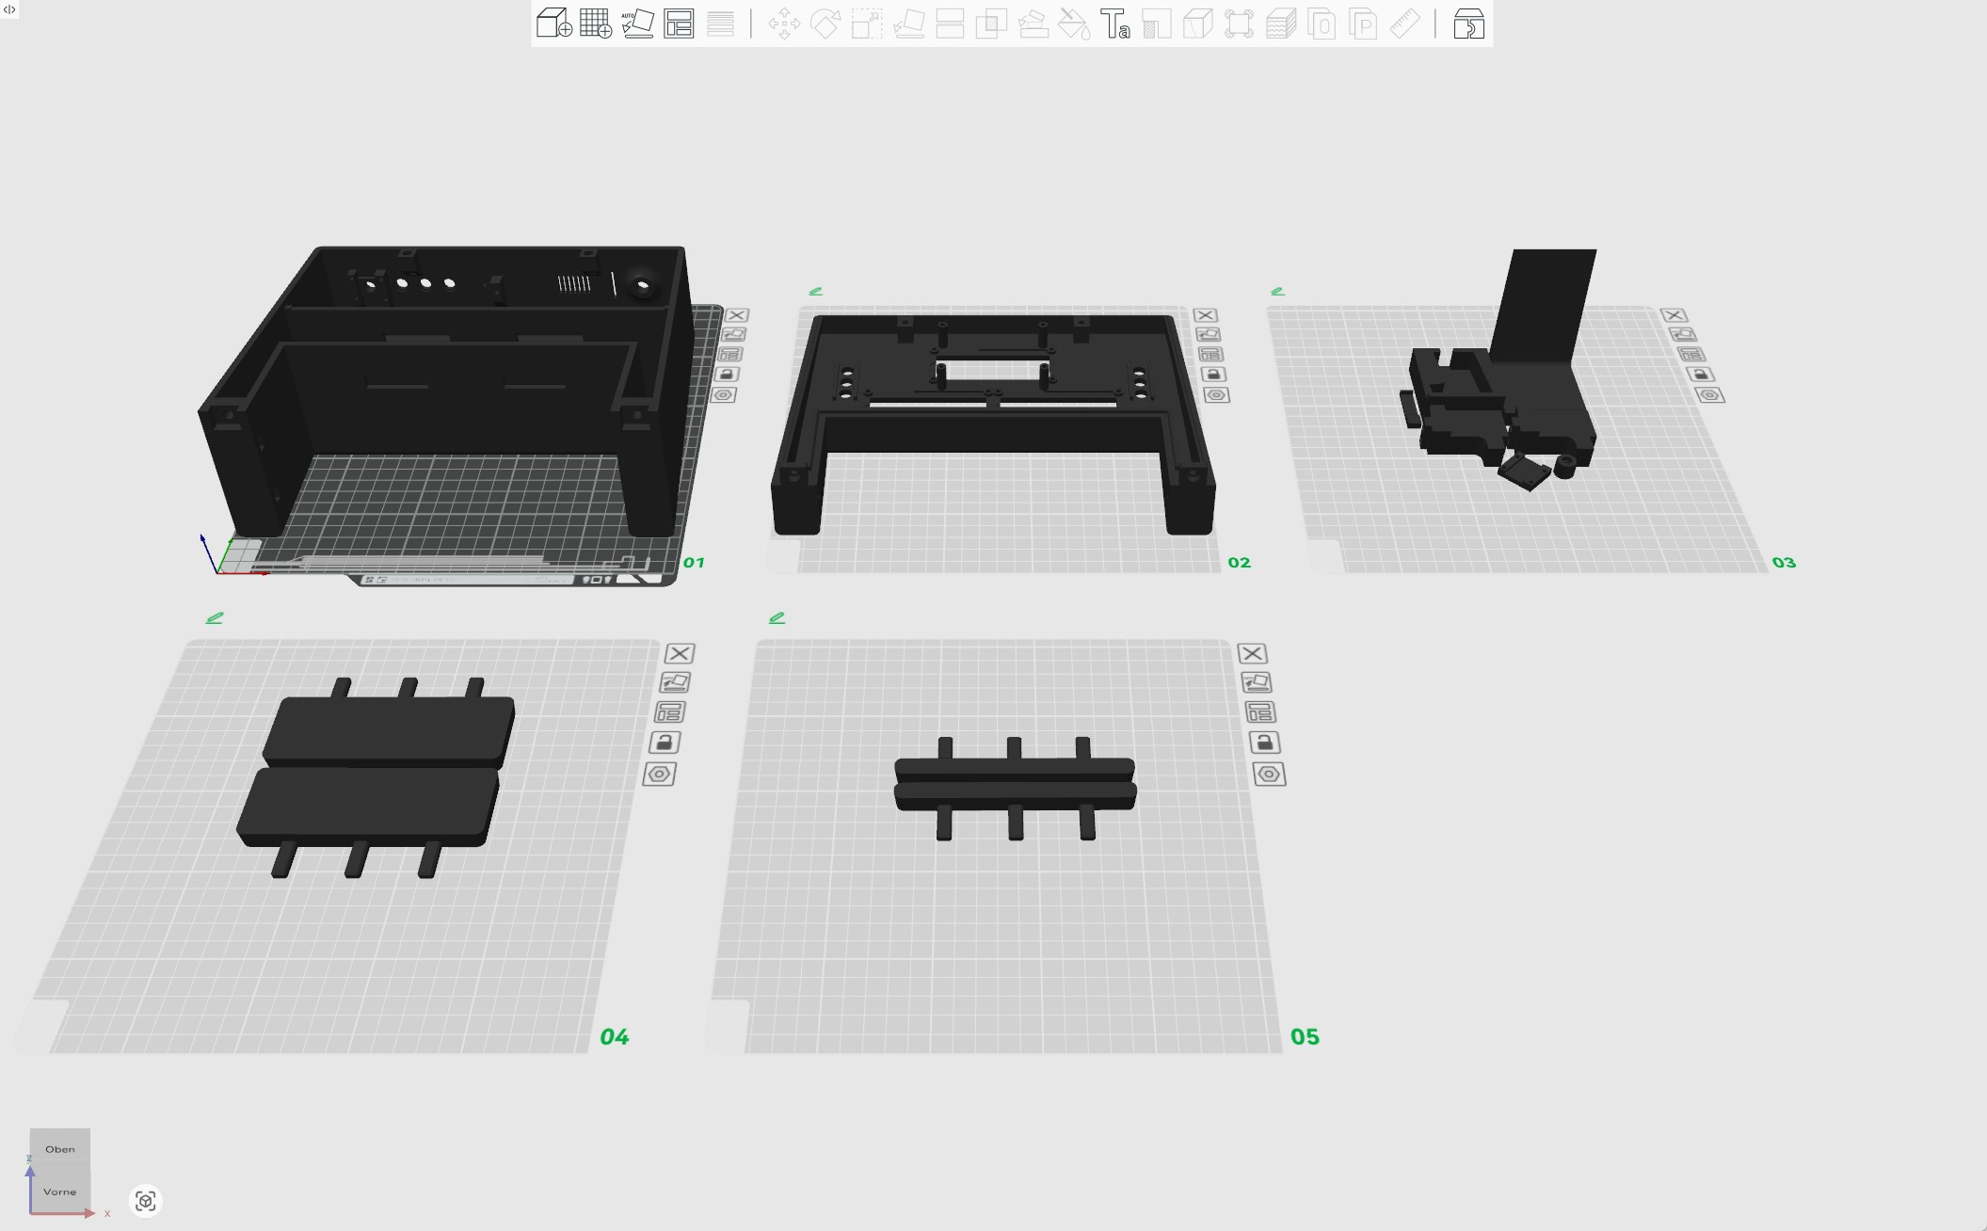
You will need to print all of plates 01, 02, 03.
Depending on the track width of your racetrack, you may also need the spacers on plate 04 (Carrera GO, Carrera GO+, Digital 143) or plate 04 (Carrera Profi).
No spacers are required for Carrera Evolution, Carrera Digital 124 and Carrera Digital 132.

Prepare Devices
In this step you will prepare the devices required for Carrera Race Monitor.

LCD Displays
Required Parts:
- 3 LCD displays (#05) which are bundled together with an I2C adapter
Tools:
- Soldering equipment (#200)
- PCB Clamp (#201)
Self-printed, such as One of the models from Makerworld
- Fiberglass eraser (#202)
Step 1: Connect I2C adapters to LCD displays
To assure equal spacing without contact, use the spacer Spacing_I2C_LCD.stl printed from plate 03.
This will also ensure that you do not need to cut off protruding contacts on the display side.
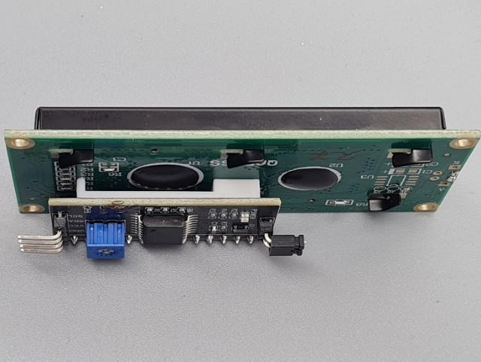
Step 2: Configure individual I2C addresses for each of the LCD displays
Once the I2C adapters have been soldered on the back of the 3 LCD displays, you will need to configure different I2C addresses for each of the displays.
This is done by soldering the pads A0, A1, A2 on the I2C adapters:
- 0x27 : All open
- 0x26 : A0 closed
- 0x25 : A1 closed
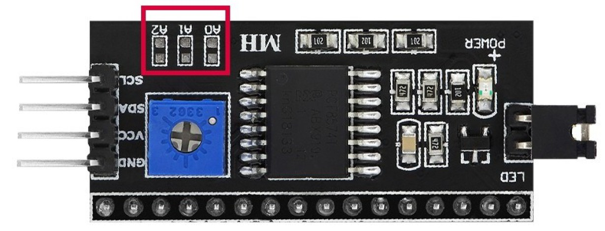
Before soldering, clean the pad with a fiberglass eraser (#202) or fine sandpaper and then wipe with isopropyl alcohol.
Note the address on the device.

Prepare Board for Logic Level Shifter
As the I2C adapter works in the 5V range, whereas GPIO pins only provide 3.3V, a logic level shifter must be used.
The board will allow parallel connection of all 3 LCD displays through JST sockets.
Required Parts:
- Logic Level Converter 3.3V 5V (#06)
- Strip Grid circuit board (#07)
Stock Items:
- 1 JST XH-5 male for circuit board (#100)
- 3 JST XH-4 male for circuit board (#101)
- 24 AWG Solid-Core Wire (black, red, blue, green, yellow) (#102)
Tools:
- Soldering equipment (#200)
- PCP Clamp (#201)
Self-printed, such as One of the models from Makerworld
- Multimeter (#203)

Board Layout
Note that the copper coated side is on the back while the drawing shows it on the front for better transparency.
The additional hole on the right side is for access of the potentiometer of the circuit LCD to allow adjustment of contrast.
- From the strip grid board (#07) cut out a piece as shown in the layout, above
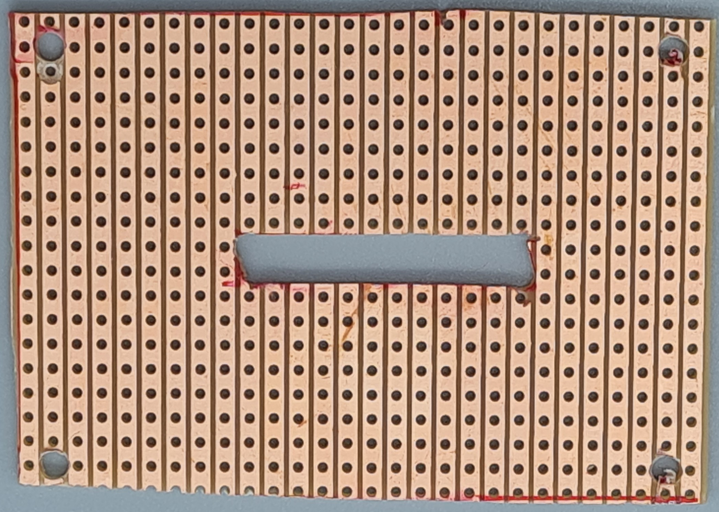
- Drill 3 mm holes at the indicated positions, centered at the grid points.
- Drill an additional 3 mm hole at the position indicated above.
- Use a rest piece of a circuit plate to position the 2 10-pin headers and the level shifter for soldering:
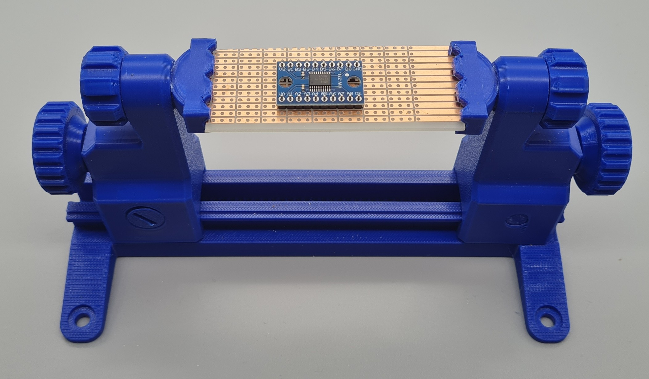
- Place the pre-soldered level shifter, the JST sockets (#100, #101) and the wired connectors (#102) on the non-coated side of the board and fix them.
The JST sockets are best fixed with superglue.
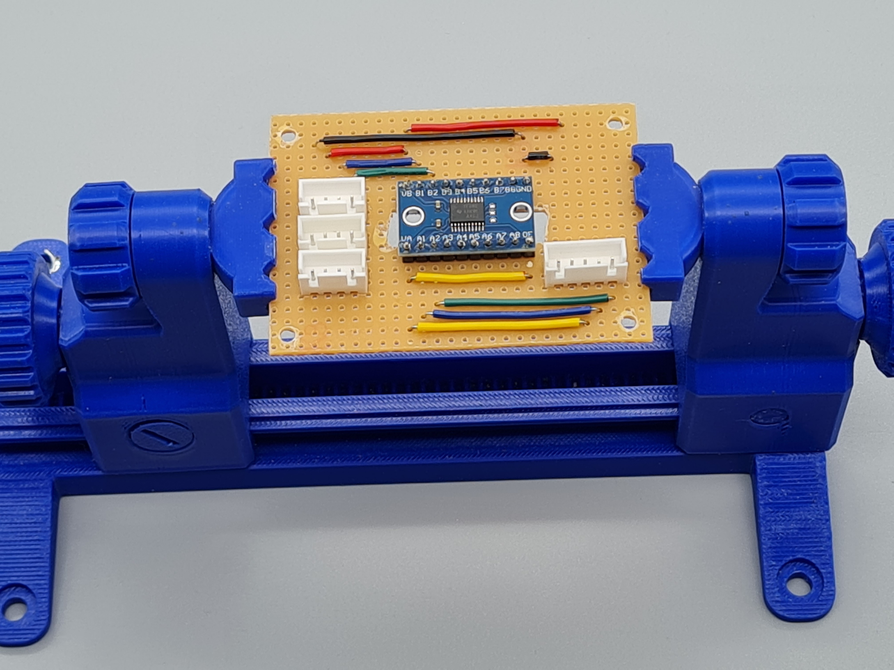
- Solder each of the 57 points on the copper-coated side.
- Check each path for zero resistance using a multimeter (#203).

Traffic Light Modules
Required Parts:
- 2 Traffic Light Modules (#08)
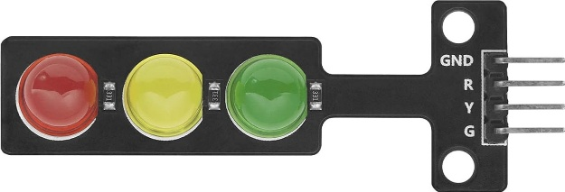

Obstacle Sensor
Required Parts:
- 2 Obstacle Sensors (#09)
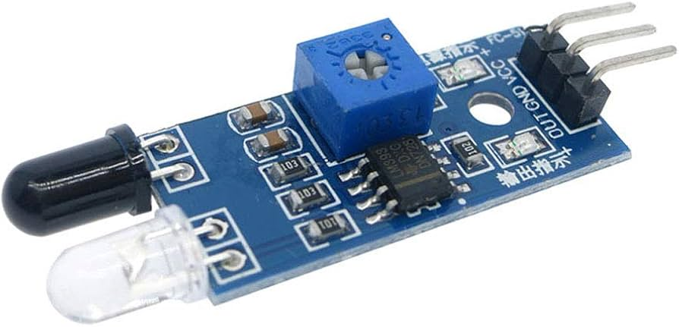

Push Buttons
Required Parts:
- 3 Push buttons (#10) in colors red, green, yellow
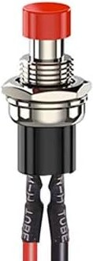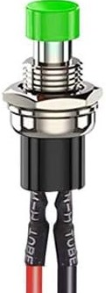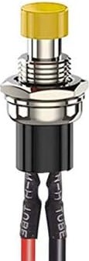

Rotary Encoder
Required Parts:
- 1 Rotary Encoder (#11)
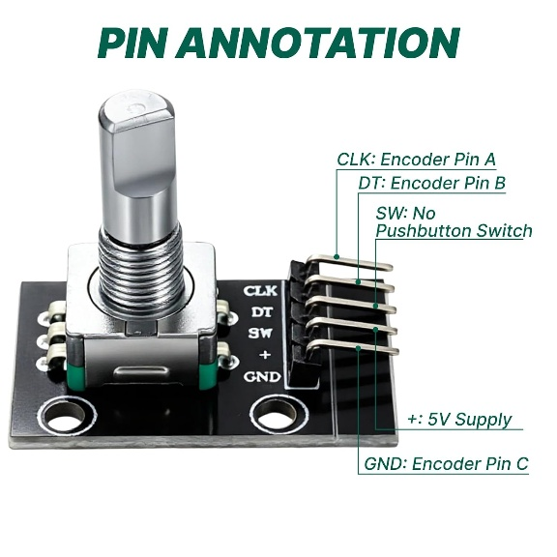

Active Buzzer
Required Parts:
- 1 Active Buzzer (#12)
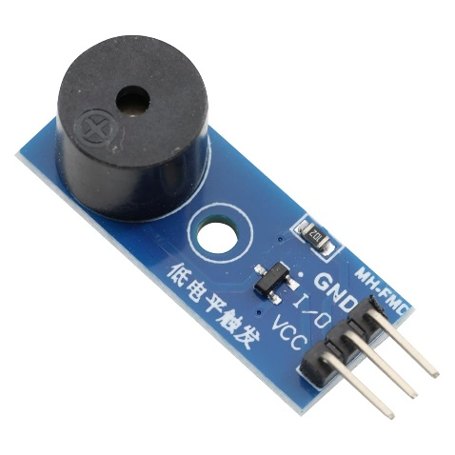

Prepare Cabling

Electrical Layout

Device-GPIO Connections
The following table shows the different devices with their various pins (Pin Out), the GPIO header pins (Pin Board / BCM) to which these need to be connected and the color of the cable to be used (Cable Col).

GPIO Header Usage
The following table shows the number of cables (Cnt) connected to each of the GPIO header Pins.

Cable Connections
From the 40 pins of the GPIO header, 28 will be used for Carrera Race Monitor.
To make the connections pluggable, the following structure will be applied, in principle:
GPIO Header – 40-Pin cable – JST XH male – JST XH female – cable – Dupont Connector

Required Parts:
- 40-Pin GPIO Rainbow Ribbon Cable (#13)
Stock Items:
- Various JST XH2.54 Sockets and Connectors (#103 … #110)
- 24 AWG Stranded Wire, Silicone (#111)
- Various Dupont Connectors (#112 … 114)
- Cable labels (#115)
- Heat Shrink Tubing (#116)
Tools:
- Crimping Tool (#204)
- Multimeter (#203)
- Soldering Equipment (#200)

Prepare 40-Pin Rainbow Ribbon Cable
You can easily identify the board number of a pin to which a cable connects by counting from the right:
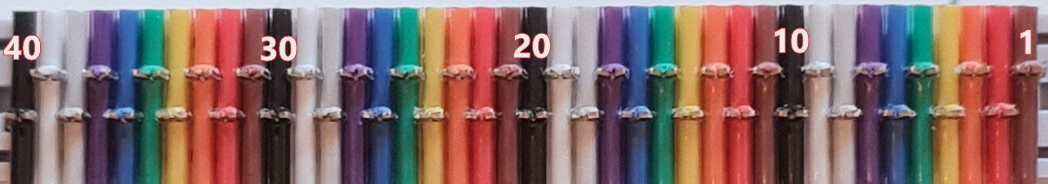
Use the table in chapter 5.3 to identify the required pins/cables
- Cut the 40-Pin Rainbow Ribbon Cable close to the male connector
- Solder 4 cable extensions (#111) (red) to cable 2 (5V)
- Solder 3 cable extensions (#111) (black) to cable 39 (Ground)
- Protect the solder connections with heat shrink tubing in the respective color
- Now, isolate the required cables and crimp a JST XH2.54 Pin on the end, including the 5V and Ground extensions
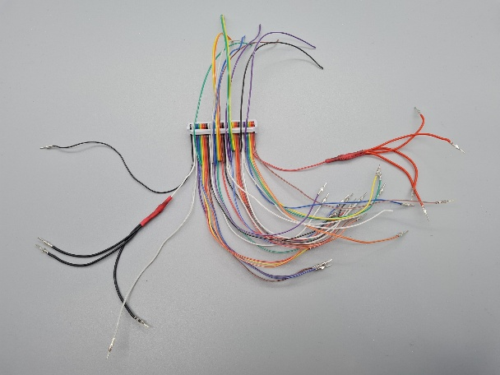

General
Cable connections should follow a consistent sequence of colors/functions, at least on the Raspberry Pi (JST) side:
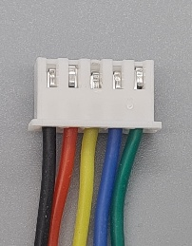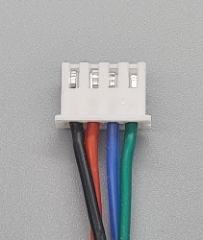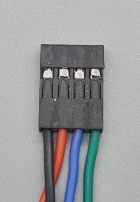
GND(black) - 5V(red) – 3.3V(yellow) – Signal(blue) – Signal (green)
On the device side (Dupont), the sequence depends on the specific device.

LCD to Level Shifter Board Connection
- Crimp 3 sets of 4-strand connection cables (#111) of about 15 cm length with a JST XH 4P female connector (#109) on one side and a 4P Dupont Connector (#113) on the other.
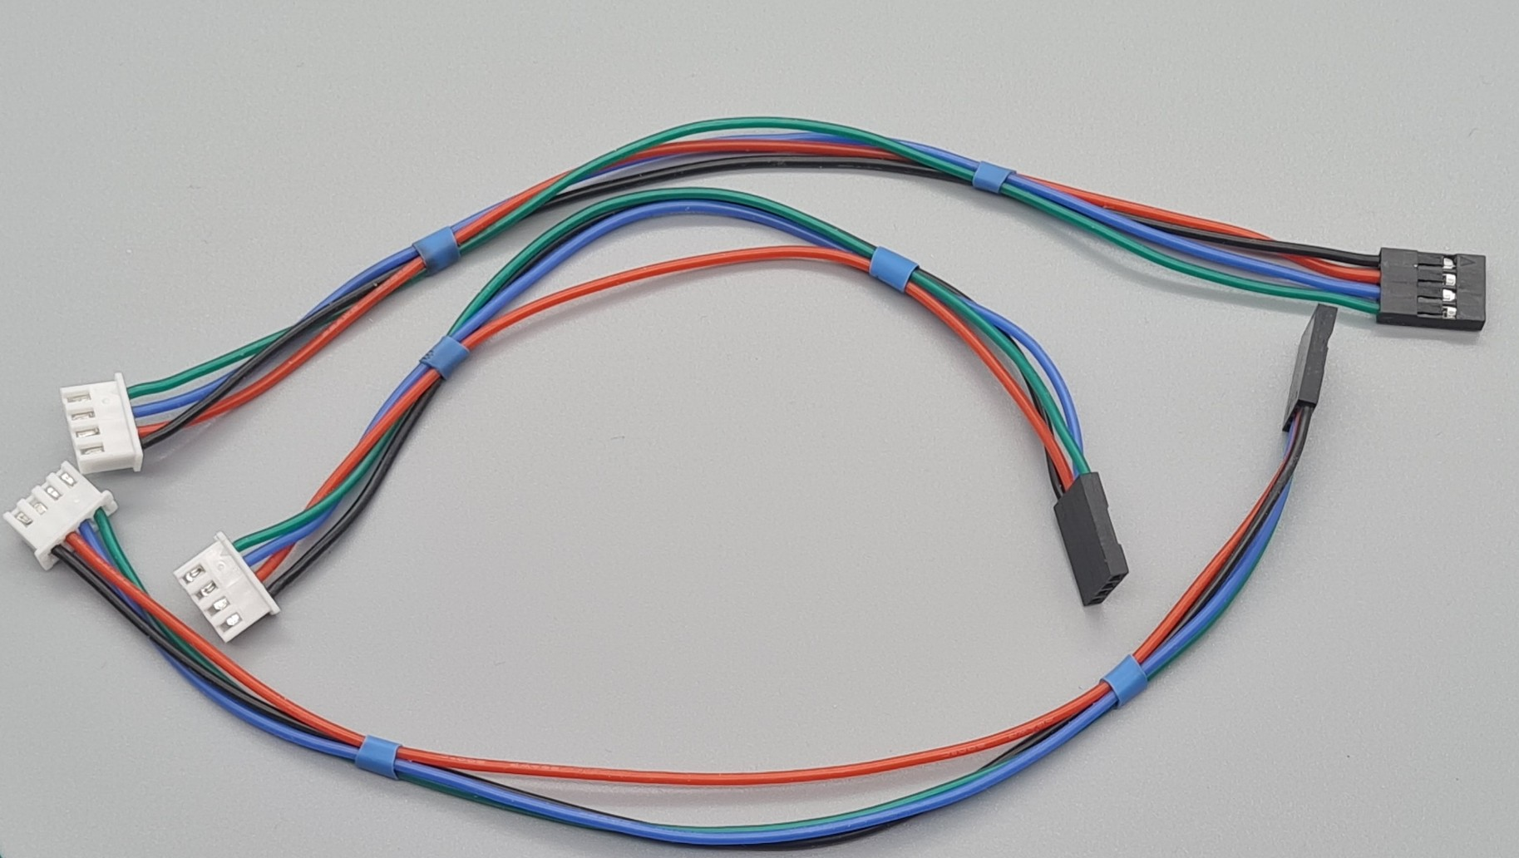

LCD to Raspberry Pi Connection
- Crimp a 5-strand connection cable (#111) of about 20 cm with a JST XH 5P female connector (#110) on each side.
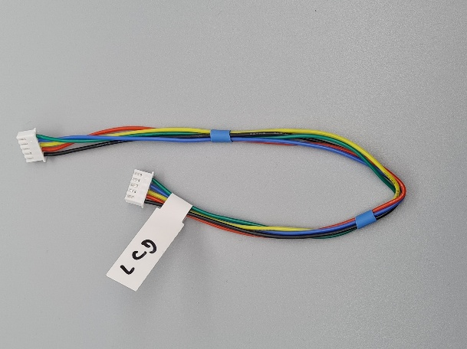
- Combine cables (9, 4, 1, 3, 4) of the 40-Pin Rainbow Ribbon Cable in a JST XH2.54 5P male socket (#106) so that 9 joins the black cable and 4 the green cable of the female connector.

Traffic Light Connection
- Crimp 2 sets of 4-strand connection cables (#111) of about 20 cm with a JST XH 4P female connector (#109) on one side and a 4P Dupont connector (#113) on the other
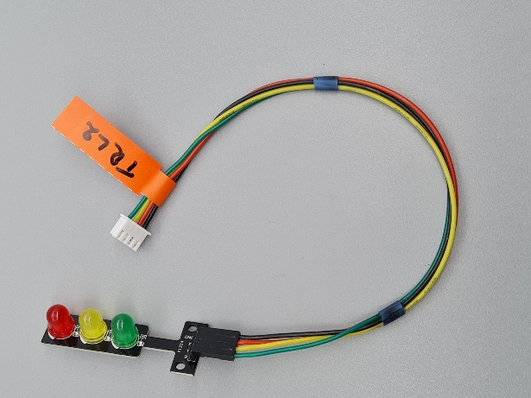
- For Traffic Light 1, combine cables (25, 27, 29, 31) of the 40-Pin Rainbow Ribbon Cable in a JST XH2.54 4P male socket (#105) so that 25 joins the black cable and 31 the green cable of the female connector.
- For Traffic Light 2, combine cables (20, 22, 18, 16) of the 40-Pin Rainbow Ribbon Cable in a JST XH2.54 4P male socket (#105) so that 20 joins the black cable and 16 the green cable of the female connector.

Obstacle Sensor Connection
- Crimp 2 sets of 3-strand connection cables (#111) of about 20 cm with a JST XH 3P female connector (#108) on one side and a 3P Dupont connector (#112) on the other
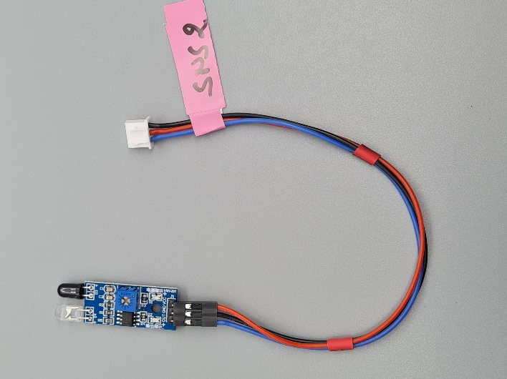
- For Sensor 1, combine cables (6, 2, 8) of the 40-Pin Rainbow Ribbon Cable in a JST XH2.54 3P male socket (#104) so that 6 joins the black cable and 8 the blue cable of the female connector.
NOTE: that the sequence of colors is different on the JST and Dupont side
- For Sensor 2, combine cables (14, 2, 12) of the 40-Pin Rainbow Ribbon Cable in a JST XH2.54 3P male socket (#104) so that 14 joins the black cable and 12 the blue cable of the female connector. .
NOTE: that the sequence of colors is different on the JST and Dupont side

Buzzer Connection
- Crimp a 3-strand connection cable (#111) of about 20 cm with a JST XH 3P female connector (#108) on one side and a 3P Dupont connector (#112) on the other
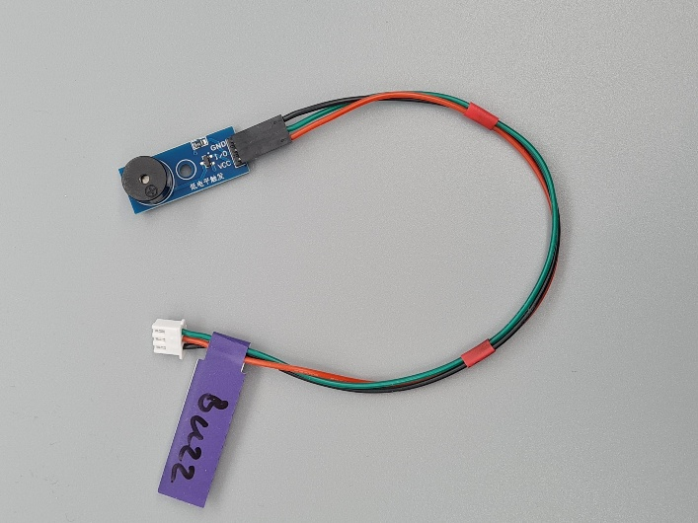
- Combine cables (30, 2, 32) of the 40-Pin Rainbow Ribbon Cable in a JST XH2.54 3P male socket (#104) so that 30 joins the black cable and 32 the green cable of the female connector.
NOTE: that the sequence of colors is different on the JST and Dupont side

Push Button Connections
- For each of the 3 Push Buttons (#10), crimp the available cables with a JST XH 2P female connector (#107)
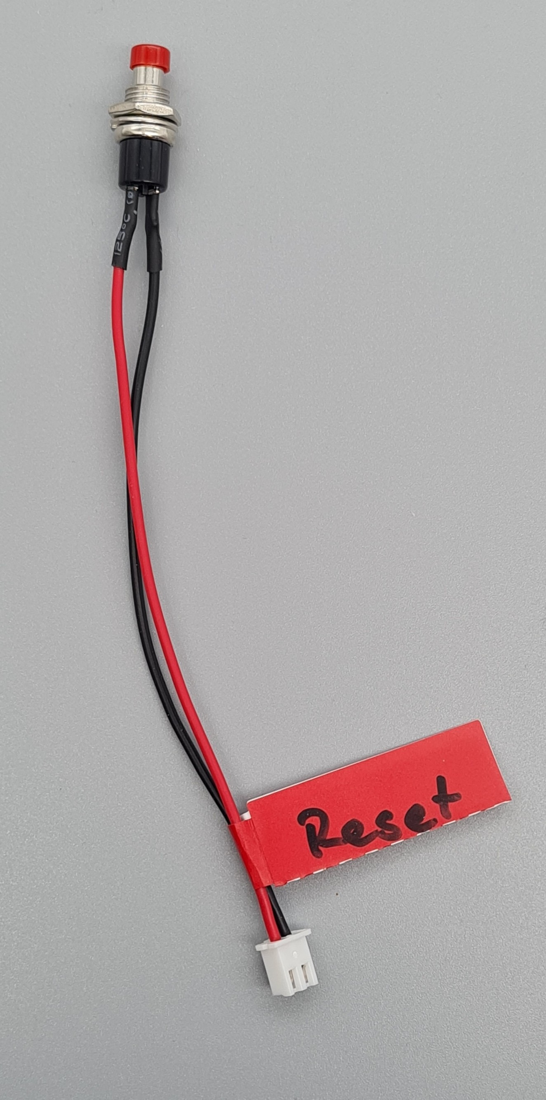 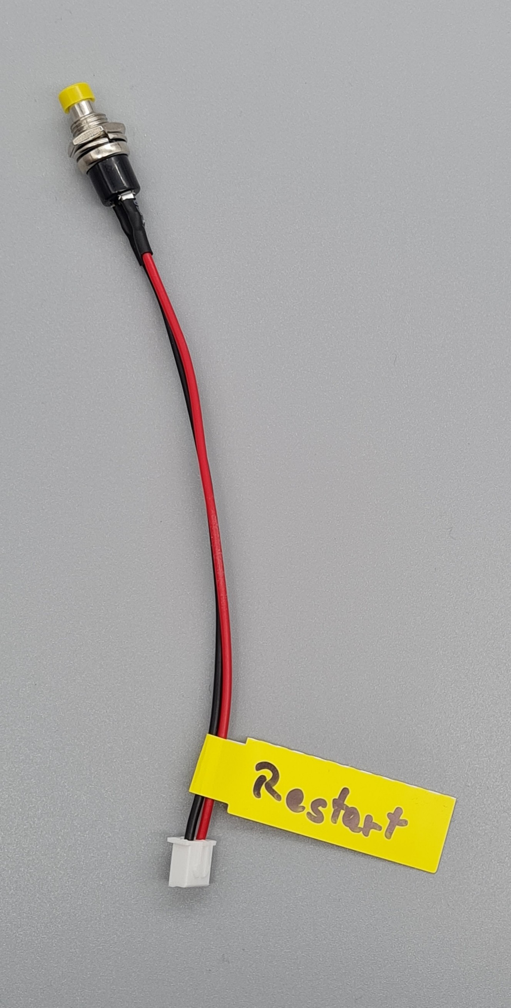 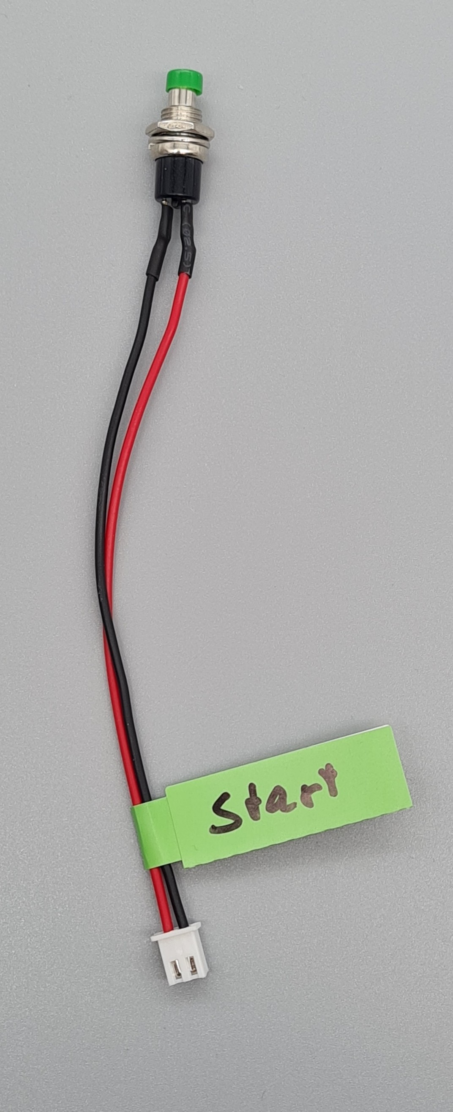
- For the Reset Button, combine cables (39, 37) of the 40-Pin Rainbow Ribbon Cable in a JST XH2.54 2P male socket (#103) so that 39 joins the black cable and 37 the red cable of the female connector.
- For the Restart Button, combine cables (39, 37) of the 40-Pin Rainbow Ribbon Cable in a JST XH2.54 2P male socket (#103) so that 39 joins the black cable and 37 the red cable of the female connector.
- For the Start Button, combine cables (39, 33) of the 40-Pin Rainbow Ribbon Cable in a JST XH2.54 2P male socket (#103) so that 39 joins the black cable and 37 the red cable of the female connector.

Rotary Encoder Connection
- Crimp a 5-strand connection cable (#111) of about 20 cm with a JST XH 5P female connector (#110) on one side and a 5P Dupont connector female (#114) on the other
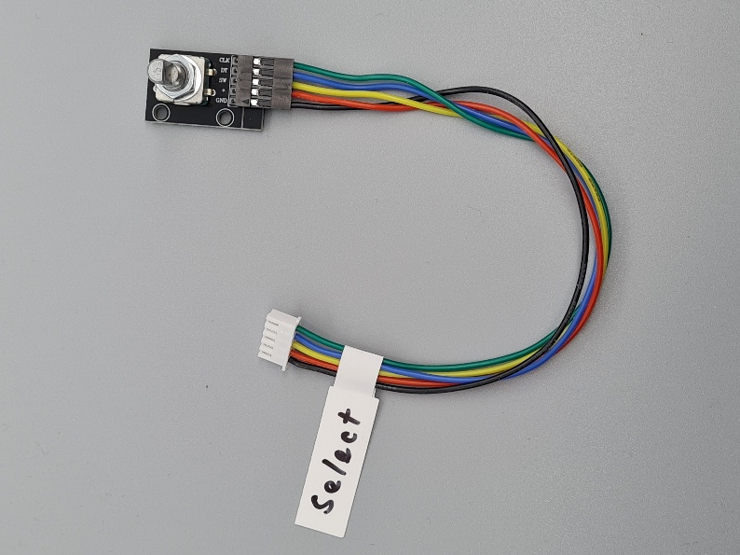
- Combine cables (34, 2, 36, 38, 40) of the 40-Pin Rainbow Ribbon Cable in a JST XH2.54 5P male socket (#106) so that 34 joins the black cable and 40 the green cable of the female connector.

Final 40-Pin Rainbow Cable
Finally, your 40-Pin cable will look like this:
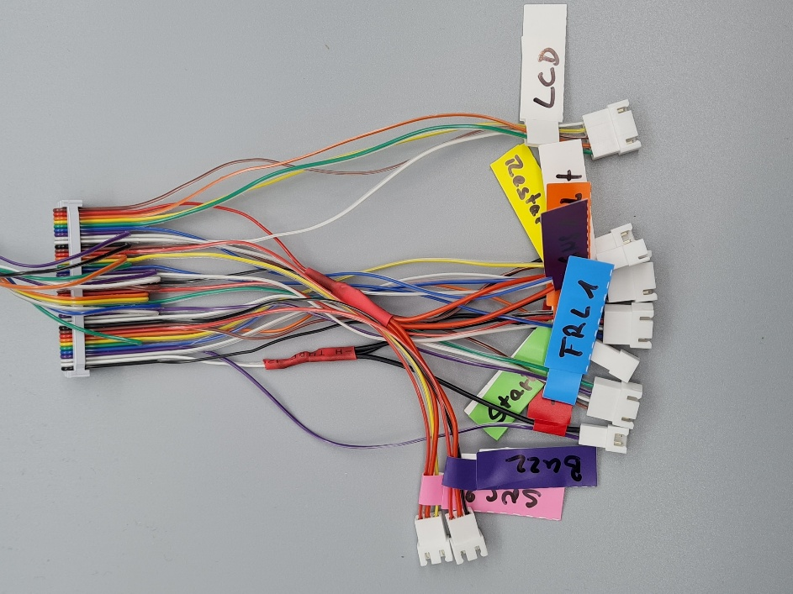

Test Connections
- Connect the 40-Pin cable with the GPIO header of the Raspberry Pi
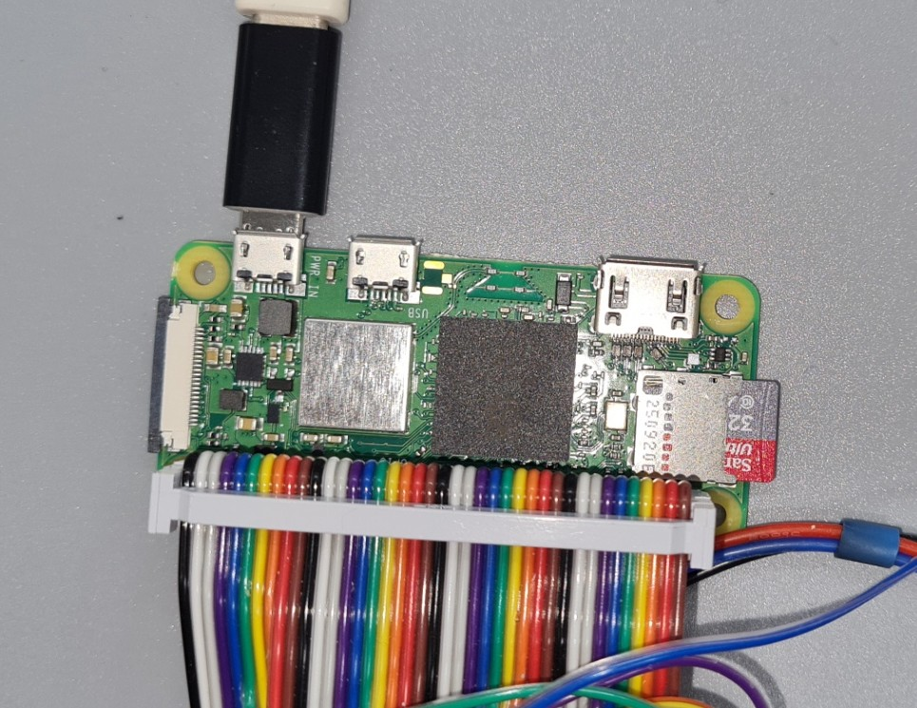
- Connect all devices with their corresponding sockets
- Power up the Raspberry Pi
- Connect through SSH
ssh <user>@<host>
- Check that the LCD displays use the correct I2C addresses:
sudo i2cdetect -y 1
You should see something like this:
0 1 2 3 4 5 6 7 8 9 a b c d e f
00: -- -- -- -- -- -- -- --
10: -- -- -- -- -- -- -- -- -- -- -- -- -- -- -- --
20: -- -- -- -- -- 25 26 27 -- -- -- -- -- -- -- --
30: -- -- -- -- -- -- -- -- -- -- -- -- -- -- -- --
40: -- -- -- -- -- -- -- -- -- -- -- -- -- -- -- --
50: -- -- -- -- -- -- -- -- -- -- -- -- -- -- -- --
60: -- -- -- -- -- -- -- -- -- -- -- -- -- -- -- --
70: -- -- -- -- -- -- -- --
If you do not see this result, you need to check the LCD devices for correct connections and correct address setting.
Probably, you may want to check each device individually using a breadboard.
- Activate the project's virtual environment
cd prg/Carrera_Race_Monitor
source .venv/bin/activate
- Run the Device Test
python code/crm_device_manager.py
The device manager (crm_device_manager.py) ,when started individually, will run an infinite test sequence which can be stopped with <Ctrl+C>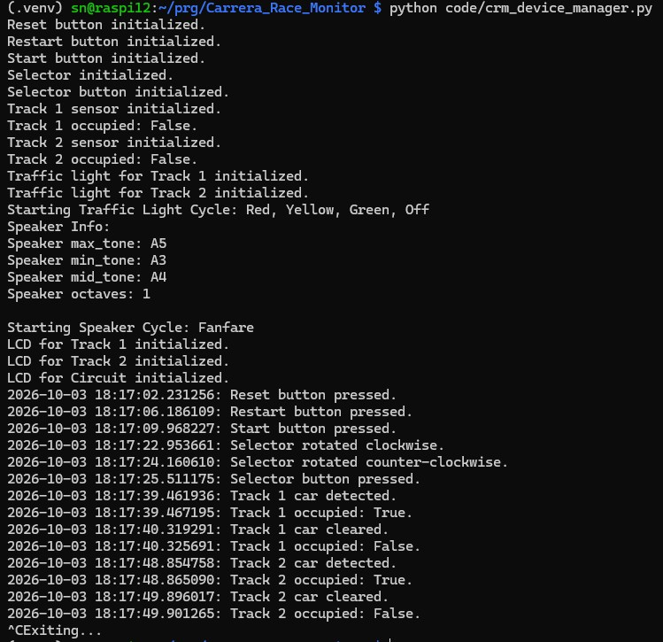
You will need to do the following tests:
- Check the LCD displays:
They should display their identity (Track 1, Track 2, Circuit) together with some additional text. Also, the background light will be switched on and off.
You may need to adjust the contrast using the potentiometer of the I2C adapter.
- Check Traffic Lights:
In a sequence, there should be red, red+yellow, green, off and all blinking.
If one of the colors does not show up brightly, you may need to check cable connections.
- Check Buzzer:
The buzzer will play two sequences (fanfare, alarm) with 5 sec pause.
If you do not hear the sound you may need to check the buzzer connections
- Test Track sensors:
Normally, the visible range of the sensors should be free. Then, after the sensor is initialized, the current status will be logged (Track x occupied: False).
Now you can block the sensor which will be indicated by the sensor's status LED.
At the same time, you should see a log output "Track x car detected" and "Track x occupied: True"
When you release the block, this should also result in a corresponding log output.
If you do not see the log output, you may need to check the cable connections of the failing sensor.
- Test Push Buttons:
Press each button: Red (Reset), Yellow (Restart), Green (Start).
Each button press should issue a log output indicating the button type.
If the log output is missing or the logged button type is wrong, you may need to check the buttons cable connection.
- Test Rotary Encoder:
Turn the encoder button to the left and to the right and push it.
You should see corresponding log output.
If you do not see the log output, you may need to check the cable connection.

Assemble the System

Press Threaded Inserts
Tools:
- Heat Insert Press (#205)

Top Connectors
Stock Items:
- 2 Threaded Inserts M4x8x6 (#150)
- 2 Cylinder Screws M4x16MM (#151)
Use printed item "Back_Stand.stl" from plate 3 for exact vertical orientation of the back part when pressing the insert.
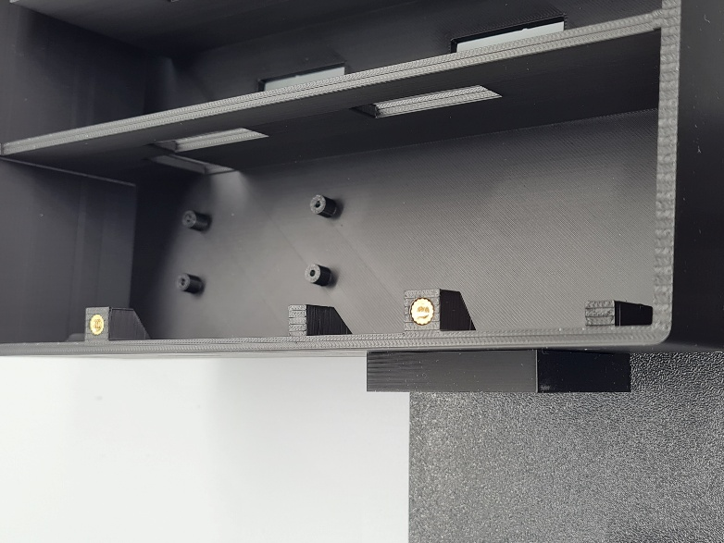

Bottom Connectors
Stock Items:
- 2 Threaded Inserts M4x4x6 (#152)
- 2 Cylinder Screws M4x8MM (#153)
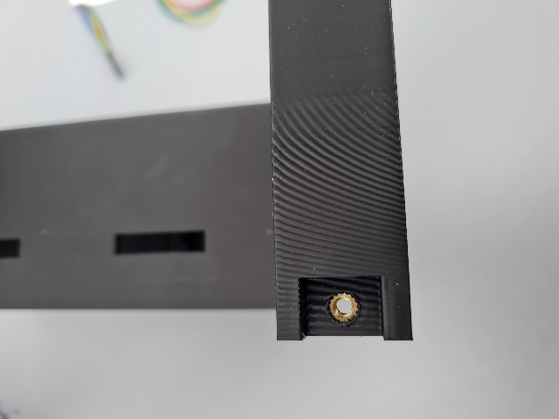

Camera Adapter
The Carrera Race Monitor features an optional Raspberry Pi Camera which can be attached to the top of the housing.
Stock Items:
- Threaded Insert 1/4"x6.4x8 (#155)
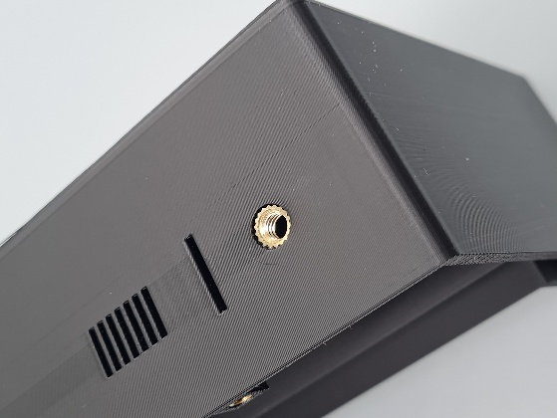

Assemble Front Part
Stock Items:
- 14 Cylinder Screws M3x6MM (#154)

It is recommended mounting the traffic lights with cables already connected.
Assure correct positioning of displays according to their I2C address (25, 26, 27) as shown below.
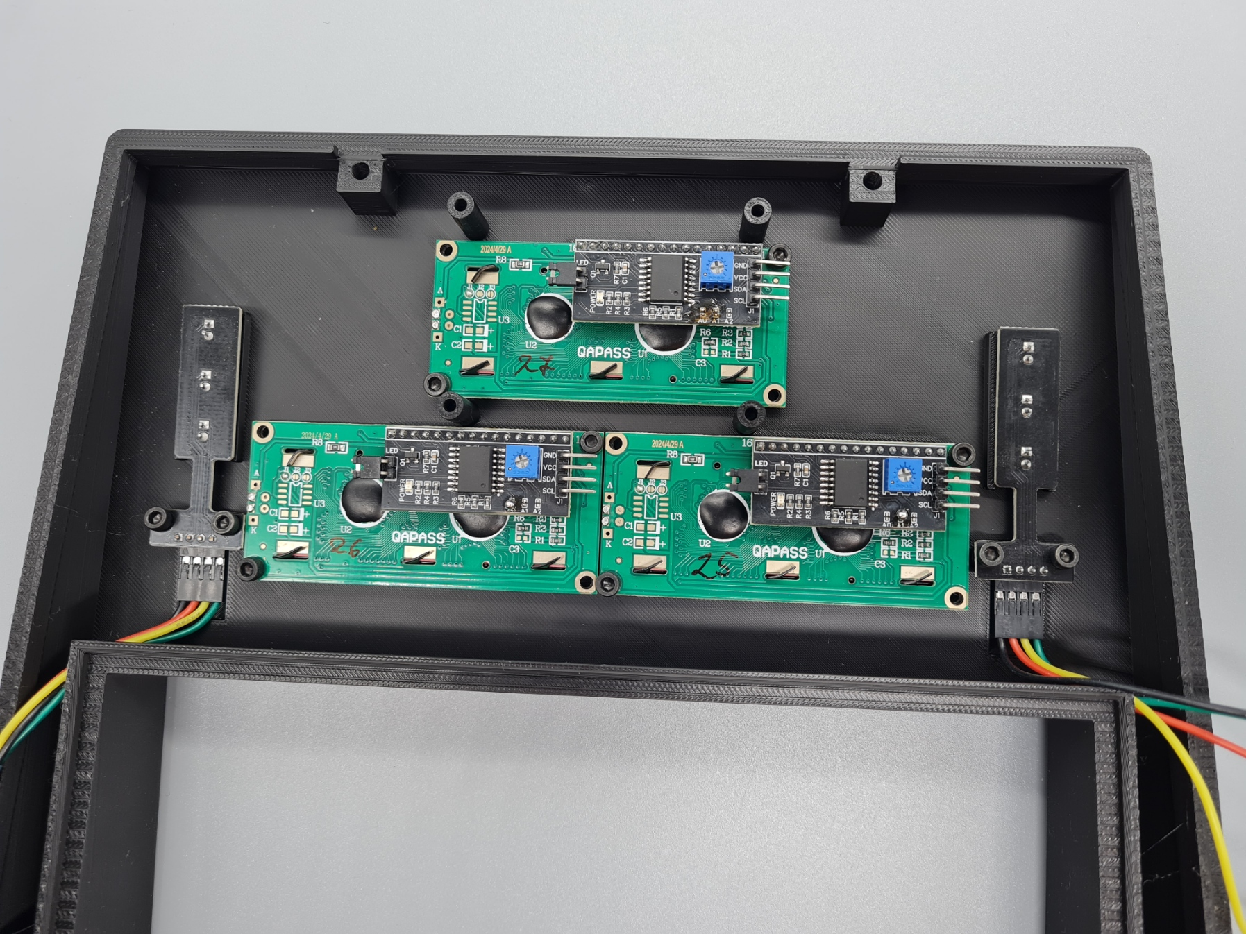
Finally, mount the Level Shifter Board and connect the LCD displays.
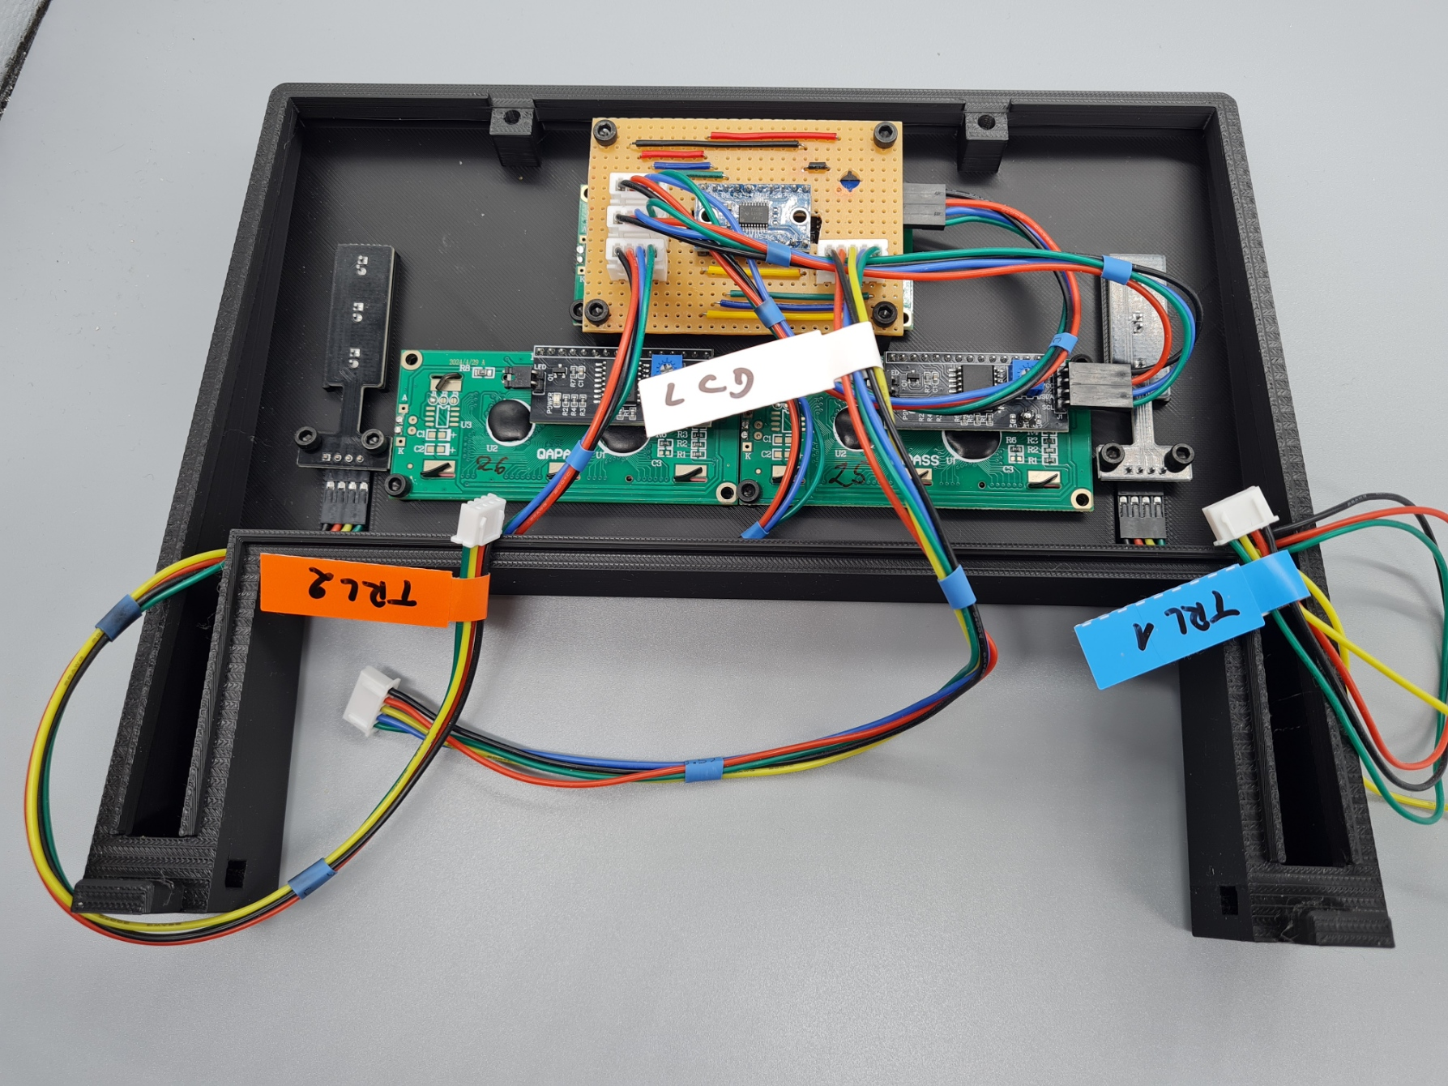

Assemble Back Part

USB Cable
The USB cable will allow powering the Raspberry Pi from outside the housing.
The outside contact is USB-C and an adapter will be used to connect to the Pi's Micro USB.
Required Parts:
- USB C Cable (#14)
Tools:
- PH1 Screwdriver with long shaft (#206)
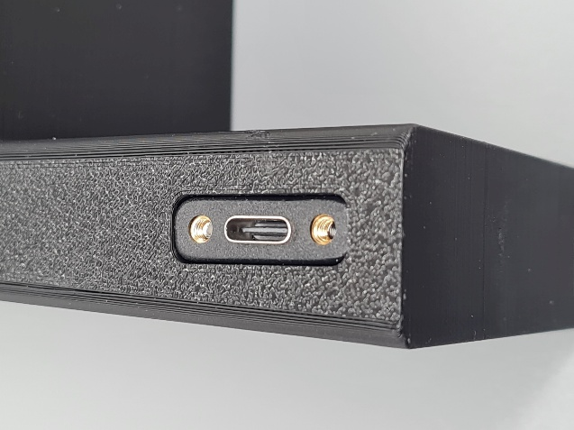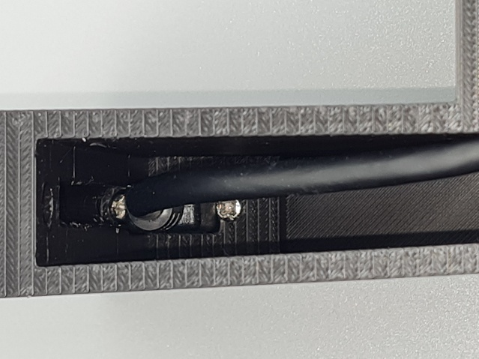
Fixing the screws is a little bit tricky. It may be helpful to glue the screw on the screwdriver to facilitate placement. Also, if the bottom screw cannot be fixed, it is sufficient to fix the upper screw.

Rotary Encoder
Required Parts
- Rotary Encoder (#11)
Stock Items
- 2 Cylinder Screws M3x6MM (#154)
Tools:
- Hex Key Allen Wrench 3.5 mm (#207)
- Socket Wrench 10 mm (#208)
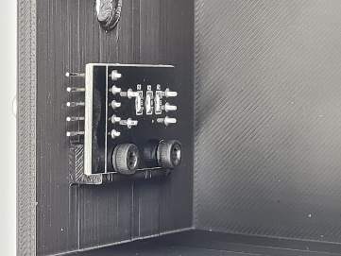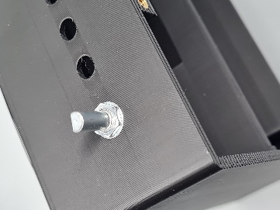

Push Buttons
Required Parts:
- 1 Push Button Red (#10)
- 1 Push Button Yellow (#10)
- 1 Push Button Green (#10)
See chapter 5.4.8
Tools:
- Metal Drill Bit 8.0 mm (#209)
- Socket Wrench 10 mm (#208)
If the holes for the bush buttons turn out to be a little bit narrow, you can gently widen them with an 8 mm Metal Drill Bit.
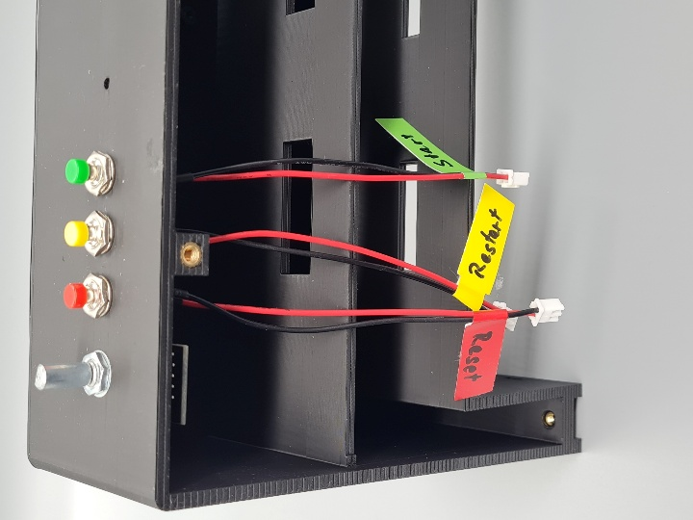
Now, attach connection cable for Rotary Encoder:
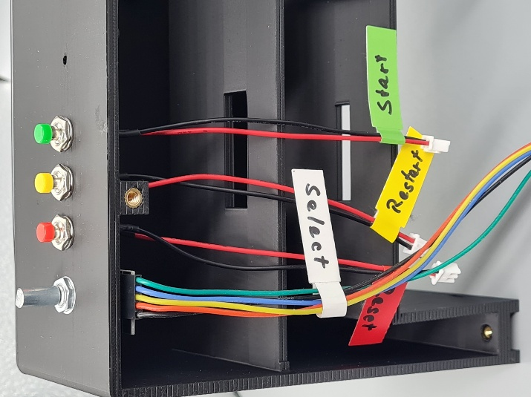

Buzzer
Required Parts:
- Buzzer (#12)
Stock Items:
- 1 Cylinder Screw M3x6MM (#154)
Tools:
- Hex Key Allen Wrench 3.5 mm (#207)
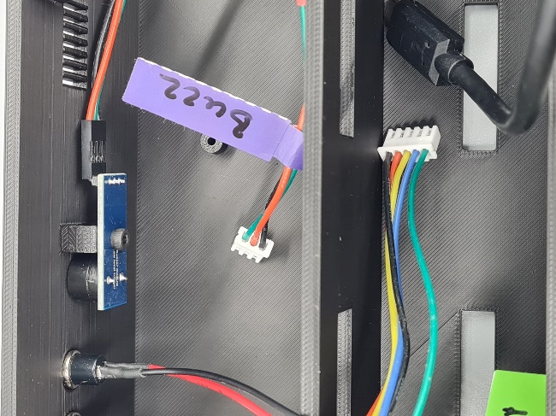

Mount Raspberry Pi
Required Parts:
- USB-C to Micro USB Adapter
Stock Items:
- 4 Cylinder Screw M2.5x8 (#157)

- First, plug the USB-C-to-Micro-USB adapter onto the USB cable.
- Then, feed the cable through the right opening of the middle level and plug the adapter into the Raspberry Pi's power socket outside the housing.
- Now push the Raspberry Pi gently in place and fix it with 4 screws.
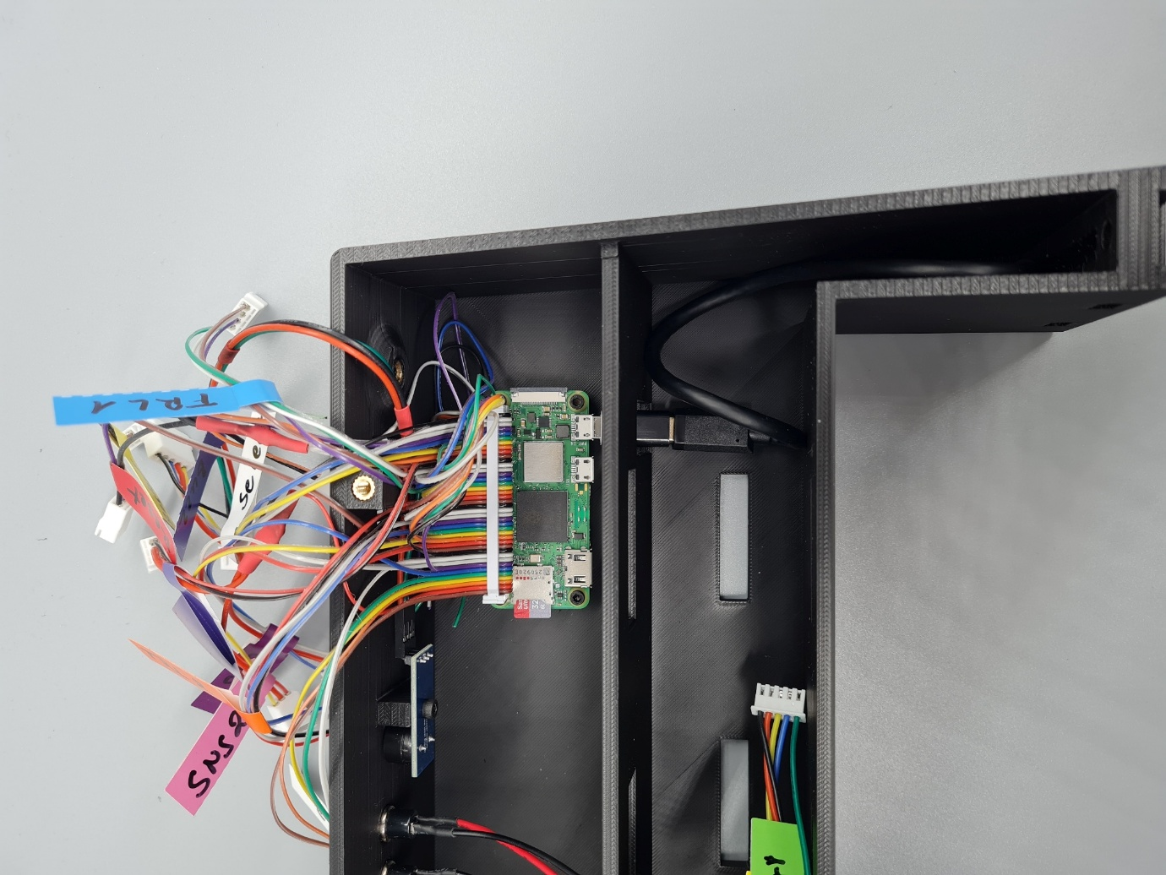

Preparing the Obstacle Sensors
Printed Parts:
- OD_Mount_1.stl (plate 3)
- OD_Mount_2.stl (plate 3)
- OD_Mount_Stand.stl (plate 3)
Parts:
- 2 Obstacle Sensors (#09)
Stock Items:
- 2 Threaded Inserts M4x6x6 (#158)
- 2 Cylinder Screws M4x8MM (#153)
- 2 Washers M4 x 12 mm (#159)
- 2 Cylinder Screws M3x6MM (#154)
Tools:
- Heat Insert Press (#205)

Press Threaded Inserts
The OD_Mount_Stand.stl will assure exact vertical orientation of the OD_Mount_x.stl parts:
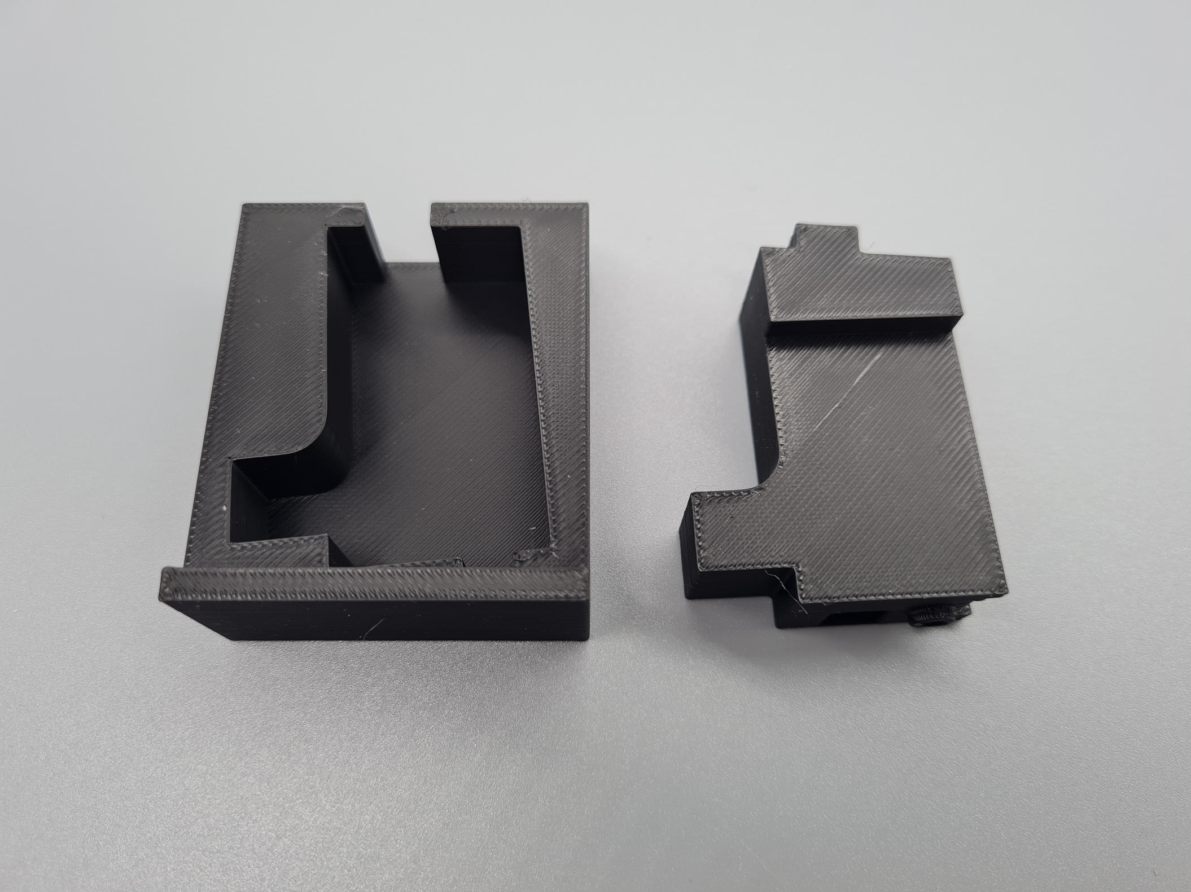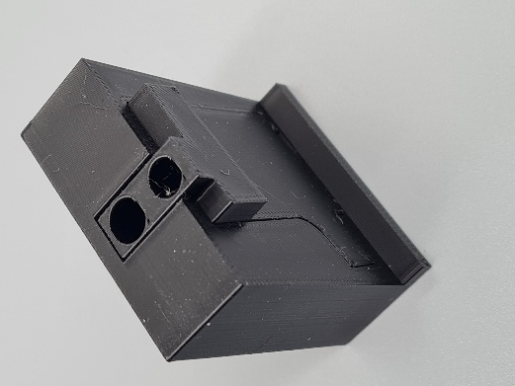
The threaded inserts must be inserted in the smaller right hole.
The larger left hole is for calibration of the obstacle sensors.
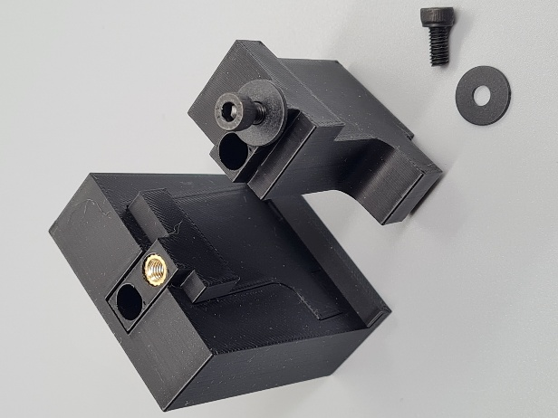

Mount Obstacle Sensors
The potentiometer of the obstacle sensors fits exactly in the square hole of the support and can be reached through the hole from outside for calibration.
The obstacle sensors are fixed with a M3x6MM Cylinder Screw (#154)

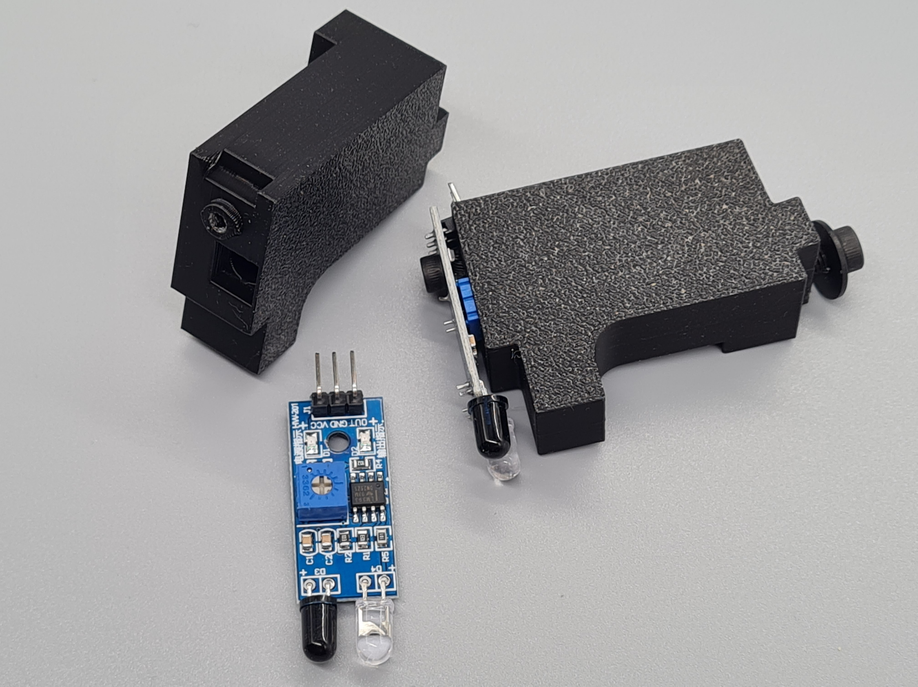

Mounting Obstacle Sensors
With the hold-down screws removed, insert the obstacle sensor supports into the main housing and tighten with washers and screws:
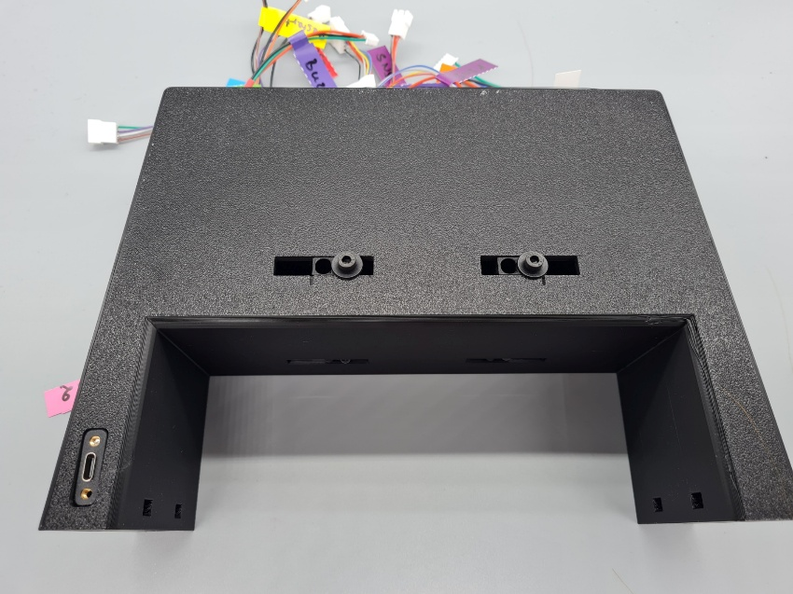
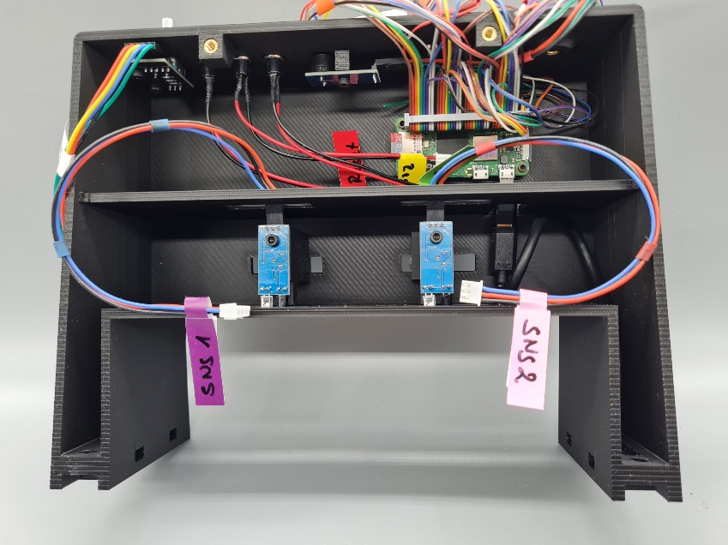
Choose the sensor position according to your track width:
- Outer position: 100 mm
(Evolution, Digital 132, Digital 124)
- Marked position as in image above: 71 mm
(Profi)
- Inner position: 60 mm
(GO!!!, GO+, Digital 143)

Connect and Test
- Close all associated connections between devices and Raspberry Pi while the housing is still open.
- Plug in a power cable
- Run the same test as in chapter 6

Close Housing
Printed Parts:
- RE_Button.stl (Plate 3)
Stock Items:
- 2 Cylinder Screws M4x16MM (#151)
- 2 Cylinder Screws M4x8 MM (#153)

- Stow all cables in the upper compartment.
- Close the housing.
Make sure that no cables get pinched when closing the case.
- Fix bottom connectors with two M4x8MM screws.
- Fix upper connectors with two M4x16MM screws.
- Push the printed button for the rotary encoder onto its axle.
You need to make sure that the cut-out section of the button aligns with the corresponding section of the axle.

Final Test
To make sure that closing has not corrupted any of the connections, repeat the test described in chapter 6.
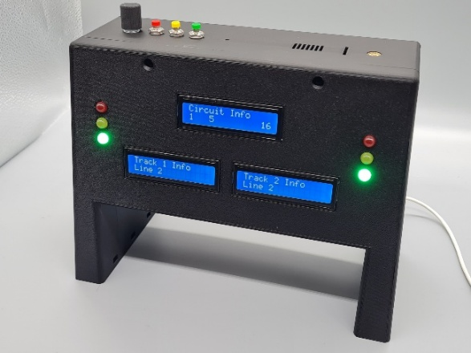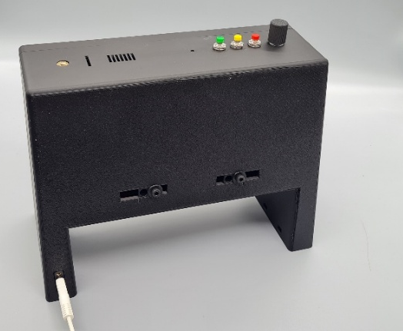
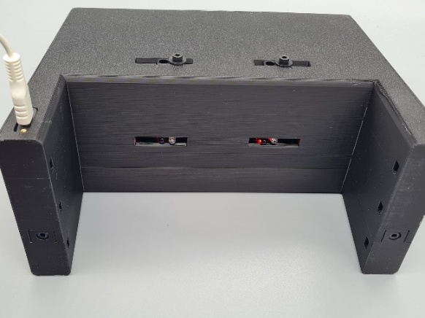

Adapting the Configuration
If you have chosen to use other I2C addresses or other GPIO contacts than suggested in this document, you will need to adjust the configuration file.
You will find it under
~/prg/Carrera_Race_Monitor/config/crm_config.json
{
"config": {
"lng": "en",
"tracks": {
"Track_1": {
"enabled": true,
"handicap": 0.0
},
"Track_2": {
"enabled": true,
"handicap": 0.0
}
},
"start_control": false,
"race_mode": "OPEN",
"race_laps": 10,
"race_time_min": 5,
"play_sound": true
},
"devices": {
"LCD_Track_1": {
"type": "LCD",
"params": {
"I2C_address": "0x25"
}
},
"LCD_Track_2": {
"type": "LCD",
"params": {
"I2C_address": "0x26"
}
},
"LCD_Circuit": {
"type": "LCD",
"params": {
"I2C_address": "0x27"
}
},
"SNS_Track_1": {
"type": "Obstacle_Sensor",
"params": {
"GPIO_pin": 14,
"bounce_time": 0.05
}
},
"SNS_Track_2": {
"type": "Obstacle_Sensor",
"params": {
"GPIO_pin": 18,
"bounce_time": 0.05
}
},
"TRL_Track_1": {
"type": "Traffic_Light",
"params": {
"GPIO_pin_red": 0,
"GPIO_pin_yellow": 5,
"GPIO_pin_green": 6
}
},
"TRL_Track_2": {
"type": "Traffic_Light",
"params": {
"GPIO_pin_red": 25,
"GPIO_pin_yellow": 24,
"GPIO_pin_green": 23
}
},
"Selector": {
"type": "Rotary_Encoder",
"params": {
"GPIO_pin_CLK": 21,
"GPIO_pin_DT": 20,
"GPIO_pin_SW": 16
}
},
"Speaker": {
"type": "Passive_Buzzer",
"params": {
"GPIO_pin": 12
}
},
"BTN_Reset": {
"type": "Button",
"params": {
"GPIO_pin": 26,
"bounce_time": 0.1
}
},
"BTN_Restart": {
"type": "Button",
"params": {
"GPIO_pin": 17
}
},
"BTN_Start": {
"type": "Button",
"params": {
"GPIO_pin": 13
}
}
}
}

