Namaste Javascript –

1. Learn difference between append() and appendChild() ?
2. What is CDN ? – Content Delivery Network

* Links : <https://legacy.reactjs.org/docs/cdn-links.html>

1. What is crossorigin?

---------------------- CDN ---------------------

1. CDN is not the preferred way to install React in our project.

**Basics Of React –**

How to write your first React Program?

    <div id="root"></div>

    <script crossorigin src="https://unpkg.com/react@18/umd/react.development.js"></script>

    <script crossorigin src="https://unpkg.com/react-dom@18/umd/react-dom.development.js"></script>

    <script>

*const* heading = React.createElement('h1', {}, 'hello world');

*const* root = ReactDOM.createRoot(document.getElementById('root'));

        root.render(heading);

    </script>

So, React.createElement() will return an **React Element which is an object.**

**React.createElement => Object => HtmlElement(render)**

**createElement(type, props, ...children)**

Call createElement to create a React element with the given type, props, and children

**Note -** Whatever you write inside div having id=”root”, render will replace the content of root and replace with react content inside the root.

React is a library --- which can work in very small section of page.

**Episode – 2: Igniting Our App**

**Npm –**

Package.json is the configuration for npm**. --- contain metadata relevant to the project**

**How to add package.json in your project ? --- with the help of npm init**

**Most important package in our app – A Bundler ( Webpack, vite, parcel ) – it bundles our code**

**Parcel -**

**Two types of Dependecies –**

1. **Dependencies**
2. **Dev Dependencies**

**Difference between Caret and Tilde -**

**X.xx.xxx – ^3.9.2**

**X = major**

**Xx = minor**

**Xxx = patch (bug fixes**

**Caret –**

* **backwards compatible new functionality**
* **old functionality deprecated, but operational**
* **bug fix**

**Tilde –**

* **bug fix**

**Node_Modules = Collection of packages**

**What is the difference between package.json and package-lock.json**

1. **Transitive Dependency**

**Igniting our App**

**npx parcel index.html**

**--- npx execute a package ( here parcel is a package )**

**--- Parcel creates a server like** [**https://localhost:1234**](https://localhost:1234)

**Facing a lovely error message –**

**parcel]: @parcel/transformer-js: Browser scripts cannot have imports or exports.**

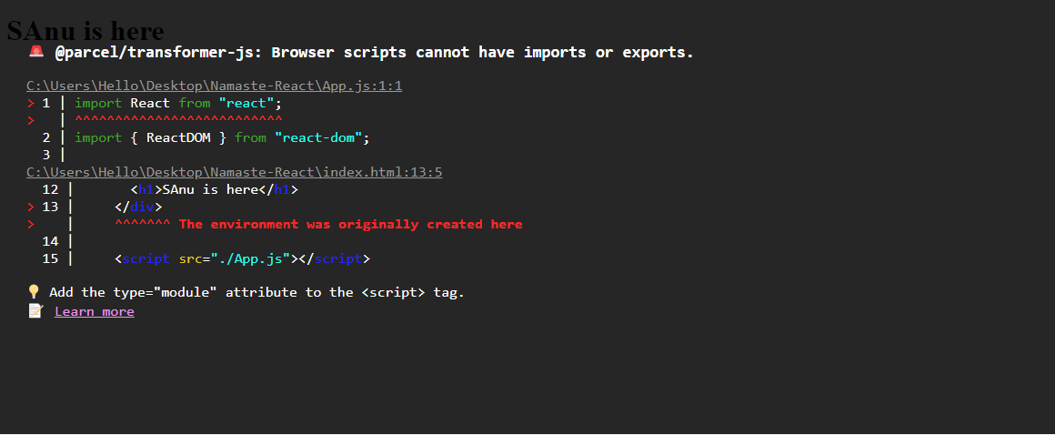

**Why because we have script tag in our index.html and it doesn’t have import statements there.**

**We need to treat js file as modules instead of normal JavaScript file.**

**------------------------**

**READ Parceljs**

* **Anything which is automatically generated, we should not push to github and add those in gitignore file.**
* **BrowsersList – You can configure on which browsers your app is definitely works properly**

**You need to add this below code in package.json –**

**“browserslist” : {**

**“last 2 versions”**

**}**

**Note : Npm run start is equivalent to npm start**