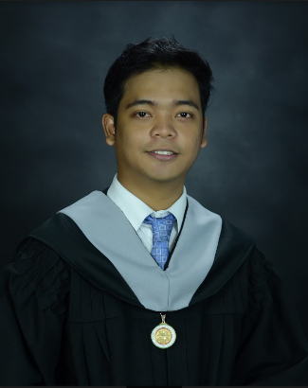

**SEAR JOHN B. VENTURINA**

1232, Ibarra St. Dapitan, Sampaloc

Manila Philippines

Contact Number: 09271635866

Email: searjohn15@gmail.com

**SKILLS**

* **Programming**
  + C++, C#, Java, HTML, CSS, JavaScript, and Json
* **Database**
  + IBM DB2, Firebase, and SQL
* **Framework**
  + ReactJS
* **Data Visualization**
  + Micro Strategy and Pentaho
* **Robotics**
  + Arduino and Processing
* **Others**
  + MVC Framework, MVP Framework, Object-Oriented Programming, DOM-Manipulation, GIT, Rest API, Bitbucket version control and Agile Development

**Work Experience**

* Front-end Web Developer in UnionBank.

**SYSTEM DEVELOPMENT EXPERIENCES**

* Front and Back-end developer of Parking Lot Reservation System in Java using Eclipse IDE **(Case Study with System)**
* Back-end developer of Debt management system using Java, JavaFX in MVC framework with IBM DB2 Express and BitBucket Version control **(Case Study with System)**
* Front-end Developer of Motorcycle Problem diagnosis system in Java with SQLite. **(Case Study with System)**
* Researcher and Developer of Document Classifier using NLP in JAVA **(Case Study with System)**
* Researcher and Developer of Robotic Application that uses natural hand motion to control a Robotic Arm using Arduino and JAVA. **(Thesis)**
* Front-end Web Developer in 1Uhub website (HR System) using ReactJS, Es6, and Rest API

**Organizations**

* NEU Web Dev Team (Development of website for College of Physical Therapy)
* Member of League of Researchers in New Era University.

**Achievements**

* 1st place in Science Fair 2017 at New Era University in software category.
* Academic Awardee 2018
* Researcher of the year

**Educational Background**

**Tertiary New Era University**

**2014-2018** 9 Central Ave, New Era, Quezon City, 1107 Metro Manila

Bachelor of Science in Computer Science

**Reference:** Available upon request