Kevin M. Capstone Planning Document

## Description:

For my Capstone Project, I will be building an experience interactive simulation of the feelings.

To begin the experience, viewers will see a room with a butterfly flying. The room will be little but there are a lot of objects, the feeling is very homely.



After a while the scenery changes, the butterfly disappears. So the scenery begins to become more darkness and the objects are vanished. The viewers will feeling fade off because everything will be deeper. The feeling of "Loneliness" and "Sadness" will arrive.

The last state will be a scary environment, finishing the circle of emotions.

## Features and Dependencies:

### Resultado de imagen de dark room 3d3D Models (Reference Images)

#### Resultado de imagen de room 3dRoom

##### Butterfly

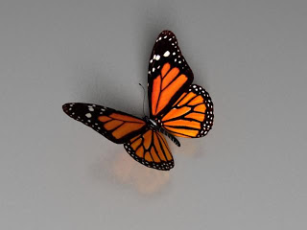

##### Furnished

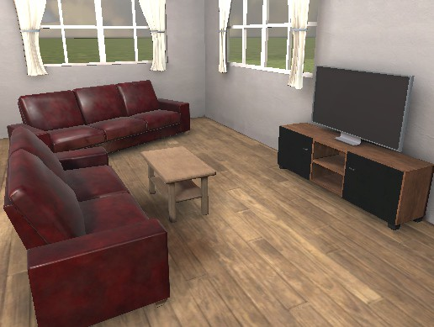

##### Animation of Disappear

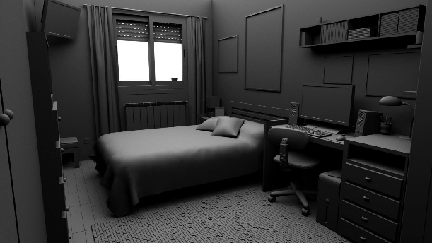

##### ~~Muffin and Candle~~



##### ~~Woman low poly and animation~~ Creppy zombie

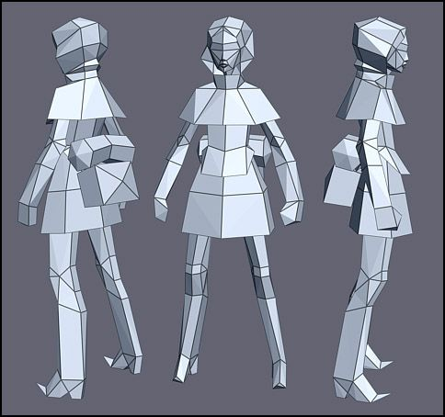

### Game Loop

* 1. Observe the butterfly travel
  2. The butterfly stops, and everything are disappearing little by little
  3. Appears a muffing with a candle in the table
  4. The game will be darkness if you go towards the candle
     1. The goal for the next step is “touch” the candle.
     2. Later of this appears a Woman in a square
  5. ~~The woman is swinging in the square if you go there this woman turn back.~~
  6. The last step is the surprise -edited: with the zombie behind you.

### Other Effects

* 1. Particles effect following the butterfly tracking.
  2. Spatial Sound effects for the room with white sound and ambient sounds
  3. Playing with the lights for a better feeling environment -edited: was change this for flick and intensity lights because a lot of Realtime lights were very poor in FPS
  4. Animations / fade off that allows see the feeling with more intensity.

Capstone Scoping

## Features and Dependencies:

### 3D Models

* 1. Room
     1. **First Revised: Will start with a basic Room.**
  2. Butterfly and animation
     1. **First Revised: Will create one model of Butterfly and later animate in unity.**
  3. Furnished
     1. **First Revised: Will not be making this in Blender, only take one of Assets Unity Store and add to the scenery.**
     2. **I found a Room in 3D very useful that doesn’t need more objects.**
  4. Animations of Disappear
     1. **First Revised: Will use the transform to hide the objects. Only with the Butterfly**
     2. **Second Revised: The Shader of Disolve for objects create a Alone room.**
  5. ~~Muffin and candle~~
     1. **~~First Revised: Will create a Muffing and candle for the aloneness feeling~~**
     2. **Second Revised: Create a Cross to interactive with the game (Grabbable) in the future will be the defend weapon against the zombie.**
  6. ~~Woman low poly~~ Zombie and animation
     1. **~~First Revised: Will create a Woman in Low Poly with her animations in Unity for the scary feeling.~~**
     2. **Second Revised: I put a zombie with AI to following the Player and create the surprise, also I used the animation of Standard Assets for this.**

### Game Loop

* 1. Observe the butterfly travel
     1. Still this feeling is important!
  2. The butterfly stops, and everything are disappearing little by little
     1. The effect of disappearing will be change for “transforming” and move eveything across the walls and floor.
  3. ~~Appears a muffin with a candle in the table~~
     1. ~~The muffin will not be instantiate, this is in the room from the start.~~
  4. ~~The game will be darkness if you go towards the candle~~
     1. ~~Maybe this part is the most complicate but I will try it.~~
  5. The ~~woman is swinging in the square if you go there this woman turn back~~. The Zombie follows you
     1. The light will help to the scenery only needs the model that is the harder of this point.
  6. The last step is the surprise
     1. ~~Only animation and sound of “white noise”~~ Surprise with the Zombie behind you.

### Other Effects

* 1. Particles effect following the butterfly tracking.
  2. Spatial Sound effects for the room with white sound and ambient sounds
  3. ~~Playing with the lights for a better feeling environment~~
  4. Animations / fade off that allows see the feeling with more intensity.