EDUREKA INTERNSHIP

(Name: Jacob Thomas)

PROJECT 2



Topic chosen: E-commerce website (ADIDAS official)

Description

Adidas is a [German](https://en.wikipedia.org/wiki/Germany) [multinational corporation](https://en.wikipedia.org/wiki/Multinational_corporation), founded and headquartered in [Herzogenaurach](https://en.wikipedia.org/wiki/Herzogenaurach), [Bavaria](https://en.wikipedia.org/wiki/Bavaria), that designs and manufactures shoes, clothing and accessories. It is the largest [sportswear](https://en.wikipedia.org/wiki/Sportswear_(activewear)) manufacturer in [Europe](https://en.wikipedia.org/wiki/Europe), and the second largest in the world, after [Nike](https://en.wikipedia.org/wiki/Nike,_Inc.). It is the [holding company](https://en.wikipedia.org/wiki/Holding_company) for the Adidas Group, which consists 8.33% stake of the football club [Bayern München](https://en.wikipedia.org/wiki/FC_Bayern_Munich) and [Runtastic](https://en.wikipedia.org/wiki/Adidas_Runtastic), an Austrian fitness technology company. Adidas's revenue for 2018 was listed at €21.915 billion.

The main aim is to recreate the official website with certain changes and additions from a design and functionality perspective.

Website Components

* HOMEPAGE

The homepage will consist of sections for the users to choose from.

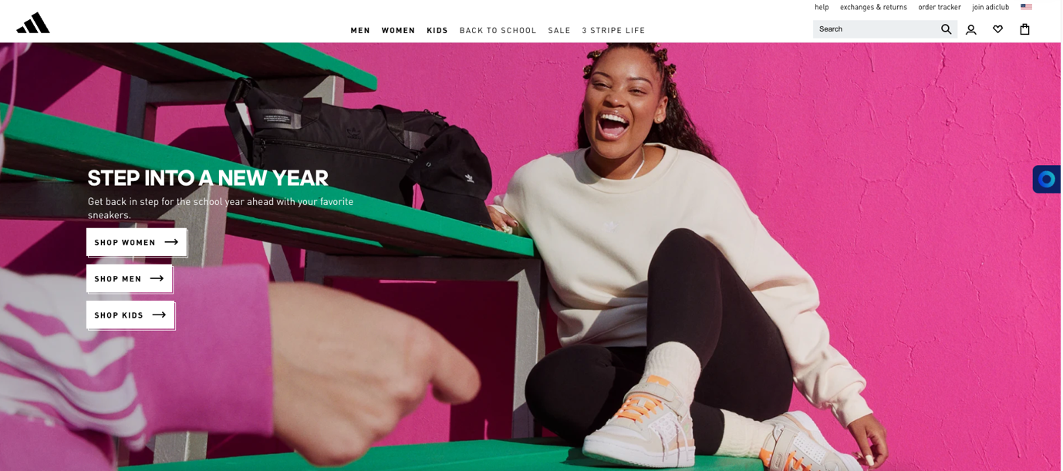

Below this section the trending products section and the latest arrivals will be available.

* PRODUCTS LISTING PAGE

This page will show the different products available in each category.

The page also has a search bar to filter out products.

* ACCOUNT CREATION/LOGIN PAGE

Users can choose to browse products without creating an account or can create a free account and access their wish lists, cart, and other offers.

* BAG

Items in your cart will be visible in the bag and from there checkout process can be initiated.

* PAYMENT GATEWAY

Users can go to a payment gateway after adding items into their cart. This page will then lead to an order confirmation page.

Essential site features like search option for filtering out products, product description, zoom option on images, related products etc. will be provided.

More payment options will be added for Indian users as the official website has lesser payment options.

Technologies used on the Website

**Site Info - Adidas.co.in**

Overview of web technologies used by Adidas.co.in.

**Website Background**

adidas India Official Website | Sportswear

Shop for adidas shoes, clothing, collections, adidas Originals, Running, Football, Training and more on the official adidas IN website.

Description on Homepage

Number 11,043 of all websites according to Alexa

Popularity rank

|  |  |  |
| --- | --- | --- |
| Country | Visitors | Country Rank |
| India | 97.8% | 15,552 |

Main visitors locations

[**Client-side Programming Language**](https://w3techs.com/technologies/overview/client_side_language)

JavaScript is a lightweight, object-oriented, cross-platform scripting language, often used within web pages.

[JavaScript](https://w3techs.com/technologies/details/cp-javascript)

[**Web Hosting Provider**](https://w3techs.com/technologies/overview/web_hosting)

Noris network is a German IT and cloud services provider.

[Noris network](https://w3techs.com/technologies/details/ho-norisnetwork)  
hosting info partly based on data from [ipinfo.io](https://ipinfo.io/)

[**Data Center Provider**](https://w3techs.com/technologies/overview/data_center)

Noris network is a German IT and cloud services provider.

[Noris network](https://w3techs.com/technologies/details/dc-norisnetwork)

[**Reverse Proxy Service**](https://w3techs.com/technologies/overview/proxy)

Akamai is a content delivery network. This includes the former brand Instart Logic.

[Akamai](https://w3techs.com/technologies/details/cn-akamai)

[**Email Server Provider**](https://w3techs.com/technologies/overview/email_server)

Microsoft is a multinational technology company headquartered in USA, also offering email services.

[Microsoft](https://w3techs.com/technologies/details/em-microsoft)

[**SSL Certificate Authority**](https://w3techs.com/technologies/overview/ssl_certificate)

DigiCert is an SSL certificate authority. This includes Verizon, whose Enterprise SSL Business has been acquired by DigiCert.

[DigiCert](https://w3techs.com/technologies/details/sc-digicert)

[**Traffic Analysis Tools**](https://w3techs.com/technologies/overview/traffic_analysis)

Google Analytics is a free service to get detailed statistics about the visitors of a website, provided by Google. This includes the Ads conversion tracking and the Floodlight services.

[Google Analytics](https://w3techs.com/technologies/details/ta-googleanalytics)

Microsoft UET (Universal Event Tracking) records what visitors do on a website after they click on an ad.

[Microsoft UET](https://w3techs.com/technologies/details/ta-microsoftuet)

Adobe Analytics is a web site traffic analysis service formerly called Omniture. Its products include SiteCatalyst, WebSideStory and Hitbox.

[Adobe Analytics](https://w3techs.com/technologies/details/ta-adobeanalytics)

[**Advertising Network**](https://w3techs.com/technologies/overview/advertising)

The Google Advertising network consists of AdSense, DoubleClick and other services.

[Google Ads](https://w3techs.com/technologies/details/ad-google)

[**Tag Managers**](https://w3techs.com/technologies/overview/tag_manager)

The Google Tag Manager is a Google service to support webmasters to manage tags on their websites.

[Google Tag Manager](https://w3techs.com/technologies/details/tg-google)

Tealium offers a website tag management system.

[Tealium](https://w3techs.com/technologies/details/tg-tealium)

[**Social Widgets**](https://w3techs.com/technologies/overview/social_widget)

Facebook Social Plugins provide a way for Facebook users to share web pages with their friends.

[Facebook](https://w3techs.com/technologies/details/so-facebookwidgets)  
used on inner pages

A Twitter Button allows a Twitter user to post a tweet from the visited site.

[Twitter](https://w3techs.com/technologies/details/so-twitterwidgets)  
used on inner pages

The Pinterest Pin-It button allows website visitors to pin images onto Pinterest.

[Pinterest](https://w3techs.com/technologies/details/so-pinterest)  
used on inner pages

[**Site Elements**](https://w3techs.com/technologies/overview/site_element)

External Cascading Style Sheets define style rules in a separate CSS file.

[External CSS](https://w3techs.com/technologies/details/ce-externalcss)

Embedded Cascading Style Sheets define a set of style rules in a <style> element within a web page.

[Embedded CSS](https://w3techs.com/technologies/details/ce-embeddedcss)

Inline Cascading Style Sheets define style rules directly within an (X)HTML element using the style attribute.

[Inline CSS](https://w3techs.com/technologies/details/ce-inlinecss)

Session cookies are temporary cookies, which are deleted when the user closes the browser.

[Session Cookies](https://w3techs.com/technologies/details/ce-sessioncookies)  
used on inner pages

Persistent cookies with an expiration time of up to 1 day.

[Cookies expiring in hours](https://w3techs.com/technologies/details/ce-persistentdaycookies)  
used on inner pages

Persistent cookies with an expiration time between 1 day and 1 month.

[Cookies expiring in days](https://w3techs.com/technologies/details/ce-persistentmonthcookies)  
used on inner pages

HttpOnly cookies are used only in the HTTP protocol and not in client side scripts, which may increase security.

[HttpOnly Cookies](https://w3techs.com/technologies/details/ce-httponlycookies)  
used on inner pages

Non-HttpOnly cookies are used in the HTTP protocol and also in client side scripts, which may be a security threat.

[Non-HttpOnly Cookies](https://w3techs.com/technologies/details/ce-nonhttponlycookies)  
used on inner pages

Secure cookies are used only via an encrypted connections, which may increase security.

[Secure Cookies](https://w3techs.com/technologies/details/ce-securecookies)  
used on inner pages

Non-secure cookies may be used via an unencrypted connections, which may be a security threat.

[Non-Secure Cookies](https://w3techs.com/technologies/details/ce-nonsecurecookies)  
used on inner pages

Gzip (GNU zip) is a file compression algorithm.

[Gzip Compression](https://w3techs.com/technologies/details/ce-gzipcompression)

HTTP/2 is the second major version of the HTTP network protocol.

[HTTP/2](https://w3techs.com/technologies/details/ce-http2)

HTTP Strict Transport Security (HSTS) defines a mechanism enabling web sites to declare themselves accessible only via secure connections.

[HTTP Strict Transport Security](https://w3techs.com/technologies/details/ce-hsts)

The websites redirects visitors to its www subdomain, e.g. from example.com to www.example.com.

[Default subdomain www](https://w3techs.com/technologies/details/ce-wwwdefault)

The websites redirects visitors to use SSL encryption, e.g. from http://example.com/ to https://example.com/.

[Default protocol https](https://w3techs.com/technologies/details/ce-httpsdefault)

[**Structured Data Formats**](https://w3techs.com/technologies/overview/structured_data)

The Open Graph protocol, originally developed by Facebook, is an RDFa-based format that enables any web page to become a rich object in a social graph.

[Open Graph](https://w3techs.com/technologies/details/da-opengraph)

JSON-LD (JavaScript Object Notation for Linked Data) is a method of encoding Linked Data using JSON.

[JSON-LD](https://w3techs.com/technologies/details/da-jsonld)

Generic RDFa (Resource Description Framework in attributes) is RDFa without further specialization.

[Generic RDFa](https://w3techs.com/technologies/details/da-genericrdfa)

[**Markup Language**](https://w3techs.com/technologies/overview/markup_language)

HTML5 is the fifth revision of the HTML standard.

[HTML5](https://w3techs.com/technologies/details/ml-html5)

[**Character Encoding**](https://w3techs.com/technologies/overview/character_encoding)

UTF-8 (8-bit Unicode Transformation Format) is a variable-length character encoding for Unicode, which is backwards compatible with ASCII.

[UTF-8](https://w3techs.com/technologies/details/en-utf8)

[**Image File Formats**](https://w3techs.com/technologies/overview/image_format)

Scalable Vector Graphics (SVG) is an XML-based vector image format.

[SVG](https://w3techs.com/technologies/details/im-svg)

JPEG (Joint Photographic Experts Group) is a lossy compression method suitable to store photographic images.

[JPEG](https://w3techs.com/technologies/details/im-jpeg)  
used on inner pages

[**Top Level Domain**](https://w3techs.com/technologies/overview/top_level_domain)

India

[.in](https://w3techs.com/technologies/details/tld-in-)

[**Server Location**](https://w3techs.com/technologies/overview/server_location)

[Germany](https://w3techs.com/technologies/details/sl-de-)