**NOTE: These instructions are meant to demonstrate how the software operates. It shall NOT serve as a substitute for any formal/approved procedures. Please refer to approved procedure for instructions.**

# Software Functionalities:

1. **The software has been developed to accomplish the following tasks:**
   1. Retrieve mean grain protrusion and grain coverage values from the Alicona PDF
   2. Display results for each bur based on pass/fail/quarantine criteria
   3. Merge all PDFs with the same lot number, date, time and create a temporary merged file.
   4. Copy the files from a temporary folder (where the Alicona machine saves the files) to a permanent location
   5. Delete all Alicona related files from temporary folder

# Software Details:

## Naming Conventions:

1. The PDF with the bur scan need to have the following format:
   1. “Lot_<lot number>_SYS<system number>_Scan_<mm>-<dd>-<yyyy>_<hh>-<mm>-<ss>_Position<position number>”
      1. Note that the “<position number>” needs to be between 1 and 40
   2. Example:
      1. “Lot_4222011902_SYS1_Scan_02-01-2022_15-47-18_Position 3”
   3. If a different naming schema is used, the software will not be able to read results
2. The PDF with the bur results need to have the following format:

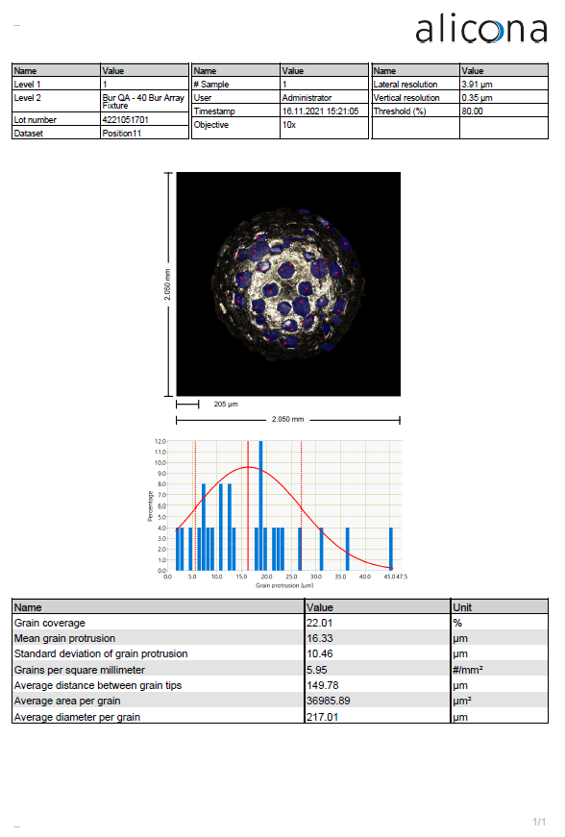

**Note: Any changes to the format may cause the software not to work**

1. The csv file generated on each scan needs to be in the following format:
   1. “Lot_<lot number>_SYS<system number>_Scan_<mm>-<dd>-<yyyy>_<hh>-<mm>-<ss>_”
   2. Example:
      1. “Lot_4222011902_SYS1_Scan_02-01-2022_15-47-18”

**Running the software**

## Folder Structure

The software extracts the PDFs results located in the Temporary Folder, and sends the files to the following folders:

* <root folder>/Good Scans/Scans 🡪 all good scans will be transferred to this folder
* <root folder>/Good Scans/Rescans 🡪 all good re-scans will be transferred to this folder
* <root folder>/Bad Scans 🡪 all bad re-scans will be transferred to this folder

See illustration of the process below

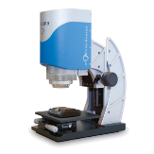

## Merged PDFs

## Merged PDFs

1. The “Temporary Folder Path” is the path where the files generated by the Alicona machine are saved to.
2. The “Root Folder Location” in which the folders are transferred to need to match the “Current File Path” under the settings tab
3. In the “Root Folder Location”, there must be a subdirectory of desired name, in which the machine will save the temporary scan PDF files (and csv) to. Such directory name need to match the directory name shown under “Current Temp Folder Name” in the settings screen. Avoid name with any special characters. That may cause an error
4. The Root Folder location + Current Temp Folder Name + the PDF file names combined need to be less than 260 characters
5. The Root Folder Location + Current Temp Folder name need to be less than 248 characters.
6. It is strongly recommended that the root folder is a clean folder, only containing the temporary folder and the saved scans. Having multiple other folders in the root folder may confuse the software. See an example of a clean folder below.

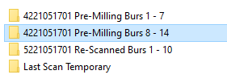

1. The folder schema used to move the temporary files to are as follow:
   1. For newly scanned burs:
      1. <lotnumber> Pre-Milling Burs <lotburnumberstartindex> – <lotburnumberendingindex>
      2. Example: “4221051701 Pre-Milling Burs 8 – 14”
   2. For re-scans:
      1. <lotnumber> Re-Scanned Burs <lotburnumberstartindex> – <lotburnumberendingindex>
      2. Example: “4221051701 Re-Scanned Burs 1000 – 1020”
   3. Note that changing the folder schema may cause errors in the system
2. If a folder needs to be created manually, it is imperative that the save folder schema above is followed.
3. The Mean Tip Value (MTV1) criteria needs to be an integer number greater than zero.
4. The grain coverage criteria (GC1, GC2, GC3) require the following:
   1. GC1>0
   2. GC2>GC1
   3. GC3>GC2
   4. GC1, GC2, GC3 are integers

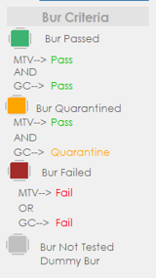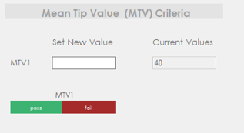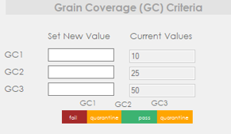**Note:** the software will utilize MTV1, GC1, GC2, GC3 to determine if a bur passed, failed, or quarantined. See criteria below:

1. The PDF files (and csv) generate by the machine must not be open or in use. Make sure to close any applications using those files (including the Alicona PDF reader)
2. The scanning of burs scans between 1-40 burs per time.
3. The computer must have adobe PDF read installed on it

**Installation:**

Copy bin Folder into desktop.

Open the folder

Right click on “User Interface” and set it to always run as administrator

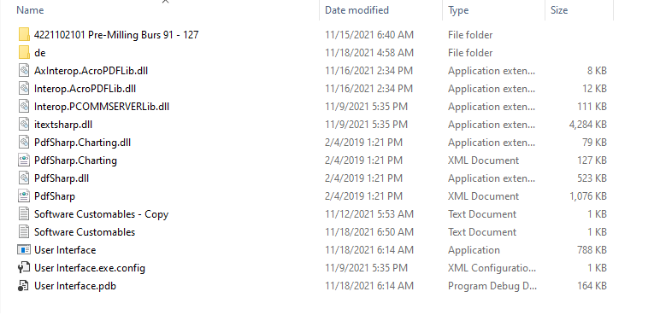

Right click on “User Interface” and copy it

Go on desktop and paste it **as a shortcut**

**Use the shortcut to open program**

**Note: tampering with any files on the software folder may break the software**

**Settings:**

To change the system settings:

* click on the “Settings” tab
* insert “User Name” and “Password” (contact system admin for more info)
* Click “Open Settings”

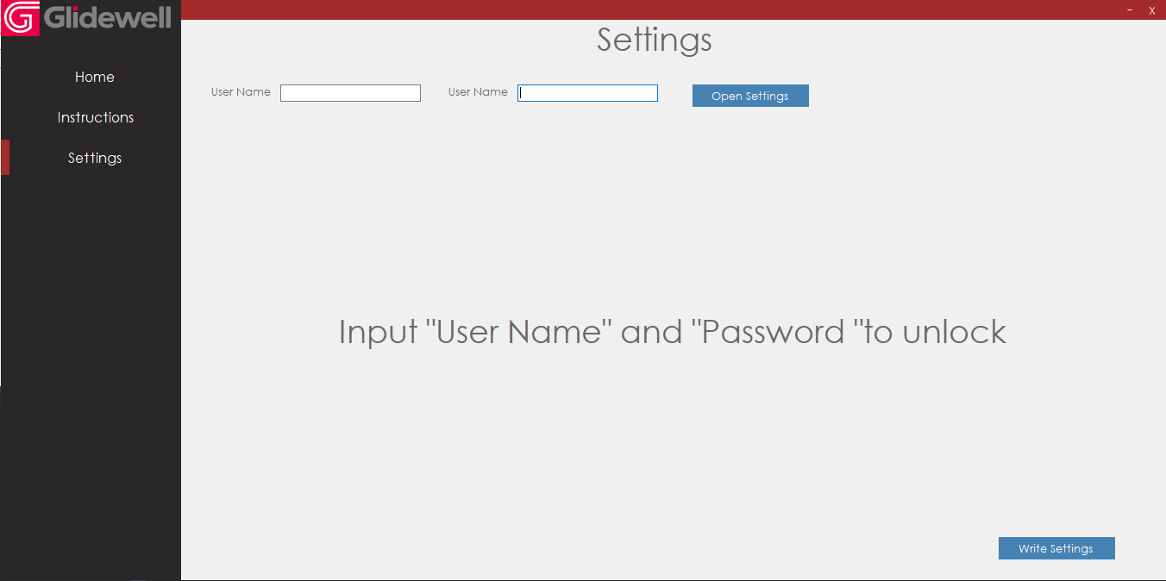

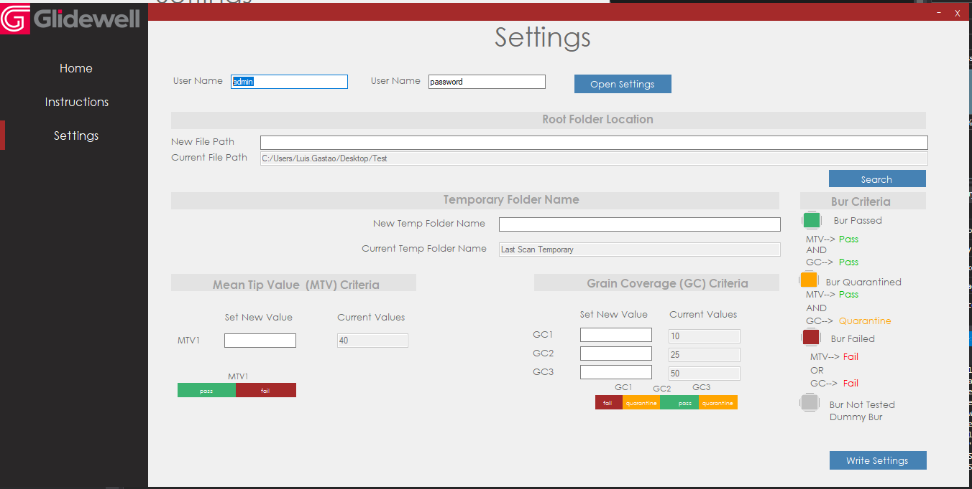Under “Root Folder Name”, select the root folder of your system. This is the folder in which sub folders will be created to transfer the temp PDF files to. You can either paste a file path to it or click the “Search” button to open the folder path browser

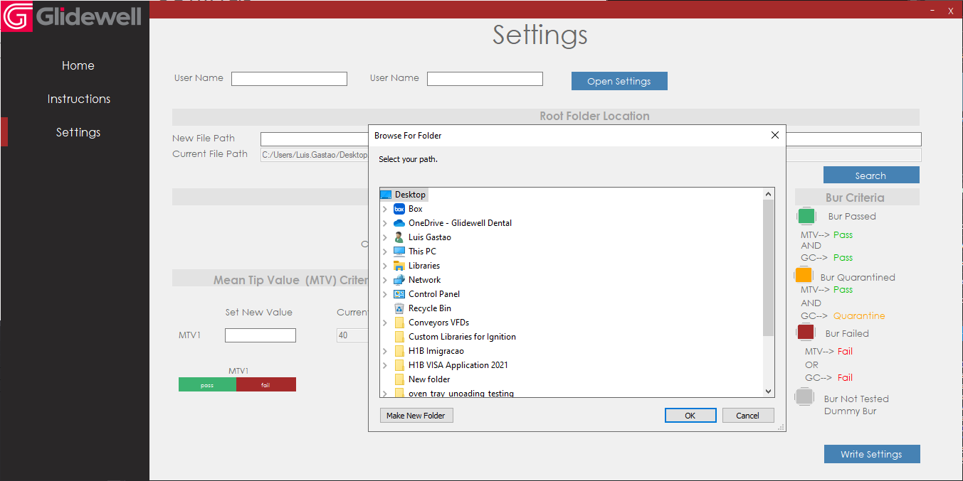

Under “Temporary Folder Name”, type the desired temporary folder name

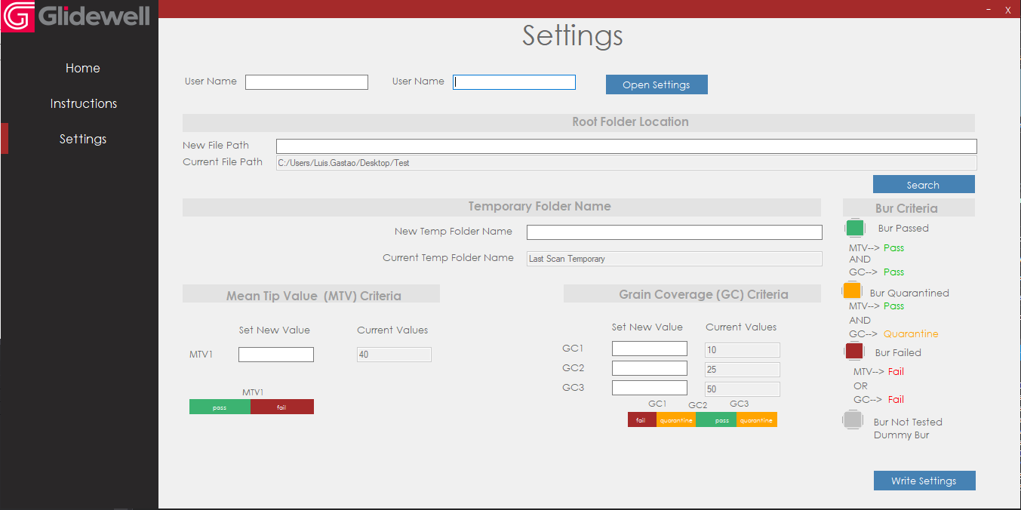

Insert values for Mean Tip Value (MTV1), Grain Coverage (GC1, GC2, GC3). Note that the software will require that these values are:

* MTV1, GC1, GC2, GC3 are integers
* MTV1>0
* GC1>0
* GC2>GC1
* GC3>GC2

If the criteria above is not followed, the software will spill an error accordingly

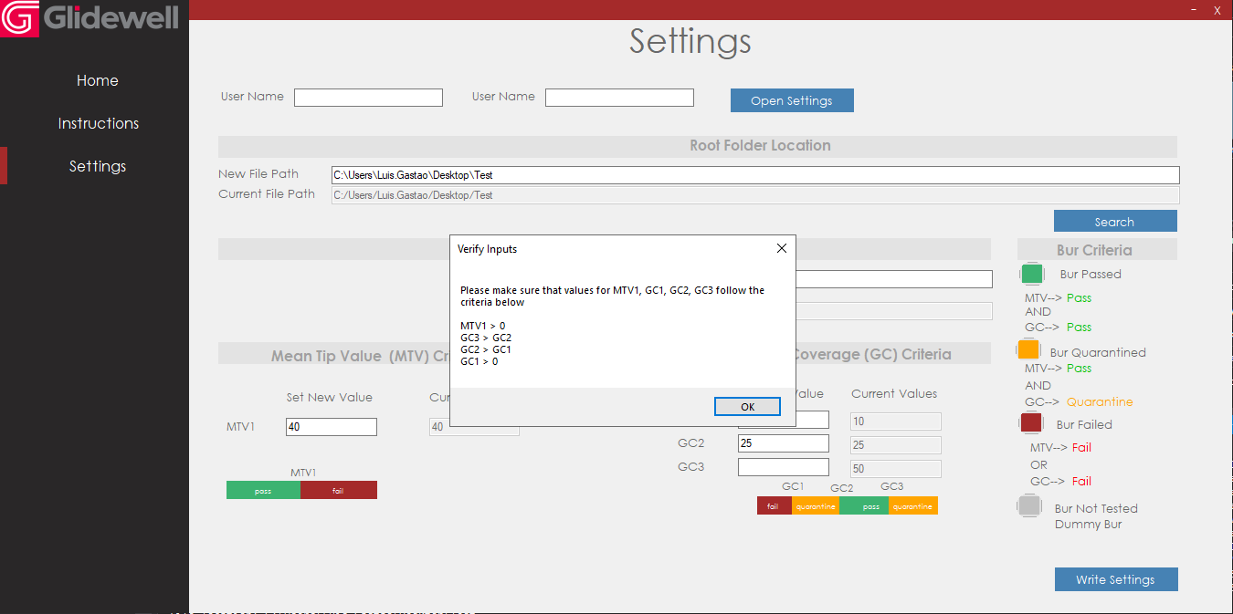

Once all the field are filled, click on write settings. Note that all the fields need to be filled for the system to write the settings.

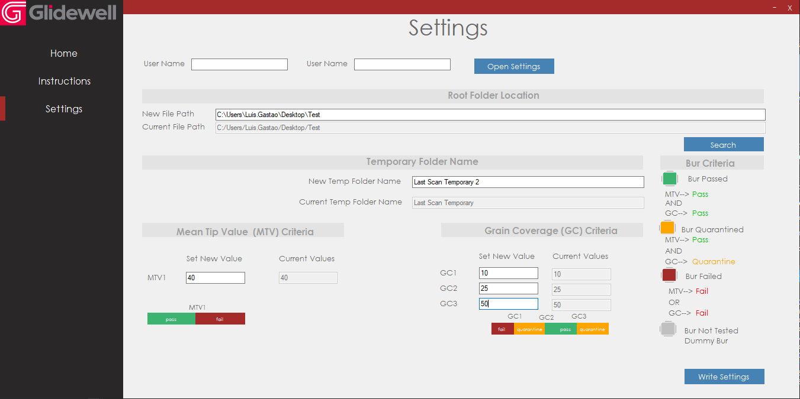

A confirmation message will appear. Confirm that the settings are as you want and click “Yes”. The system will save the settings to a local txt file called “Software Customables”.

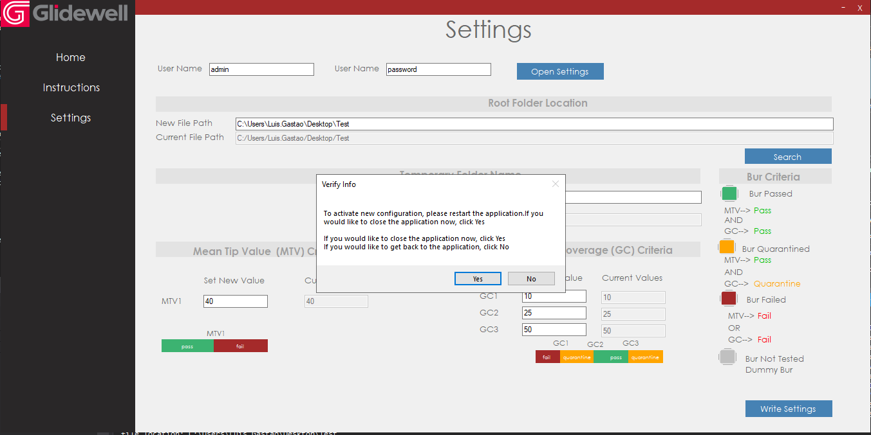

The “Software Customables” saves all the settings for the software. If it is tampered with manually, the software may stop working. The content of the file looks as follows:

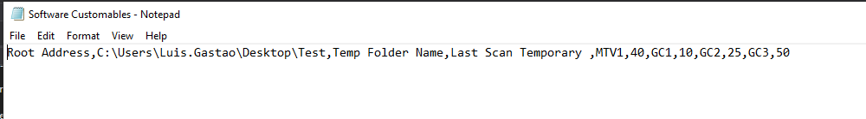

**Operation:**

Make sure that there are PDF files in the temp folder. Click on “Scan Folder” . This will scan the temporary folder for all distinct scans, according to the lot number and date_time. The results will be available under the “Select Lot # datetime” drop down menu

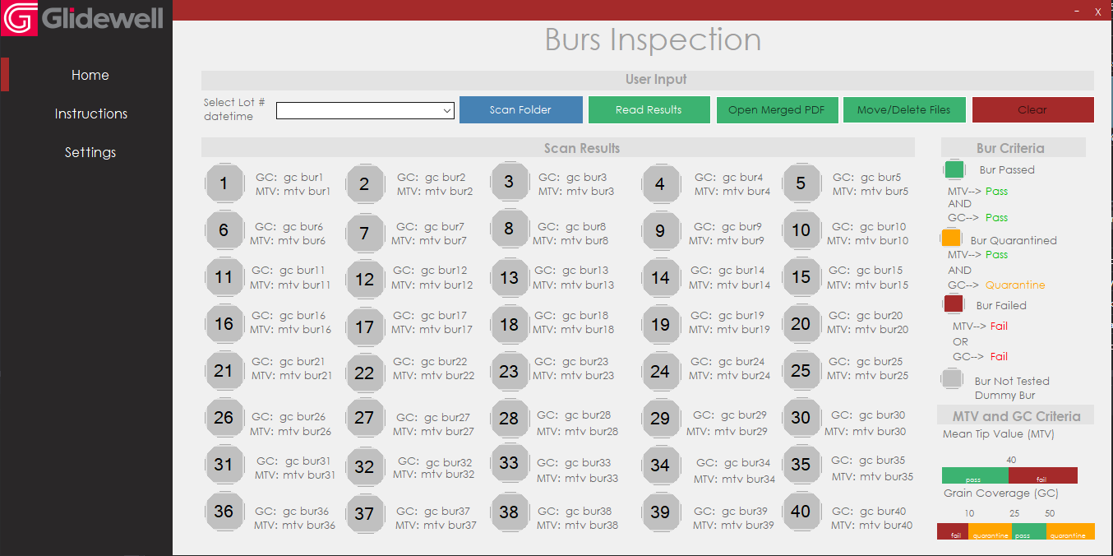

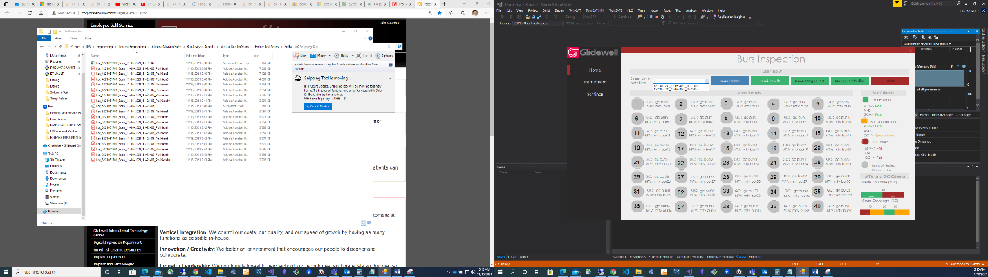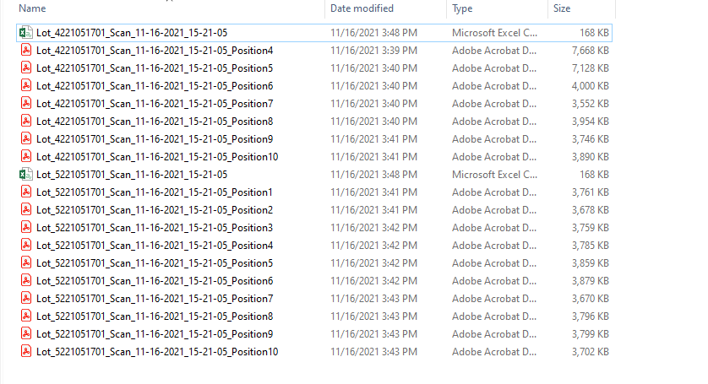

In the example of the image above, there are two lots 5221051701 and 4221051701. They both will display in the drop down menu. IF there were 3 scans of the same lot, they would still display in the drop down menu as lot as the date_time they were performed were all different

Note that the drop down menu does not automatically refresh. Any time you would like to refresh it, click on “Scan Folder”

On the drop down “Select Lot # datetime”, select desired lot # and date_time. Next, click on “Read Results”. Note: make sure ALL PDFS are closed and note in use.

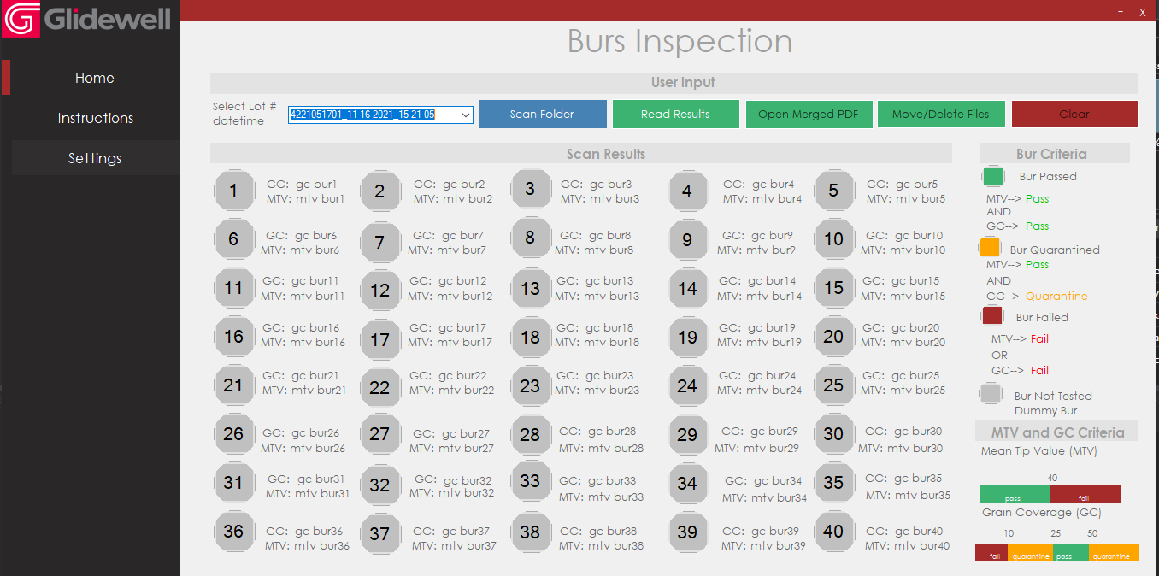

The results will populate in the screen. The software traverses through all PDFS with the selected lot # and datetime, and retrieve the mean tip value and grain coverage results. Based on the results, it uses the criteria shown to the right side of the screen to determine if the bur has passed, failed, or should be quarantined. The individual grain coverage and mean tip value for each bur is also shown in the screen and colored accordingly.

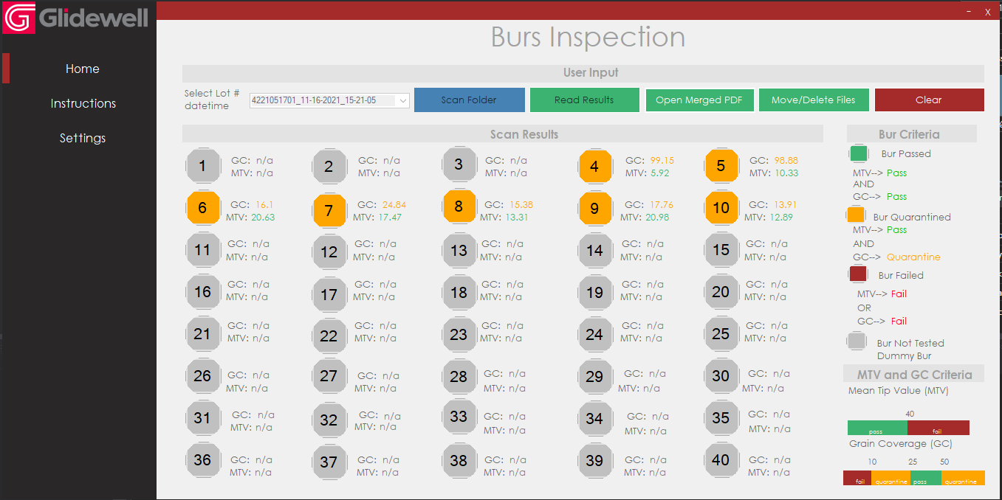

Note that he “Scan Folder” and “Read Results” buttons become disabled. If you would not like to “Open Merged PDF” or “Move/Delete Files”, simply click “Clear”, select “Yes” and the screen will go clear all values, and re-enable the “Scan” and “Read Results” button

If you would like to see all PDFs, click on “Open Merged PDF”. This will

* merge all PDFs for the select lot #/datetime a
* Save it to the temporary folder as “Merged”
  + Note that if there is a file called “Merged” in that folder already, it will simply overwrite it.
* Open the merged PDF
  + Note that if there is a file called “Merged” in the temp folder and it is opened, the software will not be able to overwrite it, merge them, and open. Please make sure to close any files called “Merged”

Note that the merging and opening of the file may take a few seconds. Please wait until the PDF

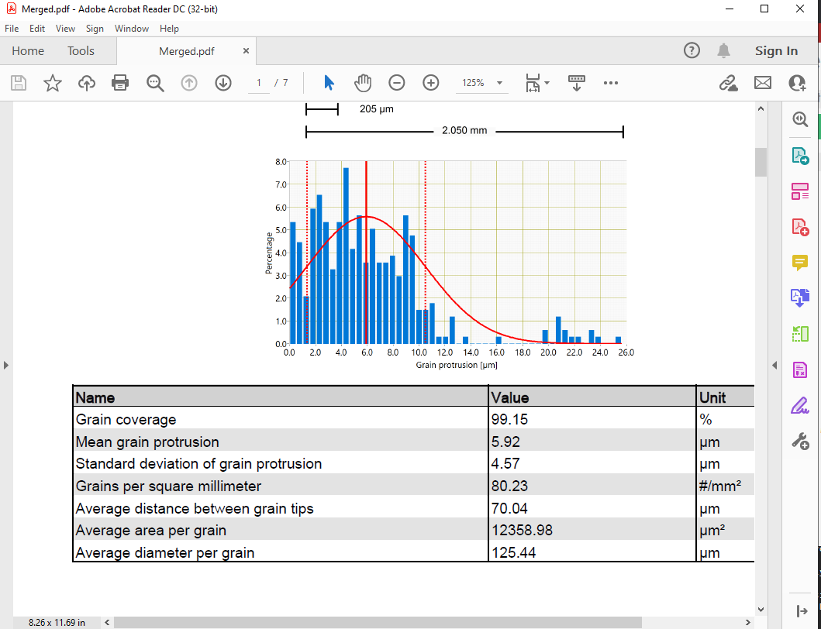

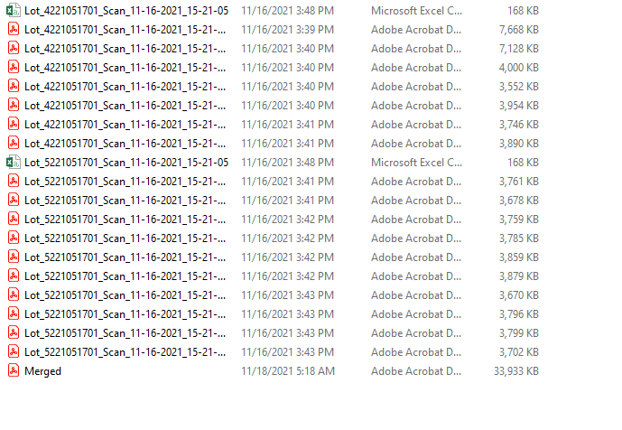

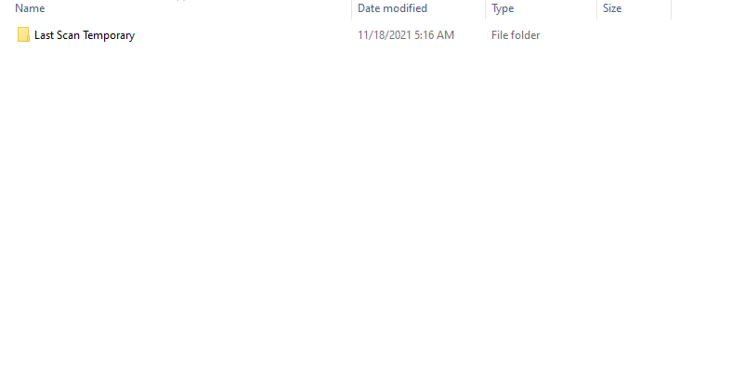

To the temporary PDF files of the select lot # and datetime to a new folder on the root directory, click on “Move/Delete Files”.

A message asking if this is a rescan will appear. If it is a re-scan, select “Yes”; if it is not, select “No”

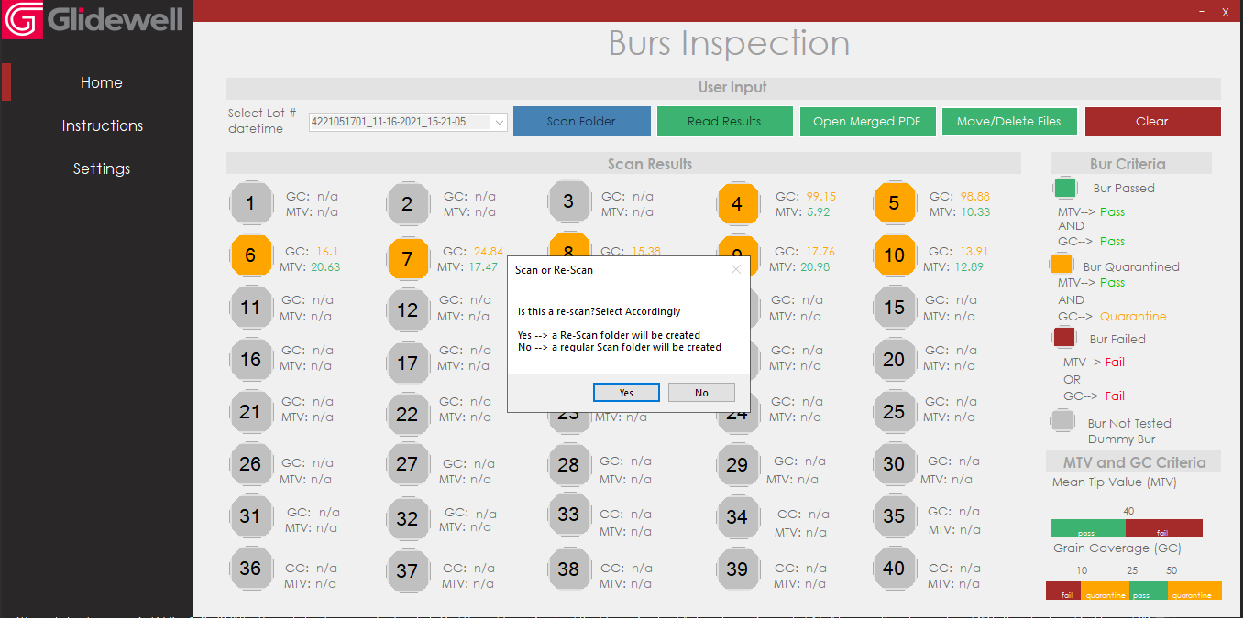

The system will now scan the root folder for directories with the same lot number. From there, it will find the last bur used on that lot number so it can discover how to name the folder in which the temporary PDF files will be moved to. For instance, if the software detects that there is a folder called “5221051701 Pre-Milling Burs 100 – 120” (matching the lot # selected on the drop down menu), and the scan has 7 burs, it will attempt to create a folder called “5221051701 Pre-Milling Burs 121 – 126”. IF there is not existing folders with that lot number, it will start from bur 1.

If it is selected it is a rescan, the software will follow the same process, but look for folders that have the same lot number, with “Re-Scanned” in the name

A new message will appear. The system will show the name and location of the folder it will try to create

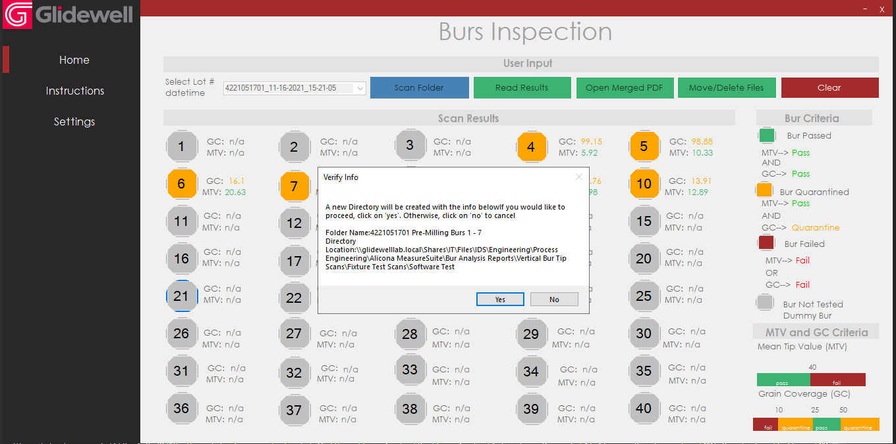

If you select “Yes” the software will attempt to

* 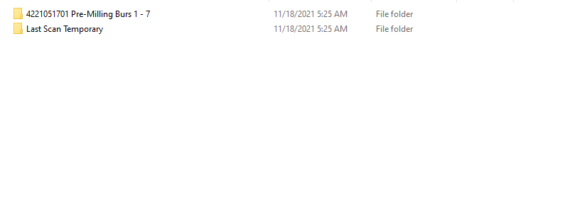create the folder with the name shown in the pop up message
* copy all the files with the lot # and datetime selected in the drop down menu (PDFs and csv) to the newly created folder

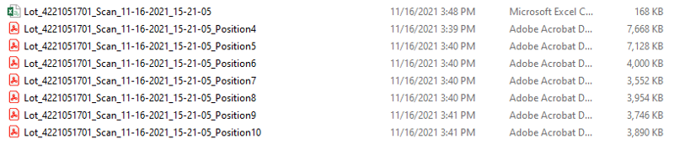

* once copying is completed, delete files from temporary folder

**Note:** this may take a few seconds/minutes depend of file size

* + When the system is running this operation, you will not be able to press any buttons
  + When the operation is completed, you will be able to press “Clear”



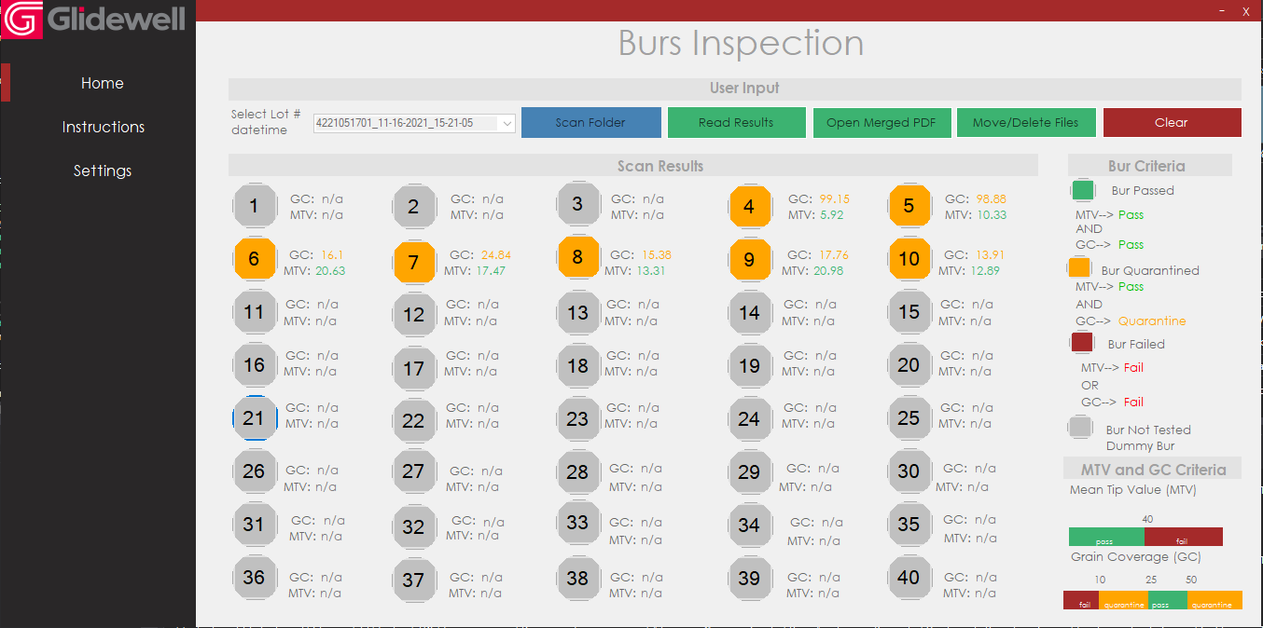

Hover over the clear button. If it highlights it, copying and deleted process finished. If it does not highlight, process is still running. Wait until process is completed (“Clear button” highlights when hovering over it).

Note: once the process is completed, it is strongly recommended to manually check that:

* The new folder was successfully created
* The files were successfully moved to the new folder
* The files were successfully deleted from the temporary folder

Click on Clear. A message will appear asking you to confirm. Select “Yes”

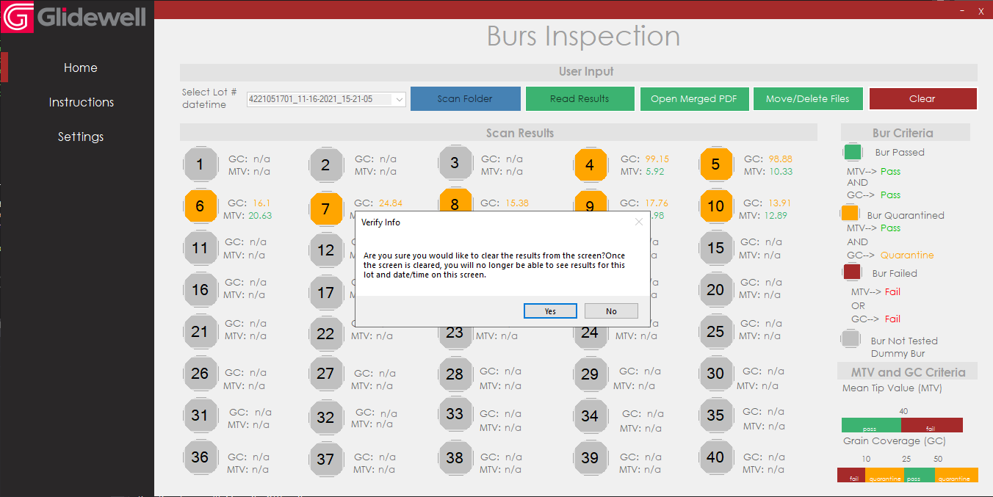

The screen results should now be cleared. Note that if you scan the folder again, by pressing the “Scan Folder” , the lot # and datetime that you just moved will no longer appear in the drop down menu.

Now the system is ready to follow the same process to read results, open merged PDF, and move/delete files.



**Running the software**

1. It is recommended to run software has to be ran as **an administrator**
   1. Right click on software executable file
   2. Click on properties
   3. Click on Compatibility
   4. Select “Run this program as an administrator”
   5. Click “Apply”
   6. Click “OK”