**Benefits DOFODY**

Dofody is an online platform for consulting doctors using online/information technology via laptop or smartphones. Whether it is for general or routine checkups or for the terminally ill, Dofody is there available 24/7. With the help of this technology Dofody can reach innumerable number of people for getting their medical checks done instantly.

In todays modern world where technology is growing exponentially , the current scenario in India as a country is lacking developments in the infrastructure sector. But in the case of information technology and its rapid growth and cost effectiveness, almost every citizens of India has some form of mobile devices at their home or office regardless of the economic condition of the country or in their family. With this in mind, Dofody can help those patients who are in need.

Dofody is most effective to patients who are in such a scenario where they have no time to travel or have the facility to travel , but can connect to the relevant doctor through information technology. Let us consider the story of Mr. Manoj he’s alone at home who has migraine and despite his self-help or bro advises he’s not able to get his pain down . With the help of smartphone he was able to contact a specialist doctor via Dofody and get the relevant help . Luckily the medicine which the doctor prescribed was the same medicine which he had in his cabinet, but with the proper advise from the doctor and he was free from migraine. Similarly Mrs. Susan who was on hiking trip , got injured on her knees as she slipped and fell and hit a boulder. Despite the pain she tried to find the necessary medical assistance but the closest one is far off. Fortunately she remembered her friend saying about the Dofody app. She quickly turned on her smartphone choosing the option of audio call made the payment in 30 seconds and and contacted the doctor for First aid care. The doctor was kind and patient enough to assist her to bandage herself with the stuffs she had with her in her backpack. With the help of Dofody she was able to pull herself through and proceed to the nearest primary health center for further treatment under the advise of the doctor.

So the number of uses for Dofody is infinite in regards to check ups or consultation. I will be posting more articles like this in future and will share the references as well. If you have found Dofody useful kindly share it with your friends and family and also comment your thoughts in the comment section below. We’ll get in touch with you soon. For reviewing our website please go to [www.dofody.com](http://www.dofody.com) and if you like to login go to [www.dofody.com/login](http://www.dofody.com/login).

**How you can use Dofody?**

Let’s imagine a scenario where a 70 year old Mr Rajan who is a retired principal and stroke patient for last 7 years. He has a retired life and enjoys life with his grandchildren despite restrictions from his local doctor to not stress much. But one night when he decided to go to bathroom and as he was being taken to the bathroom for a shower he suffers heavy stroke and falls down and hits his head as well. He was immediately rushed to the hospital for emergency treatment. The emergency department physician after carefully examining the patient, advised the family to admit him for further treatment. After 2 weeks of treatment at the hospital, Mr Rajan shows no sign of any recovery as his ribs started to show off. The hospital doctor advised to not treat the patient further in the hospital as the condition of the patient is severe. And he will not live for man than few hours. Despite the disheartening news from the emergency physician the family accepted the advise and took the patient back home.

Someone from the family heard about Dofody and they decided to give one last try . After downloading the app from google playstore and following the necessary instructions. After making the payment and within 10 minutes they were directed to a doctor, who advised them to not take the patient to hospitals anymore and instead consult a palliative medicine/care. Fortunately Dofody is tied-up with palliative doctors who are specialised in such cases. And under the advice of palliative doctor, the doctor said that the patient would have only couple of hours to live in the present condition. So the palliative doctors/caretakers were able to handle the physical, psychological and social needs of the patient before he passed away. The patients family was grateful to Dofody app, as they had no idea as to what to do in such matters.

However bad the situation is, Dofody can help you diagnose or track health issues with an easy to use app. The app can be downloaded from google playstore and can be setup in a few minutes. After filling up the necessary registration formalities, you are good to go. Dofody is just as easy to use like any other social media communication apps . Minimalist and efficient, Dofody can help, assist and can also have a 2nd opinion from our doctors. Dofody is great at which it can save a lot of time, as in today’s busy world where everyone is trying to get groceries, meeting deadlines, avoiding traffic, getting kids from school, taking care of grandparents are a daily hassle. Dofody relieves this stress on people as well as on patients. Our doctors on Dofody are certified and well trained for any medical assistance , as they are as reliable and more efficient than a clinic or a hospital visit.

For sharing your thoughts please visit our website [www.dofody.com](http://www.dofody.com) and for login to our webpage [www.dofody.com/login](http://www.dofody.com/login).

**Top 5 Steps To Get Rid Of Mosquitoes**

1. Use Loose and covering clothes at night thus minimising the exposed skin. Use mosquito swatting bats. Using rolled up newspapers and magazines can also help extend your arm reach and make a perfect swat.

2. Mosquito nets are one of the most effective and cheap method of keeping mosquitoes away from your skin for a good sleep. Make sure that there are no holes in the net and that while draping the net, it completely covers the bed without any space for mosquito entry.

3. One of the most important step in reducing the numbers of mosquitoes is to eliminate their breeding places. Stagnant water is the breeding place of mosquitoes and examples of this include coconut shells and discarded cans filled with water, broken bottles, empty pots, tires, clogged gutters, puddles etc We can greatly reduce the mosquito population in our community by removing such breeding grounds for them. We should also make sure that we dispose our home waste in a proper manner.

4. Application of oil to water is one of the oldest known mosquito control measures. The oils most widely used are Diesel oil, fuel oil, kerosene and other fractions of crude oil. When applied on water, oil spreads and form a thin film which cuts off the air supply to the mosquito larvae. Synthetic insecticides like Fenthion, Chlorpyrifos, and Abate are potent larvicidal agents.

5. There are certain fishes which feed on mosquito larvae. Examples of these include Gambusia and Lebister. These fishes can be used in burrow pits and ponds.

**Are you drinking enough Water everyday?**

A glass of crystal clear water may look simple to you, but believe me when I say that it is the best bet for your health. You can live without food for several days, but not without water. Everybody knows the importance of drinking adequate water every day, but most of them are not drinking water in the right amount required for their body to be honest. Are you aware of the health benefits of drinking water? Are you drinking enough water everyday? Do you drink water only when you are thirsty? This article will give you some guidelines to determine how much water you need to drink everyday.

Importance of Water

Water is the most important component of human body and comprises about 60% of the body weight. Water is also required to complete a [balanced diet](http://beingthedoctor.com/malnutrition-balanced-diet-and-health-tips/). Here are some of the health benefits of water that you need to know :

* One of the major function of water in our body is to flush out the metabolic wastes and toxins through the kidneys in the form of urine.
* Water is an integral component of the plasma and the extracellular fluid which supplies nutrients to the body cells.
* Drinking the right amount of water can prevent the formation of stones in the urinary tract including the kidneys.
* Adequate water is necessary to prevent infections in the urinary tract.
* It provides moisture for the proper functioning of nose, throat, ears etc.

How much water should you drink?

The amount of water a person needs to drink everyday depends on several factors. The built of the person, health status, the kind of work, lifestyle and environmental factors plays vital roles while trying to answer this question. This simply means that there is no definite formula to measure the correct amount of water a person has to drink daily.

You would have heard about the “eight by eight” rule, which requires everyone to drink 8 glasses, each containing 8 ounces of water. This will round-up to 2000 ml (2 litres) roughly. If we drink other beverages like tea, coffee, milk etc daily, the total fluid intake can go up to 2500 ml.

A person leading a [sedentary lifestyle](http://beingthedoctor.com/sedentary-life-style-and-diseases/), with minimal physical activity and working in an air-conditioned room needs just 2 to 2.5 litres of fluids daily.

In the case of those who work with moderate levels of activity, the daily fluid intake should go up to 3 litres.

Recent studies from United Kingdom have shown that drinking a glass of water half an hour before every major meal a day can help reduce the body weight by 4 kg in just 12 weeks!

One may need to drink more water after physical exercises in order to compensate for the fluid loss. About 500 ml of water is required after short bouts of exercises. It is recommended to take one glass of water before, during and after the exercise.

The water intake can also vary in several diseases. For example, a person suffering from heart failure or kidney failure has to limit the daily intake of water in order to reduce the work load on the damaged organs and prevent further complications.

Conditions which bring about loss of body fluid like fever, vomiting and diarrhoea can lead to dehydration. In such conditions, oral fluid intake should be increased. Severe dehydration cannot be managed at home and might need hospitalization.

Pregnancy and breast-feeding are two other situations where the intake needs to be increased to 3 litres per day.

Hot and humid environmental conditions are other factors, where increased water intake is needed to remain healthy. Increasing the water intake in summers according to your lifestyle is highly recommended.

So, are you drinking enough fluids?

Well, the first step to find out whether you are drinking adequate amount of fluids is to keep a count of the number of glasses of water or other fluids that you drink everyday. The fluids that can contribute to the daily quota can include beverages like milk, tea, coffee, sodas, juices etc. It should be kept in mind that these “other fluid sources” should not be made the major contributors to the daily required volume. It is best to make water your favourite beverage because it has zero calories, has no added preservatives or colour and is inexpensive too.

Do not use “thirst” as your body’s natural signal to drink water. By the time the sensation of thirst develop, your body would have gone into dehydration.

You can also seek the help of your doctor to find out whether your current fluid intake is adequate or not. Or else, use the “[Ask a Doctor](http://beingthedoctor.com/ask-me/)” page and we will be glad to help you.

We know that you are busy with your work and do not have time to check out for new posts on this website. You can fill up our free newsletter subscription at the top of this page and make sure that you never miss a post as it gets published.

**How to Login Dofody?**

Dofody is an online doctor consultation platform with the help of information technology via web/app. Minimal and more efficient than a hospital or clinical visit by themselves. Here are the steps on which how to start using Dofody.

**STEP 1: (If, using desktop or laptop)**

Type the URL - [www.dofody.com](http://www.dofody.com) on the address bar of your browser.



**STEP 2:** After entering the URL you will be directed to Dofody website below

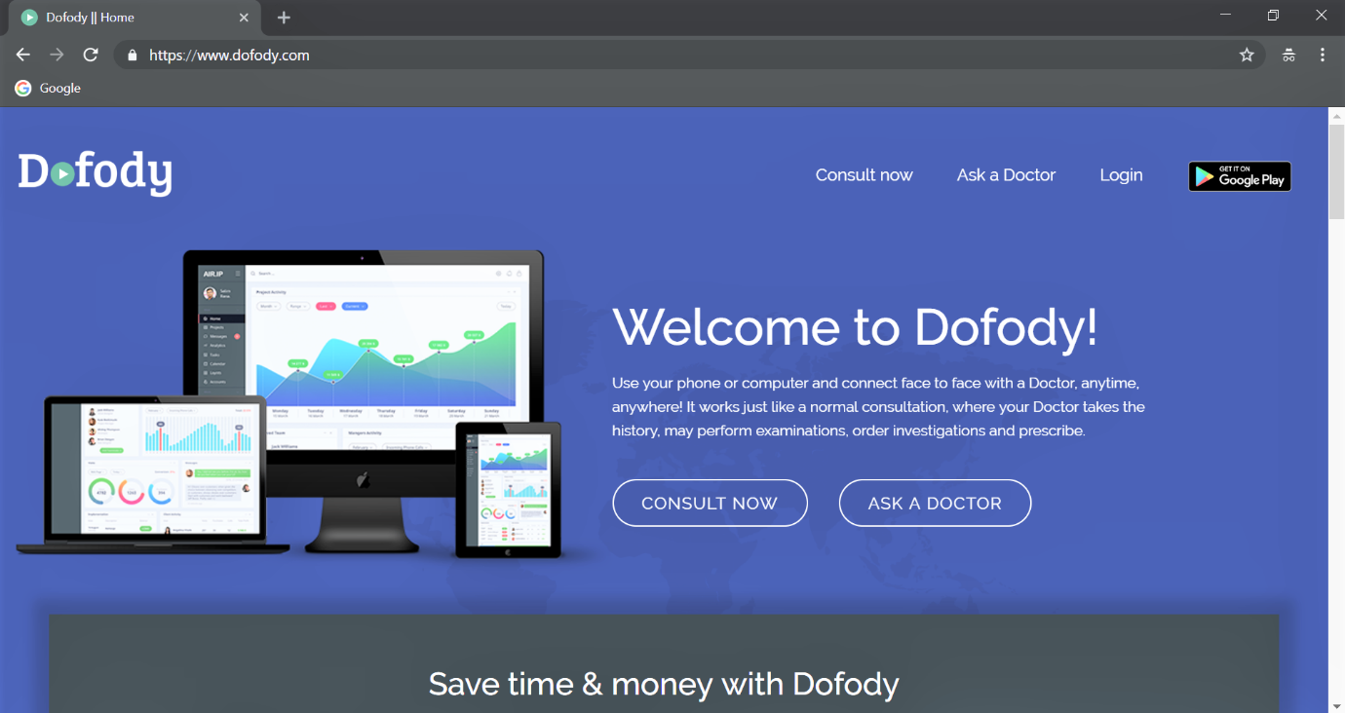

**STEP 3:** On the Dofody homepage, hover the cursor to Login and click it.

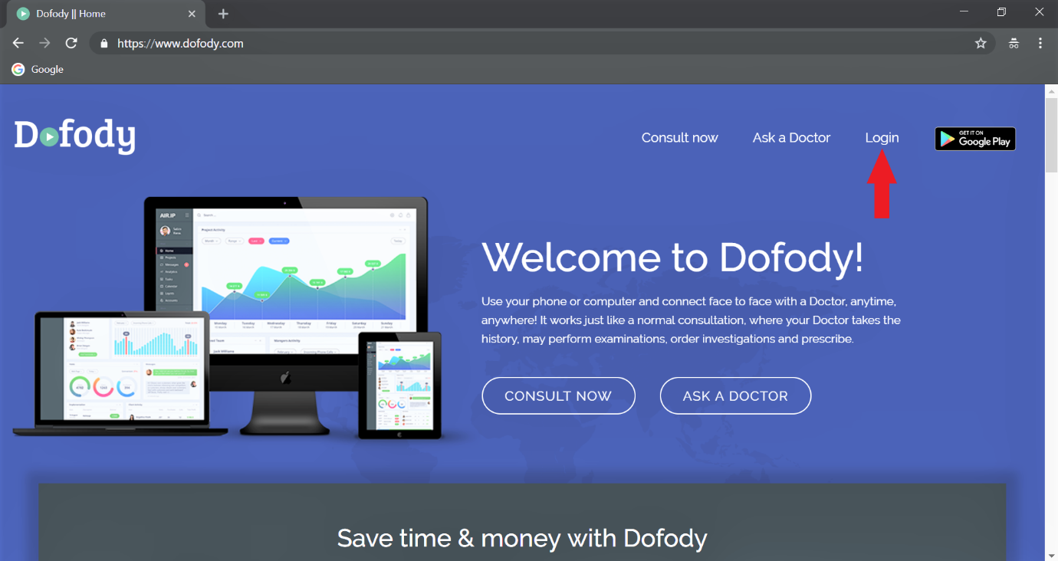

**STEP 4:** After login you’ll be directed to the page , “Doctor Login” and “User Login”.

Click “User Login”

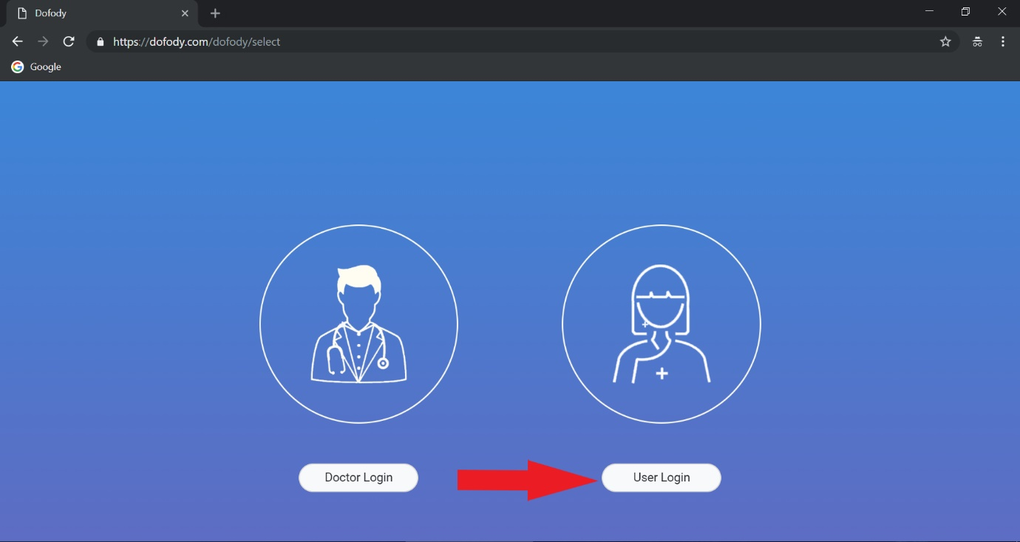

**STEP 5:**  After clicking “User Login”, you’ll be directed to Dofody Login page as described below. Enter your registered e-mail address and password. Click “Sign In”.

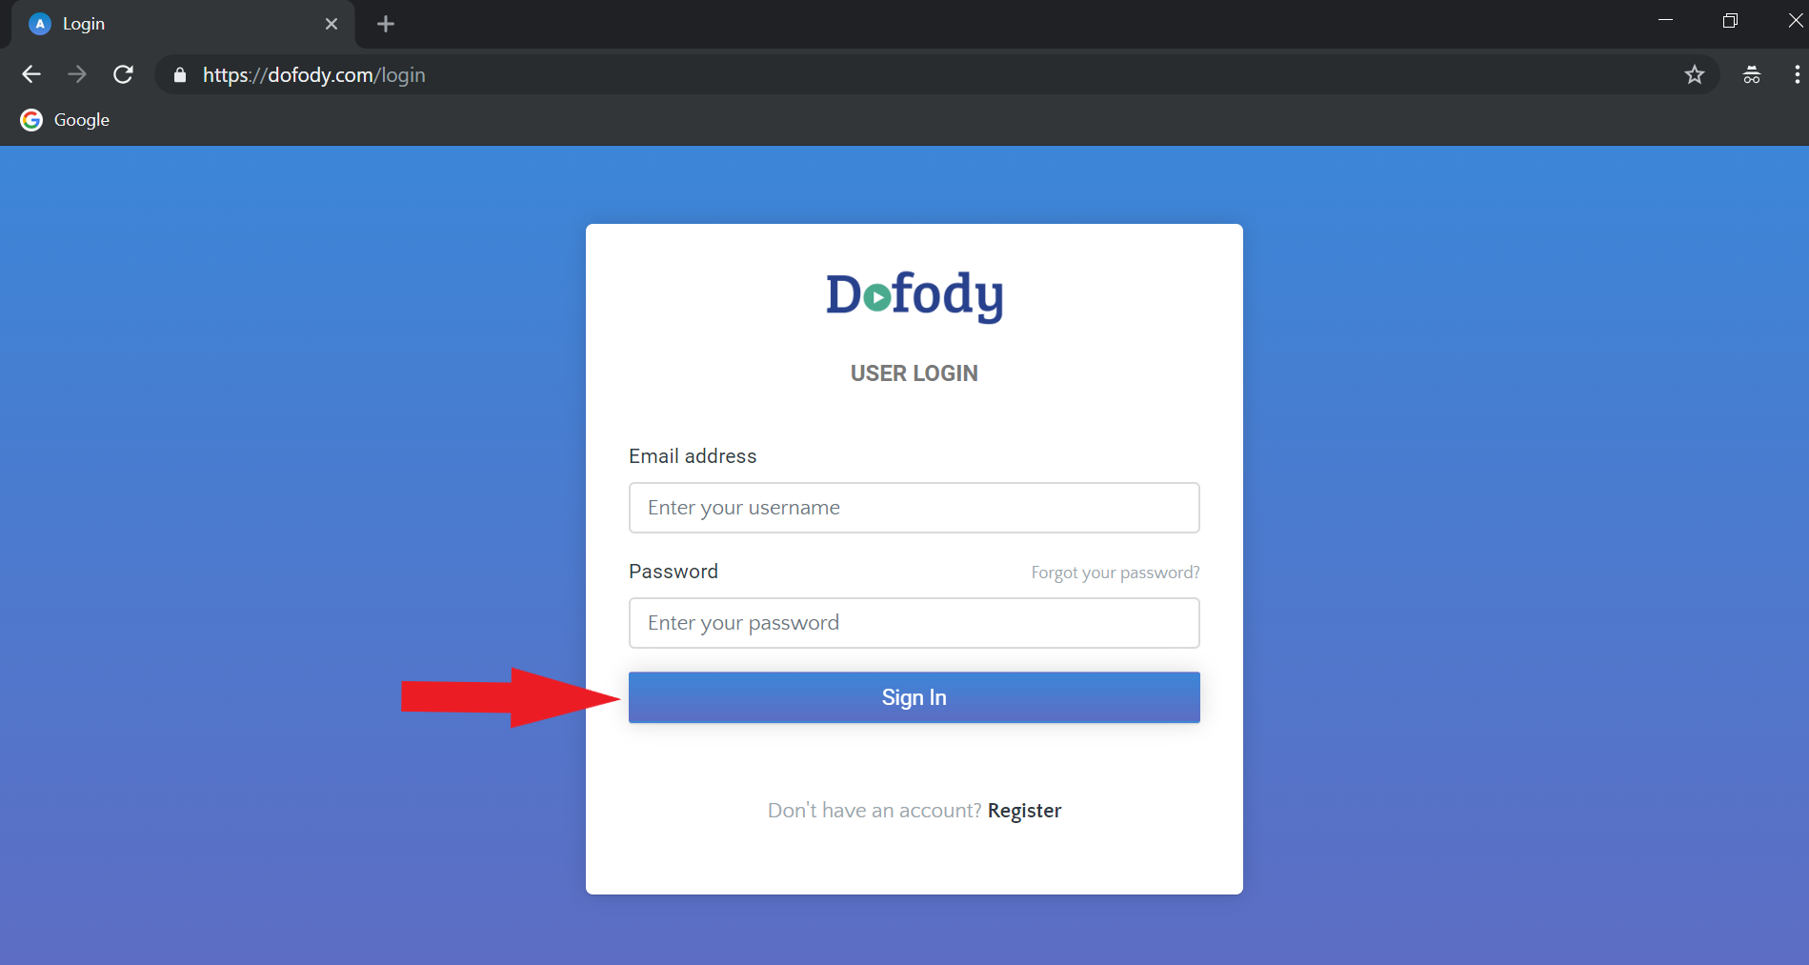

**STEP 5:** After “Sign In” you’ll see your Dofody profile homepage

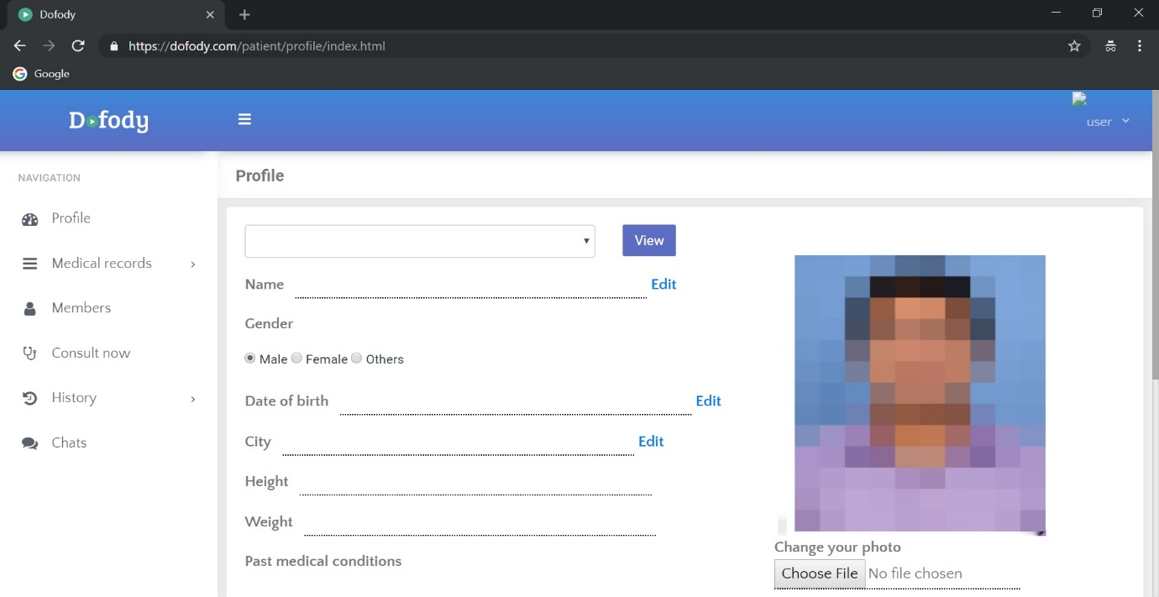

**How to Open a new Dofody Account?**

**STEP 1:** After entering the URL www.dofody.com, you will be directed to Dofody website below



**STEP 2:**  Scroll down and you’ll see “REGISTER NOW”.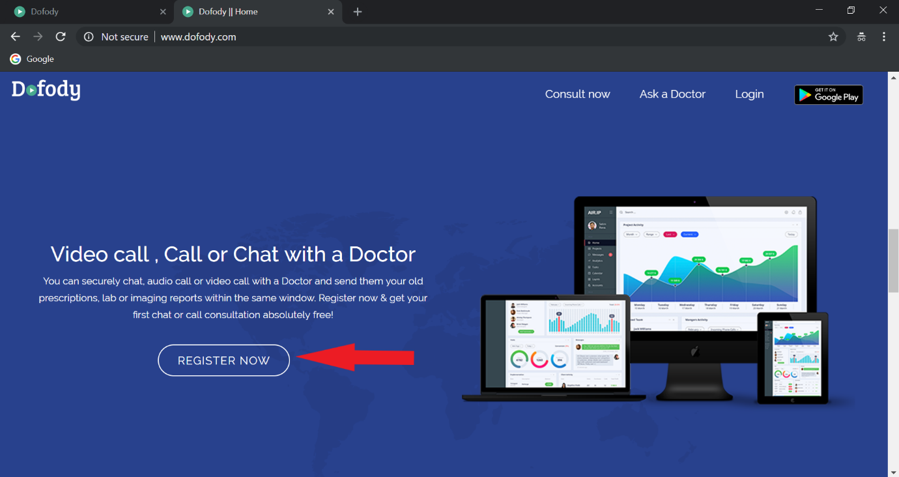 After clicking it you’ll be directed to the “Register” page.

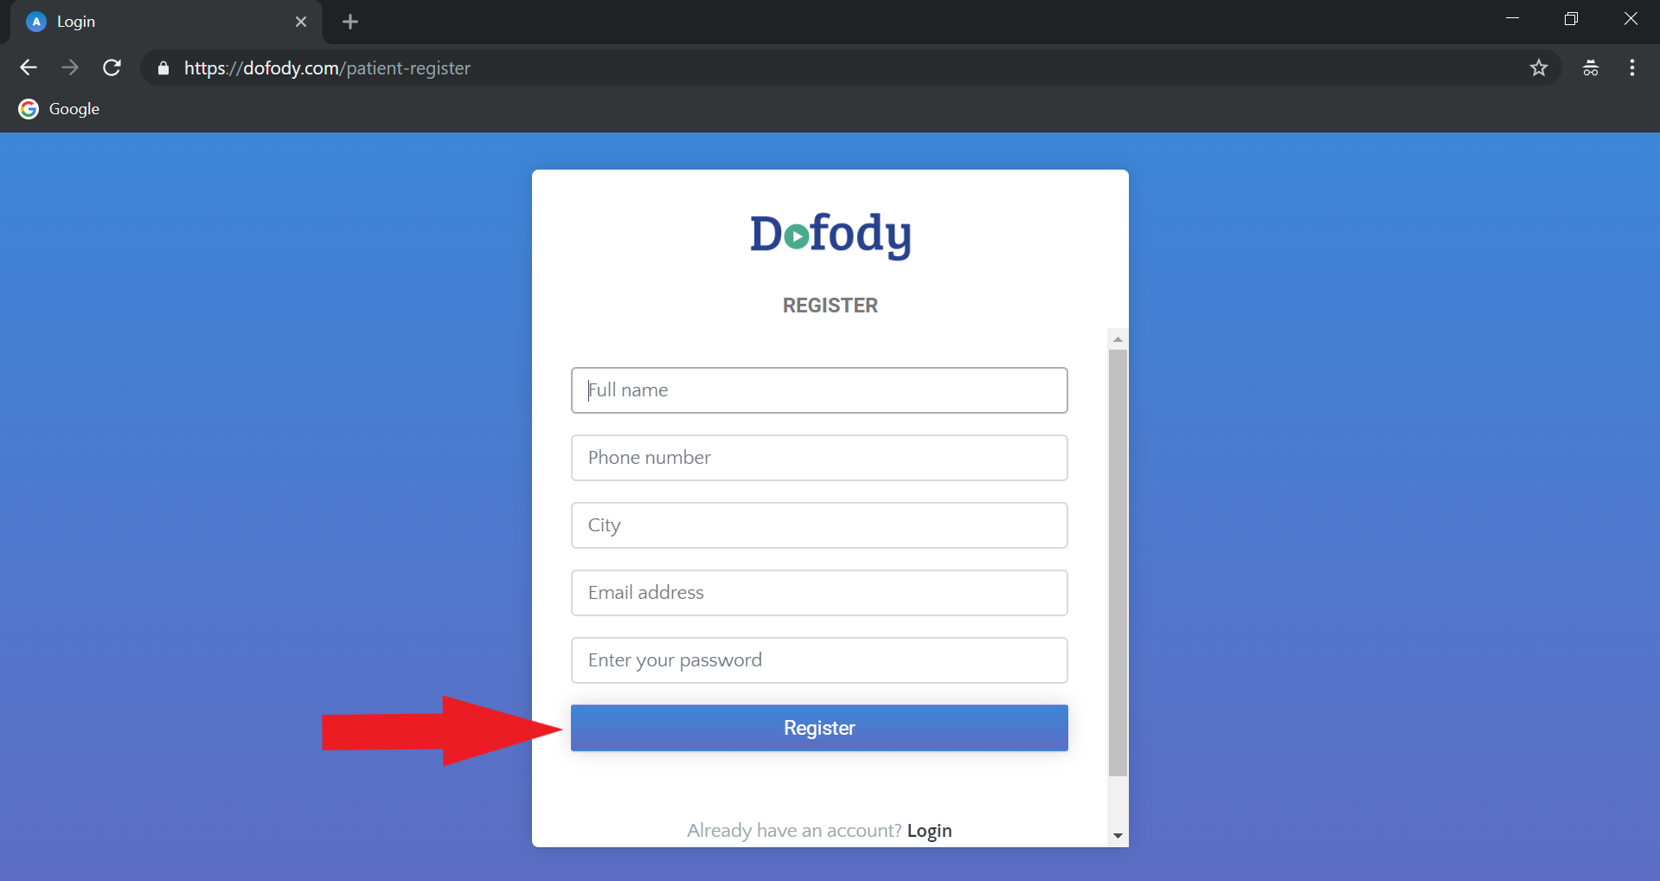

After filling in your Name, genuine phone number, city, e-mail and password, click the blue tab named “Register” and you’ll be directed to “Verify phone number” Page.

**STEP 3:**  In this page you’ll be getting an SMS on your smartphone which you have registered with Dofody.

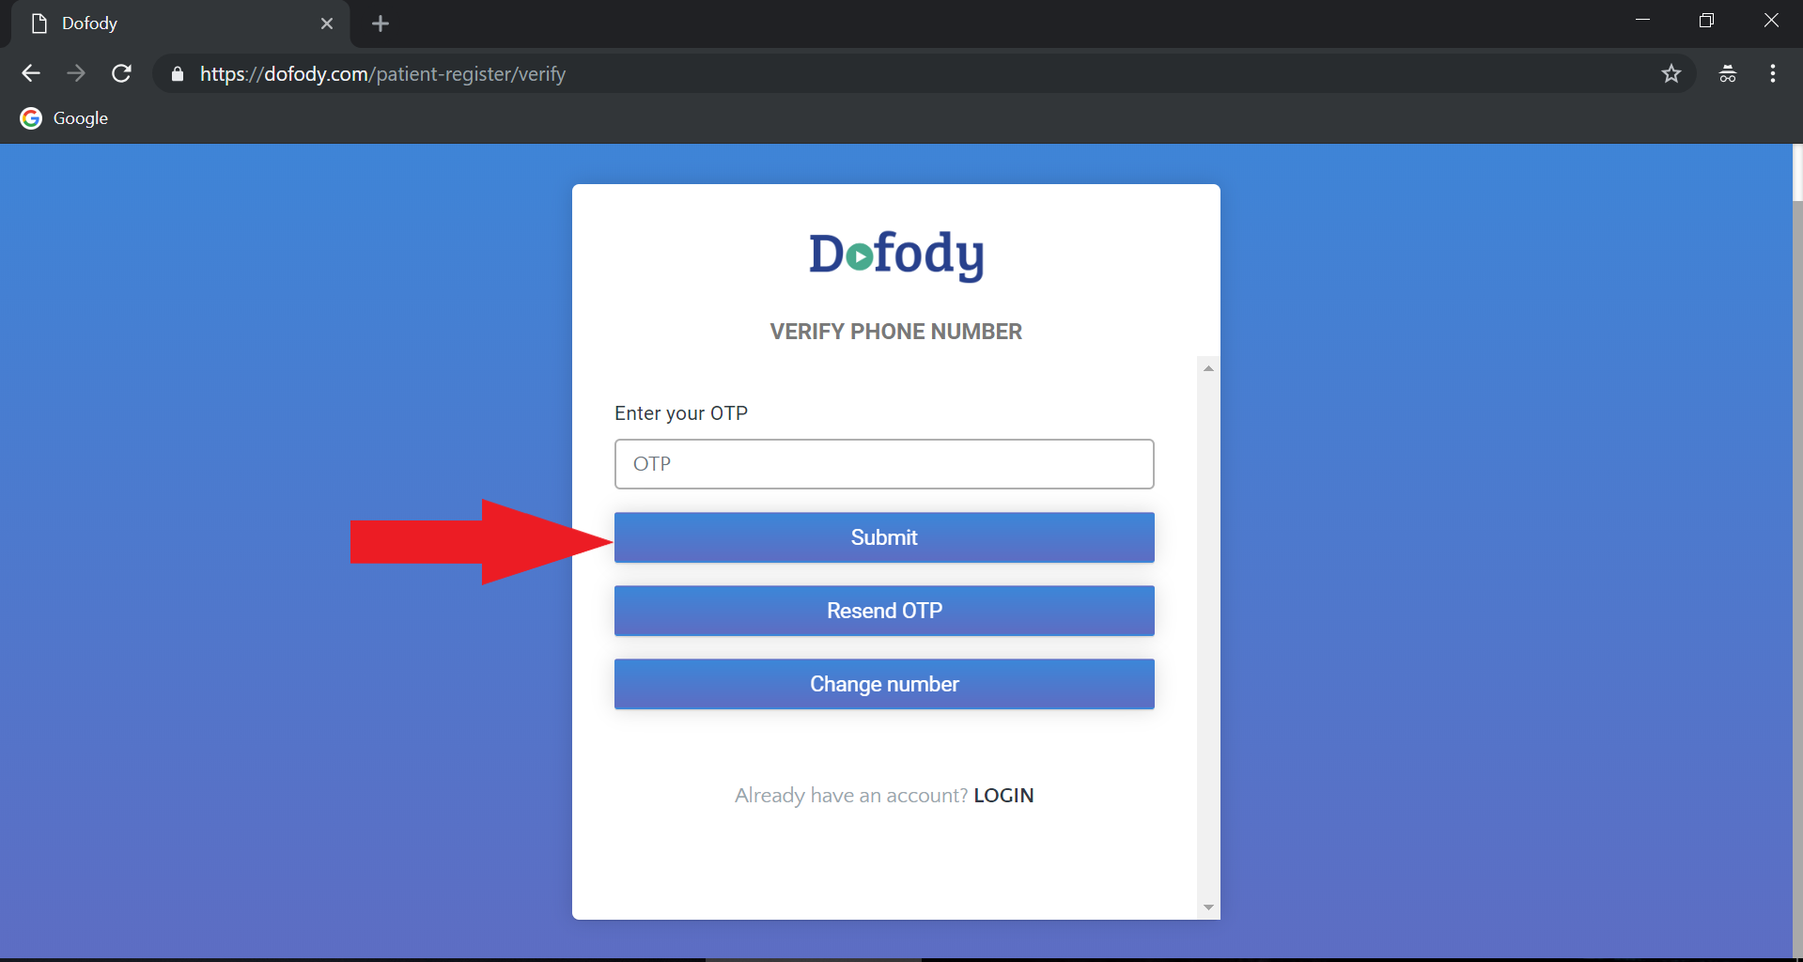

Type in the **OTP** (ONE TIME PASSWORD) number once you have received via SMS and click the blue tab “Submit”.

**STEP 4:**  After clicking “Submit” you’ll be redirected to “User Login” page as seen below

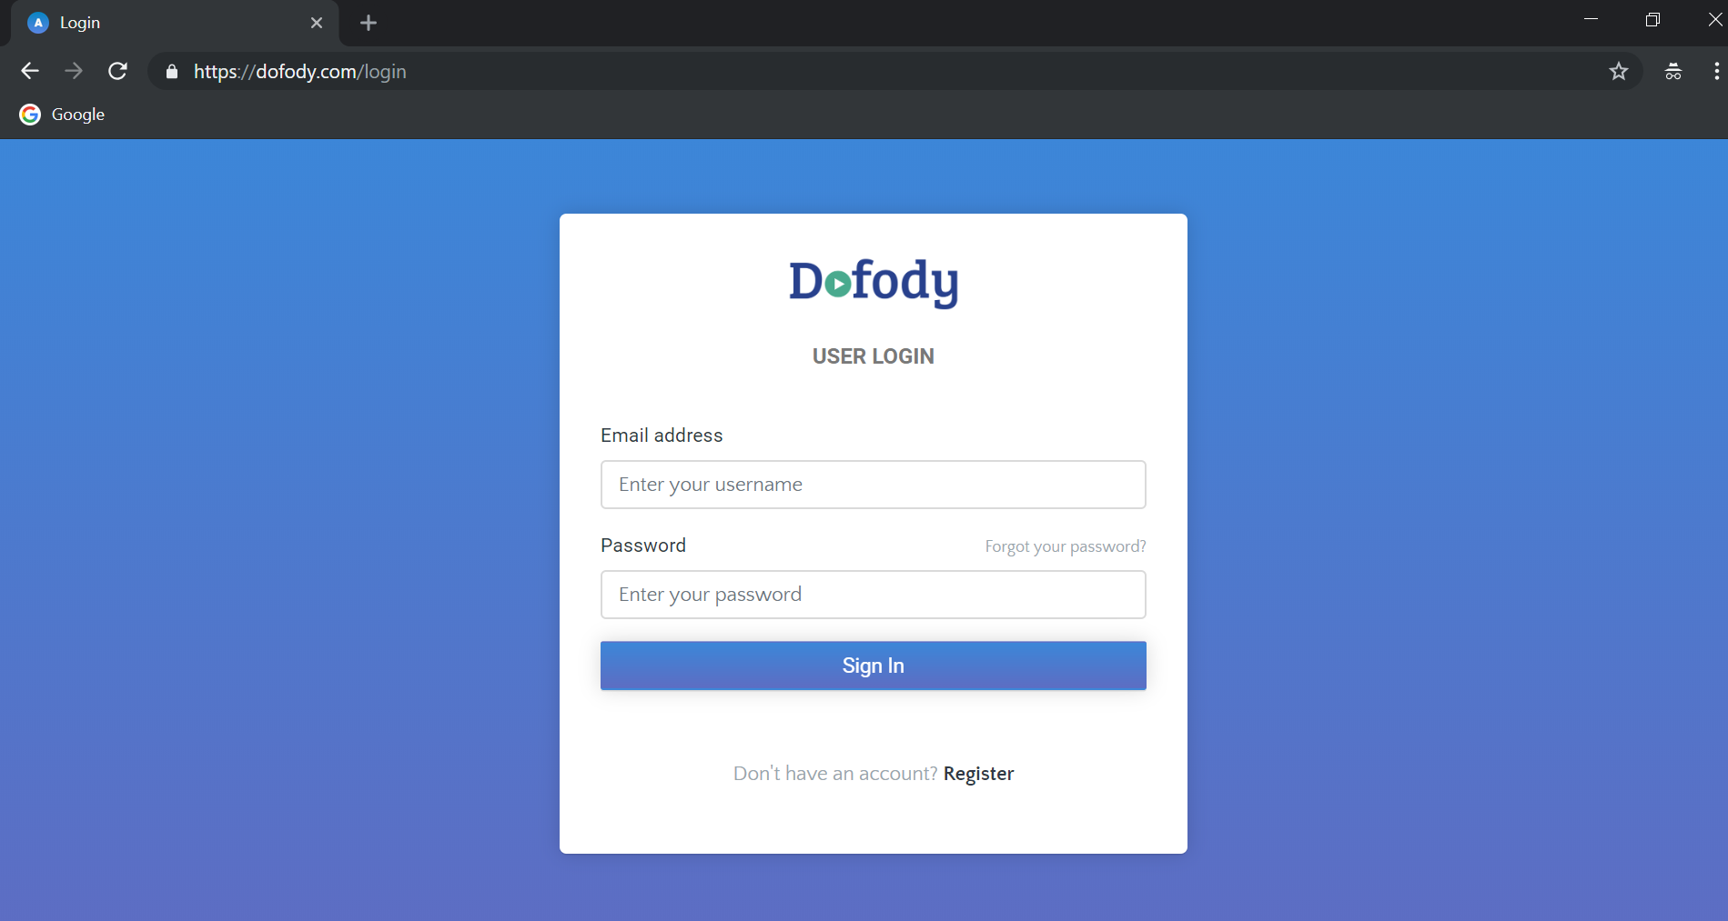

Type in your email address and password and click the blue tab button “Sign In”.

**How to consult a doctor using Dofody?**

**STEP 1:** After entering the URL [www.dofody.com](http://www.dofody.com) in the address bar of your browser. Click Login.



**STEP 2:** After clicking Login, Click “User Login” fill in your e-mail address and password and click Sign In.





**STEP 3:** After, you’ll see your homepage as displayed below. Click “Consult Now”.

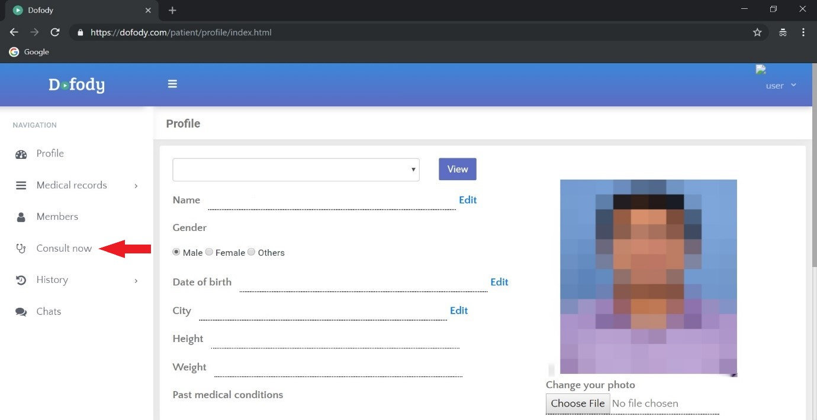

**STEP 4:** After clickingConsult Now, you’ll be led to Consult now page which the page asks the user to fill in details like, “choose user”, “Present health problem”, “Since when”, “Relevant past medical conditions”, “Upload medical records”(If any).

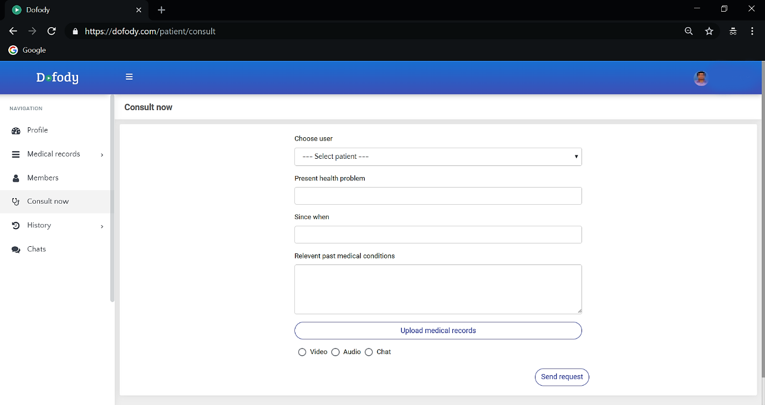

**STEP 5:** After filling in your necessary details , please select your preferred mode of communication of your doctor (Video, Audio, Chat).

**How to add a family member on Dofody**

Dofody is simple to use online doctor consultation platform, where a user can create an account and add multiple family members within the same account. This means that one user account will be sufficient for the whole family. In this article I will show you how you can add your family members so that they can also get online doctor consultations and prescriptions, so let’s get started.

1. Go to [www.dofody.com](http://www.dofody.com) and click on the “Login” button. And click “User Login”. If you don’t have an account already, read this article on how to get to started with Dofody.

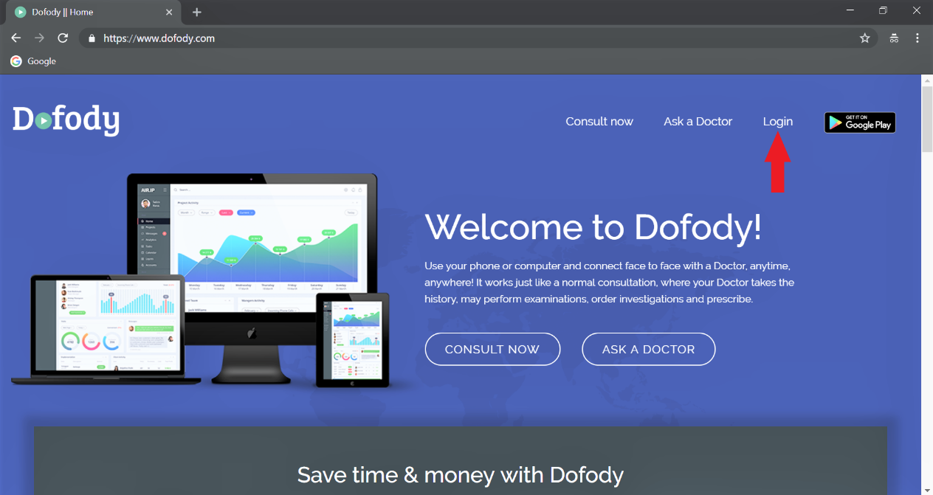

d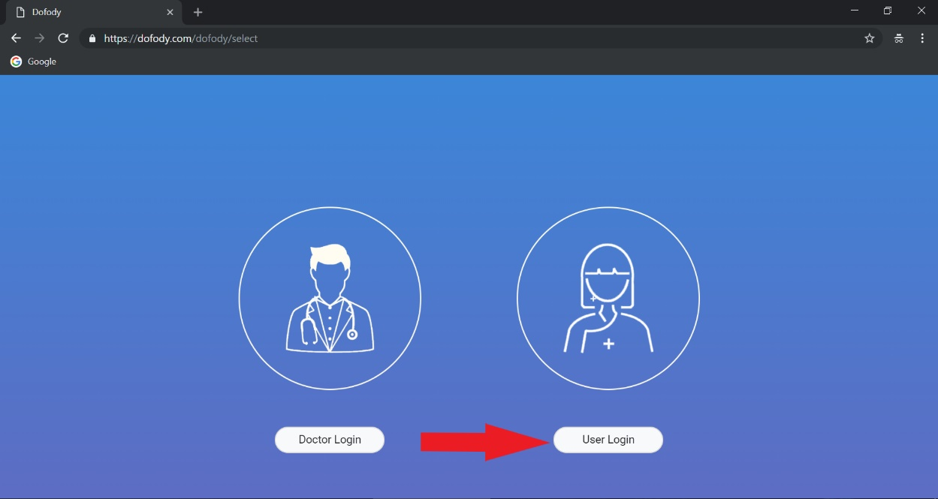

1. Enter your e-mail address and the password in the respective fields and click on the “Sign In” button. You will be now logged in to the user portal at Dofody.



1. On the left side menu, click on “Members” and then enter your family members details in the corresponding fields. Note that giving details on relevant past medical conditions will be useful for the doctors.

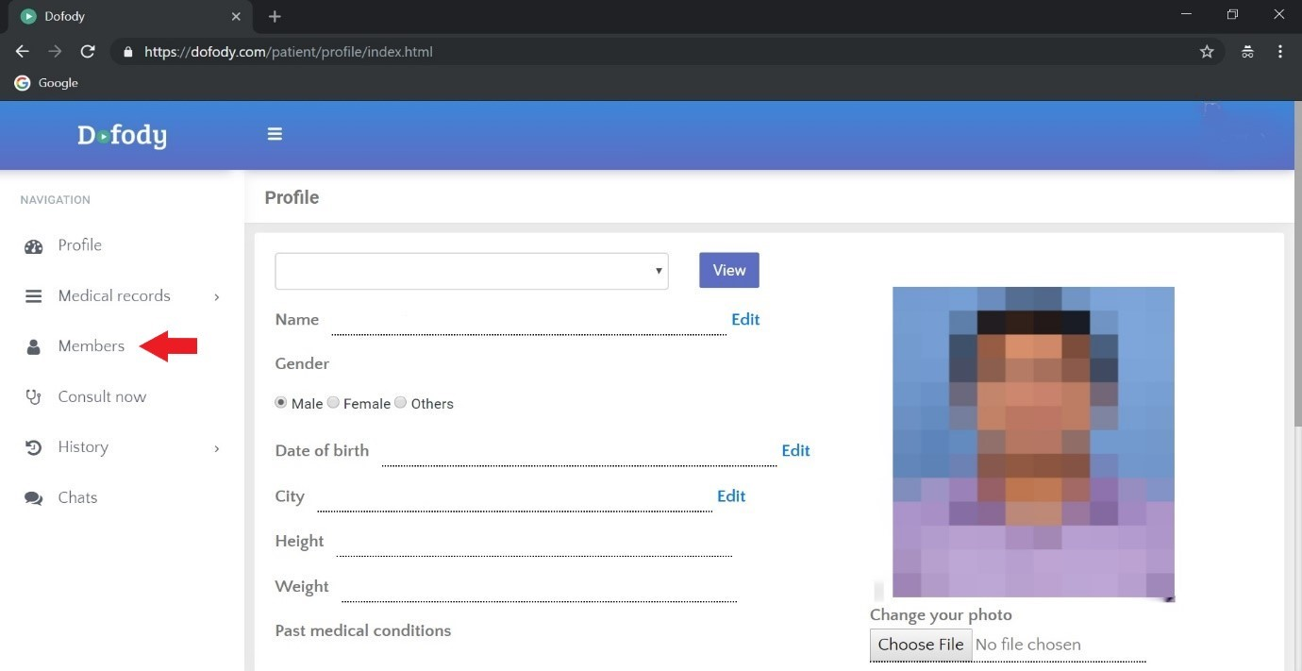

1. To add another member, you can follow step 3 all over again and click “Add member”.

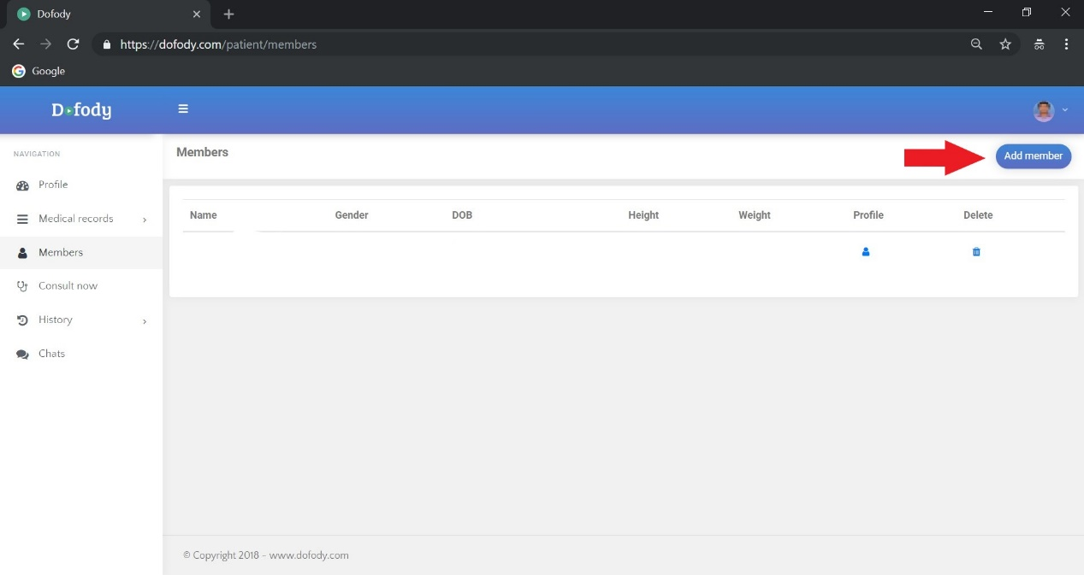

1. Next time you try to consult a doctor through Dofody, you have to select first a family member to whom the consultation is intended. This can be done in the “Consult now” page.



1. To learn how to consult on Dofody go this page



**How to use Dofody to get a valuable second opinion.**

Mr Vijay from Kerala is working in an IT company in Bangalore. One day he developed a bad chest pain, took ECG from the company clinic and diagnosed as heart attack. Advised angiogram from a popular hospital . Angiogram showed triple vessel disease, that means block in all three free cardiac vessels. Cardiologist advised Mr vijay to go for open bypass surgery instead of doing angioplasty as earlier decided. Mr Vijay was confused, as open heart surgery is a major surgery with high risk and high financial requirement. He decided to take the opinion of another cardiologist  in Kerala using Dofody. He downloaded the app, created a new account in 2 minutes and completed the payment.

After uploading his medical documents in Dofody app, his cardiologist took history, went through medical reports and finally after 20 minute video call came to a decision to go ahead with open bypass surgery and explained why . This time, Mr Vijay was satisfied with the decision. he decided to come back to his home town for the surgery; Dofody came to the rescue yet again.

Please include usual into and concluding paragraphs.

**How to use quick consult in Dofody?**

**STEP 1:**  Go to website URL www.dofody.com, click Login. If you aren’t a registered user click this link



**STEP 2:** After login , click User Login 

Enter e-mail address and password and click “Sign In”. Then you’ll be directed to your profile homepage as seen below.

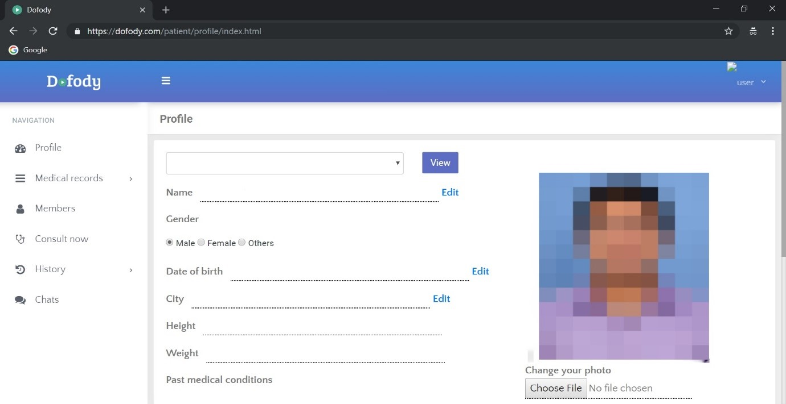

**STEP 3:** Click “consult now” on the left panel

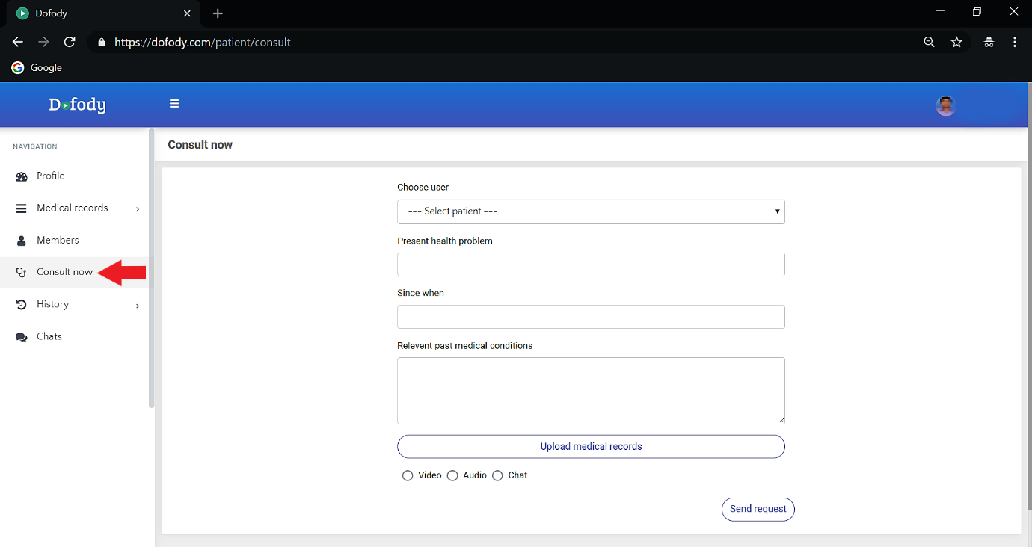

After clicking consult now, you’ll be directed to consult now page as seen below



**STEP 4:** After choosing user and filling in the other necessary medical details for consultation, click on your preferred mode of communication (Video, audio, chat) and select Quick consult.

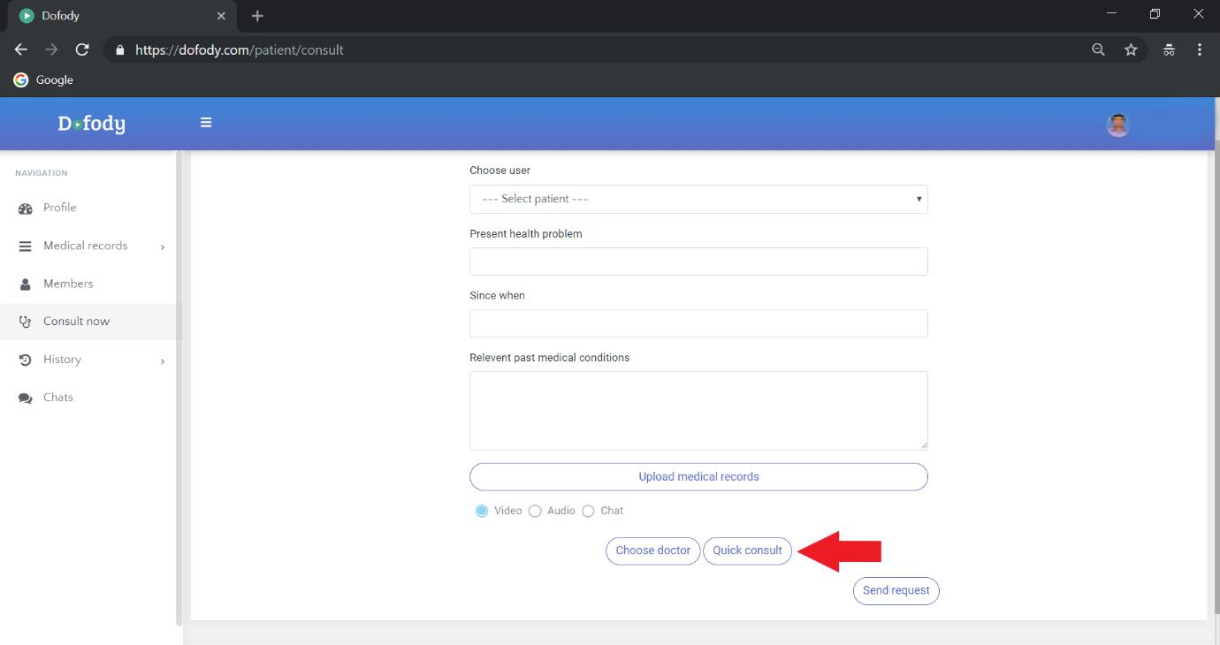

**STEP 5:** After selecting Quick consult, you’ll be directed to a popup. Select Accept.

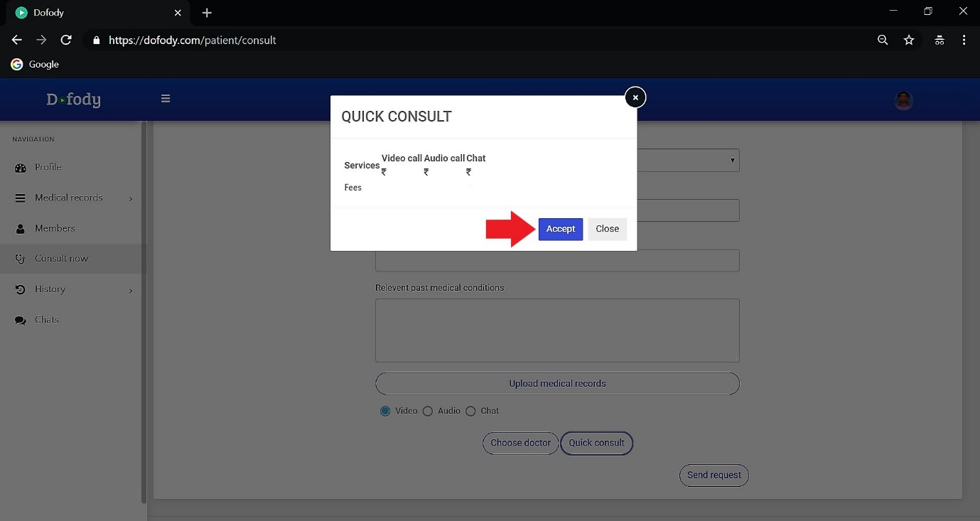

After accepting, you’ll be taken to quick consult Pay online.

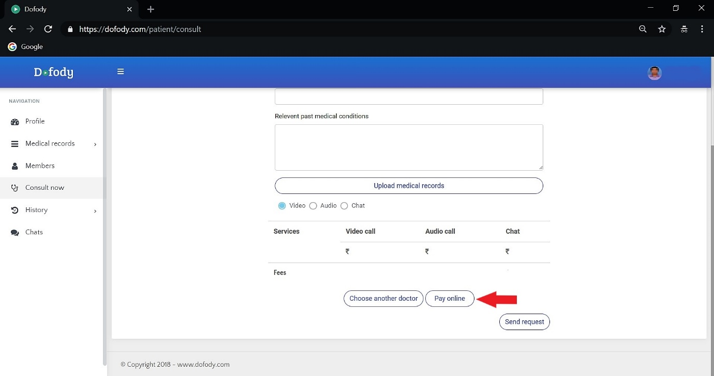

**STEP 6:** After paying online

**How to add medical records in Dofody?**

**STEP 1:** After typing in the URL [www.dofody.com](http://www.dofody.com) on the address bar of your browser. Click “Login”.



**STEP 2:** Select “User Login”



Type in e-mail address and password and click “Sign In”



**STEP 3:** After Signing in you’ll be at your homepage as seen below. Click on “Medical records”.

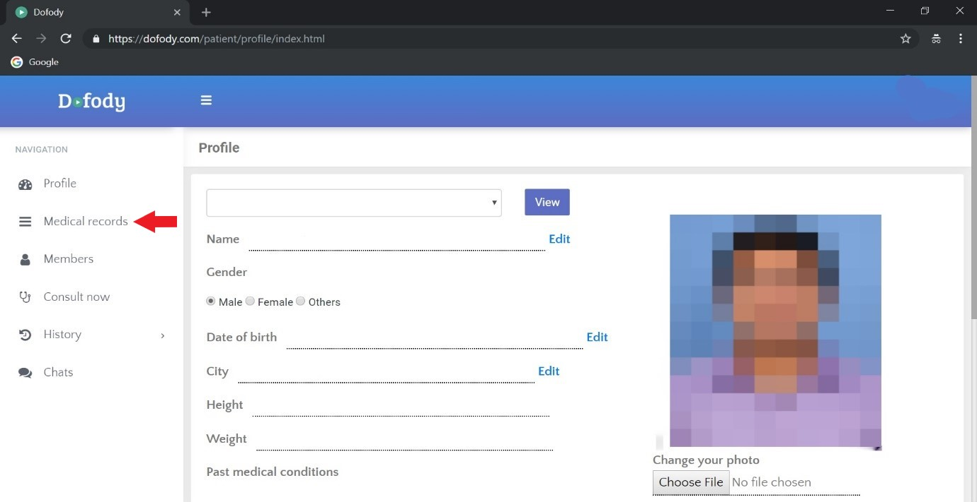

**STEP 4:** After selecting “Medical records” choose “Records” on the left panel, and it will carry forward through medical records page.

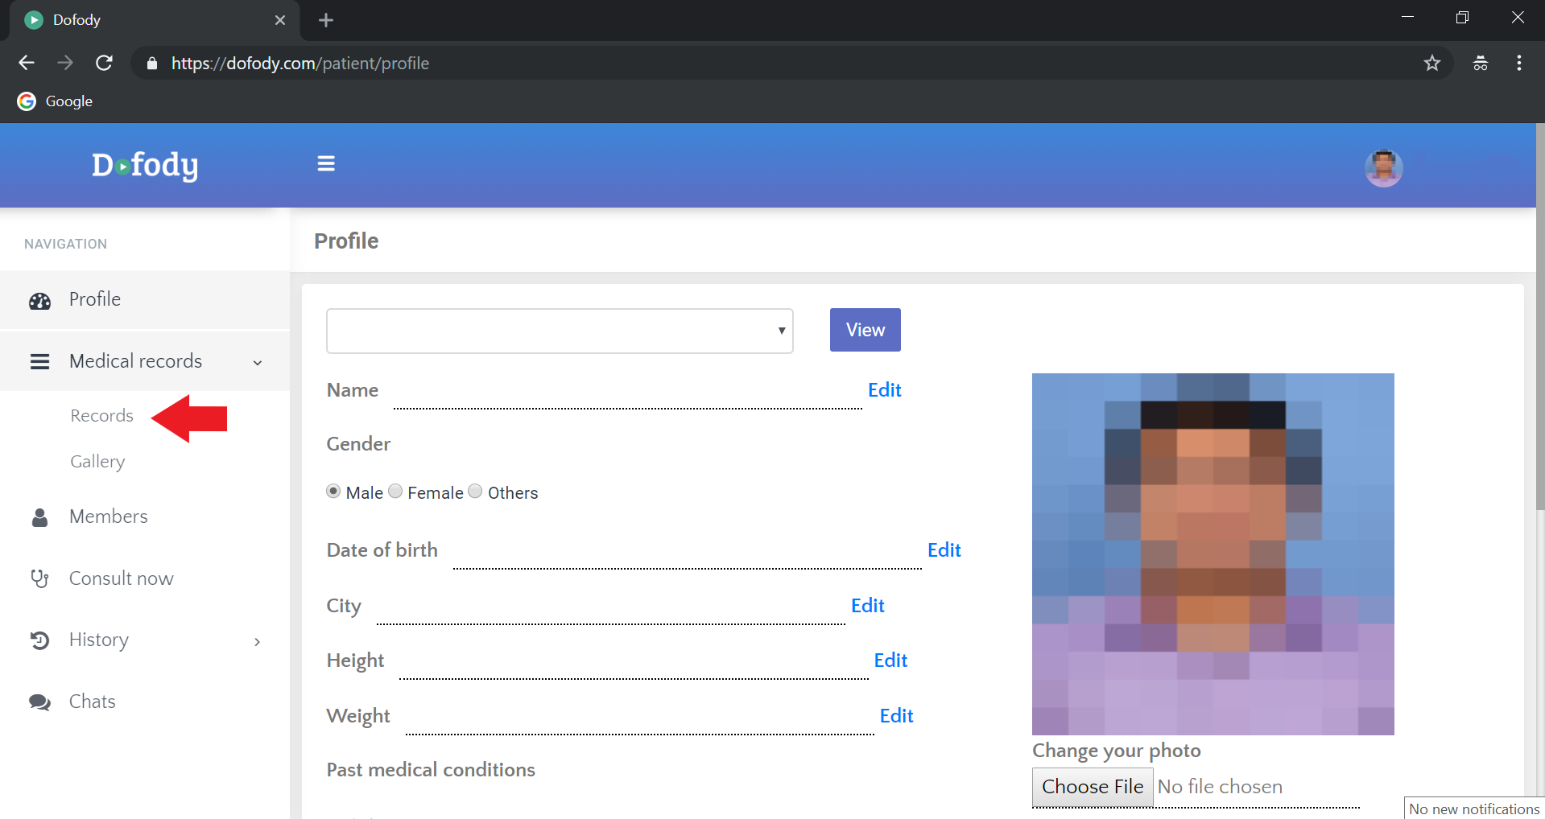

**STEP 5:** Click “Add record”.

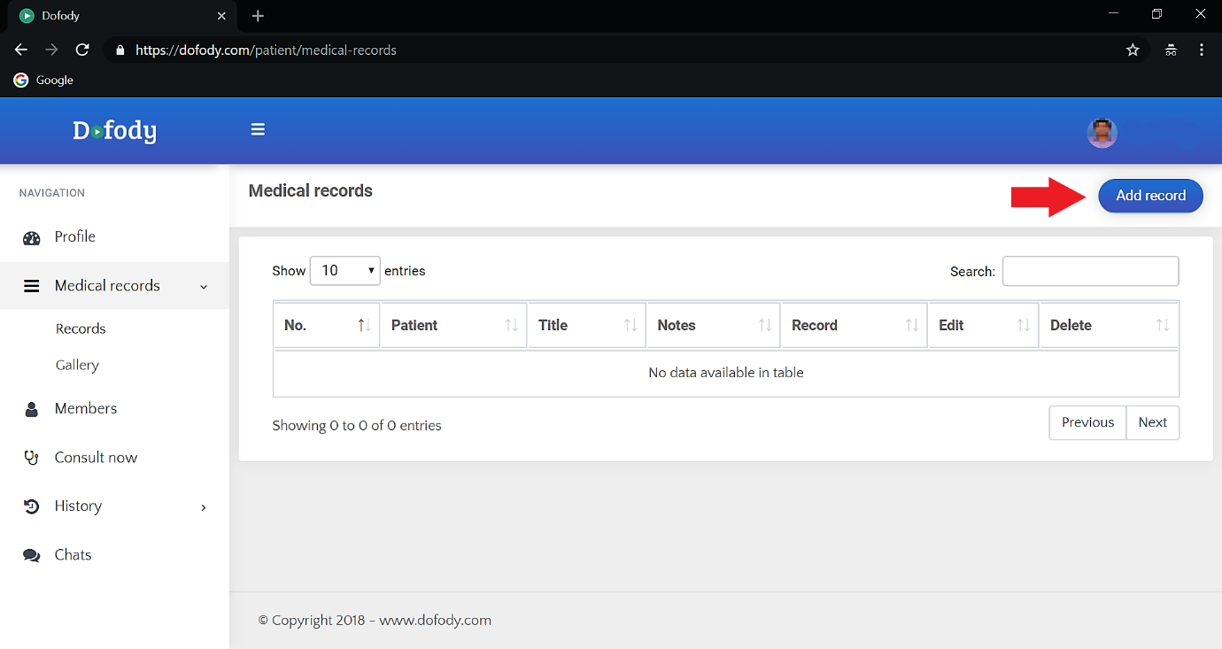

**STEP 6:** An “Add record” will popup, asking you to fill in the details.

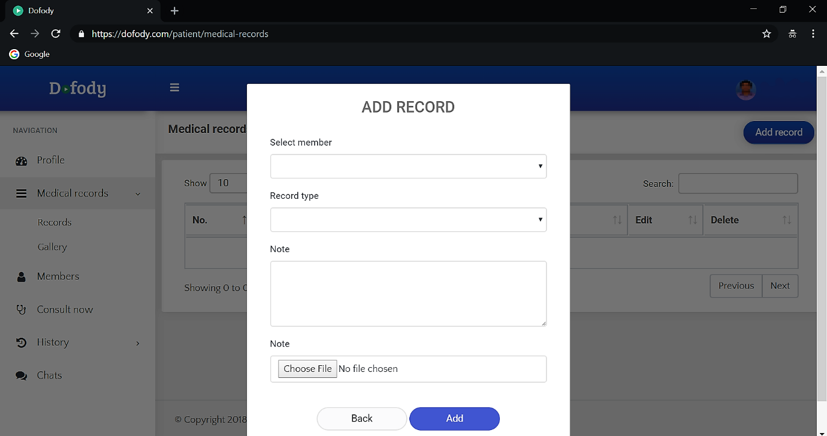

Select “member”. If you have a member other than your member select it from the dropdown if not please use this link.

**STEP 7:** Select a record type from the dropdown lists as mentioned above. In case of “Prescription” fill in the notes from the previous consultation that you had with a doctor or clinic. In case of “Lab tests” fill notes such as blood count, blood pressure, cholesterol etc. “Scan reports” mean that the reports received from a hospital or diagnostics for consultations such as brain, lungs etc. “Electronic medical record” is a record which is in softcopy or in digital format.

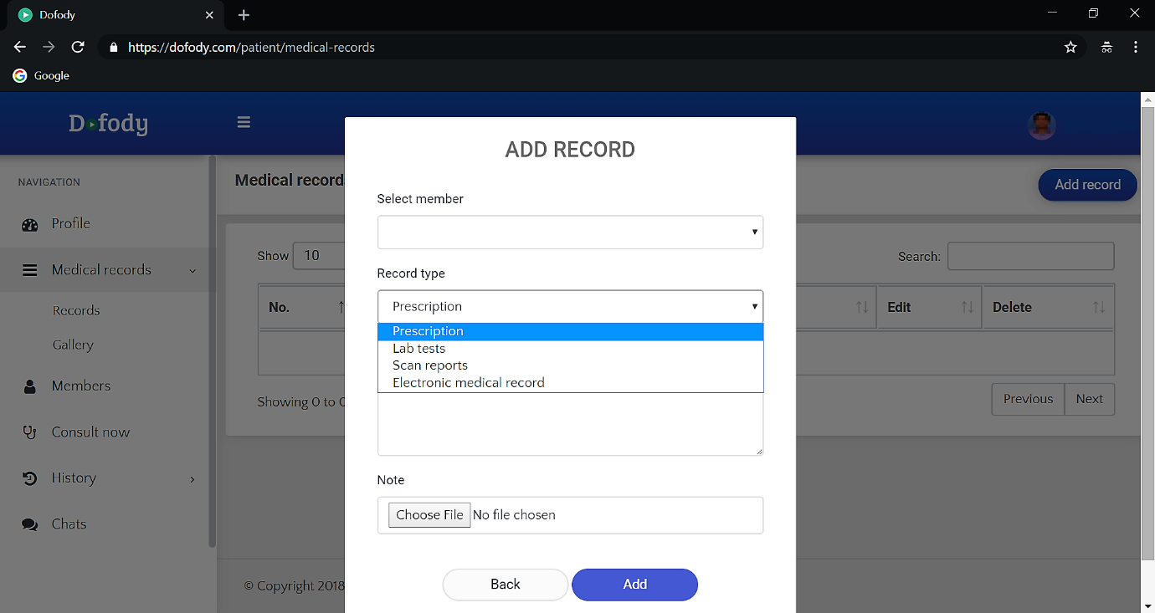

**STEP 8:** Click “Add”.

