CURICCULAM VITAE

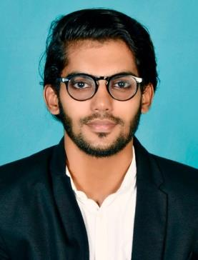

**ZIYAN NOUFAL KOTTARATH**

SUHA, PO PERINGADI

NEW MAHE

PIN:673312

EMAIL:ziyannoufal@gmail.com

8891442122

# CAREER OBJECTIVE

To obtain a responsible and challenging position where my education knowledge, technical skills and interpersonal skills will have a valuable application to support enhance cooperation of the company and further enhance my skills, knowledge to face and overcome the challenges of today’s work environment

# EDUCATION

* BBA from CALICUT UNIVERSITY (2014-2017)
* XII from MHSS, MAMBARAM
* X from ST.JOSEPHS HSS

# PERSONAL ABILITIES

* Ambitious, hard working, energetic and well disciplined
* Positive thinking, self motivated and flexible
* Good communication skills
* Good oral and written skills

# TECHINICAL SKILLS

* Microsoft Office
* Tally
* Quick book
* SAP

# CERTIFICATION

* DIFA (Diploma in Indian Foreign Accounting)
* Professional Diploma in Indian Foreign and SAP Accounting

# WORK EXPERIENCE

Accountant at Hotel Fiza (APRIL 2017- SEP 2017)  
Digital Marketing Executive at Sign In ( February 2018 to present )

# PERSONAL DETAILS

DOB : 16-09-1995

Gender : Male

Father’s name : Noufal KK

Language know : English, Malayalam, Hindi