### KABIL K

**Kurumberi(H)**

**Kotancheri(p.o),**

**Vadakara (via),**

**Kozhikode. 673503**

**Kerala**

**E-mail:** [k.kabil17@gmail.com](mailto:k.kabil17@gmail.com)

**Mobile: +91 9745317909**

**Pass port No:R1372657**

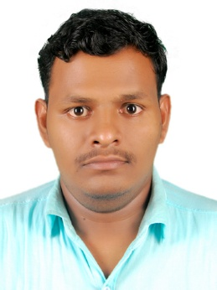

**-------------------------------------------------------------------------------------------------------**

**Web Developer**

**-------------------------------------------------------------------------------------------------------**

To be in a organization where I can contribute my skills and knowledge effectively.

**Academic Qualification:**

* **Vocational Higher Secondary School:**

K.K.M.G.V.H.S.S Vadakara( Kerala State Board)

* **Engineering Graduation in Computer Science:**

Ganamani Collage of Technology(Anna University Chennai)

# Experience Profile:

* **AIN TECHNOLOGIES**

Kerala, India.

**Position:** Dot Net Developer

**Duration:** From 13th May 2013 to 12th July 2014

* **FASTGEN TECHNOLOGIES**

Kozhikode ,India.

**Position:** PHP Developer

**Duration:** From 8th January 2015 to 8th February 2017

**Skill Set :**

* Internet Technology :-Html5,Php,JavaScript,JQuery,Css3,Bootstrap.
* E-Commerce :-Open Cart,Commerce SEO,Wordpress
* Database :-Sql Server2005
* Ide :-Visual Studio 2008,Dreamweaver, Coral Draw,Microsoft Office,Power Point,Photoshop
* Operating System :-Windows 7,Linux

# Area of interest :

* Coding
* Web Design
* IT Support
* Document Controller

# Portfolio :

* [www.fashionrunwayinternational.com](http://www.fashionrunwayinternational.com)
* [www.tacktik.in](http://www.tacktik.in)
* [www.savingsbuilders.in](http://www.savingsbuilders.in)
* [www.profutech.in](http://www.profutech.in)
* [www.dewdale.in](http://www.dewdale.in)

|  |
| --- |
| **Professional traits :** |

* Self-Motivated &Self Starter.
* Dedicated mind for committed work.
* Hard Work.

**VERIFIED PERSONALLY,**

**Truly,**

**Kabil. K,**