RESUME

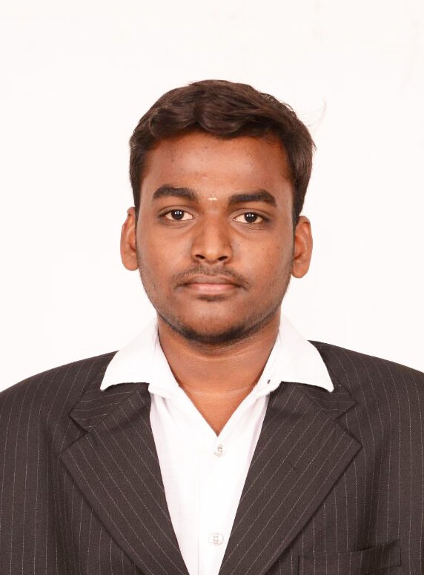
DINESHKUMAR.S.M.
70/6 R.V.E.Layout,3rd street,
Thennampalayam(extension),
Tiruppur-641604

Email: dineshkumar221540@gmail.com
Mobile: +91-9994785842

Objective:
To be a part of an organization where I could use and enhance my knowledge and talent for the development of both the organization and myself.

Educational Qualification:

Name of Institution | Stage / Level | Period of study | Board / University | Percentage obtained
Sasurie college of Engineering,Tiruppur | B.E - Electronics & Communication Engineering | 2014 - 2018 | Anna University | CGPA-8.3
Government higher secondary school,veerapandi | H.S.C. | 2013- 2014 | State board | 90.6%
Government higher secondary school,veerapandi | S.S.L.C. | 2011-2012 | State board | 83%

Technical Skills

- Languages:
- C
- C++
- Basics of java fundamentals and programming

- Softwares :
- Matlab
- Xilinx (VHDL, Verilog)
- Model-sim
- My sql
- Apache-Tomcat

Value added courses:
- FPGA,ASIC and Embedded
- Java fundamentals and programming in Oracle academy
- Attended a SMART training program from 16-08-17 to 27-08-17 to improve an aptitude and communication skills.

Field of interest:
- VLSI and Embedded
- C,C++ and java programming

Workshops:
- Android Application Development

Key Strengths:
- Quick learner
- leadership skills
- Ability to take good decisions at pressure situations
- Ability to work as individual as well in group
- Dedicated to work.
- Self-confident and self motivated.

Personal Profile:
Name : Dineshkumar.S.M.
Date of Birth : 09.03.1997
Blood group : B+ve
Languages Known : English and Tamil
Hobbies : watching TV, playing cricket and hearing songs
Marital Status : Single

Declaration:

I hereby declare that the above written particulars are true and correct to the best of my knowledge and belief.

Date :
Place : S.M.DINESHKUMAR

