Circadian Mood

2022-11-21

### Install missing packages

install.packages('pacman')

## Installing package into '/usr/local/lib/R/site-library'  
## (as 'lib' is unspecified)

pacman::p_load(lmerTest, tidyverse, lme4, wesanderson, MuMIn)

## Installing package into '/usr/local/lib/R/site-library'  
## (as 'lib' is unspecified)

##   
## MuMIn installed

#Get and clean BodyFeelingExp data

#Get FaceStroopData  
datadir<-"/work/285178/BodyFeelingExp_data"  
  
#Find files  
files<-list.files(datadir,pattern='^BodyFeelingExp_.+?csv',full.names=TRUE)  
  
#Prepare an empty data frame for the data (also removes old version)  
dataBFE<-data.frame()  
  
#How many datasets were there  
n_datasets_raw<-length(files)  
#Prepare a variable to monitor how many datasets we keep  
n_datasets<-0  
#Prepare a variable to monitor how many points we originally had  
n_datapoints_raw<-0  
  
#Loop to go through all files in the list  
for(iii in 1:n_datasets_raw){  
   
 #remove old loaded file to not risk importing it multiple times  
 if(exists('data_temp')) rm(data_temp)  
   
 #Load data  
 data_temp<-read.csv(files[iii])  
 if(dim(data_temp)[2]==31){  
 data_temp[1,6]<-data_temp[dim(data_temp)[1],6]  
 data_temp<-data_temp[1,c(6,8:27)]  
 if(length(colnames(dataBFE))==0){  
 dataBFE=data_temp  
 rm(data_temp)  
 #counter to monitor included datasets  
 n_datasets<-n_datasets+1  
 }  
 #Bind loaded data with actual data  
 else {dataBFE<-rbind(dataBFE,data_temp)  
 rm(data_temp)  
 #counter to monitor included datasets  
 n_datasets<-n_datasets+1  
 }  
 }  
}  
  
#A variable to monitor how many points we keep  
n_datapoints<-length(dataBFE[,1])

### Additional preprocessing

#Make a variable which has hour and minutes of the day as decimal variable  
dataBFE$hour2<-dataBFE$hour+(dataBFE$minute)/60

## Sigrid’s preprocessing

# getting info about dataset  
# number of participants  
length(unique(dataBFE$id)) # 35 unique entries

## [1] 35

# for loop to figure out how many times each participant participated (suspecting something is off with id's)  
df_final <- data.frame()  
  
for (i in unique(dataBFE$id)) {  
 name = dataBFE %>%filter(id == i) %>% select(id) %>% slice(1)  
 count = filter(dataBFE, id == i) %>% count()  
   
 df_temp = data_frame(name, count)  
 df_final <- rbind(df_final, df_temp)  
}

## Warning: `data_frame()` was deprecated in tibble 1.1.0.  
## Please use `tibble()` instead.  
## This warning is displayed once every 8 hours.  
## Call `lifecycle::last_lifecycle_warnings()` to see where this warning was generated.

# some of the ids are definitely made by mistake

# fixing participants who most likely used several IDs + lower case upper case and space issues  
  
dataBFE <- dataBFE %>%   
 mutate(  
 id = tolower(id),  
 id = gsub(" ", "", id),  
 id = gsub("dig05", "dlg05", id),  
 id = gsub("hej123", "hej12", id),  
 id = gsub("www111", "www11", id),  
 id = gsub("www123", "www11", id),  
 id = gsub("www12", "www11", id)  
 )  
  
# NB! rerun for loop in above chunk to make an updated boxplot below

# number of particants  
length(unique(dataBFE$id)) # 35 unique entries before

## [1] 25

# now we have 25 participants  
  
# mean number of reports   
mean(df_final$n) # mean 11.31. # mean now; 15.84

## [1] 11.31429

sd(df_final$n) # sd is 14.71

## [1] 13.90466

min(df_final$n) # min 1 # min is still 1 ofc

## [1] 1

max(df_final$n) # max is 56 # max now 57

## [1] 56

# boxplot   
df_final %>% mutate(  
 class = "participant") %>%   
 ggplot() +  
 aes(class, n) +   
 geom_boxplot(fill = wes_palette("Royal2")[5]) +   
 labs(  
 title = "Boxplot of number of reports per participant",  
 x = "",   
 y = "Number of reports") +   
 theme(  
 panel.background= element_rect(fill = wes_palette("Royal1")[3]),   
 axis.text.x = element_blank(),  
 axis.ticks.x = element_blank()  
 )

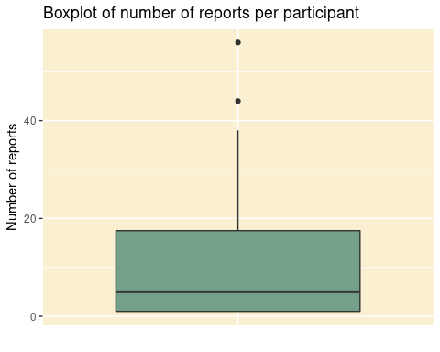

## Some plotting

library(ggplot2)  
ggplot(dataBFE,aes(x=hour2,y=HeartRate))+geom_smooth()+geom_point()

## `geom_smooth()` using method = 'loess' and formula 'y ~ x'

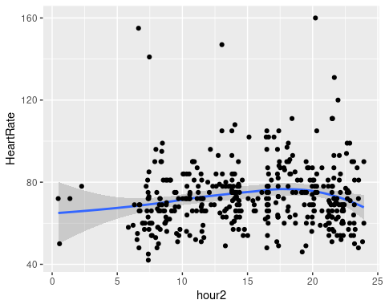

ggplot(dataBFE,aes(x=hour2,y=mood))+geom_smooth()+geom_point()

## `geom_smooth()` using method = 'loess' and formula 'y ~ x'

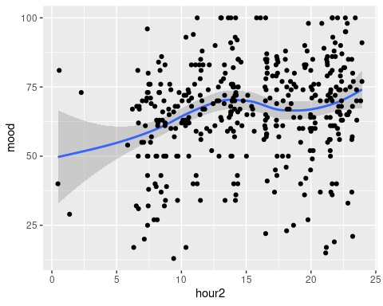

ggplot(dataBFE,aes(x=hour2,y=fresh))+geom_smooth()+geom_point()

## `geom_smooth()` using method = 'loess' and formula 'y ~ x'

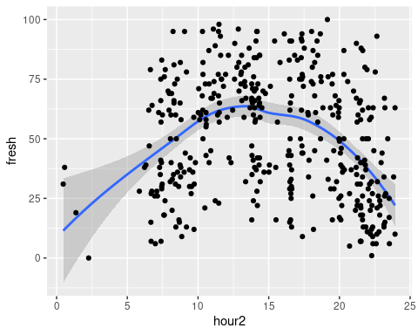

ggplot(dataBFE,aes(x=hour2,y=hunger))+geom_smooth()+geom_point()

## `geom_smooth()` using method = 'loess' and formula 'y ~ x'

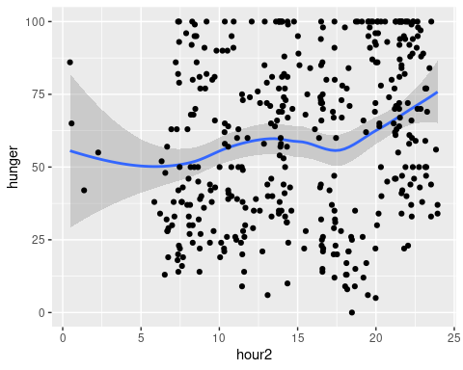 # High-school trigonometry for circidian analysis

## It all starts with a circle and a triangle

#Radius  
r<-1  
# Get x-values from minus 1 to plus 1  
x<-seq(-1,1,0.00001)  
# A circle with c(0,0) centre can be written with these two equations (following Pythagoras)  
y1<-sqrt(r^2-x^2)  
y2<--sqrt(r^2-x^2)  
y<-c(y1,y2)  
x<-c(x,x)  
#Plotting the circle with sine and cosine values  
pp=pi/4  
plot(x,y,type='l')  
lines(x=c(0,0),y=c(-1,1))  
lines(x=c(0,cos(pp)),y=c(0,sin(pp)),col='darkgreen')  
lines(x=c(cos(pp),cos(pp)),y=c(0,sin(pp)),col='darkblue')  
text(x=c(-0.15+cos(pp)),y=c(0.5*sin(pp)),labels='sin(x)',col='darkblue')  
lines(x=c(0,cos(pp)),y=c(sin(pp),sin(pp)),col='darkred')  
text(x=c(0.5*cos(pp)),y=c(+0.15+sin(pp)),labels='cos(x)',col='darkred')

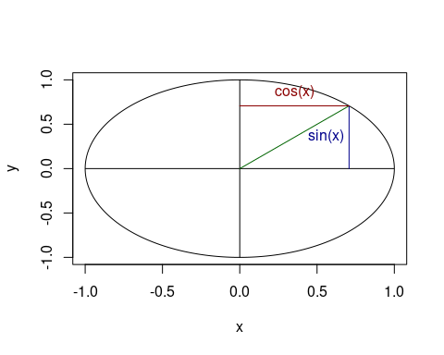

### Going beyond the circle, the sine and cosine functions can describe cycles in time

$$y\left(t\right)=βsin\left(2πft\right)$$

$$y\left(t\right)=βcos\left(2πft\right)$$

Beta is the amplitude (the height of the wave) f is the frequency (the number of cycles per time unit) t is time point

#### Plotting circadian sine and cosine waves

#cycle frequency (in this case per hour) - one cycle per 24 hours  
cf=1/24  
#sample frequency per hour  
fs=100  
#Duration in hours  
dur=24  
#A time vector divided by fs  
t = seq(0, dur, 1/fs)  
#Make a sine wave (with amplitude =1) for each time point in t  
u = sin(2*pi*cf*t)  
#Make a cosine wave (with amplitude =1) for each time point in t  
u2= cos(2*pi*cf*t)  
#Plot the waves  
plot(x=t,y=u, type='l',col='darkblue',xlab='time(hours)',ylab='Amplitude')  
text(x=1+t[1000],y=-0.2+u[500],labels='y=sin(2*pi*cf*t)',col='darkblue')  
lines(x=t,y=u2, type='l',col='darkred')  
text(x=-1+t[500],y=-0.2+u2[500],labels='Y=cos(2*pi*cf*t)',col='darkred')

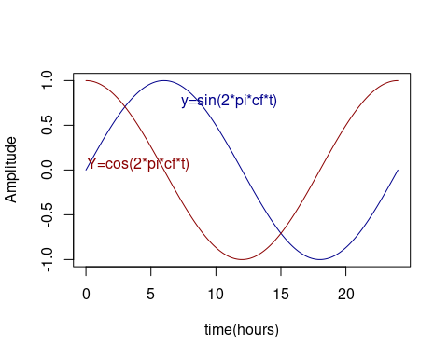 As can be seen, the sine function is a time shifted version of the cosine function and vice versa. The time shift is also called phase. We can add a constant for the phase (phi) to the sine/cosine wave function.

$$y\left(t\right)=βsin\left(2πft+ϕ\right)$$

#### Plotting circadian sine wave with phase shift

#cycle frequency (in this case per hour) - one cycle per 24 hours  
cf=1/24  
#sample frequency per hour  
fs=100  
#Duration in hours  
dur=24  
#A time vector divided by fs  
t = seq(0, dur, 1/fs)  
#a phase shift of pi/2 radians (half a cycle) This could be any number  
phi=pi/2  
#Make a sine wave (with amplitude =1)  
u = sin(2*pi*cf*t)  
#Make a sine wave (with amplitude =1), and phase shift  
u2= cos(2*pi*cf*t+phi)  
#Plot the waves  
plot(x=t,y=u, type='l',col='darkblue',xlab='time(hours)',ylab='Amplitude')  
text(x=1+t[1000],y=-0.2+u[500],labels='y=sin(2*pi*cf*t)',col='darkblue')  
lines(x=t,y=u2, type='l',lty='dashed',col='darkblue')  
text(x=-1+t[500],y=0.2+u2[500],labels='Y=cos(2*pi*cf*t+phi)',col='darkblue')

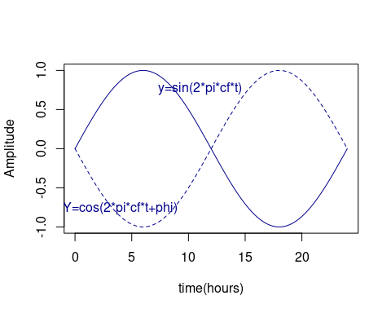 Using the trigonometric identity

$$sin\left(A+B\right)=sin\left(A\right)cos\left(B\right)−cos\left(A\right)sin\left(B\right)$$

we can rewrite the sine function (including phase) as

$$y\left(t\right)=β_{1}sin\left(2πft\right)+β_{2}cos\left(2πft\right)$$

where

$$β_{1}=βcos\left(ϕ\right),β_{2}=−βsin\left(ϕ\right)$$

We can use the rewritten sine function in a linear regression analysis, where we estimate the best fitting B1 and B2. This will yield a composite estimate of the amplitude and the phase of the data.

This will allow us to use sine and cosine waves to model a circadian rhythm, even if we don’t know when it peaks. The amplitude will be given by

$$β=\sqrt{β_{1}^{2}+β_{2}^{2}}$$

The phase (phi) will be given by

$$ϕ=atan2\left(β_{1},β_{2}\right)$$

#### Use the sine and cosine waves to make 24 hour oscillation predictors for the BodyFeelingExp data

#cycle frequency (in this case per hour) - one cycle per 24 hours  
cf=1/24  
  
#Make sine and cosine waves for each time point present in the data  
  
dataBFE$sinCirc<-sin(2*pi*cf*dataBFE$hour2)  
dataBFE$cosCirc<-cos(2*pi*cf*dataBFE$hour2)  
  
# Plot the predictors for each data point in the data  
ggplot(dataBFE, aes(x=hour2,y=sinCirc))+  
 geom_point(col='darkblue')+  
 geom_point(aes(y=cosCirc),col='darkred')+  
 ylab('sinCirc/cosCirc')

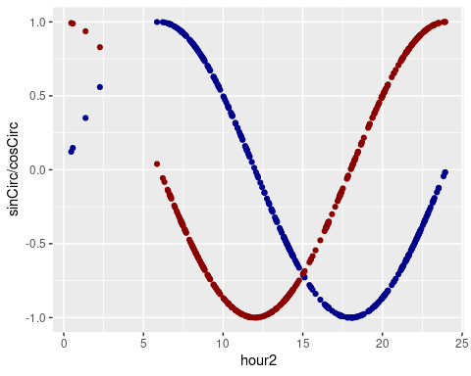

## Fitting 24 hour Oscillation model

#### Freshness

library(lmerTest)  
  
# Freshness: Simple oscillation model  
modelBFEfreshCirc<-lmer(fresh~sinCirc+cosCirc+(1|id),data=dataBFE)  
m_temp<-summary(modelBFEfreshCirc)  
m_temp

## Linear mixed model fit by REML. t-tests use Satterthwaite's method [  
## lmerModLmerTest]  
## Formula: fresh ~ sinCirc + cosCirc + (1 | id)  
## Data: dataBFE  
##   
## REML criterion at convergence: 3529.2  
##   
## Scaled residuals:   
## Min 1Q Median 3Q Max   
## -2.4949 -0.6996 0.0657 0.6999 3.6838   
##   
## Random effects:  
## Groups Name Variance Std.Dev.  
## id (Intercept) 89.52 9.462   
## Residual 414.33 20.355   
## Number of obs: 396, groups: id, 25  
##   
## Fixed effects:  
## Estimate Std. Error df t value Pr(>|t|)   
## (Intercept) 41.464 2.469 22.766 16.80 2.56e-14 ***  
## sinCirc -10.383 1.696 381.725 -6.12 2.32e-09 ***  
## cosCirc -18.102 1.585 380.438 -11.42 < 2e-16 ***  
## ---  
## Signif. codes: 0 '***' 0.001 '**' 0.01 '*' 0.05 '.' 0.1 ' ' 1  
##   
## Correlation of Fixed Effects:  
## (Intr) sinCrc  
## sinCirc 0.229   
## cosCirc 0.176 0.345

dataBFE$freshCircFit<-m_temp$coefficients[1,1]+m_temp$coefficients[2,1]*dataBFE$sinCirc+m_temp$coefficients[3,1]*dataBFE$cosCirc  
  
plot(x=dataBFE$hour2,y=dataBFE$freshCircFit,type='p',col=wes_palette("Royal2")[5])

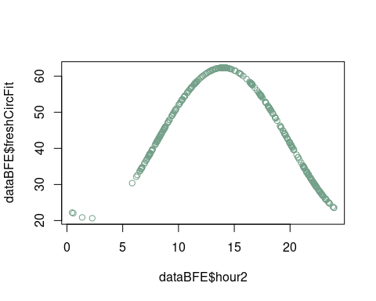

# testing colours for plotting  
#wes_palette("Royal2")  
#wes_palette("Royal1") # [2] er rød  
#wes_palette("Royal2") # [5] er grøn  
  
# plot 24 hour rhythm  
dataBFE %>%   
 ggplot() +  
 aes(hour2, fresh) +  
 geom_smooth(  
 aes(col = "data (smoothed)"), alpha = 0.25) +  
 geom_line(aes(  
 hour2, freshCircFit, col = "model fit"), size = 1) +  
 labs(  
 title = "Figure 1: Fresh/tired score during the day (24 hour circadian)",  
 x='Time of day (hours)',   
 y='Tired/Fresh score') +   
 scale_x_continuous(breaks=c(4,8,12,16,20,24)) + # changing the x-axis values   
 scale_colour_manual("",  
 values = c("data (smoothed)" = wes_palette("Royal1")[2],  
 "model fit" = wes_palette("Royal2")[5]  
 )) +  
 theme(  
 panel.background= element_rect(fill = wes_palette("Royal1")[3]),   
 legend.title = element_blank(),   
 legend.position = c(.80, .25)  
 )

## `geom_smooth()` using method = 'loess' and formula 'y ~ x'

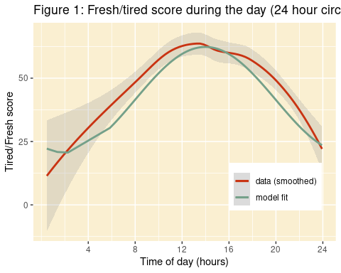

#### Mood

library(lmerTest)  
# Mood: Simple oscillation model  
modelBFEmoodCirc<-lmer(mood~sinCirc+cosCirc+(1|id),data=dataBFE)  
m_temp<-summary(modelBFEmoodCirc)  
m_temp

## Linear mixed model fit by REML. t-tests use Satterthwaite's method [  
## lmerModLmerTest]  
## Formula: mood ~ sinCirc + cosCirc + (1 | id)  
## Data: dataBFE  
##   
## REML criterion at convergence: 3312.5  
##   
## Scaled residuals:   
## Min 1Q Median 3Q Max   
## -3.3499 -0.5899 0.1815 0.6544 2.7189   
##   
## Random effects:  
## Groups Name Variance Std.Dev.  
## id (Intercept) 77.38 8.797   
## Residual 234.70 15.320   
## Number of obs: 396, groups: id, 25  
##   
## Fixed effects:  
## Estimate Std. Error df t value Pr(>|t|)   
## (Intercept) 65.2448 2.1674 25.2869 30.103 < 2e-16 ***  
## sinCirc -4.8024 1.2794 381.1749 -3.754 0.000201 ***  
## cosCirc -0.7151 1.1946 379.4816 -0.599 0.549813   
## ---  
## Signif. codes: 0 '***' 0.001 '**' 0.01 '*' 0.05 '.' 0.1 ' ' 1  
##   
## Correlation of Fixed Effects:  
## (Intr) sinCrc  
## sinCirc 0.205   
## cosCirc 0.156 0.345

dataBFE$CircFit<-m_temp$coefficients[2,1]*dataBFE$sinCirc+m_temp$coefficients[3,1]*dataBFE$cosCirc  
  
plot(x=dataBFE$hour2,y=dataBFE$CircFit,type='p',col='darkgreen')

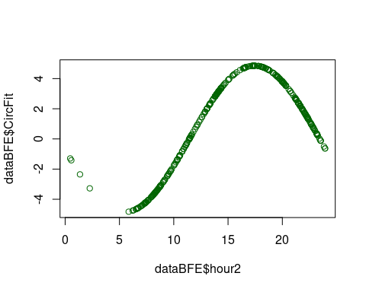

ggplot(dataBFE,aes(x=hour2,y=mood))+geom_smooth()+geom_line(aes(x=hour2,y=CircFit+mean(mood)),col='darkgreen')+labs(x='Time of day (hours)', y='Negative/Positive Mood')

## `geom_smooth()` using method = 'loess' and formula 'y ~ x'

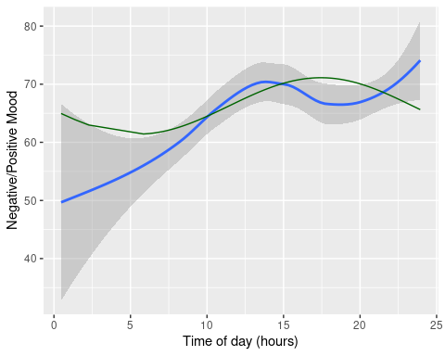

#### HeartRate

# Freshness: Simple oscillation model  
modelBFEHeartRateCirc<-lmer(HeartRate~sinCirc+cosCirc+(1|id),data=dataBFE)  
m_temp<-summary(modelBFEHeartRateCirc)  
m_temp

## Linear mixed model fit by REML. t-tests use Satterthwaite's method [  
## lmerModLmerTest]  
## Formula: HeartRate ~ sinCirc + cosCirc + (1 | id)  
## Data: dataBFE  
##   
## REML criterion at convergence: 3216.4  
##   
## Scaled residuals:   
## Min 1Q Median 3Q Max   
## -1.8964 -0.5769 -0.1585 0.3557 6.5548   
##   
## Random effects:  
## Groups Name Variance Std.Dev.  
## id (Intercept) 69.48 8.335   
## Residual 182.67 13.516   
## Number of obs: 396, groups: id, 25  
##   
## Fixed effects:  
## Estimate Std. Error df t value Pr(>|t|)   
## (Intercept) 72.272 2.019 23.182 35.791 < 2e-16 ***  
## sinCirc -3.997 1.129 379.450 -3.539 0.000451 ***  
## cosCirc -1.666 1.054 377.426 -1.580 0.115017   
## ---  
## Signif. codes: 0 '***' 0.001 '**' 0.01 '*' 0.05 '.' 0.1 ' ' 1  
##   
## Correlation of Fixed Effects:  
## (Intr) sinCrc  
## sinCirc 0.197   
## cosCirc 0.149 0.344

dataBFE$HeartRateCircFit<-m_temp$coefficients[1,1]+m_temp$coefficients[2,1]*dataBFE$sinCirc+m_temp$coefficients[3,1]*dataBFE$cosCirc  
  
plot(x=dataBFE$hour2,y=dataBFE$HeartRateCircFit,type='p',col='darkgreen')

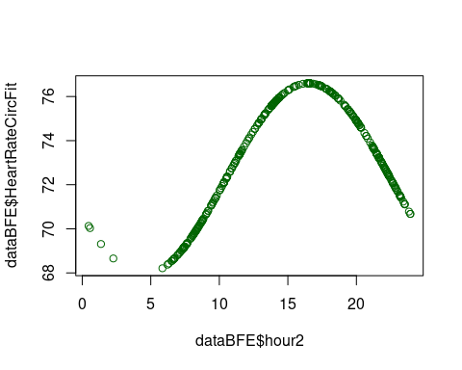

ggplot(dataBFE,aes(x=hour2,y=HeartRate))+geom_smooth()+geom_line(aes(x=hour2,y=HeartRateCircFit),col='darkgreen')+labs(x='Time of day (hours)', y='Tired/Fresh')

## `geom_smooth()` using method = 'loess' and formula 'y ~ x'

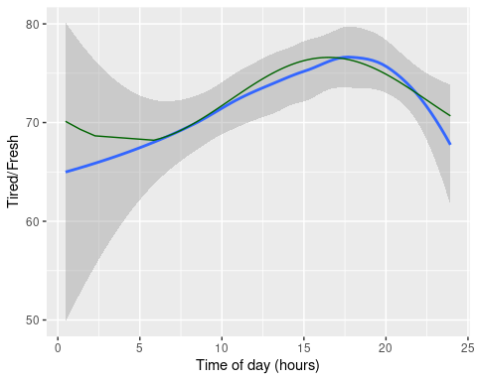

#### Make a 12 hour oscillation model to compare with the 24 hour model

#cycle frequency (in this case per hour) - one cycle per 24 hours  
cf=1/12  
  
#Make sine and cosine waves for each time point present in the data  
  
dataBFE$sinCirc12<-sin(2*pi*cf*dataBFE$hour2)  
dataBFE$cosCirc12<-cos(2*pi*cf*dataBFE$hour2)  
  
# Plot the predictors for each data point in the data  
ggplot(dataBFE, aes(x=hour2,y=sinCirc12))+  
 geom_point(col='darkblue')+  
 geom_point(aes(y=cosCirc12),col='darkred')+  
 ylab('sinCirc/cosCirc')

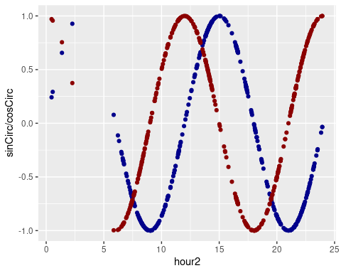

## Fitting 12 hour Oscillation models

#### Freshness

# Freshness: Simple oscillation model  
modelBFEfreshCirc12<-lmer(fresh~sinCirc12+cosCirc12+(1|id),data=dataBFE)  
m_temp<-summary(modelBFEfreshCirc12)  
m_temp

## Linear mixed model fit by REML. t-tests use Satterthwaite's method [  
## lmerModLmerTest]  
## Formula: fresh ~ sinCirc12 + cosCirc12 + (1 | id)  
## Data: dataBFE  
##   
## REML criterion at convergence: 3616.6  
##   
## Scaled residuals:   
## Min 1Q Median 3Q Max   
## -2.23217 -0.78346 0.02882 0.76421 2.63982   
##   
## Random effects:  
## Groups Name Variance Std.Dev.  
## id (Intercept) 64.59 8.037   
## Residual 527.64 22.970   
## Number of obs: 396, groups: id, 25  
##   
## Fixed effects:  
## Estimate Std. Error df t value Pr(>|t|)   
## (Intercept) 49.9564 2.2439 22.2551 22.263 < 2e-16 ***  
## sinCirc12 9.0226 1.6990 385.1641 5.311 1.85e-07 ***  
## cosCirc12 -0.4889 1.7243 382.8468 -0.284 0.777   
## ---  
## Signif. codes: 0 '***' 0.001 '**' 0.01 '*' 0.05 '.' 0.1 ' ' 1  
##   
## Correlation of Fixed Effects:  
## (Intr) snCr12  
## sinCirc12 0.167   
## cosCirc12 -0.017 -0.023

dataBFE$freshCircFit12<-m_temp$coefficients[1,1]+m_temp$coefficients[2,1]*dataBFE$sinCirc12+m_temp$coefficients[3,1]*dataBFE$cosCirc12  
  
plot(x=dataBFE$hour2,y=dataBFE$freshCircFit12,type='p',col='darkgreen')

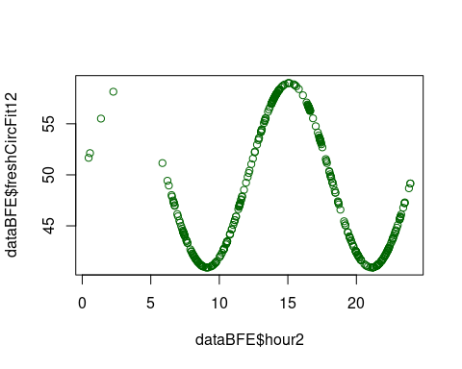

# plot 12 hour rhythm  
dataBFE %>%   
 ggplot() +  
 aes(hour2, fresh) +  
 geom_smooth(  
 aes(col = "data (smoothed)"), alpha = 0.25) +  
 geom_line(aes(  
 hour2, freshCircFit12, col = "model fit"), size = 1) +  
 labs(  
 title = "Figure 2: Fresh/tired score during the day (12 hour circadian)",  
 x='Time of day (hours)',   
 y='Tired/Fresh score') +   
 scale_x_continuous(breaks=c(4,8,12,16,20,24)) + # changing the x-axis values   
 scale_colour_manual("",  
 values = c("data (smoothed)" = wes_palette("Royal1")[2],  
 "model fit" = wes_palette("Royal2")[5]  
 )) +  
 theme(  
 panel.background= element_rect(fill = wes_palette("Royal1")[3]),   
 legend.title = element_blank(),   
 legend.position = c(.80, .25)  
 )

## `geom_smooth()` using method = 'loess' and formula 'y ~ x'

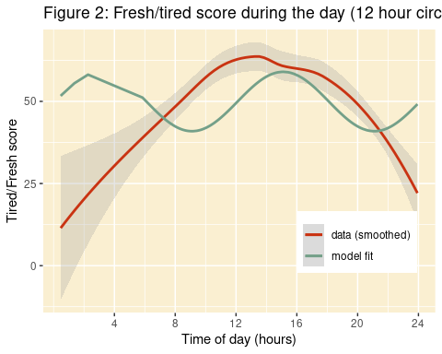

#### Mood

library(lmerTest)  
# Mood: Simple oscillation model  
modelBFEmoodCirc12<-lmer(mood~sinCirc12+cosCirc12+(1|id),data=dataBFE)  
m_temp<-summary(modelBFEmoodCirc12)  
m_temp

## Linear mixed model fit by REML. t-tests use Satterthwaite's method [  
## lmerModLmerTest]  
## Formula: mood ~ sinCirc12 + cosCirc12 + (1 | id)  
## Data: dataBFE  
##   
## REML criterion at convergence: 3311.3  
##   
## Scaled residuals:   
## Min 1Q Median 3Q Max   
## -3.4420 -0.6359 0.1314 0.6648 2.6369   
##   
## Random effects:  
## Groups Name Variance Std.Dev.  
## id (Intercept) 83.93 9.161   
## Residual 233.02 15.265   
## Number of obs: 396, groups: id, 25  
##   
## Fixed effects:  
## Estimate Std. Error df t value Pr(>|t|)   
## (Intercept) 67.260 2.189 23.780 30.721 < 2e-16 ***  
## sinCirc12 2.402 1.136 381.869 2.115 0.035108 *   
## cosCirc12 3.850 1.151 379.552 3.346 0.000902 ***  
## ---  
## Signif. codes: 0 '***' 0.001 '**' 0.01 '*' 0.05 '.' 0.1 ' ' 1  
##   
## Correlation of Fixed Effects:  
## (Intr) snCr12  
## sinCirc12 0.095   
## cosCirc12 0.003 -0.026

dataBFE$CircFit12<-m_temp$coefficients[1,1]+m_temp$coefficients[2,1]*dataBFE$sinCirc12+m_temp$coefficients[3,1]*dataBFE$cosCirc12  
  
plot(x=dataBFE$hour2,y=dataBFE$CircFit12,type='p',col='darkgreen')

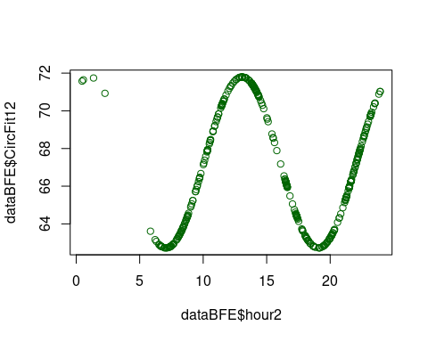

ggplot(dataBFE,aes(x=hour2,y=mood))+geom_smooth()+geom_line(aes(x=hour2,y=CircFit12),col='darkgreen')+labs(x='Time of day (hours)', y='Negative/Positive Mood')

## `geom_smooth()` using method = 'loess' and formula 'y ~ x'

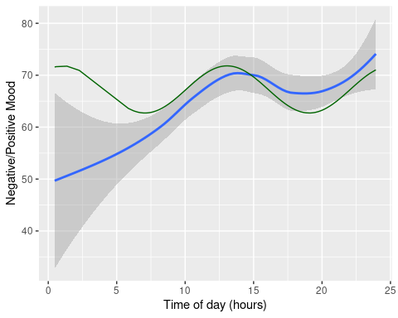

#### HeartRate

# Freshness: Simple oscillation model  
modelBFEHeartRateCirc12<-lmer(HeartRate~sinCirc12+cosCirc12+(1|id),data=dataBFE)  
m_temp<-summary(modelBFEHeartRateCirc12)  
m_temp

## Linear mixed model fit by REML. t-tests use Satterthwaite's method [  
## lmerModLmerTest]  
## Formula: HeartRate ~ sinCirc12 + cosCirc12 + (1 | id)  
## Data: dataBFE  
##   
## REML criterion at convergence: 3225.6  
##   
## Scaled residuals:   
## Min 1Q Median 3Q Max   
## -2.1213 -0.5841 -0.1673 0.3932 6.5688   
##   
## Random effects:  
## Groups Name Variance Std.Dev.  
## id (Intercept) 70.29 8.384   
## Residual 187.00 13.675   
## Number of obs: 396, groups: id, 25  
##   
## Fixed effects:  
## Estimate Std. Error df t value Pr(>|t|)   
## (Intercept) 73.957 1.994 22.186 37.083 <2e-16 ***  
## sinCirc12 1.272 1.018 380.869 1.250 0.212   
## cosCirc12 -1.465 1.031 378.394 -1.421 0.156   
## ---  
## Signif. codes: 0 '***' 0.001 '**' 0.01 '*' 0.05 '.' 0.1 ' ' 1  
##   
## Correlation of Fixed Effects:  
## (Intr) snCr12  
## sinCirc12 0.092   
## cosCirc12 0.004 -0.027

dataBFE$HeartRateCircFit12<-m_temp$coefficients[1,1]+m_temp$coefficients[2,1]*dataBFE$sinCirc12+m_temp$coefficients[3,1]*dataBFE$cosCirc12  
  
plot(x=dataBFE$hour2,y=dataBFE$HeartRateCircFit12,type='p',col='darkgreen')

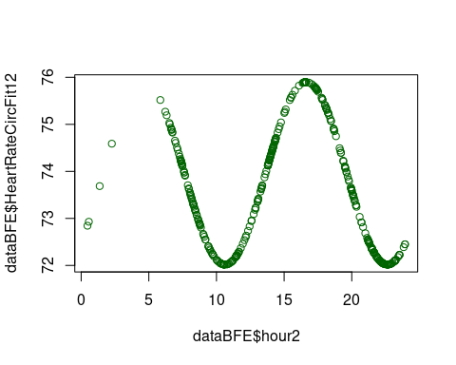

ggplot(dataBFE,aes(x=hour2,y=HeartRate))+geom_smooth()+geom_line(aes(x=hour2,y=HeartRateCircFit12),col='darkgreen')+labs(x='Time of day (hours)', y='Tired/Fresh')

## `geom_smooth()` using method = 'loess' and formula 'y ~ x'

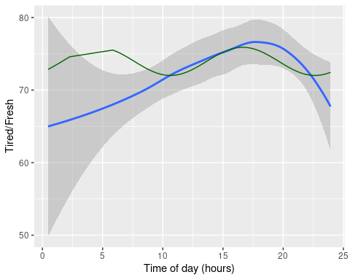 ## Combining 12 and 24 hours

#### Freshness

# Freshness: Simple oscillation model  
modelBFEfreshCircBoth<-lmer(fresh~sinCirc+cosCirc+sinCirc12+cosCirc12+(1|id),data=dataBFE)  
m_temp<-summary(modelBFEfreshCircBoth)  
m_temp

## Linear mixed model fit by REML. t-tests use Satterthwaite's method [  
## lmerModLmerTest]  
## Formula: fresh ~ sinCirc + cosCirc + sinCirc12 + cosCirc12 + (1 | id)  
## Data: dataBFE  
##   
## REML criterion at convergence: 3513.2  
##   
## Scaled residuals:   
## Min 1Q Median 3Q Max   
## -2.4678 -0.6970 0.0584 0.6880 3.7803   
##   
## Random effects:  
## Groups Name Variance Std.Dev.  
## id (Intercept) 91.85 9.584   
## Residual 405.38 20.134   
## Number of obs: 396, groups: id, 25  
##   
## Fixed effects:  
## Estimate Std. Error df t value Pr(>|t|)   
## (Intercept) 37.8986 2.7212 34.2210 13.927 1.16e-15 ***  
## sinCirc -14.9788 2.2338 380.0559 -6.706 7.28e-11 ***  
## cosCirc -22.7959 2.1576 381.0855 -10.566 < 2e-16 ***  
## sinCirc12 -7.0362 2.2299 383.0482 -3.155 0.00173 **   
## cosCirc12 0.2997 1.5339 378.4250 0.195 0.84520   
## ---  
## Signif. codes: 0 '***' 0.001 '**' 0.01 '*' 0.05 '.' 0.1 ' ' 1  
##   
## Correlation of Fixed Effects:  
## (Intr) sinCrc cosCrc snCr12  
## sinCirc 0.424   
## cosCirc 0.396 0.637   
## sinCirc12 0.408 0.654 0.687   
## cosCirc12 -0.058 -0.146 -0.051 -0.093

dataBFE$freshCircFitBoth<-m_temp$coefficients[1,1]+m_temp$coefficients[2,1]*dataBFE$sinCirc+m_temp$coefficients[3,1]*dataBFE$cosCirc+m_temp$coefficients[4,1]*dataBFE$sinCirc12+m_temp$coefficients[5,1]*dataBFE$cosCirc12  
  
plot(x=dataBFE$hour2,y=dataBFE$freshCircFitBoth,type='p',col='darkgreen')

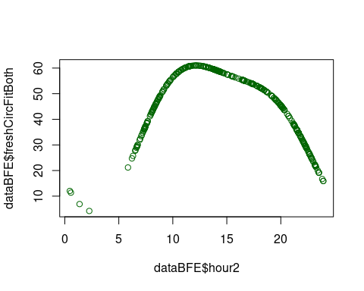

ggplot(dataBFE,aes(x=hour2,y=fresh))+geom_smooth()+geom_line(aes(x=hour2,y=freshCircFitBoth),col='darkgreen')+labs(x='Time of day (hours)', y='Tired/Fresh')

## `geom_smooth()` using method = 'loess' and formula 'y ~ x'

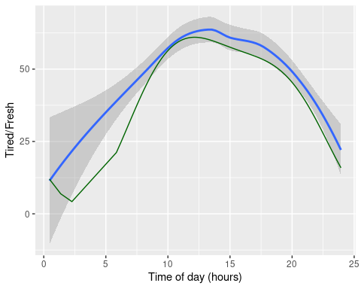

# plot both 24h and 12h oscillation  
dataBFE %>%   
 ggplot() +  
 aes(hour2, fresh) +  
 geom_smooth(  
 aes(col = "data (smoothed)"), alpha = 0.25) +  
 geom_line(aes(  
 hour2, freshCircFitBoth, col = "model fit"), size = 1) +  
 labs(  
 title = "Figure 3: Fresh/tired score during the day (12 and 24 hour circadian)",  
 x='Time of day (hours)',   
 y='Tired/Fresh score') +   
 scale_x_continuous(breaks=c(4,8,12,16,20,24)) + # changing the x-axis values   
 scale_colour_manual("",  
 values = c("data (smoothed)" = wes_palette("Royal1")[2],  
 "model fit" = wes_palette("Royal2")[5]  
 )) +  
 theme(  
 panel.background= element_rect(fill = wes_palette("Royal1")[3]),   
 legend.title = element_blank(),   
 legend.position = c(.80, .25)  
 )

## `geom_smooth()` using method = 'loess' and formula 'y ~ x'

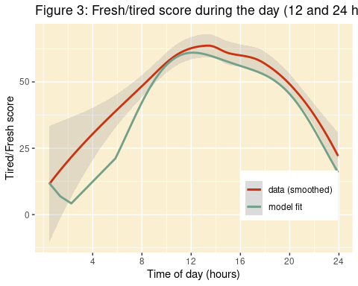

# calculate R-squared  
library('MuMIn')  
  
r.squaredGLMM(modelBFEfreshCircBoth)

## Warning: 'r.squaredGLMM' now calculates a revised statistic. See the help page.

## R2m R2c  
## [1,] 0.2428835 0.3827357

# marginal Rsq = 0.2429  
# conditional Rsq = 0.3827

#### Mood

library(lmerTest)  
# Mood: Simple oscillation model  
modelBFEmoodCircBoth<-lmer(mood~sinCirc+cosCirc+sinCirc12+cosCirc12+(1|id),data=dataBFE)  
m_temp<-summary(modelBFEmoodCircBoth)  
m_temp

## Linear mixed model fit by REML. t-tests use Satterthwaite's method [  
## lmerModLmerTest]  
## Formula: mood ~ sinCirc + cosCirc + sinCirc12 + cosCirc12 + (1 | id)  
## Data: dataBFE  
##   
## REML criterion at convergence: 3292.1  
##   
## Scaled residuals:   
## Min 1Q Median 3Q Max   
## -3.3824 -0.5976 0.1204 0.6906 2.5617   
##   
## Random effects:  
## Groups Name Variance Std.Dev.  
## id (Intercept) 79.11 8.894   
## Residual 226.23 15.041   
## Number of obs: 396, groups: id, 25  
##   
## Fixed effects:  
## Estimate Std. Error df t value Pr(>|t|)   
## (Intercept) 65.3036 2.3262 33.3337 28.074 < 2e-16 ***  
## sinCirc -5.1396 1.6720 378.0435 -3.074 0.002266 **   
## cosCirc -0.4104 1.6154 378.7859 -0.254 0.799572   
## sinCirc12 0.3378 1.6707 381.0135 0.202 0.839868   
## cosCirc12 4.5024 1.1478 377.6659 3.923 0.000104 ***  
## ---  
## Signif. codes: 0 '***' 0.001 '**' 0.01 '*' 0.05 '.' 0.1 ' ' 1  
##   
## Correlation of Fixed Effects:  
## (Intr) sinCrc cosCrc snCr12  
## sinCirc 0.374   
## cosCirc 0.347 0.637   
## sinCirc12 0.353 0.654 0.687   
## cosCirc12 -0.045 -0.147 -0.052 -0.095

dataBFE$CircFitBoth<-m_temp$coefficients[1,1]+m_temp$coefficients[2,1]*dataBFE$sinCirc+m_temp$coefficients[3,1]*dataBFE$cosCirc+m_temp$coefficients[4,1]*dataBFE$sinCirc12+m_temp$coefficients[5,1]*dataBFE$cosCirc12  
  
plot(x=dataBFE$hour2,y=dataBFE$CircFitBoth,type='p',col='darkgreen')

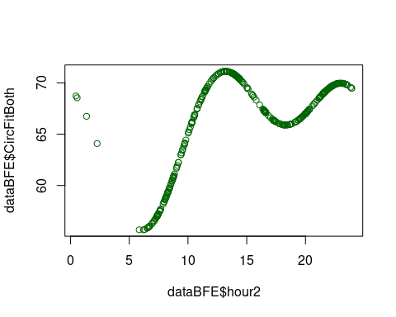

ggplot(dataBFE,aes(x=hour2,y=mood))+geom_smooth()+geom_line(aes(x=hour2,y=CircFitBoth),col='darkgreen')+labs(x='Time of day (hours)', y='Negative/Positive Mood')

## `geom_smooth()` using method = 'loess' and formula 'y ~ x'

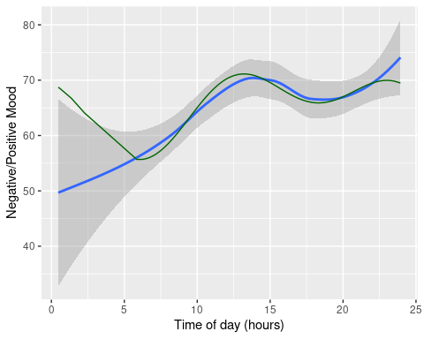 #### HeartRate

# Freshness: Simple oscillation model  
modelBFEHeartRateCircBoth<-lmer(HeartRate~+sinCirc+cosCirc+sinCirc12+cosCirc12+(1|id),data=dataBFE)  
m_temp<-summary(modelBFEHeartRateCircBoth)  
m_temp

## Linear mixed model fit by REML. t-tests use Satterthwaite's method [  
## lmerModLmerTest]  
## Formula: HeartRate ~ +sinCirc + cosCirc + sinCirc12 + cosCirc12 + (1 | id)  
## Data: dataBFE  
##   
## REML criterion at convergence: 3208.9  
##   
## Scaled residuals:   
## Min 1Q Median 3Q Max   
## -1.8863 -0.5650 -0.2001 0.3551 6.4700   
##   
## Random effects:  
## Groups Name Variance Std.Dev.  
## id (Intercept) 71.59 8.461   
## Residual 181.94 13.489   
## Number of obs: 396, groups: id, 25  
##   
## Fixed effects:  
## Estimate Std. Error df t value Pr(>|t|)   
## (Intercept) 71.2821 2.1700 30.1767 32.849 < 2e-16 ***  
## sinCirc -5.2229 1.5001 376.1732 -3.482 0.000557 ***  
## cosCirc -3.0687 1.4494 376.9081 -2.117 0.034894 *   
## sinCirc12 -2.0778 1.4993 379.3996 -1.386 0.166606   
## cosCirc12 -0.9324 1.0298 376.0790 -0.905 0.365831   
## ---  
## Signif. codes: 0 '***' 0.001 '**' 0.01 '*' 0.05 '.' 0.1 ' ' 1  
##   
## Correlation of Fixed Effects:  
## (Intr) sinCrc cosCrc snCr12  
## sinCirc 0.360   
## cosCirc 0.333 0.637   
## sinCirc12 0.339 0.654 0.687   
## cosCirc12 -0.042 -0.147 -0.052 -0.095

dataBFE$HeartRateCircFitBoth<-m_temp$coefficients[1,1]+m_temp$coefficients[2,1]*dataBFE$sinCirc+m_temp$coefficients[3,1]*dataBFE$cosCirc++m_temp$coefficients[4,1]*dataBFE$sinCirc12+m_temp$coefficients[5,1]*dataBFE$cosCirc12  
  
plot(x=dataBFE$hour2,y=dataBFE$HeartRateCircFitBoth,type='p',col='darkgreen')

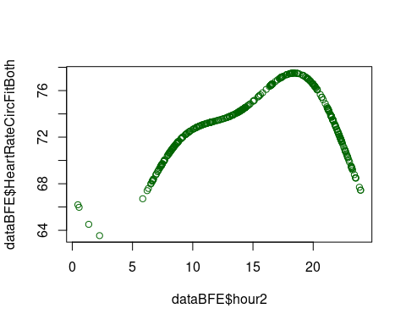

ggplot(dataBFE,aes(x=hour2,y=HeartRate))+geom_smooth()+geom_line(aes(x=hour2,y=HeartRateCircFitBoth),col='darkgreen')+labs(x='Time of day (hours)', y='HeartRate')

## `geom_smooth()` using method = 'loess' and formula 'y ~ x'

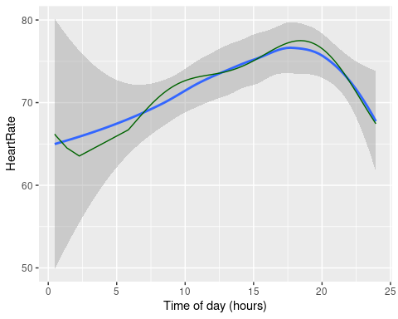

## Model comparisons

### Is the 24 hour or the 12 hour model the best?

#Comparing models for freshness  
anova(modelBFEfreshCirc12, modelBFEfreshCircBoth)

## refitting model(s) with ML (instead of REML)

## Data: dataBFE  
## Models:  
## modelBFEfreshCirc12: fresh ~ sinCirc12 + cosCirc12 + (1 | id)  
## modelBFEfreshCircBoth: fresh ~ sinCirc + cosCirc + sinCirc12 + cosCirc12 + (1 | id)  
## npar AIC BIC logLik deviance Chisq Df Pr(>Chisq)  
## modelBFEfreshCirc12 5 3635.8 3655.7 -1812.9 3625.8   
## modelBFEfreshCircBoth 7 3542.4 3570.2 -1764.2 3528.4 97.44 2 < 2.2e-16  
##   
## modelBFEfreshCirc12   
## modelBFEfreshCircBoth ***  
## ---  
## Signif. codes: 0 '***' 0.001 '**' 0.01 '*' 0.05 '.' 0.1 ' ' 1

anova(modelBFEfreshCirc, modelBFEfreshCircBoth)

## refitting model(s) with ML (instead of REML)

## Data: dataBFE  
## Models:  
## modelBFEfreshCirc: fresh ~ sinCirc + cosCirc + (1 | id)  
## modelBFEfreshCircBoth: fresh ~ sinCirc + cosCirc + sinCirc12 + cosCirc12 + (1 | id)  
## npar AIC BIC logLik deviance Chisq Df Pr(>Chisq)  
## modelBFEfreshCirc 5 3548.3 3568.2 -1769.2 3538.3   
## modelBFEfreshCircBoth 7 3542.4 3570.2 -1764.2 3528.4 9.9206 2 0.007011  
##   
## modelBFEfreshCirc   
## modelBFEfreshCircBoth **  
## ---  
## Signif. codes: 0 '***' 0.001 '**' 0.01 '*' 0.05 '.' 0.1 ' ' 1

#Comparing models for mood  
anova(modelBFEmoodCirc12, modelBFEmoodCircBoth)

## refitting model(s) with ML (instead of REML)

## Data: dataBFE  
## Models:  
## modelBFEmoodCirc12: mood ~ sinCirc12 + cosCirc12 + (1 | id)  
## modelBFEmoodCircBoth: mood ~ sinCirc + cosCirc + sinCirc12 + cosCirc12 + (1 | id)  
## npar AIC BIC logLik deviance Chisq Df Pr(>Chisq)  
## modelBFEmoodCirc12 5 3328.9 3348.8 -1659.5 3318.9   
## modelBFEmoodCircBoth 7 3318.7 3346.5 -1652.3 3304.7 14.259 2 0.0008012  
##   
## modelBFEmoodCirc12   
## modelBFEmoodCircBoth ***  
## ---  
## Signif. codes: 0 '***' 0.001 '**' 0.01 '*' 0.05 '.' 0.1 ' ' 1

anova(modelBFEmoodCirc, modelBFEmoodCircBoth)

## refitting model(s) with ML (instead of REML)

## Data: dataBFE  
## Models:  
## modelBFEmoodCirc: mood ~ sinCirc + cosCirc + (1 | id)  
## modelBFEmoodCircBoth: mood ~ sinCirc + cosCirc + sinCirc12 + cosCirc12 + (1 | id)  
## npar AIC BIC logLik deviance Chisq Df Pr(>Chisq)  
## modelBFEmoodCirc 5 3330.2 3350.1 -1660.1 3320.2   
## modelBFEmoodCircBoth 7 3318.7 3346.5 -1652.3 3304.7 15.541 2 0.000422  
##   
## modelBFEmoodCirc   
## modelBFEmoodCircBoth ***  
## ---  
## Signif. codes: 0 '***' 0.001 '**' 0.01 '*' 0.05 '.' 0.1 ' ' 1

#Comparing models for heartrate  
anova(modelBFEHeartRateCirc12,modelBFEHeartRateCircBoth)

## refitting model(s) with ML (instead of REML)

## Data: dataBFE  
## Models:  
## modelBFEHeartRateCirc12: HeartRate ~ sinCirc12 + cosCirc12 + (1 | id)  
## modelBFEHeartRateCircBoth: HeartRate ~ +sinCirc + cosCirc + sinCirc12 + cosCirc12 + (1 | id)  
## npar AIC BIC logLik deviance Chisq Df  
## modelBFEHeartRateCirc12 5 3242.5 3262.4 -1616.3 3232.5   
## modelBFEHeartRateCircBoth 7 3234.5 3262.4 -1610.2 3220.5 12.058 2  
## Pr(>Chisq)   
## modelBFEHeartRateCirc12   
## modelBFEHeartRateCircBoth 0.002408 **  
## ---  
## Signif. codes: 0 '***' 0.001 '**' 0.01 '*' 0.05 '.' 0.1 ' ' 1

anova(modelBFEHeartRateCirc,modelBFEHeartRateCircBoth)

## refitting model(s) with ML (instead of REML)

## Data: dataBFE  
## Models:  
## modelBFEHeartRateCirc: HeartRate ~ sinCirc + cosCirc + (1 | id)  
## modelBFEHeartRateCircBoth: HeartRate ~ +sinCirc + cosCirc + sinCirc12 + cosCirc12 + (1 | id)  
## npar AIC BIC logLik deviance Chisq Df  
## modelBFEHeartRateCirc 5 3233.5 3253.4 -1611.7 3223.5   
## modelBFEHeartRateCircBoth 7 3234.5 3262.4 -1610.2 3220.5 2.9985 2  
## Pr(>Chisq)  
## modelBFEHeartRateCirc   
## modelBFEHeartRateCircBoth 0.2233

#effect(modelBFEHeartRateCirc)

### Activity and Mental activity

library(ggplot2)  
ggplot(dataBFE,aes(x=MentalActivity))+geom_bar()

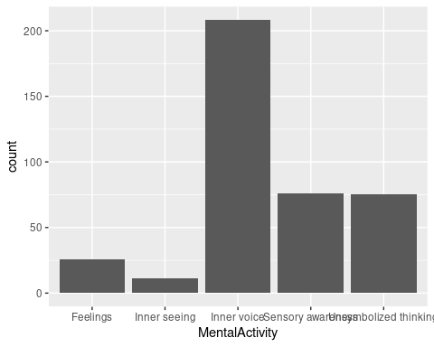

ggplot(dataBFE,aes(x=Activity))+geom_bar()+coord_flip()

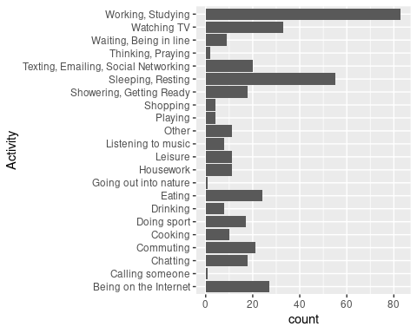

#Mood as function of Mental activity  
modelBFEmoodMentalAct<-lmer(mood~MentalActivity + (1|id),data=dataBFE)  
anova(modelBFEmoodMentalAct)

## Type III Analysis of Variance Table with Satterthwaite's method  
## Sum Sq Mean Sq NumDF DenDF F value Pr(>F)   
## MentalActivity 2571.9 642.99 4 387.73 2.7103 0.0299 *  
## ---  
## Signif. codes: 0 '***' 0.001 '**' 0.01 '*' 0.05 '.' 0.1 ' ' 1

#Mood as function of activity  
modelBFEmoodAct<-lmer(mood~Activity + (1|id),data=dataBFE)  
anova(modelBFEmoodAct)

## Type III Analysis of Variance Table with Satterthwaite's method  
## Sum Sq Mean Sq NumDF DenDF F value Pr(>F)   
## Activity 8946 426 21 362.12 1.8354 0.01445 *  
## ---  
## Signif. codes: 0 '***' 0.001 '**' 0.01 '*' 0.05 '.' 0.1 ' ' 1

### Mood by month

library(ggplot2)  
ggplot(dataBFE,aes(y=mood, x=as.factor(month)))+geom_boxplot()

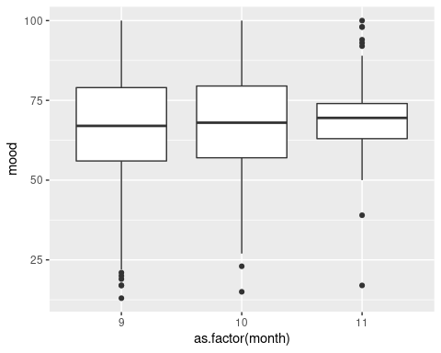

### Mood by hunger level

model_mood_hunger <- lmer(mood ~ hunger+(1|id),data=dataBFE)  
m_temp <- summary(model_mood_hunger)  
m_temp

## Linear mixed model fit by REML. t-tests use Satterthwaite's method [  
## lmerModLmerTest]  
## Formula: mood ~ hunger + (1 | id)  
## Data: dataBFE  
##   
## REML criterion at convergence: 3330.3  
##   
## Scaled residuals:   
## Min 1Q Median 3Q Max   
## -3.6519 -0.5939 0.1460 0.6590 2.6915   
##   
## Random effects:  
## Groups Name Variance Std.Dev.  
## id (Intercept) 77.22 8.787   
## Residual 239.23 15.467   
## Number of obs: 396, groups: id, 25  
##   
## Fixed effects:  
## Estimate Std. Error df t value Pr(>|t|)   
## (Intercept) 62.15863 2.80208 64.91588 22.183 <2e-16 ***  
## hunger 0.07446 0.02973 391.35954 2.505 0.0127 *   
## ---  
## Signif. codes: 0 '***' 0.001 '**' 0.01 '*' 0.05 '.' 0.1 ' ' 1  
##   
## Correlation of Fixed Effects:  
## (Intr)  
## hunger -0.656

dataBFE %>%   
 ggplot() +  
 aes(x=hour2, y=mood) +   
 geom_smooth() +   
 geom_smooth(aes(hour2, hunger), col = 'darkgreen') +   
 coord_cartesian(y = c(0,100))+geom_line(aes(x=hour2,y=HeartRateCircFitBoth),col='darkgreen')+labs(x='Time of day (hours)', y='HeartRate')

## `geom_smooth()` using method = 'loess' and formula 'y ~ x'  
## `geom_smooth()` using method = 'loess' and formula 'y ~ x'

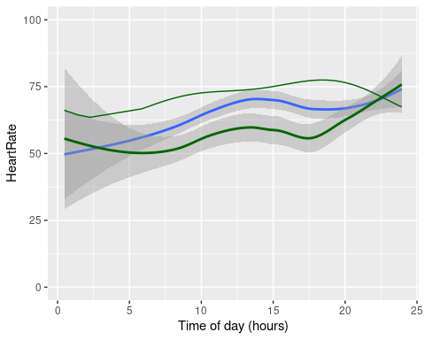

# Demographics   
df_final <- data.frame()  
  
for (i in unique(dataBFE$id)) {  
 name = dataBFE %>%filter(id == i) %>% select(id, Gender, age, Handedness) %>% slice(1)  
 count = filter(dataBFE, id == i) %>% count()  
   
 df_temp = data_frame(name, count)  
 df_final <- rbind(df_final, df_temp)  
}  
  
# gender  
df_final %>% filter(  
 Gender == "female"  
 ) %>% count() # 17 girls

## # A tibble: 1 × 1  
## n  
## <int>  
## 1 17

df_final %>% filter(  
 Gender == "male"  
 ) %>% count() # 8 boys

## # A tibble: 1 × 1  
## n  
## <int>  
## 1 8

# age  
mean(df_final$age) # mean age 24.44

## [1] 24.44

sd(df_final$age) # sd age 5.38

## [1] 5.378042

min(df_final$age) # 21

## [1] 21

max(df_final$age) # 49

## [1] 49

# figuring out the start and end data of the experiment by manipulating the Time column  
dataBFE$Time

## [1] "Tue Nov 15 2022 12:54:16 GMT+0100 (CET)"   
## [2] "Fri Sep 23 2022 08:44:33 GMT+0200 (Centraleuropæisk sommertid)"   
## [3] "Sun Sep 11 2022 12:36:18 GMT+0200 (Centraleuropæisk sommertid)"   
## [4] "Thu Oct 13 2022 14:07:14 GMT+0200 (Centraleuropæisk sommertid)"   
## [5] "Mon Sep 12 2022 12:04:23 GMT+0200 (Centraleuropæisk sommertid)"   
## [6] "Fri Oct 14 2022 21:47:36 GMT+0200 (Centraleuropæisk sommertid)"   
## [7] "Wed Nov 16 2022 18:40:26 GMT+0100 (Centraleuropæisk normaltid)"   
## [8] "Sat Sep 10 2022 13:56:28 GMT+0200 (Centraleuropæisk sommertid)"   
## [9] "Fri Nov 11 2022 10:21:11 GMT+0100 (Centraleuropæisk normaltid)"   
## [10] "Thu Sep 08 2022 21:30:01 GMT+0200 (Centraleuropæisk sommertid)"   
## [11] "Wed Sep 14 2022 13:37:45 GMT+0200 (Centraleuropæisk sommertid)"   
## [12] "Thu Sep 08 2022 16:35:20 GMT+0200 (Centraleuropæisk sommertid)"   
## [13] "Fri Sep 09 2022 10:18:32 GMT+0200 (Centraleuropæisk sommertid)"   
## [14] "Wed Oct 19 2022 23:56:22 GMT+0200 (Centraleuropæisk sommertid)"   
## [15] "Tue Sep 13 2022 11:36:54 GMT+0200 (Centraleuropæisk sommertid)"   
## [16] "Tue Nov 08 2022 15:03:24 GMT+0100 (Centraleuropæisk normaltid)"   
## [17] "Tue Sep 13 2022 15:48:07 GMT+0200 (Centraleuropæisk sommertid)"   
## [18] "Thu Sep 08 2022 18:25:15 GMT+0200 (Centraleuropæisk sommertid)"   
## [19] "Mon Sep 19 2022 21:16:05 GMT+0200 (Centraleuropæisk sommertid)"   
## [20] "Thu Sep 22 2022 21:52:07 GMT+0200 (Centraleuropæisk sommertid)"   
## [21] "Sun Oct 16 2022 17:25:21 GMT+0200 (Centraleuropæisk sommertid)"   
## [22] "Fri Sep 09 2022 10:01:19 GMT+0200 (CEST)"   
## [23] "Fri Nov 11 2022 10:21:27 GMT+0100 (CET)"   
## [24] "Sat Oct 08 2022 20:06:39 GMT+0200 (CEST)"   
## [25] "Sat Sep 10 2022 13:55:39 GMT+0200 (CEST)"   
## [26] "Fri Sep 23 2022 09:11:41 GMT+0200 (CEST)"   
## [27] "Thu Sep 15 2022 20:06:56 GMT+0200 (CEST)"   
## [28] "Fri Nov 18 2022 13:19:08 GMT+0100 (CET)"   
## [29] "Mon Sep 19 2022 22:02:53 GMT+0200 (CEST)"   
## [30] "Sat Oct 08 2022 20:13:22 GMT+0200 (CEST)"   
## [31] "Thu Oct 27 2022 07:35:33 GMT+0200 (CEST)"   
## [32] "Tue Oct 11 2022 22:16:59 GMT+0200 (CEST)"   
## [33] "Fri Nov 18 2022 07:40:16 GMT+0100 (CET)"   
## [34] "Mon Oct 31 2022 06:59:56 GMT+0100 (CET)"   
## [35] "Tue Oct 18 2022 11:31:54 GMT+0200 (CEST)"   
## [36] "Thu Sep 08 2022 21:30:22 GMT+0200 (CEST)"   
## [37] "Tue Oct 25 2022 17:24:38 GMT+0200 (CEST)"   
## [38] "Sun Oct 16 2022 17:21:06 GMT+0200 (CEST)"   
## [39] "Sun Sep 18 2022 17:49:45 GMT+0200 (CEST)"   
## [40] "Sun Oct 23 2022 13:48:14 GMT+0200 (CEST)"   
## [41] "Mon Sep 12 2022 17:02:41 GMT+0200 (CEST)"   
## [42] "Sat Sep 10 2022 13:55:51 GMT+0200 (CEST)"   
## [43] "Wed Nov 02 2022 22:23:18 GMT+0100 (CET)"   
## [44] "Tue Oct 04 2022 14:04:48 GMT+0200 (CEST)"   
## [45] "Fri Nov 11 2022 10:34:21 GMT+0100 (CET)"   
## [46] "Wed Nov 16 2022 08:39:01 GMT+0100 (CET)"   
## [47] "Mon Sep 12 2022 07:29:05 GMT+0200 (CEST)"   
## [48] "Wed Oct 19 2022 08:24:35 GMT+0200 (CEST)"   
## [49] "Tue Sep 13 2022 14:12:05 GMT+0200 (CEST)"   
## [50] "Tue Nov 15 2022 10:47:26 GMT+0100 (CET)"   
## [51] "Thu Sep 08 2022 18:15:28 GMT+0200 (CEST)"   
## [52] "Thu Sep 15 2022 20:04:42 GMT+0200 (CEST)"   
## [53] "Thu Sep 22 2022 21:52:16 GMT+0200 (CEST)"   
## [54] "Fri Sep 23 2022 08:21:52 GMT+0200 (CEST)"   
## [55] "Sat Nov 12 2022 14:24:32 GMT+0100 (CET)"   
## [56] "Sun Sep 11 2022 23:13:01 GMT+0200 (Central European Summer Time)"   
## [57] "Fri Nov 11 2022 10:34:25 GMT+0100 (Central European Standard Time)"   
## [58] "Mon Sep 12 2022 13:06:51 GMT+0200 (Central European Summer Time)"   
## [59] "Thu Sep 08 2022 16:30:11 GMT+0200 (Central European Summer Time)"   
## [60] "Tue Oct 25 2022 18:07:04 GMT+0200 (Central European Summer Time)"   
## [61] "Fri Sep 09 2022 12:20:37 GMT+0200 (Central European Summer Time)"   
## [62] "Sun Oct 02 2022 13:15:39 GMT+0200 (Central European Summer Time)"   
## [63] "Thu Oct 06 2022 20:10:51 GMT+0200 (Central European Summer Time)"   
## [64] "Mon Oct 24 2022 13:23:56 GMT+0200 (Central European Summer Time)"   
## [65] "Thu Oct 27 2022 07:25:45 GMT+0200 (Central European Summer Time)"   
## [66] "Sun Nov 06 2022 22:20:59 GMT+0100 (Central European Standard Time)"   
## [67] "Wed Oct 19 2022 08:45:06 GMT+0200 (Central European Summer Time)"   
## [68] "Sun Oct 30 2022 17:11:22 GMT+0100 (Central European Standard Time)"   
## [69] "Sun Oct 23 2022 09:01:20 GMT+0200 (Central European Summer Time)"   
## [70] "Thu Nov 03 2022 08:05:01 GMT+0100 (Central European Standard Time)"   
## [71] "Thu Oct 20 2022 08:48:12 GMT+0200 (Central European Summer Time)"   
## [72] "Fri Oct 07 2022 12:45:45 GMT+0200 (Central European Summer Time)"   
## [73] "Tue Sep 27 2022 11:30:42 GMT+0200 (Central European Summer Time)"   
## [74] "Sun Sep 25 2022 19:58:51 GMT+0200 (Central European Summer Time)"   
## [75] "Fri Oct 21 2022 11:39:56 GMT+0200 (Central European Summer Time)"   
## [76] "Fri Sep 09 2022 08:06:03 GMT+0200 (Central European Summer Time)"   
## [77] "Fri Oct 14 2022 22:53:43 GMT+0200 (Central European Summer Time)"   
## [78] "Fri Nov 11 2022 10:34:33 GMT+0100 (Central European Standard Time)"   
## [79] "Sat Oct 08 2022 19:37:15 GMT+0200 (Central European Summer Time)"   
## [80] "Fri Sep 23 2022 11:57:07 GMT+0200 (Central European Summer Time)"   
## [81] "Sat Oct 29 2022 09:27:08 GMT+0200 (Central European Summer Time)"   
## [82] "Wed Oct 05 2022 17:22:27 GMT+0200 (Central European Summer Time)"   
## [83] "Mon Nov 14 2022 09:06:30 GMT+0100 (Central European Standard Time)"   
## [84] "Thu Sep 08 2022 16:37:50 GMT+0200 (Centraleuropæisk sommertid)"   
## [85] "Fri Nov 18 2022 08:18:21 GMT+0100 (Central European Standard Time)"   
## [86] "Wed Oct 26 2022 22:40:52 GMT+0200 (Central European Summer Time)"   
## [87] "Tue Sep 13 2022 14:19:54 GMT+0200 (Central European Summer Time)"   
## [88] "Wed Oct 26 2022 22:36:26 GMT+0200 (Centraleuropæisk sommertid)"   
## [89] "Tue Oct 04 2022 13:59:30 GMT+0200 (CEST)"   
## [90] "Thu Sep 15 2022 19:58:49 GMT+0200 (CEST)"   
## [91] "Tue Sep 27 2022 07:26:46 GMT+0200 (CEST)"   
## [92] "Sat Sep 24 2022 10:03:37 GMT+0200 (CEST)"   
## [93] "Sun Oct 09 2022 18:43:47 GMT+0200 (CEST)"   
## [94] "Wed Nov 02 2022 22:21:11 GMT+0100 (Centraleuropæisk normaltid)"   
## [95] "Fri Oct 14 2022 21:38:19 GMT+0200 (Centraleuropæisk sommertid)"   
## [96] "Tue Oct 11 2022 22:41:23 GMT+0200 (CEST)"   
## [97] "Mon Oct 24 2022 15:07:03 GMT+0200 (Centraleuropæisk sommertid)"   
## [98] "Sun Nov 13 2022 15:01:30 GMT+0100 (Centraleuropæisk normaltid)"   
## [99] "Fri Sep 09 2022 10:20:04 GMT+0200 (CEST)"   
## [100] "Sat Oct 22 2022 13:05:53 GMT+0200 (Central European Summer Time)"   
## [101] "Wed Oct 05 2022 22:03:02 GMT+0200 (Central European Summer Time)"   
## [102] "Thu Sep 22 2022 22:17:15 GMT+0200 (Central European Summer Time)"   
## [103] "Mon Oct 31 2022 21:38:26 GMT+0100 (Central European Standard Time)"   
## [104] "Thu Nov 17 2022 19:48:21 GMT+0100 (Central European Standard Time)"   
## [105] "Sat Nov 19 2022 21:38:13 GMT+0100 (Central European Standard Time)"   
## [106] "Thu Sep 08 2022 16:30:06 GMT+0200 (中欧夏令时间)"   
## [107] "Tue Sep 13 2022 16:50:25 GMT+0200 (Central European Summer Time)"   
## [108] "Fri Oct 14 2022 20:19:55 GMT+0200 (Central European Summer Time)"   
## [109] "Mon Nov 07 2022 10:55:44 GMT+0100 (Central European Standard Time)"   
## [110] "Sat Sep 10 2022 16:27:34 GMT+0200 (Central European Summer Time)"   
## [111] "Fri Sep 23 2022 19:42:30 GMT+0200 (Central European Summer Time)"   
## [112] "Sun Oct 09 2022 17:21:09 GMT+0200 (Central European Summer Time)"   
## [113] "Thu Sep 15 2022 22:03:33 GMT+0200 (Central European Summer Time)"   
## [114] "Tue Oct 04 2022 22:39:58 GMT+0200 (Central European Summer Time)"   
## [115] "Wed Sep 14 2022 16:06:06 GMT+0200 (Central European Summer Time)"   
## [116] "Sun Sep 18 2022 23:25:31 GMT+0200 (Central European Summer Time)"   
## [117] "Mon Sep 19 2022 21:39:27 GMT+0200 (Central European Summer Time)"   
## [118] "Sun Oct 23 2022 19:09:55 GMT+0200 (Central European Summer Time)"   
## [119] "Mon Sep 12 2022 22:22:32 GMT+0200 (Central European Summer Time)"   
## [120] "Tue Oct 25 2022 17:21:17 GMT+0200 (Centraleuropæisk sommertid)"   
## [121] "Tue Oct 18 2022 10:12:18 GMT+0200 (Centraleuropæisk sommertid)"   
## [122] "Sat Sep 10 2022 10:54:54 GMT+0200 (CEST)"   
## [123] "Thu Nov 17 2022 10:07:54 GMT+0100 (Centraleuropæisk normaltid)"   
## [124] "Thu Sep 22 2022 21:57:37 GMT+0200 (Centraleuropæisk sommertid)"   
## [125] "Sun Oct 30 2022 16:26:19 GMT+0100 (Centraleuropæisk normaltid)"   
## [126] "Sat Sep 10 2022 13:48:30 GMT+0200 (CEST)"   
## [127] "Sat Sep 17 2022 13:02:30 GMT+0200 (Centraleuropæisk sommertid)"   
## [128] "Fri Oct 21 2022 14:36:38 GMT+0200 (Centraleuropæisk sommertid)"   
## [129] "Sun Sep 25 2022 19:56:34 GMT+0200 (Centraleuropæisk sommertid)"   
## [130] "Mon Oct 17 2022 18:50:30 GMT+0200 (Centraleuropæisk sommertid)"   
## [131] "Tue Nov 15 2022 23:31:20 GMT+0100 (Centraleuropæisk normaltid)"   
## [132] "Fri Sep 09 2022 09:03:22 GMT+0200 (CEST)"   
## [133] "Sun Oct 23 2022 13:41:01 GMT+0200 (Centraleuropæisk sommertid)"   
## [134] "Sun Nov 06 2022 18:19:25 GMT+0100 (Centraleuropæisk normaltid)"   
## [135] "Fri Sep 09 2022 08:02:43 GMT+0200 (CEST)"   
## [136] "Fri Nov 18 2022 08:44:32 GMT+0100 (Centraleuropæisk normaltid)"   
## [137] "Fri Sep 23 2022 08:51:37 GMT+0200 (Centraleuropæisk sommertid)"   
## [138] "Mon Sep 12 2022 11:08:53 GMT+0200 (CEST)"   
## [139] "Thu Oct 20 2022 00:28:00 GMT+0200 (Centraleuropæisk sommertid)"   
## [140] "Wed Sep 14 2022 13:33:39 GMT+0200 (Centraleuropæisk sommertid)"   
## [141] "Mon Sep 12 2022 20:43:21 GMT+0200 (CEST)"   
## [142] "Sat Sep 24 2022 17:51:01 GMT+0200 (Centraleuropæisk sommertid)"   
## [143] "Wed Oct 05 2022 10:35:43 GMT+0200 (Centraleuropæisk sommertid)"   
## [144] "Sat Nov 19 2022 14:00:50 GMT+0100 (Centraleuropæisk normaltid)"   
## [145] "Thu Sep 08 2022 16:37:10 GMT+0200 (CEST)"   
## [146] "Tue Sep 27 2022 10:47:24 GMT+0200 (Centraleuropæisk sommertid)"   
## [147] "Wed Nov 02 2022 22:48:17 GMT+0100 (Centraleuropæisk normaltid)"   
## [148] "Thu Sep 08 2022 18:10:21 GMT+0200 (CEST)"   
## [149] "Tue Oct 04 2022 14:02:23 GMT+0200 (Centraleuropæisk sommertid)"   
## [150] "Sat Oct 08 2022 19:36:15 GMT+0200 (Centraleuropæisk sommertid)"   
## [151] "Mon Sep 19 2022 23:09:48 GMT+0200 (Centraleuropæisk sommertid)"   
## [152] "Tue Oct 18 2022 20:00:20 GMT+0200 (Centraleuropæisk sommertid)"   
## [153] "Sun Oct 16 2022 18:01:29 GMT+0200 (Centraleuropæisk sommertid)"   
## [154] "Thu Oct 27 2022 09:24:32 GMT+0200 (Centraleuropæisk sommertid)"   
## [155] "Tue Oct 11 2022 22:26:50 GMT+0200 (Centraleuropæisk sommertid)"   
## [156] "Sun Sep 18 2022 17:18:37 GMT+0200 (Centraleuropæisk sommertid)"   
## [157] "Thu Sep 08 2022 21:32:25 GMT+0200 (CEST)"   
## [158] "Mon Sep 12 2022 07:53:31 GMT+0200 (CEST)"   
## [159] "Fri Oct 14 2022 23:01:36 GMT+0200 (Centraleuropæisk sommertid)"   
## [160] "Thu Oct 13 2022 19:06:39 GMT+0200 (Centraleuropæisk sommertid)"   
## [161] "Thu Sep 15 2022 19:58:45 GMT+0200 (Centraleuropæisk sommertid)"   
## [162] "Wed Nov 09 2022 22:08:02 GMT+0100 (Centraleuropæisk normaltid)"   
## [163] "Fri Oct 07 2022 08:32:26 GMT+0200 (Centraleuropæisk sommertid)"   
## [164] "Thu Sep 08 2022 16:34:01 GMT+0200 (Centraleuropæisk sommertid)"   
## [165] "Thu Sep 08 2022 16:30:09 GMT+0200 (Central European Summer Time)"   
## [166] "Wed Sep 14 2022 11:30:22 GMT+0200 (CEST)"   
## [167] "Sat Sep 10 2022 14:31:32 GMT+0200 (CEST)"   
## [168] "Tue Sep 13 2022 14:10:31 GMT+0200 (CEST)"   
## [169] "Sun Sep 18 2022 17:46:52 GMT+0200 (CEST)"   
## [170] "Mon Sep 19 2022 21:13:10 GMT+0200 (CEST)"   
## [171] "Fri Sep 09 2022 06:41:03 GMT+0200 (CEST)"   
## [172] "Mon Sep 12 2022 11:13:01 GMT+0200 (CEST)"   
## [173] "Thu Sep 08 2022 21:29:08 GMT+0200 (CEST)"   
## [174] "Thu Sep 15 2022 20:19:08 GMT+0200 (CEST)"   
## [175] "Thu Sep 08 2022 16:37:38 GMT+0200 (CEST)"   
## [176] "Thu Sep 08 2022 21:32:50 GMT+0200 (CEST)"   
## [177] "Thu Sep 08 2022 16:35:46 GMT+0200 (Centraleuropæisk sommertid)"   
## [178] "Thu Sep 08 2022 16:29:20 GMT+0200 (Hora de verão da Europa Central)"  
## [179] "Sat Sep 10 2022 13:49:01 GMT+0200 (CEST)"   
## [180] "Mon Sep 12 2022 07:22:13 GMT+0200 (CEST)"   
## [181] "Thu Sep 08 2022 21:30:07 GMT+0200 (CEST)"   
## [182] "Fri Sep 09 2022 20:50:55 GMT+0200 (CEST)"   
## [183] "Thu Sep 08 2022 16:33:44 GMT+0200 (CEST)"   
## [184] "Sat Sep 17 2022 13:04:59 GMT+0200 (Centraleuropæisk sommertid)"   
## [185] "Thu Sep 08 2022 21:30:17 GMT+0200 (Centraleuropæisk sommertid)"   
## [186] "Fri Sep 16 2022 10:31:00 GMT+0200 (Centraleuropæisk sommertid)"   
## [187] "Fri Sep 09 2022 09:31:08 GMT+0200 (Centraleuropæisk sommertid)"   
## [188] "Fri Sep 09 2022 22:51:31 GMT+0200 (Centraleuropæisk sommertid)"   
## [189] "Tue Sep 13 2022 17:48:49 GMT+0200 (Centraleuropæisk sommertid)"   
## [190] "Wed Sep 14 2022 11:26:55 GMT+0200 (Centraleuropæisk sommertid)"   
## [191] "Mon Sep 19 2022 01:22:26 GMT+0200 (Centraleuropæisk sommertid)"   
## [192] "Sat Sep 10 2022 17:27:44 GMT+0200 (Centraleuropæisk sommertid)"   
## [193] "Fri Sep 09 2022 19:23:51 GMT+0200 (Centraleuropæisk sommertid)"   
## [194] "Mon Sep 12 2022 07:28:05 GMT+0200 (Centraleuropæisk sommertid)"   
## [195] "Thu Sep 08 2022 16:29:18 GMT+0200 (Central European Summer Time)"   
## [196] "Mon Oct 17 2022 15:37:11 GMT+0200 (CEST)"   
## [197] "Wed Nov 16 2022 22:15:58 GMT+0100 (CET)"   
## [198] "Tue Sep 20 2022 07:08:49 GMT+0200 (CEST)"   
## [199] "Wed Nov 02 2022 14:14:41 GMT+0100 (CET)"   
## [200] "Mon Sep 12 2022 11:08:06 GMT+0200 (CEST)"   
## [201] "Mon Oct 24 2022 20:43:56 GMT+0200 (CEST)"   
## [202] "Sat Oct 08 2022 23:11:02 GMT+0200 (CEST)"   
## [203] "Sun Oct 30 2022 21:08:59 GMT+0100 (CET)"   
## [204] "Thu Oct 27 2022 12:35:12 GMT+0200 (CEST)"   
## [205] "Sat Oct 29 2022 08:46:06 GMT+0200 (CEST)"   
## [206] "Thu Sep 29 2022 09:11:57 GMT+0200 (CEST)"   
## [207] "Wed Sep 14 2022 11:48:22 GMT+0200 (CEST)"   
## [208] "Thu Sep 08 2022 21:29:22 GMT+0200 (CEST)"   
## [209] "Thu Sep 08 2022 20:21:43 GMT+0200 (CEST)"   
## [210] "Fri Nov 18 2022 15:31:54 GMT+0100 (CET)"   
## [211] "Sun Sep 25 2022 14:46:44 GMT+0200 (CEST)"   
## [212] "Fri Oct 07 2022 14:40:47 GMT+0200 (CEST)"   
## [213] "Sat Sep 10 2022 12:09:09 GMT+0200 (CEST)"   
## [214] "Mon Sep 12 2022 20:19:15 GMT+0200 (CEST)"   
## [215] "Fri Sep 09 2022 07:41:25 GMT+0200 (CEST)"   
## [216] "Thu Nov 03 2022 08:03:43 GMT+0100 (CET)"   
## [217] "Fri Sep 23 2022 21:11:34 GMT+0200 (CEST)"   
## [218] "Tue Oct 04 2022 21:17:05 GMT+0200 (CEST)"   
## [219] "Tue Sep 13 2022 14:19:38 GMT+0200 (CEST)"   
## [220] "Thu Sep 08 2022 18:28:39 GMT+0200 (CEST)"   
## [221] "Thu Sep 08 2022 16:35:46 GMT+0200 (Centraleuropæisk sommertid)"   
## [222] "Mon Sep 26 2022 19:22:08 GMT+0200 (CEST)"   
## [223] "Fri Oct 14 2022 22:12:56 GMT+0200 (CEST)"   
## [224] "Fri Nov 11 2022 10:21:05 GMT+0100 (CET)"   
## [225] "Thu Sep 22 2022 19:46:55 GMT+0200 (CEST)"   
## [226] "Mon Sep 12 2022 07:23:21 GMT+0200 (CEST)"   
## [227] "Tue Sep 20 2022 09:24:07 GMT+0200 (CEST)"   
## [228] "Mon Nov 07 2022 17:31:23 GMT+0100 (CET)"   
## [229] "Sun Sep 18 2022 21:38:12 GMT+0200 (CEST)"   
## [230] "Mon Sep 19 2022 20:13:40 GMT+0200 (CEST)"   
## [231] "Sat Oct 22 2022 09:42:19 GMT+0200 (CEST)"   
## [232] "Thu Sep 15 2022 21:12:13 GMT+0200 (CEST)"   
## [233] "Sat Sep 10 2022 22:57:32 GMT+0200 (CEST)"   
## [234] "Thu Nov 10 2022 13:20:21 GMT+0100 (Central European Standard Time)"   
## [235] "Sat Sep 17 2022 21:31:40 GMT+0200 (Centraleuropæisk sommertid)"   
## [236] "Fri Sep 09 2022 10:46:23 GMT+0200 (Centraleuropæisk sommertid)"   
## [237] "Wed Nov 16 2022 10:34:39 GMT+0100 (Central European Standard Time)"   
## [238] "Mon Sep 12 2022 09:49:48 GMT+0200 (Centraleuropæisk sommertid)"   
## [239] "Mon Nov 07 2022 09:33:24 GMT+0100 (Central European Standard Time)"   
## [240] "Mon Nov 14 2022 09:43:31 GMT+0100 (Central European Standard Time)"   
## [241] "Thu Nov 10 2022 17:23:26 GMT+0100 (Central European Standard Time)"   
## [242] "Fri Nov 18 2022 08:47:07 GMT+0100 (Central European Standard Time)"   
## [243] "Tue Nov 15 2022 12:53:43 GMT+0100 (Central European Standard Time)"   
## [244] "Fri Oct 14 2022 19:12:55 GMT+0200 (Centraleuropæisk sommertid)"   
## [245] "Mon Nov 07 2022 11:27:09 GMT+0100 (Centraleuropæisk normaltid)"   
## [246] "Mon Nov 21 2022 09:44:37 GMT+0100 (Central European Standard Time)"   
## [247] "Thu Sep 08 2022 17:15:58 GMT+0200 (Centraleuropæisk sommertid)"   
## [248] "Thu Oct 13 2022 21:53:12 GMT+0200 (Centraleuropæisk sommertid)"   
## [249] "Wed Nov 16 2022 09:38:37 GMT+0100 (Central European Standard Time)"   
## [250] "Thu Sep 08 2022 16:32:20 GMT+0200 (Central European Summer Time)"   
## [251] "Sat Sep 10 2022 22:51:23 GMT+0200 (Centraleuropæisk sommertid)"   
## [252] "Sun Sep 25 2022 20:08:34 GMT+0200 (Central European Summer Time)"   
## [253] "Wed Oct 05 2022 06:44:23 GMT+0200 (Central European Summer Time)"   
## [254] "Thu Sep 08 2022 18:28:24 GMT+0200 (Central European Summer Time)"   
## [255] "Thu Sep 15 2022 20:00:34 GMT+0200 (Central European Summer Time)"   
## [256] "Fri Sep 23 2022 06:56:49 GMT+0200 (Central European Summer Time)"   
## [257] "Mon Sep 12 2022 12:12:32 GMT+0200 (Central European Summer Time)"   
## [258] "Tue Sep 13 2022 21:16:24 GMT+0200 (Central European Summer Time)"   
## [259] "Tue Oct 04 2022 16:38:58 GMT+0200 (Central European Summer Time)"   
## [260] "Tue Sep 27 2022 14:00:09 GMT+0200 (Central European Summer Time)"   
## [261] "Mon Sep 12 2022 08:11:47 GMT+0200 (Central European Summer Time)"   
## [262] "Sat Sep 24 2022 14:22:46 GMT+0200 (Central European Summer Time)"   
## [263] "Fri Sep 09 2022 07:05:28 GMT+0200 (Central European Summer Time)"   
## [264] "Sat Sep 10 2022 13:54:11 GMT+0200 (Central European Summer Time)"   
## [265] "Fri Sep 23 2022 08:33:04 GMT+0200 (Central European Summer Time)"   
## [266] "Thu Sep 08 2022 21:41:05 GMT+0200 (Central European Summer Time)"   
## [267] "Fri Oct 07 2022 13:22:05 GMT+0200 (Central European Summer Time)"   
## [268] "Mon Nov 14 2022 07:17:10 GMT+0100 (Central European Standard Time)"   
## [269] "Thu Sep 08 2022 16:36:18 GMT+0200 (Centraleuropæisk sommertid)"   
## [270] "Tue Sep 27 2022 07:22:40 GMT+0200 (CEST)"   
## [271] "Wed Oct 26 2022 22:32:13 GMT+0200 (CEST)"   
## [272] "Fri Sep 09 2022 05:51:41 GMT+0200 (CEST)"   
## [273] "Thu Oct 27 2022 06:45:13 GMT+0200 (CEST)"   
## [274] "Sat Nov 19 2022 13:51:22 GMT+0100 (Centraleuropæisk normaltid)"   
## [275] "Sat Sep 10 2022 18:05:31 GMT+0200 (CEST)"   
## [276] "Thu Nov 03 2022 06:33:43 GMT+0100 (Centraleuropæisk normaltid)"   
## [277] "Sat Sep 24 2022 14:21:29 GMT+0200 (CEST)"   
## [278] "Fri Nov 11 2022 10:19:49 GMT+0100 (Centraleuropæisk normaltid)"   
## [279] "Sun Sep 18 2022 17:18:07 GMT+0200 (CEST)"   
## [280] "Wed Oct 05 2022 06:13:56 GMT+0200 (CEST)"   
## [281] "Mon Nov 14 2022 07:13:43 GMT+0100 (Centraleuropæisk normaltid)"   
## [282] "Wed Nov 09 2022 22:07:54 GMT+0100 (Centraleuropæisk normaltid)"   
## [283] "Fri Oct 21 2022 11:35:11 GMT+0200 (CEST)"   
## [284] "Fri Sep 09 2022 06:31:17 GMT+0200 (CEST)"   
## [285] "Thu Sep 08 2022 21:19:07 GMT+0200 (CEST)"   
## [286] "Sun Oct 30 2022 16:22:26 GMT+0100 (Centraleuropæisk normaltid)"   
## [287] "Sat Sep 10 2022 13:48:20 GMT+0200 (CEST)"   
## [288] "Wed Nov 02 2022 22:21:03 GMT+0100 (Centraleuropæisk normaltid)"   
## [289] "Sat Sep 17 2022 12:51:31 GMT+0200 (CEST)"   
## [290] "Thu Oct 13 2022 14:06:13 GMT+0200 (CEST)"   
## [291] "Sat Nov 12 2022 21:00:46 GMT+0100 (Centraleuropæisk normaltid)"   
## [292] "Mon Oct 17 2022 18:15:00 GMT+0200 (CEST)"   
## [293] "Tue Oct 11 2022 22:18:00 GMT+0200 (CEST)"   
## [294] "Mon Sep 12 2022 07:26:25 GMT+0200 (CEST)"   
## [295] "Thu Sep 08 2022 21:15:59 GMT+0200 (CEST)"   
## [296] "Mon Sep 19 2022 21:12:30 GMT+0200 (CEST)"   
## [297] "Mon Sep 19 2022 23:09:43 GMT+0200 (CEST)"   
## [298] "Fri Nov 18 2022 08:18:13 GMT+0100 (Centraleuropæisk normaltid)"   
## [299] "Tue Sep 13 2022 21:48:37 GMT+0200 (CEST)"   
## [300] "Thu Sep 08 2022 18:08:55 GMT+0200 (CEST)"   
## [301] "Fri Sep 23 2022 08:14:43 GMT+0200 (CEST)"   
## [302] "Wed Nov 16 2022 18:41:04 GMT+0100 (Centraleuropæisk normaltid)"   
## [303] "Fri Oct 14 2022 21:38:13 GMT+0200 (CEST)"   
## [304] "Tue Sep 13 2022 18:02:43 GMT+0200 (CEST)"   
## [305] "Sat Sep 24 2022 14:23:00 GMT+0200 (CEST)"   
## [306] "Sat Oct 29 2022 07:37:40 GMT+0200 (Centraleuropæisk sommertid)"   
## [307] "Sun Oct 16 2022 17:19:45 GMT+0200 (CEST)"   
## [308] "Thu Sep 22 2022 21:50:51 GMT+0200 (CEST)"   
## [309] "Tue Oct 04 2022 13:58:42 GMT+0200 (CEST)"   
## [310] "Thu Sep 08 2022 21:25:50 GMT+0200 (Central European Summer Time)"   
## [311] "Sat Nov 12 2022 14:08:05 GMT+0100 (Centraleuropæisk normaltid)"   
## [312] "Fri Oct 07 2022 08:25:53 GMT+0200 (CEST)"   
## [313] "Wed Oct 19 2022 23:50:27 GMT+0200 (CEST)"   
## [314] "Tue Oct 25 2022 17:21:14 GMT+0200 (CEST)"   
## [315] "Wed Sep 14 2022 11:27:29 GMT+0200 (CEST)"   
## [316] "Sun Nov 13 2022 23:12:51 GMT+0100 (Centraleuropæisk normaltid)"   
## [317] "Mon Sep 12 2022 11:05:45 GMT+0200 (CEST)"   
## [318] "Sun Nov 06 2022 15:25:43 GMT+0100 (Centraleuropæisk normaltid)"   
## [319] "Wed Oct 19 2022 07:57:22 GMT+0200 (CEST)"   
## [320] "Tue Nov 15 2022 23:31:24 GMT+0100 (Centraleuropæisk normaltid)"   
## [321] "Sat Oct 08 2022 19:31:35 GMT+0200 (CEST)"   
## [322] "Sun Oct 23 2022 08:08:42 GMT+0200 (CEST)"   
## [323] "Sat Sep 10 2022 23:13:10 GMT+0200 (CEST)"   
## [324] "Sat Sep 10 2022 18:39:50 GMT+0200 (CEST)"   
## [325] "Tue Sep 13 2022 14:09:55 GMT+0200 (CEST)"   
## [326] "Tue Oct 18 2022 00:34:10 GMT+0200 (CEST)"   
## [327] "Mon Sep 12 2022 07:26:57 GMT+0200 (Centraleuropæisk sommertid)"   
## [328] "Thu Sep 22 2022 22:39:12 GMT+0200 (Centraleuropæisk sommertid)"   
## [329] "Thu Sep 08 2022 21:15:17 GMT+0200 (Centraleuropæisk sommertid)"   
## [330] "Fri Sep 09 2022 14:21:26 GMT+0200 (Centraleuropæisk sommertid)"   
## [331] "Sun Sep 25 2022 21:58:25 GMT+0200 (Centraleuropæisk sommertid)"   
## [332] "Sun Sep 11 2022 02:16:33 GMT+0200 (Centraleuropæisk sommertid)"   
## [333] "Wed Sep 14 2022 11:28:08 GMT+0200 (Centraleuropæisk sommertid)"   
## [334] "Thu Sep 08 2022 21:29:14 GMT+0200 (Centraleuropæisk sommertid)"   
## [335] "Thu Sep 08 2022 16:29:22 GMT+0200 (Central European Summer Time)"   
## [336] "Mon Sep 19 2022 23:09:58 GMT+0200 (Centraleuropæisk sommertid)"   
## [337] "Fri Sep 23 2022 08:41:21 GMT+0200 (Centraleuropæisk sommertid)"   
## [338] "Wed Oct 05 2022 14:01:21 GMT+0200 (Centraleuropæisk sommertid)"   
## [339] "Tue Sep 27 2022 20:06:09 GMT+0200 (Centraleuropæisk sommertid)"   
## [340] "Fri Oct 07 2022 08:26:48 GMT+0200 (Centraleuropæisk sommertid)"   
## [341] "Tue Sep 13 2022 14:12:00 GMT+0200 (Centraleuropæisk sommertid)"   
## [342] "Fri Sep 09 2022 08:38:17 GMT+0200 (Centraleuropæisk sommertid)"   
## [343] "Sat Sep 10 2022 19:30:24 GMT+0200 (Centraleuropæisk sommertid)"   
## [344] "Thu Sep 08 2022 16:31:26 GMT+0200 (Midden-Europese zomertijd)"   
## [345] "Fri Sep 23 2022 08:16:22 GMT+0200 (CEST)"   
## [346] "Fri Sep 09 2022 06:41:46 GMT+0200 (CEST)"   
## [347] "Tue Nov 15 2022 23:32:44 GMT+0100 (CET)"   
## [348] "Sat Sep 24 2022 14:21:56 GMT+0200 (CEST)"   
## [349] "Sat Sep 10 2022 13:49:43 GMT+0200 (Central European Summer Time)"   
## [350] "Thu Sep 08 2022 16:29:02 GMT+0200 (Central European Summer Time)"   
## [351] "Mon Sep 12 2022 07:23:48 GMT+0200 (CEST)"   
## [352] "Sat Sep 10 2022 13:48:50 GMT+0200 (CEST)"   
## [353] "Tue Sep 13 2022 13:18:04 GMT+0200 (CEST)"   
## [354] "Mon Sep 12 2022 15:30:26 GMT+0200 (CEST)"   
## [355] "Sat Sep 17 2022 18:08:33 GMT+0200 (CEST)"   
## [356] "Tue Sep 13 2022 20:35:52 GMT+0200 (CEST)"   
## [357] "Thu Sep 15 2022 08:10:48 GMT+0200 (CEST)"   
## [358] "Thu Sep 08 2022 19:12:57 GMT+0200 (CEST)"   
## [359] "Sat Sep 24 2022 19:29:26 GMT+0200 (CEST)"   
## [360] "Sat Sep 24 2022 11:01:18 GMT+0200 (CEST)"   
## [361] "Thu Sep 22 2022 22:11:05 GMT+0200 (CEST)"   
## [362] "Sun Sep 25 2022 19:56:41 GMT+0200 (CEST)"   
## [363] "Fri Sep 09 2022 06:40:38 GMT+0200 (CEST)"   
## [364] "Thu Sep 08 2022 21:29:26 GMT+0200 (CEST)"   
## [365] "Tue Nov 01 2022 11:23:02 GMT+0100 (CET)"   
## [366] "Wed Oct 05 2022 22:45:08 GMT+0200 (CEST)"   
## [367] "Mon Sep 26 2022 06:38:59 GMT+0200 (CEST)"   
## [368] "Tue Sep 13 2022 13:02:42 GMT+0200 (CEST)"   
## [369] "Sat Sep 10 2022 13:48:36 GMT+0200 (CEST)"   
## [370] "Fri Oct 07 2022 23:56:39 GMT+0200 (CEST)"   
## [371] "Sat Nov 19 2022 13:51:25 GMT+0100 (CET)"   
## [372] "Sat Oct 29 2022 07:37:41 GMT+0200 (CEST)"   
## [373] "Thu Sep 15 2022 19:59:24 GMT+0200 (CEST)"   
## [374] "Wed Sep 28 2022 12:27:26 GMT+0200 (CEST)"   
## [375] "Tue Sep 13 2022 14:11:04 GMT+0200 (CEST)"   
## [376] "Sat Nov 12 2022 14:18:13 GMT+0100 (CET)"   
## [377] "Mon Sep 12 2022 07:22:21 GMT+0200 (CEST)"   
## [378] "Sun Oct 16 2022 17:20:21 GMT+0200 (CEST)"   
## [379] "Sun Oct 23 2022 10:29:37 GMT+0200 (CEST)"   
## [380] "Fri Sep 09 2022 06:19:29 GMT+0200 (CEST)"   
## [381] "Fri Nov 18 2022 08:18:23 GMT+0100 (CET)"   
## [382] "Mon Nov 14 2022 07:20:13 GMT+0100 (CET)"   
## [383] "Thu Sep 08 2022 16:37:27 GMT+0200 (CEST)"   
## [384] "Wed Oct 19 2022 07:58:25 GMT+0200 (CEST)"   
## [385] "Fri Oct 21 2022 11:40:01 GMT+0200 (CEST)"   
## [386] "Wed Oct 12 2022 21:40:41 GMT+0200 (CEST)"   
## [387] "Fri Oct 07 2022 08:28:12 GMT+0200 (CEST)"   
## [388] "Sat Oct 08 2022 19:32:28 GMT+0200 (CEST)"   
## [389] "Mon Oct 17 2022 18:15:53 GMT+0200 (CEST)"   
## [390] "Sun Nov 13 2022 23:16:19 GMT+0100 (CET)"   
## [391] "Fri Oct 14 2022 21:38:24 GMT+0200 (CEST)"   
## [392] "Tue Oct 11 2022 22:16:12 GMT+0200 (CEST)"   
## [393] "Wed Sep 14 2022 11:29:57 GMT+0200 (CEST)"   
## [394] "Mon Sep 12 2022 11:13:08 GMT+0200 (CEST)"   
## [395] "Thu Oct 13 2022 14:06:22 GMT+0200 (CEST)"   
## [396] "Wed Nov 09 2022 22:08:52 GMT+0100 (CET)"

dataBFE <- dataBFE %>%   
 mutate(  
 new_date = as.Date(Time, format = "%a %b %d %Y")  
 )  
# start data Sep 8  
# end data Nov 21   
# = 2 months and 13 days