Silkwood Visual Identity Design
Extracted content from the supplied visual-identity PDF
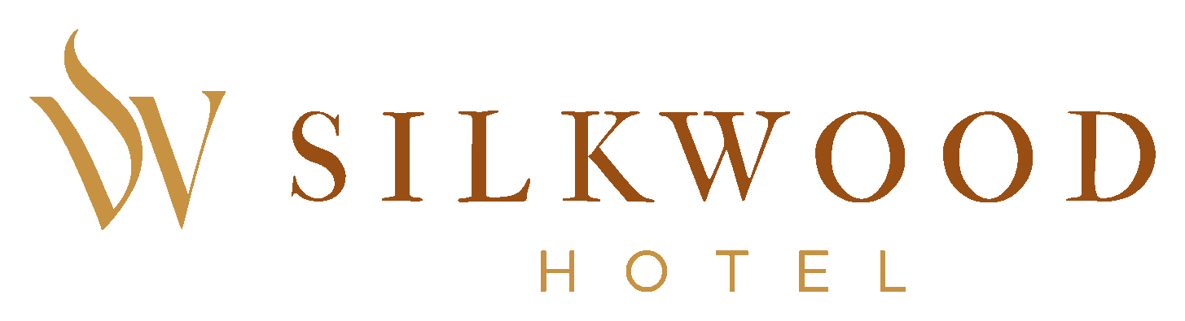

Logo Brief
The Silkwood Hotel logo is designed as a refined visual signature that embodies modern luxury, quiet confidence, and timeless sophistication. It balances minimalism with character, ensuring versatility across physical and digital touchpoints. Its purpose is both identification and positioning: to immediately communicate Silkwood as a premium hospitality brand within Ikeja's upscale GRA environment.

About Project
Silkwood Hotel is envisioned as a refined expression of modern luxury for a discerning clientele that values comfort, privacy, and elevated experiences. Situated in GRA, Ikeja, Lagos, it serves people seeking more than accommodation: a space that reflects their taste, status, and lifestyle.
The project goes beyond aesthetics. Every element of the identity and brand language is designed to communicate quiet confidence, elegance, warmth, and premium sophistication.
The aim is to establish Silkwood as a distinctive presence within Ikeja's hospitality landscape: elegant yet comfortable, consistent yet full of character, and a new standard for luxury hospitality.

Brand Interpretation
Silkwood is a study in quiet luxury, where elegance is felt rather than forced. Built on refinement, balance, and intention, the brand creates an experience that feels personal, exclusive, and effortlessly elevated.
The visual identity reflects:
- Refined simplicity and quiet confidence.
- A grounded aesthetic that celebrates richness and calm.
- A cohesive system designed to feel intimate and timeless.

Logo Symbol Meaning
S: Represents silk: smoothness, softness, and luxury.
W: Represents wood: strength, warmth, and stability.
Flowing curves: Represent silk in motion, conveying elegance and grace.
Overall form: Creates a sense of shelter, trust, and exclusivity.

Colour Palette
Warm Copper - #994E14
Golden Ochre - #C79242
Peach Cream - #FFE3BA
Vanilla Cream - #FFF1DB

Typography
Primary Typeface: Trajan Pro
Secondary Typeface: AventaVariable

Tagline
Refined Living. Elevated Stay.

