Silkwood Visual Identity Design
Extracted content from the supplied PDF
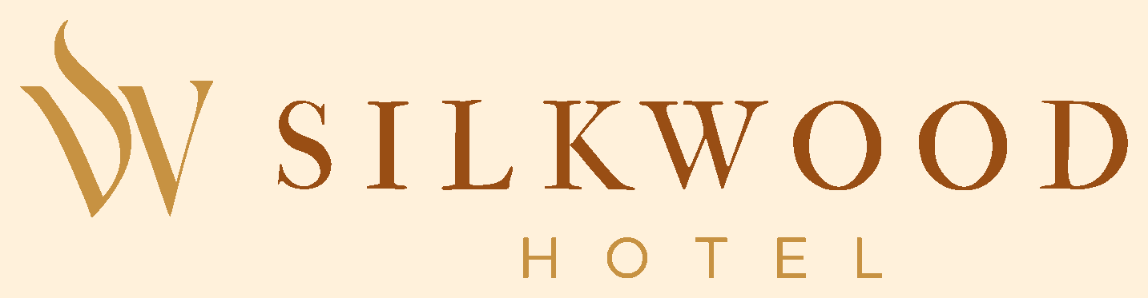

Logo Brief
The Silkwood Hotel logo is designed as a refined visual signature that embodies modern luxury, quiet confidence, and timeless sophistication. It balances minimalism with character, ensuring versatility across both physical and digital touchpoints. The objective of the logo is not just identification, but positioning: to immediately communicate Silkwood as a premium hospitality brand within Ikeja's upscale GRA environment.

About Project
Silkwood Hotel is envisioned as a refined expression of modern luxury, created for a discerning clientele that values comfort, privacy, and elevated experiences. Situated in the heart of GRA, Ikeja, Lagos, the brand is positioned to serve individuals who are not just seeking accommodation, but a space that reflects their taste, status, and lifestyle.
This project goes beyond aesthetics. It is a strategic effort to define how Silkwood is perceived, experienced, and remembered. From its visual identity to its brand language, every element is intentionally designed to communicate quiet confidence, elegance, warmth, and premium sophistication.
The goal is to establish Silkwood Hotel as a distinctive presence within Ikeja's hospitality landscape, one that seamlessly blends elegance with comfort, and consistency with character. A brand that doesn't just compete, but sets a new standard for what luxury hospitality should feel like.

Brand Interpretation
Silkwood Hotels is a study in quiet luxury, where elegance is felt, not forced. Built on the principles of refinement, balance, and intention, the brand creates an experience that feels personal, exclusive, and effortlessly elevated.
Its visual identity reflects this through:
- Refined simplicity and quiet confidence.
- A grounded aesthetic that celebrates richness and calm.
- A cohesive system designed to feel intimate and timeless.
Silkwood is a space for those who value subtlety over spectacle, a space where luxury is not announced, but felt. It is deeply experienced.

Logo Symbol Meaning
S: Represents silk: smoothness, softness, and luxury.
W: Represents wood: strength, warmth, and stability.
Flowing curves: Represent silk in motion, conveying elegance and grace.
Overall form: Creates a sense of shelter, trust, and exclusivity.

Colour Palette
Colour | HEX
Warm Copper | #994E14
Golden Ochre | #C79242
Peach Cream | #FFE3BA
Vanilla Cream | #FFF1DB

Typography
Primary Typeface: Trajan Pro
Secondary Typeface: AventaVariable

Tagline
Refined Living. Elevated Stay.
Source: Silkwood visual identity design.pdf. Text that appears only within photographic mock-ups has not been transcribed as body content.

