PROBLEM#4.MATLAB

(if x is negative)

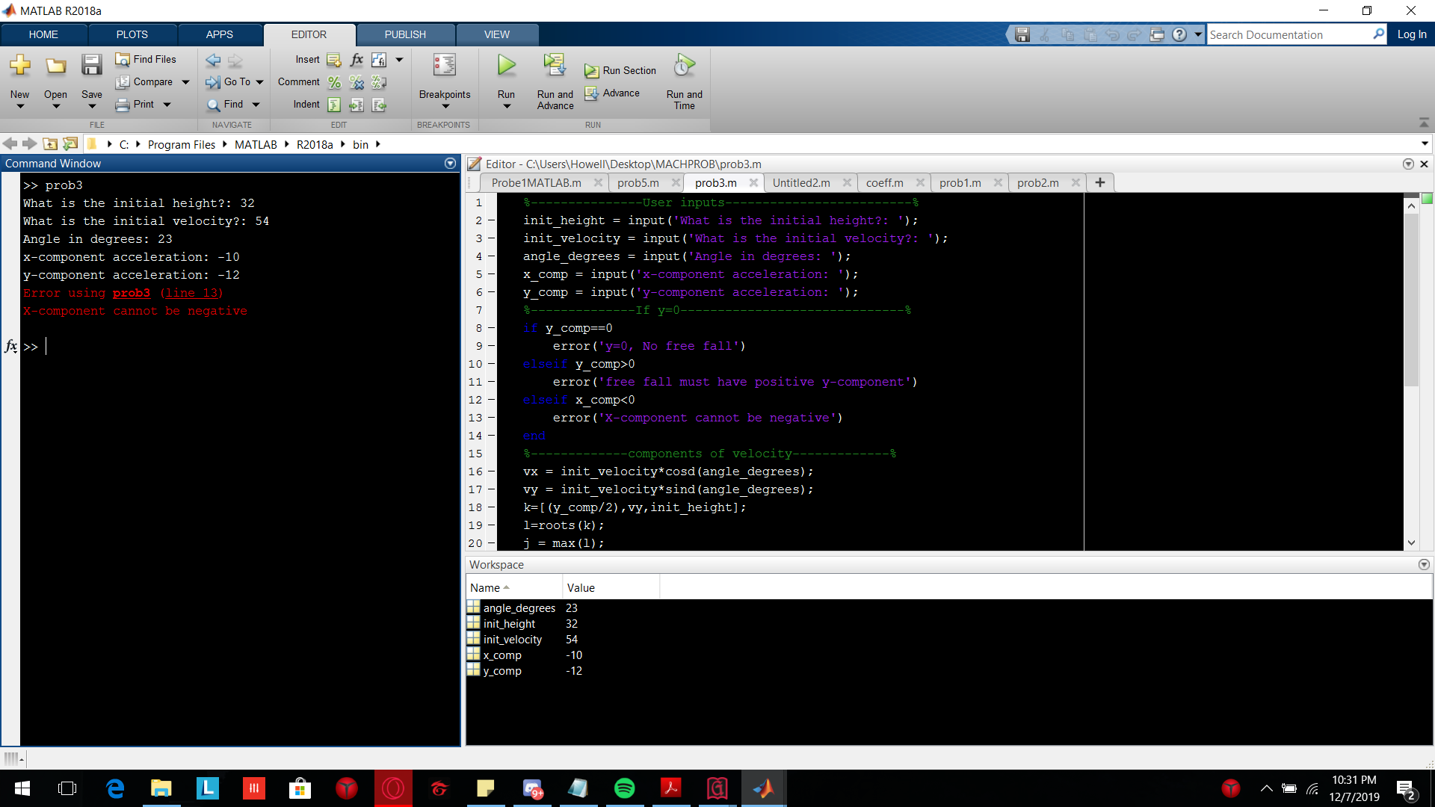

(if y is positive)



If no hindrance

