PROBLEM#5.MATLAB

Assuming the x(n) is the given.

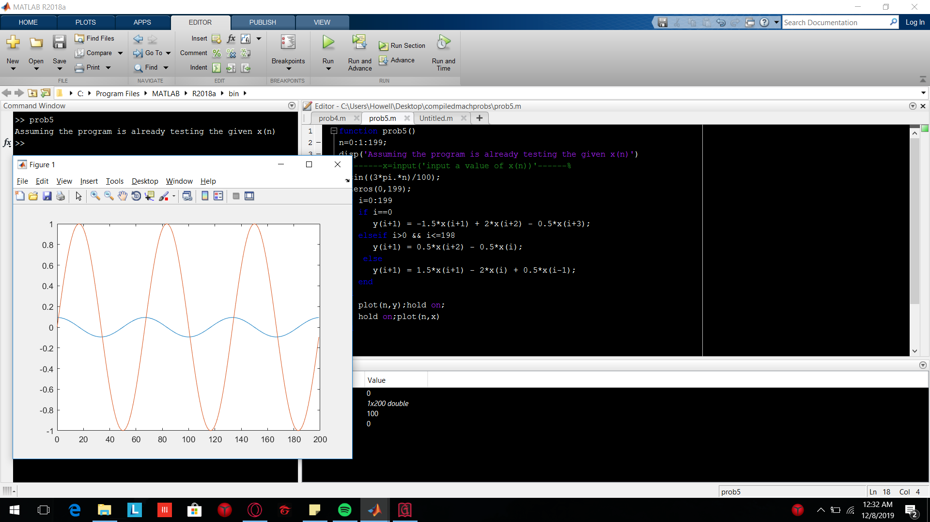

Using other functions for x(n); used x(8.\*n).

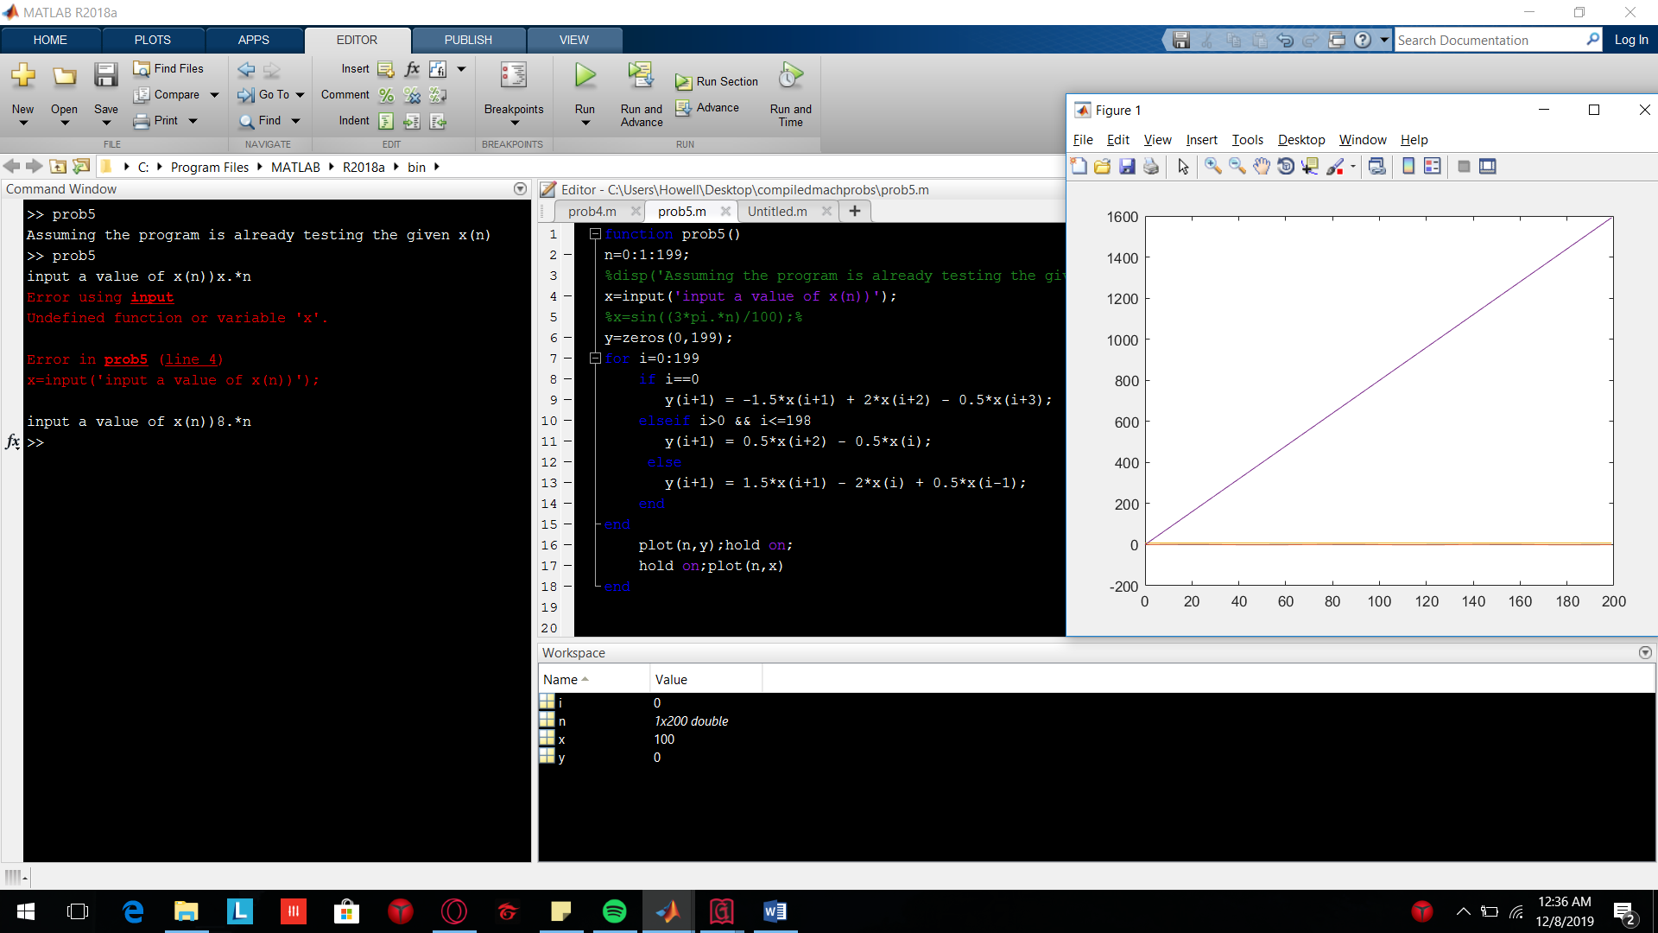

Using the given as input for x

