Hannah Arendt on why Jews ‘of all people’ where targeted by Nazi ideology, in her book The Origins of Totalitarianism, 1951 (LINK)
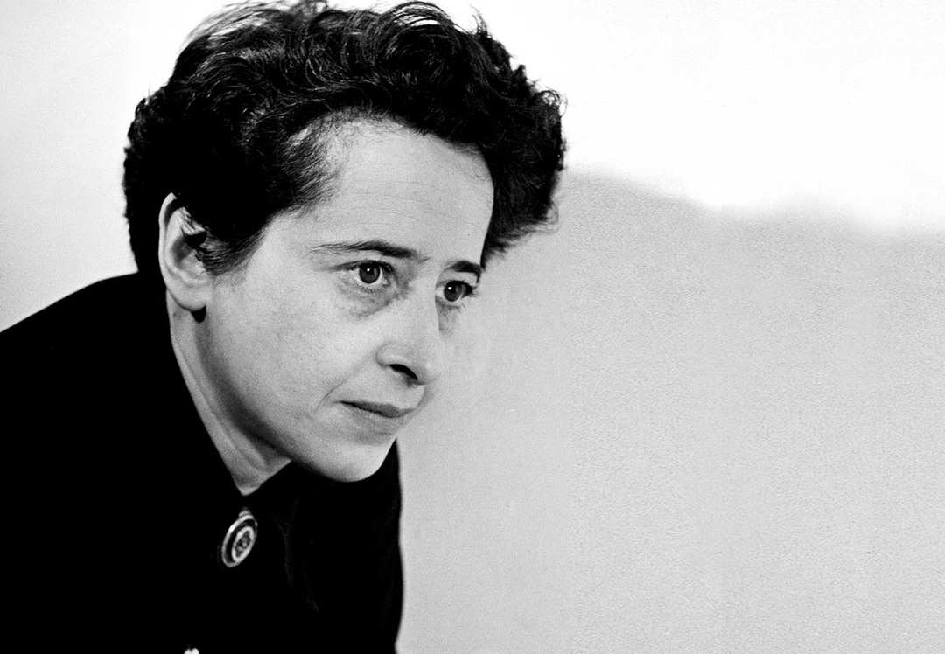
Excerpt 1, p.43, the outline
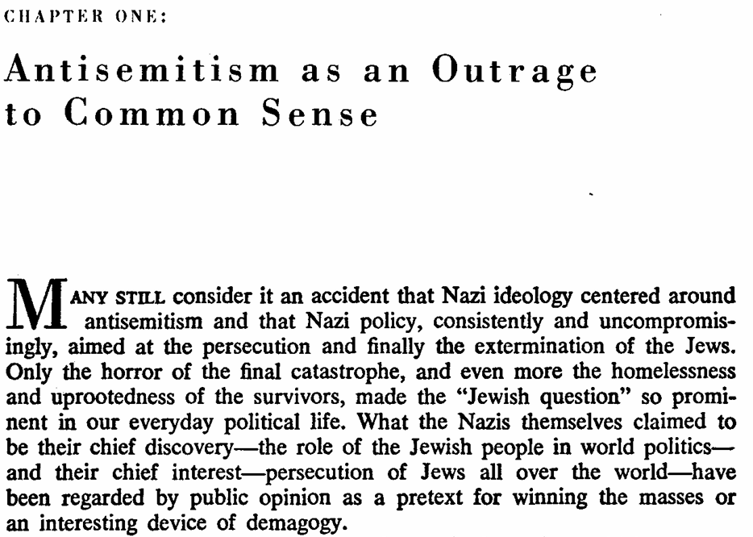
Excerpt 2, p.44, some context about banking
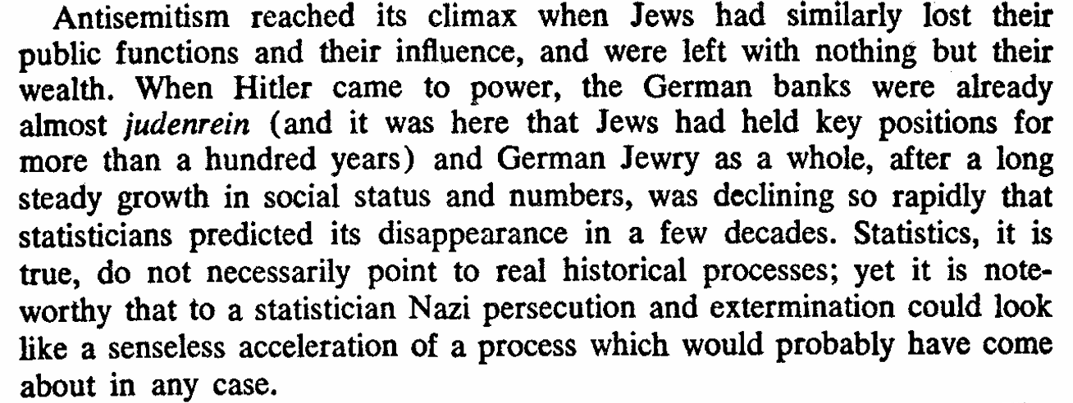
Excerpt 3, p.45, the scapegoat theory
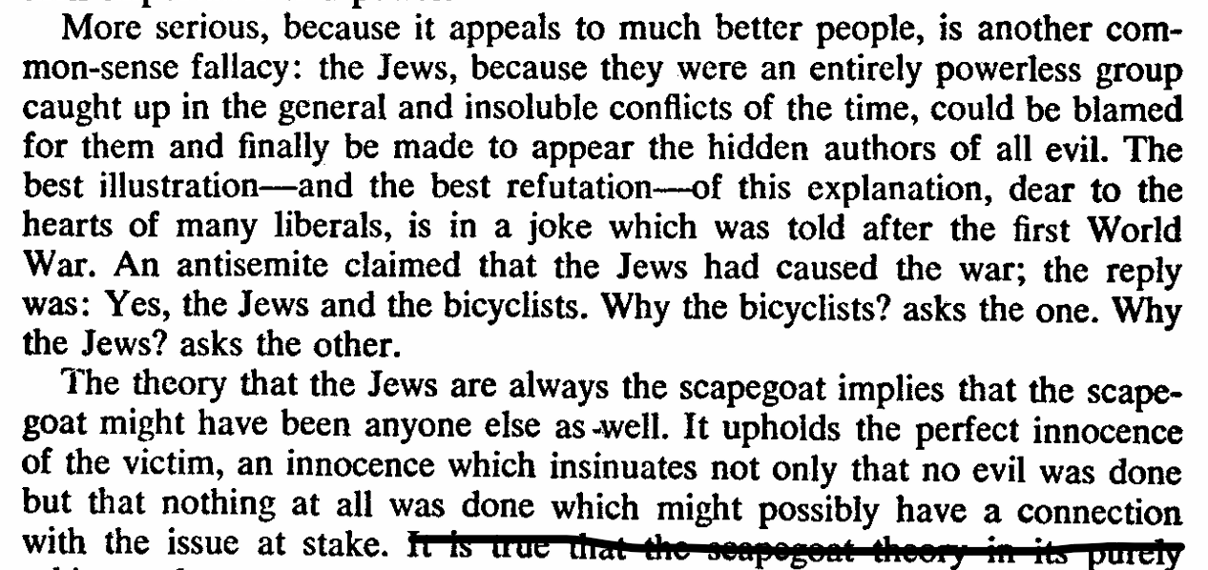
Excerpt 4, p.46, on why state terror is useful
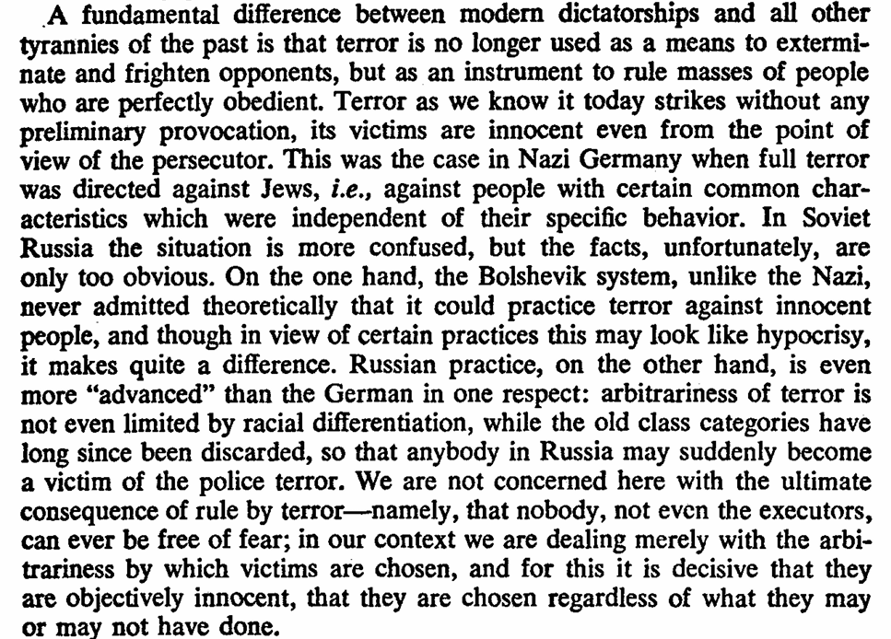
Excerpt 5, p.47, on the two most common (dumb) theories
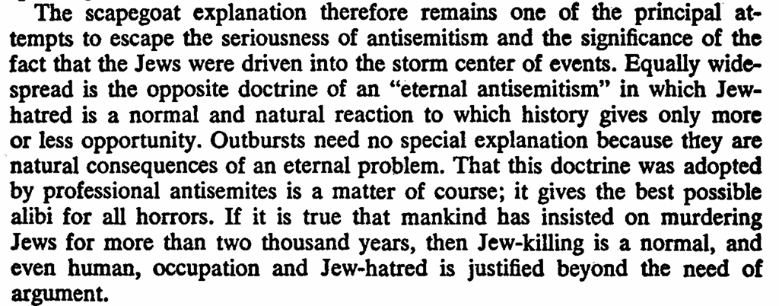
Excerpt 6, p.48, her summarized answer to the question (if you don’t want to read the entire book)
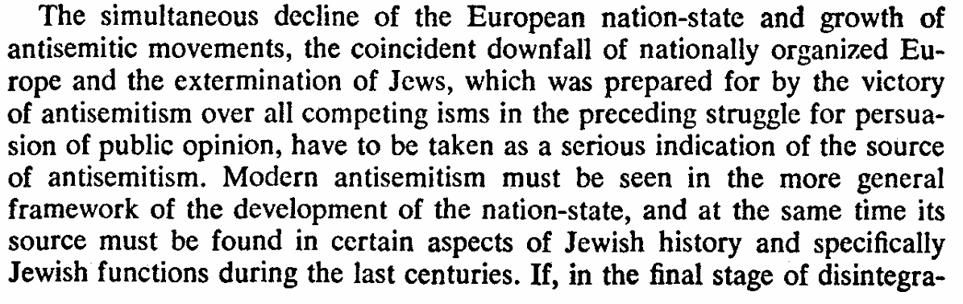
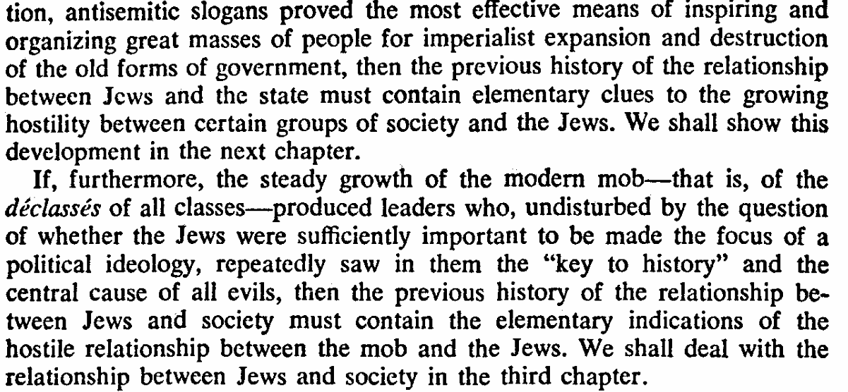

Umberto Eco’s 14 traits of fascism from his very famous essay Ur-Fascism
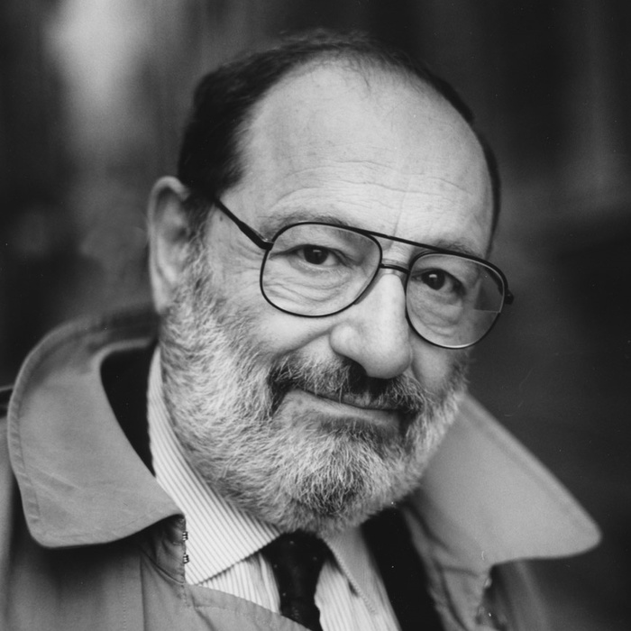
LINK:
Trait 1 “The first feature of Ur-Fascism is the cult of tradition. Traditionalism is of course much older than fascism. Not only was it typical of counter-revolutionary Catholic thought after the French revolution, but it was born in the late Hellenistic era, as a reaction to classical Greek rationalism. In the Mediterranean basin, people of different religions (most of them indulgently accepted by the Roman Pantheon) started dreaming of a revelation received at the dawn of human history. This revelation, according to the traditionalist mystique, had remained for a long time concealed under the veil of forgotten languages — in Egyptian hieroglyphs, in the Celtic runes, in the scrolls of the little known religions of Asia.”
Trait 2: “Traditionalism implies the rejection of modernism. Both Fascists and Nazis worshiped technology, while traditionalist thinkers usually reject it as a negation of traditional spiritual values. However, even though Nazism was proud of its industrial achievements, its praise of modernism was only the surface of an ideology based upon Blood and Earth (Blut und Boden). The rejection of the modern world was disguised as a rebuttal of the capitalistic way of life, but it mainly concerned the rejection of the Spirit of 1789 (and of 1776, of course). The Enlightenment, the Age of Reason, is seen as the beginning of modern depravity. In this sense Ur-Fascism can be defined as irrationalism.”
Trait 3: “Irrationalism also depends on the cult of action for action’s sake. Action being beautiful in itself, it must be taken before, or without, any previous reflection. Thinking is a form of emasculation.”
Trait 7: “To people who feel deprived of a clear social identity, Ur-Fascism says that their only privilege is the most common one, to be born in the same country. This is the origin of nationalism. Besides, the only ones who can provide an identity to the nation are its enemies. Thus at the root of the Ur-Fascist psychology there is the obsession with a plot, possibly an international one. The followers must feel besieged. The easiest way to solve the plot is the appeal to xenophobia. But the plot must also come from the inside: Jews are usually the best target because they have the advantage of being at the same time inside and outside. In the U.S., a prominent instance of the plot obsession is to be found in Pat Robertson’s The New World Order, but, as we have recently seen, there are many others.”
Trait 8: “The followers must feel humiliated by the ostentatious wealth and force of their enemies. When I was a boy I was taught to think of Englishmen as the five-meal people. They ate more frequently than the poor but sober Italians. Jews are rich and help each other through a secret web of mutual assistance. However, the followers must be convinced that they can overwhelm the enemies. Thus, by a continuous shifting of rhetorical focus, the enemies are at the same time too strong and too weak. Fascist governments are condemned to lose wars because they are constitutionally incapable of objectively evaluating the force of the enemy.”
Trait 12: “Since both permanent war and heroism are difficult games to play, the Ur-Fascist transfers his will to power to sexual matters. This is the origin of machismo (which implies both disdain for women and intolerance and condemnation of nonstandard sexual habits, from chastity to homosexuality). Since even sex is a difficult game to play, the Ur-Fascist hero tends to play with weapons — doing so becomes an ersatz phallic exercise.”

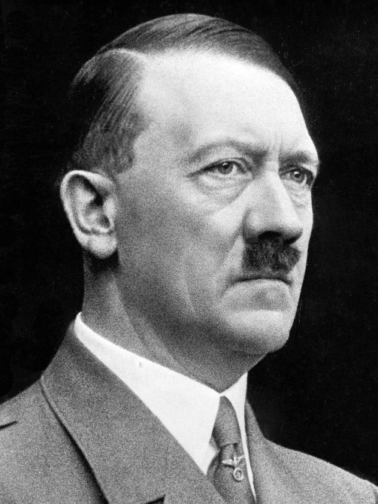
Excerpts from Adolf Hitler’s Mein Kampf, translated by Ralph Manheim, gathered by the Holocaust & Human Rights Education center
- “The personification of the devil as the symbol of all evil assumes the living shape of the Jew . . . “
- “I believe that I am acting in accordance with the will of the almighty creator. By defending myself against the Jew, I am fighting for the work of the Lord . . .”
- “With satanic joy in his face, the black-haired Jewish youth lurks in wait for the unsuspecting girl whom he defiles with his blood, thus stealing her from her people With every means he tries to destroy the racial foundations of the people he has set out to subjugate. . . .”
- “In the course of the centuries their outward appearance had become Europeanized and had taken on a human look; in fact, I even took them for Germans . . .”
- “Wherever I went, I began to see Jews, and the more I saw, the more sharply they became distinguished in my eyes from the rest of humanity . . .”
- “The Jew was never in possession of a culture of his own, the foundations of his intellectual work was always provided by others . . .”
- “Culturally, he contaminates art, literature, the theater, makes a mockery of natural feeling, overthrows all concepts of beauty and sublimity, of the noble and the good, and instead drags men down into the sphere of his own base nature.”
- “For a racially pure people which is conscious of its blood can never be enslaved by the Jew. In this world he will forever be master over bastards and bastards alone. And so he tries systematcally to lower the racial level by a continuous poisoning of individuals.”
- “The Jew is always a parasite in the body of other people. . .. He is and remains the typical parasite, a sponger who like a noxious bacillus keeps spreading as soon as a favorable medium invites him. And the effect of his existence is also like that of spongers; wherever he appears, the host people dies out after a shorter or longer period . . .”
Excerpts from Henry Ford’s The International Jew.
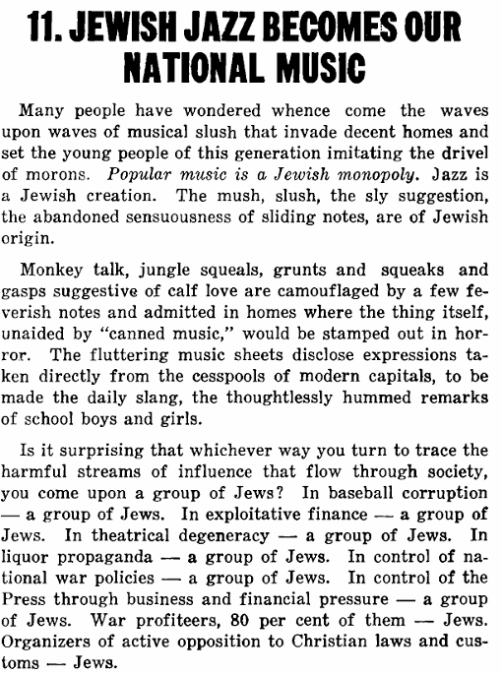
Excerpst from the fake document Protocols of the Elders of Zion alleged to be from 1897 but proven to be written at least after 1901 in Russia.From Protocol nr.1:
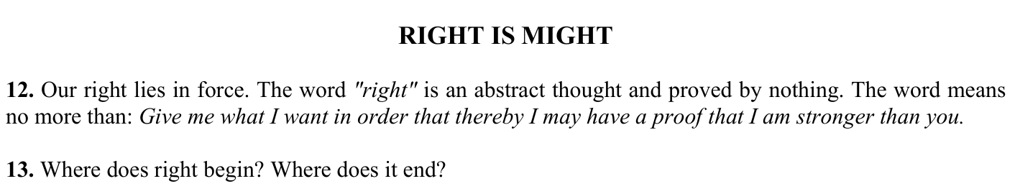
From Protocol nr.2:
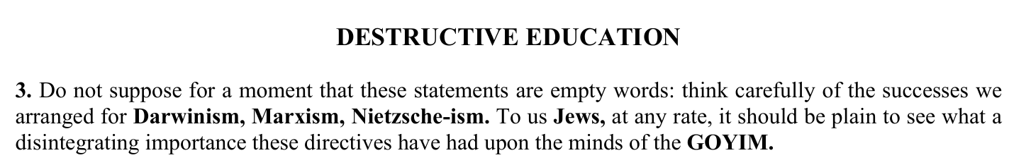
From Protocol nr.3:
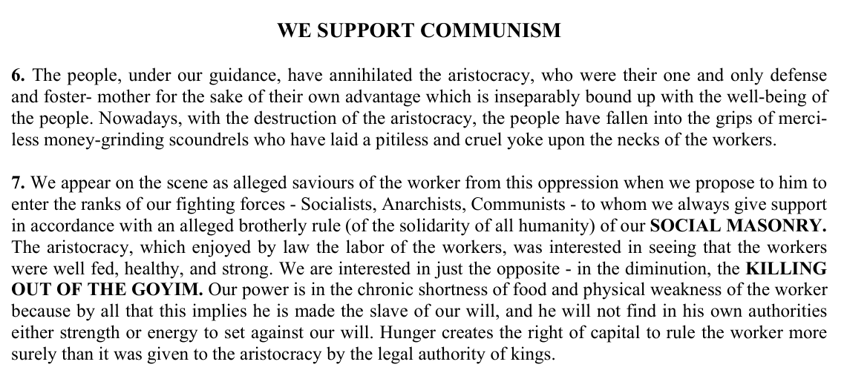
From Protocol nr.4:
