BAL cell analysis
A guide to segmenting, labelling, training and classifying cells in bronchoalveolar lavage slides with QuPath.

This guide is for using the software. For editing the code, read CLAUDE.md in the project folder instead.
Every figure below is an empty frame. Click inside it, paste your QuPath screenshot, and edit the caption underneath.

Contents
1. Before you start
2. Opening the project
3. The dialog
4. Segmenting cells
5. Labelling cells by type
6. Improving the segmentation (fine-tuning)
7. Classifying cell types
8. Processing many slides
9. Reading the results
10. When something goes wrong

1. Before you start
You need QuPath 0.7.0 with two extensions installed — Cellpose and InstanSeg — and the two conda environments the scripts call (cellpose_seg and cellpose3). These are already set up on this machine.
A quick check that everything is in place: open QuPath and look under Extensions → Manage extensions. Cellpose and InstanSeg should both be listed.
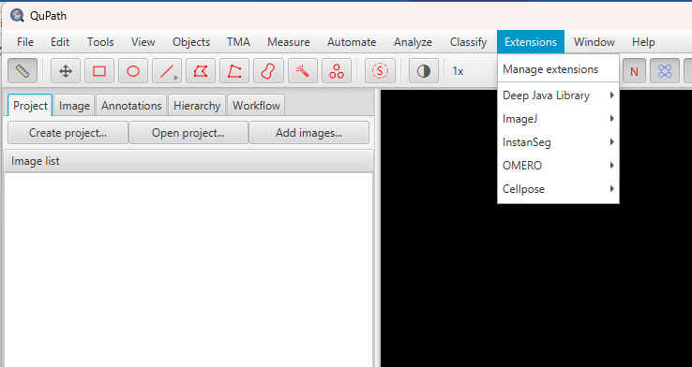
Figure 1. QuPath's Extensions → Manage extensions window, with Cellpose and InstanSeg installed.

2. Opening the project
1. File → Open Project and choose QuPath Project/project.qpproj.
2. Double-click the image you want. Pick the 40x_BF_01 series, not label or overview — those are the small thumbnail images stored inside the same .vsi file.
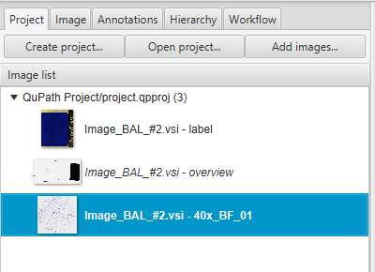
Figure 2. The project pane, showing which image series to open.
The slide is about 55,000 × 52,000 pixels at 0.137 µm per pixel, so a typical cell is roughly 58 pixels across. QuPath opens it as a pyramid, so zooming stays quick.

3. The dialog
Everything runs from one window: Automate → User scripts → qupath_bal_gui.
If the menu is empty, restart QuPath once — the scripts folder is linked in, and QuPath builds that menu at startup.
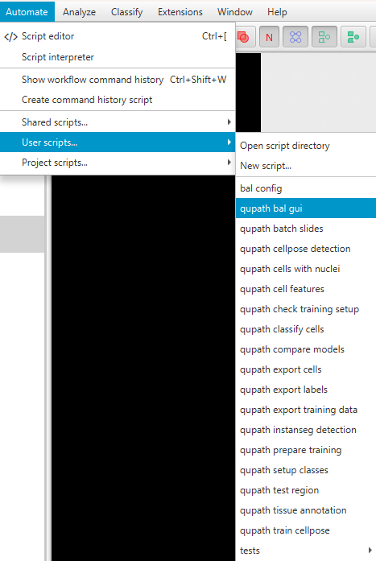 | 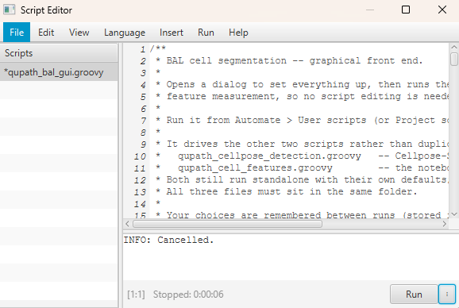

Figure 3. The Automate menu, showing User scripts → qupath_bal_gui.
The dialog has one Task dropdown at the top. Everything below it enables or disables itself according to the task you pick, and the grey text under each choice explains what it will do. Your settings are remembered between runs.

The eight tasks
Task | Use it when
Segment cells | You want cells found and measured in a region
Prepare training regions | You are about to correct outlines to improve the model
Export labelled cells | You have labelled cells and want to use them for training
Export corrections to training corpus | Adding this project's corrections to the shared pool
Train model on corrected regions | Fine-tuning Cellpose on your corrections
Classify cells: explore | You have cells but no labels yet, and want to see the types present
Classify cells: train classifier | You have labelled cells and want a cell-type classifier
Classify cells: predict | Applying a trained classifier to new cells

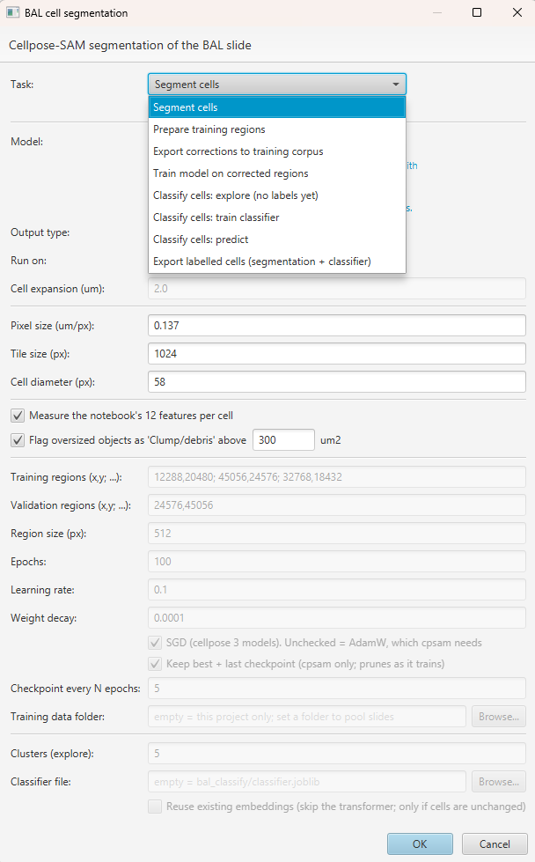
Figure 4. The BAL dialog with the Task dropdown open, showing all eight tasks.

4. Segmenting cells
1. Draw a rectangle over the area you want (the rectangle tool in the toolbar).
2. Make sure it is selected — it turns yellow.
3. Open the dialog, choose Segment cells, and press OK.
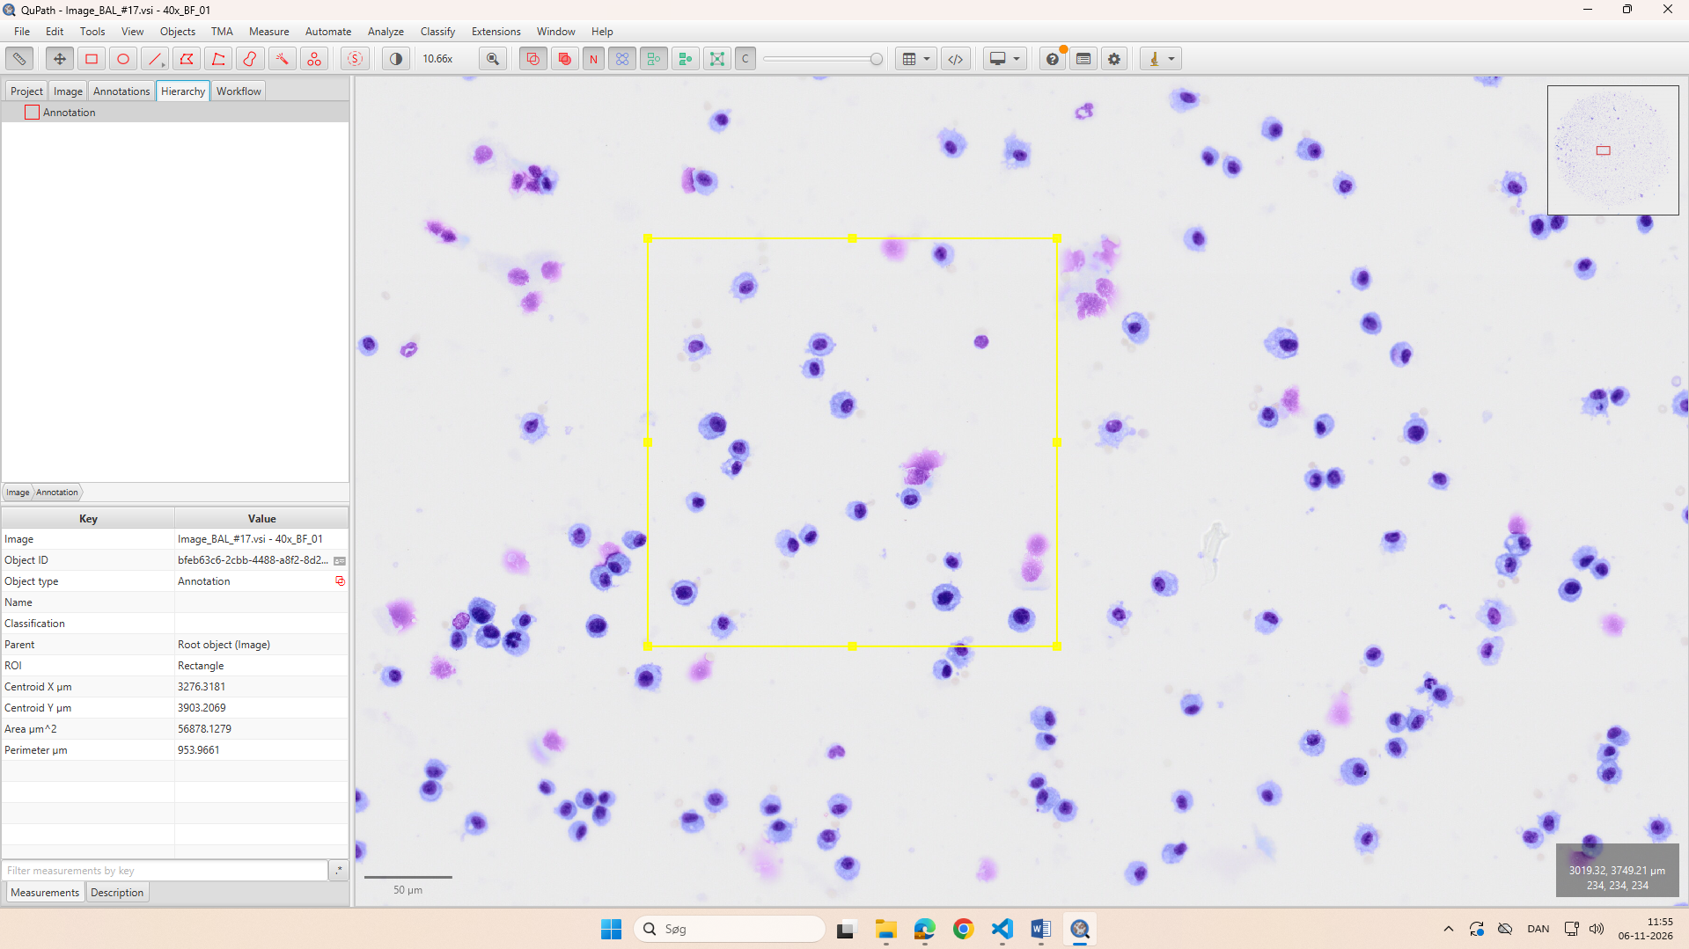
Figure 5. A rectangle drawn over a cell-rich area, selected and highlighted.

Which model to choose
The dropdown explains each one, but in short:
Model | What it gives you
cyto3 cells + InstanSeg nuclei (Experimental) | Cell outline and nucleus — needed for cell typing
Cellpose cyto3 | Cell outlines only;
Cellpose-SAM (cpsam) (best and should be used for fine-tuning) | Cell outlines only; best for fine tuning as it is parameter agnostic, i.e., it requires fewer optimizations of parameter specification per individual image.
InstanSeg brightfield | Nuclei only
Custom Cellpose model | runs a model you fine-tuned yourself (section 6).

A fifth entry, Custom Cellpose model…, runs a model you fine-tuned yourself (section 6). Picking it opens the file chooser straight away, so you can see which model you are about to run while the rest of the settings are still in front of you. Cancel the chooser and the dropdown goes back to the model you had. The Browse… button beside the dropdown changes the file later; it is enabled only for this entry.
Once a file is chosen, the grey text under the dropdown names it and says which cellpose version it will run in — taken from the filename, since a model whose name contains cpsam needs the cellpose 4 environment. The rest of the dialog then follows: cell diameter greys out for a cpsam fine-tune, and the training settings fill in that model's learning rate. Your choice is remembered between runs, so you are not asked again next time.

The settings
Only the settings this task uses stay enabled; the rest grey out when you pick Segment cells. The defaults are right for these slides, so the short answer is *change nothing*.
Setting | Default | What it does | When to change it
Output type | Detections | The kind of object created (see below) | Switch to Annotations when you want to edit outlines by hand
Run on | Selected objects only | Segment inside what you selected, or inside every annotation in the image | Use “All annotations” to do several regions in one go, unattended
Cell expansion (µm) | 2.0 | Only for Output type Cells: how far the outline grows outwards to form the cell boundary | Leave it; the default model does not use it
Pixel size (µm/px) | 0.137 | The resolution the model works at. Larger = coarser and faster | 0.274 halves the resolution and runs ~4× faster. Greyed out for InstanSeg, which fixes its own
Tile size (px) | 1024 | How the region is cut up for the GPU | Leave it. Throughput was flat across tile sizes, so this buys nothing
Cell diameter (px) | 58 | What cyto2/cyto3 expect a cell to measure; the image is rescaled by 30 ÷ diameter to match | Only if your cells really are a different size. 0 means “use the model's own value” — the right choice for a model you fine-tuned
Measure the notebook's 12 features | on | Adds all the per-cell measurements after segmentation | Turn off only if you want outlines and nothing else; the classifier needs these
Flag oversized objects as Clump/debris above … µm² | on, 300 | Classifies anything bigger as Clump/debris so you can exclude it | Raise it if genuine cells are being flagged. The largest genuine cell measured here was 263 µm²

Values are checked before anything runs, and a bad one stops the dialog with a message naming the fix. The ranges are: pixel size 0.001–10, tile size 64–4096, cell expansion 0–100, clump area 1–1,000,000.
Cell diameter is greyed out for cpsam and InstanSeg, and that is deliberate. cpsam is scale-free — cellpose 4 marks the setting deprecated and ignores it — and InstanSeg works at its own fixed resolution. The field is only live for cyto2, cyto3 and models fine-tuned from them.

Output type
Choice | What you get | Use it for
Detections (default) | Lightweight, read-only objects | Big runs, measurement export, the object classifier
Annotations | Editable objects — brush, wand and split all work on them | Checking and correcting outlines by hand. Slow once there are many thousands
Cells | Cell objects with an inner and an outer boundary | Nucleus-segmenting models only

Output type and Cell expansion do nothing with the default model. The paired cyto3 + InstanSeg mode builds its own cell objects — a real cell outline with a real nucleus inside it — so it overrides both settings. They apply to the single-model choices. On a whole-cell model such as cyto3 alone, Cells would put the whole cell in the nucleus slot and merely add a ring around it, which is rarely what you want.

What you get
Objects in the image, plus a line in the log for each stage. With the default model you get cell objects: an outer cell boundary with its nucleus inside, which is what section 7's classifier reads. Cells where no nucleus was found are kept as plain detections rather than discarded.
Each object carries 24 measurements:
Group | Measurements
Shape | area_um2, equiv_diameter_um, eccentricity, solidity, extent
Colour | mean_r, mean_g, mean_b, std_intensity, mean_hue, mean_sat
Nucleus estimate | nucleus_fraction — the dark share of the cell by thresholding; a rough stand-in when there is no real nucleus
With a paired nucleus | nc_ratio, nucleus_area_um2, nucleus_diameter_um, nucleus_solidity, nucleus_circularity, nucleus_eccentricity
Cytoplasm only | cyto_area_um2, cyto_mean_r, cyto_mean_g, cyto_mean_b, cyto_r_minus_g, cyto_std_intensity

The four that do most of the work when telling cell types apart:
- nc_ratio — nucleus area ÷ cell area. High (0.8+) for lymphocytes, low (0.3–0.5) for macrophages. The single most useful number. It is a true measured ratio, unlike nucleus_fraction.
- nucleus_circularity — low for the lobed nuclei of neutrophils and eosinophils.
- cyto_r_minus_g — eosin and granules in the cytoplasm, with the nucleus excluded. Measured as red minus green, because eosin renders magenta in MGG.
- equiv_diameter_um — cell size in micrometres.
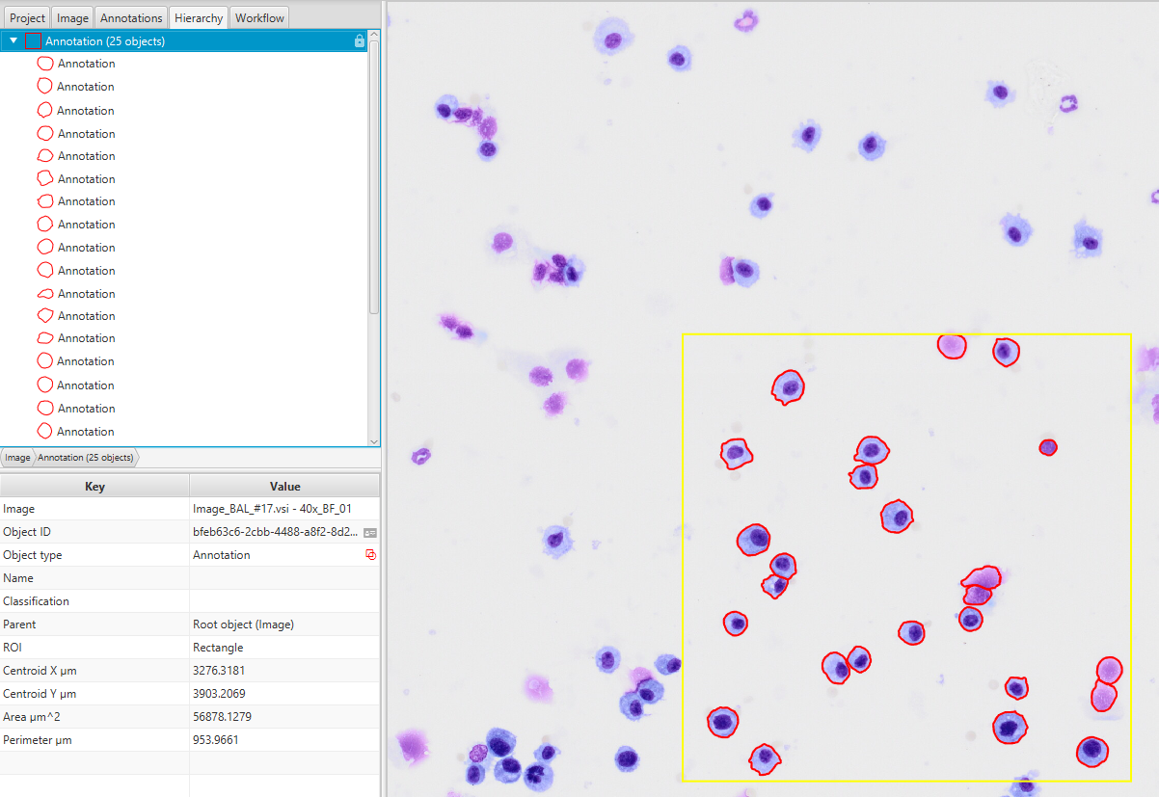
Figure 6. Segmented cells with outlines visible, and the measurement table below.

What the log tells you (diagnostics)
Worth reading rather than skipping:
- Training time
- Number of cells found
- Parameter settings used
- Nucleus and cells fractions (if model with nucleus segmentation used)
Step 1/3: cell outlines with cyto3... 63 cells
Step 2/3: nuclei with InstanSeg... 61 nuclei
Step 3/3: pairing...
58 cells paired with a nucleus
5 cells with no nucleus found (kept as plain detections)
2 cells held more than one nucleus -- the largest was used
Done: measured 63 cells in 4.2s
Flagged 1 object(s) as 'Clump/debris' (area > 300.0 um2)

A large “no nucleus found” count means the nuclei are being missed, and every one of those cells is left without nc_ratio or any nuclear shape — so the classifier has much less to go on. A large “fell outside every cell” count means the opposite: nuclei are being found where the cell model saw nothing.
Timing. About 3 seconds per 1024-pixel tile. A small region takes a few seconds; a whole slide at full resolution is roughly 2.4 hours. Read section 8 before starting anything that large.

5. Labelling cells by type
Labelling is how you teach both the segmentation model and the cell-type classifier. The same labels serve both.

Setting up the class list (once per project)
Run qupath_setup_classes from Automate → User scripts. It adds Macrophage, Lymphocyte, Neutrophil, Eosinophil, Epithelial, Clump/debris and Uncertain to the class list, in colours that stand out against the blue-violet stain.
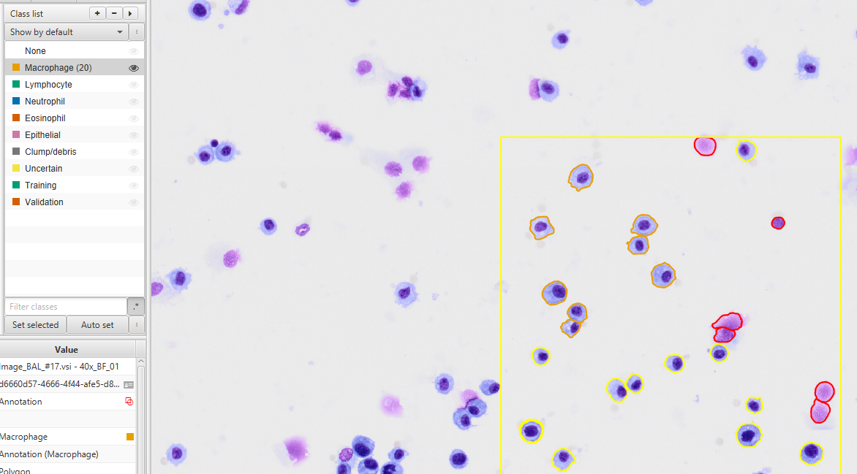
Figure 7. The Annotations tab with the BAL class list populated and colour-coded.

Labelling a cell
QuPath 0.7 has no “Set class” in the right-click menu. Instead:
1. Click a cell in the viewer to select it (Ctrl+click to add more).
2. In the Annotations tab, click the class you want in the list.
3. Right-click that class → “Set selected”.
The cell takes the class colour, so labelled cells are obvious as you work.
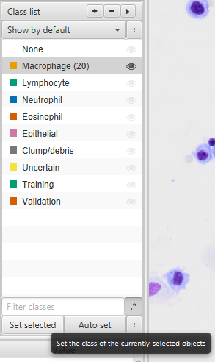
Figure 8. The class list with “Set selected” shown in the right-click menu.
If you cannot click cells, turn detections on: View → Show detections, or press D.

How to tell the types apart
Type | Size | Nucleus | Cytoplasm | The giveaway
Macrophage | 15–40 µm | round, off-centre | plentiful, grey-blue, often vacuoles | Biggest cell, lots of cytoplasm
Lymphocyte | 7–12 µm | round, dense, fills the cell | barely a rim | Small, almost all nucleus
Neutrophil | 10–14 µm | 2–5 lobes joined by strands | pale | The lobes
Eosinophil | 12–17 µm | two lobes | coarse granules | Two lobes plus granular cytoplasm
Epithelial | elongated | at one end | columnar, may show cilia | Not round
Clump/debris | varies | none distinct | none — uniform magenta | No pale rim at all

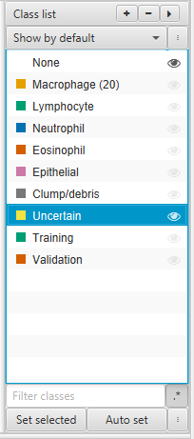
Figure 9. A gallery of example cells, one of each type, labelled.
Park anything you cannot confidently call as Uncertain rather than guessing. A wrong label does more damage than a missing one.

6. Improving the segmentation (fine-tuning)
Only worth doing if you can point at something the model gets wrong repeatedly — merged clumps, missed pale cells. If the outlines already look right, your effort is better spent on labelling for the classifier.
The loop is always the same four moves:
pick a region → predict the cells as annotations → correct them by hand → save them into the ground-truth folder. Repeat until the folder holds enough, then train on all of it at once.
Nothing is thrown away between rounds: the ground-truth folder accumulates, across regions and across slides, and every training run uses everything in it.

Step 1 — pick a region and class it
Draw a rectangle over an area worth teaching from, then class it (select it, then in the Annotations tab right-click the class → Set selected, as in section 5):
Class the rectangle | Where its data lands | What it is for
Training | <corpus>/train/ | What the model learns from
Validation | <corpus>/test/ | Scored but never trained on — how you know whether it worked

Make at least one of each. Without a Validation region you cannot tell whether training helped, only that it finished.
Choose regions that show the model failing — the clumps it merges, the pale cells it misses — plus some ordinary areas, so it does not forget the easy cases. About 512 px square is a good size: big enough to hold a few dozen cells, small enough to correct properly.
Many small regions beat one big one. Training draws one crop per image per epoch, so ten rectangles give ten times the training signal of one of the same total area.

Step 2 — predict the cells as annotations
Select the rectangle, open the dialog and run Segment cells with two settings that matter more here than anywhere else:
- Output type = Annotations. Only annotations can be edited with the brush, and the exporter reads annotations — detections are invisible to it. This is the single setting that makes the rest of the pipeline work.
- Model = a plain Cellpose model (Cellpose cyto3 or Cellpose-SAM).
Leave Run on at Selected objects only so it works inside your rectangle and nowhere else.
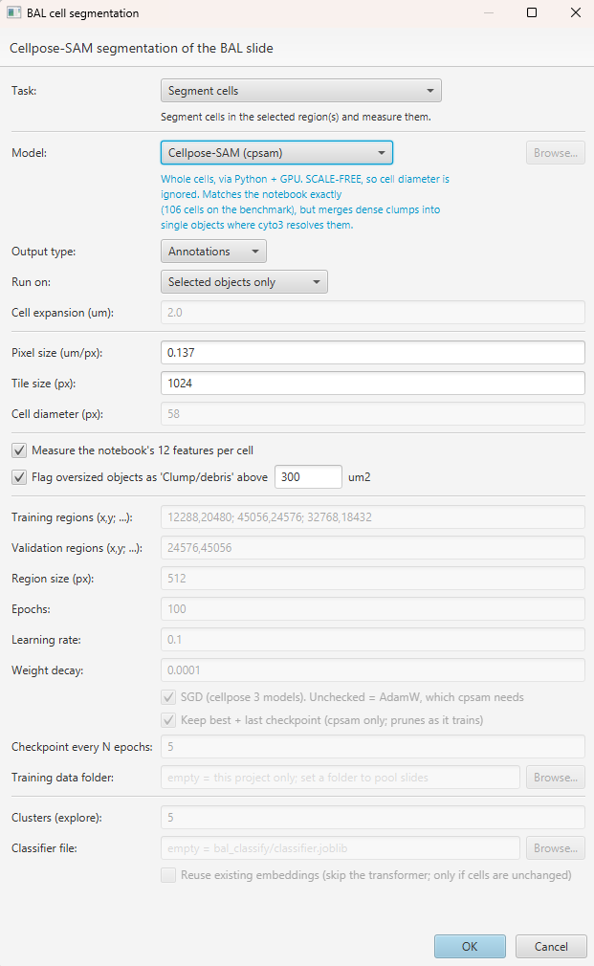
Figure 10. The dialog set to Segment cells, with Output type Annotations and a plain Cellpose model.

Step 3 — correct every outline
This is the part that decides whether training helps.
- Brush (B) and wand (W) to reshape an outline
- Delete outlines around things that are not cells
- Draw the cells the model missed entirely
Correct densely. Every cell inside the rectangle must end up outlined. A cell you leave out keeps its pixels in the image but not in the mask, so the model is taught that a cell there is background — a half-corrected rectangle teaches worse than no rectangle at all.
While you are here you can also class each cell by type (section 5). The same corrected cells then serve both jobs: their outlines train Cellpose, their classes train the cell-type classifier. Classifying a cell does not remove it from the segmentation masks.
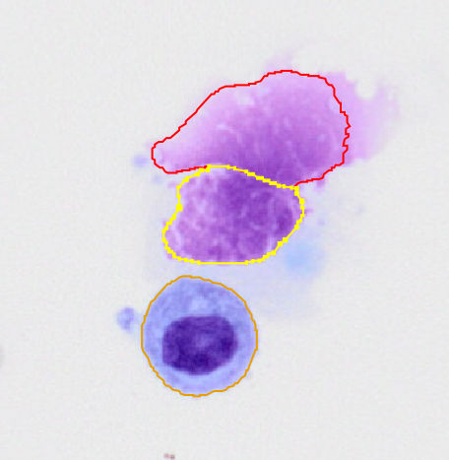 | 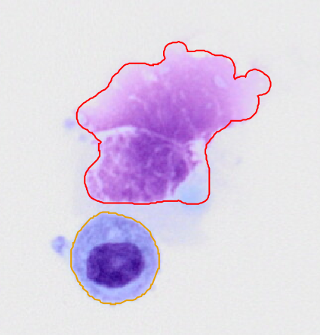

Figure 11. Before and after correcting outlines with the brush inside a training rectangle.

Step 4 — save them into the ground-truth folder
Press Ctrl+S first. Both the export and the training read the image's saved data, so unsaved corrections simply are not there — the symptom is “Found 0 Training objects”.
Then run Export labelled cells (segmentation + classifier) with Training data folder set to your corpus folder. For every Training/Validation rectangle in the image it writes:
<corpus>/train/<project>__<image>_region_1.tif the pixels
<corpus>/train/<project>__<image>_region_1_masks.tif one label per cell
<corpus>/test/... the same, for Validation
bal_classify/crops/<ClassName>/....png one crop per classified cell

The filenames carry the project and image, so regions from different slides never collide. The export adds to what is already there and never deletes, so repeat steps 1–4 on as many regions and slides as you like; the corpus just grows.
Run qupath_check_training_setup if anything looks wrong — it reports exactly what the trainer will see and catches the silent failures: a class spelled wrong, unsaved work, a region that is not a rectangle.
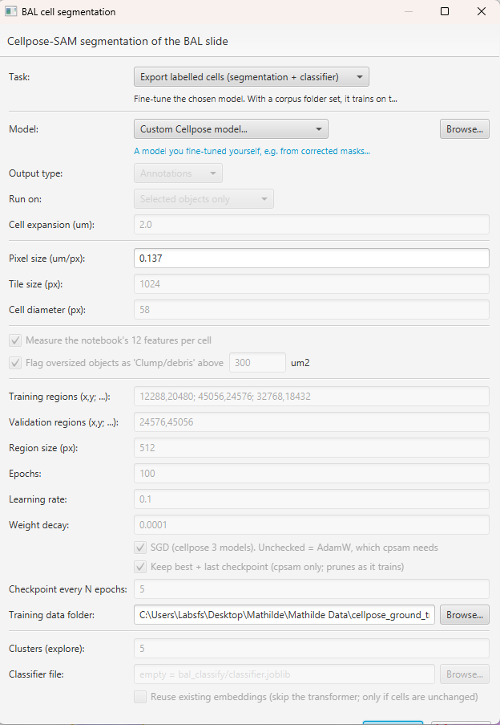
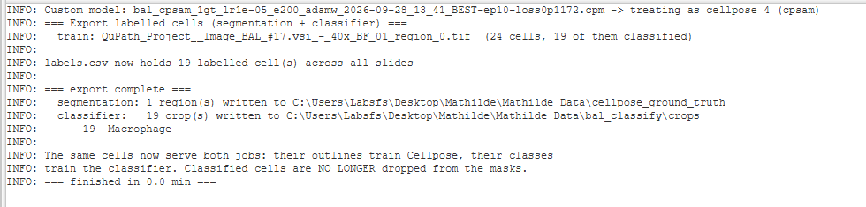

Figure 12. The Export labelled cells task with the ground-truth folder set, and the log listing the regions written.

Step 5 — train on everything banked so far
Run Train model on corrected regions with the same corpus folder and a plain Cellpose model. It trains on the pooled data from every slide in that folder, not just this image.
Training settings follow the model automatically: cyto3 trains at learning rate 0.1 with SGD, cpsam at 0.00001 with AdamW. Do not mix these — the dialog refuses combinations that would destroy the model. The finished model is saved into the project's models/ folder under a name recording what it came from.
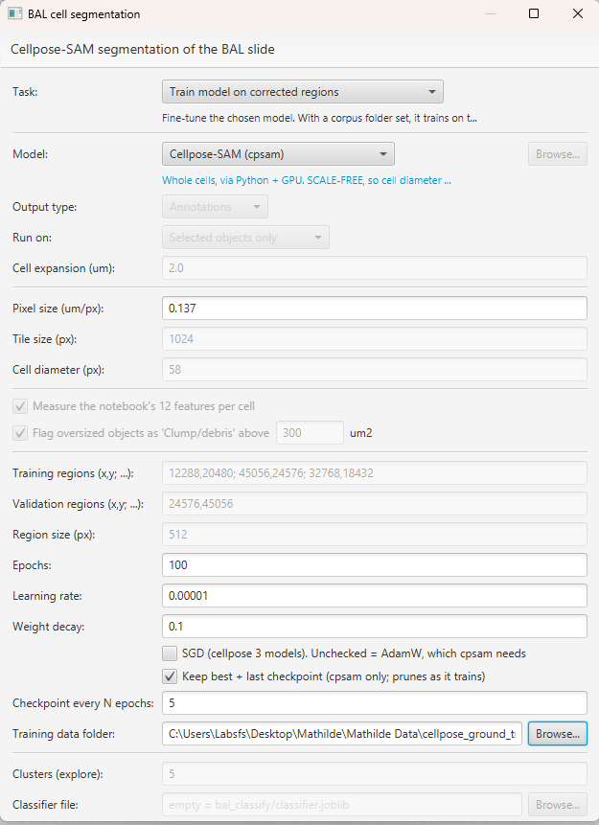
Figure 13. The dialog on the Train task, with the corpus folder and the training settings.

Step 6 — check it actually helped
When training finishes, the log reports where the validation loss bottomed and whether the saved model ended better than it started.
Always compare the new model against the stock one on a region you did not train on. A fine-tune that looks better is often just a diameter effect; if the new model matches stock at a matched diameter, it learned nothing.
To use the result, pick Custom Cellpose model… in the model list and choose the file (section 4) — then set Cell diameter to 0, so the model uses the size it learned.
How much ground truth? A few hundred corrected cells, spread over several regions and ideally several slides, before expecting a difference.
Shortcut for the first round. Prepare training regions does steps 1 and 2 in one go: give it region centres as x,y; x,y (read the coordinates off QuPath's status bar) and it places the Training/Validation rectangles and segments inside them as annotations, ready to correct.

7. Classifying cell types

If you have no labels yet
Run Classify cells: explore. It embeds every cell with a pathology vision transformer and groups them, writing bal_classify/clusters.png — each row shows the most typical cells of one group. Use it to see which types are on the slide before labelling anything.
[ paste screenshot here ]
Figure 14. clusters.png — the montage of cells grouped by cluster.

Training the classifier
1. Label 40–60 cells per type (section 5).
2. Run Classify cells: train classifier.
The log reports cross-validated scores. Read the per-class recall, not the accuracy. BAL is macrophage-dominant, so a model that never predicts “eosinophil” can still look 90% accurate while being useless for the rare types you care about.
[ paste screenshot here ]
Figure 15. The classification report in the log, with per-class precision and recall.

Applying it
Classify cells: predict applies a saved classifier to every cell and writes the classes back into QuPath, so you can see them in colour, correct the wrong ones, and retrain. Each round of corrections makes the next one better.
Predictions below 0.6 confidence are counted in the log — correcting those first is the quickest way to improve the model.
[ paste screenshot here ]
Figure 16. Cells coloured by predicted class in the viewer.

8. Processing many slides
qupath_batch_slides runs the whole pipeline over every image in the project, unattended.
Run it from the QuPath window (not the command line, where QuPath would start it once per image). It:
- skips the label and overview series automatically
- skips images already processed, so an interrupted run can simply be restarted
- keeps going if one slide fails
- saves each image as it finishes
- writes batch_summary.csv next to the project
[ paste screenshot here ]
Figure 17. batch_summary.csv open in Excel, showing cells per slide.
Plan the time. Roughly 2.4 hours per slide at full resolution — about four days for 39 slides. Before committing to that, either segment only tissue regions, or try half resolution (pixel size 0.274), which is four times faster and gave the same cell counts in testing. Run two or three slides first and check the results are what you want.

9. Reading the results
In QuPath: Measure → Show detection measurements for the table; Measure → Show measurement maps to colour cells by any single measurement. Colouring by nc_ratio makes the lymphocyte/macrophage split visible at a glance.
[ paste screenshot here ]
Figure 18. The measurement map coloured by nc_ratio.
Outside QuPath: batch_summary.csv holds per-slide counts; bal_classify/predictions.csv holds each cell's predicted type and confidence.

Two things to know before reporting numbers
- Cells at the edge of a region are counted whole but measured partially. On a small region that is about 11% of cells; on a large one it is negligible.
- Objects over 300 µm² are flagged Clump/debris. The largest genuine cell measured here was 263 µm². Keep them out of differential counts, or re-segment them.

10. When something goes wrong
What you see | What it means
“Found 0 Training objects” | The project is not saved. Press Ctrl+S and run again.
Masks look completely black | They are fine. Masks store cell numbers (1, 2, 3…), which look black. In Fiji use Image → Adjust → Brightness/Contrast → Auto.
The User scripts menu is empty | Restart QuPath; the menu is built at startup.
“No cells found” | Segment a region first, and check View → Show detections.
Training loss goes up | Learning rate too high for that model, or too little ground truth. Check that the model and its settings match (section 6, step 4).
A fine-tuned model behaves oddly | Set the cell diameter to 0 — a fine-tuned model stores its own, and overriding it undoes part of the training.
Classes do not appear in the list | Run qupath_setup_classes, then reopen the project.

[ paste screenshot here ]
Figure 19. The QuPath log window, where all script messages appear.
The log is where every script reports what it did. If something looks wrong, read it from the top — the scripts are written to say what happened, what it means, and what to do next.

