Module 08939: Advanced Graphics

Cubic Splines

Simon Hartley

Summary
The aim of this assessment was to produce a program to generate and display cubic splines. The program was tested by fitting a cubic spline to a cubic function, and comparing the results of the cubic spline with those of the cubic function. The program’s user interface allows data points to be inserted, deleted and moved. Data points can be read from and written to text files, and several pre-defined curves are provided. Cubic splines of one, two or three functions can be displayed. Cubic splines of more than one function are displayed both independently, and as curves in a two or three dimensional coordinate system. Three dimensional curves can be rotated and projected.

Appendix 1: Absolute Errors

The cubic function defined by
y = (((((a * x) + b) * x) + c) * x) + d
was evaluated with coefficients
a = 0.5
b = -0.25
c = 0.5
d = 0.25
for 5 values of x
x[0] = -1
x[1] = -0.7
x[2] = -0.3
x[3] = 0.2
x[4] = 1
to produce 5 values of y
y[0] = -1
y[1] = -0.394
y[2] = 0.064
y[3] = 0.344
y[4] = 1

The spline function generated from 5 data points and defined by
y = a0 * y0 + a1 * y1 + h * b0 * s0 + h * b1 * s1
was evaluated at its midpoints
y = 0.5 * y0 + 0.5 * y1 + 0.125 * h * s0 - 0.125 * h * s1
dy/dx = (-1.5 * y0 + 1.5 * y1 - 0.25 * h * s0 - 0.25 * h * s1) / h
d2y/dx2 = (0.0 * y0 + 0.0 * y1 - 1.0 * h * s0 + 1.0 * h * s1) / (h * h)

The values of the cubic and the spline were compared
x = -0.85 cubic = -0.662687 spline = -0.662687 error = 0
x = -0.5 cubic = -0.125 spline = -0.125 error = -2.77556e-017
x = -0.05 cubic = 0.224313 spline = 0.224312 error = 2.77556e-017
x = 0.6 cubic = 0.568 spline = 0.568 error = 1.11022e-016
to find the maximum absolute error of 1.11022e-016

The first derivatives of the cubic and the spline were compared
x = -0.85 cubic = 2.00875 spline = 2.00875 error = -4.44089e-016
x = -0.5 cubic = 1.125 spline = 1.125 error = 2.22045e-016
x = -0.05 cubic = 0.52875 spline = 0.52875 error = -1.11022e-016
x = 0.6 cubic = 0.74 spline = 0.74 error = 1.11022e-016
to find the maximum absolute error of 4.44089e-016

The second derivatives of the cubic and the spline were compared
x = -0.85 cubic = -3.05 spline = -3.05 error = 1.33227e-015
x = -0.5 cubic = -2 spline = -2 error = -8.88178e-016
x = -0.05 cubic = -0.65 spline = -0.65 error = 0
x = 0.6 cubic = 1.3 spline = 1.3 error = -4.44089e-016
to find the maximum absolute error of 1.33227e-015

Appendix 2: Sample Curves

Figure 1:
A plot of the cubic spline fitted to the cubic function, showing the data points.
y = at³ + bt² + ct + d
for a = 0.5, b = -0.25, c = 0.5, d = 0.25
for t = -1.0, -0.7, -0.3, 0.2, 1.0

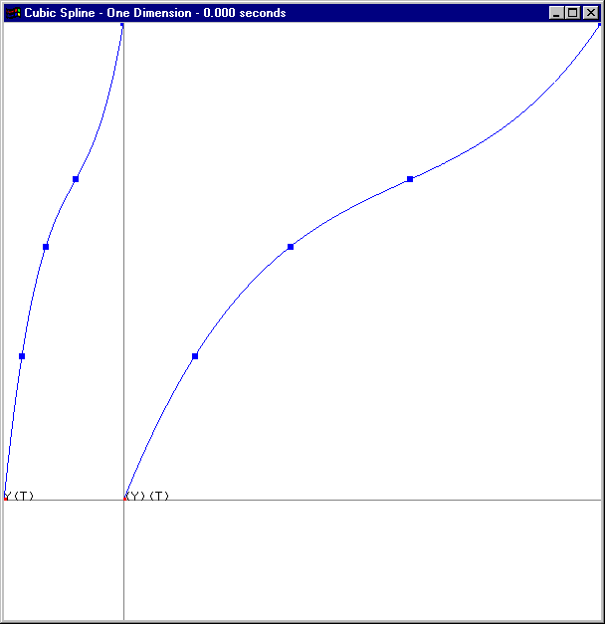

Figure 2:
A plot of the cubic spline fitted to the circular function, showing the data points, and the animation point.
x = a.cos(π.t)
y = a.sin(π.t)
for a = 0.5
for t = -1.0 … 1.0 in 8 steps

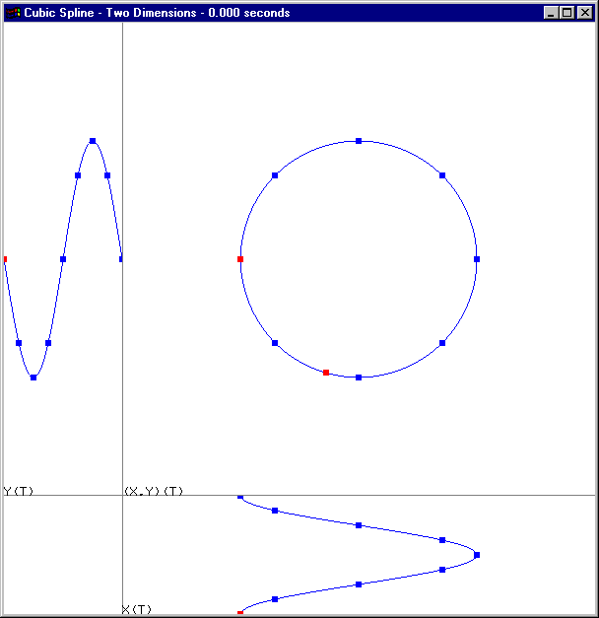

Figure 3:
A plot of the cubic spline fitted to the spherical function, showing the data points.
x = a.cos(0.5.π.t).cos(c.π.t)
y = a.cos(0.5.π.t).sin(c.π.t)
z = b.sin(0.5.π.t)
for a = 0.5, b = 0.5, c = 7.0
for t = -1.0 ... 1.0 in 60 steps

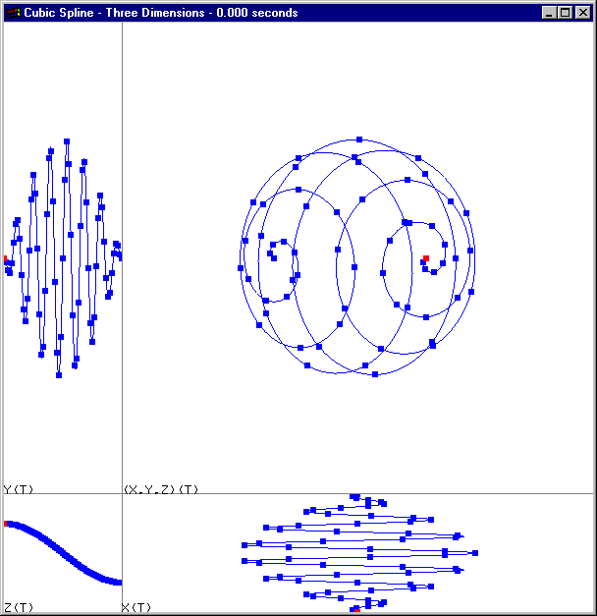

Figure 4:
A plot of the cubic spline fitted to the conical helix function.
x = (a+b.t).cos(c.π.t)
y = (a+b.t).sin(c.π.t)
z = d.t
for a = 0.5, b = 0.2, c = 3.0, d = 0.5
for t = -1.0 ... 1.0 in 30 steps

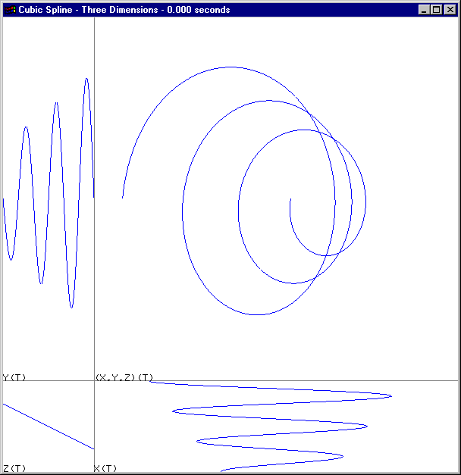

Appendix 3: User Guide
The program is run from the command line as “CubicSpline.exe”. The following menu, which details the use of the mouse and keyboard, is displayed in the console window.

Escape | Exit Program
F1 | Select Dimensions
F2 | Select Test
F3 | Select Spiral
F4 | Select Clover
F5 | Select Circle
F6 | Select Helix
F7 | Select Torus
F8 | Select Sphere
F9 | Change Position with Mouse
F10 | Change Time with Mouse
F11 | Change Second Derivative with Mouse
1 | Select Markers
2 | Play or Stop Animation
3 | Play or Stop Spin
4 | Play or Pause Spin
5 | Select Spin Axis
6 | Read Files
7 | Write Files
Enter | Clear Points
Insert | Insert Point
Delete | Delete Point
Left or Down | Select Previous Point
Right or Up | Select Next Point
Home | Select First Point
End | Select Last Point
Left Mouse Button | Change X and Y Coordinates
Right Mouse Button | Change Z Coordinate

