Design:

3-tier:

Waiting for connection

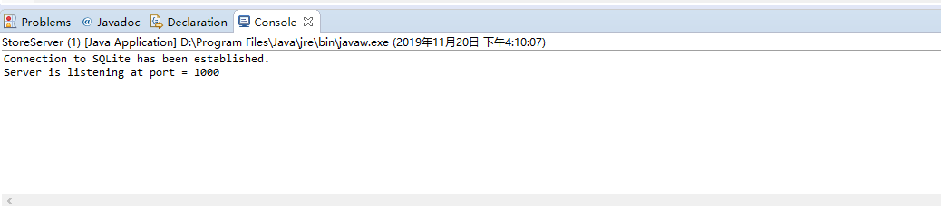

User interface:

MainView class,

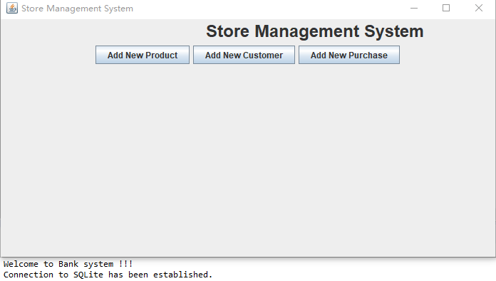

AddProduct class

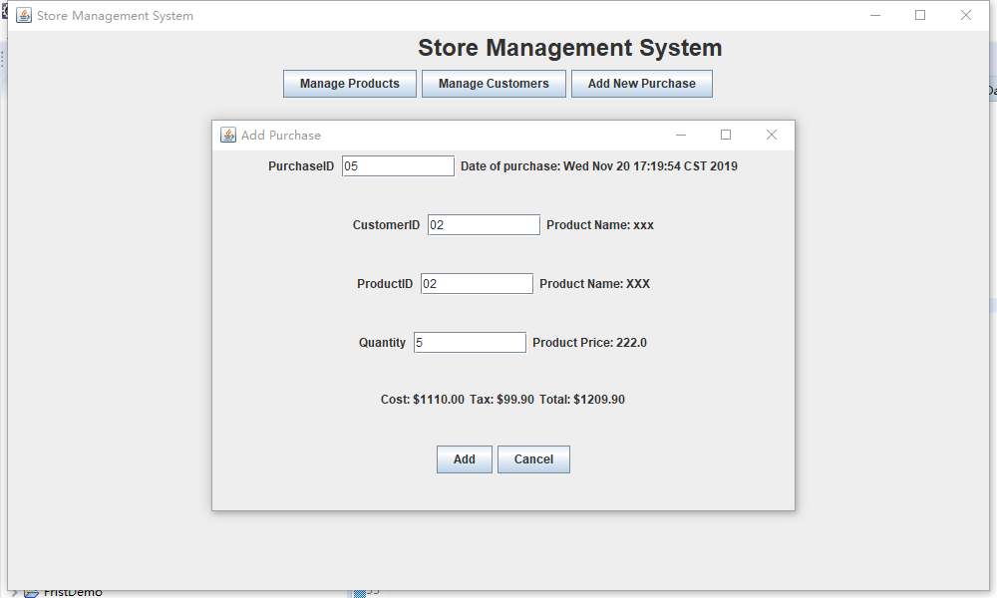

Business Logic

ProductModel class: store information of a product

AddProductController: process events of AddProductView

StoreManager: main application object

Data Access

SQLiteDataAdapter class: read/write data

Add Customer class

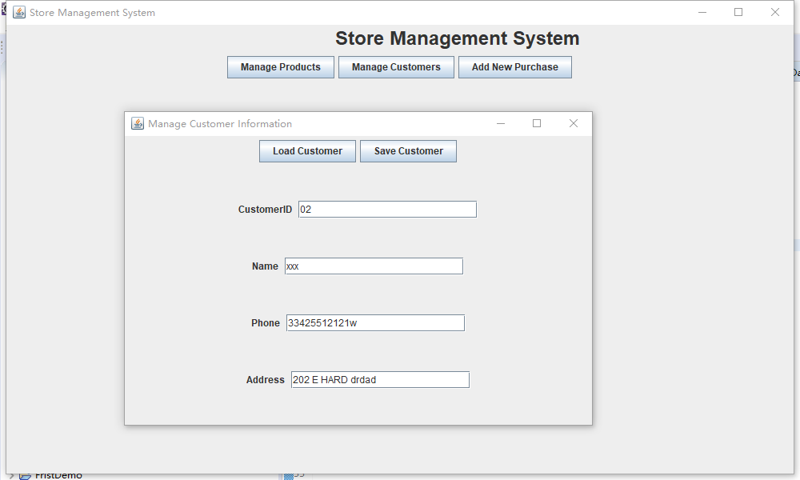

Business Logic

Customer Model class: store information of a Customer

AddCustomerController: process events of AddCustomerView

StoreManager: main application object

Data Access

SQLiteDataAdapter class: read/write data

Add Purchase class

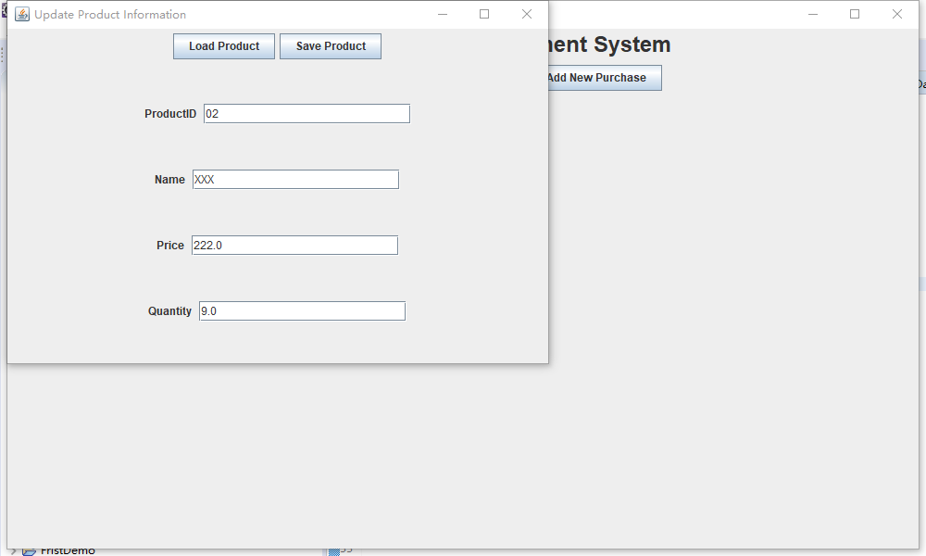

Business Logic

Purchase Model class: store information of a Purchase

AddPurchaseController: process events of AddPurchaseView

StoreManager: main application object

Data Access

SQLiteDataAdapter class: read/write data

Tasks:

1. Write a common use case for each user story. Sketch the screens the system should display in each use case.

|  |  |
| --- | --- |
| Actor | System |
| 1. Choose command “Add Product”   Main screen: | 1. Display “Add Product” screen”   “Add Product” screen |
| 1. Input data then click “Add” button   “Add Product” screen with data: | 1. Hide “Add Product” screen and display “Add Product successfully” screen:   “Add Product successfully” screen: |
| 1. If you Add the invalid value, system will report the error   “Error report” screen | 1. Click on “OK” button |
| 1. Display “Main” screen   Choose command “Add Customer” | 1. Display “Add Customer” screen |
| 1. Input data then click “Add” button   “Add Customer” screen with data: | 1. If you Add the invalid value, system will report the error   “Error report” screen” |
| 1. Hide “Add Customer” screen and display “Add Customer successfully” screen:   “Add Product successfully” screen: | 11.click on “OK” button |
| 1. Display “Main” screen   Choose command “Add Purchase” | 1. Display “Add Purchase” screen”   “Add Purchase” screen |
| 1. Input data then click “Add” button   “Add Purchase” screen with data: | 1. Hide “Add Purchase”” screen and display “Add Purchase successfully” screen:   “Add Purchase successfully” screen: |
| 1. If you Add the invalid value, system will report the error   “Error report” screen” | 1. Click on “OK” button |
| 1. Display “Main” screen |

1. Draw the entity-relationship diagram for this system. We assume the minimal requirement with two entities: products and customers, and one relationship "a customer purchases a product".

purchase

record

Products

buy

Customers

1. Design the database logically, i.e., write the relations, attributes, and define keys.

Entity

Products(productid, Barcode, name, expiration date, price, tax rate, quantity, supplier, manufactured date)

Customers(customerid, name, address, phone, payment info)

Purchase(purchaseid, customerid, date time, quantity, price, tax, total cost)

Relationship:

Buy(productid, customerid, price, expiration date, payment info)

Record(productid, purchaseid, date time, tax, total cost)

1. Design the database physically using SQL, i.e., write SQL code to create the tables for those relations.

CREATE TABLE "Purchase" (

"PurchaseID" INTEGER NOT NULL,

"CustomerID" INTEGER,

"Date_Time" TEXT,

"Quantity" REAL,

"Price" REAL,

"Tax" REAL,

"Total_Cost" REAL,

PRIMARY KEY("PurchaseID")

)

CREATE TABLE "Customers" (

"CustomerID" INTEGER NOT NULL,

"Name" TEXT,

"Address" TEXT,

"Phone" INTEGER,

"payment_info" TEXT,

PRIMARY KEY("CustomerID")

)

CREATE TABLE "Products" (

"ProductID" INTEGER,

"Barcode" TEXT,

"Name" TEXT,

"Expiration_Date" TEXT,

"Price" REAL,

"Tax_Rate" REAL,

"Quantity" REAL,

"Supplier" TEXT,

"Manufactured_Date" TEXT

)

CREATE TABLE "Buy" (

"Productid" INTEGER NOT NULL,

"Customerid" INTEGER,

"Price" REAL,

"Expiration_Date" TEXT,

"payment_info" TEXT,

PRIMARY KEY("Productid")

)

CREATE TABLE "Record" (

"ProductID" INTEGER NOT NULL,

"PurchaseID" INTEGER,

"Date_Time" TEXT,

"Tax" REAL,

"Total_Cost" REAL,

PRIMARY KEY("ProductID")

)

1. Insert data into the tables, with at least 5 products, 5 customers, and 10 purchases.

INSERT INTO Purchase

VALUES

(001, 00001, 'May 1', 1, 8888.8, 0.1, 9999.9),

(002, 00002, 'May 2', 9, 8888.8, 0.1, 99999.9),

(003, 00003, 'May 3', 2, 8888.8, 0.1, 19999.9),

(004, 00004, 'May 4', 5, 8888.8, 0.1, 49999.9),

(005, 00005, 'May 5', 1, 8888.8, 0.1, 9999.9),

(006, 00006, 'May 6', 2, 8888.8, 0.1, 19999.9),

(007, 00007, 'May 21', 1, 7777.7, 0.1, 8888.8),

(008, 00008, 'May 23', 2, 8888.8, 0.1, 19999.9),

(009, 00009, 'May 12', 5, 8888.8, 0.1, 49999.9),

(010, 00010, 'May 7', 3, 8888.8, 0.1, 29999.9);

INSERT INTO Products

VALUES

(001, 23124125415, 'XIAO A', 'May 1', 8888.81, 0.1, 1, NULL, 'May 11'),

(002, 23124121231, 'XIAO A', 'May 2', 8888.81, 0.1, 9, NULL, 'May 12'),

(003, 23124122342, 'XIAO A', 'May 3', 8888.81, 0.1, 19, NULL, 'May 1'),

(004, 23124123241, 'XIAO A', 'May 4', 8888.81, 0.1, 41, NULL, 'May 5'),

(005, 23124165431, 'XIAO A', 'May 5', 8888.81, 0.1, 76, NULL, 'May 1'),

(006, 23124125345, 'XIAO A', 'May 6', 8888.81, 0.1, 21, NULL, 'May 1');

INSERT INTO Customers

VALUES

(001, 23124125415, 'XIAO A', 'May 1', 8888.81, 0.1, 1, NULL, 'May 11'),

(002, 23124121231, 'XIAO A', 'May 2', 8888.81, 0.1, 9, NULL, 'May 12'),

(003, 23124122342, 'XIAO A', 'May 3', 8888.81, 0.1, 19, NULL, 'May 1'),

(004, 23124123241, 'XIAO A', 'May 4', 8888.81, 0.1, 41, NULL, 'May 5'),

(005, 23124165431, 'XIAO A', 'May 5', 8888.81, 0.1, 76, NULL, 'May 1'),

(006, 23124125345, 'XIAO A', 'May 6', 8888.81, 0.1, 21, NULL, 'May 1');

Products(productid, Barcode, name, expiration date, price, tax rate, quantity, supplier, manufactured date)

Customers(customerid, name, address, phone, payment info)

Purchase(purchaseid, customerid, date time, quantity, price, tax, total cost)

Buy(productid, customerid, price, expiration date, payment info)

Record(productid, purchaseid, date time, tax, total cost)

INSERT INTO Record

VALUES

(001, 001, 'May 1', 0.1, 9999.9),

(002, 002, 'May 2', 0.1, 99999.9),

(003, 003, 'May 3', 0.1, 19999.9),

(004, 004, 'May 4', 0.1, 49999.9),

(005, 005, 'May 5', 0.1, 9999.9),

(006, 006, 'May 6', 0.1, 19999.9);

INSERT INTO Buy

VALUES

(001, 001, 8888.81, 'May 1', NULL),

(002, 002, 8888.81, 'May 2', NULL),

(003, 003, 8888.81, 'May 3', NULL),

(004, 004, 8888.81, 'May 4', NULL),

(005, 005, 8888.81, 'May 5', NULL),

(006, 006, 8888.81, 'May 6', NULL);