1)
a)
So stack protector is a mechanism in the gcc compiler to prevent stack based buffer overflows from happening. This can cause an error when we attempt to force a buffer overflow as such :

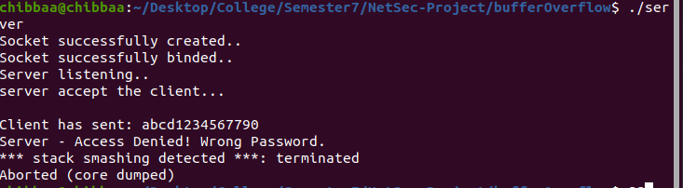
To prevent this from happening, we use the command -fno-stack-protector to disable this mechanism.

b)

