**A TECHNICAL REPORT ON STUDENTS INDUSTRIAL WORK**

**EXPERIENCE SCHEME (SIWES)**

***AT***

**MCLORDS MOBILE SOLUTION LIMITED ADJASCENT RADIO KWARA,**

**GRA, ILORIN, KWARA STATE.**

**PERIOD OF ATTACHMENT: MARCH 2020 – SEPTEMBER 2020**

**BY**

**OLAIFA OLUWASIJIBOMI IBUKUNOLU**

**17/52HA082**

**A REPORT SUBMITTED TO THE DEPERTMENT OF COMPUTER SCIENCE, UNIVERSITY OF ILORIN. KWARA STATE NIGERIA.**

**IN PARTIAL FULFILLMENT OF THE COMPULSORY REQUIREMENT FOR THE AWARD OF B.Sc. IN COMPUTER SCIENCE**

**REPORT OVERVIEW**

This report gives detailed description of the Students Industrial Work Experience Scheme (SIWES), which commenced on the 20th of May 2018, attended on the 3rd of November 2018**McLords MOBILE SOLUTION LIMITED ADJASCENT RADIO KWARA,GRA, ILORIN, KWARA STATE**. The company description is included which comprises various departments of the Establishment with their functions. Also compiled in this report the department where I served at **McLords MOBILE SOLUTION LIMITED**. The SIWES programme has provided a training ground where skills relating to computer operations that is it has provided me knowledge on Computer Engineering. And also provide me with more ideas on the usage of Computer System. This has gone a long way in equipping me in merging what was being taught in the lecture room to what was actually learnt during the SIWES programme.

Table of Contents

CHAPTER ONE 5

INTRODUCTION 5

CHAPTER TWO 7

2.0 DESCRIPTION OF ESTABLISHMENT OF ATTACHMENT 7

2.1 VISION OF THE COMPANY 7

2.2 CORE VALUE 7

2.3 ORGANIZATIONAL STRUCTURE 8

2.4 COMPANY AREA OF SPECIALIZATION 9

CHAPTER THREE ……………………………………………………………………………………………………………………………………..9

3.0 Introduction…………………………………………………………………………………………………………………………………..9

3.1 Weekly Summary ………………………………………………………………………………………………………………………….9

CHAPTER FOUR 24

4.0 INDUSTRIAL EXPERIENCE 24

4.1HYPER TEXT MARKUP LANGUAGE (HTML) 24

4.2CASCADING STYLE SHEETS (CSS) 25

4.3 BOOTSTRAP 26

4.4 JAVASCRIPT 27

4.5 PHP 27

4.6 CAR REGISTRATION SYSTEM 29

Fig 4.6.1 Interface Of Car Registration Page 29

Fig 4.6.2 Database of Car Registration System 30

Fig 4.6.3 Display of Registered User Information 30

Fig 4.6.4 Display of Print Page 31

4.7 31

CHAPTER FIVE 32

CHALLENGES AND RECOMMENDATION 32

5.1 CONCLUSION 32

5.2 CHALLENGES 32

5.3 RECOMMENDATIONS 32

# CHAPTER ONE

## INTRODUCTION

In the earlier stage of science and technology education in Nigeria, students wee graduating from their respective institution without any technical knowledge or working experience. It was in this view that students undergoing science and technology related courses were mandated for students in different institution in the view of widening their horizons so as to enable them have technical knowledge or working experience before graduating from their various institutions.

The Student Industrial Work Experience Scheme (SIWES) was established by the industrial Training Fund (ITF) 1973 to enable students of tertiary institution have basic technical knowledge of industrial works base on their course of study before the completion of their program in their respective institutions. It was established to solve the problem of lack of adequate practical skills preparatory for employment in industries by Nigeria graduates of tertiary institutions.

The scheme exposes students to industry based skills necessary for a smooth transition from classroom to the world of work. It affords students of tertiary institutions the opportunity of being familiarized and exposed to the needed experience in handling machinery and equipment which are usually not available in the educational institutions.

One of the primary goals of the SIWES is to help students integrate leadership development into experiential learning process. Students are expected to learn and develop basic non-profit leadership skills through a mentoring relationship with innovative non-profit leaders.

The major benefits accruing to students who participate conscientiously in Students Industrial Work Experience Scheme (SIWES) are the skills and competencies they acquire. The relevant production skills remain a part of the recipients of industrial training as life-long assets which cannot be taken away from them. This is because the knowledge and skills acquired through training area internalized and become relevant when required to perform jobs or functions.

Participation in SIWES has become a necessary pre-condition for the award of Diploma and Degree certificates in specific disciplines in most institutions of higher learning in the country, in accordance with the education policy of government.

Operators – The ITF, the coordinating agencies (NUC, NCCE, NBTE). Employers of labour and the institutions Funding – The Federal Government of Nigeria.

**1.1 OBJECTIVES**

The Industrial Training Fund’s policy Document No.1 of 1973 which established SIWES outlined the objectives of the scheme. The objectives are as follows:

* Prepare students for industrial work situations that they are likely to meet after graduation.
* Provide an avenue for students in higher institutions of higher learning to acquire industrial skills and experiences during their course of study.
* Expose students to industrial work methods and techniques in handling equipment and machinery that may not be available in their institutions.
* Make the transition from school to the world of work easier and enhance students contact for later job placements.
* Provide students with the opportunities to apply their educational knowledge in real work situations, thereby bridging the gap between theory and practice.
* Enlist and strengthen employers’ involvement in the entire educational process through SIWES
* To expose students to latest developments and technological innovations in their chosen professions.

# CHAPTER TWO

## 2.0 DESCRIPTION OF ESTABLISHMENT OF ATTACHMENT

McLords Mobile Solution Limited has history of creativity and innovation in the simulation of clients. Since inception, they have remained focus on delivery quality I.T solution and training to their clients. Year after years, McLords Mobile Solution Limited has refined her quality process, focusing on course development, instructor training and facility expansion. This is to ensure the training investment will produce the desire results.

## 2.1 VISION OF THE COMPANY

They have turned out quite an impressive number of students performing well both in Government and private establishments within and outside the country. They tailor their training program to meet the needs of individual clients according to their professional background, Tier track record can speak for them. McLords Mobile Solution Limited is an ICT firm registered in Nigeria to provide ICT related Services.

McLords Mobile Solution Limited was registered by corporate affairs commission in 2009. The company has its head office at Georgia in USA, one branch at Ikeja, Lagos State and another branch at GRA in Ilorin.

The company has implemented several project that covers.

* Banking Application for micro-finance bank.
* Payroll for government parastatals.
* They also provide solution for event ticketing, transportation, restaurant, hotels etc

## 2.2 CORE VALUE

The strength of our company lies in our Human Resources which are continually rejuvenated by bringing in more hands which can make us live up to our name by being the foremost software development company in Nigeria. Leveraging current technology to provide simple solution to complex processes.

## 2.3 ORGANIZATIONAL STRUCTURE

MANAGING DIR.

DIRECTOR I.T PROJECT

INSTRUCTOR P.M

INSTRUCTOR ON SIWES ASPECT

SECRETARY

WEB DEVELOPMENT

COMPUTER HARDWARE

SOFTWARE DEV.

DATA MINING

## 2.4 COMPANY AREA OF SPECIALIZATION

There are various Departments/Units namely;

1. **ENGINEERING DEPARTMENT**

The computer engineering department deals with the maintenance, repair and upgrading of computer system.

1. **SOFTWARE DEVELOPMENT DEPARTMENT**

Software Development Department deals with computer programming, documenting, testing, and dug fixing involved in creating and maintaining application and frame work resulting in a software product.

1. **DATA MINING DEPARTMENT**

This department deals with computing process of discovering patterns in large data sets involving methods at the intersecting of machine learning, statistics, and database system. However the overall goal of the data mining process is to extract information from a data set and transform it into an understandable structure for further use.

1. **WEB DEVELOPMENT DEPARTMENT**

These department deals with designing a website for the internet (World Wide Web) or an intranet (a private network). Web development can range from developing the simplest static single page of plain text to the most complex web-based internet application (or just ‘web apps”) electronic businesses and social network service.

**CHAPTER THREE**

|  |  |
| --- | --- |
| DAY  &  DATE | DESCRIPTION OF WORKDONE |
| MONDAY  16/03/2020 | Introduction to the company,rules and regulation of the company.I was grouped with the other interns to work on MS.WORD,MS EXCEL , MS POWERPOINT and MS ACCESS. |
| TUESDAY  17/03/2020 | I and other interns decided to work on the Microsoft office packages.We were grouped to do this. |
| WEDNESDAY  18/03/2020 | I and other interns finished working on Microsoft offices packages.We had General sanitation. |
| THURSDAY  19/03/2020 | Myself and my group members did a presentation on Microsoft offices packages. |
| FRIDAY  20/03/2020 | I made a presentation on Microsoft powerpoint on how to use it,the advantages behind it.I made use of Powerpoint to display the work I did on MS WORD , MS ACCESS. |

WEEK NO 1

WEEK ENDING Friday

**Summary**:This week I was introduced to the company staffs and I was given a task to make use of Microsoft offices.

WEEK NO 2

WEEK ENDING Friday

|  |  |
| --- | --- |
| DAY  &  DATE | DESCRIPTION OF WORKDONE |
| MONDAY  23/03/2020 | I was introduced to web development and categories under web development.I was given a project to differentiate between web development and web design. |
| TUESDAY  24/03/2020 | I and other interns started working on HTML5 and we were given some tasks to do. |
| WEDNESDAY  25/03/2020 | We continued to work on some couple of HTML5 tags.I created a simple form using HTML5.I and other interns also carried out sanitation which is observed every Wednesday. |
| THURSDAY  26/03/2020 | LOCKDOWN DUE TO COVID 19. |
| FRIDAY  27/03/2020 | LOCKDOWN DUE TO COVID 19. |

**Summary**: I was able to start web development and have basic knowledge of HTML5 tags and how they work.

WEEK NO 3

WEEK ENDING Friday

|  |  |
| --- | --- |
| DAY  &  DATE | DESCRIPTION OF WORKDONE |
| MONDAY  30/03/2020 | I started working remotely from home and my supervisor announced that we would be having a presentation at the end of the week. |
| TUESDAY  31/03/2020 | I started to work with the layout in which I will use for my HTML5 and CSS3 to implement the layout |
| WEDNESDAY  01/04/2020 | I continued with my project and I started to design my page with CSS3. |
| THURSDAY  02/04/2020 | I completed my design and I prepared for my presentation which will hold on Friday. |
| FRIDAY  03/04/2020 | I presented my project online. |

**Summary**:I was able to make my first project this week and present the project online.

WEEK NO 4

WEEK ENDING Friday

|  |  |
| --- | --- |
| DAY  &  DATE | DESCRIPTION OF WORKDONE |
| MONDAY  06/04/2020 | I started learning CSS3,I learnt about inline and external CSS styling. |
| TUESDAY  07/04/2020 | I learnt the usefulness of opacity,border and how to create and how to create a navigation bar using CSS3.I also learnt about the hover effect on navigation bar. |
| WEDNESDAY  08/04/2020 | I learnt about CSS positioning in order to make my site responsive. |
| THURSDAY  09/04/2020 | I created a Registration Form and made use of the CSS 3 properties that I have learnt so far. |
| FRIDAY  10/03/2020 | I revised my CSS3. |

**Summary:**At the end of this week I was able to learn the core basics of CSS3,how it works and the main reason why it is used.

WEEK NO 5

WEEK ENDING Friday

|  |  |
| --- | --- |
| DAY  &  DATE | DESCRIPTION OF WORKDONE |
| MONDAY  13/04/2020 | Continuation of CSS3 for web design.I learnt about the use of progress Bar. |
| TUESDAY  14/04/2020 | I practiced CSS media queries so as to make my webpage look responsive. |
| WEDNESDAY  15/04/2020 | I continued to add features to my webpage in order to give it a good look.We had General Sanitation. |
| THURSDAY  16/04/2020 | Continuation of my HTML5 and CSS3. |
| FRIDAY  17/04/2020 | Presentation. |

**Summary**:I continued learning CSS3 and I majorly learnt the use of the media queries and it major advantages to the web

WEEK NO 6

WEEK ENDING Friday

|  |  |
| --- | --- |
| DAY  &  DATE | DESCRIPTION OF WORKDONE |
| MONDAY  20/04/2020 | COMPANY WENT ON TOTAL LOCKDOWN DUE TO COVID 19. |
| TUESDAY  21/04/2020 | COMPANY WENT ON TOTAL LOCKDOWN DUE TO COVID 19. |
| WEDNESDAY  22/04/2020 | COMPANY WENT TOTAL OCKDOWN DUE TO COVID 19. |
| THURSDAY  23/04/2020 | COMPANY WENT ON TOTAL LOCKDOWN DUE TO COVID 19. |
| FRIDAY  24/04/2020 | COMPANY WENT ON TOTAL LOCKDOWN DUE TO COVID 19. |

**Summary**:Total lockdown due to COVID 19.

WEEK NO 7

WEEK ENDING Friday

|  |  |
| --- | --- |
| DAY  &  DATE | DESCRIPTION OF WORKDONE |
| MONDAY  27/04/2020 | COMPANY WENT ON TOTAL LOCKDOWN DUE TO COVID 19. |
| TUESDAY  28/04/2020 | COMPANY WENT ON TOTAL LOCKDOWN DUE TO COVID 19. |
| WEDNESDAY  29/04/2020 | COMPANY WENT ON TOTAL LOCKDOWN DUE TO COVID 19. |
| THURSDAY  30/04/2020 | COMPANY WENT ON TOTAL LOCKDOWN DUE TO COVID 19. |
| FRIDAY  01/05/2020 | COMPANY WENT ON TOTAL LOCKDOWN DUE TO COVID 19. |

**Summary**:Company went on total lockdown due to COVID 19.

WEEK NO 8

WEEK ENDING Friday

|  |  |
| --- | --- |
| DAY  &  DATE | DESCRIPTION OF WORKDONE |
| MONDAY  04/05/2020 | I started to learn Bootstrap 4,I learnt about typography, floats fixed position,text alignment. |
| TUESDAY  05/05/2020 | Continuation on bootstrap 4.  I worked on Button Groups,Form Input and alert progress. |
| WEDNESDAY  06/05/2020 | I learn about cards,containers.  I learn about input groups and to design a Navbar with bootstrap.We had general sanitation |
| THURSDAY  07/05/2020 | Today I worked on Grid System and grid Alignment.  I also learn about flexbox classes. |
| FRIDAY  08/05/2020 | I did a quick review on what I have leant so far during the week |

**Summary**: I learnt the basics of bootstrap4,how it makes responsiveness swift and make your design have a perfect alignment.

WEEK NO 9

WEEK ENDING Friday

|  |  |
| --- | --- |
| DAY  &  DATE | DESCRIPTION OF WORKDONE |
| MONDAY  11/05/2020 | I worked on bootstrap4 Cards,ovelay,carousel sliders and modals |
| TUESDAY  12/05/2020 | I decided to learn how figma tools work.Figma is platform where you get to design User interface.I learnt how to select frame for my design such as mobile or desktop frame. |
| WEDNESDAY  13/05/2020 | Continuation on Figma.  I learnt how to use shapes such as rectangles,ellipse,polygon and star for my design.  We had general sanitation. |
| THURSDAY  14/05/2020 | I learnt how to peform good typography,text alignment and how to use colors |
| FRIDAY  15/05/2020 | I learnt how to make us of plugins to ensure smooth UI design.  I was able to design a dashboard and GYM app UI. |

**Summary**:This week I was able to learn how use figma for UI/UX design and I was able to build a gym app ui.

WEEK NO 10

WEEK ENDING Friday

|  |  |
| --- | --- |
| DAY  &  DATE | DESCRIPTION OF WORKDONE |
| MONDAY  18/05/2020 | I did a review on everything I have learnt on CSS and bootstrap 4. |
| TUESDAY  19/05/2020 | I started learning the basics of Javascript. |
| WEDNESDAY  20/05/2020 | I learnt datatypes,comparisons conditionals and logical operators.  I learnt about loops.We had general sanitation. |
| THURSDAY  21/05/2020 | I learnt about switch statement functions and function expression. |
| FRIDAY  22/05/2020 | I learnt about objects,constructor optional chaining. |

**Summary**: I learnt the basics of javascript such as datatypes,comparisons conditionals and functions.

WEEK NO 11

WEEK ENDING Friday

|  |  |
| --- | --- |
| DAY  &  DATE | DESCRIPTION OF WORKDONE |
| MONDAY  25/05/2020 | EID-FITRI PUBLIC HOLIDAY |
| TUESDAY  26/05/2020 | EID-FITRI PUBLIC HOLIDAY |
| WEDNESDAY  27/05/2020 | I learnt about javascript functions and how to perform validation with it. |
| THURSDAY  28/05/2020 | Continuation of Javascript functions |
| FRIDAY  29/05/2020 | I made a simple page that made use API to give a random facts about numbers |

**Summary**:I continued learning javascript this week and I was able to make a side project using an API to give a random facts about numbers.

WEEK NO 12

WEEK ENDING Friday

|  |  |
| --- | --- |
| DAY  &  DATE | DESCRIPTION OF WORKDONE |
| MONDAY  01/06/2020 | I leant how to use git.Git is a distributed version control system for tracking changes in source code during software development.I opened and registered my account and created a repository.A repository is where your files are stored. |
| TUESDAY  02/06/2020 | I learnt how to push files from the github website by going to my repository and uploading my files .I learnt the use of some git commands such as “git commit”,”git push”,”git add.”. |
| WEDNESDAY  03/06/2020 | I installed git on my local machine and pushed in some files from my local machine into my repository.I made use of the “git add.” Command through the command line |
| THURSDAY  04/06/2020 | I learnt how to fork a repository.  I learnt how to clone a repository in order to put it on my local machine. |
| FRIDAY  05/06/2020 | I revised everything I have learnt on git. |

**Summary:**At the end of this week I was able to learn Git,a platform where you can store your files and how to use for my codebase.

WEEK NO 13

WEEK ENDING Friday

|  |  |
| --- | --- |
| DAY  &  DATE | DESCRIPTION OF WORKDONE |
| MONDAY  08/06/2020 | I learnt about recursion,rest parametes and spread syntax |
| TUESDAY  09/06/2020 | I participated in the creation of the website for my Group. |
| WEDNESDAY  10/06/2020 | I learnt javascript prototypes,prototype methods,I learnt regular expression. |
| THURSDAY  11/06/2020 | During this project I learnt the use of query selectors. |
| FRIDAY  12/06/2020 | My group members and I did some work on how group project. |

**Summary**:I learnt about javascript recursion,prototypes and how to make use of query selectors.

WEEK NO 14

WEEK ENDING Friday

|  |  |
| --- | --- |
| DAY  &  DATE | DESCRIPTION OF WORKDONE |
| MONDAY  15/06/2020 | I learnt javascript promise. |
| TUESDAY  16/06/2020 | My Group members and I had a meeting on the project and made some changes to our project. |
| WEDNESDAY  17/06/2020 | We had a general sanitation.I learnt about javascript objects and classes. |
| THURSDAY  18/06/2020 | I joined my group members to prepare for our presentation. |
| FRIDAY  19/06/2020 | I learnt javascript object oriented programming today,I worked on inheritance and constructors |

**Summary:**I had a project presentation with group members this week and I learnt javascript object oriented programming.

WEEK NO 15

WEEK ENDING Friday

|  |  |
| --- | --- |
| DAY  &  DATE | DESCRIPTION OF WORKDONE |
| MONDAY  22/06/2020 | I started to learn php.I worked on php datatypes,strings,string functions. |
| TUESDAY  23/06/2020 | I worked on operators,loops,control structures and arrays.Introduction to form handling |
| WEDNESDAY  24/06/2020 | I worked on form validation.I learnt the differences between POST and GET.  We had a general sanitation |
| THURSDAY  25/06/2020 | I learned how to use multidimensional array,the use of foreach loop to perform multidimensional array.I learned how to use the PHP Date and Time function. |
| FRIDAY  26/06/2020 | I learned how to use the “include” and “require” statement that takes all the text/code/markup that exists in the specified file.The “require” will produce a fatal error and stop the script while the “include” will only produce warning. |

**Summary**:At the end of this week I was able to learn the basics of php,the use of form validation with POST or GET along with the REQUIRE and INCLUDE keyword.

WEEK NO 16

WEEK ENDING Friday

|  |  |
| --- | --- |
| DAY  &  DATE | DESCRIPTION OF WORKDONE |
| MONDAY  29/06/2020 | I learned the use of file ”Open” and “Read function and the different types of modes used in file.I also learned how to use the fclose(); which is used to close a file. |
| TUESDAY  30/06/2020 | I learned how to use the php cookie function,set the cookie which is available to the entire website and how to set an expiry date for the cookie. |
| WEDNESDAY  01/07/2020 | I learned the use PHP SESSION which is declared with a global variable “$_SESSION” .Session is use to store user information to be used across multiple pages |
| THURSDAY  02/07/2020 | I learned about the use of filter which is use to make validation easy |
| FRIDAY  03/07/2020 | I learned the use of PHP Error handling which is sent to the browser when there is an error. |

WEEK NO 17

WEEK ENDING Friday

|  |  |
| --- | --- |
| DAY  &  DATE | DESCRIPTION OF WORKDONE |
| MONDAY  06/07/2020 | Introduction to Object oriented programming,I learnt about the use of class,object,properties and methods along with constructors. |
| TUESDAY  07/07/2020 | I learnt about the usefulnessof getters and setter,how to make use of the $this keyword,when to use the private and protected access modifiers. |
| WEDNESDAY  08/07/2020 | I learnt about inheritance,PHP instanceof(check whether a class belongs to a specific class).We had a general sanitation. |
| THURSDAY  09/07/2020 | I learnt about destructor function which is invoked at the end of the script.I learnt about class constant and how it is invoked using self(::) operator. |
| FRIDAY  10/07/2020 | I learnt about abstract classes,static properties which is easy to get referenced without actually creating an object and how it is being invoked using the “self” keyword and (::) operator |

WEEK NO 18

WEEK ENDING Friday

|  |  |
| --- | --- |
| DAY  &  DATE | DESCRIPTION OF WORKDONE |
| MONDAY  13/07/2020 | I was given a task to create a registration page that accept information from the user where the date of birth must not exceed current date,password must include special characters and when user submit his/her information get displayed. |
| TUESDAY  14/07/2020 | I started with the layouts of the registration page,I made use of bootstrap 4 for my styling along with CSS3. |
| WEDNESDAY  15/07/2020 | I included validation to the form using the “if(isset)” method,I also made use of regular expression through my validation,the password must be length > 15.Errors can be viewed through the header:location syntax. |
| THURSDAY  16/07/2020 | I added color input type on the form in my HTML so that when the users get Registered successfully the background color of the success page is the color the user filed during the form registration |
| FRIDAY  17/07/2020 | I learnt how to use Heroku to deploy my registration page.I first pushed my folder to my github repository and I merged it into my heroku account and I was able to host the registration page. |

WEEK NO 19

WEEK ENDING Friday

|  |  |
| --- | --- |
| DAY  &  DATE | DESCRIPTION OF WORKDONE |
| MONDAY  20/7/2020 | Introduction to SQL. I learnt how to create table,columns and to make use of the ‘SELECT’ syntax ‘WHERE’ and the SQL AND,OR and NOT operators. |
| TUESDAY  21/07/2020 | I learnt how to specify the type of datatype each column should have according to the available data.I learnt how to parse in data into the database by using the ‘INSERT’ Keyword |
| WEDNESDAY  22/07/2020 | I learnt how to update a record in a table using the ‘UPDATE’ keyword along with deleting a record using ‘DELETE’ keyword. |
| THURSDAY  23/07/2020 | I learnt how to make use of SQL functions such as SQL COUNT(),AVG() and SUM().I also learnt about the use of ‘LIKE’ and ‘WILDCARD’ |
| FRIDAY  24/07/2020 | I learnt how to make use of ALIASES JOIN,UNION,GROUPBY,HAVING and SQL COMMENTS.I learnt about the usefulness of primary key. |

WEEK NO 20

WEEK ENDING Friday

|  |  |
| --- | --- |
| DAY  &  DATE | DESCRIPTION OF WORKDONE |
| MONDAY  27/7/2020 | I learnt how to connect my php with MYSQLI.I learnt how to create a connection between php and MYSQLI by using the “mysqli.connect()” method.I learnt how to declare my DBHOST,DB_USER,DB_PASSWORD and my DB_NAME |
| TUESDAY  28/07/2020 | I learnt how to set a try and catch for my database connection incase I made a error in my connection by using the “mysqli_connect.error()” method. |
| WEDNESDAY  29/07/2020 | I learnt about different mysqli functions such as connect error(),error(),fetch all(), fetch assoc(),fetch row() |
| THURSDAY  30/07/2020 | SALAH BREAK |
| FRIDAY  31/07/2020 | SALAH BREAK |

WEEK NO 21

WEEK ENDING Friday

|  |  |
| --- | --- |
| DAY  &  DATE | DESCRIPTION OF WORKDONE |
| MONDAY  3/08/2020 | SALAH BREAK |
| TUESDAY  4/08/2020 | SALAH BREAK |
| WEDNESDAY  5/08/2020 | I learnt how to make use of the PDO database connection because it is more widely used and secured.I learnt how to create a connection in PDO and how to create an instance |
| THURSDAY  06/08/2020 | I learnt how to perform a query using PDO,how to fetch a query like an object or like associative array.I learnt how to get row count. |
| FRIDAY  07/08/2020 | I learnt how to update and delete record using PDO. |

WEEK NO 22

WEEK ENDING Friday

|  |  |
| --- | --- |
| DAY  &  DATE | DESCRIPTION OF WORKDONE |
| MONDAY  10/08/2020 | I started the layout of my CRUD application making use of CSS3,BOOTSTRAP 4 and HTML5. |
| TUESDAY  11/08/2020 | I created a interface where users can create,update and delete post.I also included a read more button for the post.I made use of mysqli datatbase connection. |
| WEDNESDAY  12/08/2020 | I created an interface where user can add POST such as title,author and body of the information.I made use of ‘INSERT’ keyword to parse the information into my database. |
| THURSDAY  13/08/2020 | I created and merged my edit post page with my database.In my edit post page user can edit their post.I made use of the ‘UPDATE’ keyword to update my post and set it to the new updated value in the database |
| FRIDAY  14/08/2020 | I added a delete post feature in my code where user can delete post and post whatever they don’t want again.I made use of the ‘DELETE’ keyword when performing my sql query. |

WEEK NO 23

WEEK ENDING Friday

|  |  |
| --- | --- |
| DAY  &  DATE | DESCRIPTION OF WORKDONE |
| MONDAY  17/08/2020 | I designed the homepage of my application using HTML5,CSS3 and bootstrap 4.I designed Navbar and the body of the homepage. |
| TUESDAY  18/08/2020 | I designed the registration page of the car registration system.I created a database using XAMPP.I wrote down the fields that will be in my database. |
| WEDNESDAY  19/08/2020 | I added fields such as fullname,phone number,car plate number,gender,next of kin,next of kin phone number,car color,image,car model and car chassis number. |
| THURSDAY  20/08/2020 | I made use of PDO in my database connection.I created my connection,added try and catch incase there is any error in my connection.I created a query in my code base to insert whatever user input to go into the database. |
| FRIDAY  21/08/2020 | I made use of bindParam method to bind each variable declared for each field to the actual name of the column in the database. I made a search bar in my homepage in which when a car plate number is inserted the car information get displayed and can be printed. |

WEEK NO 24

WEEK ENDING Friday

|  |  |
| --- | --- |
| DAY  &  DATE | DESCRIPTION OF WORKDONE |
| MONDAY  24/08/2020 | I started designing the layouts of my app.The aim of this app is to be able to search for any animal pictures . |
| TUESDAY  25/08/2020 | I created a search bar where user will input the name of the animal they wish to search for.I made use of jquery so that users can see that their request is being proccessed |
| WEDNESDAY  26/08/2020 | I had an entrepreneurship class which we discussed traits of a successful entrepreneur,mindset of an entrepreneur financial risk in business. |
| THURSDAY  27/08/2020 | I consumed a API that will show the pictures which the user intend to search for.I made JSON format of request. |
| FRIDAY  28/08/2020 | I designed the layouts of the searched pictures where user can see the images of any animal searched. |

WEEK NO 25

WEEK ENDING Friday

|  |  |
| --- | --- |
| DAY  &  DATE | DESCRIPTION OF WORKDONE |
| MONDAY  31/08/2020 | I started the design of my movie search app homepage using HTML5,CSS3,BOOTSTRAP4 and JQUERY. |
| TUESDAY  1/09/2020 | I wrote a function which I will use to pass in my API through JQUERY and AXIOS.I made a axios request. |
| WEDNESDAY  2/09/2020 | I had an entrepreneurship class where we discussed types of mindsets of an entrepreneur,importance of knowing your target market,successful entrepreneur in Nigeria and their journey. |
| THURSDAY  3/09/2020 | I continued with my movie search app today,I designed the layout of how the movie searched will look like after the omdb api has been consumed. |
| FRIDAY  4/09/2020 | I added features such as genre of the movie,plot,the view IMDB button to display the rating. |

WEEK NO 26

WEEK ENDING Friday

|  |  |
| --- | --- |
| DAY  &  DATE | DESCRIPTION OF WORKDONE |
| MONDAY  7/09/2020 | I designed the layout of the game |
| TUESDAY  8/09/2020 | I created a vue instance for each game control |
| WEDNESDAY  09/09/2020 | I implemented the player control methods |
| THURSDAY  10/9/2020 | I designed an action log for the attack |
| FRIDAY  11/9/2020 | I was able to print the log |

# CHAPTER FOUR

## 4.0 INDUSTRIAL EXPERIENCE

**WEB DEVELOPMENT DEPARTMENT**

This department was where my industrial training took place , I was exposed to the world of web development especially through creation of websites taking me step by step with pratical all through the process.During six month of the SIWES training I was able to acquire much knowledge on web development.I was able to use HTML5,CSS,Bootstrap4, Javascript and Php to achieve some tasks during this time.

## 4.1HYPER TEXT MARKUP LANGUAGE (HTML)

Hypertext markup language (HTML) is the backbone of any website development process, without which a web page doesn't exist. Hypertext means that text has links, termed hyperlinks, embedded in it. When a user clicks on a word or a phrase that has a hyperlink, it will bring another web-page. A markup language indicates text can be turned into images, tables, links, and other representations. It is the HTML code that provides an overall framework of how the site will look.

**Below is an example of HTML used to define a basic webpage with a title and a single paragraph of text**

<!DOCTYPE html>

<html>

<head>

<meta charset =”UTF – 8”

<title>About Report</title>

</head>

<body>

<p> Hello this is my SIWES Report </p>

</body>

</html>

The first line defines what type of contents the document contains. "<!DOCTYPE html>" means the page is written in HTML5. Properly formatted HTML pages should include <html>, <head>, and <body> tags, which are all included in the example above. The page title, metadata, and link to referenced files are placed between the <head> tags. The actual contents of the page go between the <body> tags.

The web has gone through many changes over the past few decades, but HTML has always been the fundamental language used to develop web pages. Interestingly, while websites have become more advanced and interactive, HTML has actually gotten simpler. If you compare the source of an HTML5 page with a similar page written in HTML 4.01 or XHTML 1.0, the HTML5 page would probably contain less code. This is because modern HTML relies on cascading style sheets or JavaScript to format nearly all the elements within a page.

## 4.2CASCADING STYLE SHEETS (CSS)

CSS stands for "Cascading Style Sheet." Cascading style sheets are used to format the layout of [Web pages](https://techterms.com/definition/webpage). They can be used to define text styles, table sizes, and other aspects of Web pages that previously could only be defined in a page's [HTML](https://techterms.com/definition/html).

CSS helps Web developers create a uniform look across several pages of a Web site. Instead of defining the style of each table and each block of text within a page's HTML, commonly used styles need to be defined only once in a CSS document. Once the style is defined in cascading style sheet, it can be used by any page that references the CSS file. Plus, CSS makes it easy to change styles across several pages at once. For example, a Web developer may want to increase the default text size from 10pt to 12pt for fifty pages of a Web site. If the pages all reference the same style sheet, the text size only needs to be changed on the style sheet and all the pages will show the larger text.

While CSS is great for creating text styles, it is helpful for formatting other aspects of Web page layout as well. For example, CSS can be used to define the cell padding of table cells, the style, thickness, and color of a table's border, and the padding around images or other objects. CSS

gives Web developers more exact control over how Web pages will look than HTML does. This is why most Web pages today incorporate cascading style sheets.

## 4.3 BOOTSTRAP

Bootstrap is a framework to help you design websites faster and easier. It includes HTML and CSS based design templates for typography, forms, buttons, tables, navigation, modals, image carousels, etc. It also gives you support for JavaScript plugins. The basic file structure looks like this:

bootstrap/

├── css/

│ ├── bootstrap.css

│ ├── bootstrap.css.map

│ ├── bootstrap.min.css

│ ├── bootstrap-theme.css

│ ├── bootstrap-theme.css.map

│ └── bootstrap-theme.min.css

├── js/

│ ├── bootstrap.js

│ └── bootstrap.min.js

└── fonts/

├── glyphicons-halflings-regular.eot

├── glyphicons-halflings-regular.svg

├── glyphicons-halflings-regular.ttf

├── glyphicons-halflings-regular.woff

└── glyphicons-halflings-regular.woff2

The Bootstrap structure is pretty simple and self-explanatory. It includes precompiled files that enable quick usage in any web project. Besides compiled and minified CSS and JS files, it also includes fonts from [Glyphicons](http://glyphicons.com/), and the optional starting Bootstrap theme.

This structure can be easily incorporated in your own project’s file structure by just including the Bootstrap files exactly as they come out of the zip archive, or if it suits your project better, you can rearrange these files and place them anywhere you like. Just be sure that the Glyphicons fo nts folder is on the same level as the CSS folder

## 4.4 JAVASCRIPT

JavaScript is a scripting or programming language that allows you to implement complex features on web pages every time a web page does more than just sit there and display static information for you to look at displaying timely content updates, interactive maps, animated 2D/3D graphics, scrolling video jukeboxes, etc.You can bet that JavaScript is probably involved. It is the third layer of the layer cake of standard web technologies, two of which (HTML and CSS)

## 4.5 PHP

PHP is a server scripting language, and a powerful tool for making dynamic and interactive Web pages.

PHP is a widely-used, free, and efficient alternative to competitors such as Microsoft's ASP.

Instead of lots of commands to output HTML (as seen in C or Perl), PHP pages contain HTML with embedded code that does "something" (in this case, output "Hi, I'm a PHP script!"). The PHP code is enclosed in special start and end processing instructions <?php and ?> that allow you to jump into and out of "PHP mode."

What distinguishes PHP from something like client-side JavaScript is that the code is executed on the server, generating HTML which is then sent to the client. The client would receive the results of running that script, but would not know what the underlying code was. You can even configure your web server to process all your HTML files with PHP, and then there's really no way that users can tell what you have up your sleeve.

The best things in using PHP are that it is extremely simple for a newcomer, but offers many advanced features for a professional programmer.

**Below is an example of PHP used to define a basic webpage**

<!DOCTYPE html>  
<html>  
<body>  
  
<?php  
echo "My first PHP script!";  
?>  
  
</body>  
</html>

# 4.6 CAR REGISTRATION SYSTEM



### Fig 4.6.1 Interface Of Car Registration Page

Car Registration System is a platform where user can register information about their car and get it printed after registration.

MYSQL database was used in this application and a car system database was created along with a table called “users” where the input field such as Full name,car plate number,phone number,next of kin,car color,car chassis number,next of kin phone number,car color,car model and image from the registration form get submitted into the database table.

In the the registration there is an input field called “image” the user have put in his/her image for the purpose recognition and it get parsed into the database.

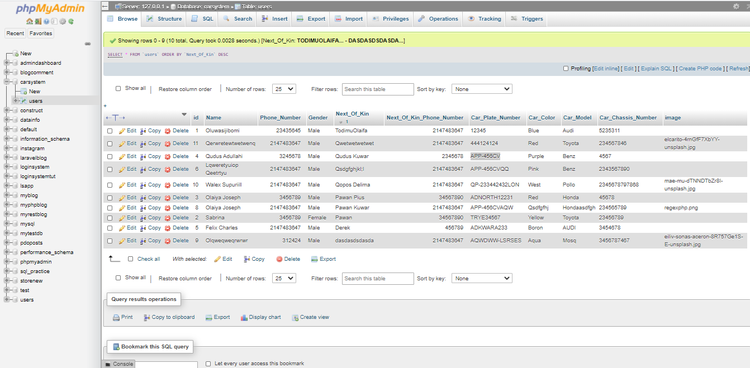

### Fig 4.6.2 Database of Car Registration System

In the home page the user can search by Place Number in the search textbox and the user car information get displayed

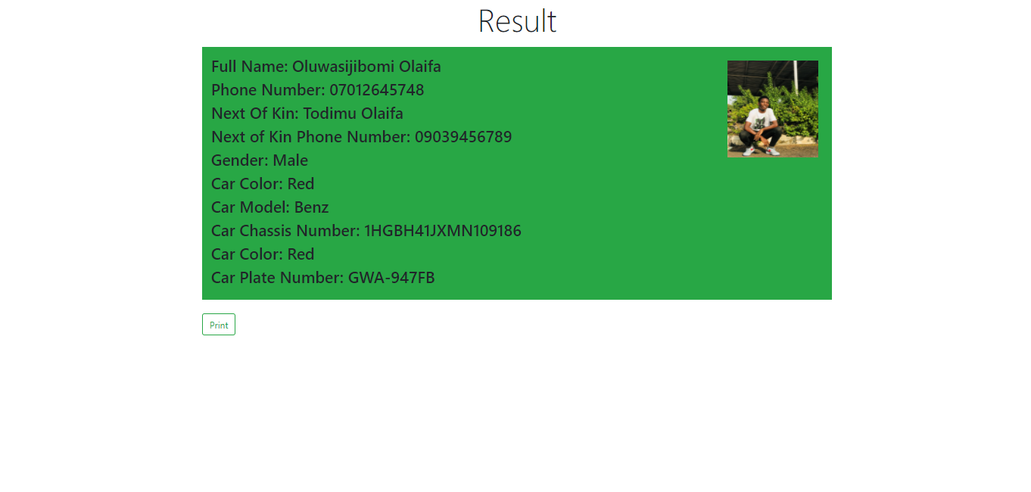

### Fig 4.6.3 Display of Registered User Information

When the user click print this page get displayed

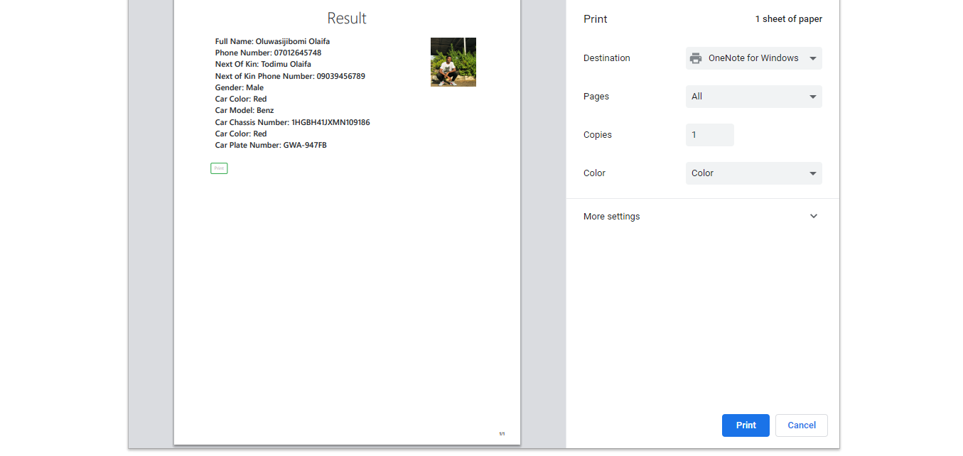

### Fig 4.6.4 Display of Print Page

### 4.7

# CHAPTER FIVE

## CHALLENGES AND RECOMMENDATION

## 5.1 CONCLUSION

My six months Industrial Training at MCLORDSS MOBILE SOLUTION LIMITED was a huge success and a great time of acquiring new skills.During my training I was able to appreciate the aspect of web development more because I was able to set a goal for myself to build some applications. SIWES as a course has truly exposed me to the challenges faced in a growing I.T world that is dependent on programming.

### 5.2 CHALLENGES

**●** Difficulty in seeking for IT placement.

**●** I was not paid in my place of attachment.

**●** One of my major problem was the unavailability of internet access. Internet access was a major challenge for me because I make use of internet everyday anytime I encounter an error I have to check my browser and look for the solution to my problems.

### 5.3 RECOMMENDATIONS

**●** School should provide a place of attachment for student.

**●** Allowance should be paid to students during the programme and not after.

**●** Supervisor should visit student in their various place of attachment.

**●**  The ITF also should ensure that the payment of the student allowance is paid on time in other to keep the SIWES students zealous and motivated.

**●**  I recommend that the Nigerian educational system should be reviewed as what is taught in the classroom totally contradicts with what is needed the in the actual work place.