Libtorch cpu 版本下载链接:
https://download.pytorch.org/libtorch/cpu/libtorch-win-shared-with-deps-2.0.1%2Bcpu.zip

1.配置VC++目录：
VS新建空项目
1.1添加包含目录：
D:\soft\libtorch\libtorch\include
D:\soft\libtorch\libtorch\include\torch\csrc\api\include
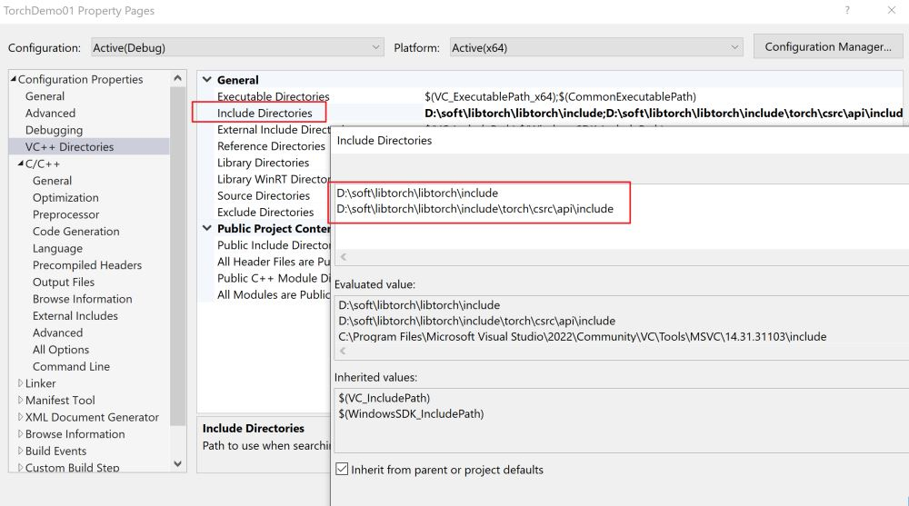
1.2添加库目录：
D:\soft\libtorch\libtorch\lib

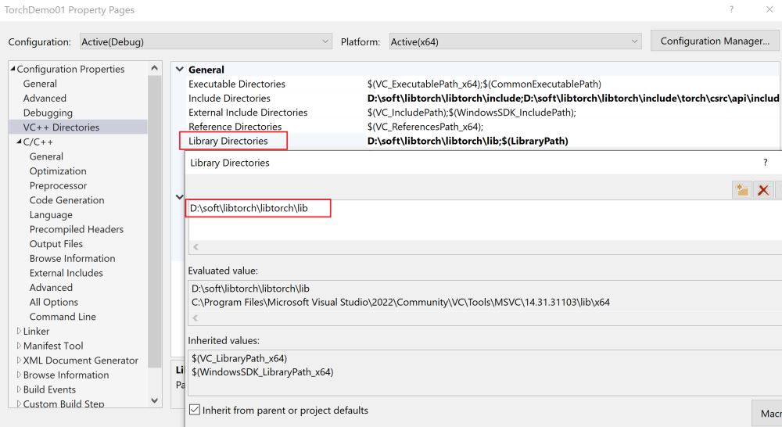

2.配置环境变量：
PATH=D:\soft\libtorch\libtorch\lib;%PATH%

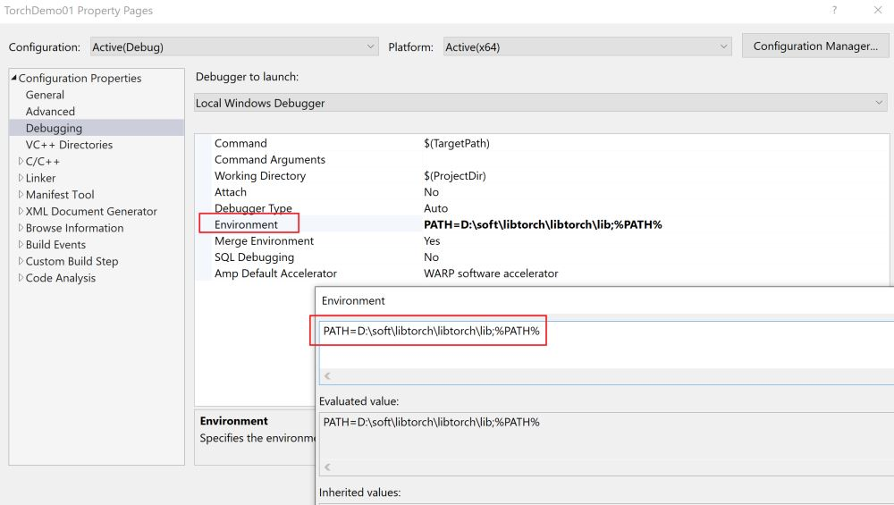

配置链接器：
D:\soft\libtorch\libtorch\lib\*.lib
