Sijia’s notes on the pupillometric test

# (A little) introduction

Of relevance for developmental studies, pupil diameter changes with age., which might be associated with changes in cerebral levels of norepinephrine (Herlenius and Lagercrantz, 2001). In general, pupil diameter increases rapidly from birth and plateaus around 7mm at the age of 11-15 years (measured in dim light) (MacLachlan and Howland, 2002) and afterwards slowly but persistently shrinks reaching around 4.5 mm in 80-year olds (Loewenfeld and Lowenstein, 1993).

Despite that the fact that the pupil diameter decreases with ageing is well-known to both clinical professionals and researchers, based on my knowledge, there has been a very limited systemic measurement of pupil diameter amongst the elder adults (>65 years). Thus, we introduce a simple and short pupillometric test to capture a basic pupillometric profile of all subjects. This test requires binocular pupil diameters (i.e. recording both pupils simultaneously) and includes two stages: (1) the 30s resting state and (2) passive listening to 30 harmonic tones.

The first stage — 30s resting state — will provide the subject’s (1) the absolute pupil diameter baseline (for both eyes) and (2) the pupil dynamics during 30s resting state. Normally, pupil diameter is about 2mm to 8mm (2-4 in bright, 4-8 in dark). Pupil diameter fluctuates over time even in unchanged luminance. Meanwhile, both pupils should have the same size and should change together.

The second stage – listening to harmonic tones — will show the subject’s pupil dilation response in response to salient (auditory) stimuli (i.e. harmonic tone). The average pupil diameter response (PDR) from the onset of the harmonic tone can assess whether the subject’s pupil is sensitive to external stimuli.

# Methods

## The 30s resting state

Instruct subjects to sit, with their head fixed on a chinrest, in front of a monitor at a viewing distance of 65cm in a dimly lit and acoustically shielded room (IAC triple walled sound-attenuating booth). After the standard 5-point fixation calibration, the subjects need to continuously fixate at a black cross presented at the centre of the screen against a grey background for 30 seconds. When time’s up, the text ‘FINISHED!’ will replace the fixation cross. Then the subject can have a break. Both eyes need to be recorded.

## Passive listening to harmonic tones

Subjects listen passively to a 500ms-long harmonic tone with a frequency step of 200Hz starting from 200Hz and with 30 components (Figure 1). In total, 30 trials will be presented with a random inter sound interval between 6 and 7 seconds. This session lasts 4 minutes. The visual display remained the same throughout. No response from subjects.

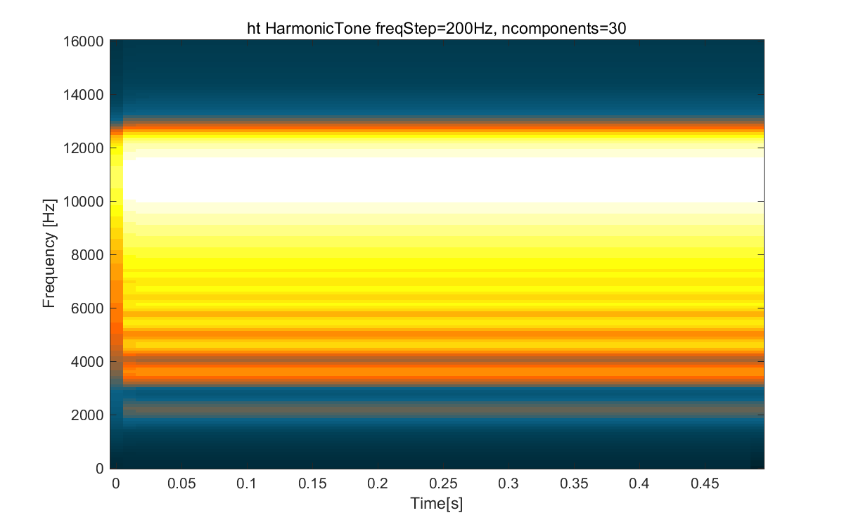

Figure 1. Spectrogram of the harmonic tone.

## The 30s resting state (after the experiment)

After the experimental session, repeat the 30s resting state again to double check the absolute pupil diameter.

Note: To avoid confounding effects from the pupillary light reflex, the luminance of the screen and the ambient illuminance of the experimental room must be kept constant throughout the experiment.

# Analysis

## Conversion from arbitrary unit to mm

In order to convert the arbitrary unit of pupil diameter into real-world units (e.g. millimetre), I did a calibration of pupil diameter. I attached two black dots of a known size (5mm) on the horizontal bar of the chin-rest.

Then I ran a 30s resting state session on these two black dots. Even though the dots were unchanged and fixed, the ‘pupil’ diameter fluctuated over time suggesting unstable recording. Figure 2 [left] shows the distribution of all recording samples in the arbitrary unit over the 30s.To have a better estimation about the ratio between the arbitrary unit and real-world mm, Figure 2 [right] shows the same distribution in arbitrary units per mm. I define: For the left pupil, 1mm = 683.4 a.u.; for the right pupil, 1mm = 682.2 a.u.. Note these values are specific to the current distance between the chinrest and the camera and the height of the horizontal bar.

Based on this estimation, the eyetracker’s recording error is <0.01mm (see Figure 3).

You can re-estimate the conversion values for each subject by attaching the black dots on the subject’s eyelids. But remember, if you track a black dot (rather than an artificial pupil), you'll have to record under the pupil-only mode. I have added this mode to our (Chait lab) eyetracker. See Appendix for more information about how to add this mode to a new eyetracker.

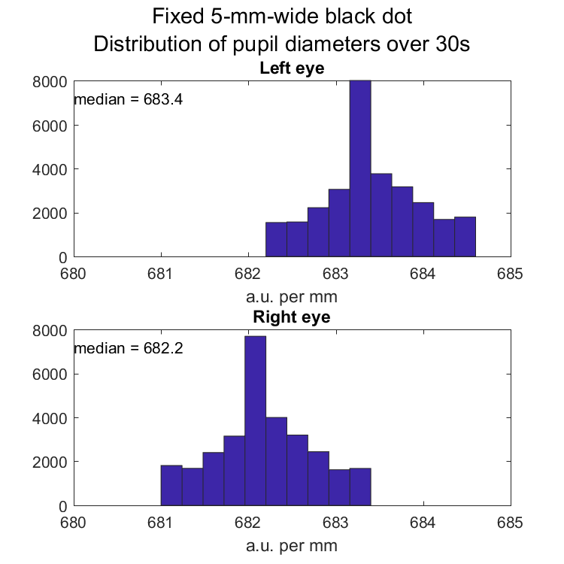

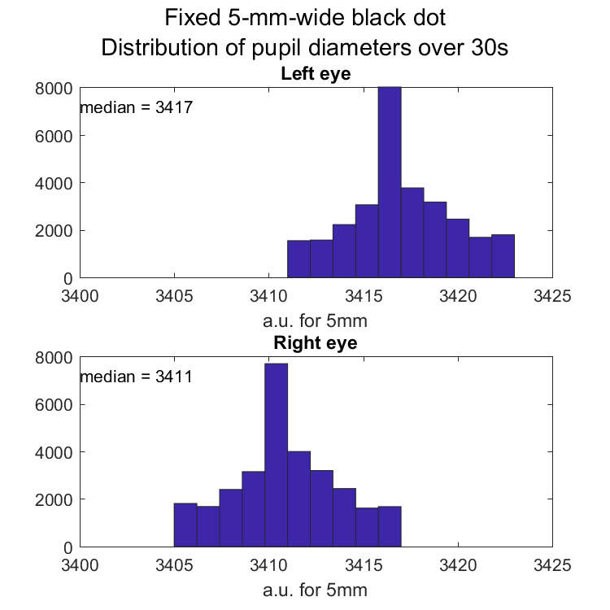

Figure 2. [Left] Distribution of recorded values in arbitrary units (a.u.) over the 30s. [Right] All values have been divided by 5 (because the black dot is 5mm wide). The conversion rate is thus defined as the median of values in arbitrary units per mm. For example, here, for left pupil, the conversion rate is 683.4 arbitrary unit per mm.

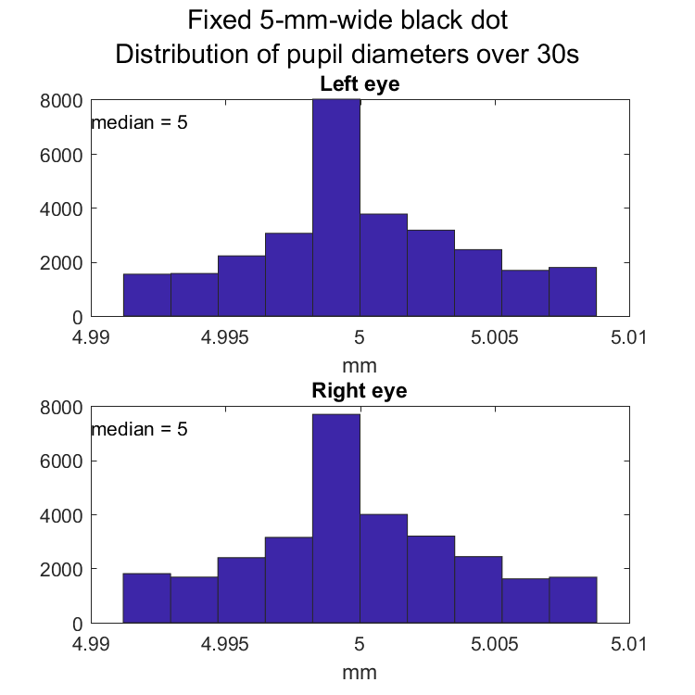

Figure 3.

# Result: Pupillometric profile

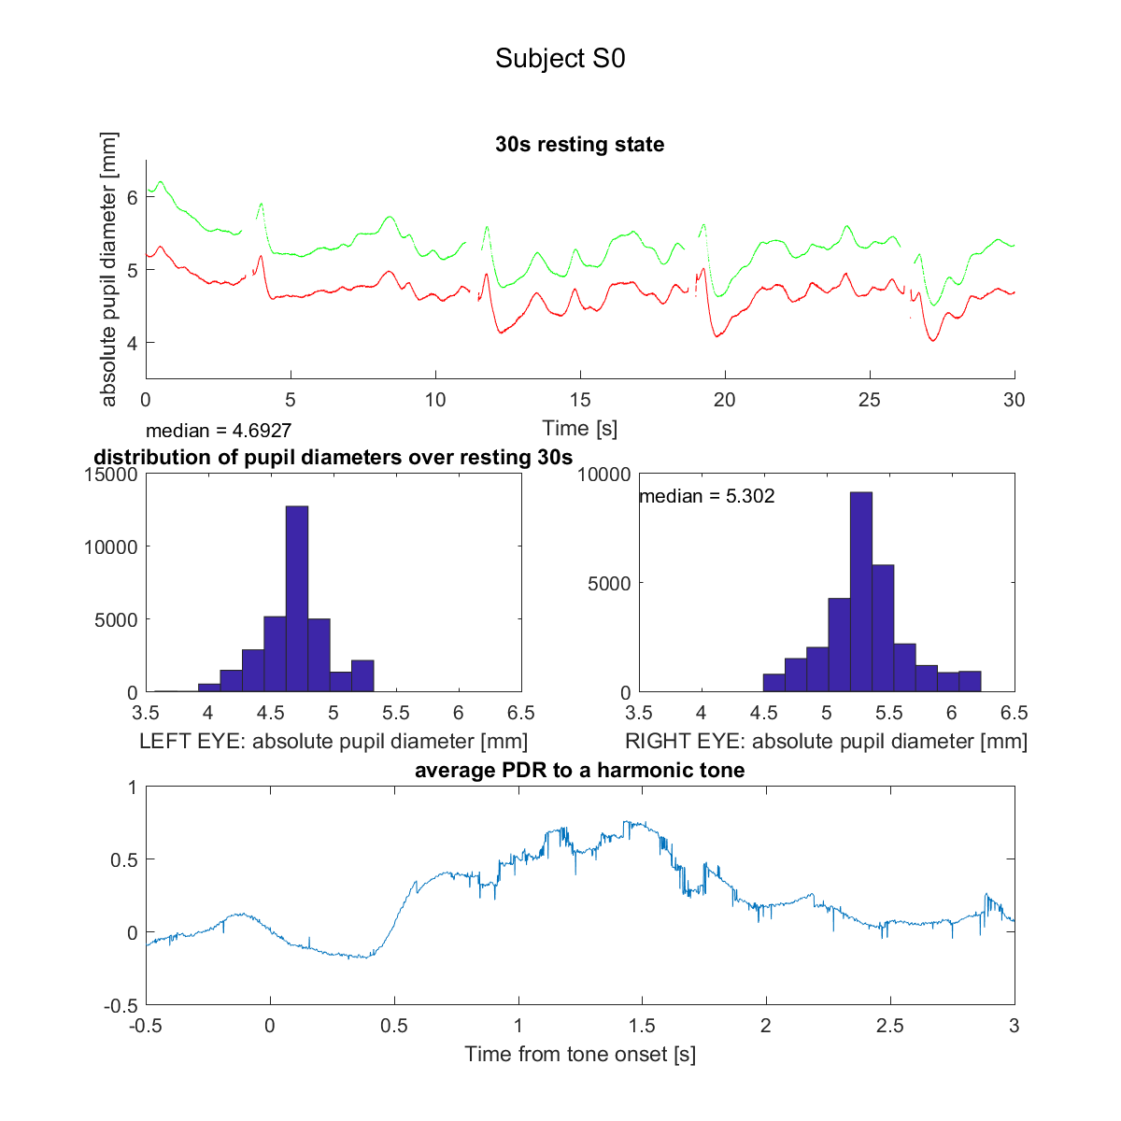

Figure 4. An example of result for the 30s-resting-state and the PDR to harmonic tones. The top panel shows the absolute pupil diameter of left (in red) and right (in green) pupils over time during resting state. The distribution of all samples is shown in the middle panel. Here this subject’s left pupil was 4.70mm and right was 5.30mm. The bottom panel shows the average PDR to harmonic tone. The normalised and baseline-corrected pupil diameter (z-score) is plotted again time from the harmonic tone onset. The result was the grand average over 30 trials, not cleaned or smoothed except for blink removal.

# Appendix

## What are the units of pupil size? How do I convert pupil size to real-world units?

https://www.sr-support.com/forum/frequently-asked-questions/eyelink-host-pc-and-hardware-faq/5173-answers-to-eyelink-host-pc-and-hardware-faq/page2

Pupil size can be measured in either area or diameter in arbitrary units based on the size of the thresholded area of the pupil in the camera image. Pupil area is based on the number of pixels the pupil takes up in the camera image; pupil diameter is derived from this value, and is a square root transformation multiplied by a scalar. The level of accuracy doesn’t vary at all between the two measurements—it’s just a matter of preference and what will be easier for your analysis.

To convert pupil size to absolute units (e.g., mm), you can do a “calibration” of pupil size. You will need an artificial pupil with a known pupil size or simply print out a black dot of a known size (say 5 mm) on a piece of paper using a laser printer. Attach the artificial pupil to something that you can put close to the subject's eye at the start of the session, so that it is at the same distance from the camera as the eye itself as much as possible. Do a recording of the artificial pupil as the first or last trial of your recording session (or you can simply do this once, if you can be sure that all participants will be the same distance from the camera). Once you have you recorded the data, you can get the pupil size for this artificial pupil or printed dot. You can then do a linear interpolation of the actual pupil size from the subject based on the diameter value. (If you recorded the pupil size data in AREA, first take a square root of all pupil size data before applying a linear interpolation).

For example, if you use diameter:

You know that your artificial eye has a diameter of 8mm. You know that the eye tracker is reporting 1260 at the distance you are using. If you put a real eye in the chinrest at the same distance as the artificial eye was in your recording, and the eye tracker reports a diameter of 1000 then you can take the eye data to correspond to about 6.35mm. (because 8/1260 = x/1000).

For example, if you use area:

You know that your artificial eye has a diameter of 8mm. You know that the eye tracker is reporting 7070 at the distance you are using. If you put a real eye in the chinrest at the same distance as the artificial eye was in your recording, and the eye tracker reports a diameter of 6000 then you can take the eye data to correspond to about 7.37mm. (because [8/sqrt(7070)] = [x/sqrt(6000)]).

If you track a black dot (rather than an artificial pupil), you'll have to use a pupil-only mode. You can add the following commands to your FINAL.INI file in the "ELCL\EXE" directory of the EyeLink Host computer. This will allow you to select “Pupil Only” mode on the Camera Setup screen so that the system will track this black dot (without a CR):

Code:

#####################################################

## force_corneal_reflection = <Value>

;; Hides "Pupil" mode button on Camera Setup screen

;; Pupil Only mode should only be used in EyeLink 1000 when

participants head is completely fixed.

;; Default Value: OFF

force_corneal_reflection OFF

## allow_pupil_without_cr = <switch>

;; Allows pupil without a CR nearby to be detected

;; in pupil search (after pupil loss or on startup).

;; This command is overridden in P-CR mode.

allow_pupil_without_cr = ON

## elcl_hold_if_no_corneal = <switch>

;; If true, eye window is frozen until both pupil and CR are

present.

;; Default Value: OFF

elcl_hold_if_no_corneal = OFF

## elcl_search_if_no_corneal = <switch>

;; If corneal missing for long period, assumes false target and

searches for pupil/CR candidate.

;; Default Value: OFF

elcl_search_if_no_corneal = OFF

## elcl_use_pcr_matching = <switch>

;; Selects enhanced pupil-CR matching during pupil identification.

;; If used, pupil and CR are selected as best matching pair.

;; This can be used even if CR is not being used for tracking.

;; Default Value: ON

elcl_use_pcr_matching = OFF

#####################################################

When tracking the printed dot, you can click Pupil mode and record some data. Be sure to switch back to Pupil-CR tracking for the real subject though! Otherwise, the recorded eye movements will be affected substantially by even very slight movements.