# 24-10-27 logbook

* To do: read their statistical analysis for % difference
* Just use the original method for difference
* To do: put the same finding onto Ziv’s and Ali’s PPT

# 24-11-29 logbook

For this plot there looks like some time shift problem, take a look and try to fix it

# 24-11-30

* Run the code to see the plot
* See if the “merged_data” has timestamp information in time
* Add the timestamp into the IV curve feature
* Modified the code
  + Updated the title
  + Updated the saved file name by adding summer and site id
* Run the code to see if it works
* A graph of different colored lines

  Description automatically generated with medium confidence

# 2024-12-13

* Make sure the code works for
  + Summer good
  + Summer bad
  + Winter good
  + Winter bad
* Use the first day 12:00 data point as example
* The IV data and the MPPT data looks OK
* Store a list of data that is taken in the tittle
* 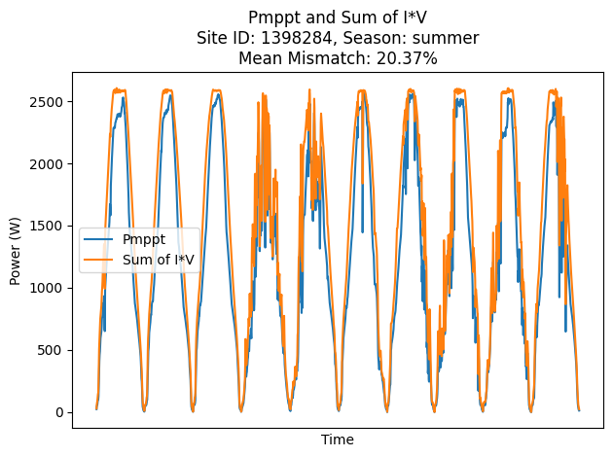
* 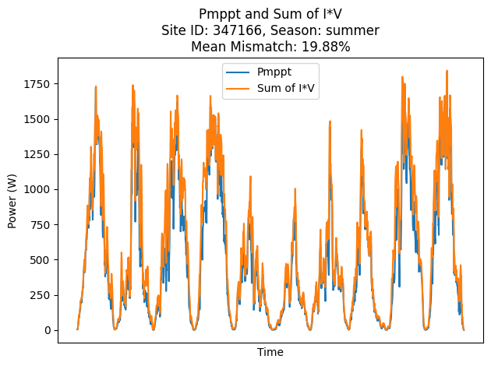
* Still something is wrong
* Find one day and do by hand
* Use 1-10 12pm as an example
* Do the calculation on excel
* 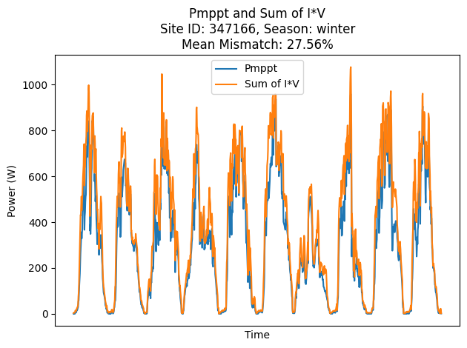
* Check if the plot
* Find one timestamp where it is clearly very different
* In summer
* A graph of a number of lines

  Description automatically generated with medium confidence
* A graph of a number of lines

  Description automatically generated with medium confidence
* A graph of different colored lines

  Description automatically generated with medium confidence
* A screen shot of a computer program

  Description automatically generated
* Do the same on excel to see if you get identical results
* 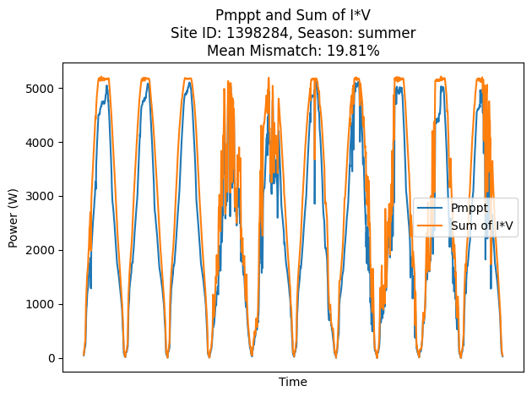
* Check list
  + The percentage difference process:
    - Redo the difference in Excel (done)
    - Check the paper to see how they did the difference
      * Read the paper
  + Another way to make it smaller is to use the output power
  + Try to use the power collected by inverter instead of optimizer
* Run to check if the results still exists
* Something wrong with the power
* Do not use the power
* Run the summer for both sites
  + 347166

# 25-3-14

* Try to find the file that works
* Run the file to ensure it works
* Save it
* Yes,it works
* Put the existing results onto an excel to summarise all the data

# 25-3-15

* Try to change the input folder path to see what happens
* Find where did you define input folder path
* Put the solar panel data input to the front

# 25-3-16

* Change the file to summer/winter/autumn/spring