# Quantifying Photovoltaic Module-to-Module Mismatch Losses with Real-World Rooftop Systems

Authors: Sijin Wang, Ziv Hameiri, Baran Yildiz, James Sturch

## Novelty Points

* Development of a novel method to estimate mismatch losses based on the recorded MPPT of each module from real-world SolarEdge systems
* Comprehensive benchmark of module-to-module mismatch losses across 22 diverse rooftop systems spanning multiple countries and climate zones
* Advanced filtering methodology to separate bypass diode activation from normal mismatch conditions
* Monte Carlo validation framework quantifying methodology error (±1.2%)

## Introduction

### Commercial PV Overview

* PV is essential for combating climate change, with exponential growth in deployment
* Recent rapid growth in rooftop PV installations globally
* Rooftop PV systems typically suffer more from mismatch losses compared to utility-scale installations due to:
  + Complex roof geometries
  + Partial shading from nearby objects
  + Non-uniform orientations
  + Installation constraints

### Mismatch Loss Introduction

* Definition: Mismatch loss in a PV system series connection is the difference between the sum of individual module maximum power points and the actual combined string power output
* Sources of mismatch losses in rooftop PV:
  + Manufacturing inconsistencies and parameter variations
  + Light-induced degradation (LID) and ageing effects
  + Module ageing at different rates
  + Soiling and temperature differences across the array
  + Site-specific conditions: partial shading, varying module orientations
  + Potential-induced degradation (PID) and damaged module diodes
  + Bypass diode activation events
* Literature Review:
  + Historically, studies on mismatch losses have presented conflicting conclusions
  + Some research indicates mismatch losses significantly reduce system output [refs]
  + Other studies argue that these losses have minimal impact on overall performance [refs]
  + A gap exists in comprehensive real-world field studies across diverse conditions

### SolarEdge Technology Introduction

* To mitigate mismatch losses, SolarEdge Technologies has developed DC-DC converters known as optimisers
* Key features:
  + Allow modules to operate independently at their maximum power points (MPP)
  + Provide real-time MPP data on each module’s operating conditions
  + Enable module-level monitoring and fault detection
  + Continuous 5-minute interval telemetry data collection
* Research Opportunity:
  + The extensive data available from SolarEdge optimisers presents an unprecedented opportunity to assess real-world PV mismatch losses
  + Large-scale deployment enables statistical analysis across diverse geographic and climatic conditions

### Study Objectives

* Quantify mismatch losses accurately based on MPP data recorded by SolarEdge systems across diverse real-world conditions

## Methodology

### Overview of Proposed Method

* The proposed method consists of four sequential steps:
  + 1. Reconstruct the I-V curve of each module based on the measured MPPT using the single-diode model.
  + 2. Calculate the combined I-V curve if the modules were connected in series
  + 3. Find the MPPT of the combined series I-V curve
  + 4. Compare the energy produced by a series connection vs. the sum of individual module energies to calculate mismatch loss

### I-V Curve Reconstruction

#### Single-Diode Model Foundation

The single-diode equation is given by:

$$I=I_{L}-I_{0}\left(e^{\frac{V+IR_{s}}{nN_{s}v_{th}}}-1\right)-\frac{V+IR_{s}}{R_{sh}} (1)$$

Where:

* $I$ = module output current
* $I_{L}$ = photogenerated current
* $I_{0}$ = dark saturation current
* $n$ = diode ideality factor
* $N_{s}$ = number of cells in the module
* $v_{th}$ = thermal voltage = $\frac{k_{B}T}{q}$
* $k_{B}$ = Boltzmann constant
* $T$ = cell temperature in Kelvin
* $q$ = electron charge
* $V$ = module output voltage
* $R_{s}$ = module series resistance
* $R_{sh}$ = module shunt resistance

#### Parameter Extraction

* Based on the single-diode equation and assuming measured voltage and current represent the maximum power point, the dark saturation current can be derived as:
$$I_{0}=\frac{I_{MP}\left(1+\frac{R_{s}}{R_{sh}}\right)-\frac{V_{MP}}{R_{sh}}}{1-\frac{I_{MP}R_{s}}{V_{MP}}}\frac{N_{s}v_{th}}{V_{MP}}e^{-\frac{V_{MP}+I_{MP}R_{s}}{N_{s}v_{th}}} (2)$$

* The photogenerated current is calculated by rearranging equation (1):

$$I_{L}=I_{MP}\left(1+\frac{R_{s}}{R_{sh}}\right)+\frac{V_{MP}}{R_{sh}}+I_{0}\left(e^{\frac{V_{MP}+I_{MP}R_{s}}{nN_{s}v_{th}}}-1\right) (3)$$

#### Implementation Process

For each measurement timestamp:

* $R_{s},n,N_{s},R_{sh}$ extracted from PV module datasheet (.PAN files)
* $v_{th}$ calculated based on the measured module temperature
* $I_{MP},V_{MP}$ recorded by the SolarEdge optimiser
* $I_{0}$ and $I_{L}$ calculated using equations (2) and (3)
* Full I-V curve constructed using pvlib.pvsystem.v_from_i function
* An example of a reconstructed IV curve from the measured MPP is shown in Figure 1 (a) and (b)

### Series Connection I-V Simulation

* Methodology: Simulated I-V curve constructed assuming all modules are connected in series
* Bypass diode modelling: Each module is assumed to have at least one bypass diode with a negligible voltage drop
* Mathematical approach: Series connection I-V curve calculated as the voltage sum for each current value
* Current limiting: When combined current modules into reverse voltage, bypass diodes activate
* An example of a series connection IV curve from the individual module IV is shown in Figures 1 (b) and (c)

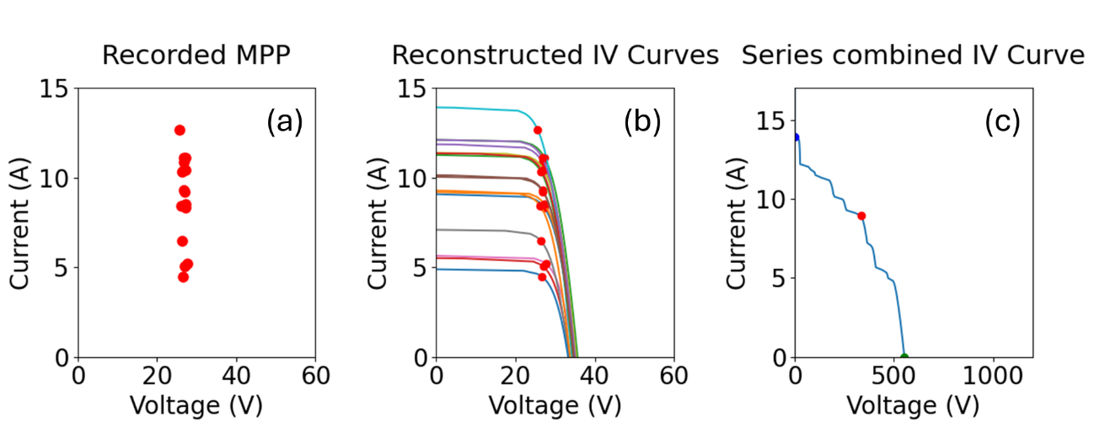

Figure : (a) The recorded MPP for each module, (b) The reconstructed IV curve for each module, (c) The reconstructed IV curve if they were connected in series

### Power Comparison and Mismatch Calculation

* MPP of the series connection I-V curve identified through power curve optimisation
* Comparison performed between:
  + Sum of individual module MPP powers (SolarEdge case)
  + Combined series string MPP power (traditional string inverter case)
* Mismatch loss calculation:
$$\text{Mismatch Loss (\%)}=\frac{∑P_{individual}-P_{series}}{∑P_{individual}}×100$$

* An example of the power comparison of one test site for 10 days is shown in Figure 2

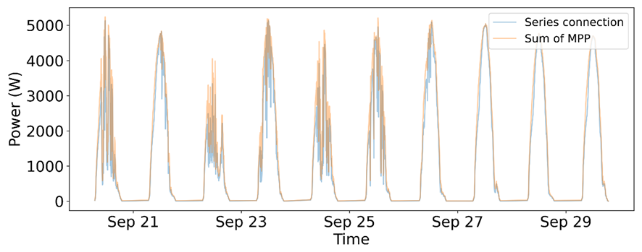

*Figure 2: Power comparison between the case of each maximum power and the power if they were connected in series.*

### Bypass Diode Filtering

* Motivation: Internal bypass diode activation creates artificial mismatch signals
* Detection methodology:
  + The rule is defined based on LTSpice simulation
  + Voc outlier analysis using IQR methods
  + Isc outlier detection for fault identification
  + Classification system:
    - Type 1: 1/3 Voc loss (1 diode activated)
    - Type 2: 2/3 Voc loss (2 diodes activated)
    - Type -1: High Voc + Low Isc (variable activation)
* Data filtering: Timestamps with diode activation excluded from mismatch analysis
* Please see Appendix B for the detailed bypass diode filtering algorithm

## Test Site Selection and Aggregation

### Site Characteristics

* Total sites: 22 selected installations with diverse orientations and technologies
* Geographic distribution:
  + Australia: Queensland, Victoria, South Australia, New South Wales
  + North America: Texas, Arizona, Nevada, California, Ohio, and Iowa
  + Europe: Netherlands, Germany, France
* System specifications: Detailed in the comprehensive site database are shown in Table 1

*Table 1: Site database details*

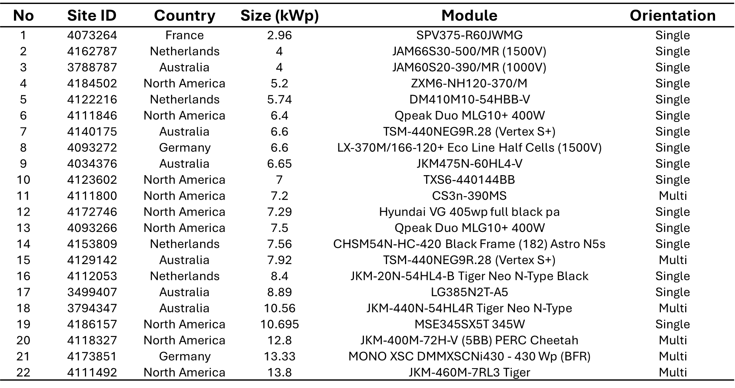

### Data Collection Protocol

* Temporal sampling: 10 days selected per season (March, June, September, December 2024)
* Measurement frequency: 5-minute intervals for all parameters
* Recorded parameters:
  + Module temperature and ambient temperature
  + Module MPP current and voltage
  + Power output per optimiser
  + Inverter-level data

### Site Classification System

* Based on visual analysis using satellite and street view imagery, sites are classified into two categories based on module orientation:

#### Category 1: Single Orientation (16 sites)

* All modules face the same direction
* Uniform tilt and azimuth angles across the installation
* Mismatch sources: manufacturing tolerances, temperature gradients, soiling variations, and potential partial shading effects
* Common in standard residential and commercial installations

#### Category 2: Multiple Orientation (6 sites)

* Modules face different directions due to complex roof geometry
* Mixed tilt and/or azimuth angles across the installation
* Additional mismatch sources: varying irradiance conditions due to orientation differences
* Typically found in installations with architectural constraints or complex roof designs

## Results

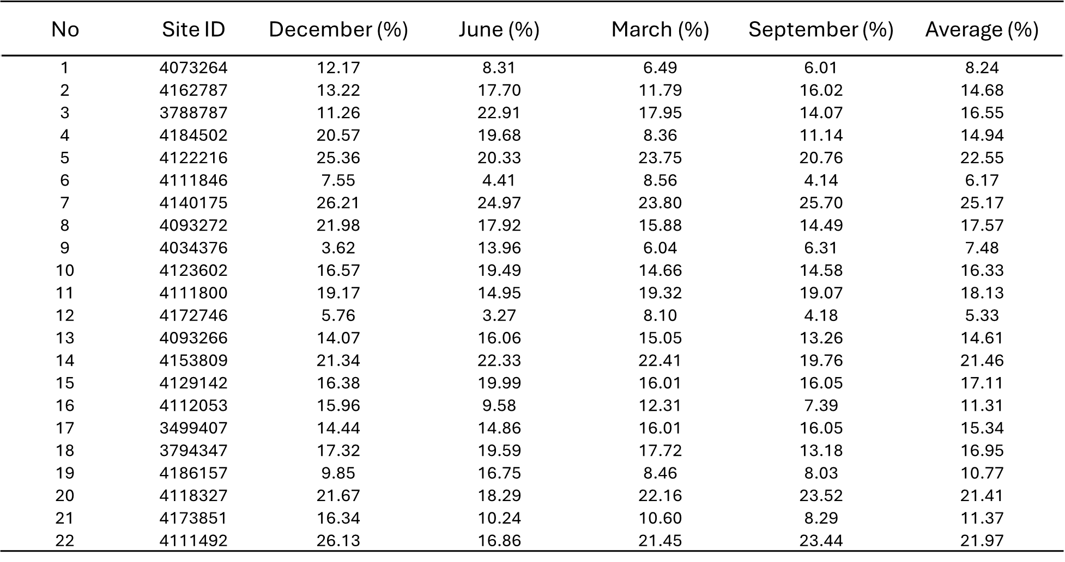

### Overall Statistical Analysis

* The mismatch results of all test sites are shown in Table 2
* Comprehensive dataset: 22 sites × 4 seasons = 88 site-season combinations
* Mean mismatch loss: 14.4 ± 5.0% (after bypass diode filtering)
* Range: 5.3% (Site 4034376, single orientation) to 22.0% (Site 4111492, multiple orientation)
* Distribution characteristics: Site-specific variation attributed to local installation conditions and orientation complexity

### Orientation-Based Results

#### Case 1: Single Orientation Sites (16 sites)

* Representative examples: Site 4034376 (7.5% loss), Site 4002138 (9.2% loss)
* Average mismatch loss: 12.6 ± 4.6%
* Range: 5.3% to 21.5%
* Installation characteristics: Uniform orientation provides consistent irradiance conditions, but is still subject to environmental factors such as shading

#### Case 2: Multiple Orientation Sites (6 sites)

* Representative examples: Site 3455043 (19.0% loss), Site 4111492 (22.0% loss)
* Average mismatch loss: 19.1 ± 2.2%
* Range: 17.0% to 22.0%
* Impact quantification: ~6.5% additional mismatch compared to single orientation sites
* Installation reality: Common when architectural constraints require multiple orientations

#### Comparison

* Single orientation sites generally have lower mismatch loss
* However, if there is significant shading nearby, the upper limit of the mismatch of both single orientations can be close to multiple orientation sites

### Seasonal Analysis

* Winter pattern: Generally, higher mismatch losses are observed
* Physical explanation: Lower solar altitude increases shadowing effects and reduces overall irradiance uniformity
* Summer stability: More consistent performance with reduced mismatch variation
* Seasonal variation: 2-4% difference between winter and summer averages

## Error Estimation Using Monte Carlo Simulation (MCS)

### Motivation for Validation

* Model accuracy assessment: Single-diode model approximation needs quantitative validation
* Parameter dependencies: Temperature and irradiance effects on model parameters:
  + Ideality factor variations
  + Series resistance temperature coefficient
  + Shunt resistance irradiance dependency

### Monte Carlo Methodology

#### Two-Diode Reference Model

* Truth generation: Use a comprehensive two-diode model with temperature/irradiance dependencies
* Parameter distributions: Based on literature review and manufacturer data
* System simulation:
  + Generate 10,000 dummy modules with realistic parameter distributions
  + Create 1000 dummy systems (10 modules each)
  + Apply temperature and irradiance variations

#### Validation Process

* Branch 1: True Results Generation
  + Calculate actual series connection I-V curves using the two-diode model
  + Account for temperature/irradiance parameter dependencies
  + Determine true series MPP power - Calculate true mismatch loss
* Branch 2: Reconstructed Results
  + Extract only MPP data (simulating SolarEdge measurements)
  + Apply proposed single-diode reconstruction methodology
  + Calculate reconstructed mismatch loss
  + Compare with true values

### Monte Carlo Results

* Error quantification: Mean error of 1.2% absolute (methodology underestimates true mismatch)
* Error distribution: Systematic bias toward underestimation
* Uncertainty bounds: ±1.2% confidence interval for mismatch loss estimates
* Model validation: Confirms single-diode approach is sufficiently accurate for field studies

#### Error Analysis Results

* Statistical Metrics:
  + Mean absolute error: 1.2%
  + Standard deviation: 0.8%
  + 95% confidence interval: ±1.6%
  + Systematic bias: Slight underestimation
* Validation Conclusions:
  + Single-diode approach sufficient for field study accuracy requirements
  + Temperature dependencies have minimal impact on overall results
  + Irradiance effects on shunt resistance are properly captured in the model

## Discussion

### Comparison with Previous Studies

#### NREL Distributed Power Electronics Research

* MacAlpine et al. (2009) - University of Colorado/NREL Study:
  + Focus: Building-integrated PV systems with complex roof geometries using module-integrated DC-DC converters (MICs)
  + Key findings: Annual power output gains of over 10% for systems with differing panel orientations when using MICs
  + Methodology: Comprehensive simulation model validated with experimental data, accounting for cell-level irradiance and temperature variations
  + Mismatch sources: Primarily, orientation differences and the nearby tree shading in series string configurations
* Deline (2011) - NREL Technology Seminar Findings: Comprehensive mismatch loss estimates:
  + Residential roof shade (single string): 5-15% system loss
  + Residential rooftop shade (multiple strings): 5-20% system loss
  + Orientation mismatch (East-West, single string): 5-20% system loss
  + Commercial inter-row shading: 1-5% system loss
  + Manufacturing parameter distribution: 0.2-1% system loss
  + Soiling (California/Southwest): 1.5-6.2% system loss

#### Comparison with Current Study

* Current study findings:
  + 14.4 ± 5.0% mean mismatch loss in real-world field installations (22 sites)
  + Single orientation: 12.6 ± 4.6% (16 sites)
  + Multiple orientation: 19.1 ± 2.2% (6 sites)
* Key differences in methodology:
  + NREL approach: Controlled experiments with validated simulation models to simulate the electric loss from the optical measurement
  + Current study approach: Real-world field electrical data from SolarEdge optimiser measurements across 22 diverse installations
  + This study also uses a number of sites across the globe, while NREL studies focus on a single test site
* Validation of mismatch loss estimation:
  + Despite different data sources and methodologies
  + Both studies arrive at similar results: the mismatch loss on the rooftop system is ~15%

### Implications for System Designers

* Orientation planning: Single orientation installations show lower mismatch losses (12.6%) compared to multiple orientation designs (19.1%)
* Installation strategy: Architectural constraints requiring multiple orientations add ~6.5% mismatch penalty
* Technology selection: Quantified benefits of module-level power electronics, especially for complex installations

## Conclusion

* Overall mismatch quantification: Real-world rooftop systems exhibit 14.4 ± 5.0% average mismatch loss
* Orientation-based category impacts:
  + Single orientation installations: 12.6 ± 4.6% (16 sites)
  + Multiple orientation installations: 19.1 ± 2.2% (6 sites)
* Orientation impact: Multiple orientations add ~6.5% additional mismatch compared to a single orientation
* Seasonal patterns: Winter conditions show elevated mismatch losses due to lower solar altitude
* Methodology validation: Monte Carlo simulation confirms ±1.2% accuracy of proposed approach
* Novel methodology: First comprehensive field study using optimiser-derived data for mismatch quantification
* Geographic diversity: Multi-continental study spanning diverse climate zones
* Practical relevance: Direct applicability to rooftop PV system design and modelling

## Appendices

### Appendix A: Derivation of Dark Saturation Current

#### Known Parameters

* From SolarEdge measurements: - Maximum power point voltage: $V_{MP}$- Maximum power point current: $I_{MP}$
* From PV module datasheet: - Module ideality factor: $n$- Module cell number: $N_{s}$- Module series resistance: $R_{s}$- Module shunt resistance: $R_{sh}$

#### Mathematical Derivation

* Objective: Derive an expression for the dark saturation current from the single-diode equation
  + At maximum power point: $\frac{∂P}{∂V}=0$
  + Since $P=IV$: $\frac{∂(IV)}{∂V}=0$
  + This yields: $\frac{∂I_{MP}}{∂V_{MP}}V_{MP}+I_{MP}=0$… (4)
  + Taking the derivative of equation (1) with respect to voltage:
$$\frac{∂I}{∂V}=-\left(\frac{I_{0}e^{\frac{V+IR_{s}}{nN_{s}v_{th}}}}{nN_{s}v_{th}}+\frac{1}{R_{sh}}\right)-\left(\frac{I_{0}e^{\frac{V+IR_{s}}{nN_{s}v_{th}}}}{nN_{s}v_{th}}+\frac{1}{R_{sh}}\right)R_{s}\frac{∂I}{∂V}$$

* Solving for $\frac{∂I}{∂V}$:
$$\frac{∂I}{∂V}=\frac{-\left(\frac{I_{0}e^{\frac{V+IR_{s}}{nN_{s}v_{th}}}}{nN_{s}v_{th}}+\frac{1}{R_{sh}}\right)}{1+\left(\frac{I_{0}e^{\frac{V+IR_{s}}{nN_{s}v_{th}}}}{nN_{s}v_{th}}+\frac{1}{R_{sh}}\right)R_{s}}$$

* Substituting into equation (4) and solving for $I_{0}$ yields equation (2).

### Appendix B: Bypass Diode Filtering Algorithm

#### Statistical Outlier Detection

* Voc Outlier Classification: - High outliers: $Voc>Q3+1.5×IQR$- 1-diode activation: $1/3×Q3<Voc<2/3×Q3$- 2-diode activation: $Voc<1/3×Q3$
* Isc Outlier Detection: - High outliers: $Isc>Q3+3.0×IQR$- Low outliers: $Isc<Q1-1.5×IQR$

#### Activation Classification Algorithm

For each timestamp and optimiser:  
 if (Voc_outlier == -1) AND (Isc_outlier == 0):  
 diode_activation = 1 # Type 1: 1 diode  
 elif (Voc_outlier == -2) AND (Isc_outlier == 0):  
 diode_activation = 2 # Type 2: 2 diodes  
 elif (Voc_outlier == 1) AND (Isc_outlier == -1):  
 diode_activation = -1 # Type -1: Variable  
 else:  
 diode_activation = 0 # Normal operation

### Appendix C: Temperature and Irradiance Dependencies

#### Series Resistance (Rs)

* Temperature dependency: 0.356%/K (based on PERC module studies) [refs]
* Physical basis: Silver grid fingers and copper interconnects resistance increase with temperature
* Irradiance dependency: Minimal impact under normal operating conditions

#### Shunt Resistance (Rsh)

* Temperature dependency: Negligible effect on overall performance
* Irradiance dependency: Decreases with irradiance following the PVsyst exponential model
* Implementation: Dynamic adjustment based on measured irradiance levels

#### Ideality Factor (n)

* Temperature dependency: Minimal variation (0.006%/K for PERC modules)
* Irradiance dependency: Varies between 1.4-1.5 for 0.4-1.0 sun conditions
* Model treatment: Constant value approach validated within error bounds