24-10-27 logbook
- To do: read their statistical analysis for % difference
- Just use the original method for difference
- To do: put the same finding onto Ziv’s and Ali’s PPT

24-11-29 logbook
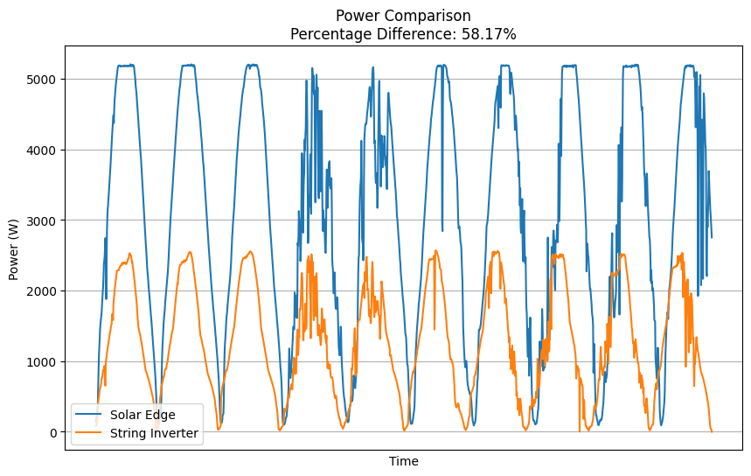
For this plot there looks like some time shift problem, take a look and try to fix it

24-11-30
- Run the code to see the plot
- See if the “merged_data” has timestamp information in time
- Add the timestamp into the IV curve feature
- Modified the code
  - Updated the title
  - Updated the saved file name by adding summer and site id
- Run the code to see if it works
- 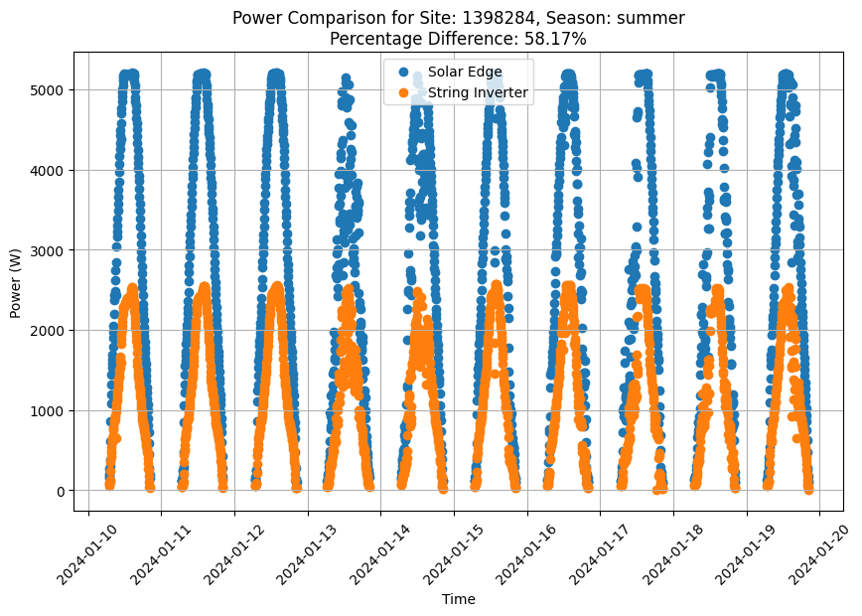

2024-12-13
- Make sure the code works for
  - Summer good
  - Summer bad
  - Winter good
  - Winter bad
- Use the first day 12:00 data point as example
- The IV data and the MPPT data looks OK
- Store a list of data that is taken in the tittle
- 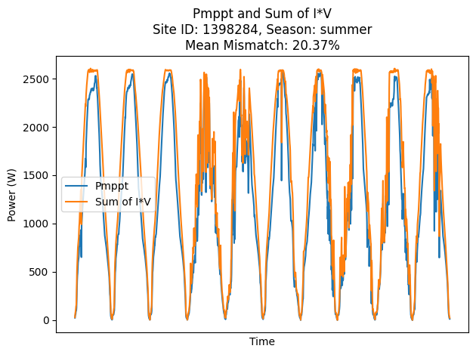
- 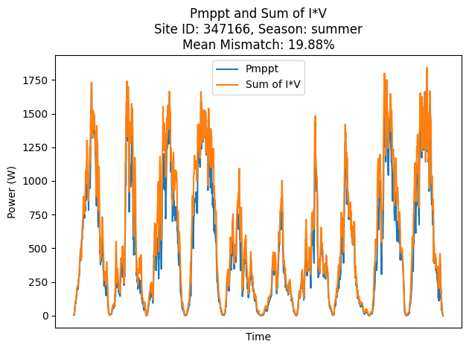
- Still something is wrong
- Find one day and do by hand
- Use 1-10 12pm as an example
- Do the calculation on excel
- 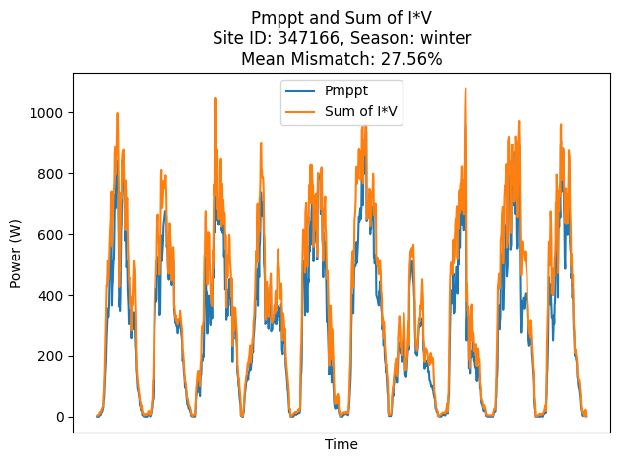
- Check if the plot
- Find one timestamp where it is clearly very different
- In summer
- 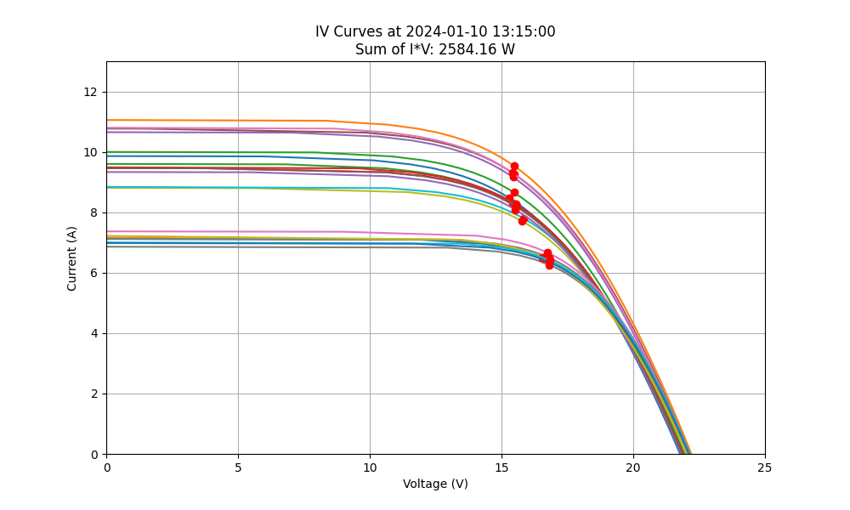
- 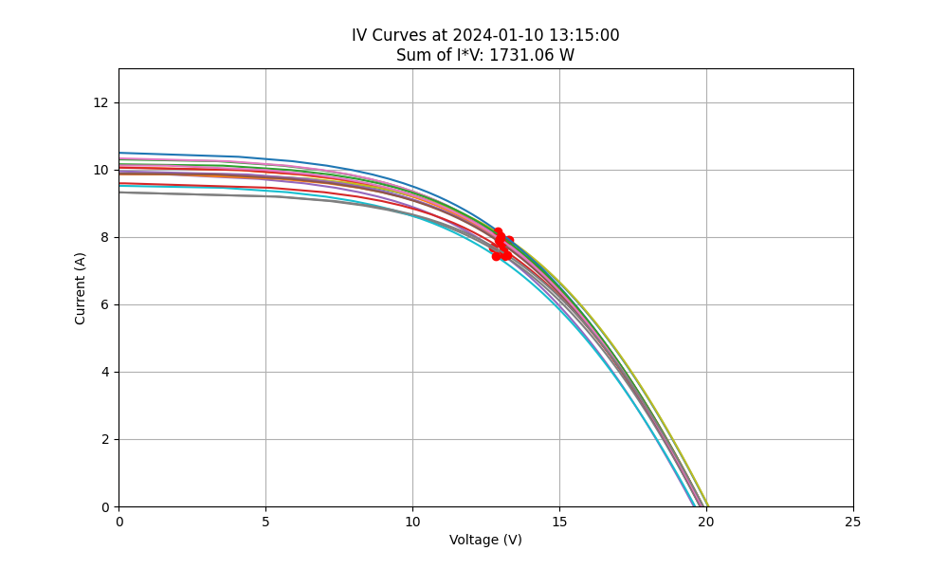
- 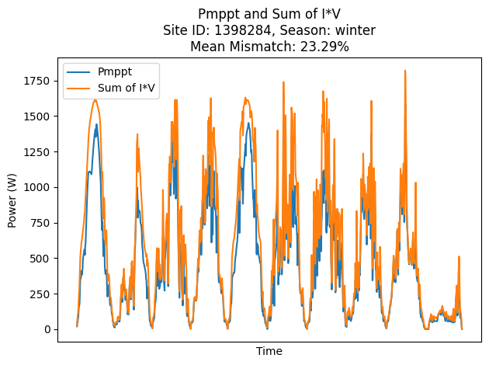
- 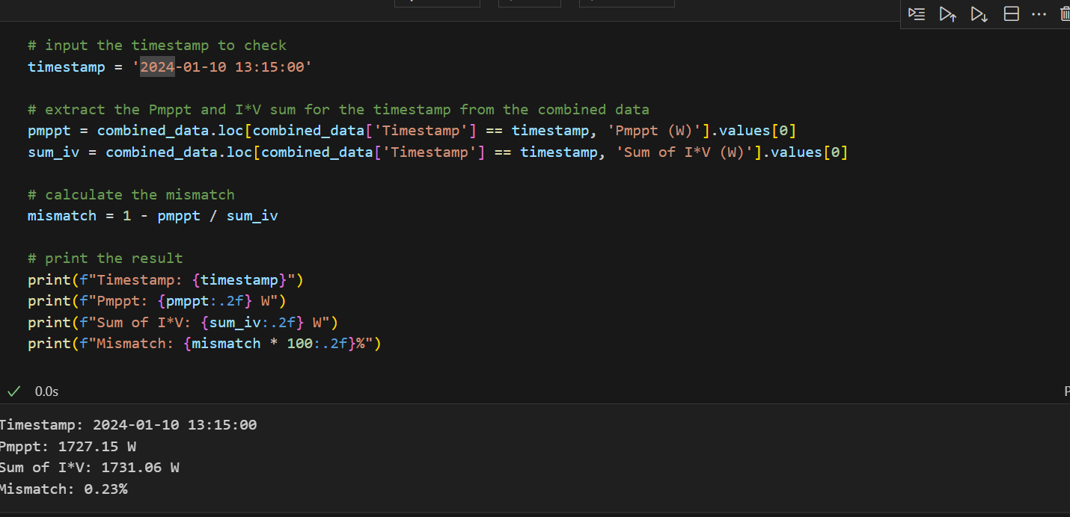
- Do the same on excel to see if you get identical results
- 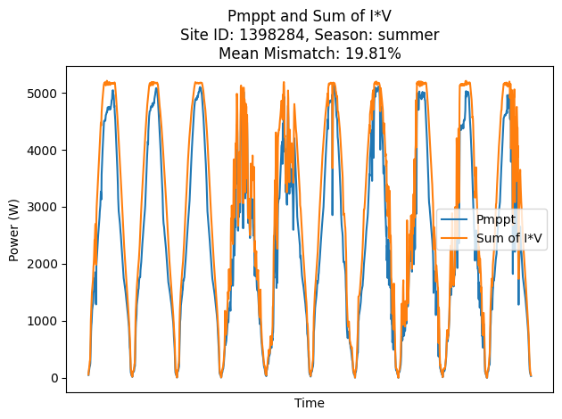
- Check list
  - The percentage difference process:
    - Redo the difference in Excel (done)
    - Check the paper to see how they did the difference
      - Read the paper
  - Another way to make it smaller is to use the output power
  - Try to use the power collected by inverter instead of optimizer
- Run to check if the results still exists
- Something wrong with the power
- Do not use the power
- Run the summer for both sites
  - 347166

25-3-14
- Try to find the file that works
- Run the file to ensure it works
- Save it
- Yes,it works
- Put the existing results onto an excel to summarise all the data

25-3-15
- Try to change the input folder path to see what happens
- Find where did you define input folder path
- Put the solar panel data input to the front

25-3-16
- Change the file to summer/winter/autumn/spring
- Maybe ask AI to tell me the list to do
  - Update site id
  - Check if the folder exist and is matching
  - Change the folder name into season
  - Update the module parameters
  - Update the upper limit of the V and I
  - Review data extraction filter and visualisatoin
  - Update the output directory
  - Run and check
- Optimise the code a little bit
- Update the cell parameter
- Run again
- The window is not responding
- Reopen and save on github
- The project it is not on githuhb, clone it first (done)
- Run for the winter
- 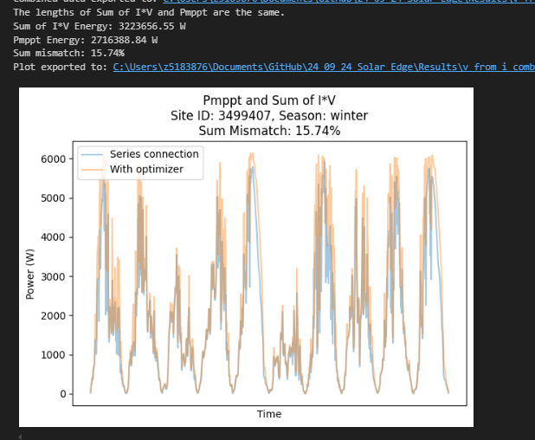
- See why summer is the same
- Check if the summer is the same as the witner through the exported data
- 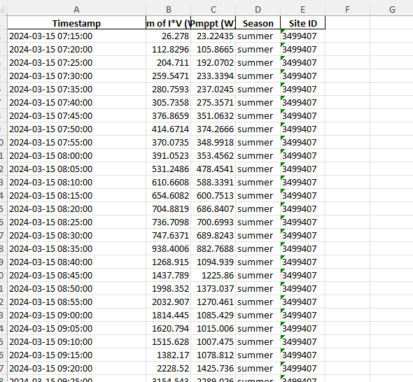
- The exported data is identical
- 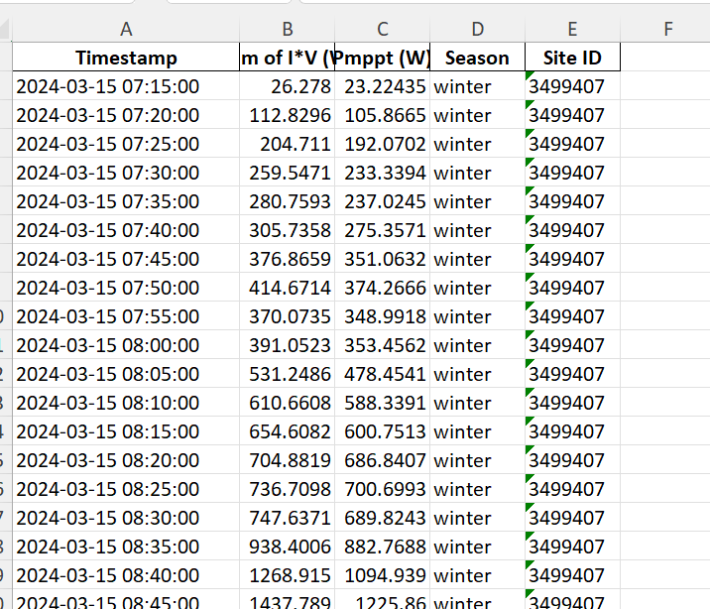
- Just the lable is different
- Check the original data
- The file
- 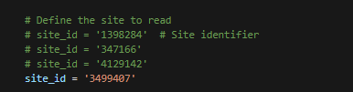
- The problem comes from my code
- It was named wrongly

25-11-01
- Analyse the new data
  - Check for duplicated files, no duplication
  - Check what is in the site id folder
    - New
      - Four season
        - Inverter
        - Optimiser (core)
        - Site daily
      - Inverter meta
      - Optimiser meta
    - Old
      - Four season
        - Inverter
        - Optimiser (core)
        - Site daily
      - Inverter meta
      - Optimiser meta
      - PAN file
  - The new data is missing the PAN file
  - Put them manually (done)
  - Check if the core excel has the same column names (yes)
  - Look up the orientation number from Google Maps

25-11-03
- Read the SolarEdge again
- Design the reconstruction workflow graph (done)
- Add into journal (done)
- Update the figure number (done)

25-11-04
- Update the Table
  - Shift the sites down
  - Add the new USA one
  - Update the number
  - Insert into the document
- Update the results table
- Update the text
  - The mismatch loss of each season
  - The mismatch loss of multi
  - The mismatch loss of mono
- Still missing a lot of results, all June are missing
- Run the model again to calculate June results

