25-12-31 journal
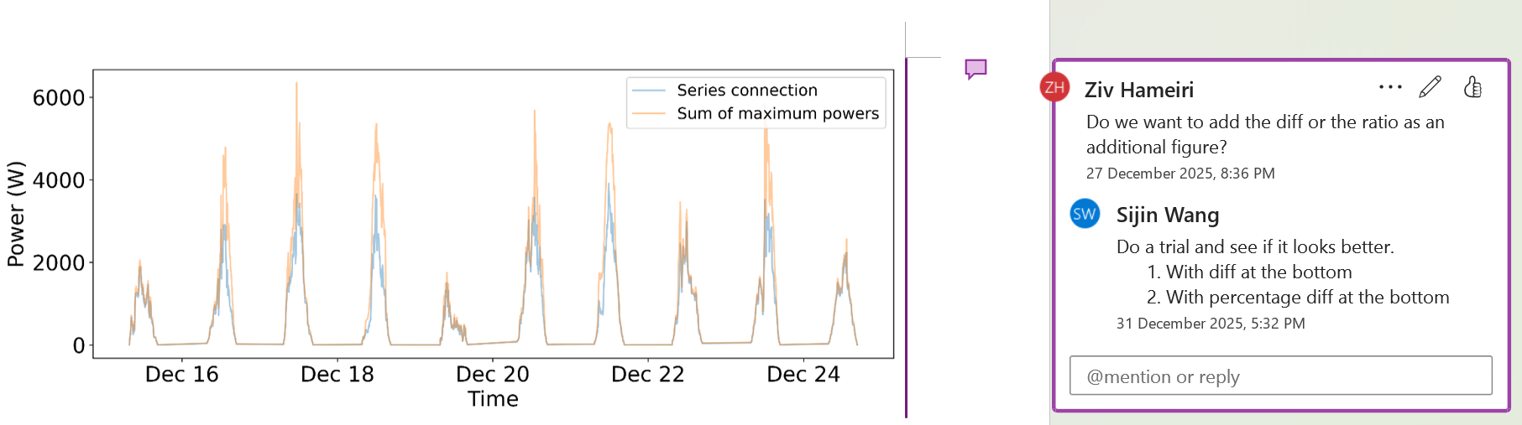
- Find the site id and season of this graph
  - Cannot use the one after applying the multi-orientation method
  - Let us see if previous logbook recorded it
  - Found via cropping: 4111492, December
- Gone to this folder, try to ask AI to write a script to reproduce this plot
  - Init
  - Can you see how … was created based on … and …? Can you explain how this graph was created?
  - Can you write a script to reproduce the plot?
- Actually, I can do that by myself faster
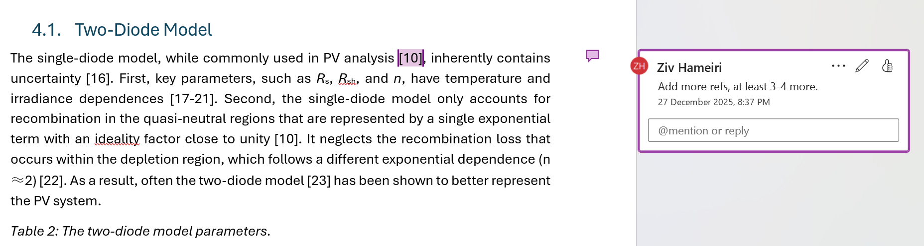
- Change from merging ref to separate ref (done)
- Add extra ref (done)
- Check ref format, especially the new ones (done)
- Change from separate ref to merging ref (done)

